Nama : Adika Setyadharma Susilo  
NIM : 2308561088

**DOKUMENTASI TEST CASE**

1. Test Case DFA
   1. L1 (All strings that start with '10' and end with '01')
      1. Accepted (101101101)

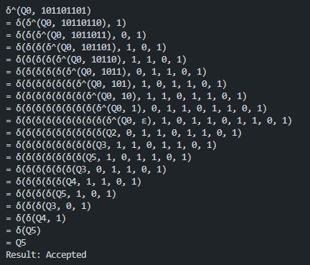

* + 1. Accepted (101001101)

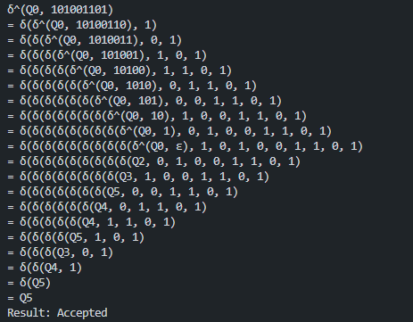

* + 1. Rejected (01000010)

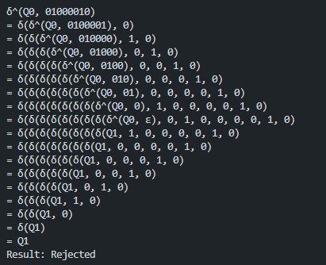

* + 1. Rejected (101000010)

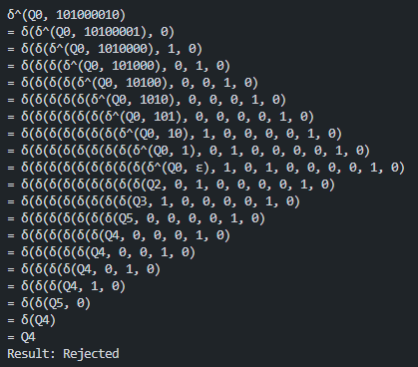

* 1. L2 (All strings that contain '000' and end with '1')
     1. Accepted (110001001)

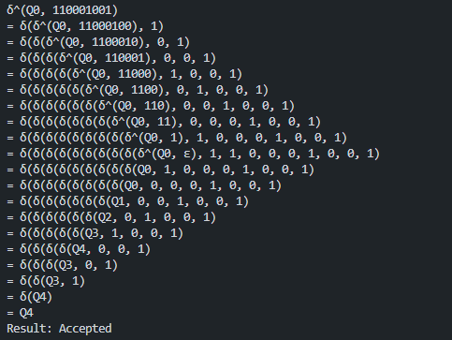

* + 1. Accepted (110000011)

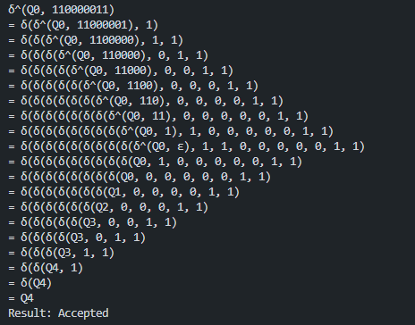

* + 1. Rejected (11000100)

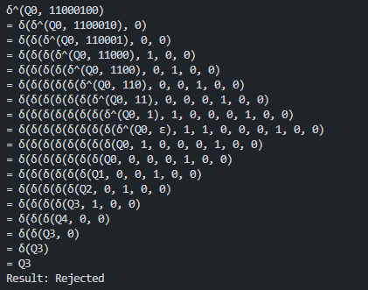

* + 1. Rejected (11001101)

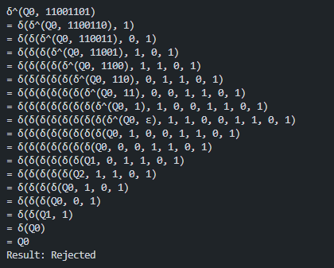

* 1. L3 (All strings that start and end with a different symbol)
     1. Accepted (10101010)

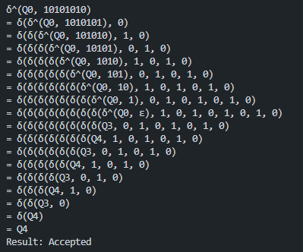

* + 1. Accepted (01110111)

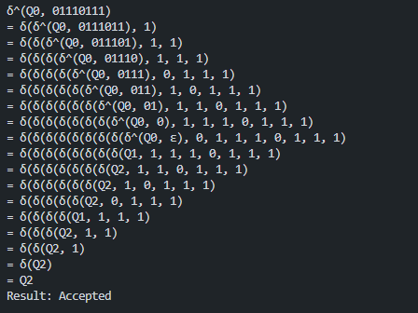

* + 1. Rejected (11010111)

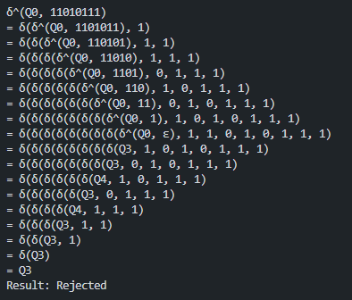

* + 1. Rejected (01010110)

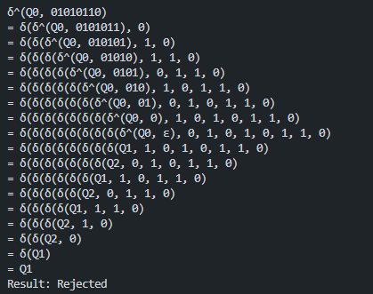

* 1. L4 (All strings that start and end with an identical symbol and contain '101')
     1. Accepted (110101101)

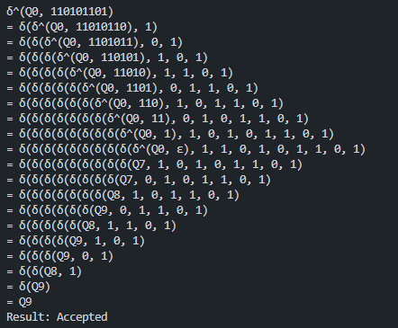

* + 1. Accepted (010101010)

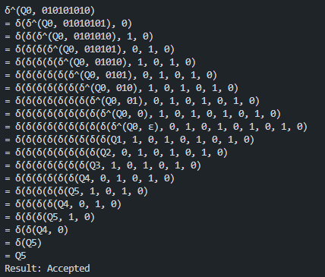

* + 1. Rejected (111010110)

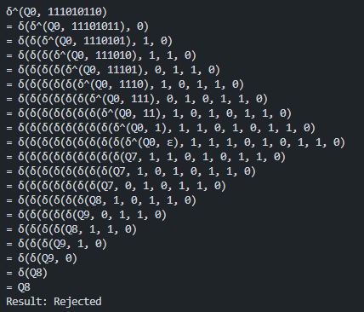

* + 1. Rejected (110011001)

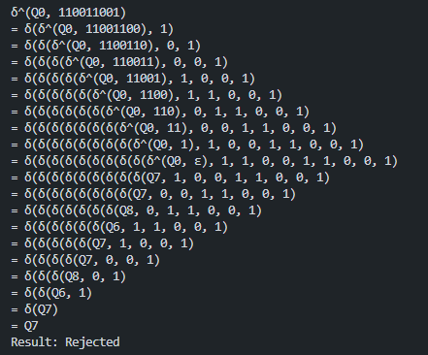

1. Test Case NFA
   1. L1 (All strings that start with '10' and end with '01')
      1. Accepted (101101101)

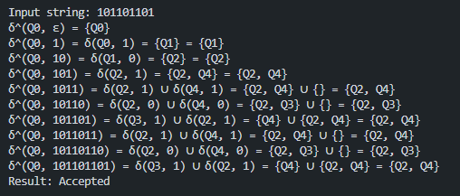

* + 1. Accepted (101001101)

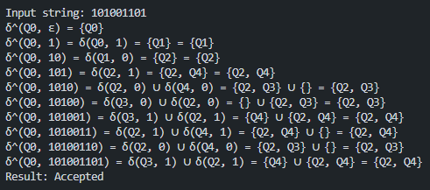

* + 1. Rejected (01000010)

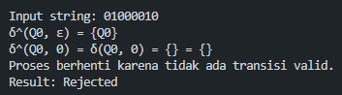

* + 1. Rejected (101000010)

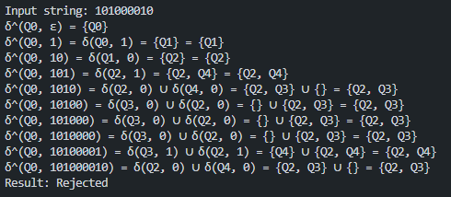

* 1. L2 (All strings that contain '000' and end with '1')
     1. Accepted (110001001)

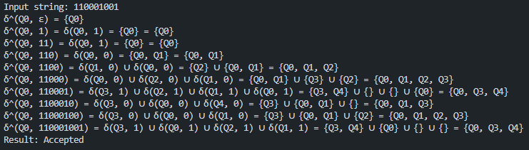

* + 1. Accepted (110000011)

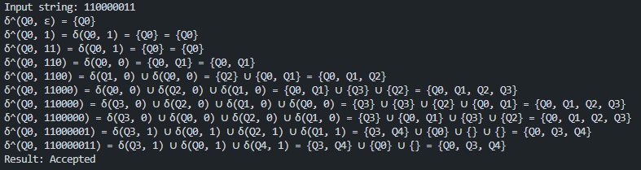

* + 1. Rejected (11000100)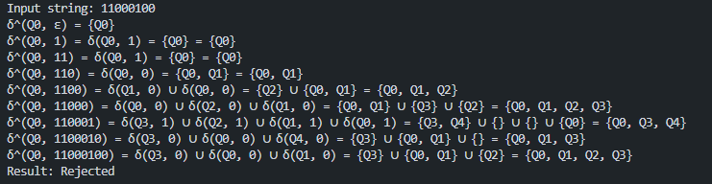
    2. Rejected (11001101)

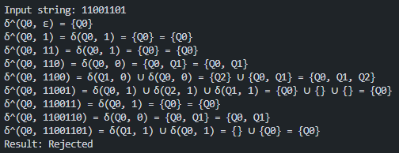

* 1. L3 (All strings that start and end with a different symbol)
     1. Accepted (10101010)

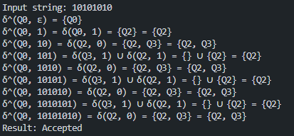

* + 1. Accepted (01110111)

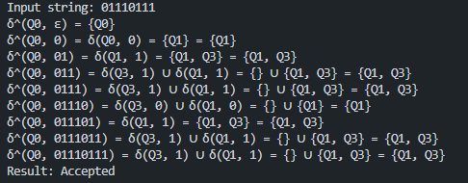

* + 1. Rejected (11010111)

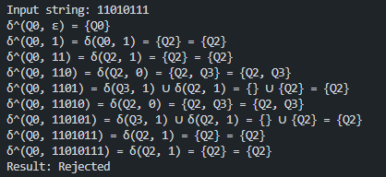

* + 1. Rejected (01010110)

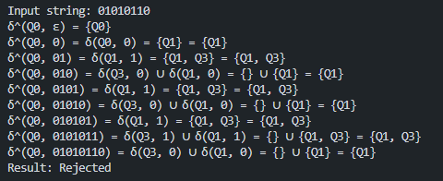

* 1. L4 (All strings that start and end with an identical symbol and contain '101')
     1. Accepted (110101101)

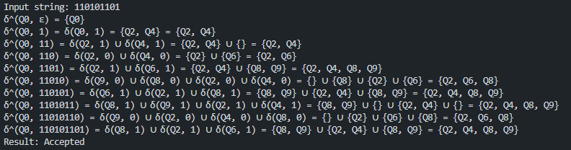

* + 1. Accepted (010101010)

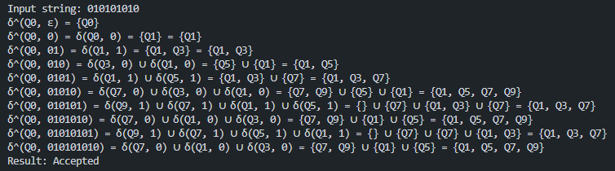

* + 1. Rejected (111010110)

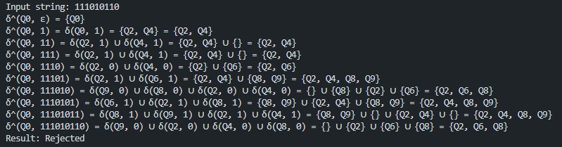

* + 1. Rejected (110011001)

