

CANSAT Guidebook

**Contents**

Preparation 3

Hardware Preparation 3

3D Components 3

Receiver Components 3

Software Preparation 4

Sensor Part 4

Sensors Communication 5

FPV Camera Part 6

Setup 7

Mechanical Part 7

Assemble 7

Programming Part 9

LoRa Layer 9

Sensors Layer 10

FPV Camera Layer 12

Troubleshoot 13

Mechanical Part 13

Programming Part 13

Obligation and Caution 14

Obligation 14

Caution 14

Specifications 15

# Preparation

In this part you can only doing it only one time per PC and you must do this before go to setup part. Before you go to do you must extract the folder.

Our CANSAT model we have 3 layers

1. LoRa Communication Layer
2. Sensor Layer
3. FPV Layer

## Hardware Preparation

Count and check the component before you go to setup part.

### 3D Components

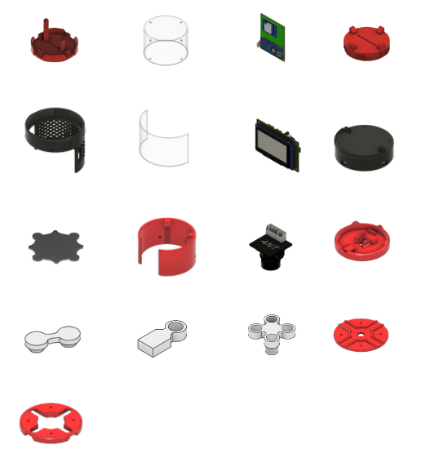





### Receiver Components

## Software Preparation

Before you go to another process you need to download every file from [github](https://github.com/Redcomet8300/Hestia_Cansat) and extract it.

### Sensor Part

1. Install [Arduino IDE](https://www.arduino.cc/en/software)
2. Open Arduino IDE
3. Search and Install libraries by selecting library manager on the left side

* “MS5611 by Rob Tillaart [rob.tillaart@gmail.com](mailto:rob.tillaart@gmail.com) ”
* “MPU6050 by Electronic Cats”
* “Adafruit GFX Library by Adafruit”
* “Adafruit SSD1306 by Adafruit”
* 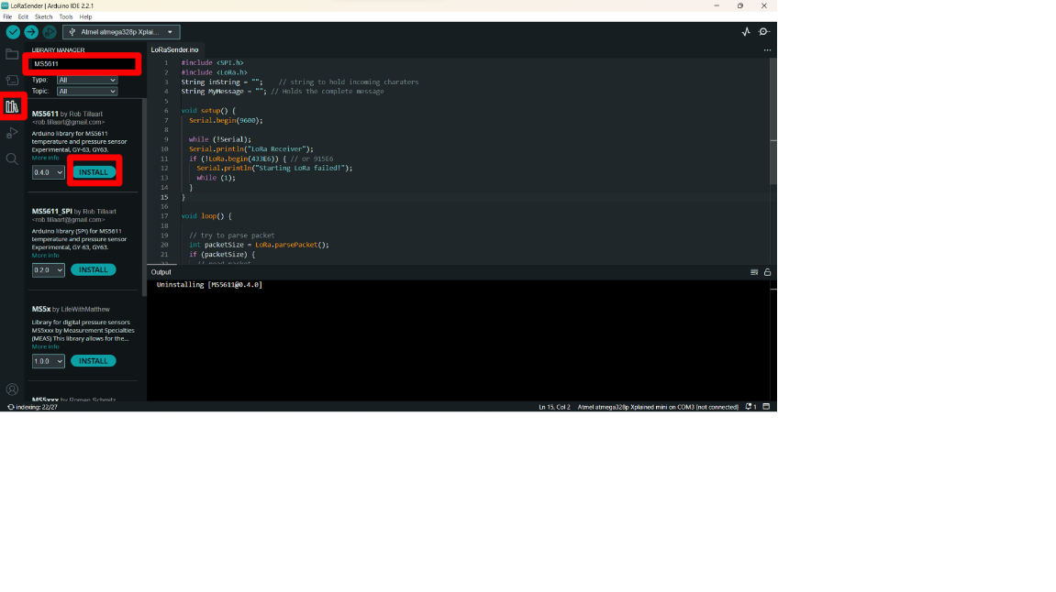“LoRa by Sandeep Mistry <Sandeep.mistry@gmail.com>”

### Sensors Communication

1. Install [Visual Studio Code](https://code.visualstudio.com/download)
2. Install [Python](https://www.python.org/downloads/)
3. Open Visual Studio Code
4. Click “file” at the left corner
5. Select “open folder” or you can open by use “Ctrl + Shift + O”
6. Navigate file “Communication Part” to the workspace
7. Click “Select”
8. Open the terminal bar in the app
9. 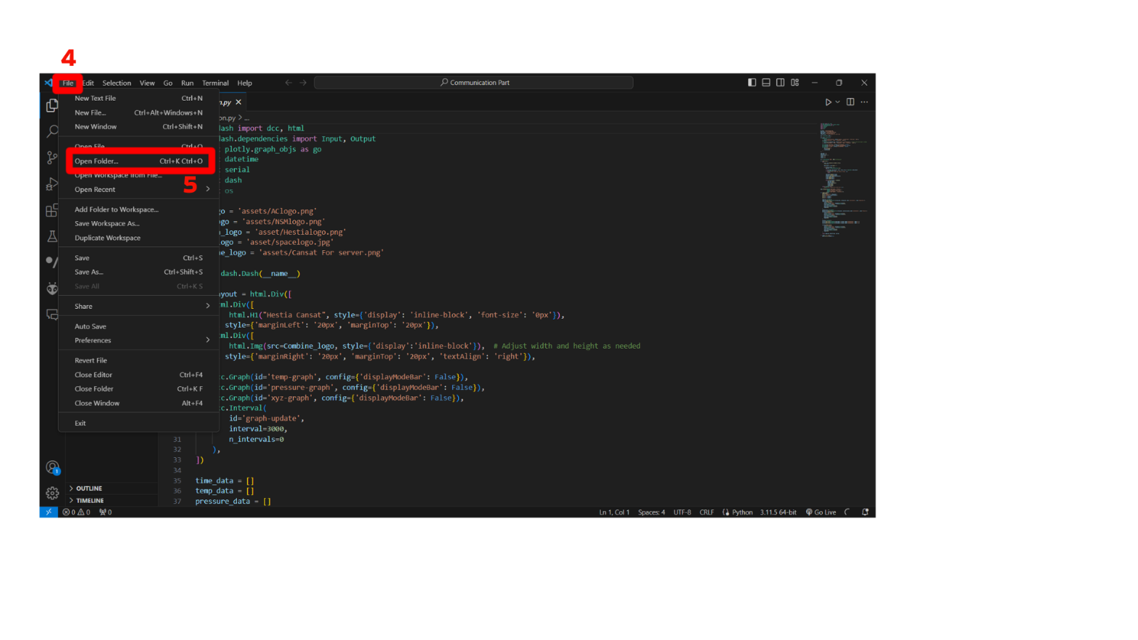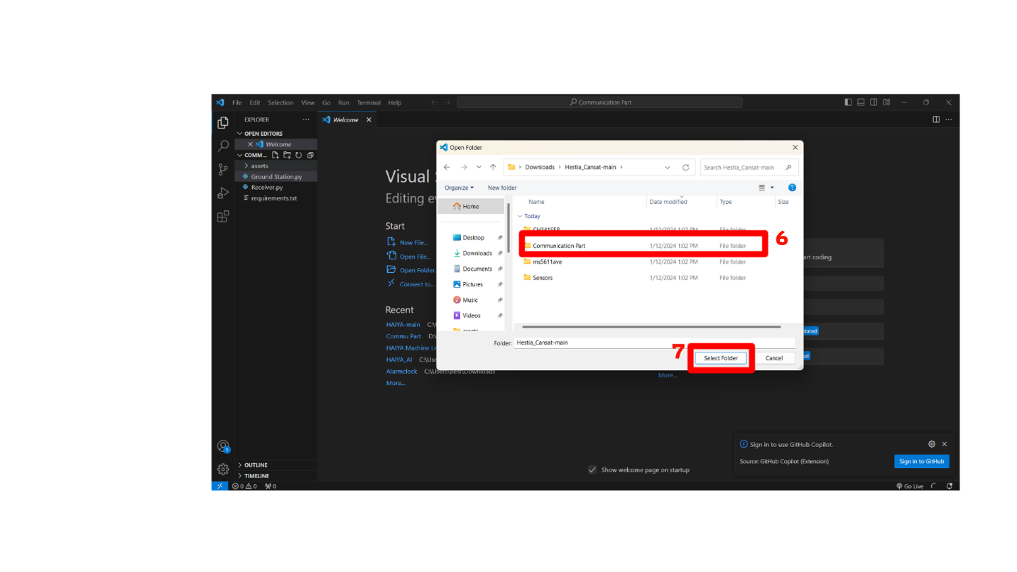Install library by type command “pip install -r requirements.txt”

### FPV Camera Part

1. Go to [FPV Software](https://www.nchsoftware.com/capture/index.html)
2. Click “Download Now”
3. Select “DebutVideoCaptureSoftware.exe”
4. 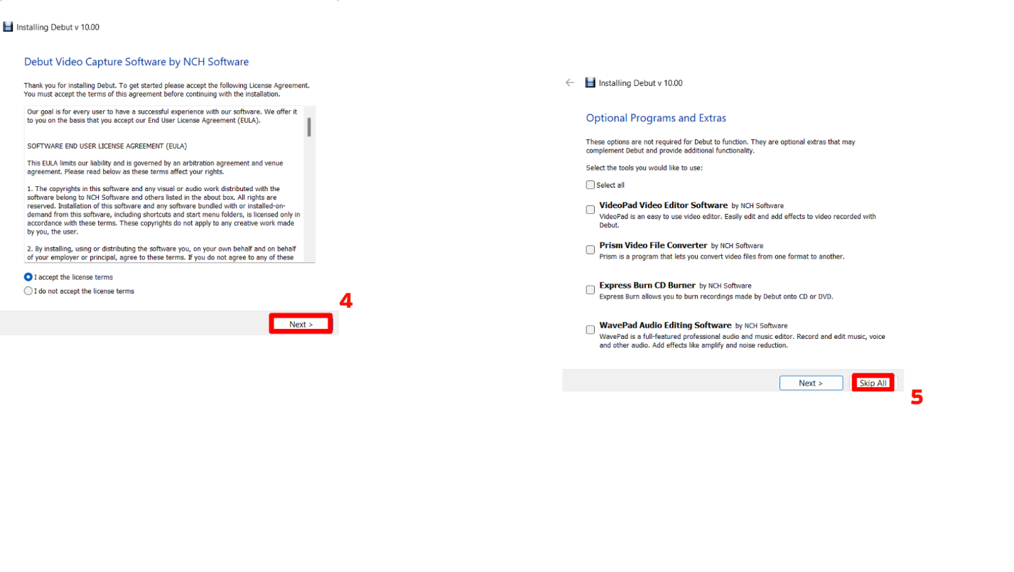Click “Next”
5. 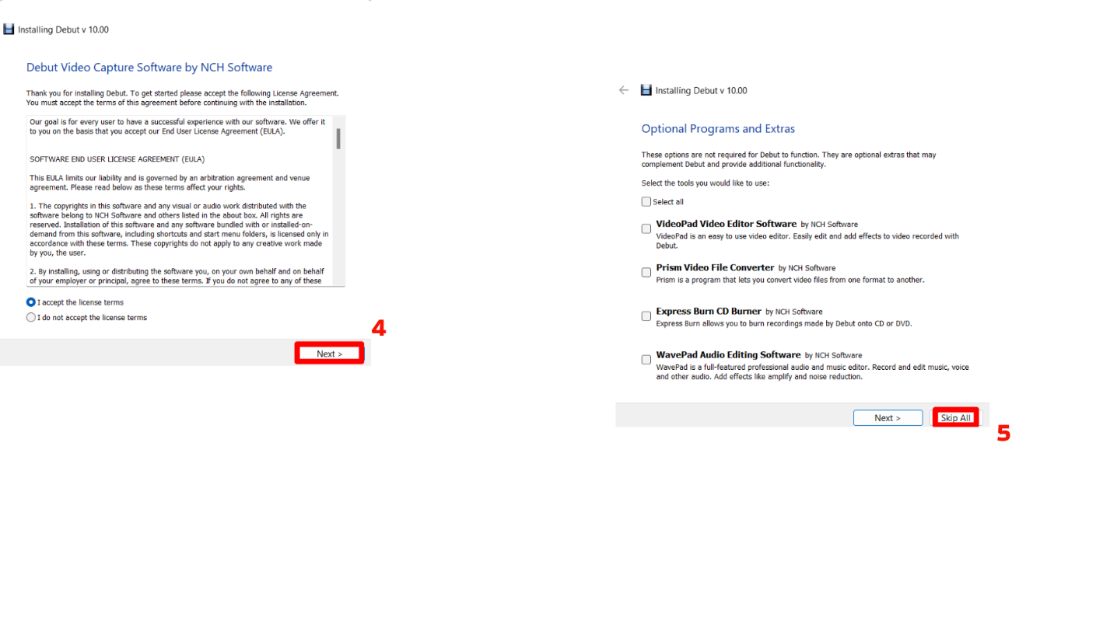Click “Skip all”

# Setup

In this part you need to do everytime before start to use it

## Mechanical Part

### Assemble

#### Top layer

1.Put a PCB in a middle of the object

2.Put an acrylic around it

3.Put the top part over the object

4.Use a screw to lock all of the component

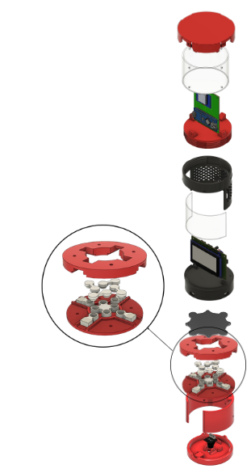

#### Middle Layer

1.Put a sensor board with a LCD screen in the gap and lock it with a screw

2.Put the acrylic in front of the LCD screen

3.Use a lit to cover it all and lock it

#### Bottom Layer

Rotate to the right to activate the lock system with a middle part

1.Put the grey component on top of the lit

2.Assemble the grey component like the picture

3.Put a camera into the bottom lit and use a screw

4.Use a screw to connected all the components

## Programming Part

### LoRa Layer

#### LoRa in CANSAT

1. Open “Main.cpp” by Arduino
2. Change the word in line 7 whatever you want but leave “...”
3. Select port and Upload your code to CANSAT

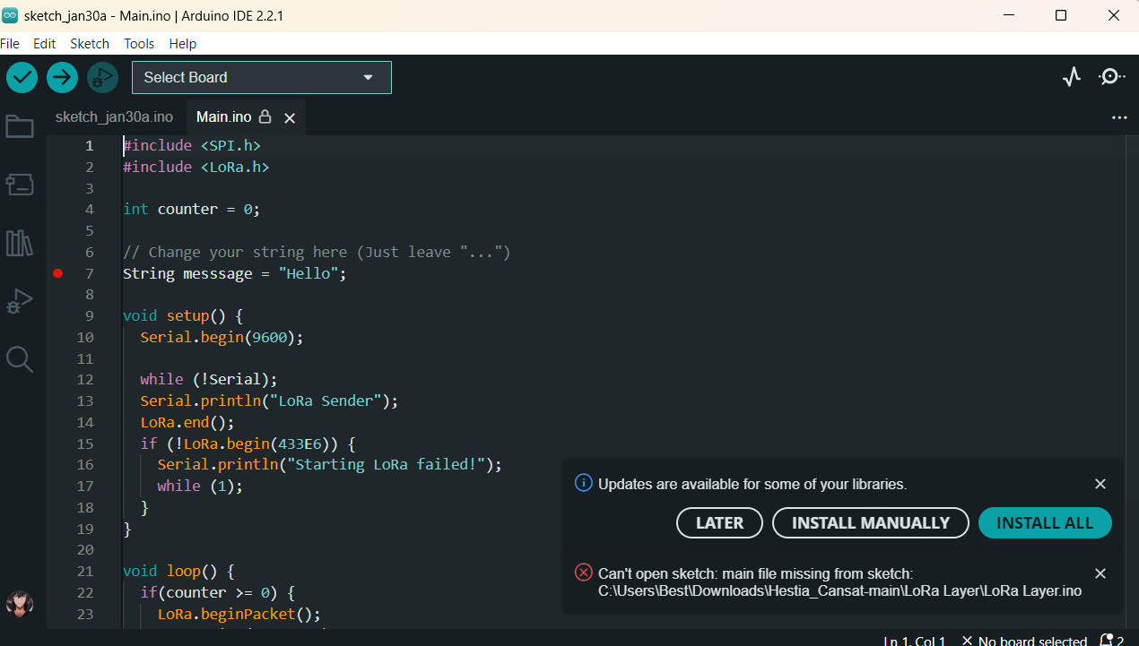

#### LoRa Communication

1. Go to “LoRa Layer” folder
2. Open “Groundstation.ino” by Arduino app
3. Upload code to LoRa communication board
4. Open serial monitor by press “Ctrl + Shift + M” to watch message

### Sensors Layer

#### Sensors in CANSAT

1. Open Arduino IDE
2. Click file at the top left corner
3. Select “open” or Press ctrl + O
4. Select “Transmittercansat.ino”
5. Connect the USB Cable to the board and Computer
6. Select “Atmel atmega328pb Xplained mini” board and port (depends on the computer COM Port)
7. Verify code
8. Upload code

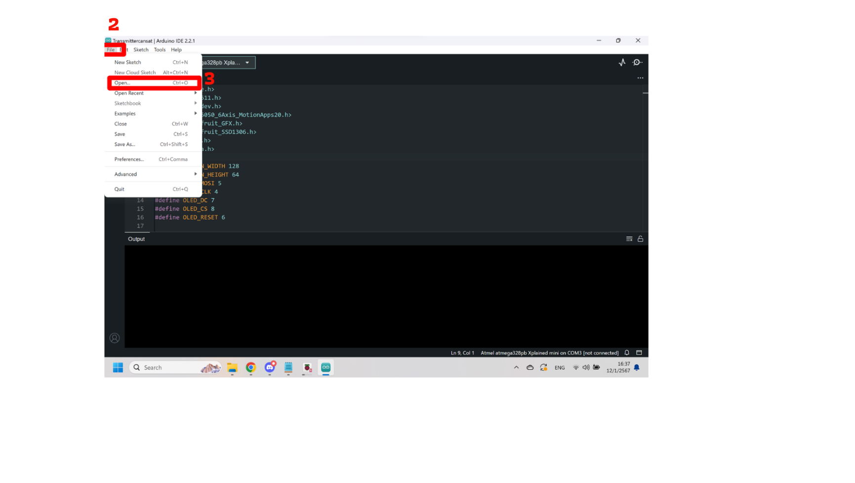When you upload the code You can connect with powerbank or other power supply

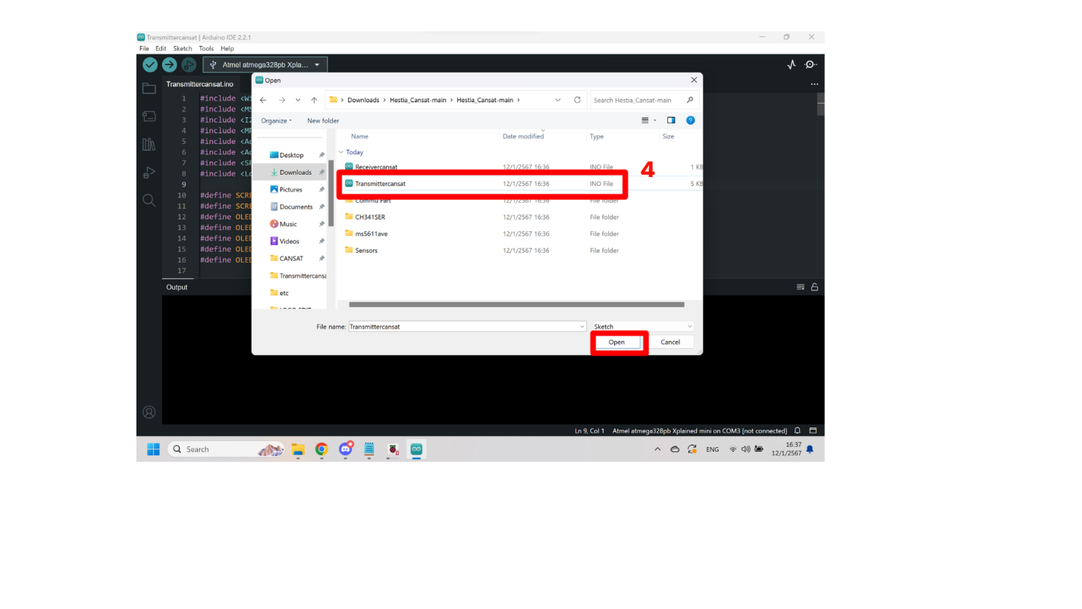

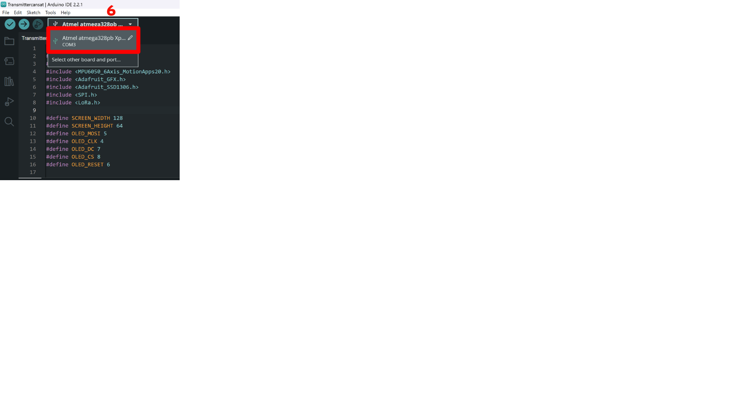

#### Sensors Communication

1. Open the program ”Visual Studio code”
2. Click “file” at the left corner
3. Select “open folder” or you can open by use “Ctrl + Shift + O”
4. Navigate file “Sensors Communication” to the workspace
5. Click “Select”
6. Select file “Ground Station.py”
7. Open Terminal
8. Find the “Setting port and Baud rate”
9. Edit setting port and baud rate (You can check by open Arduino and check)
10. Run the file
11. Open the link in the terminal
12. Wait for 10 second for calibrate

*\*\*Every time you use and want to open it again disconnect and reconnect the receiver\*\**

*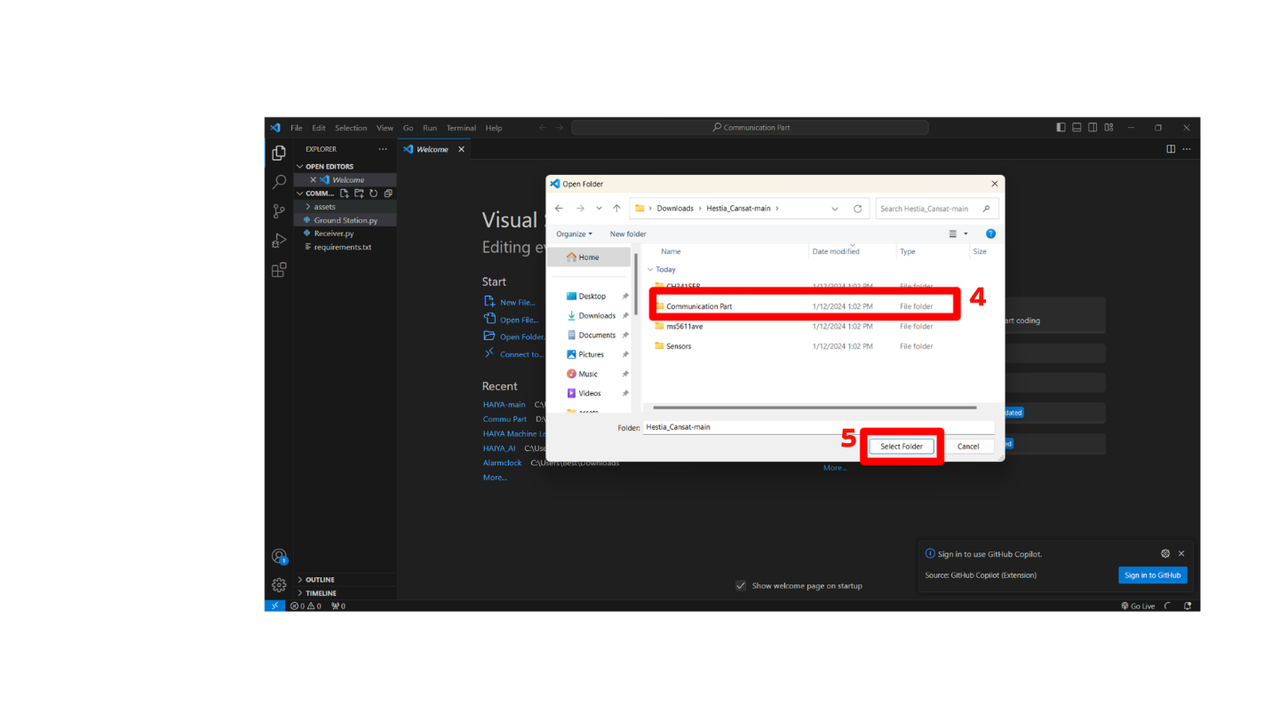**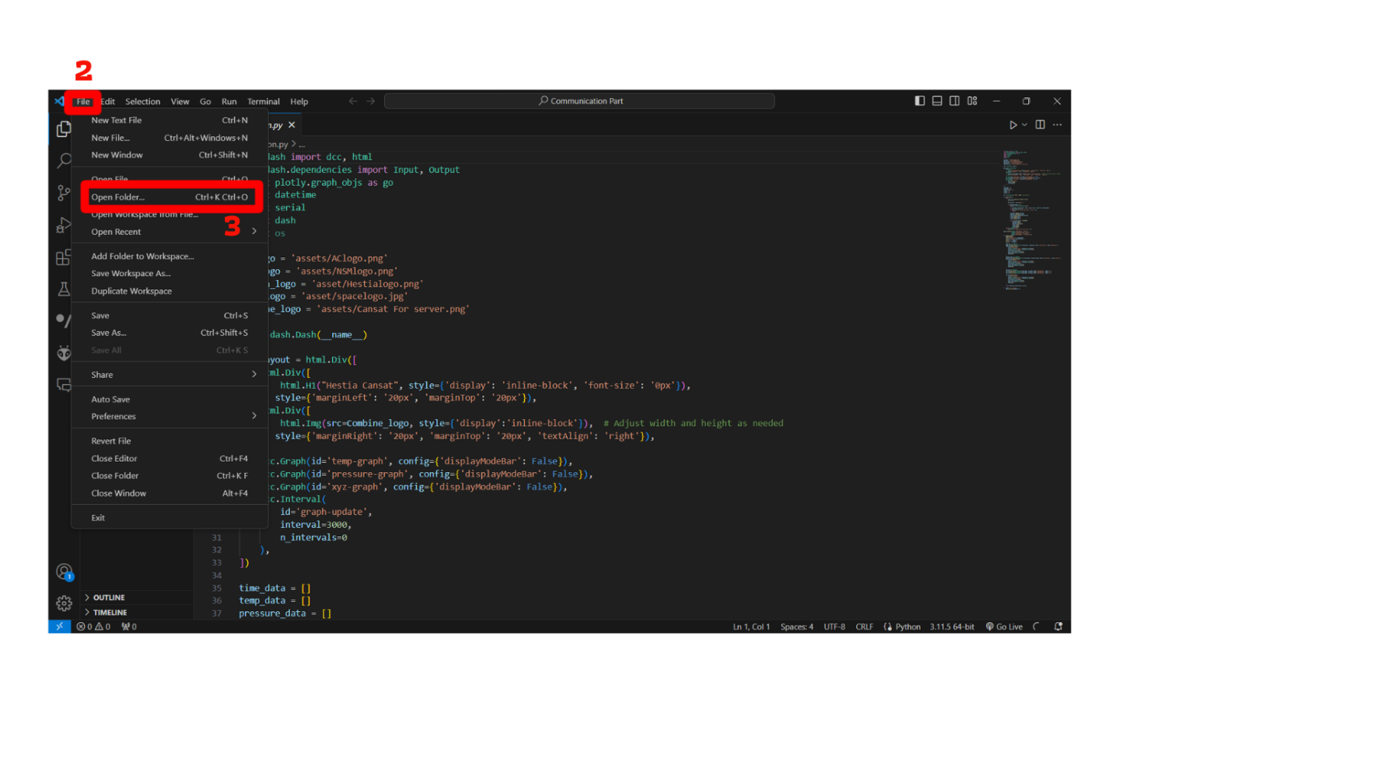You need to connect to run the Programming part before run the Communication part\*\**

### FPV Camera Layer

#### FPV Camera in CANSAT

1. Connect the antenna to the CANSAT with your power supply
2. Connect port USB with your power supply

#### FPV Camera Communication

1. Open “Debut by NCH Software”
2. Connect your receiver
3. Select “Tools” and select “Other Options”

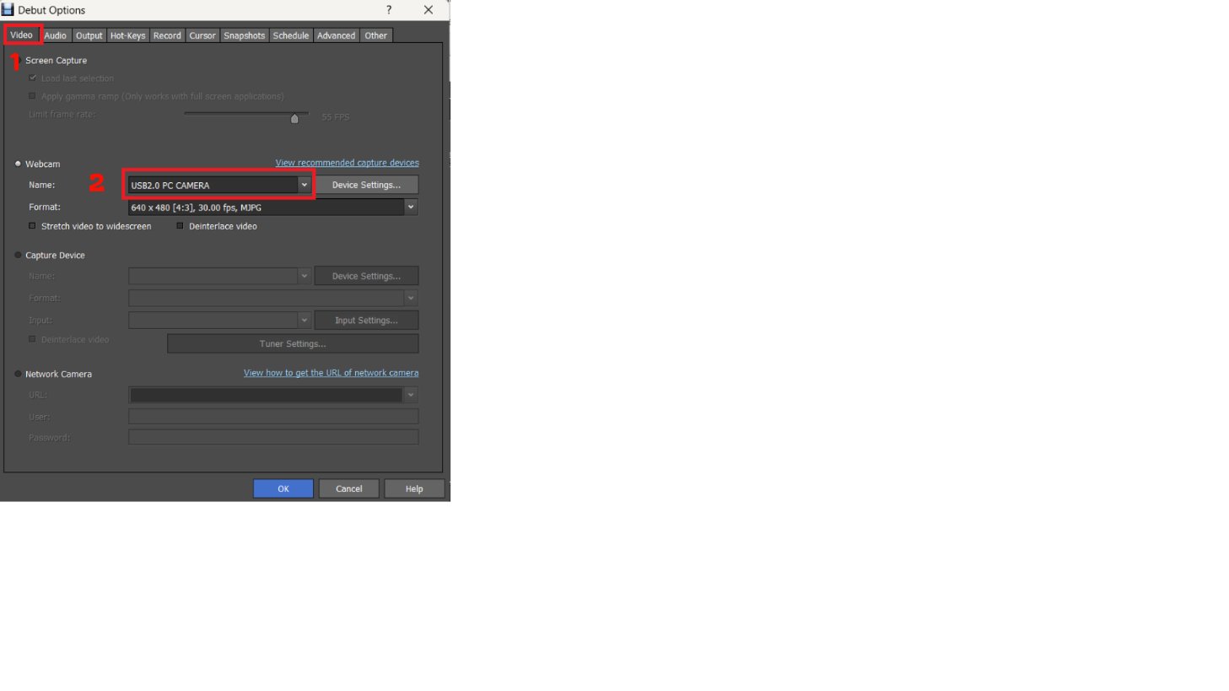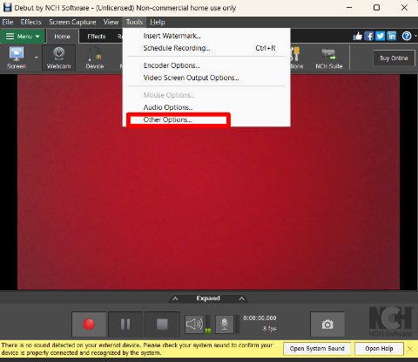

1. Choose “Receiver device name” in device option in setting and click “ok”.
2. 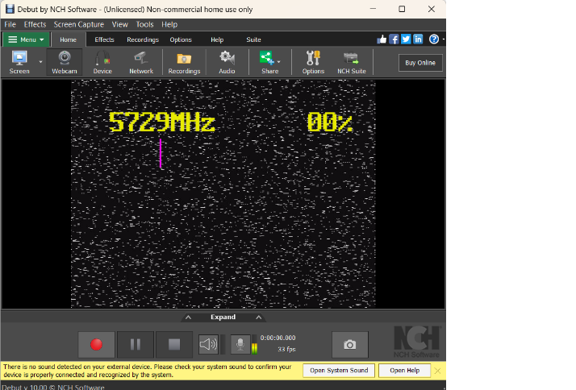You will see the radio wave video like in the picture. Please wait for 15 second for calibrating

# Troubleshoot

## Mechanical Part

Simply remove all of the components then re-assemble again with a new component set

## Programming Part

1. "Upload Error” Reinstall the driver of MCU by

* Select the “CH341SER” folder
* Select and Open “SETUP”
* Select “UNINSTALL”
* Select “INSTALL”
* Pull out the USB Cable
* 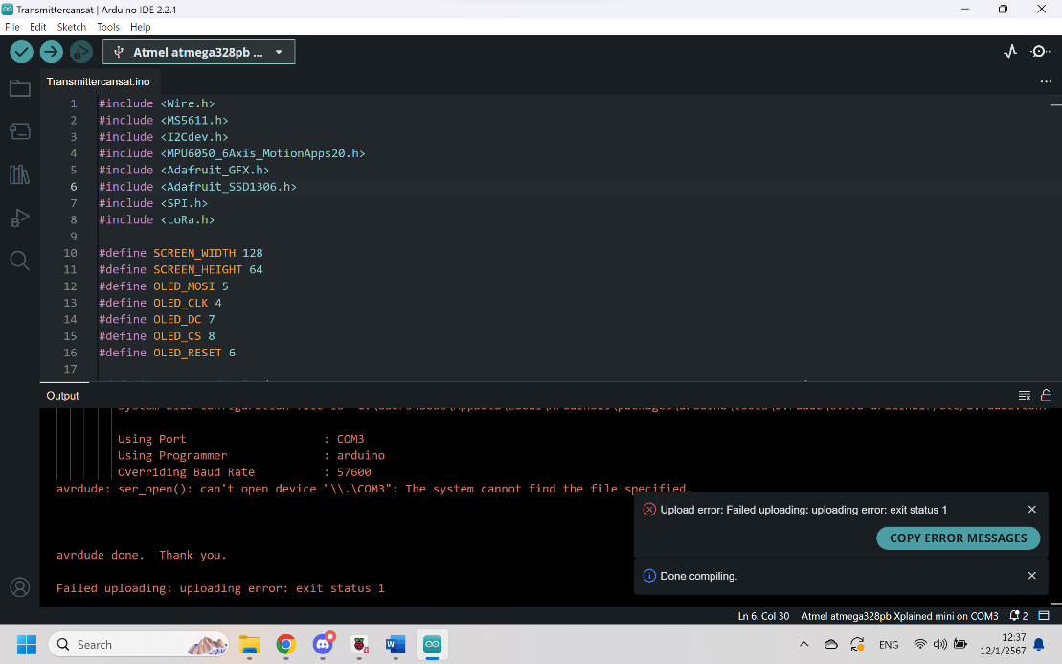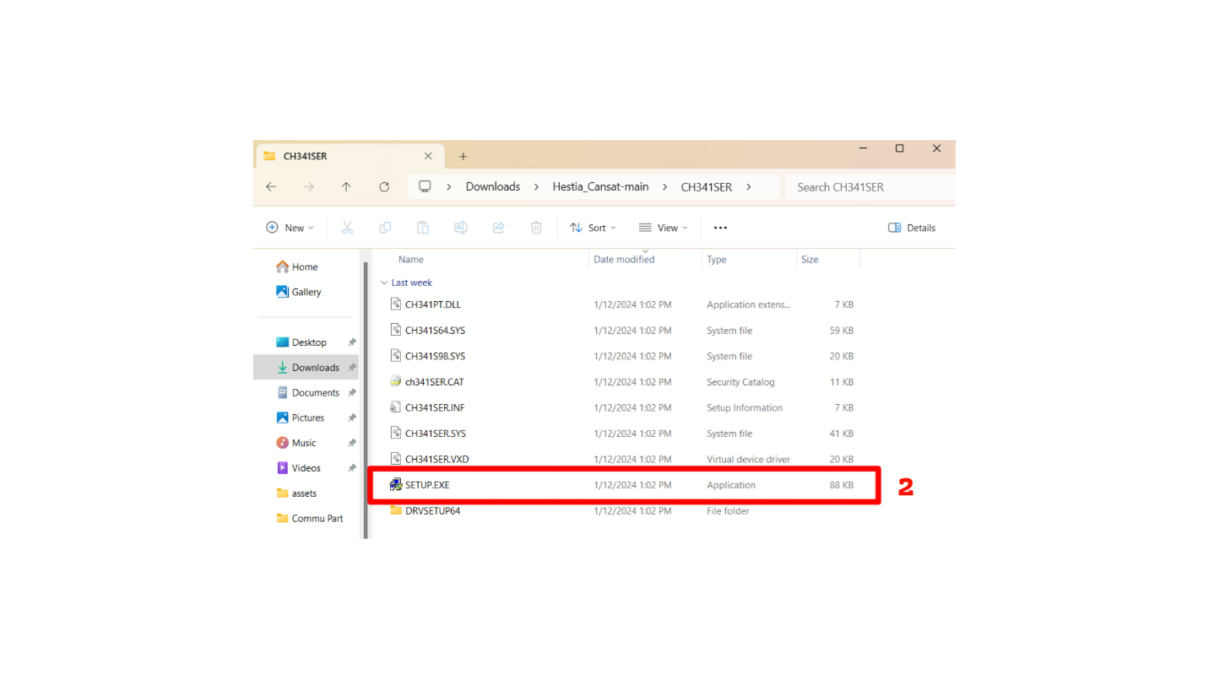Connect the USB Cable to the computer again

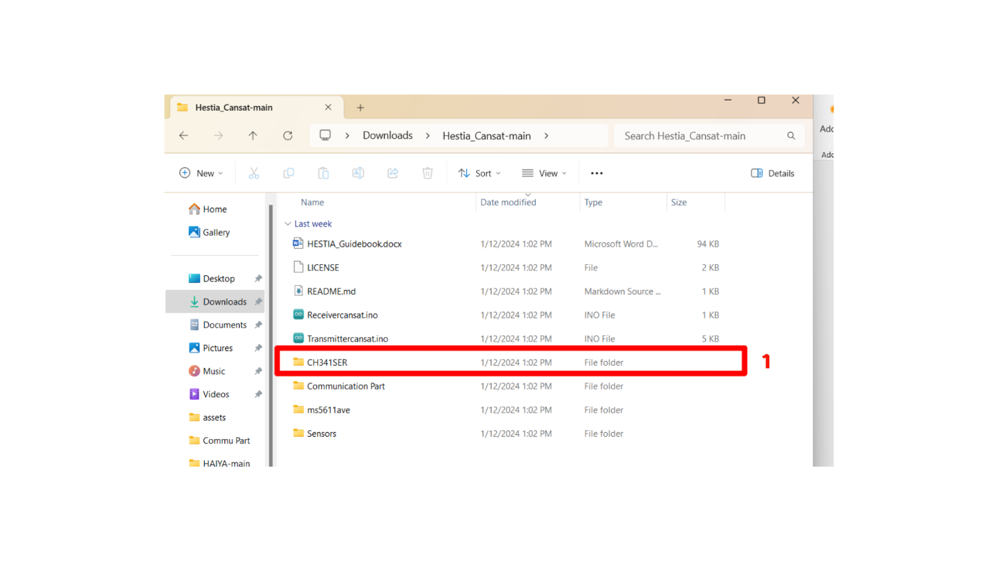

1. “Permission Error”

* Disconnect receiver port and reconnect it
* If it doesn’t display, Restart your device and setup again.

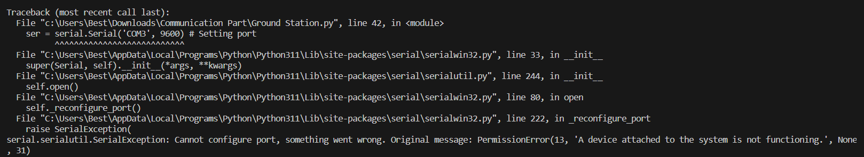

# Obligation and Caution

## Obligation

* You should follow the preparation and setup part step by step
* Turn off the switch and unplug when not in use.
* After use, store it in a bag and keep it dry.
* CANSAT should be connected to a stable power source and port USB because it will have huge impact in transmitting and receiving.
* If your communication part and programming part is damaged. try to delete and do preparation and set up again.

## Caution

* If any issues another what is covered in the manual, please contact and send the item for repair to the service center.
* Do not use steam cleaners or high-pressure water sprayers to clean the equipment, as it may cause electric shock.
* Children under 15 years old should have receive advice from adult before use.
* Do not use make anything that make spark occur.
* Do not touch the transmitter and receiver with wet or dirty hands.

# Specifications

|  |  |
| --- | --- |
| Model Name | Hestia CANSAT |
| Dimension | Ø 90 mm. |
| Net Weight (Transmitter and 3D Model) | 420 g. |

SPACE AC Institute of Technology

26, 40 Charoenkrung, Bangrak, Bangkok 10500

Tel: 063-231-7613

Email: phachara@spaceac.net

<https://spaceac.net>