SMART PARKING USING IOT AND MACHINE LEARNING
Dr. G. Ramu¹, Gangannagari Nithin Goud², Aman Kumar³, Chepyala Praneeth⁴, Punnam Bhagyalaxmi⁵, Gandham Srinivas⁶
¹Professor, ^{2, 3,4,5,6} UG Students
^{1,2,3,4,5,6} Department of Computer Science and Engineering,
^{1,2,3,4,5,6} Narsimha Reddy Engineering College, Hyderabad, India
Abstract:
Smart parking systems are innovative solutions designed to address the challenges of urban parking through the integration of Internet of Things (IOT) technology and machine learning (ML). These systems utilize a network of sensors, cameras, and cloud computing to provide real-time information about parking space availability, thereby enhancing user convenience and optimizing resource management. The architecture of smart parking systems typically includes several key components: sensors to detect vehicle presence, gateway devices for data processing, a cloud platform for data storage and analytics, and user applications that facilitate interaction between the system and drivers. The sensors can employ various technologies such as ultrasonic, magnetic, or camera-based detection methods to accurately monitor parking space occupancy
Smart parking systems that leverage IOT and machine learning technologies provide a comprehensive solution to urban parking challenges. They not only improve the efficiency of parking operations but also enhance the user experience by reducing search times and facilitating seamless payment processes. As cities continue to grow, these systems will be pivotal in promoting sustainable urban mobility and improving overall quality of life for residents.
Keyword:-Real-time availability updates, Mobile application, Machine Learning& IOT, slots availability data.
Block Diagram of the Project:
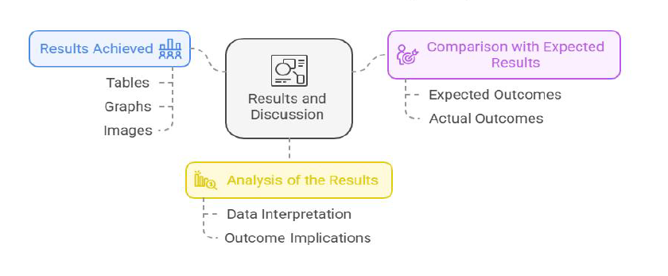
Note: If the block diagram is not available, please remove this section.

