1. Algorithm to multiply 2 numbers and print the result.

Algorithm:

Step 1: Start
Step 2: Read two integer values num1 and num2
Step 3: Initialize 1 to integer variable product
Step 4: Now, product = num1 * num2
Step 5: print “product”
Step 6: End

Flow Chart:
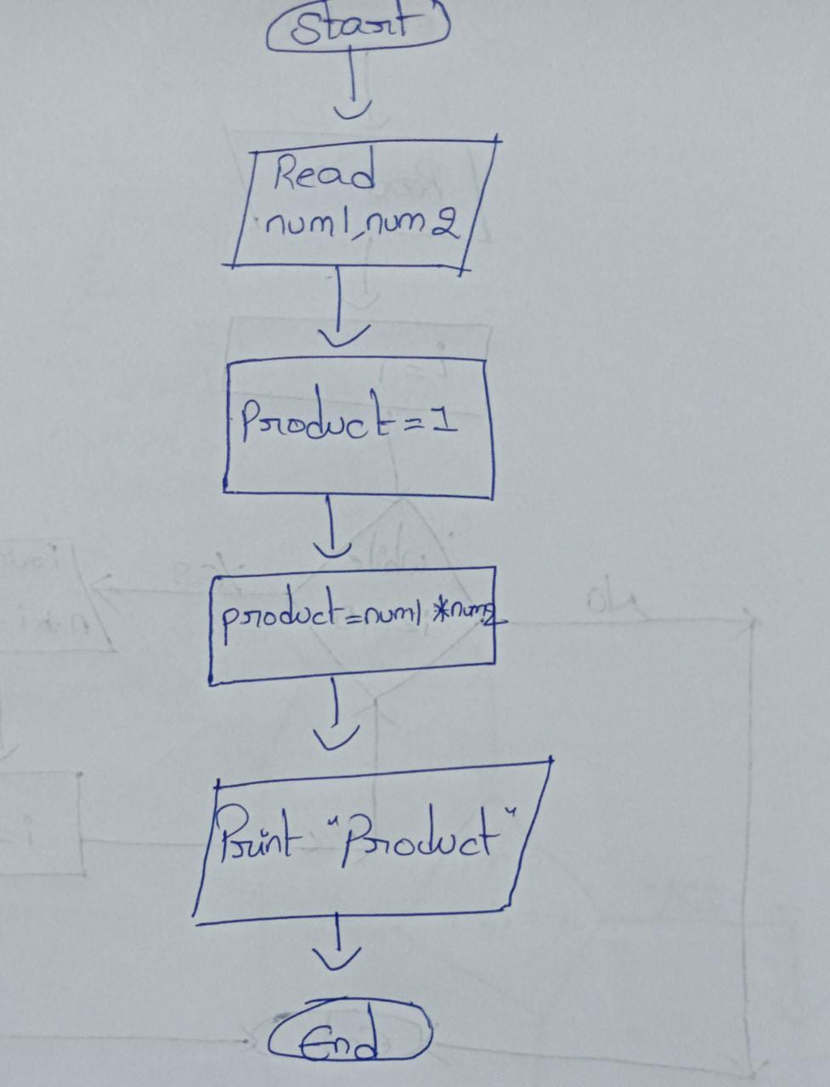

2. Write an algorithm to find the average of 3 subjects.

Algorithm:

Step 1: Start
Step 2: Read three subject marks let say marks1, marks2 and marks3
Step 3: Declare an integer variable total
Step 4: Now, total = marks1 + marks2 + marks3
Step 5: Declare double value to store the average
Step 6: average = total / 3
Step 7: print “average”
Step 8: End

Flow Chart:
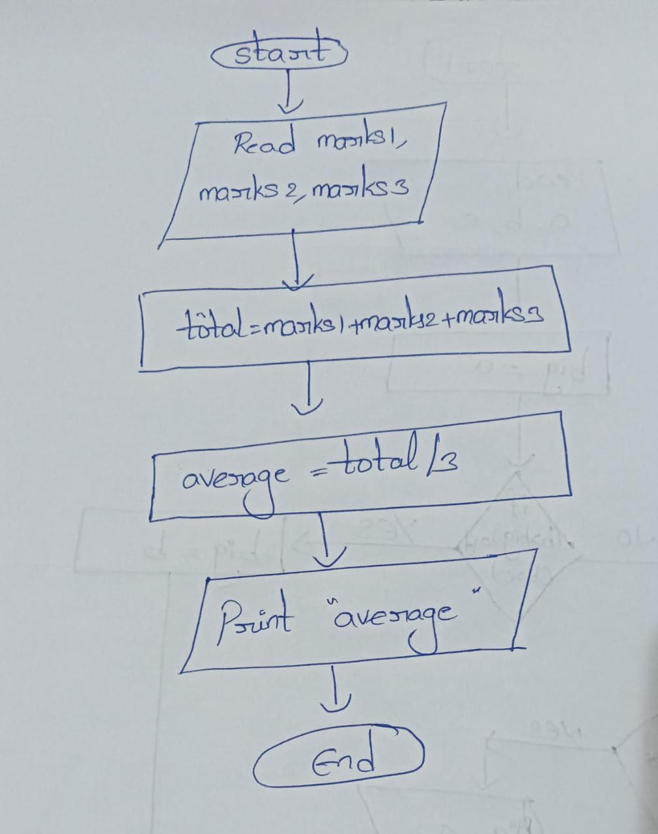

3. Print odd numbers till n.

Algorithm:

Step 1: Start
Step 2: Read an integer value n
Step 3: Initialize i to 0
Step 4: Check i is less than or equal to n
Step 5: Check if i is not divisible by 2, then print i
Step 6: Increment i by 1.
Step 7: Repeat step 4, 5 and 6, until i equal to n
Step 8: End

Flow Chart:
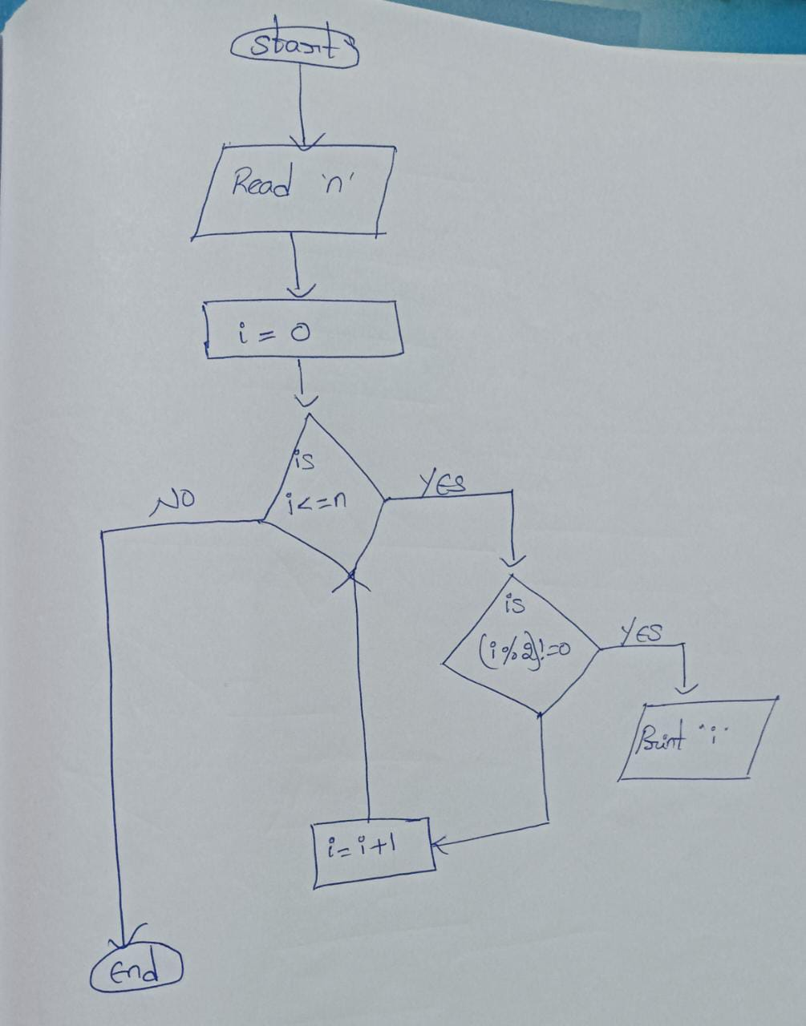

4. How to make vegetable biryani.

Algorithm:

Step 1: Start
Step 2: Take ingredients rice, vegetables, spices and water.
Step 3: Wash the rice and soak it in water for 30 minutes.
Step 4: Cut the vegetables into small pieces.
Step 5: Prepare the masala by combining spices
Step 6: Take one vessel pour some oil and add masala to it.
Step 7: Fry for a minute to release flavours
Step 8: Add the chopped vegetables to the vessel and stir – fry them for a few minutes.
Step 9: Now add the soaked rice.
Step 10: Pour the required amount of water
Step 11: Add salt and mix everything gently and cover the vessel with lid for 20 to 25 minutes.
Step 12: Once done turn off heat.
Step 13: Vegetable biryani ready.
Step 14: End

5. Sides of a triangle given, check whether a triangle is equilateral, isosceles or scalene.

Algorithm:

Step 1: Start
Step 2: Read three sides let say side1, side2 and side3.
Step 3: Check if side1 , side2 and side3 are equal, then print equilateral.
Step 4: Otherwise, check if side1 , side2 and side3 are not equal, then print scalene.
Step 5: Otherwise, print isosceles.
Step 6: End

Flow Chart:
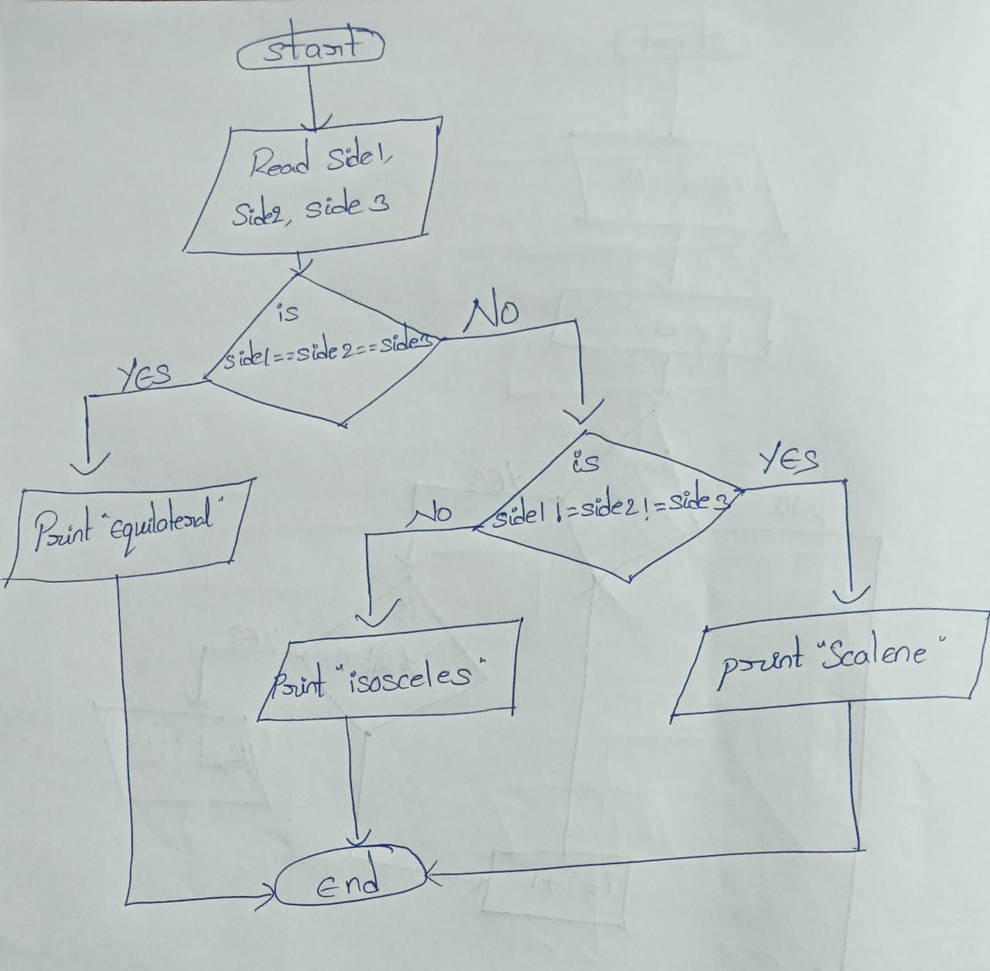

6. Sum of even numbers till n.

Algorithm:

Step 1: Start
Step 2: Read n
Step 3: Initialize i to 1 and sum to 0
Step 4: Check is i less than or equal to n
Step 5: Read num
Step 6: Check if num is divisible by 2, then sum = sum + num
Step 7: Increment i by 1
Step 8: Repeat step 4 to 7 until i is equal to n
Step 9: Print “sum”
Step 10: End

Flow Chart:
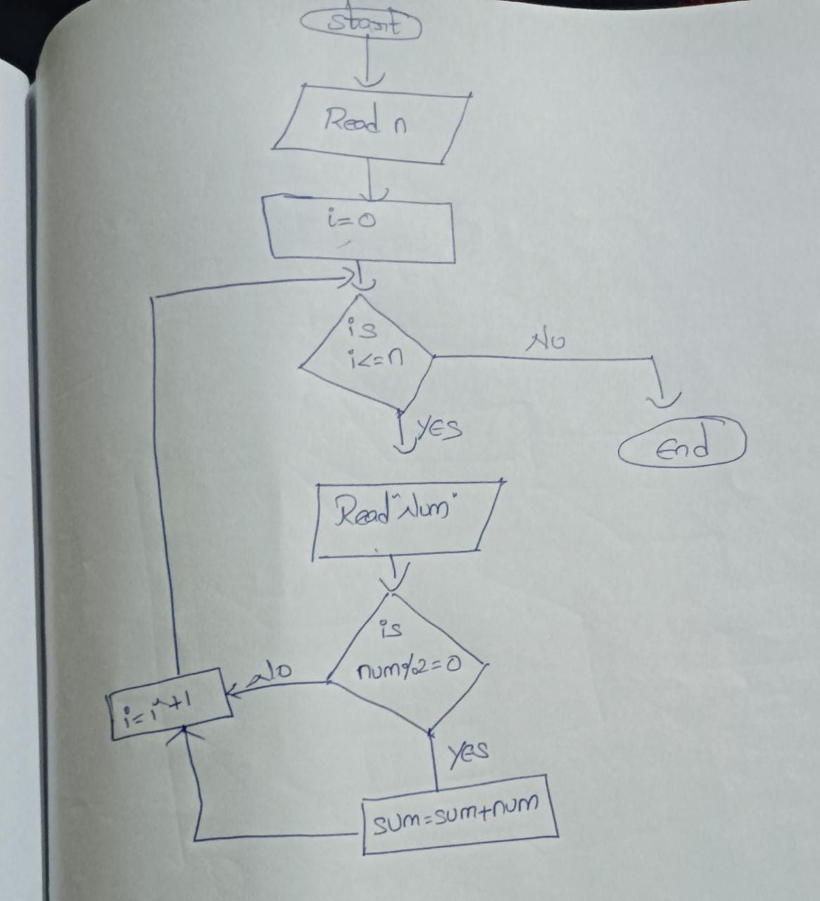
7. Find the GCD of given two numbers.

Algorithm:

Step 1: Start
Step 2: Read two integer values num1 and num2
Step 3: Initialize 1 to integer variable gcd
Step 4: Declare integer variable i and assign minimum of two numbers
Step 5: i = Math.min(num1, num2)
Step 6: Check if i is greater than 0
Step 6: Check if num1 and num2 divisible by i, then gcd = i and stop the loop
Step 7: Otherwise, decrement i one.
Step 8: Repeat step 6 and 7 until i greater than 0.
Step 9: Print “gcd”
Step 10: End

Flow Chart:
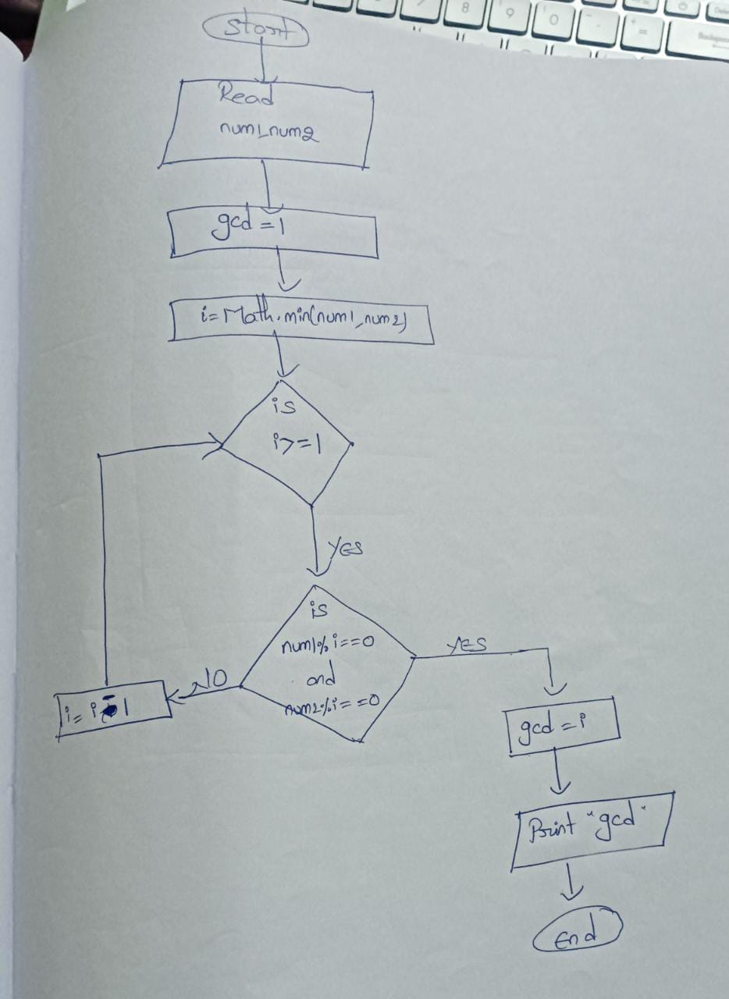

8. Find LCM of given 3 numbers.

Algorithm:

Step 1: Start
Step 2: Read three integer numbers, let say num1, num2 and num3.
Step 3: Initialize 1 to integer variable lcm
Step 4: Assign greatest number to lcm among three numbers
Step 5: Declare loop and repeat until true
Step 6: Check if num1, num2 and num3 divisible by lcm
Step 7: If yes, then print “lcm” and stop the loop
Step 8: Otherwise increment lcm by 1
Step 9: Repeat step 6 and 8 until condition true
Step 10: End

Flow Chart:

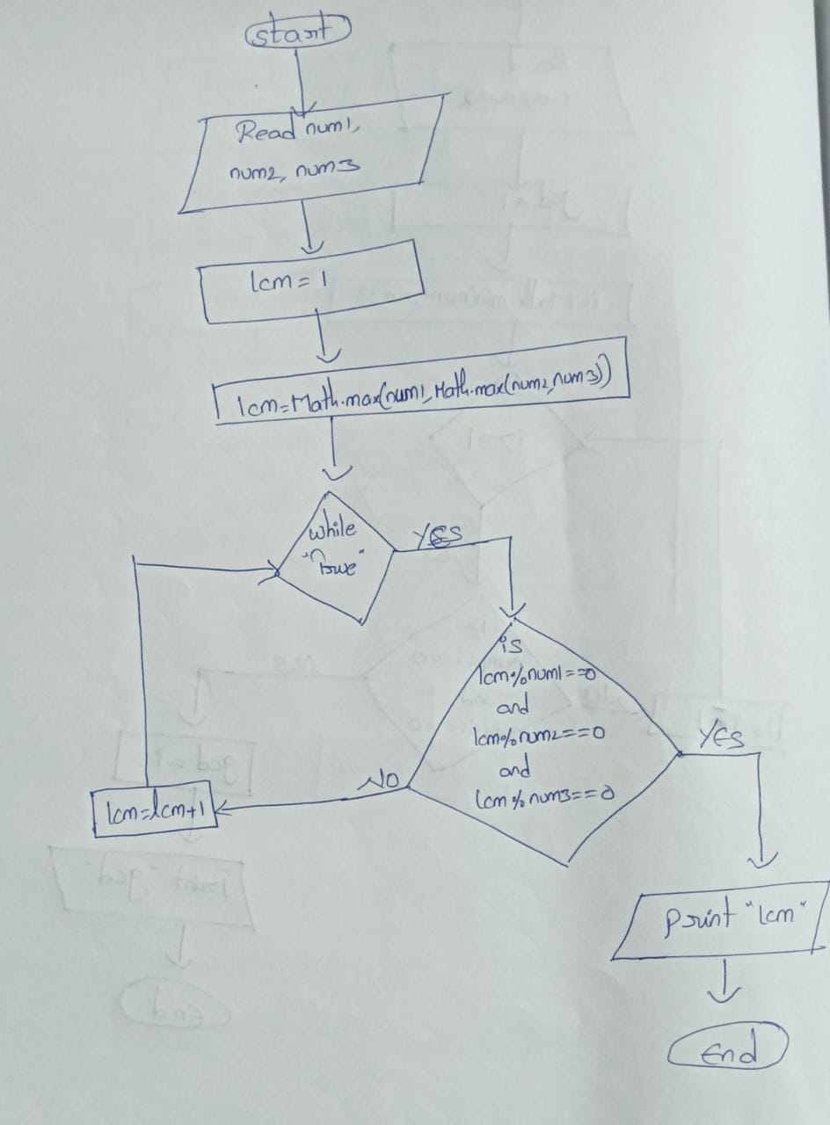

9. Find largest of N numbers.

Algorithm:

Step 1: Start
Step 2: Read an integer value n.
Step 3: Initialize 1 to integer variable i, and Math.min value to max
Step 4: Check if i less than n
Step 5: Read num
Step 6: Check if num is greater than max, then max = num
Step 7: Increment i value by 1.
Step 8: Repeat step 4 to 7 until i value is equal to n.
Step 9: Print “max”
Step 10: End

Flow Chart:

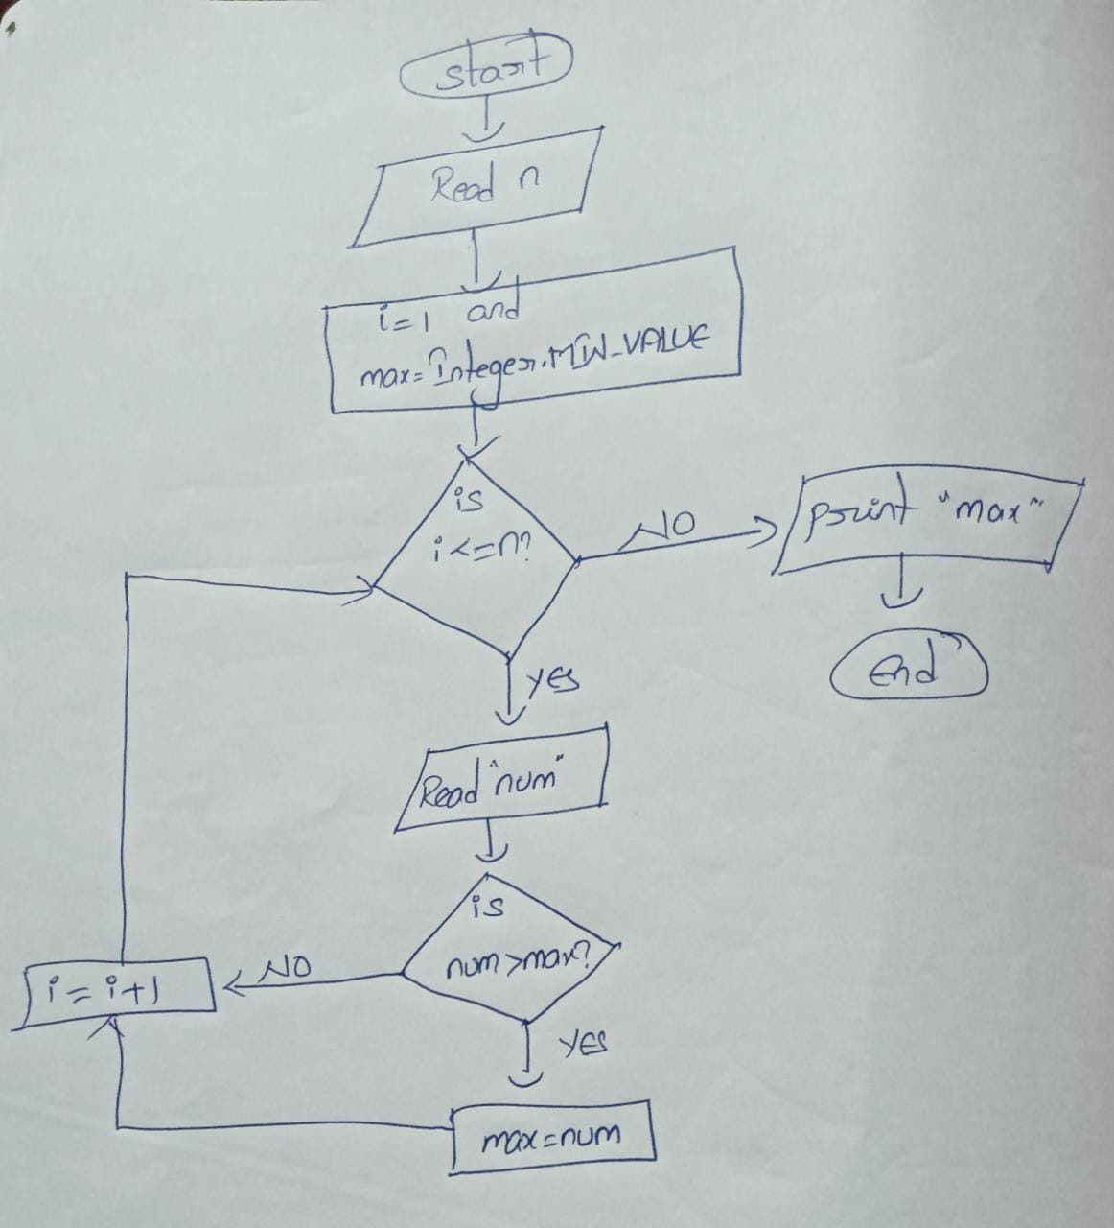

10. Check whether a number is prime or composite.

Algorithm:

Step 1: Start
Step 2: Read an integer value num
Step 3: Initialize div with 2
Step 4: Check if div is less than num, if no print “prime”
Step 5: if yes, then check is num is divisible with div
Step 6 : if yes, then print “composite” and end the loop
Step 7: Otherwise, increment div by 1
Step 8: Repeat step 4 to 7 until div less than num
Step 9: End

Flow Chart:

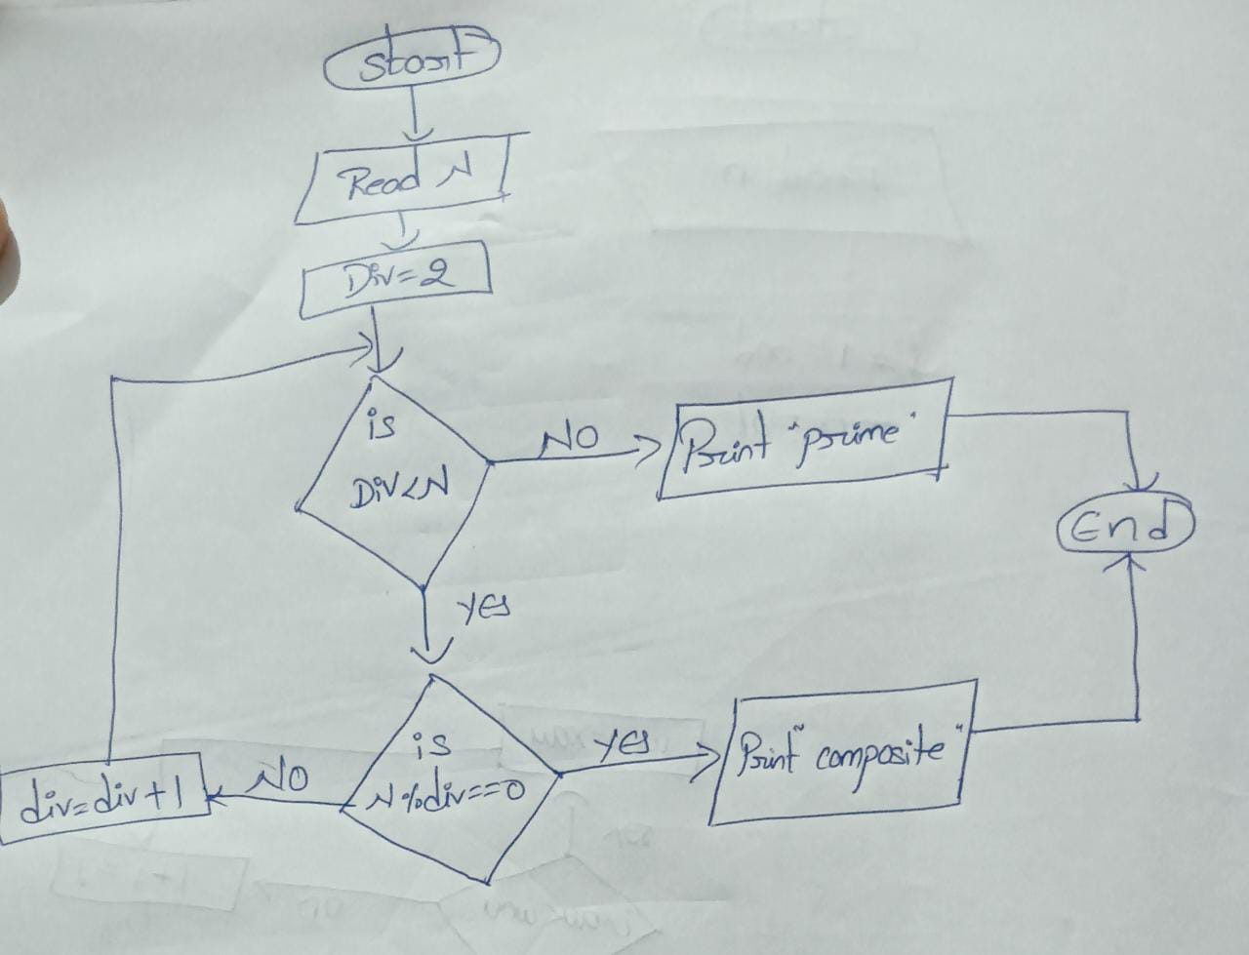

11. Print primes till N.

Algorithm:

Step 1: Start
Step 2: Read n
Step 3: Initialize 1 to i
Step 4: Declare the loop that repeats until n
Step 4: Set count =0
Step 5: Take another loop that repeats until n/2 and set j to 2
Step 6: Check if i is divisible by j
Step 7: If yes, increment count by 1 and stop the loop
Step 8: Check if count is equal to 0, then print i
Step 9: Repeat step 4 to 8, until i is equal to n
Step 10: End.

Flow Chart:

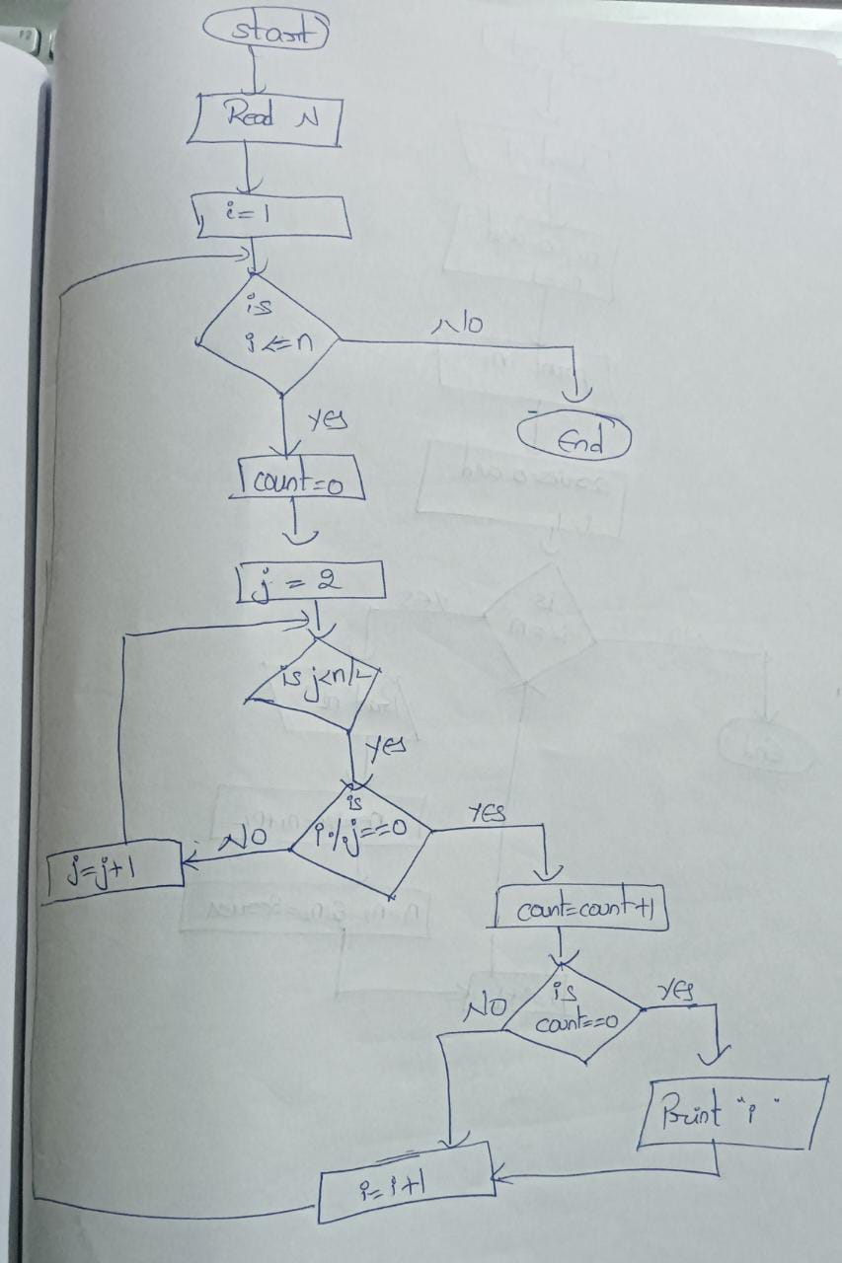

12. Print Fibonacci series till N.

Algorithm:

Step 1: Start
Step 2: Read an integer value n
Step 3: Initialize n1 as 0 and n2 as 1
Step 4: Print n1
Step 5: Declare an integer variable series and set 1 to integer variable i
Step 6: Check if i is less than or equal to n
Step 7: If yes, then print n2
Step 8: Now, series = n1 + n2
Step 9: Assign n2 to n1 and result to n2
Step 10: Repeat step 6 to step 9, until i equal to n
Step 11: End.

Flow Chart:

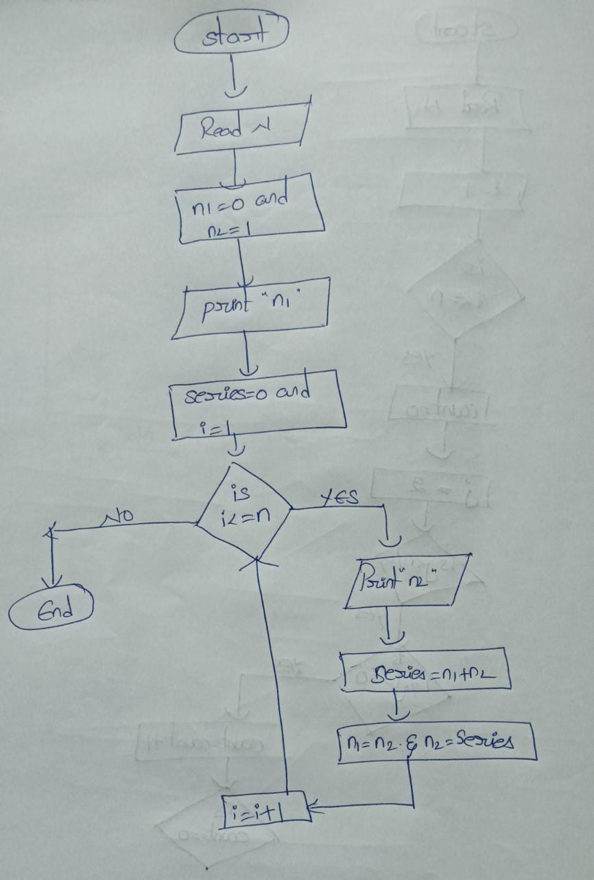

13. Check whether given number is Fibonacci or not?

Algorithm:

Step 1: Start
Step 2: Read an integer value n
Step 3: Declare an integer value x and y
Step 4: Now, x = 5*n*n+4 and y = 5*n*n-4
Step 5: Check, if x and y is perfect square
Step 6: Now, square = Math.sqrt(x) and square1 = Math.sqrt(y)
Step 7: check if square * square is equal to x, if yes then print “Fibonacci”
Step 8: Otherwise, check if square * square is equal to y, if yes then print “Fibonacci”
Step 9: Otherwise, print “not Fibonacci”
Step 10: End.

Flow Chart:
