**HashSet in java?**

**Source Code:**

import java.util.HashSet;

public class HashSetEx {

public static void main(String[] args) {

HashSet<Integer> hashSet = new HashSet<>();

hashSet.add(10);

hashSet.add(3);

hashSet.add(6);

hashSet.add(5);

System.out.println(hashSet);

boolean result = HashSetEx.contains(6);

System.out.println(result);

}

static boolean contains(int key) {

if(key != -1)

return true;

else

return false;

}

}

**The values stored internally in Hashset as:**

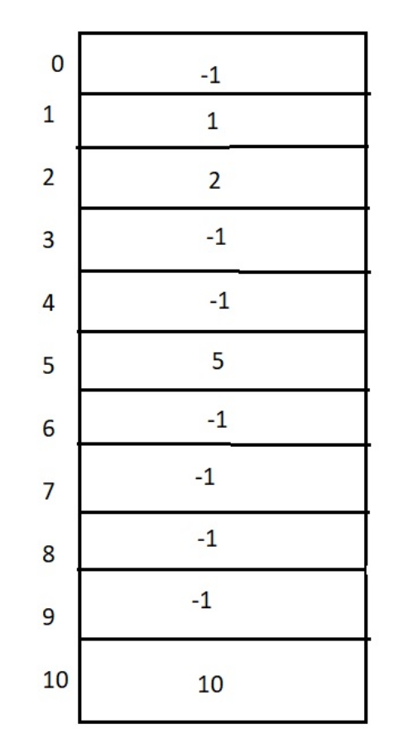

**Hence, the Hashset returns the values in ascending order, irrespective of the order we stored.**