Histone Purification Protocol

Liv Jensen, 03/2017 annotated 181025 Lucy Brennan

Adapted from Luger, et al.

1. Grow xenopus histones from overnight starter culture in 2XYT at 37˚C. Induce with 200mM IPTG when OD600 = 0.6; express for 4 hours at 37˚C. (Yield ~50-100mg/L; all buffer volumes given below assume 1L expression culture)
   1. Add phosphate salts to growth media (1.7 mM KH2PO4, 9.4 mM K2HPO4 final, follow CSH terrific broth protocol)
   2. One day growth:
      1. Scape freshly transformed plate (from pLys BL21, Carb/ Cam selection) into 5 mL 2xYT starter, shake at 37 deg for 2 hours
      2. Transfer starter to 100 mL 2xYT and grow to OD=0.4
      3. Add 25mL of 100mL growth to each liter of 2xYT, shake at 37 deg until OD=0.6
      4. Induce at OD=0.6 with 200 mM IPTG (made fresh), grow for 4 hours at 37 deg
2. Spin down cells (10min @ 4000RPM), remove supernatant, ~~and freeze pellets at -80˚C~~.
   1. Resuspend cell pellet in 25 mL (per liter pellet) of Buffer B (wash buffer with triton)
   2. Flash freeze and store at -20
3. Lyse cells:
   1. Thaw cell slurry and transfer to metal beaker, on ice, for sonication
   2. Sonicate on ice: 75% power, sonicator on 4th floor, 4x 20 seconds: 1 second on/ 1 second off, one minute rest between
   3. Spin at 20,000g for 15 min. Remove supernatant and retain pellet – protein is expressed in inclusion bodies. (Stop point, store pellets at -20)
4. Wash inclusion bodies: resuspend inclusion bodies by crushing with a scoopula
   1. Wash pellet with 25ml Buffer B, spin at 20,000g for 15min.
   2. Repeat step 4a for a total of 3 washes with Buffer B.
   3. Wash pellet with 25ml Buffer A, spin at 20,000g for 15min.
   4. Repeat step 4c for a total of 3 washes with Buffer A.
5. Inclusion bodies can be stored at -20˚C at this point.
6. Inclusion body solubilization:
   1. Add 0.5ml DMSO, breaking up inclusion body pellet as necessary.
      1. Pellet should resuspend easily and look kind of grainy
   2. Incubate 1 hr at RT.
   3. Add 10ml Buffer C, stiring, RT for 4 hr or overnight.
      1. The liquid should be clear after ~4 hours
      2. Spin down at 15,000 RPM (JA-20 roter), 4 deg, 20 minutes, load supe into dialysis bag
7. Dialyze protein against 3 changes of 1L Buffer D at RT (use 6-8kDa MWCO tubing; histone MW ~11kDa-15kDa).
   1. 2 hours per liter minimum, usually I do one overnight (for sanity)
   2. There is almost always crash out at this stage, likely due to DNA in the inclusion body
8. Ion exchange chromatography:
   1. ~~Dilute protein 1:1 with Buffer D~~, spin down (JA-20 roter), 15,000 RPM, 20 minutes and pass through a 0.2µM syringe-tip filter.
      1. Save pellet to assay loss to precipation during dialysis
   2. Wash ion exchange column (TOSOH TSKgel SP-5PW, 50ml CV) with Buffer E, then equilibrate with Buffer D for 2 CV at 4ml/min.
   3. Load protein onto column at 1 ml/min. Collect flow-through.
      1. By keeping the inclusion body solubilization volume to 10 mL, I use a loop as opposed to loading directly through the inlet line
   4. Wash column with 1CV Buffer D, 4 mL/min
   5. Elute protein in a linear gradient from 0 – 100% Buffer E over 60 min at 4ml/min.
      1. 5mL fractions
9. Collect and analyze peak fractions by 18% SDS-PAGE.
   1. I save the pellets from the Gu-HCl solubilization and after the dialysis to urea to assay histone loss; each pellet is resuspended in 1x TGS buffer and 10uL is loaded on the gel
      1. Gu-HCl will precipitate with SDS at room temp, so loading this sample can be tricky. Keep it at hot as possible
10. Pool desired fractions and dialyze against water.
11. Measure protein concentration by A280, and lyophilize in aliquots of useful size.
    1. I ran a BSA standard with dilutions of the histone after dialysis to water
    2. To simplify the octamer refolding aliquots of “useful size” are as follows:
       1. 1.5 mg H2A and H2B
       2. 1.36 mg H3
       3. 1 mg H4
       4. This allows one to resuspend in 1mL of unfolding buffer and mix all of them together 1:1:1:1 volumetrically, but at a molar ratio or 1.2:1.2:1:1 (H2A:H2B:H3:H4)
12. Store lyophilized protein at -80˚C indefinitely.

Buffers:

A:

50mM Tris-HCl pH7.5

100mM NaCl

1mM EDTA

1mM Benzamidine

5mM BME

B:

Buffer A + 1% Triton X-100

C:

6M Guanidinium HCl

50mM Tris-HCl pH7.5

5mM BME

D:

6M Urea (deionized with MB AG 501-X8 (D) Resin from BioRad)

20mM Tris-HCl pH7.5

20mM NaCl

5mM BME

E:

6M Urea (deionized as above)

20mM Tris-HCl pH7.5

2M NaCl

5mM BME

example gels

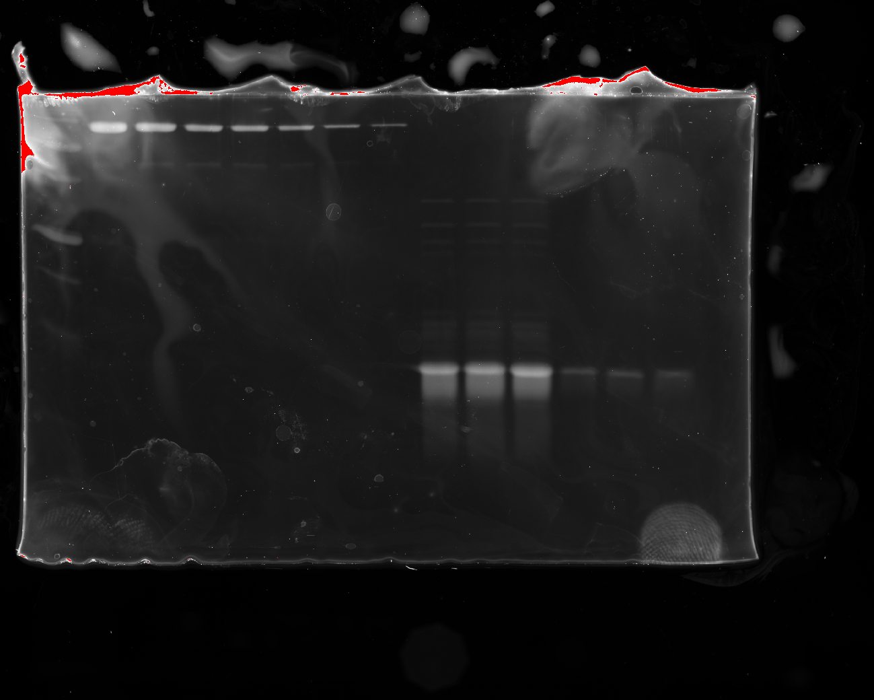

Left to right: precision plus ladder, BSA standard (lanes 2-8), H4 (lanes 9-11, 1:10 dilution),

H4 (lanes 12-14, 1:100 dilution)

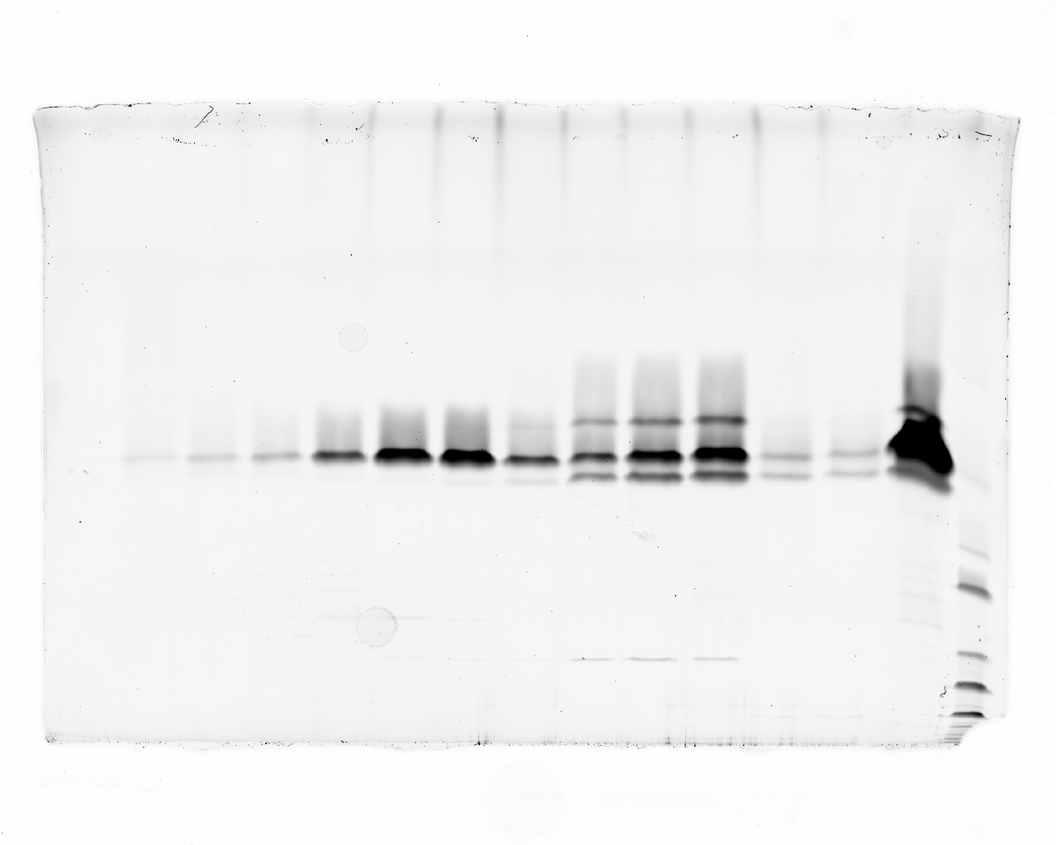

refolded Octamer, unlabeled off the S200 sizing column (FPLC trace not shown)

lanes 8-10 (from the left) pooled and used for mono-nucleosome assemblies