**Test cases scenarios:**

1. Login page

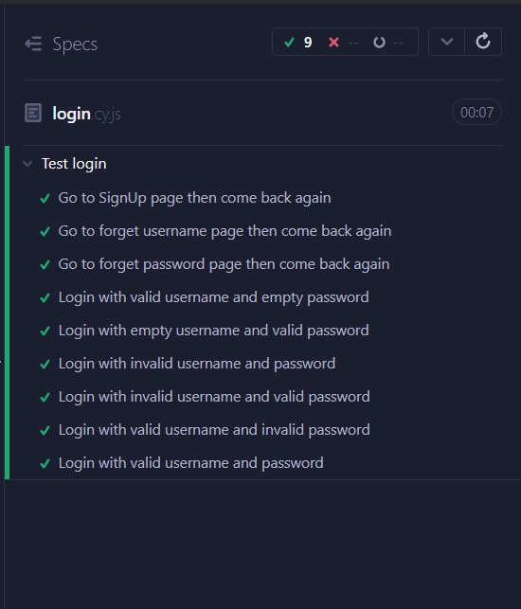

1. Signup page

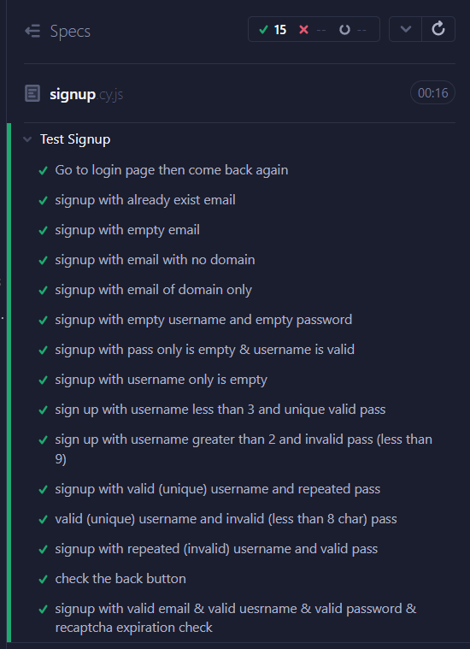

1. Home page

The following was before merging the dev to master

I took this image from the old video generated by the command and the rest of cases failed

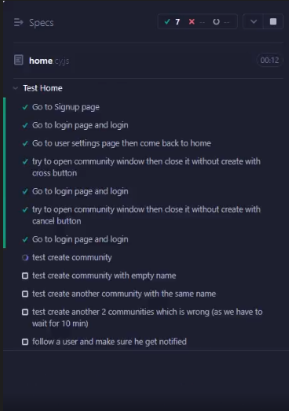

But the following 🡪 after merging

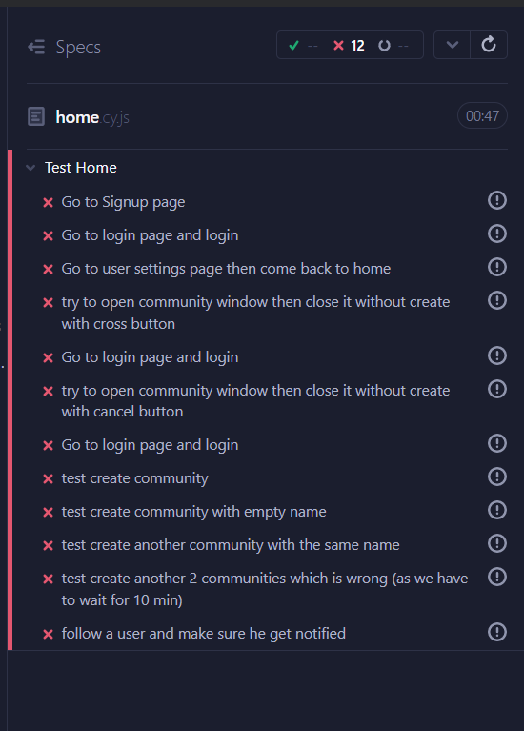

1. Account settings

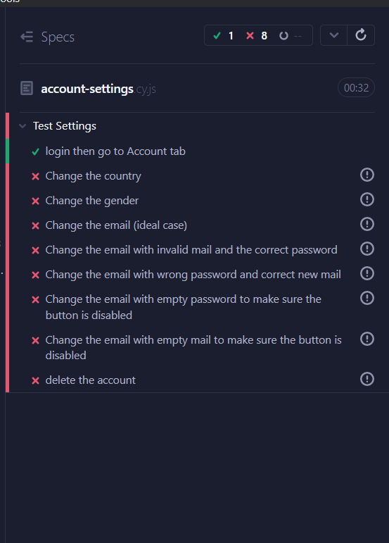

1. Profile settings

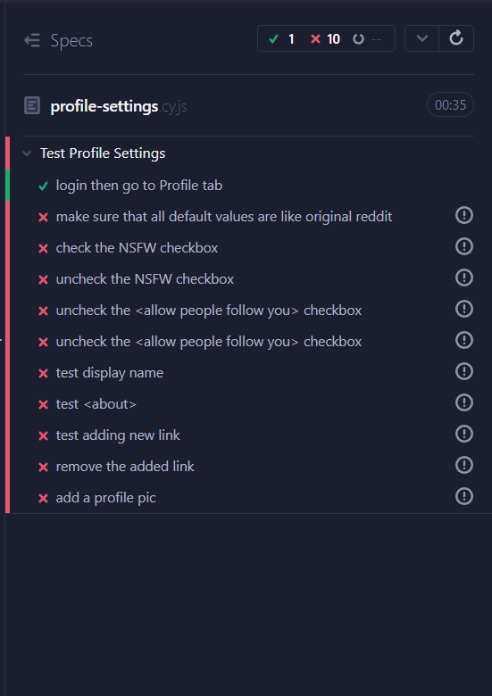

1. Safety and privacy

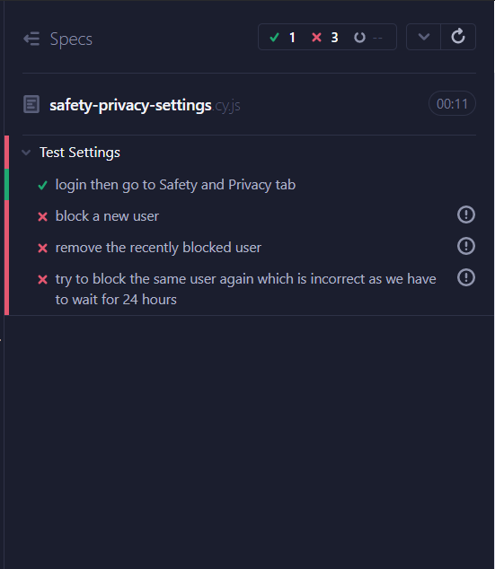

1. Feed settings

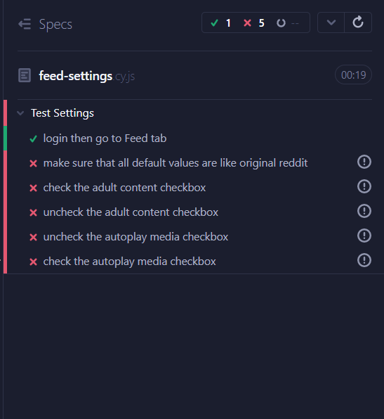

1. Emails

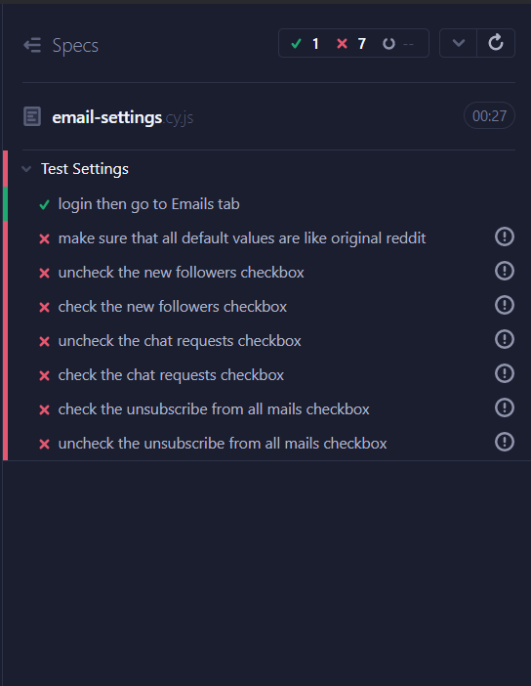

comments:

All user settings 🡪 only UI (i.e., not completed yet by the backend team so all cases failed)