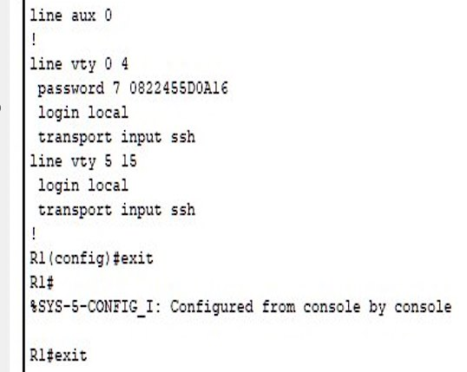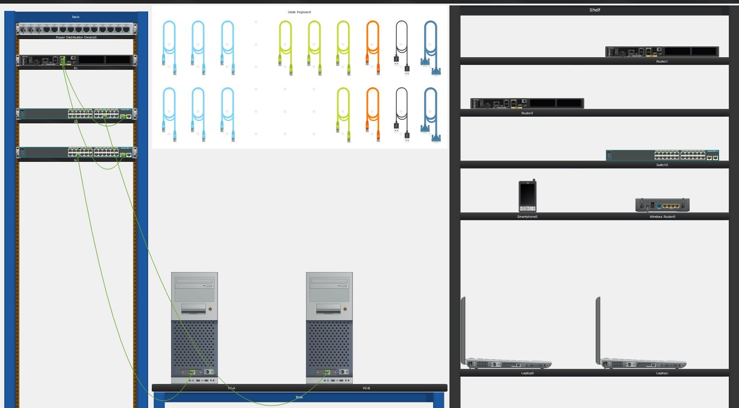**BC Packet Tracer – 17.8.1 Design and Build a Small Business Network**

**Ping Results From PC-B SSH Results**

**Switch-1’s VLAN BRIEF**