PUNITH V

## ABOUT ME

A motivated and inquisitive B.Tech student with a strong foundation in Artificial Intelligence and Machine Learning. Passionate about leveraging AI to solve real-world problems, I have worked on projects ranging from AI-powered candlestick prediction to resume shortlisting and interview proctoring. Proficient in Python, Machine Learning frameworks, and database management, I am eager to apply my skills in a research-driven environment. Seeking an opportunity at IITH to deepen my understanding of AI/ML applications through hands-on experience and collaboration with experts

**PROJECTS**

## YouTube to Text and Summarization Tool:

Converted speech from YouTube videos into text and generated concise summaries using text processing techniques.

Skills Gained: Speech-to-Text Processing, Text Summarization, Data Processing, Python

## Sales Data Scraping & Analytics

**March 2025 - Present**

**Feb 2025**

Extracted and analyzed sales data from e-commerce websites using web scraping techniques, identifying

key trends and insights through data visualization. Processed and structured data efficiently for reporting and business decision-making.

Skills Gained: Web Scraping (BeautifulSoup, Scrapy, Selenium), Data Processing (Pandas, NumPy, SQL, Excel), Data Visualization (Matplotlib, Seaborn, Power BI, Tableau).

## AI-Based Resume Screening Tool: Nov 2024

Developed an AI system to extract candidate names, identify skills, and score resumes with improvement recommendations.

Skills Gained: Machine Learning, Data Processing, Scikit-learn, Python

# Research Experience

**Enhancing Solar powered Electrical Vehicle With IoT Driven Smart rechargeable systems**

Developed a dynamic solar panel tracking system to optimize energy capture, reducing grid dependency by 60% and improving battery life by 30%.

Published findings on the integration of flexible solar cells and IoT sensors in EVs, contributing to advancements in renewable energy utilization in transportation.

# EDUCATION

## 2020 - 2023

Woxsen University

## 2021- 2023

Raju junior College

**B Tech in Computer Science Engineering (AI&ML)**

**Intermediate (MPC)**

# CERTIFICATES

 Crash Course on Python (Coursera)

Probability & Statistics for Machine Learning & Data Science (Coursera)

Mathematics for Machine Learning: Linear Algebra (Coursera)

 Mathematics for Machine Learning (PCA) (Coursera)

# ACHIEVEMENTS

 IIC CO-ORDINATOR AT TRADE TOWER

# DETAILS

Contact : 9908686628

Mail ID : [punih.vuppu.17@gmail.com](mailto:punih.vuppu.17@gmail.com) LinkedIn : [LinkedIn Profile](http://www.linkedin.com/in/punith-v-258466296)

**Mark sheet**

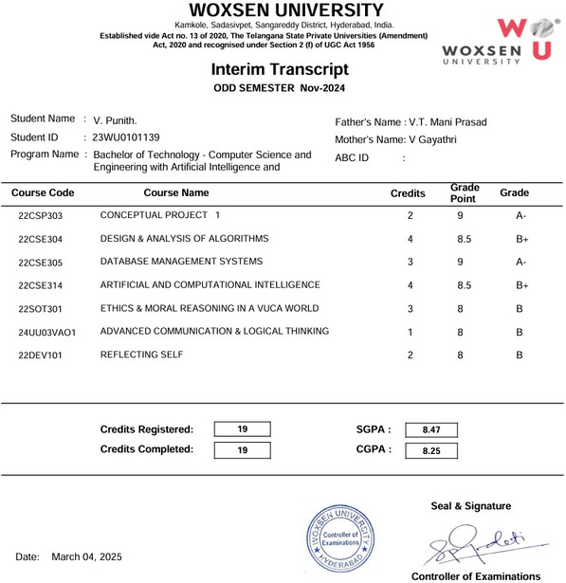

**Letter of Recommendation**

