**Virtual Trial Room**

**ABSTRACT**

The AI-Powered Virtual Garment Trial Room is an innovative solution designed to enhance the online shopping experience by enabling users to virtually try on apparel and accessories. The project addresses a major limitation of e-commerce: the inability to physically try products before purchase. Using augmented reality (AR) technology and advanced image processing, the system captures the user’s image via a webcam and superimposes selected garments and accessories onto their body in real-time.

The system leverages Haar cascade datasets for body and face detection and convolutional neural networks (CNNs) for accurate alignment of apparel. The Flask framework integrates the back-end Python scripts with an interactive HTML front-end, allowing seamless user interaction. Users can register, shop, and virtually try on items, while administrators can manage the product catalog through an intuitive interface.

This cost-effective solution eliminates the need for expensive hardware, relying instead on efficient software tools like OpenCV and Dlib. Future enhancements include the integration of advanced networks, such as Pose Alignment Network (PAN) and Texture Refinement Network (TRN), to improve accuracy and realism. By bridging the gap between physical trials and online shopping, this project promises to revolutionize the e-commerce industry and enhance customer satisfaction.

**INTRODUCTION**

**Motivation:**

The AI-Powered Virtual Garment Trial Room is inspired by the challenges of online apparel shopping, where customers cannot physically try on garments before purchase, leading to dissatisfaction, returns, and cancellations. This project aims to address these issues by leveraging augmented reality and image processing techniques to provide a virtual trial experience. Initially conceptualized from a problem statement in the Smart Gujarat Hackathon, the project seeks to offer an affordable and accessible alternative to expensive hardware-based solutions, such as Kinect motion sensors. By combining innovative technologies with user-centric design, it enhances customer confidence and satisfaction in e-commerce platforms.

**Problem Statement**

The inability to try on apparel before purchase is a significant limitation of e-commerce platforms, leading to customer dissatisfaction, high return rates, and order cancellations. Traditional solutions, like Kinect motion sensors, are expensive and inaccessible for most users. This project aims to develop a cost-effective, AI-powered virtual garment trial room using augmented reality and image processing techniques. By allowing users to virtually try on garments and accessories through a webcam, the system enhances the online shopping experience, reduces return rates, and increases customer satisfaction, bridging the gap between physical and digital retail experiences.

**Objective of the Project:**

The main objective of this project is to provide an augmented reality-based solution for trying apparel and accessories online without the need for physical trials. This system reduces return rates and boosts customer satisfaction in e-commerce.

**Scope:**

The AI-Powered Virtual Garment Trial Room has broad applications and potential for enhancing the online shopping experience in the e-commerce industry. Its primary scope includes:

1. E-commerce Integration:
   * Seamlessly integrates with e-commerce platforms to provide users with a virtual dressing room.
   * Allows users to try on apparel and accessories virtually, reducing product return rates and cancellations.
2. Customer Experience:
   * Enhances the user experience by offering an interactive and personalized shopping journey.
   * Builds customer confidence in purchasing decisions through real-time virtual try-ons.
3. Cost-Effective Solution:
   * Eliminates the need for expensive hardware like Kinect motion sensors by utilizing image processing techniques that work efficiently on standard devices.
4. Technology Applications:
   * Leverages advanced technologies like Haar cascades, convolutional neural networks (CNNs), and augmented reality to ensure accurate body detection and realistic garment overlay.
   * Offers scalability to incorporate advanced networks, such as Pose Alignment Network (PAN) and Texture Refinement Network (TRN), for improved performance.
5. Future Expansion:
   * Adaptable for use in other industries, such as cosmetics, eyewear, and furniture visualization.
   * Potential for integration with virtual reality (VR) for a fully immersive shopping experience.

By addressing critical gaps in online retail, this project promises significant value to both customers and businesses.

**SYSTEM ANALYSIS**

**Existing Method**

The existing virtual try-on systems primarily rely on hardware-intensive solutions like Kinect motion sensors or high-end augmented reality setups. These methods use motion-tracking sensors and cameras to align garments with body movements.

**Disadvantages**

1. High Cost: These systems require expensive hardware, making them inaccessible for smaller businesses and regular users.
2. Time-Consuming Setup: The setup and calibration of motion sensors are time-intensive, requiring skilled personnel.
3. Limited Accuracy: Despite the high costs, the alignment of garments often lacks precision, especially for varied body shapes and movements.

**Proposed Method**

The proposed system utilizes cost-effective software-based solutions using image processing techniques (Haar cascades) and convolutional neural networks (CNNs). It replaces hardware dependency with algorithms capable of running on standard devices.

Advantages

1. Cost-Effective: The reliance on readily available tools like webcams and open-source libraries significantly reduces implementation costs.
2. Time-Efficient: The software-based approach is faster to deploy and requires minimal setup, making it user-friendly and scalable.
3. Improved Accuracy: Advanced body detection techniques, such as Pose Alignment Networks (PAN), ensure precise garment overlay and alignment, enhancing the realism of virtual try-ons.

**Block Diagram**

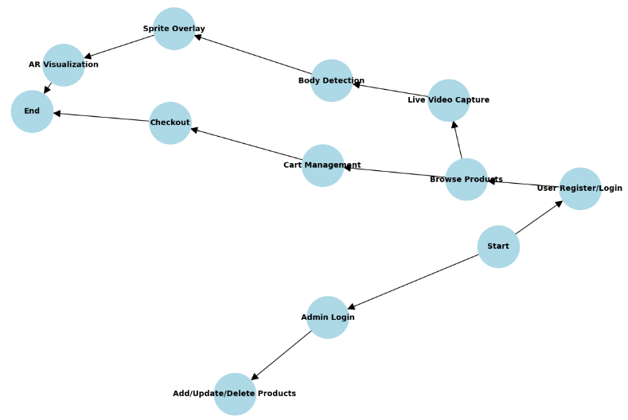

**REQUIREMENT ANALYSIS**

**Hardware Requirements**

• Processor - I3/Intel Processor

• Hard Disk -160GB

• RAM - 8Gb

**Software Requirements:**

• Operating System : Windows 7/8/10 .

• IDE : Pycharm.

• Libraries Used : CMake (3.12.0), Dlib (19.15.0), OpenCV (3.4.2.17), SciPy (1.0.0), Tkinter, NumPy (1.18.1), Flask (3.0.3)

• Technology : Python 3.10.8.

**MODULES**

### ****1. Admin Module****

#### **Purpose**: Manages the product catalog for the virtual trial room.

#### **Functionalities**:

* **Login**: Secure access for administrators to manage the system.
* **Add Product**:
  + Admin can upload new cloths:
    - Category
    - Name.
    - Cost.
    - Image of the product.
* **Update Product**:
  + Modify details such as the price or category of existing products.
* **Delete Product**:
  + Remove outdated or unavailable products from the catalog.

#### **Flow**:

1. Admin logs into the system.
2. Admin performs CRUD (Create, Read, Update, Delete) operations on the product catalog.
3. Updates are reflected in the user’s interface for real-time browsing.

### ****2. User Module****

#### **Purpose**: Enables users to interact with the system for virtual trials and purchases.

#### **Functionalities**:

* **Register**: Users create an account with basic details for a personalized experience.
* **Login**: Users securely log in to access the trial and cart functionalities.
* **Shop**: Browse products categorized by type.
* **Add to Cart**: Users can select and add items to their shopping cart for review or purchase.
* **Try On with AR**: The user can select garments and accessories to overlay on their live video feed or image for a virtual trial.

#### **Flow**:

1. Users log in and browse products.
2. Users select items to try on and visualize them in real-time.
3. Selected items can be added to the cart for checkout.

### ****3. AR Module****

#### **Purpose**: Handles live video feed and overlays garments/accessories on detected regions.

#### **Functionalities**:

* **Live Video Feed**: Captures the user’s video feed using a webcam or camera.
* **Body and Face Detection**:
  + Detects key regions using:
    - Haar cascades for initial detection.
    - Dlib for facial landmarks.
* **Overlay**:
  + Dynamically resizes and positions selected garments or accessories over detected body parts.
  + Ensures accurate alignment using offsets and transparency.

#### **Flow**:

1. The webcam captures frames.
2. Detection algorithms identify key regions for overlay.
3. Selected items are superimposed on the detected regions in real-time.

### ****5. Video Processing Module****

#### **Purpose**: Processes video frames for detecting and superimposing garments/accessories.

#### **Functionalities**:

* **Video Capture**:
  + Captures live feed using OpenCV.
* **Frame Processing**:
  + Reads frames from the video and applies detection algorithms.
* **Real-Time Rendering**:
  + Continuously updates the overlay for each new frame.

#### **Flow**:

1. Frames are captured from the webcam.
2. Detected regions are processed for sprite overlay.
3. Updated frames are rendered back to the user in real-time.