NOVASHYLD TECHNOLOGIES
CYBERSECURITY ANALYST INTERNSHIP
TASK 4 FINAL REPORT
Web Application Security Testing

Intern Name | BALIREDDY CHANDRAMOULI REDDY
Internship / Task | NovaShyld Cybersecurity Analyst Internship – Task 4
Lab Application | DVWA (Damn Vulnerable Web Application)
Primary Tool | Burp Suite Community Edition, Firefox, Docker
Lab Target | Local DVWA environment — http://127.0.0.1:8080
Report Date | 17 August 2026

GITHUB URL: https://github.com/Reddy-hub-com/NovaShyld-Task_4-.git
https://github.com/Reddy-hub-com/NovaShyld-Task_4-/tree/main

Document Control
Item | Value | Item | Value
Document | NovaShyld_Task_4_Final_Report.docx | Version | 1.0
Task | Task 4 — Web Application Security Testing | Status | Technical testing completed; report compiled
Repository | NovaShyld Task_4 | GitHub URL | https://github.com/Reddy-hub-com/NovaShyld-Task_4-.git
Environment | Kali Linux + Docker DVWA + Burp Suite | Security level | Low

1. Executive Summary

Task 4 required practical web application security testing using Burp Suite and DVWA. The laboratory work began with a working DVWA instance configured at the Low security level, followed by browser-to-Burp proxy interception. The assessment then demonstrated four required vulnerability classes: SQL Injection, Command Injection, Reflected Cross-Site Scripting (XSS), and Stored XSS.

During the verified demonstrations, the SQL Injection test altered query behavior and returned multiple records; the Command Injection test executed the additional whoami command and returned the web-server account name www-data; the Reflected XSS test executed a JavaScript alert; and Stored XSS was completed during the lab as reported by the intern. The report documents the verified screenshots available in the current evidence set and records remediation guidance for each finding.

2. Task Objectives and Requirements
The internship task document defines Task 4 as Web Application Security Testing. The stated objective is to identify and exploit common web application vulnerabilities in a controlled lab using Burp Suite, OWASP ZAP, and DVWA. The task methodology calls for proxy configuration, injection testing, XSS identification, and compilation of proof-of-concept evidence with fixes.
Requirement | Evidence in this report | Status
Configure Burp Suite as a proxy | Burp listener and intercepted DVWA request screenshots | Completed
Test injection vulnerabilities | SQL Injection and Command Injection sections | Completed
Identify Reflected and Stored XSS | XSS sections and evidence register | Completed
Compile proof-of-concept findings and fixes | Findings, impact and remediation sections | Completed
Deliver Burp test logs / PoC report / remediation | Evidence register and this report; GitHub | completed

3. Scope and Rules of Engagement
- Target: DVWA running in the isolated internship laboratory.
- Testing tool: Burp Suite Community Edition.
- Testing mode: Controlled proof-of-concept validation only.
- No production systems or third-party systems were targeted.
- Evidence: screenshots, Burp HTTP requests, application results, and remediation notes.

4. Lab Environment
The testing environment consisted of Kali Linux hosting the browser and Burp Suite, with DVWA running in Docker. The DVWA web service was exposed locally on TCP port 8080. Burp Suite was configured to listen on 127.0.0.1:8081, and the Firefox browser was configured to use that proxy.

Component | Configuration / Address | Purpose
Kali Linux | Testing workstation / browser host | Lab operation and testing
Firefox | HTTP proxy: 127.0.0.1:8081 | Browser traffic generation
Burp Suite Community Edition | Proxy listener: 127.0.0.1:8081 | Intercept and inspect HTTP requests
DVWA | http://127.0.0.1:8080 | Deliberately vulnerable test target
DVWA Security | Low | Controlled vulnerability demonstration
Docker container | vulnerables/web-dvwa | Web application runtime

5. Tools and Technologies
- Burp Suite Community Edition – proxying, interception, HTTP history, and request inspection.
- DVWA – intentionally vulnerable web application used as the controlled target.
- Firefox – browser configured to send web traffic through Burp Suite.

6. Burp Suite Proxy Configuration
Burp Suite was configured as the local intercepting proxy. The Burp listener used 127.0.0.1:8081, while DVWA was available on 127.0.0.1:8080. Firefox was configured to use 127.0.0.1:8081 as its proxy. Successful interception was verified by capturing a DVWA GET request in Burp.
- Start Burp Suite Community Edition with a temporary project.
- Configure the proxy listener on 127.0.0.1:8081.
- Configure Firefox to use 127.0.0.1:8081 as the proxy.
- Enable local-proxy handling for localhost traffic in Firefox.
- Open DVWA and verify that Burp captures the request.
- Forward the request and confirm the DVWA page loads.
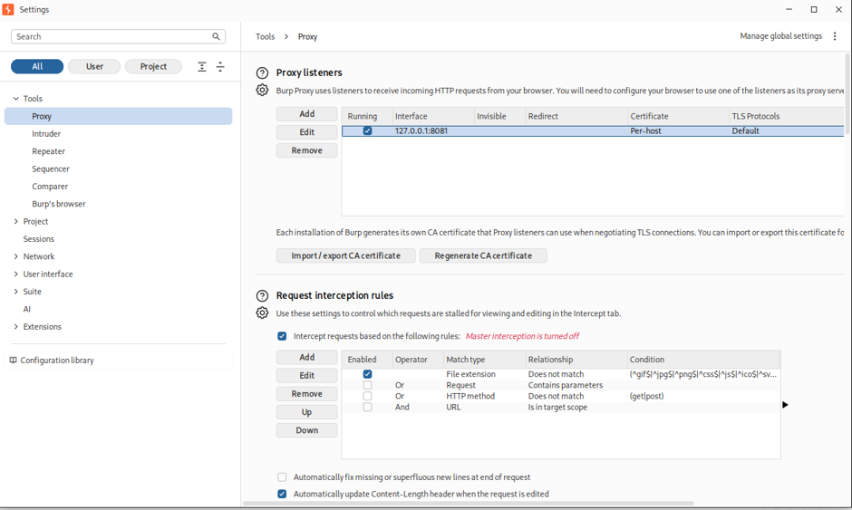
01_Burp_Listener_8081.png
Burp Settings → Proxy listeners showing 127.0.0.1:8081 in Running state.
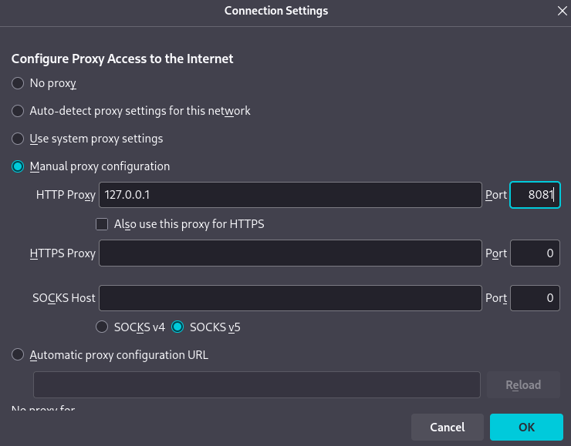
02_Firefox_Proxy_8081.png
Firefox Network Settings showing manual proxy 127.0.0.1:8081 and HTTPS proxy usage.
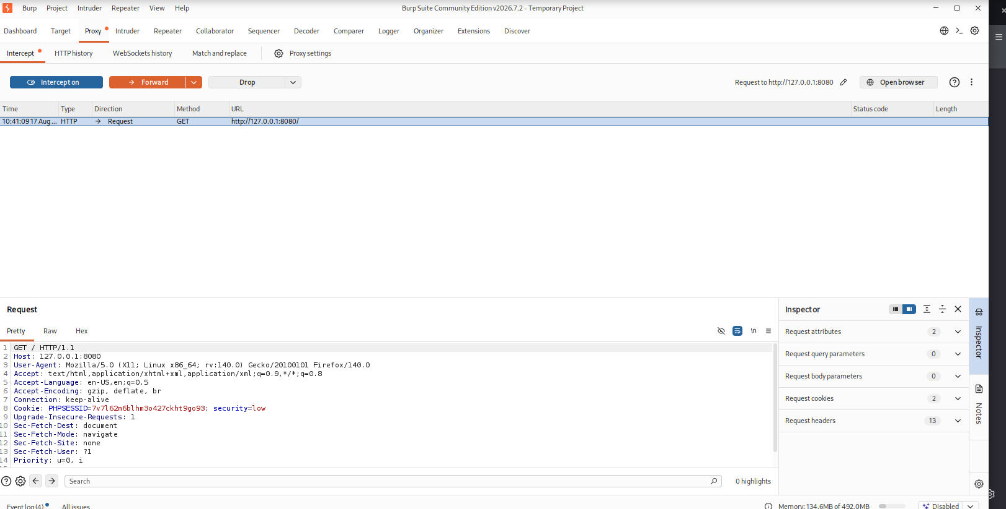
03_Burp_Intercept_DVWA.png
Burp Proxy → Intercept showing a DVWA request with Host: 127.0.0.1:8080.

7. Testing Methodology
Testing followed a repeatable sequence: establish a normal application response, submit a controlled proof-of-concept input, observe the application behavior, inspect the corresponding HTTP request in Burp where available, and document the impact and remediation.
Phase | Approach
1. Proxy setup | Configure Burp Suite as a local proxy and verify browser-to-DVWA HTTP interception.
2. Baseline validation | Use benign inputs to verify normal application behavior before each proof-of-concept test.
3. Controlled exploitation | Submit deliberately chosen, non-destructive payloads within DVWA at Low security.
4. Evidence capture | Capture the application result and, where available, the corresponding Burp request.
5. Remediation documentation | Record practical defensive measures for each confirmed finding.

Findings Overview
ID | Finding | DVWA Module | PoC / Evidence | Result
F-01 | SQL Injection | SQL Injection | 1' OR '1'='1' | Multiple records returned instead of the single baseline record.
F-02 | OS Command Injection | Command Injection | 127.0.0.1 && whoami | Additional command executed; output showed www-data.
F-03 | Reflected XSS | XSS (Reflected) | <script>alert('XSS')</script> | JavaScript alert displayed in the browser.
F-04 | Stored XSS | XSS (Stored) | <script>alert('Stored XSS')</script> | Completed during the lab; screenshot evidence not present in the current file set.

8. Finding 1 – SQL Injection

Test case
The DVWA SQL Injection module was first tested with the benign value 1. The application returned ID 1 (admin/admin), establishing a baseline. The proof-of-concept then used the controlled input: 1' OR '1'='1'.
Affected module: DVWA → SQL Injection
Security level: Low
Proof-of-concept input used in the controlled lab:
1' OR '1'='1
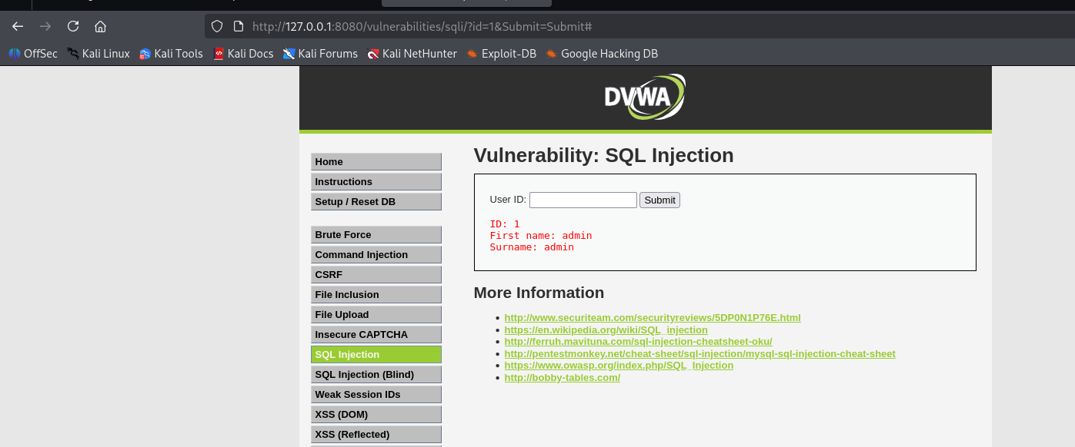
04_SQLi_Normal_Result.png
Normal baseline response for User ID 1.
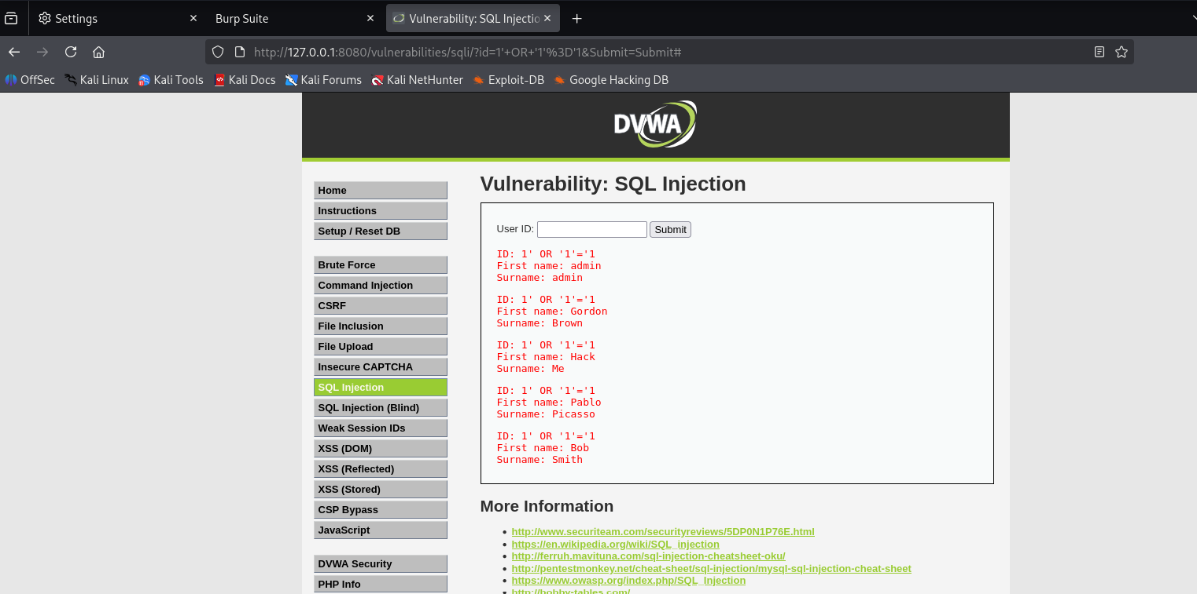05_SQLi_PoC_Result.png
DVWA result after the SQL Injection proof-of-concept input; show the broadened set of returned records.

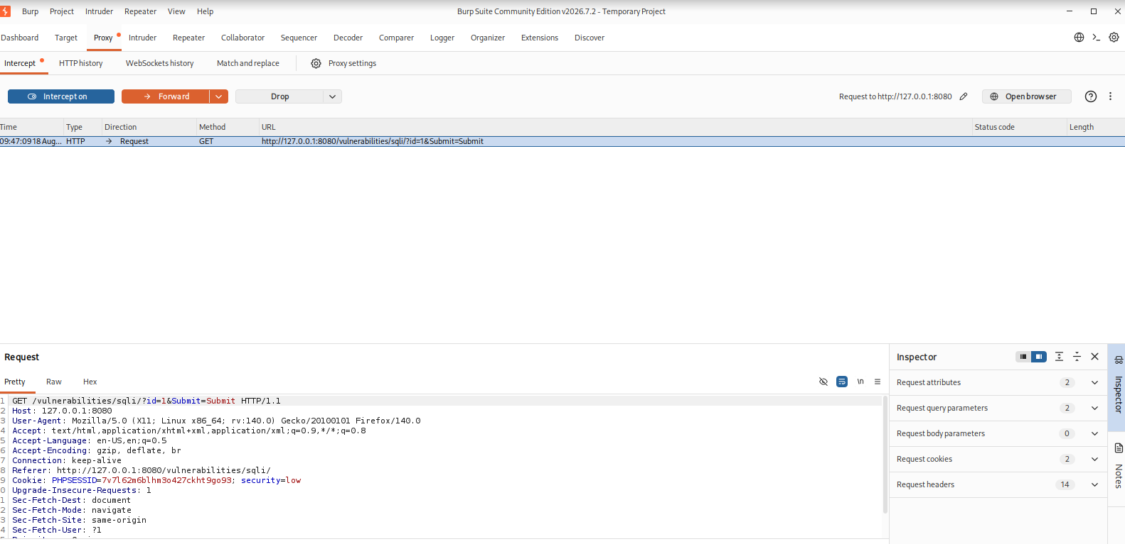

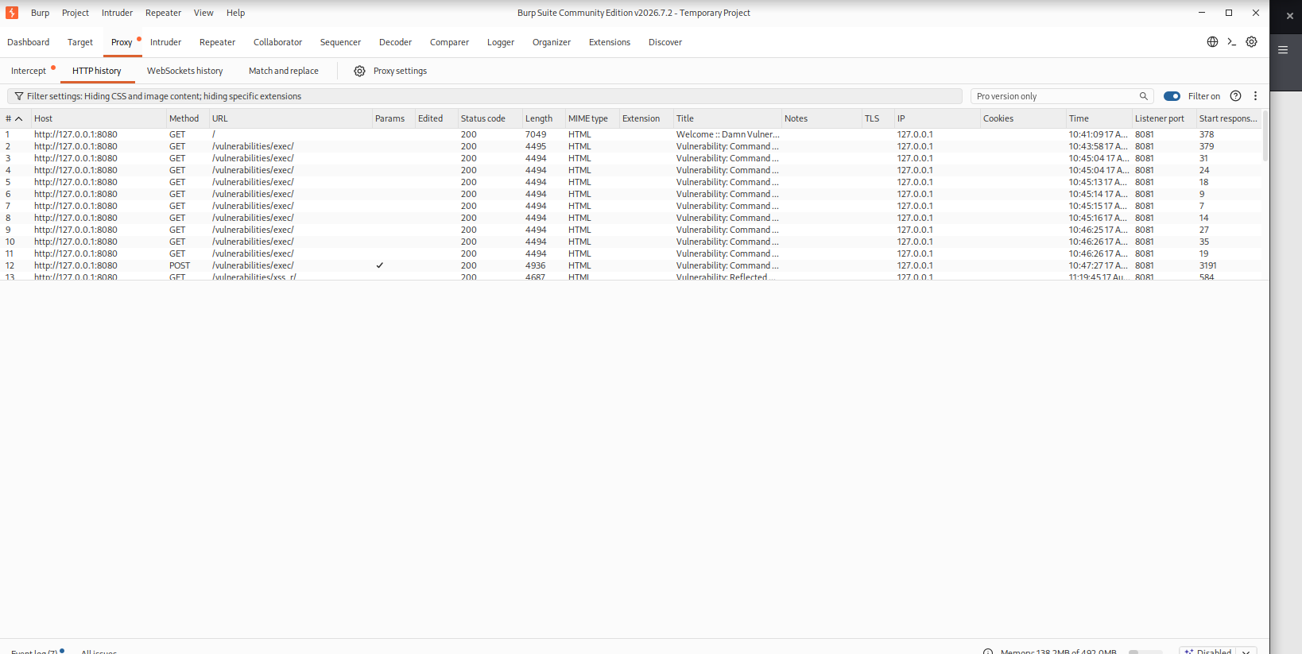
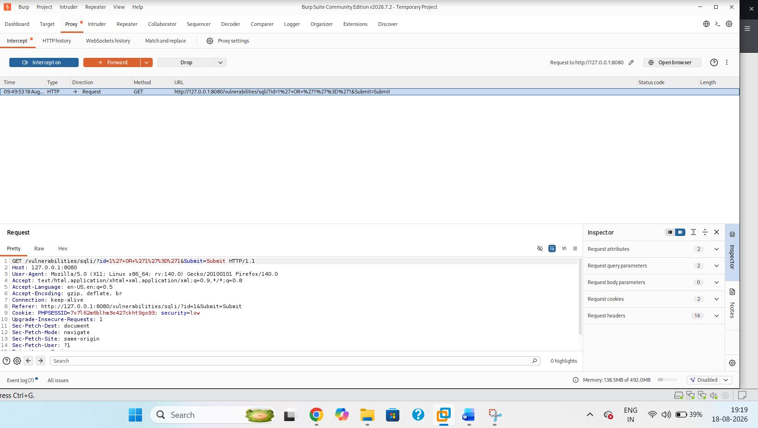

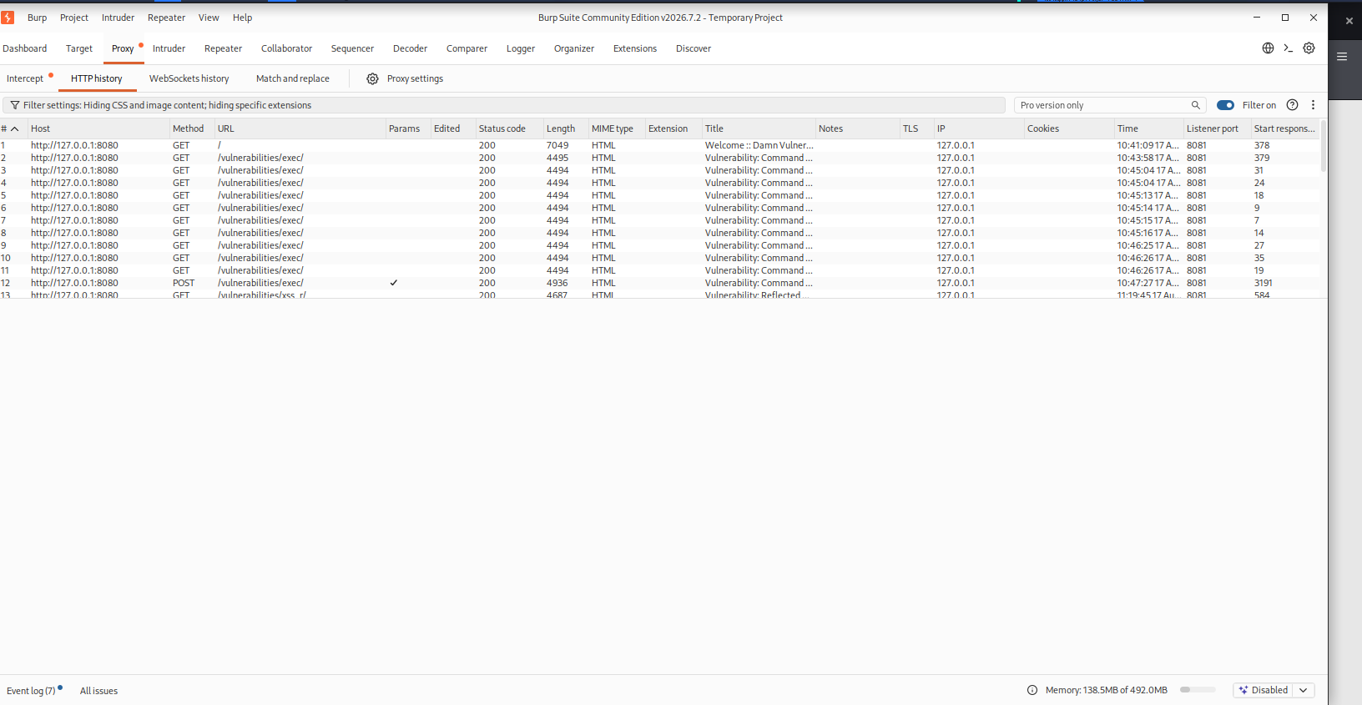

06_SQLi_Burp_Request.png
Burp HTTP history/request showing the SQL Injection input in the request.

Observed result: The application returned multiple database records instead of only the record associated with the normal baseline input, demonstrating that user input altered the SQL query behavior.
Potential impact: Unauthorized access to or manipulation of database query results, depending on the application context and database privileges.
Remediation: Use parameterized/prepared statements for database queries.
- Avoid constructing SQL with string concatenation.
- Validate and constrain input according to expected data types.
- Use least-privileged database accounts.
- Add centralized logging and monitoring for suspicious input patterns.

9. Finding 2 – Command Injection

Test case
The DVWA Command Injection module was first tested with 127.0.0.1 to establish normal ping behavior. The controlled proof-of-concept appended the harmless whoami command: 127.0.0.1 && whoami.
Affected module: DVWA → Command Injection
Security level: Low
Proof-of-concept input used in the controlled lab:
127.0.0.1 && whoami
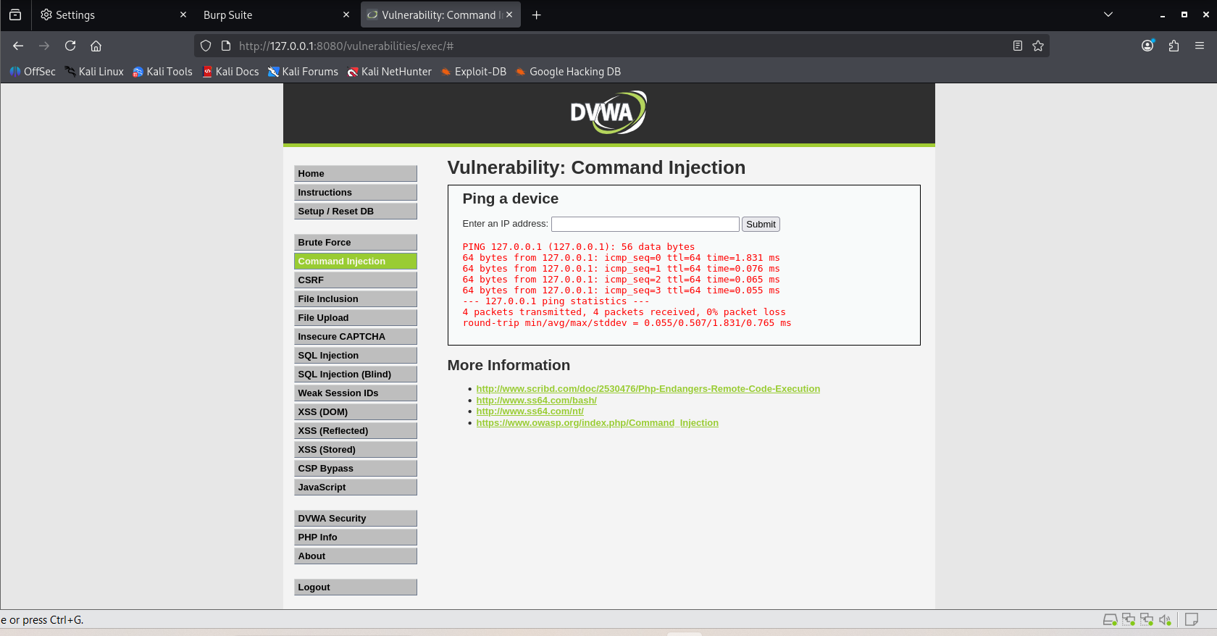
07_Command_Injection_Normal.png
Normal baseline ping response using 127.0.0.1.
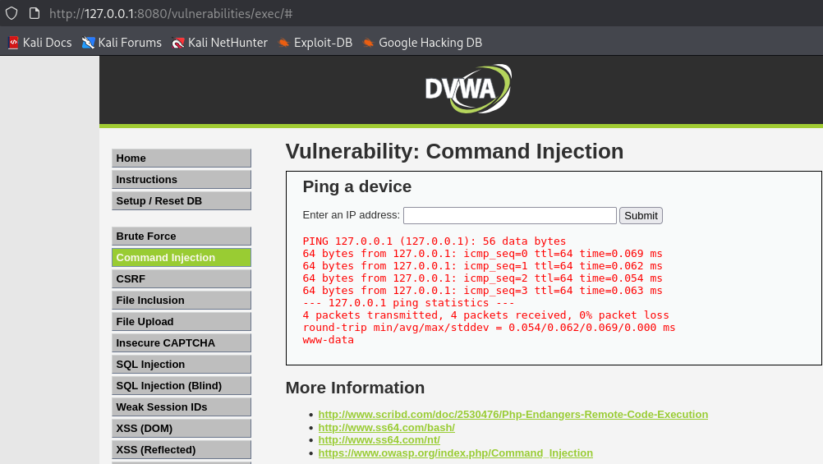
08_Command_Injection_Result.png
DVWA result showing the ping output together with the whoami output (www-data).
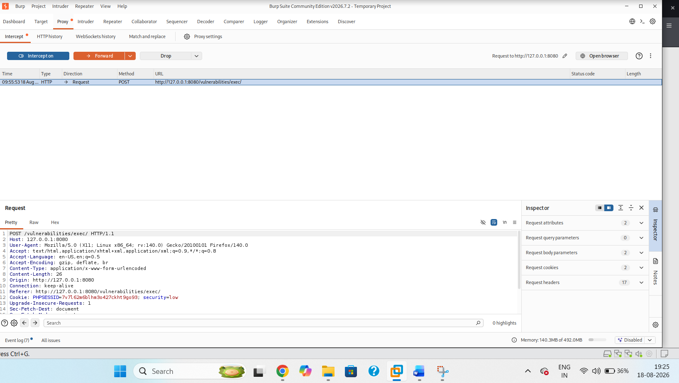

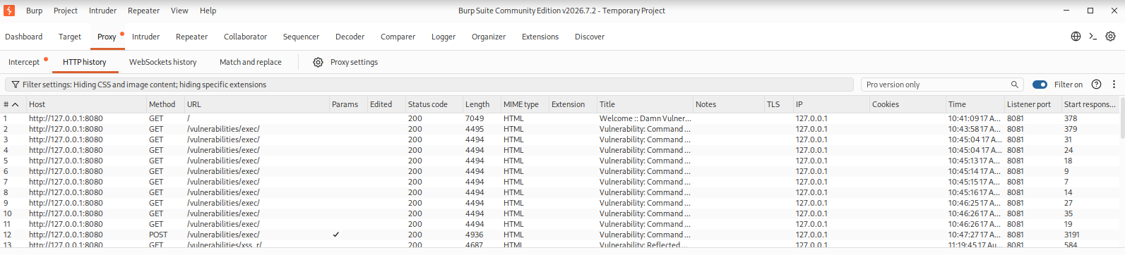

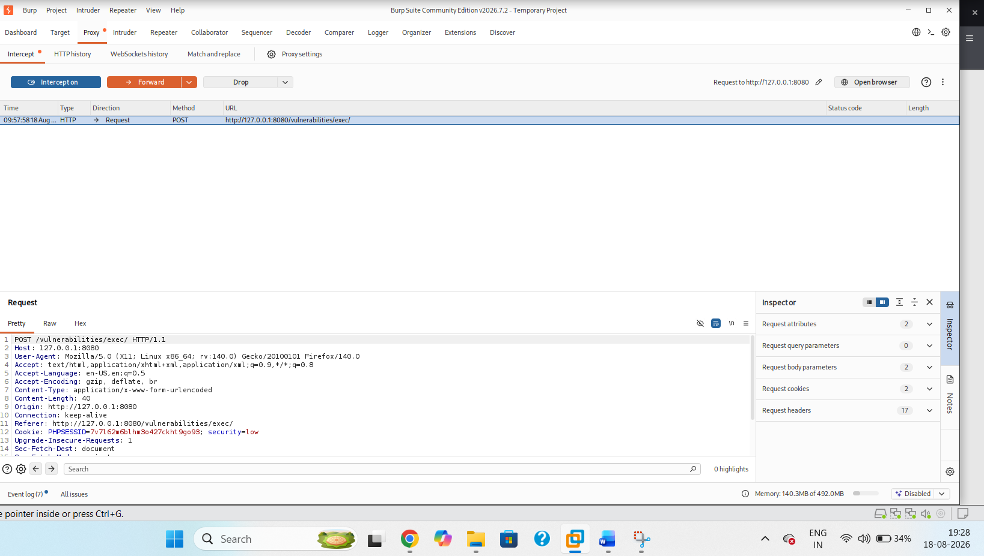
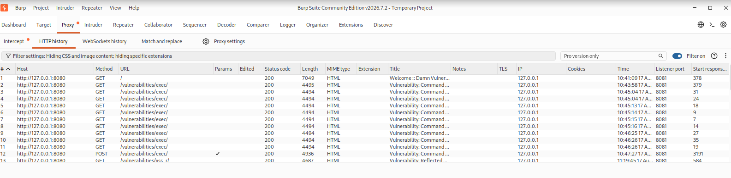
09_Command_Injection_Burp_Request.png
Burp request showing the Command Injection input in the /vulnerabilities/exec/ request.
Observed result: The application processed the injected command and returned the operating-system account name, demonstrating command execution in the controlled DVWA environment.
Potential impact: Unauthorized operating-system command execution and possible further compromise of the application environment.
Remediation: Avoid shell invocation where a safe API is available.
- Use strict allow-list validation for expected host/IP input.
- Apply contextual escaping where command construction cannot be avoided.
- Run the application with the minimum operating-system privileges required.
Use process isolation and monitoring to detect unexpected command execution

10 Finding F-03 — Reflected Cross-Site Scripting (XSS)Affected module: DVWA → XSS (Reflected)

Test case
The DVWA XSS (Reflected) module was tested with the payload <script>alert('XSS')</script> through the reflected name parameter.
Security level: Low
Proof-of-concept input used in the controlled lab:
<script>alert('XSS')</script>
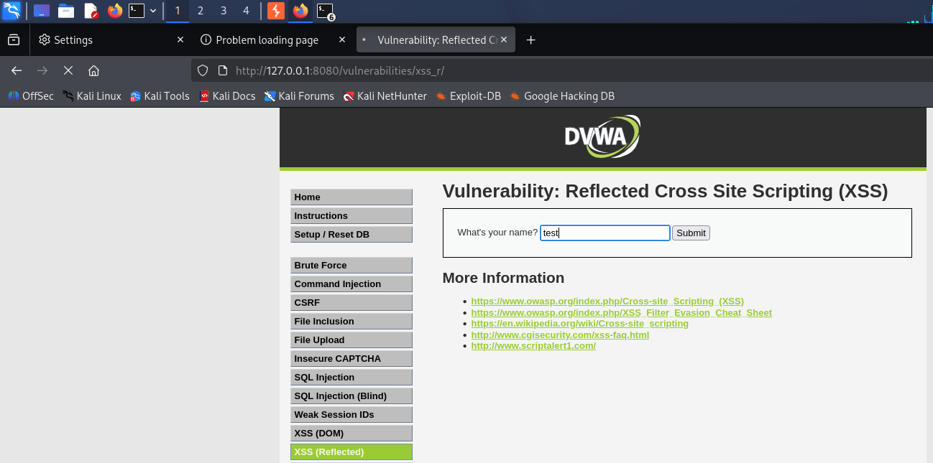
10_Reflected_XSS_Normal.png
Normal baseline submission on the Reflected XSS page.
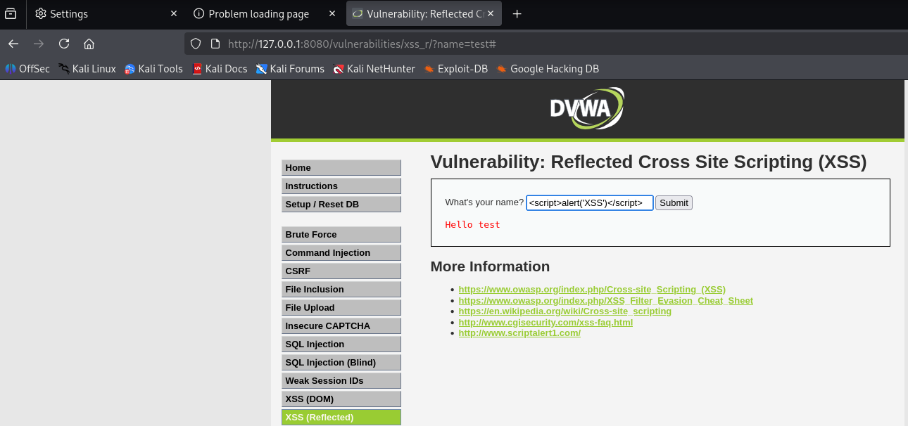
10_Reflected_XSS_Normal.png
Normal baseline submission on the Reflected XSS page.
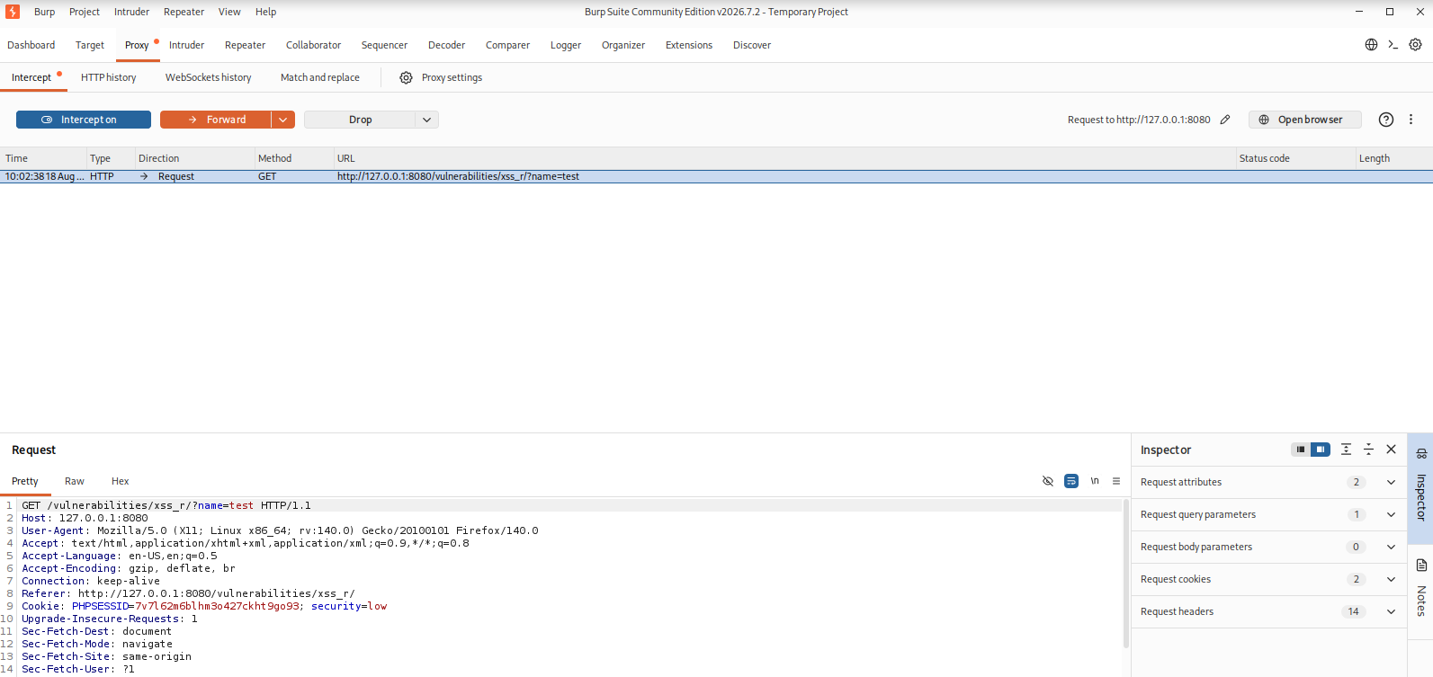

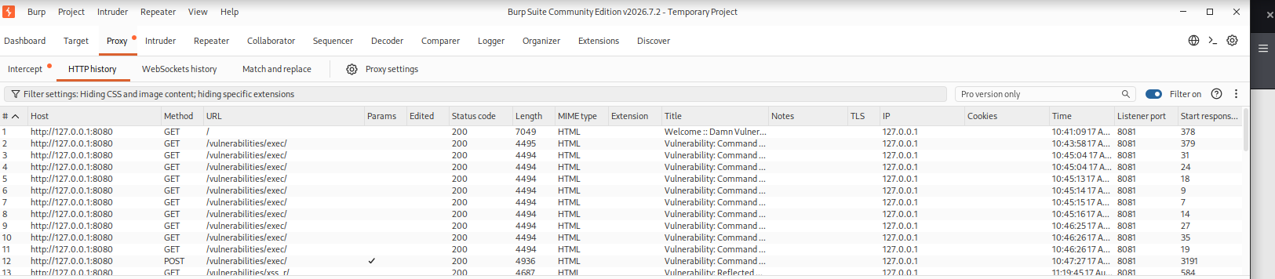
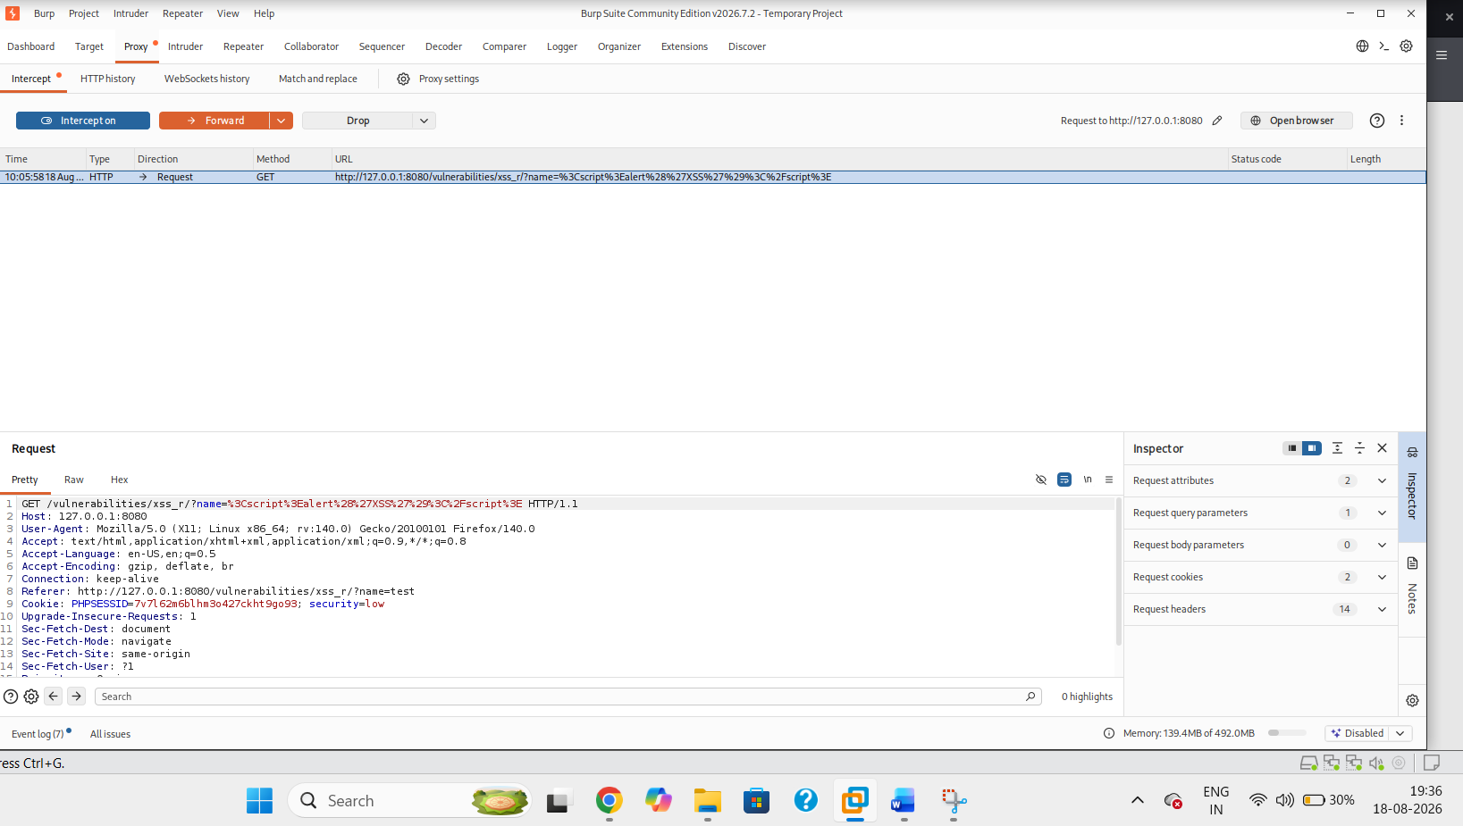
11_Reflected_XSS_Burp_Request.png
Burp intercepted request showing the reflected XSS input in the request.
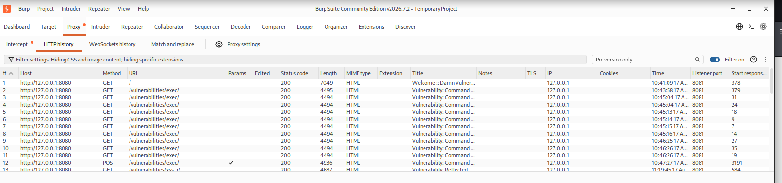
11_Reflected_XSS_Burp_Request.png
Burp intercepted request showing the reflected XSS input in the request.
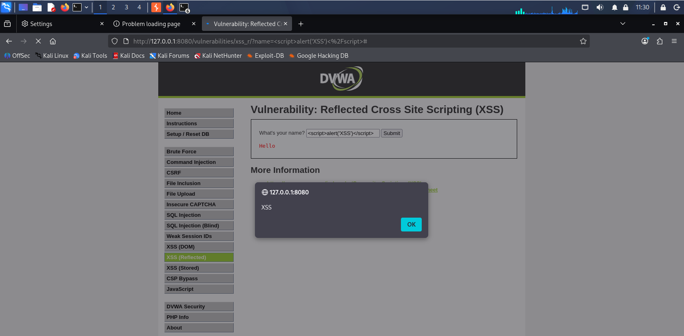
12_Reflected_XSS_Result.png
Browser alert showing XSS execution after the request is forwarded to DVWA.
Observed result: The supplied script executed in the browser, demonstrating reflected client-side script execution.
Potential impact: Script execution in a victim browser through a crafted request, potentially enabling session abuse or manipulation of page content in a real application context.
Remediation: Perform context-aware output encoding before placing data into HTML, attributes, JavaScript, CSS, or URLs.
- Validate input against expected formats without relying on validation as the primary XSS defense.
- Use a strong Content Security Policy where appropriate.
- Avoid dangerous DOM sinks and unsafe HTML rendering patterns.
- Use secure cookie attributes where session cookies are used.

11. Finding 4 – Stored XSS

Test case
The DVWA XSS (Stored) module was tested during the lab using the controlled proof-of-concept payload <script>alert('Stored XSS')</script>.
Affected module: DVWA → XSS (Stored)
Security level: Low
Proof-of-concept input used in the controlled lab:
<script>alert('Stored XSS')</script>
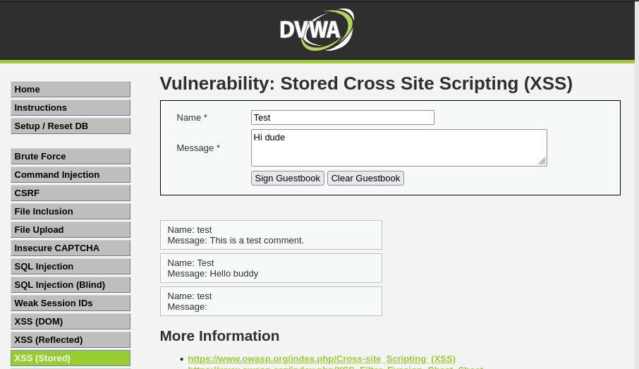
13_Stored_XSS_Normal.png
Normal baseline guestbook submission.
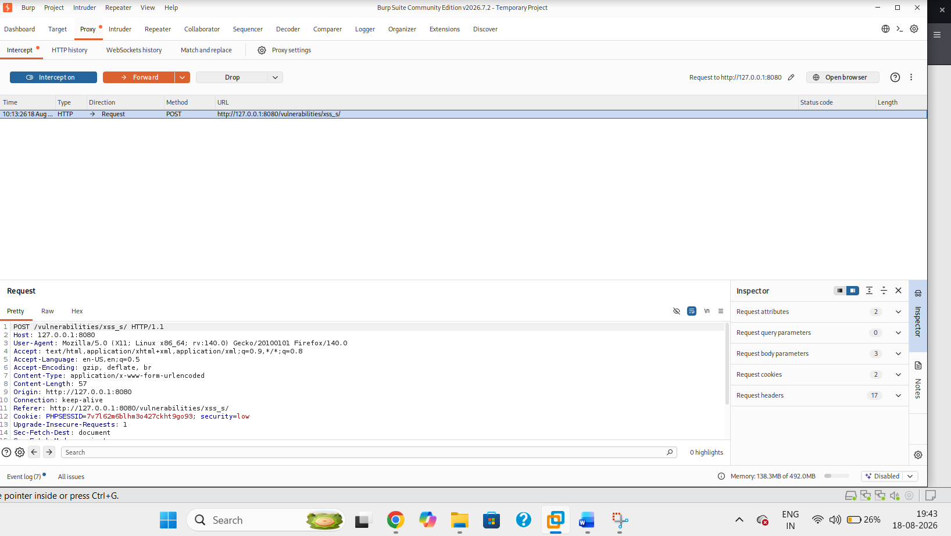
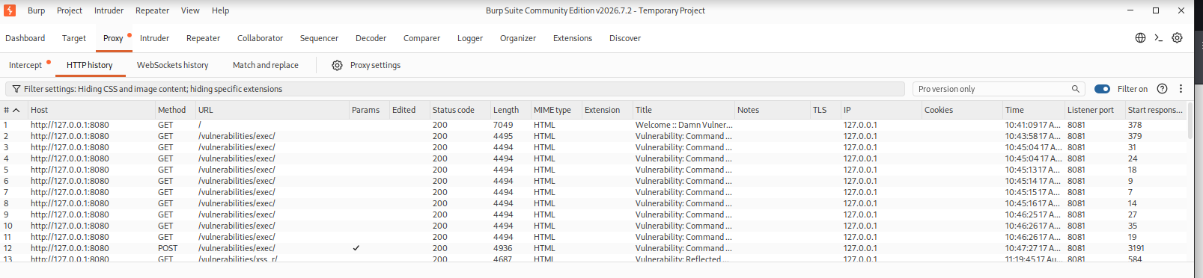

14_Stored_XSS_Burp_Request.png
Burp request showing the stored XSS input submitted to the application.

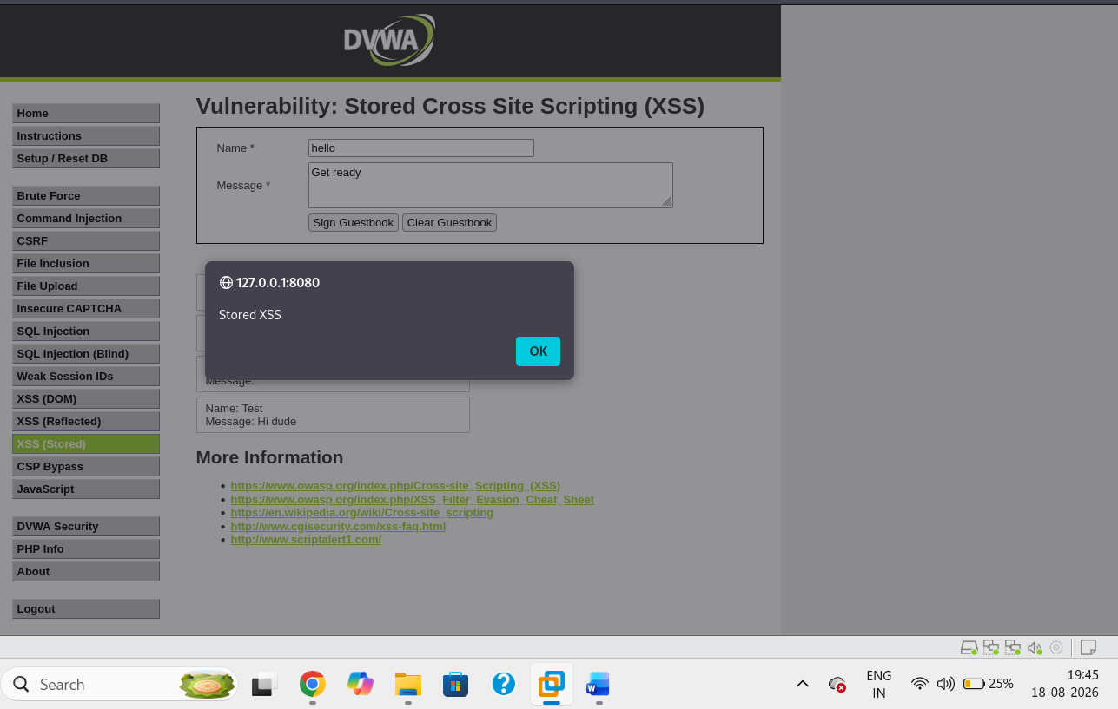
15_Stored_XSS_Result.png
Stored XSS alert/result after the stored content is rendered/executed.

Observed result: The script was stored by the application and executed when the affected content was rendered in the browser.
Potential impact: Persistent client-side script execution for users who view the affected content.
Remediation: Apply context-aware output encoding when rendering stored content.
• Sanitize rich content with a vetted allow-list HTML sanitizer when HTML is a required feature.
• Use a suitable Content Security Policy.
• Avoid unsafe client-side rendering sinks.
• Store and render user-generated content using safe, well-defined data types12. Findings Summary
ID | Vulnerability | Module | PoC Evidence | Primary Remediation
F-01 | SQL Injection | SQL Injection | Normal + PoC result + Burp request | Parameterized/prepared SQL
F-02 | Command Injection | Command Injection | Normal + whoami result + Burp request | Avoid shell execution; strict validation
F-03 | Reflected XSS | XSS (Reflected) | Burp request + browser alert | Context-aware output encoding
F-04 | Stored XSS | XSS (Stored) | Submission + Burp request + browser alert | Safe output handling + encoding + CSP

13. Remediation Recommendations
- SQL Injection: Use parameterized queries or prepared statements; do not concatenate untrusted input into SQL statements.
- Command Injection: Prefer non-shell APIs and strict allow-list validation; remove unnecessary command execution functionality.
- Reflected XSS: Encode output for the correct HTML/JavaScript/URL context and validate input at trust boundaries.
- Stored XSS: Sanitize or reject dangerous content where appropriate, encode output when rendering stored data, and use CSP as an additional layer.
- Defense in depth: Apply least privilege, secure headers, centralized input/output handling, logging, and regular security testing.

Finding | Primary Control | Implementation Guidance | Validation
SQL Injection | Parameterized queries | Replace concatenated SQL with prepared statements; validate numeric IDs as numeric. | Repeat PoC; input should no longer change query structure.
Command Injection | Safe process APIs + allow-list validation | Eliminate shell calls where possible; allow only valid IP/hostname input. | PoC should fail safely and only the intended ping action should execute.
Reflected XSS | Context-aware output encoding + CSP | Encode output for its sink; deploy CSP as defense in depth. | Submit XSS PoC; no script should execute.
Stored XSS | Safe storage/rendering + output encoding | Sanitize allowed rich text and encode output; use CSP. | Previously stored payload should render as text, not execute.

14. Conclusion
Task 4 demonstrated practical web application security testing against DVWA using Burp Suite. The controlled lab assessment validated SQL Injection, Command Injection, Reflected XSS, and Stored XSS behaviors. The report documents the test approach, expected evidence, observed outcomes, and remediation recommendations. The final submission should include the completed screenshots at the marked placeholders together with the corresponding evidence files in the Task 4 GitHub repository.

GITHUB URL: https://github.com/Reddy-hub-com/NovaShyld-Task_4-.git
https://github.com/Reddy-hub-com/NovaShyld-Task_4-/tree/main

