NOVASHYLD TECHNOLOGIES
TASK 5 — ADVANCED VAPT ASSESSMENT
FINAL VULNERABILITY ASSESSMENT & PENETRATION TEST
REPORT
Target: Metasploitable2
Target IP: 192.168.195.133
Assessment Platform: Kali Linux
Assessment Type: Authorized isolated laboratory assessment
Primary Validated Vulnerability: vsFTPd 2.3.4 Backdoor — CVE-2011-2523
Primary Validation Result: Meterpreter session established; root privileges confirmed
Prepared By: BALIREDDY CHANDRAMOULI REDDY

Submission Date: 21-08-2026
Repository: https://github.com/Reddy-hub-com/NovaShyld-Task_5

Table of Contents
- Executive Summary
- Assessment Background
- Scope and Objectives
- Lab Environment and Architecture
- VAPT Methodology
- Phase 1 — Connectivity Verification
- Phase 2 — Nmap Reconnaissance and Enumeration
- Phase 3 — Vulnerability Assessment
- Phase 4 — Controlled Exploitation
- Phase 5 — Post-Exploitation Verification
- Detailed Vulnerability Findings
- CVSS v3.1 Risk Assessment
- Remediation Plan
- Evidence and Screenshot Guide
- Limitations and Assumptions
- Conclusion

1. Executive Summary
The Task 5 VAPT assessment was conducted against Metasploitable2 at 192.168.195.133 from Kali Linux within an authorized isolated laboratory environment. The assessment followed a structured sequence of connectivity verification, reconnaissance, service enumeration, vulnerability assessment, controlled exploitation, post-exploitation verification, risk assessment and remediation planning.
The most significant finding was the vsFTPd 2.3.4 backdoor vulnerability associated with CVE-2011-2523. Nmap identified the service as vulnerable, and the finding was subsequently validated using the Metasploit vsftpd_234_backdoor module. The resulting Meterpreter session was verified using getuid, which returned Server username: root. This establishes successful root-level compromise of the authorized laboratory target.
Additional vulnerabilities and configuration weaknesses were identified by Nmap, including SSL POODLE, weak Diffie-Hellman parameters, Logjam-related weaknesses, an OpenSSL CCS Injection finding, an UnrealIRCd backdoor indication and an RMI registry configuration issue. These are documented as detected findings only unless separate exploitation evidence exists.

1.1 Assessment Summary
Assessment Item | Result
Target | Metasploitable2
Target IP | 192.168.195.133
Assessment Type | Authorized isolated laboratory VAPT
Primary Vulnerability | vsFTPd 2.3.4 Backdoor
CVE | CVE-2011-2523
CVSS v3.1 | 9.8 — Critical
Exploit Status | Successfully exploited
Access Level | Root
Additional Findings | Multiple scanner-detected weaknesses | vulnerabilities/configuration
Retesting | Required after remediation

2. Assessment Background
2.1 What is VAPT?
Vulnerability Assessment and Penetration Testing (VAPT) combines vulnerability discovery with controlled validation. Vulnerability assessment identifies weaknesses, while penetration testing verifies whether selected weaknesses can actually be exploited within an authorized scope.
2.2 Why Metasploitable2?
Metasploitable2 is an intentionally vulnerable training system. It is suitable for learning network scanning, vulnerability identification and exploitation because the target is deliberately designed for security practice.

2.3 Authorization Boundary
All activities described in this report were performed against the authorized laboratory target 192.168.195.133.
Production systems, third-party systems and unrelated networks were outside scope.

3. Scope and Objectives

3.1 In-Scope Activities
- Metasploitable2 at 192.168.195.133.
- Network connectivity and reachability testing.
- Port and service discovery.
- Operating-system/service identification using Nmap.
- Nmap vulnerability scripts.
- Controlled validation of a suitable vulnerability using Metasploit.
- Post-exploitation session verification.
- CVSS v3.1 risk assessment and remediation recommendations.

3.2 Out of Scope
- Production systems and unrelated hosts.
- Denial-of-service testing.
- Destructive actions.
- Persistence mechanisms.
- Data exfiltration.
- Unapproved lateral movement.

3.3 Objectives
- Confirm that the target is reachable from Kali Linux.
- Identify exposed ports and services.
- Identify known vulnerabilities.
- Select an appropriate vulnerability for controlled validation.
- Demonstrate exploitability in the isolated lab.
- Verify the resulting level of access.
- Assess business/security impact.
- Recommend remediation and retesting.

4. Lab Environment and Architecture
The exercise used two virtual machines: Kali Linux as the assessment workstation and Metasploitable2 as the intentionally vulnerable target. The target address used throughout the assessment was 192.168.195.133
Component | Role | Identifier
Kali Linux | Assessment workstation | Kali VM
Metasploitable2 | Intentionally vulnerable target | 192.168.195.133
Network | Isolated virtual laboratory | VMware lab network

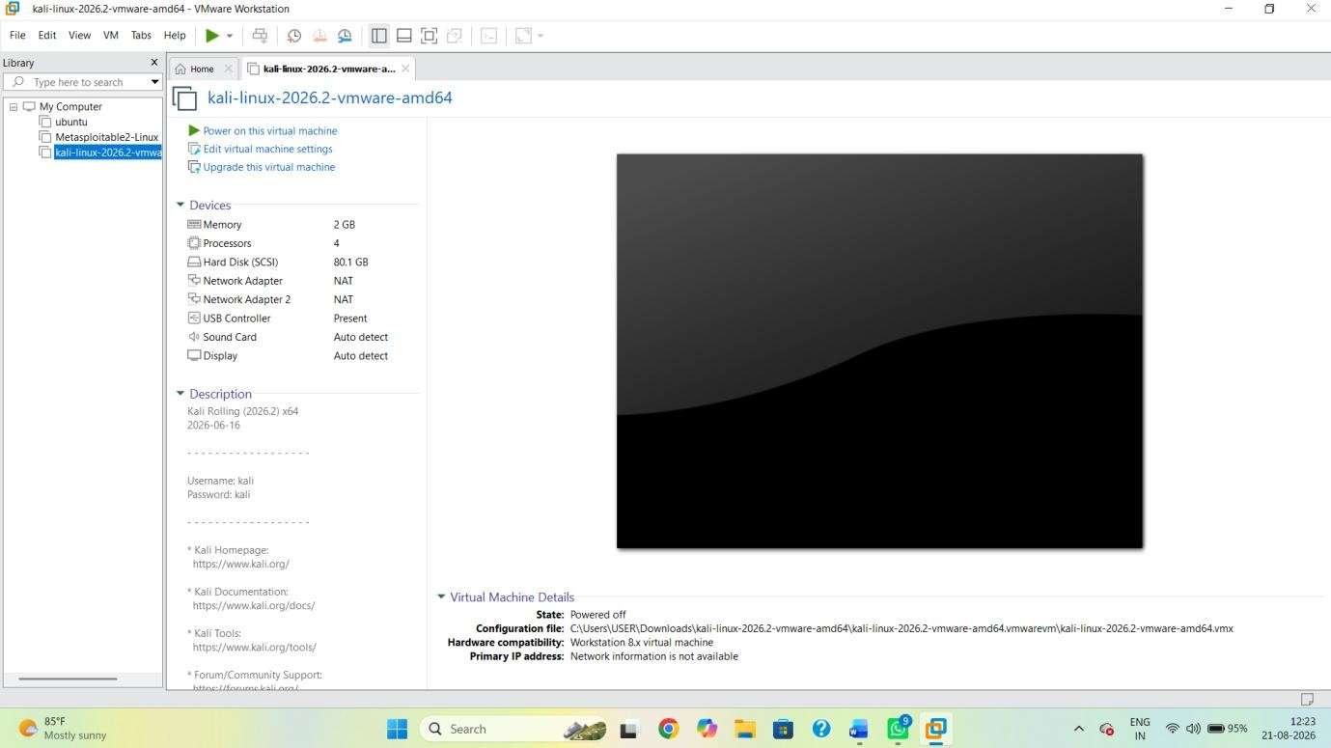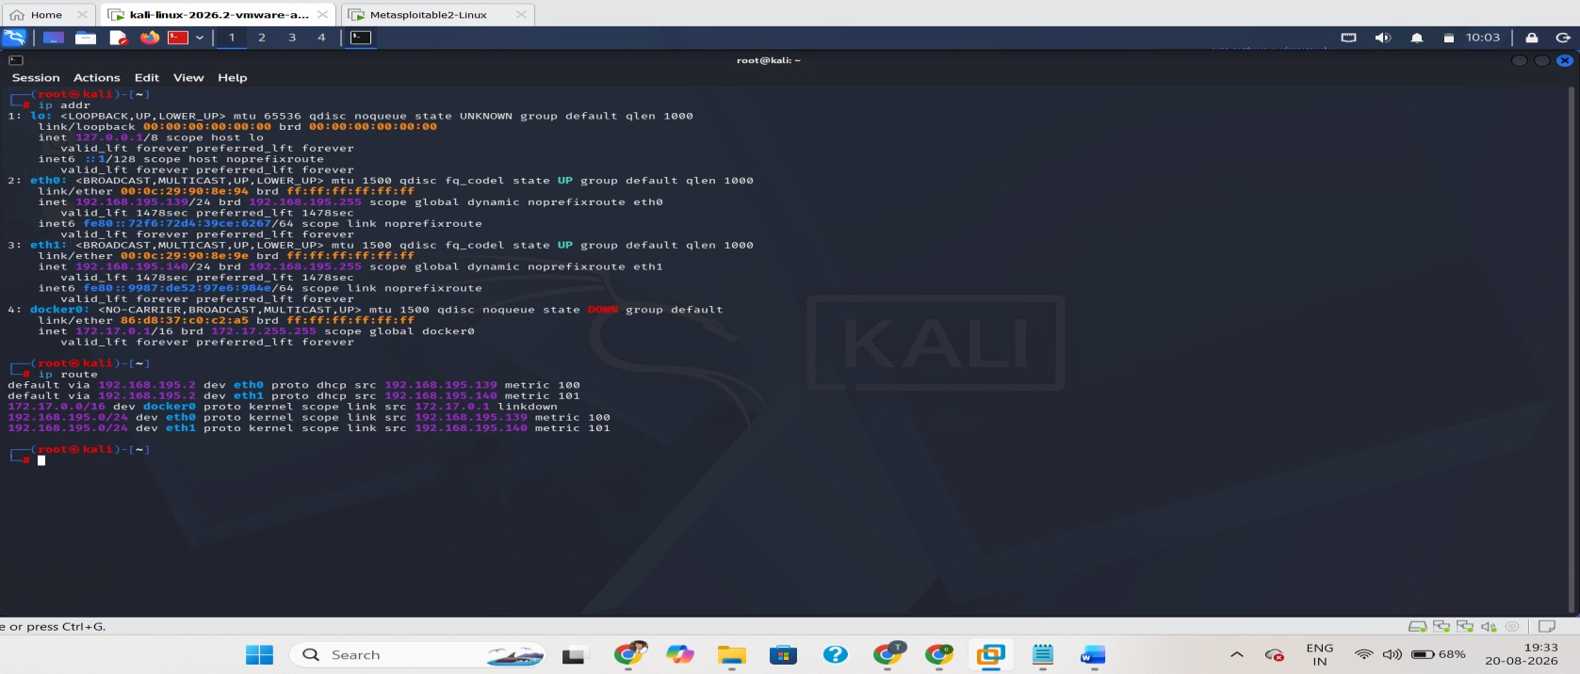

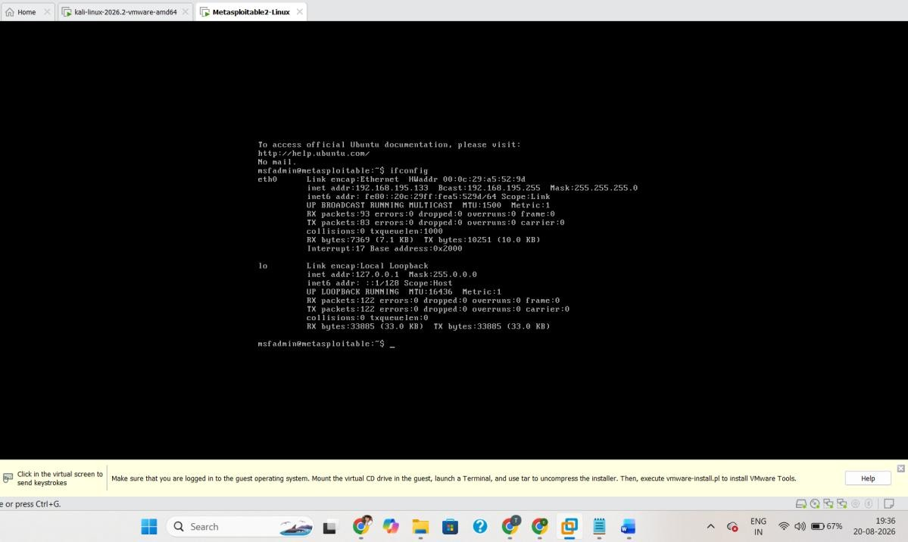
Figure 1. Kali Linux / lab network configuration.

5. VAPT Methodology
Phase | Activity | Purpose | Primary Evidence
1 | Connectivity | Confirm target is reachable | Ping
2 | Reconnaissance | Identify ports/services | Nmap -A
3 | Vulnerability assessment | Identify known weaknesses | Nmap --script vuln
4 | Controlled exploitation | Validate selected finding | Metasploit
5 | Post-exploitation | Verify access level | getuid/sysinfo/pwd/ls
6 | Risk assessment | Prioritize findings | CVSS/risk table
7 | Reporting | Document results and  remediation | Final VAPT report

6. Phase 1 — Connectivity Verification
Connectivity verification is the first technical step. It confirms that the assessment workstation can reach the target before scanning begins. A successful ping does not prove a vulnerability; it only confirms basic network reachability.
ping 192.168.195.133
The supplied lab evidence showed successful responses from the target and no packet loss in the ping statistics.
Purpose: Proves target reachability before security testing.

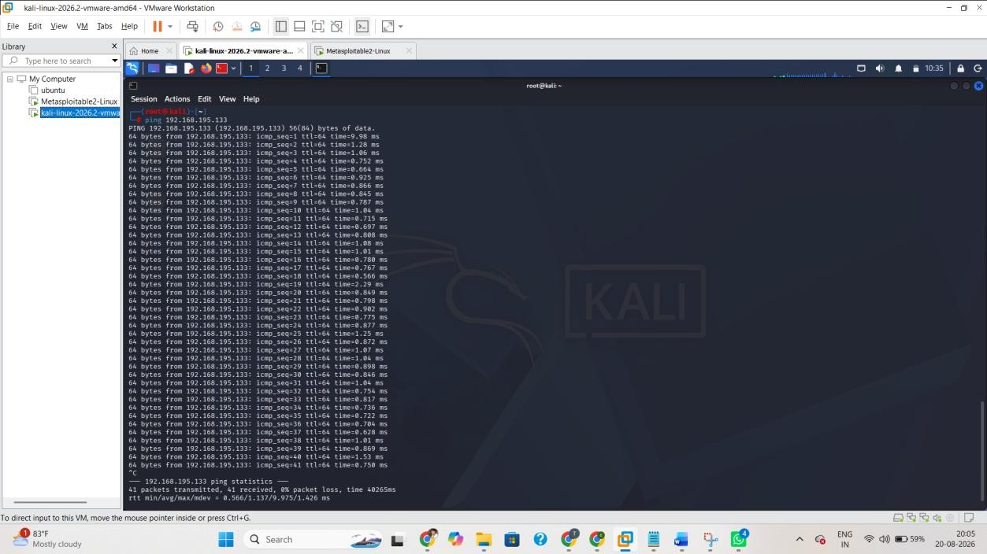
Figure 2. Successful ping to 192.168.195.133.

7. Phase 2 — Reconnaissance and Enumeration
Nmap is used to identify exposed ports and services. The -A option enables a comprehensive scan including service/version detection, operating-system detection and default scripts. Open ports represent attack surface; an open port alone is not proof of a vulnerability.
Command Used
nmap -A 192.168.195.133

Why Enumeration Matters
A security assessor needs to know what the target exposes before deciding what to investigate. An open port is not automatically a vulnerability. It is an entry point or attack surface that requires further investigation

7.1 Key Exposed Services
Port | Service | State | Security Relevance
21/tcp | FTP | Open | vsFTPd 2.3.4; primary  validated vulnerability
22/tcp | SSH | Open | Remote administration  service
23/tcp | Telnet | Open | Legacy clear-text remote access
25/tcp | SMTP | Open | Mail service
80/tcp | HTTP | Open | Web service/attack surface
139/tcp | NetBIOS | Open | Legacy network service
445/tcp | SMB/Microsoft-DS | Open | Network/file service
1099/tcp | Java RMI | Open | Configuration/RCE finding detected
3306/tcp | MySQL | Open | Database service
5432/tcp | PostgreSQL | Open | Database service
6667/tcp | IRC | Open | UnrealIRCd finding detected

Why Enumeration Matters
A security assessor needs to know what the target exposes before deciding what to investigate. An open port is not automatically a vulnerability. It is an entry point or attack surface that requires further investigation Provides evidence of enumeration and exposed attack surface.
Expected visible content: The command nmap -A 192.168.195.133 and readable output showing relevant ports/services.

Purpose:
Figure 3. Nmap comprehensive scan output.
7.2 Saving the Nmap Results nmap -A 192.168.195.133 -oN task5_nmap_scan.txt
Saving the output preserves the original scan as an evidence artifact and allows the assessor to reference the same results when writing the report
Purpose: Demonstrates that the Nmap output was preserved as task5_nmap_scan.txt.
Expected visible content: Terminal output showing task5_nmap_scan.txt exists.
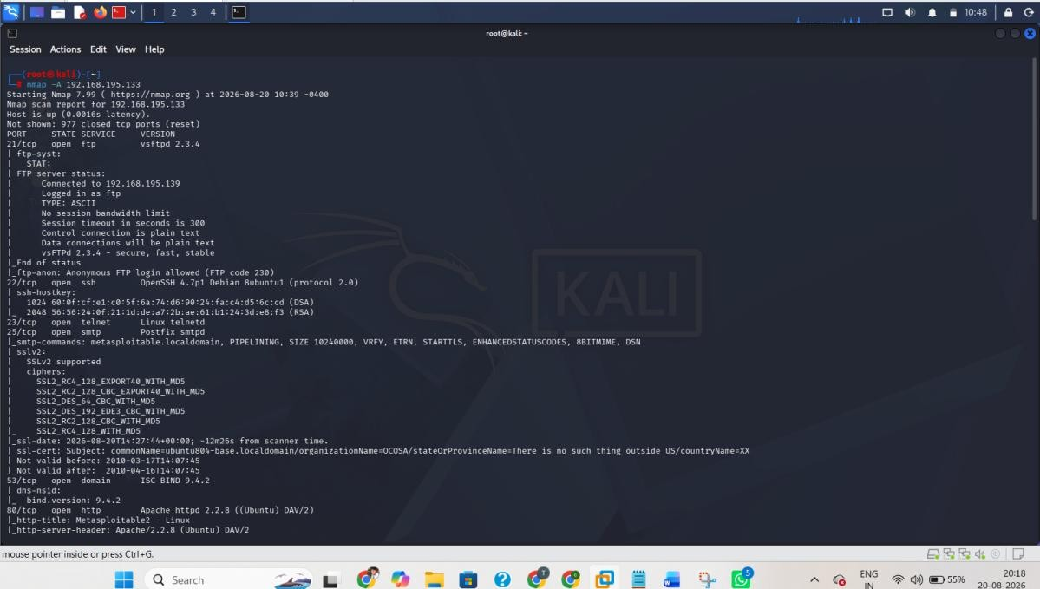

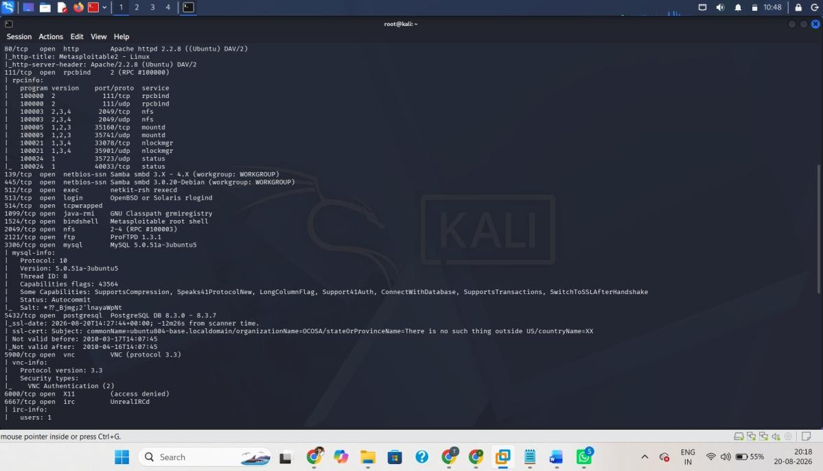
Evidence — Open ports and services.
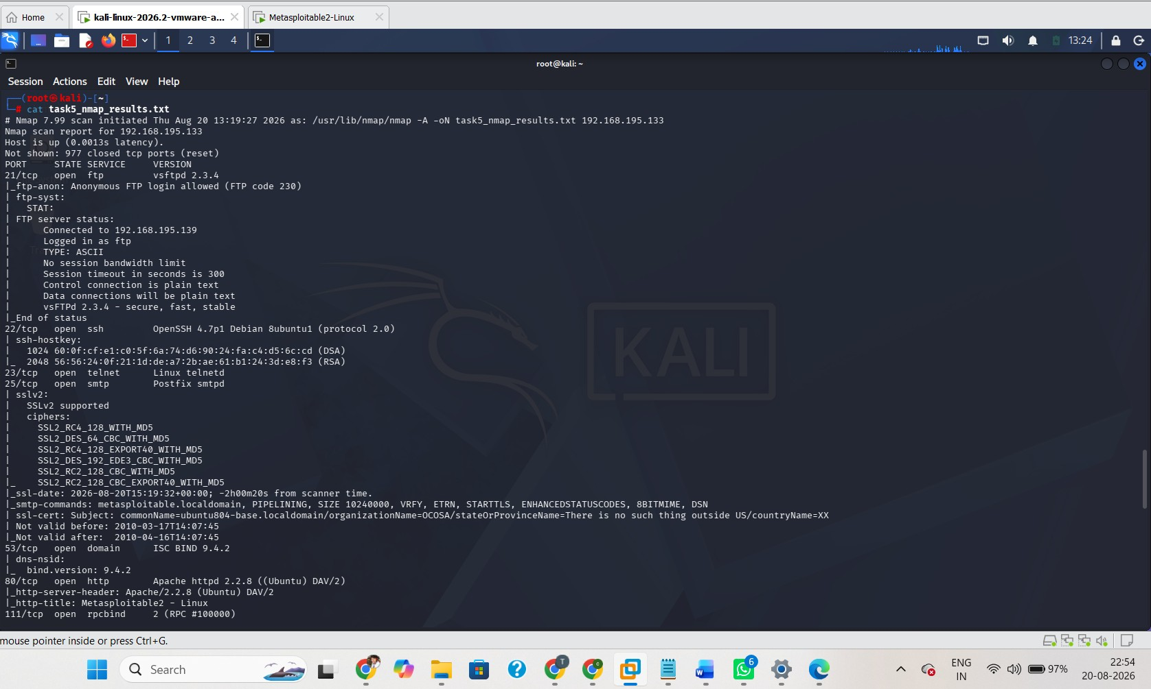
Figure 4. Saved Nmap scan file.

8. Phase 3 — Vulnerability Assessment

Why Enumeration Matters
A security assessor needs to know what the target exposes before deciding what to investigate. An open port is not automatically a vulnerability. It is an entry point or attack surface that requires further investigation
Command Used
nmap --script vuln 192.168.195.133 -oN task5_vuln_scan.txt

8.1 Detected Findings
ID | Finding | Port/Service | Identifier | Severity | Status | Action
V-01 | vsFTPd 2.3.4  Backdoor | 21/tcp FTP | CVE-20112523 | Critical | Exploited/Confirmed | Immediate
V-02 | OpenSSL CCS  Injection | Verify saved Nmap output | CVE-20140224 | High | Detected only | High
V-03 | SSL POODLE | TLS/SSL | CVE-20143566 | Low | Detected only | Planned
V-04 | Logjam / DHE  export weakness | TLS/SSL | CVE-20154000 | Low | Detected only | Planned
V-05 | Weak/anonymous DH parameters | TLS/SSL | — | N/A | Detected | Review
V-06 | UnrealIRCd backdoor indication | 6667/tcp IRC | CVE-20102075 | Review | Detected only | High priority review
V-07 | RMI registry configuration finding | 1099/tcp | — | Review | Detected only | High priority review
Important reporting rule: only V-01 is classified as exploited because the supplied evidence demonstrates a successful Meterpreter session and root privilege. The other findings must not be described as exploited unless separate evidence exists.
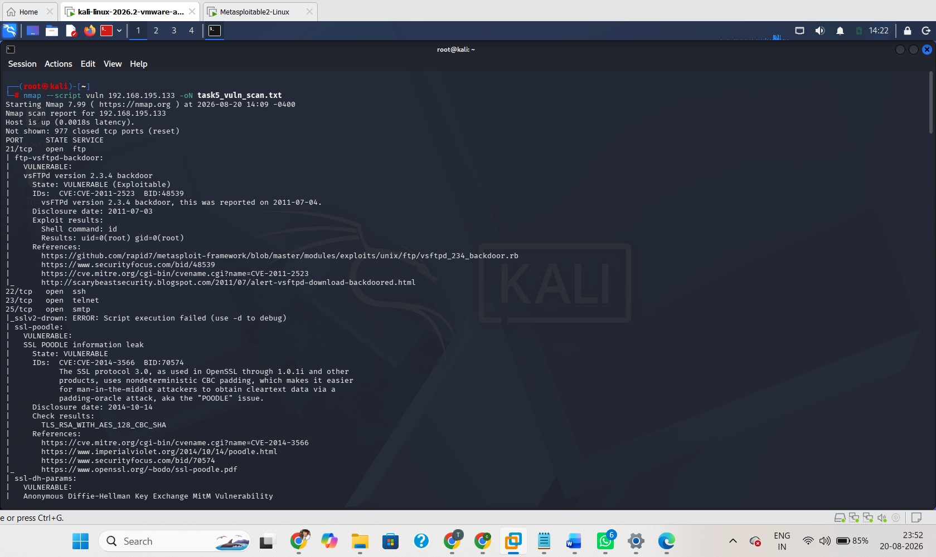

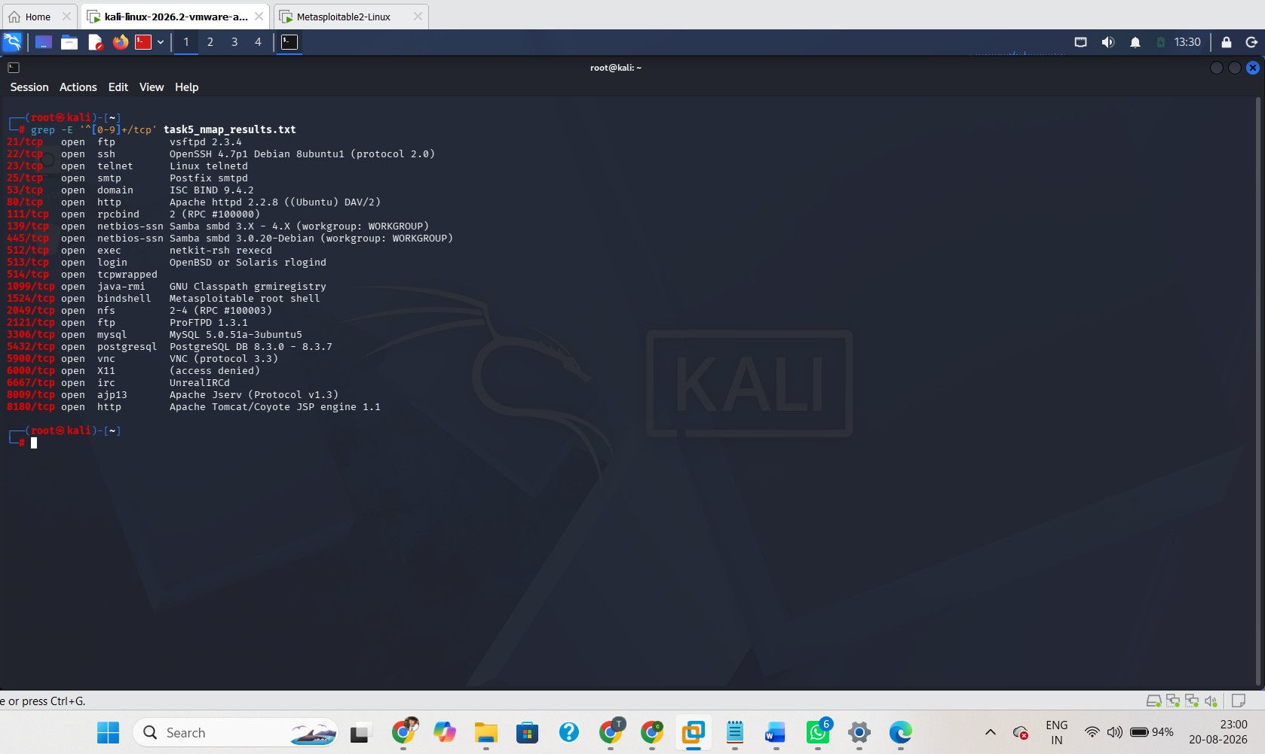
Figure 5. Nmap vulnerability scan output.

9. Phase 4 — Controlled Exploitation
Controlled exploitation validates whether a vulnerability can actually be abused in the authorized lab. The vsFTPd 2.3.4 finding was selected because the scanner identified the known backdoor and a corresponding Metasploit module was available.
9.1 Metasploit Module Selection use exploit/unix/ftp/vsftpd_234_backdoor set RHOSTS 192.168.195.133
RHOSTS identifies the remote target. The module corresponds to the known vsFTPd 2.3.4 backdoor vulnerability.
Target Configuration set RHOSTS 192.168.195.133
RHOSTS identifies the remote host against which the module will operate. Because this is an authorized isolated lab, the target is the Metasploitable2 VM used throughout this report.

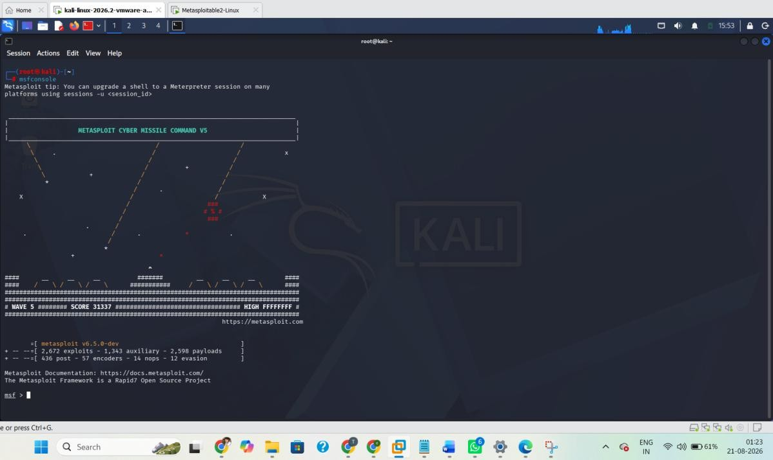

Evidence — Metasploit module selection/configuration.
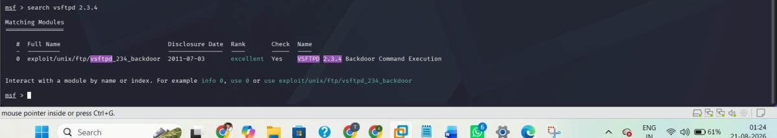
Evidence — Metasploit target/options.
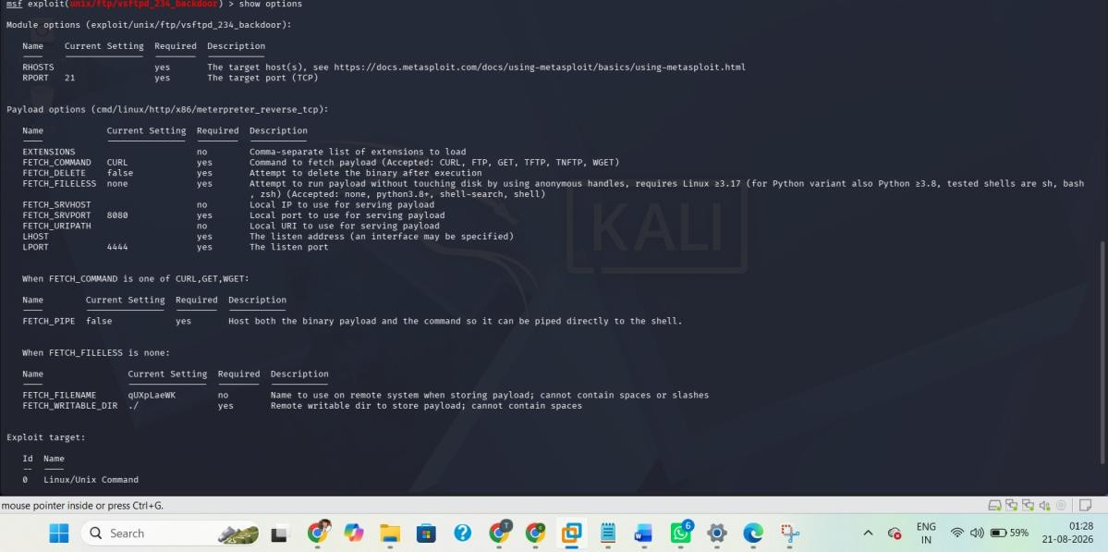

Evidence — Exploitation / session establishment.
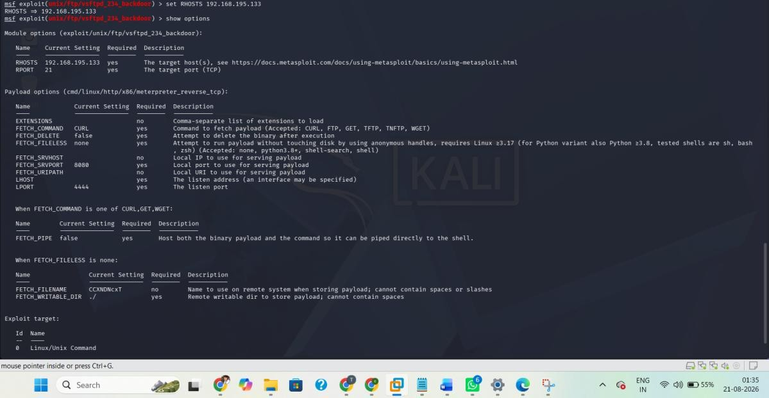
Purpose: Shows the correct exploit module was selected and the authorized target was configured.
Expected visible content: Metasploit prompt showing exploit/unix/ftp/vsftpd_234_backdoor and RHOSTS 192.168.195.133.
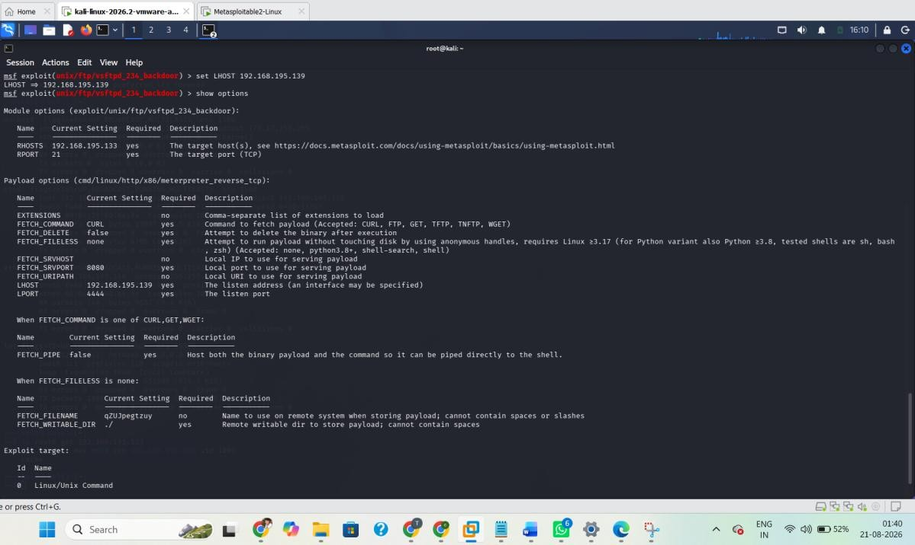
Figure 6. Metasploit module and RHOSTS configuration.

9.2 Vulnerability Check check
The check command is used to assess whether the target appears vulnerable before exploitation.
Purpose: Provides evidence that the target was identified as vulnerable before exploitation.
Expected visible content: The check command and its vulnerable/positive result.
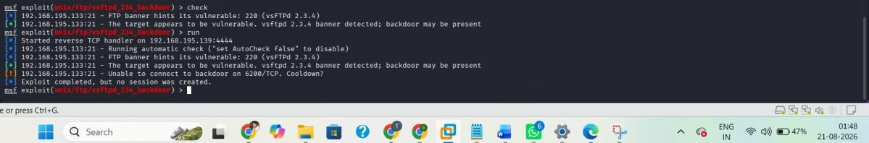
Figure 7. Metasploit vulnerability check.

9.3 Exploit Execution
run
The exploit was executed against the authorized Metasploitable2 target. The supplied evidence showed that a Meterpreter session was successfully established.
Purpose: Demonstrates that exploitation progressed beyond scanner detection to an interactive session.
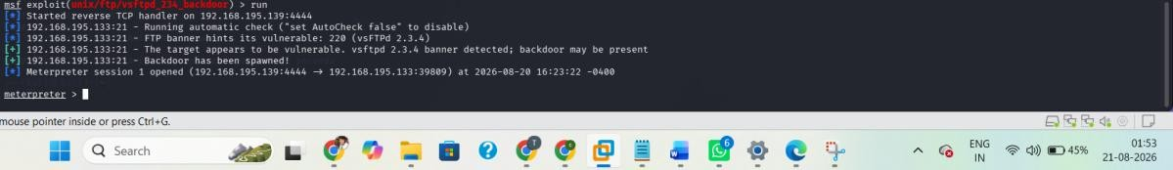
Figure 8. Successful exploitation and Meterpreter session.

10. Phase 5 — Post-Exploitation Verification
Post-exploitation verification determines what the successful exploit actually provided. Professional reporting should not claim full compromise solely from a scanner result; the obtained session and privilege level should be verified.

10.1 Root Privilege Verification getuid
Server username: root
The getuid result is the most important post-exploitation evidence in this assessment. It confirms that the Meterpreter server process was operating with root privileges on the target.
Purpose: Confirms the level of access obtained through exploitation.

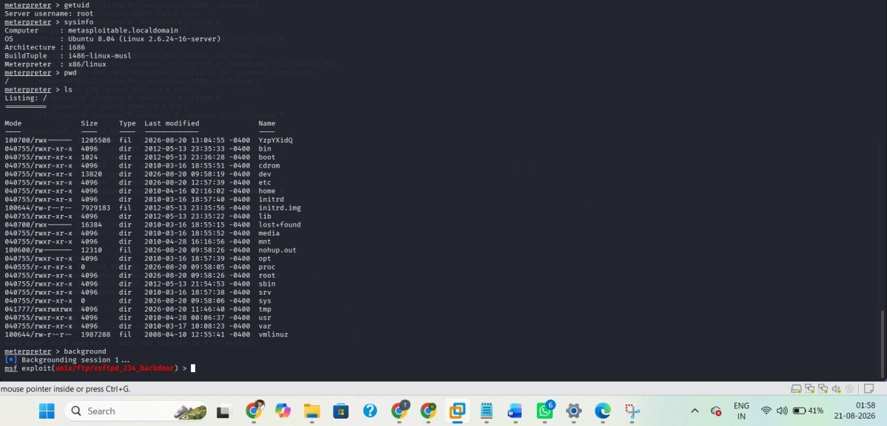
Figure 9. Root privilege verification.

10.2 System Information
sysinfo
sysinfo provides information about the target operating system and Meterpreter session.
Purpose: Confirms the target system associated with the Meterpreter session.
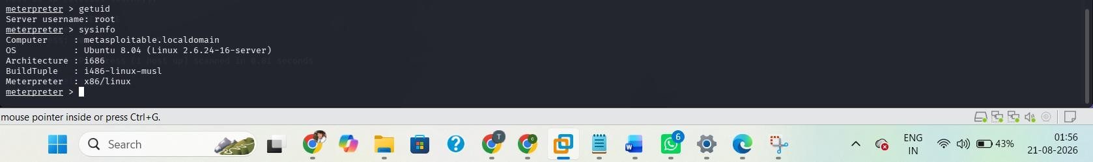
Figure 10. System information.

10.3 Filesystem Access
pwd ls
pwd identifies the current working directory and ls lists directory contents. Together they demonstrate interactive filesystem access through the established session.
Purpose: Demonstrates post-exploitation interaction with the target filesystem.

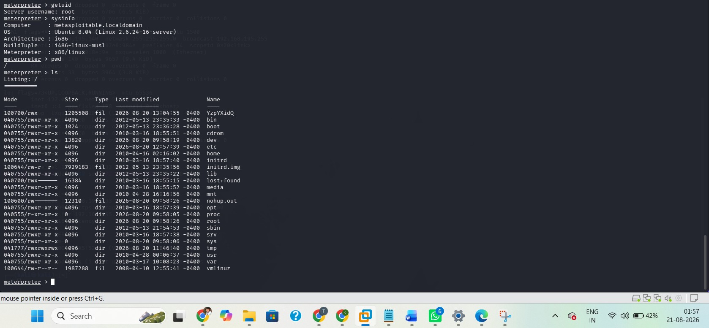
Figure 11. Filesystem access.

10.4 Session Management
background sessions
The session can be backgrounded and later confirmed using sessions. This demonstrates that the established session remained available to the Metasploit framework.
Purpose: Confirms the established Meterpreter session is registered with Metasploit.
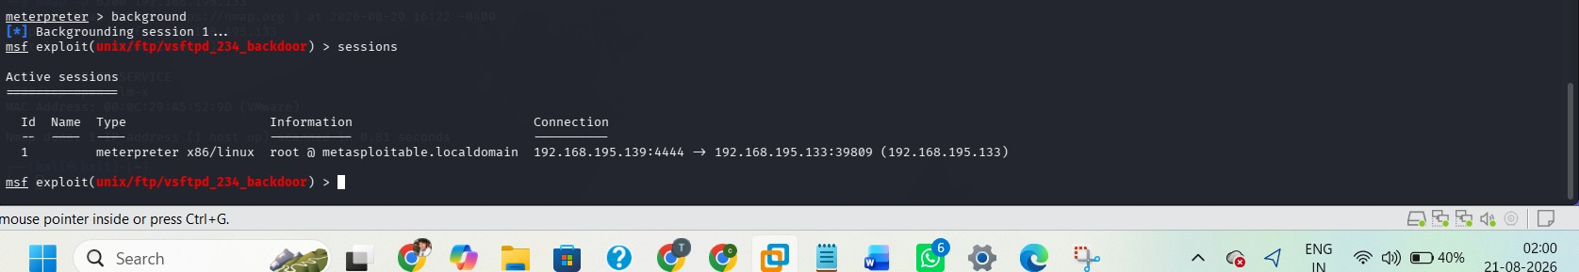
Figure 12. Metasploit session listing.

11. Attack Path Demonstrated
The assessment can be summarized as the following controlled attack path:
- Network reachability
- Port and service discovery
- FTP service identification
- vsFTPd 2.3.4 version identification
- CVE-2011-2523 vulnerability detection
- Metasploit module selection
- Vulnerability check
- Controlled exploitation
- Meterpreter session establishment
- getuid verification
- Root-level access confirmed
This attack path shows how an exposed legacy service can progress from network discovery to complete host compromise when a known exploitable vulnerability is present.

12. Finding Status Definitions
Status | Definition
Detected | Identified by scanning or automated assessment, but not manually exploited in this assessment.
Validated | Supported by additional assessment evidence beyond a basic discovery result.
Exploited / Confirmed | Successfully exploited in the authorized lab and supported by session/access evidence.

13. Detailed Vulnerability Findings

13.1 V-01 — vsFTPd 2.3.4 Backdoor
Affected Service: FTP / vsFTPd 2.3.4
Port: 21/tcp
CVE: CVE-2011-2523
CVSS v3.1: 9.8 — Critical
Status: Exploited / Confirmed
Observed Access: Meterpreter session with root privileges
Description
The target exposed vsFTPd 2.3.4, a version associated with a known backdoor. Nmap reported the service as vulnerable and the issue was subsequently validated through the Metasploit vsftpd_234_backdoor module.
Root Cause
The primary root cause is the presence of obsolete and intentionally vulnerable FTP software containing the known backdoor. Contributing factors include legacy software exposure and insufficient service hardening.
Impact
Successful exploitation resulted in root-level access. From a security perspective, root access can affect confidentiality, integrity and availability of the target system.
Remediation
- Remove the vulnerable vsFTPd 2.3.4 installation.
- Replace it with a supported, trusted version if FTP is genuinely required.
- Disable FTP entirely when it is not required.
- Restrict access to required hosts/networks.
- Verify software provenance and integrity.
- Perform a vulnerability scan after remediation.

13.2 V-02 — OpenSSL CCS Injection
The vulnerability scan reported an OpenSSL CCS Injection finding associated with CVE-2014-0224. The finding should be treated as a high-priority patching issue. The supplied evidence does not show that this finding was exploited during the assessment.
- Update affected OpenSSL/TLS libraries to supported versions.
- Remove obsolete cryptographic libraries and packages.
- Restart affected services after patching.
- Re-run vulnerability checks to verify remediation.
.

13.3 V-03 — SSL POODLE
The scanner reported SSL POODLE (CVE-2014-3566), a weakness associated with SSL 3.0. The finding was not exploited in the supplied evidence.
- Disable SSL 3.0.
- Use modern TLS versions.
- Disable obsolete cipher suites.
- Verify the resulting TLS configuration with a follow-up scan.

13.4 V-04 — Logjam / Weak DHE
The scan reported a Logjam-related weakness (CVE-2015-4000) and weak/export-grade Diffie-Hellman parameters. The issue was not exploited in the supplied evidence.
- Disable export-grade cryptography.
- Use strong, modern Diffie-Hellman parameters where DHE is required.
- Prefer modern TLS configurations and supported cryptographic suites.

13.5 V-05 — Weak/Anonymous DH Parameters
The scan reported weak/anonymous Diffie-Hellman configuration. This is treated as a configuration weakness rather than assigning an unsupported CVSS score.

13.6 V-06 — UnrealIRCd Backdoor Indication
The scan reported a Logjam-related weakness (CVE-2015-4000) and weak/export-grade Diffie-Hellman parameters. The issue was not exploited in the supplied evidence.
- Disable export-grade cryptography.
- Use strong, modern Diffie-Hellman parameters where DHE is required.
- Prefer modern TLS configurations and supported cryptographic suites.

13.7 V-07 — Java RMI Registry Configuration
The vulnerability scan reported an RMI registry default-configuration remote-code-execution finding on TCP/1099. The supplied evidence does not show that this issue was exploited.
- Disable the RMI registry if not required.
- Restrict access to trusted hosts.
- Disable unsafe remote class loading/configuration.
- Patch the Java runtime/application stack.
- Re-test the service after hardening.

14. Business and CIA Impact
Confidentiality
Root-level access could allow an attacker to access sensitive files and system information.
Integrity
Root-level access could allow modification of system files, services and configurations.

Availability
Root-level access could allow disruption or modification of system services.
Overall CIA impact for the validated vsFTPd compromise: HIGH.

15. CVSS v3.1 Risk Assessment
CVSS provides a standardized framework for communicating vulnerability severity. The primary validated finding is rated Critical because it is remotely exploitable with low complexity, requires no privileges or user interaction, and can produce high impact to confidentiality, integrity and availability.
CVSS:3.1/AV:N/AC:L/PR:N/UI:N/S:U/C:H/I:H/A:H
ID | Finding | CVSS | Severity | Validation | Priority | Reason
V-01 | vsFTPd 2.3.4 Backdoor | 9.8 | Critical | Exploited/root | Immediate | Remote unauthenticated compromise with high CIA impact
V-02 | OpenSSL CCS  Injection | 7.4 | High | Detected only | High | Known cryptographic weakness; patching required
V-03 | SSL POODLE | 3.4 | Low | Detected only | Planned | Legacy SSL configuration weakness
V-04 | Logjam | 3.7 | Low | Detected only | Planned | Weak/export-  grade DHE  configuration
V-05 | Weak DH  parameters | N/A | Configuration | Detected | Review | Cryptographic hardening required
V-06 | UnrealIRCd backdoor | N/A | Review | Detected only | High | Potentially dangerous legacy/backdoor condition
V-07 | RMI configuration | N/A | Review | Detected only | High | Potential remotecode-execution exposure requires review

16. Remediation Plan
Priority | Action | Reason | Retest / Expected Result
P1 | Remove/upgrade vsFTPd  2.3.4 | Eliminate validated root-level compromise path | Nmap/vuln scan no longer identifies CVE-2011-2523
P1 | Review and harden RMI on 1099 | Reduce potential remotecode-execution exposure | Port/configuration finding resolved
P2 | Patch OpenSSL/TLS  components | Address known CCS/crypto weaknesses | Vulnerability scan no longer flags affected weakness
P2 | Remove/upgrade UnrealIRCd | Eliminate backdoor/legacy  service risk | Service removed or secure supported version confirmed
P3 | Disable SSLv3 and exportgrade crypto | Remove legacy  cryptographic exposure | TLS scan shows modern  protocols/ciphers only
P3 | Harden Diffie-Hellman  parameters | Improve cryptographic  strength | Weak/anonymous DH  findings removed
P3 | Disable unnecessary  services | Reduce overall attack  surface | Post-remediation Nmap shows fewer unnecessary  ports

16.1 Retesting Procedure
- Repeat the Nmap service/version scan.
- Repeat the Nmap vulnerability scan.
- Confirm vsFTPd 2.3.4 is no longer exposed.
- Confirm legacy TLS protocols and weak parameters are removed.
- Review RMI and UnrealIRCd exposure.
- Compare before/after results.
- Record remediation evidence and update finding status.

17. Final Screenshot Insertion Guide
Insert the following 12 screenshots only. The numbering below is final and intentionally contains no duplicate ping screenshot. Insert each image at the corresponding numbered placeholder in the report.
No. | Screenshot | Insert After | Must Show |  | Why
1 | Kali/network configuration | Section 4 | Relevant Kali network information |  | Lab setup evidence
2 | Ping target | Section 6 | ping 192.168.195.133  + final statistics |  | Reachability evidence
3 | Nmap -A | Section 7.1 | Command + open  ports/services |  | Reconnaissance evidence
4 | Saved Nmap file | Section 7.2 | task5_nmap_scan.txt exists |  | Evidence preservation
5 | Nmap vuln scan | Section 8.1 | vsFTPd vulnerable result + relevant  findings |  | Vulnerability evidence
6 | Metasploit module/options | Section 9.1 | vsftpd_234_backdoor + RHOSTS |  | Exploit setup
7 | Metasploit check | Section 9.2 | Vulnerable result |  | Pre-exploitation validation
8 | Exploit/Meterpreter | Section 9.3 | run + Meterpreter  session |  | Successful exploitation
9 | getuid root | Section 10.1 | Server username: root |  | Root compromise  proof
10 | sysinfo | Section 10.2 | System information |  | Target/session verification
11 | pwd + ls | Section 10.3 | Filesystem commands/output |  | Post-exploitation evidence
12 | sessions | Section 10.4 | Established listed | session | Session confirmation

18.1 Screenshot Quality Requirements
- Use readable resolution; terminal text must be legible.
- Keep the command and relevant output visible.
- Do not crop away the prompt if it is needed to identify the tool/command.
- Do not include unrelated personal information.
- Use the exact screenshot corresponding to the described evidence.
- Keep captions with the figures.
- Do not add screenshots for vulnerabilities that were not actually tested/exploited.
- Do not duplicate the ping screenshot.

19. Limitations and Assumptions
- The assessment was performed against an intentionally vulnerable training system.
- Results should not be interpreted as a production security assessment.
- Automated scanner findings may require manual verification and can include errors or false positives.
- Only the vsFTPd vulnerability is classified as successfully exploited because the supplied evidence demonstrates the Meterpreter session and root privilege.
- No destructive activity, persistence, data exfiltration or denial-of-service testing was performed.
- The Metasploitable2 VM and evidence files should remain intact until submission and review are complete.

20. Conclusion
Task 5 successfully demonstrated the core lifecycle of a VAPT assessment: reachability verification, reconnaissance, service enumeration, vulnerability identification, controlled exploitation, post-exploitation verification, risk assessment and remediation planning.
The primary security result was the successful exploitation of the vsFTPd 2.3.4 backdoor vulnerability. The resulting Meterpreter session was verified with getuid and returned root, demonstrating a complete root-level compromise of the authorized Metasploitable2 target.
The additional scanner findings should be remediated according to their priority and then re-tested. The final submission should include the completed report, evidence screenshots, scan output files and the required repository materials.

Appendix A — Commands Used
- ping 192.168.195.133
- nmap -A 192.168.195.133
- nmap -A 192.168.195.133 -oN task5_nmap_scan.txt
- nmap --script vuln 192.168.195.133 -oN task5_vuln_scan.txt
- nmap -p 6200 192.168.195.133
- use exploit/unix/ftp/vsftpd_234_backdoor
- set RHOSTS 192.168.195.133
- _{check}
- _{run}
- _{getuid}
- sysinfo
- _{pwd}
- _{ls}
- background
- sessions

Appendix B — References
- CVE-2011-2523 — vsFTPd 2.3.4 backdoor vulnerability.
- CVE-2014-0224 — OpenSSL CCS Injection.
- CVE-2014-3566 — SSL POODLE.
- CVE-2015-4000 — Logjam.
- Nmap vulnerability scan output generated during Task 5.
- Metasploit/Meterpreter evidence generated during Task 5.

END OF REPORT
Thank you

