**Task-vpc-02**

1. Create one VPC,with 1 one public subnet and 1 private subnet.

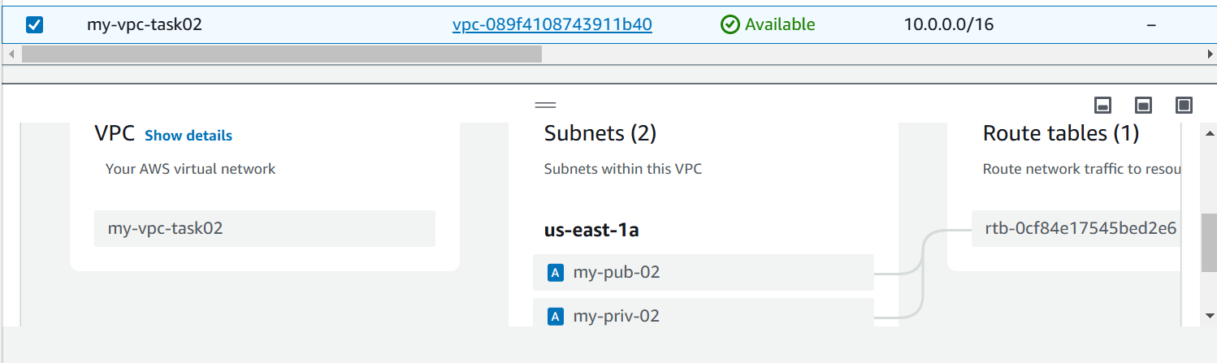

1. Enable VPC peering for cross region.

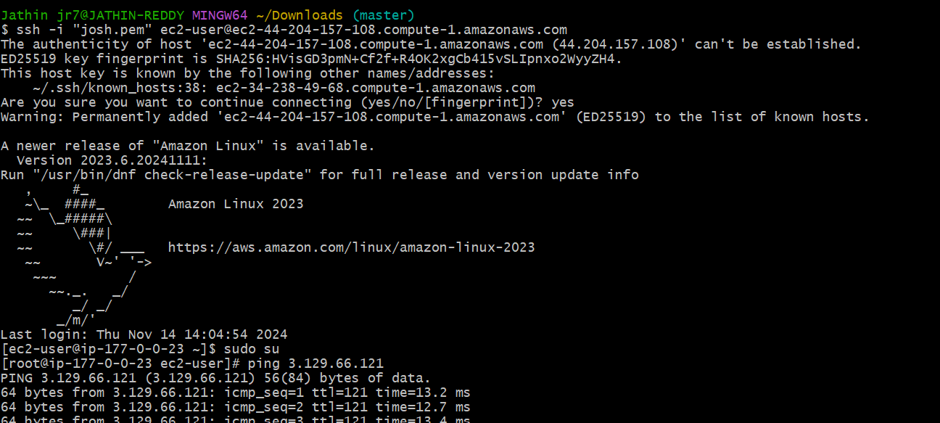

1. Enable VPC peering for cross account.

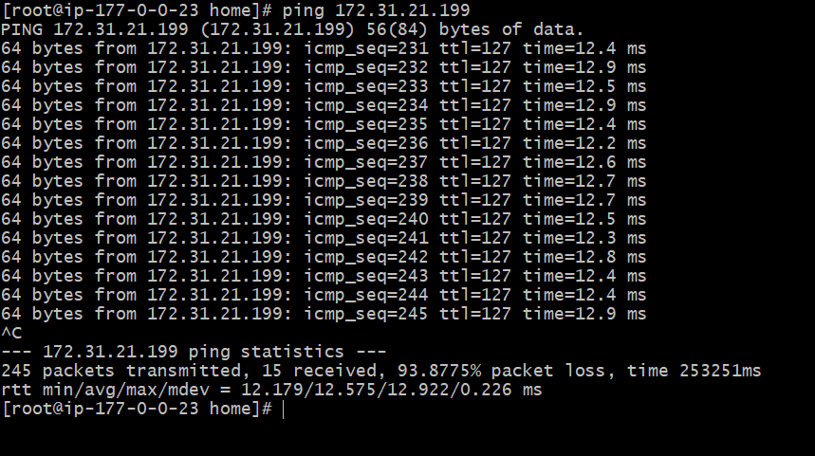

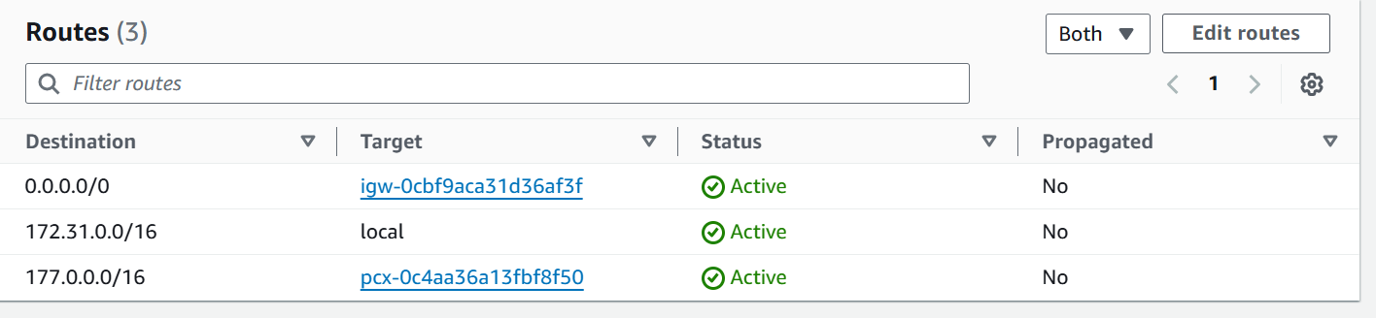

1. Setup VPC Transist gateway.

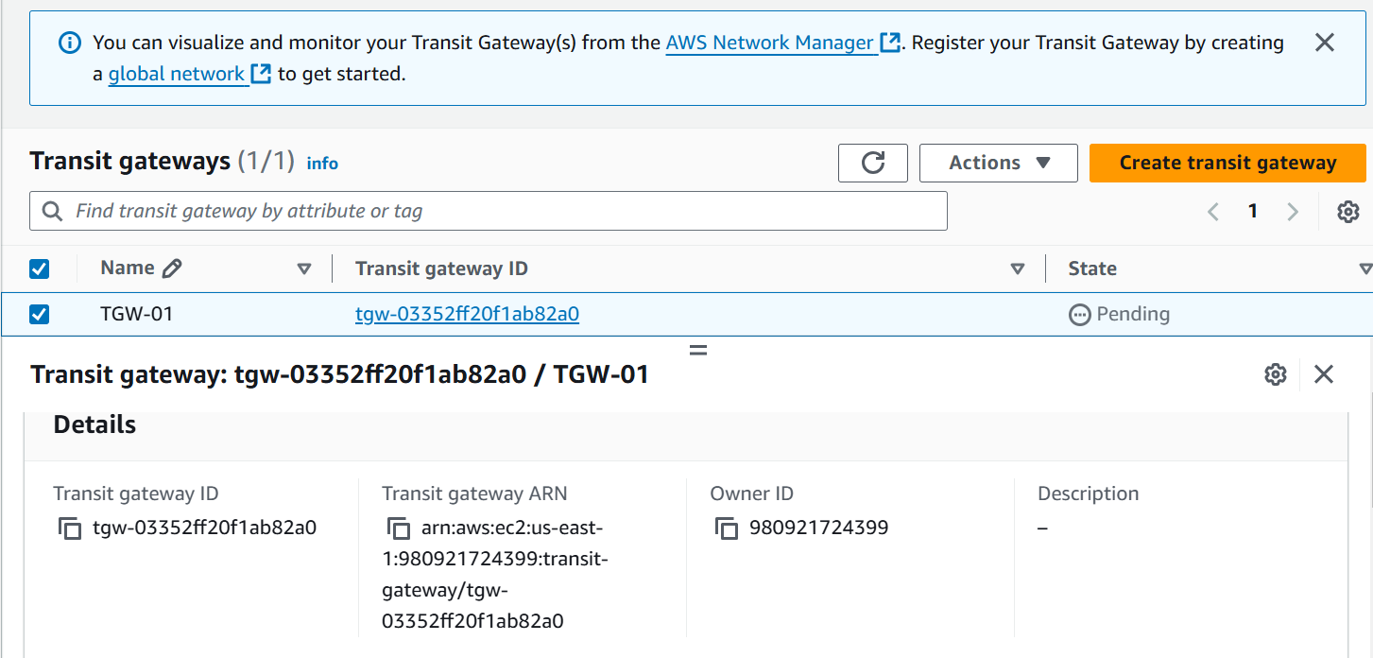

1. Setup VPC End Point.

