1 **DDL Commands – CREATE, ALTER, DROP, TRUNCATE**

Create a Table as Workers with the fields S_No, Name, Designation, and Branch. Alter the Table by adding a column Branch. Drop the table.

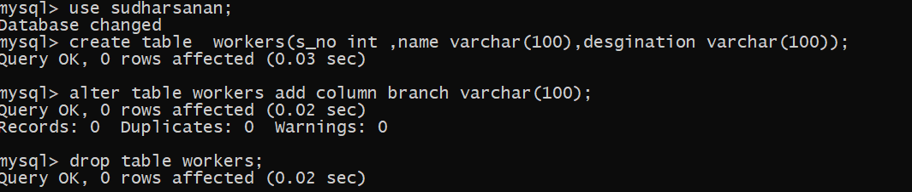

2 **DML Commands – INSERT, SELECT, UPDATE, DELETE**

Create a table Bank with the fields S_No , Cust_Name, Acc_No,Balance, cus_Branch. Insert five rows into the table. Give a select statement using Simple Select * for selecting all fields in the table. Then Update the Cus_Branch in the second row as Pondicherry. SELECT with various clause.

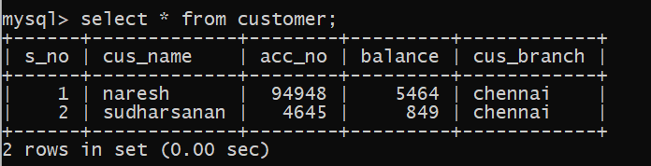



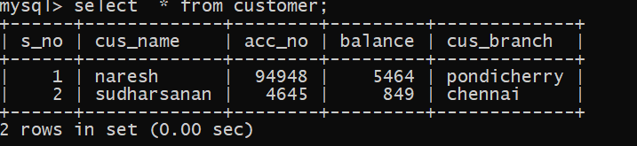

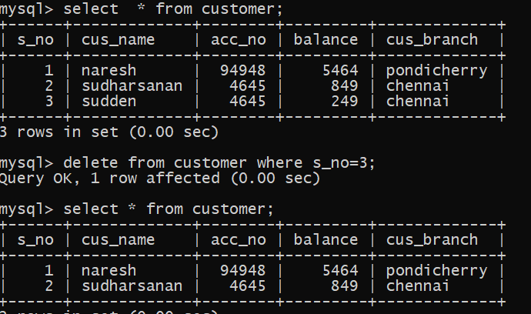

**3** **DDL Commands with Constraints – PRIMARY, FOREIGN KEY, UNIQUE, CHECK**

Create a Table Employee with fields S_No, name, Designation Branch with primary key as S_No. Create a table Workers with the same fields and make the field S_No as foreign key.



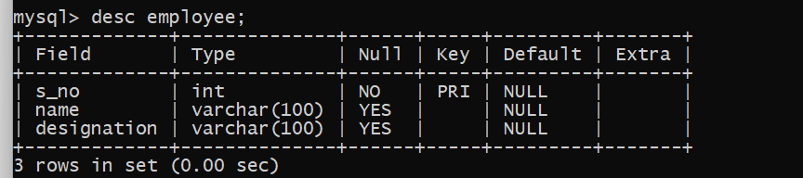

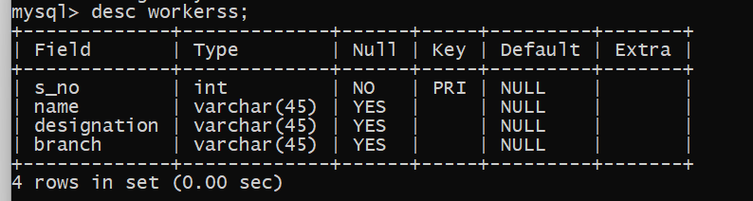

**4 DCL and TCL Commands**

Create a Table Book with the fields S_No, B_Name, Author, Price, and Publisher. Create a save point for the table book as B . Rollback the table book after inserting four and five rows respectively. Execute the commands Grant & Revoke and finally Commit the table.

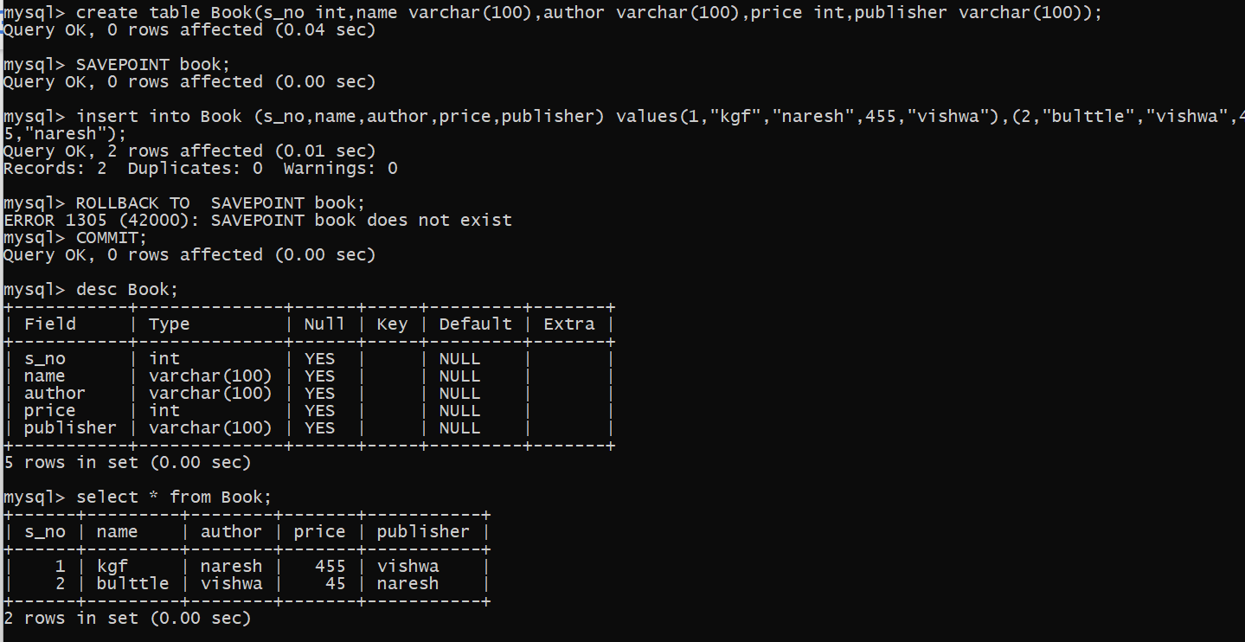

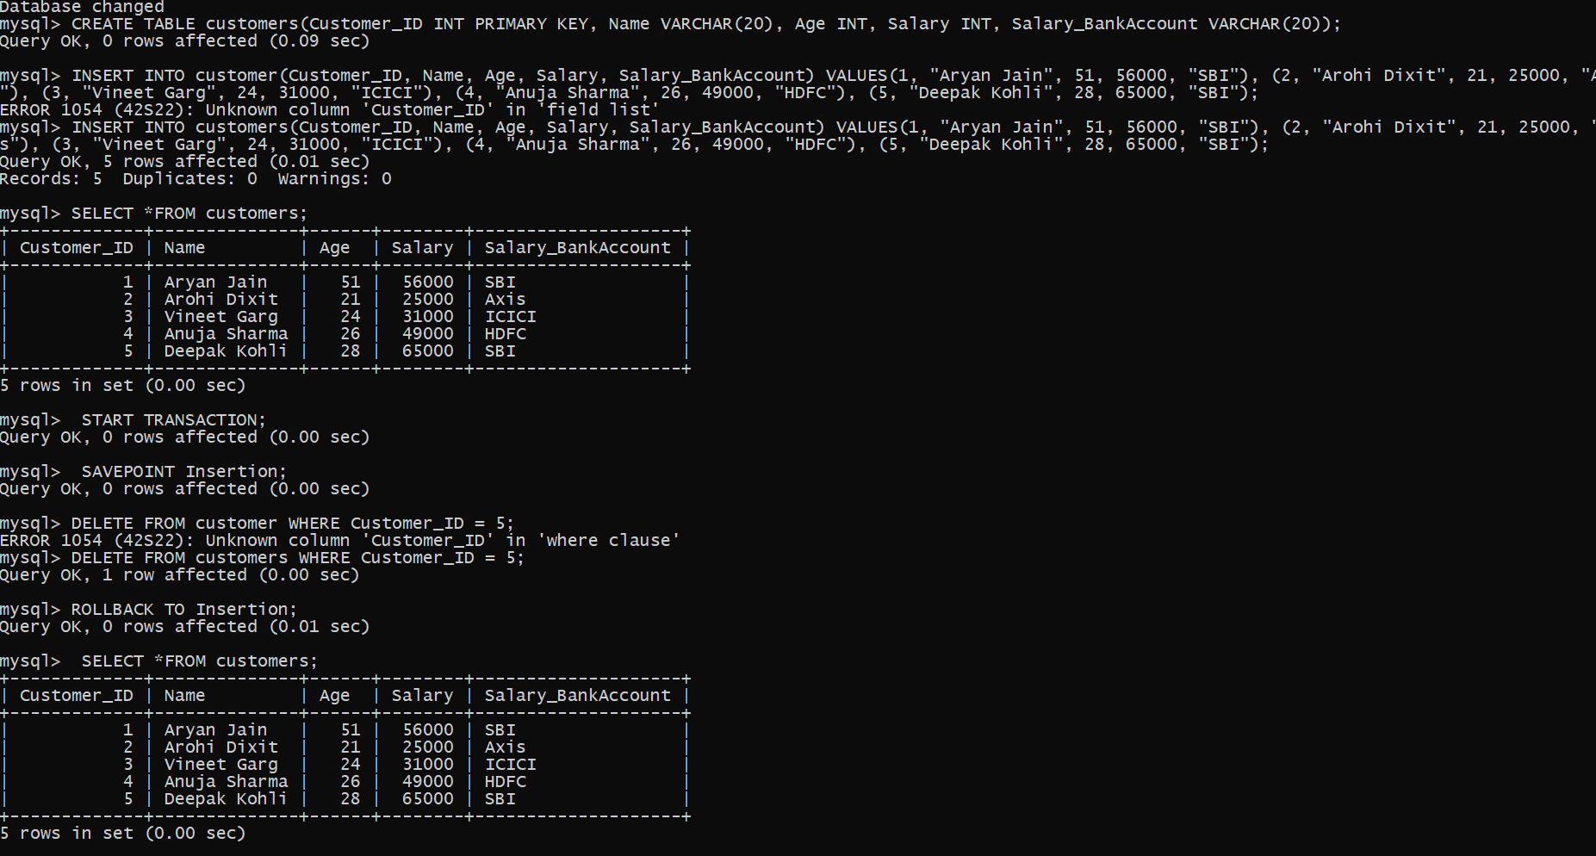

**5** **SELECT with various clause – WHERE, BETWEEN, IN and pattern matching** Commands

Create a table bank with fields S_No, Cust_Name, Acc_No , Balance, cas_Branch. Give the select statement with Simple Select * with where clause for the field name Acc_No.

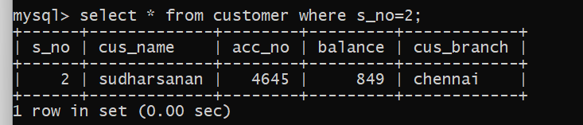

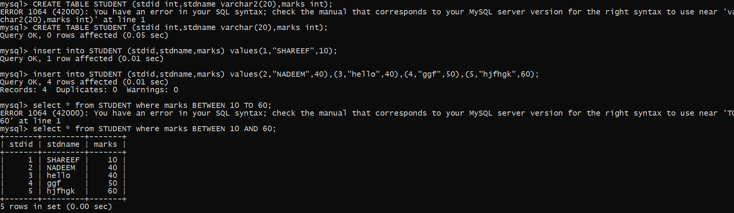

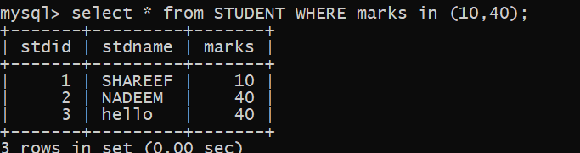

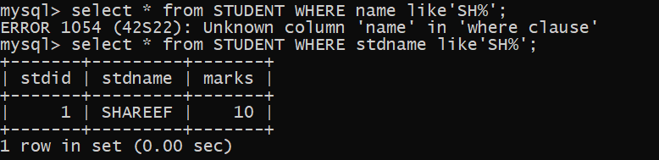

**6** **SELECT with various clause – GROUP BY, HAVING, ORDER BY**

Create table Project with the fields S_No, P_Name, Coordinators, P_Price, and Location. Select the rows in the table using Group by clause for Location. Select the rows in the table order by Coordinators.

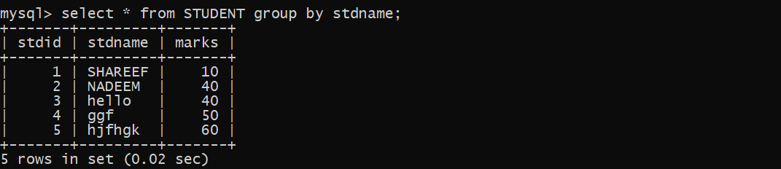

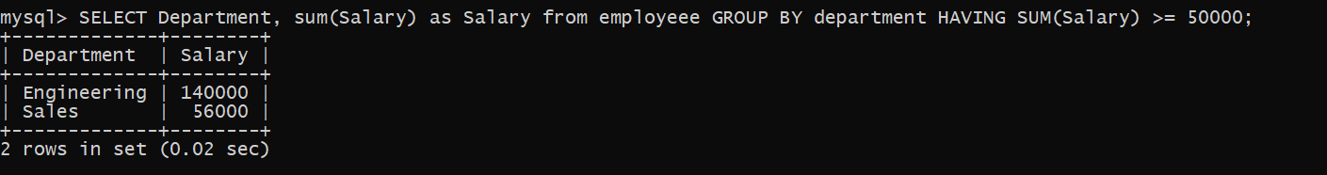

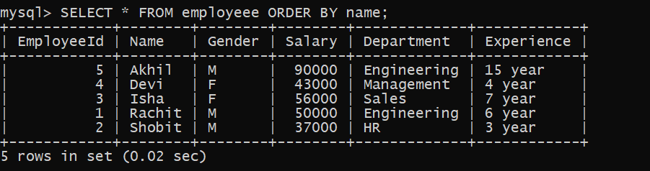

**7 Sub Query**

Create a Table Employee with fields S_No, name, Designation Branch. Select employee’s names whose designation is manager and working in the branch Chennai.

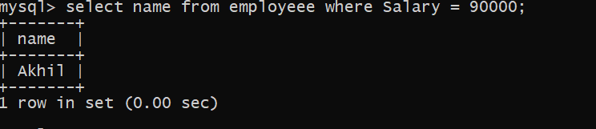

**8** **Indexing & View**

Create a view table with the same fields S_No, name, Designation, Branch in the Employee table and insert more records in the table.

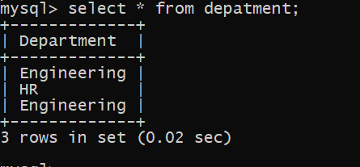

**9 Procedures and Functions**

Crearte a recursive MySQL computing the factorial of a given number using high level programing Extension with Functions.

Create a simple procedure to get all the records from the table ‘Employee’ and List out the name, department, salary where salary > 20000 in the Table.