CASE STUDY 2 [Medium Level Application]

Home Automation: -

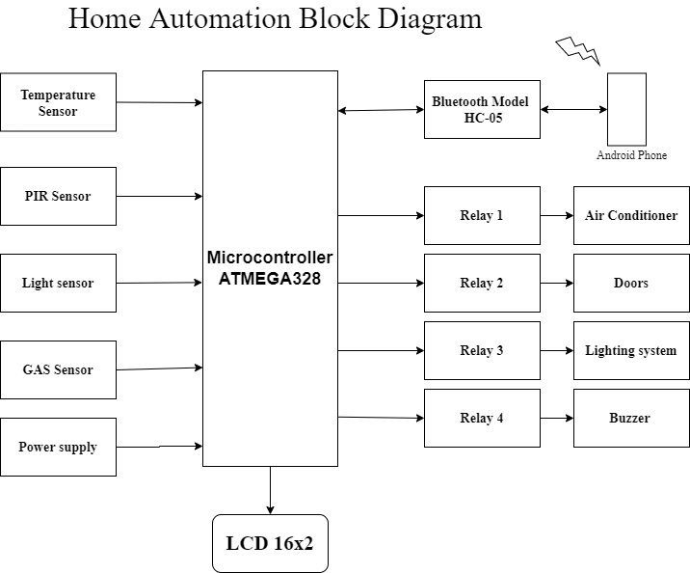

Explanation: -

1. Temperature Sensor: -

* Temperature sensors measure the atmospheric temperature and send the data to home automation system (Microcontroller).
* Home automation system which controls the heating, ventilation, and air conditioning (HV AC).

1. PIR Sensor: -

* A PIR Sensor is utilized to identify the infrared radiation from the warm object.
* As it comprises of sensor which start changes in their temperature (because of occurrence infrared radiation) into electric flag called PYRO ELECTRIC SENSORS.
* It produces an electric charge when infrared light strikes a gem.
* Like this, PIR Sensor recognize an encompassing attribute (Person) moving around roughly just inside 10m from the PIR Sensor.

1. Gas Sensor: -

* Gas sensor is a device which sense the presence of various gases within an area, usually as part of a safety system.
* This type of devices is used to detect a gas leak and interface with a microcontroller so a process can be automatically shut down.
* A gas sensor can also sound an alarm to operators in the area where the leak is occurring, giving them the opportunity to leave the area.

1. Light Sensor: -

* **Light intensity data can help you to automate your lighting system to switch it on or off.**
* **Switching off light automatically with your home automation system, where light intensity is high enough to see, will save energy.**
* **You can also create your own luminance data table and use it to automate your application to regulate when to switch lights on or off.**

1. **Relay: -**

* **Relays are a fundamental device for switching an electrical circuit on or off, much like a toggle switch or a limit switch.**
* **But a relay is operated based on an electrical control signal obtained from Sensors as opposed to a toggle switch that is operated by a microcontroller, or by equipment contact.**

1. **Bluetooth model: -**

* This module enables you to wireless transmit & receive serial data.
* It is a drop-in replacement for wired serial connections allowing transparent two-way data communication.
* You can simply use it for serial port replacement to establish connection between MCU

Requirements: -

High level requirements: -

|  |  |
| --- | --- |
| RID | Description |
| HLR_1 | To detect the Light intensity in the area and control it. |
| HLR_2 | To detect the atmospheric temperature in the area and control it. |
| HLR_3 | To detect any gas leak of toxic gases around area. |
| HLR_4 | To detect the motion of the object or peoples in the area. |
| HLR_5 | Remotely control the home automation from Mobile phone. |

Low level requirements: -

|  |  |
| --- | --- |
| RID | Description |
| LLR_1 | Light Sensor |
| LLR_2 | Temperature Sensor |
| LLR_3 | Gas Sensor |
| LLR_4 | PIR Sensor |
| LLR_5 | Bluetooth Model |
| LLR_6 | LCD Display |

# 