**SOEN6011 – SOFTWARE ENGINEERING PROCESS**

**Brief Description (Problem 1)**

Submitted by Aravind Ashoka Reddy(40103248) <https://github.com/ReddyAravindAru/SOEN6011_Calculator_Project>

**Function Assigned**: **Γ(x)**

The (complete) gamma function  Gamma(n)  is defined to be an extension of the factorial to complex and real number arguments. It is related to the factorial by

|  |
| --- |
| Gamma(n)=(n-1)!, |

{\displaystyle \Gamma (n)=(n-1)!\ .}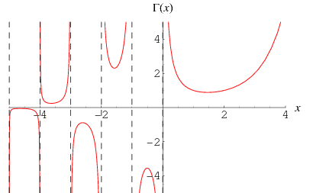

The gamma function is given by this integral for all positive xx. Then there exists an analytic function with domain C∖{0,−1,−2,…}, such that its restriction to positive axis coincides with the value of that integral.

* C/{n∈Z,n≤0}

Properties of the Gamma Function

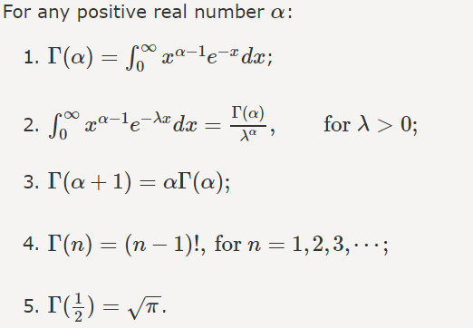

**References:**

<http://mathworld.wolfram.com/GammaFunction.html>

<https://www.probabilitycourse.com/chapter4/4_2_4_Gamma_distribution.php>

<https://math.stackexchange.com/questions/705103/what-is-the-domain-of-gamma-function>