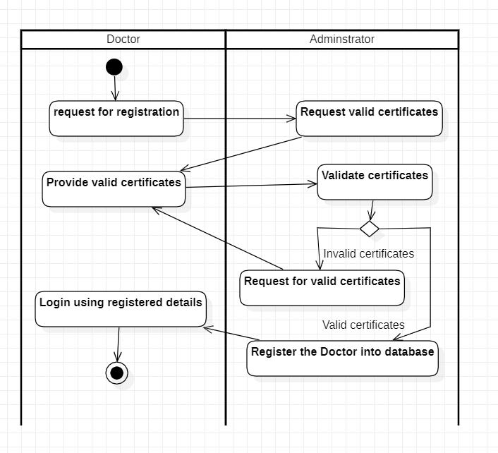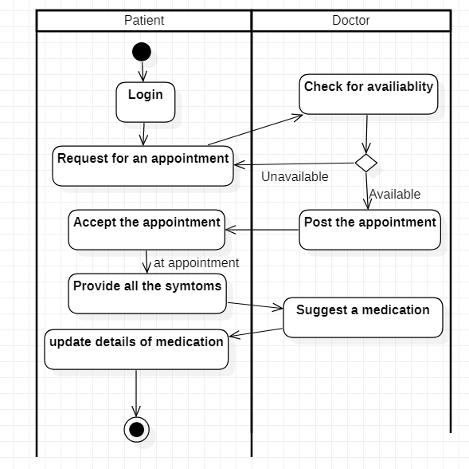

Activity Diagrams describe how activities are coordinated to provide a service which can be at different levels of abstraction. Typically, an event needs to be achieved by some operations, particularly where the operation is intended to achieve a number of different things that require coordination, or how the events in a single use case relate to one another, in particular, use cases where activities may overlap and require coordination. It is also suitable for modeling how a collection of use cases coordinate to represent business workflows.

(link) <https://www.visual-paradigm.com/guide/uml-unified-modeling-language/what-is-activity-diagram/>

The First diagram shows the step wise registration process of the doctor and provides our perspective regarding the procedure involved in validating various certificates of the doctor.

The second diagram shows the step wise communication between Patient and doctor, Patient first registers with the system, requests doctor for an appointment, Post the details of the symptoms and finally doctor suggests a possible medication for the symptoms.