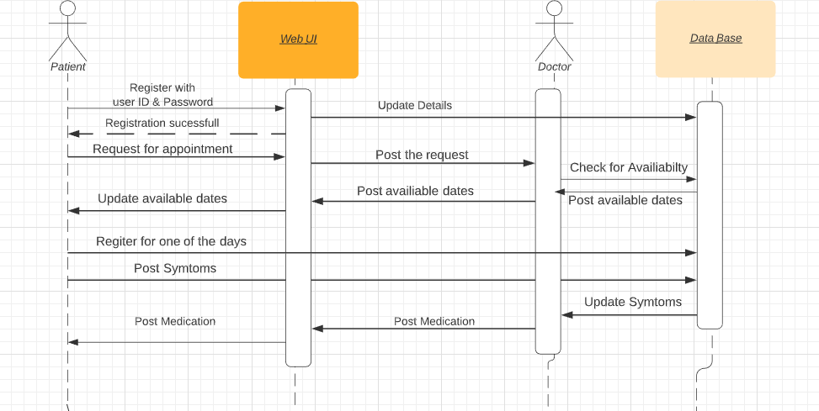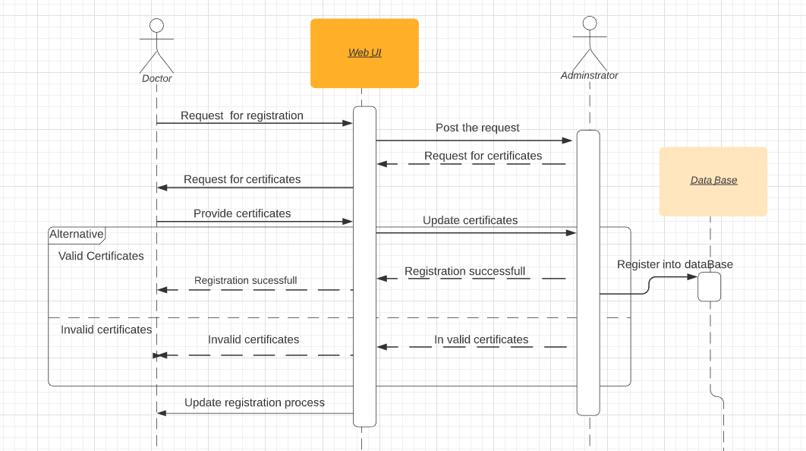

UML Sequence Diagrams are interaction diagrams that detail how operations are carried out. They capture the interaction between objects in the context of a collaboration. Sequence Diagrams are time focus and they show the order of the interaction visually by using the vertical axis of the diagram to represent time what messages are sent and when.

The first diagram shows the order of communication between Patient and doctor, Patient first registers with the system, requests doctor for an appointment, Post the details of the symptoms and finally doctor suggests a possible medication for the symptoms.

The second diagram shows the registration process of the doctor, Give a detail regarding the validation procedure, provides respective details regarding the procedure involved in the validation and verification of doctors.