Design and Implementation of a 5-Stage Pipelined RISC Processor using Verilog HDL

VAIDSYS TECHNOLOGIES

Chenga Reddy Bhargavi
National Institute of Technology Durgapur
02/06/2026

Abstract
This project presents the design and implementation of a 5-stage pipelined RISC(Reduced Instruction Set Computer) processor using Verilog HDL. The processor consists of Instruction Fetch (IF), Instruction Decode (ID), Execute (EX), Memory Access (MEM), and Write Back (WB) stages. Pipeline registers are inserted between stages to enable conurrent instruction execution. Hazard Detection and Forwarding Units are implemented to resolve data hazards and improve performance. The design was verified in Xilinx Vivado through behavioral simulation. Simulation results confirm correct execution of arithematic, multipliation, memory access, forwarding, and hazard handling operations.

Introduction
Modern processors improve performance using pipelining, where multiple instructions are executed simultaneously in different stages of execution.
Instead of completing one instruction before starting the next, pipelining divides instruction execution into stages, allowing higher throughput and efficient hardware utilization.
This project implements a simplified RISC architecture with:
- 8-bit data width
- 16-bit instruction width
- 8 general-purpose registers
- Five-stage pipeline
- Data hazard detection
- Data forwarding
- ALU operations
- Multiplication support
- Data memory access
- Register write-back

Problem Statement
Design and implement a 5-stage pipelined RISC processor in Verilog HDL capable of:
- Fetching instructions from instruction memory
- Decoding instruction fields
- Performing arithmetic and logical operations
- Accessing data memory
- Writing results back to registers
- Handling pipeline hazards using forwarding and stalling mechanisms
The processor should be simulated and verified using Vivado.

Objectives
The main objectives of this project are:
- Design a pipelined processor architecture
- Implement pipeline registers
- Implement ALU and Multiplier modules
- Design Register File and Memory modules
- Implement Hazard Detection Unit
- Implement Forwarding Unit
- Verify correct processor operation through simulation
- Analyze pipeline behavior using waveforms

Module Description :
1.Program Counter (pc.v) :
The Program Counter (PC) stores the address of the next instruction to be executed. It is updated on every positive clock edge when pc_write is enabled. During reset, the PC is initialized to zero. The PC provides the address for instruction fetching from Instruction Memory.

2.Instruction Memory (instr_mem.v) :
Instruction Memory stores the machine code program. It receives the address from the Program Counter and outputs the corresponding 16-bit instruction. The instructions are initialized using the program1.mem file.

3. Instruction Decoder (instr_decoder.v) :
The Instruction Decoder extracts various instruction fields such as opcode, source registers, destination register, and memory address from the 16-bit instruction format. These fields are used by subsequent stages of the processor.
4.Control Unit (control_unit.v) :
The Control Unit generates control signals based on the instruction opcode. These signals determine whether the processor performs arithmetic operations, memory access, register updates, or program termination.
5.Register File (register_file.v) :
The Register File consists of eight 8-bit general-purpose registers. It supports two simultaneous read operations and one write operation. Register values are updated during the Write-Back stage.
6.Arithematic Logic Unit (alu.v) :
The ALU performs arithmetic and comparison operations based on the instruction opcode. In this processor, the ALU supports addition, subtraction, and comparison operations.
7.Multiplier (multiplier.v) :
The Multiplier performs multiplication of two 8-bit operands. It operates in parallel with the ALU and is selected when a multiplication instruction is decoded.
8.Forwarding Unit (forwarding_unit.v) :
The Forwarding Unit resolves Read-After-Write (RAW) hazards by forwarding results from later pipeline stages directly to the ALU inputs. This minimizes pipeline stalls and improves performance.
9.Hazard Detection Unit (hazard_detection.v) :
The Hazard Detection Unit identifies load-use hazards in the pipeline. When a dependency is detected, it temporarily stalls the Program Counter and IF/ID register to prevent incorrect execution.
10.IF/ID Pipeline Register (if_id.v) :
The IF/ID pipeline register separates the Instruction Fetch and Instruction Decode stages. It stores the fetched instruction and corresponding PC value for one clock cycle before forwarding them to the decode stage.

11.ID/EX Pipeline Register (id_ex.v) :
The ID/EX pipeline register stores decoded operands, control signals, source registers, destination register, and memory address information. It transfers this information from the Decode stage to the Execute stage.
12.EX/MEM Pipeline Register (ex_mem.v) :
The EX/MEM pipeline register stores execution results and memory-related control signals. It transfers data from the Execute stage to the Memory stage.
13.MEM/WB Pipeline Register (mem_wb.v) :
The MEM/WB pipeline register stores ALU results and memory data before they are written back into the Register File. It forms the final stage of the pipeline.
14.Data Memory (data_mem.v) :
Data Memory stores application data used during program execution. It supports both read and write operations for load and store instructions.
15.Top Module (risc_processor.v) :
The risc_processor module integrates all processor components including the pipeline stages, pipeline registers, forwarding unit, hazard detection unit, ALU, multiplier, and memories. It represents the complete 5-stage pipelined RISC processor.
Chapter 1: Processor Architecture
1.1 Overall Processor Architecture
Schematics
This schematics diagram shows the RTL architecture of the proposed 5-stage pipelined RISC processor. The processor consists of a Program Counter, Instruction Memory, Register File, Control Unit, ALU, Multiplier, Data Memory, Hazard Detection Unit, Forwarding Unit, and four pipeline registers (IF/ID, ID/EX, EX/MEM, MEM/WB). The architecture supports concurrent execution of multiple instructions through pipelining while resolving data hazards using forwarding and stalling mechanisms.

1.2 Pipeline Stages
The processor follows a standard five-stage pipeline.
1.2.1 Instruction Fetch (IF)
The Program Counter stores the address of the next instruction to be fetched from instruction memory. It increments on every clock cycle when pc_write is enabled.
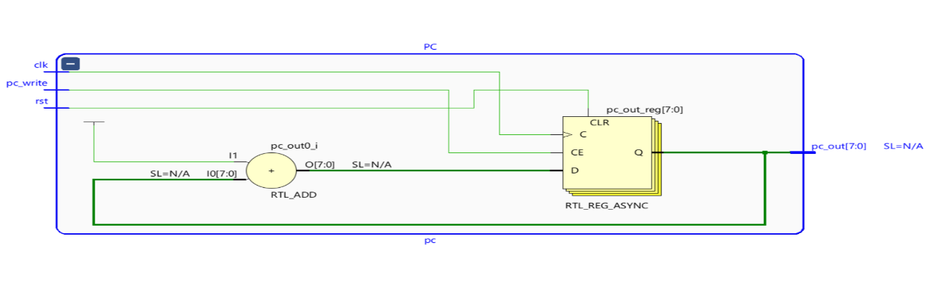
Signal Description of PC :
Signal |  |  |  |  |  | Type |  |  |  |  |  | Description
clk |  |  |  |  |  | Input |  |  |  |  |  | System clock signal
rst |  |  |  |  |  | Input |  |  |  |  |  | Resets PC to 0
pc_write |  |  |  |  |  | Input |  |  |  |  |  | Enables PC update
pc_out[7:0] |  |  |  |  |  | Output |  |  |  |  |  | Current instruction address

Instruction Memory stores the program instructions and provides the instruction corresponding to the address generated by the Program Counter.S
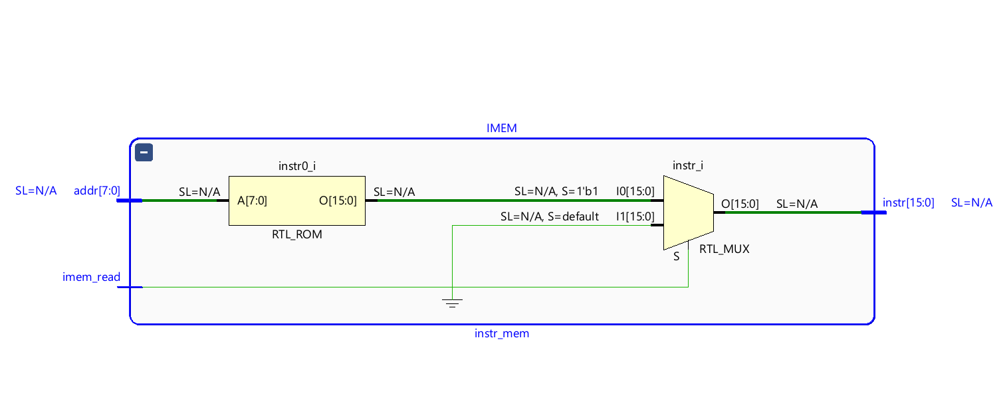
Signal Description of Instruction Memory
Signal |  |  |  |  |  | Type |  |  |  | Description
imem_read |  |  |  |  |  | Input |  |  |  | Enables instruction memory read
addr[7:0] |  |  |  |  |  | Input |  |  |  | Address from Program Counter
instr[15:0] |  |  |  |  |  | Output |  |  |  | Instruction fetched from memory
The IF/ID pipeline register stores fetched instructions and the corresponding PC value before they enter the Decode stage.
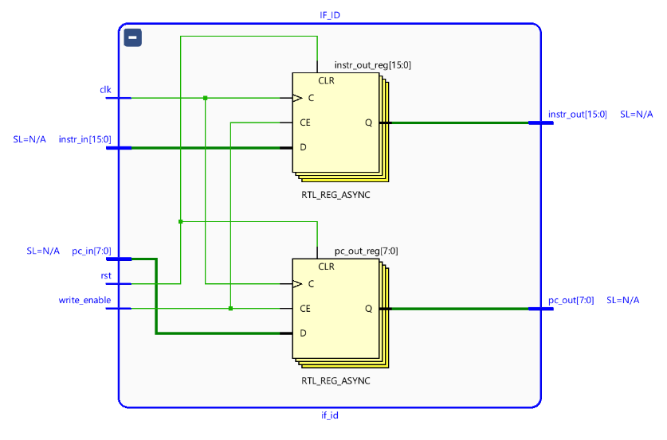
Signal Description of IF/ID pipeline register :
Signal |  |  |  |  |  | Type |  |  |  |  |  |  | Description
clk |  |  |  |  |  | Input |  |  |  |  |  |  | System clock
rst |  |  |  |  |  | Input |  |  |  |  |  |  | Reset signal
write_enable |  |  |  |  |  | Input |  |  |  |  |  |  | Enables register update
pc_in[7:0] |  |  |  |  |  | Input |  |  |  |  |  |  | PC value from IF stage
instr_in[15:0] |  |  |  |  |  | Input |  |  |  |  |  |  | Instruction from memory
pc_out[7:0] |  |  |  |  |  | Output |  |  |  |  |  |  | Stored PC value
instr_out[15:0] |  |  |  |  |  | Output |  |  |  |  |  |  | Stored instruction

1.2.2 Instruction Decode (ID)
The Instruction Decoder extracts opcode, source registers, destination register, and memory address fields from the fetched instruction.
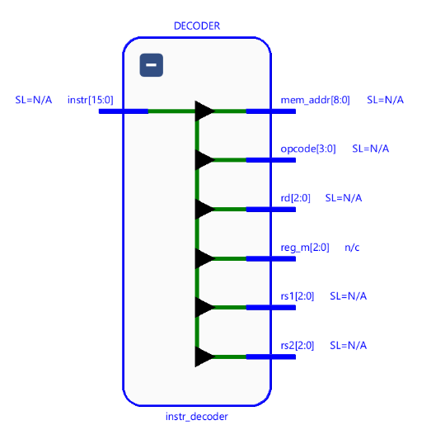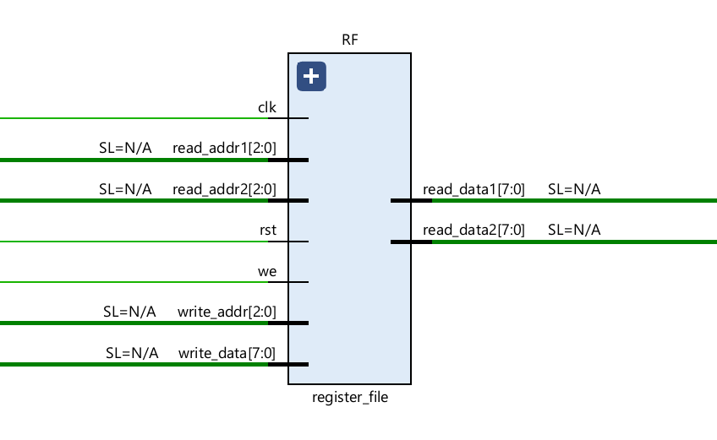
Signal Description of Instruction Decode (ID) :
Signal |  |  |  | Type |  |  |  | Description
instr[15:0] |  |  |  | Input |  |  |  | Input instruction
opcode[3:0] |  |  |  | Output |  |  |  | Operation code
rd[2:0] |  |  |  | Output |  |  |  | Destination register
rs1[2:0] |  |  |  | Output |  |  |  | Source register 1
rs2[2:0] |  |  |  | Output |  |  |  | Source register 2
mem_addr[8:0] |  |  |  | Output |  |  |  | Memory address field

The Register File contains eight 8-bit general-purpose registers and supports two simultaneous reads and one write operation.
Signal Description of Register File :
Signal |  |  |  | Type |  |  |  | Description
clk |  |  |  | Input |  |  |  | Clock signal
rst |  |  |  | Input |  |  |  | Resets all registers
we |  |  |  | Input |  |  |  | Write enable
read_addr1[2:0] |  |  |  | Input |  |  |  | First source register
read_addr2[2:0] |  |  |  | Input |  |  |  | Second source register
write_addr[2:0] |  |  |  | Input |  |  |  | Destination register
write_data[7:0] |  |  |  | Input |  |  |  | Data to be written
read_data1[7:0] |  |  |  | Output |  |  |  | Data from source register 1
read_data2[7:0] |  |  |  | Output |  |  |  | Data from source register 2

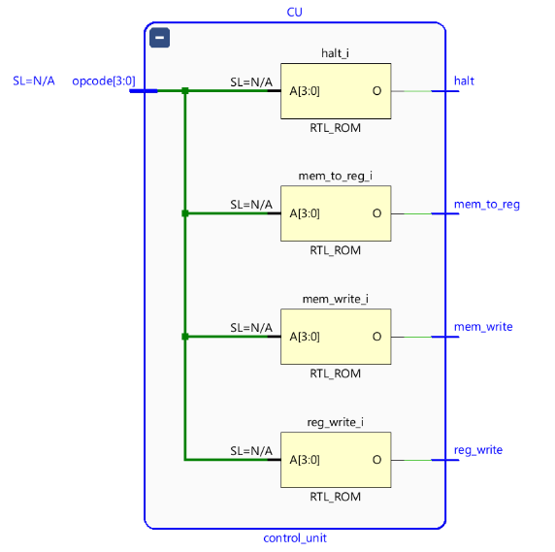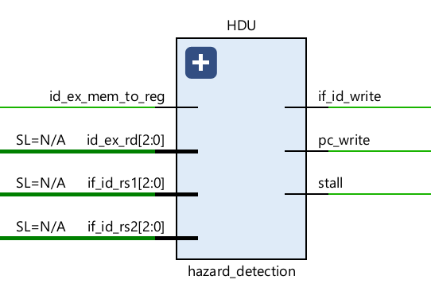

Signal Description of Control Unit :
Signal |  | Type |  | Description
opcode[3:0] |  | Input |  | Instruction opcode
reg_write |  | Output |  | Register write enable
mem_write |  | Output |  | Memory write enable
mem_to_reg |  | Output |  | Select memory data for write-back
halt |  | Output |  | Stops processor execution
The Hazard Detection Unit detects load-use hazards and temporarily stalls the pipeline to avoid incorrect execution.

Signal Description of Hazard Detection Unit :
Signal |  |  |  |  | Type |  |  |  |  | Description
id_ex_mem_to_reg |  |  |  |  | Input |  |  |  |  | Load instruction indicator
id_ex_rd[2:0] |  |  |  |  | Input |  |  |  |  | Destination register in EX stage
if_id_rs1[2:0] |  |  |  |  | Input |  |  |  |  | Source register 1 in ID stage
if_id_rs2[2:0] |  |  |  |  | Input |  |  |  |  | Source register 2 in ID stage
pc_write |  |  |  |  | Output |  |  |  |  | Controls PC update
if_id_write |  |  |  |  | Output |  |  |  |  | Controls IF/ID update
stall |  |  |  |  | Output |  |  |  |  | Pipeline stall signal

1.2.3 Execute (EX)
The Arithmetic Logic Unit performs arithmetic and comparison operations.
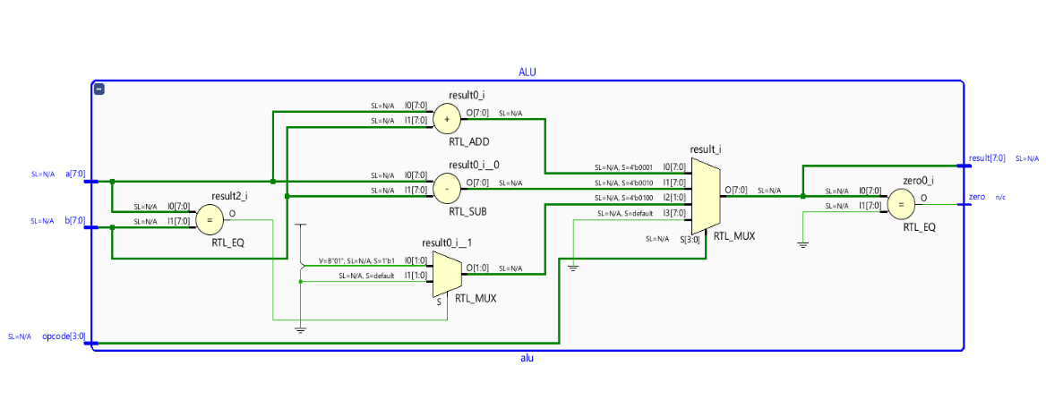
Signal Description of ALU :
Signal |  |  |  |  |  | Type |  |  |  |  |  | Description
a[7:0] |  |  |  |  |  | Input |  |  |  |  |  | Operand A
b[7:0] |  |  |  |  |  | Input |  |  |  |  |  | Operand B
opcode[3:0] |  |  |  |  |  | Input |  |  |  |  |  | Operation selection
result[7:0] |  |  |  |  |  | Output |  |  |  |  |  | ALU result
zero |  |  |  |  |  | Output |  |  |  |  |  | Indicates zero result

The Forwarding Unit resolves data hazards by forwarding data from later pipeline stages directly to the ALU inputs.

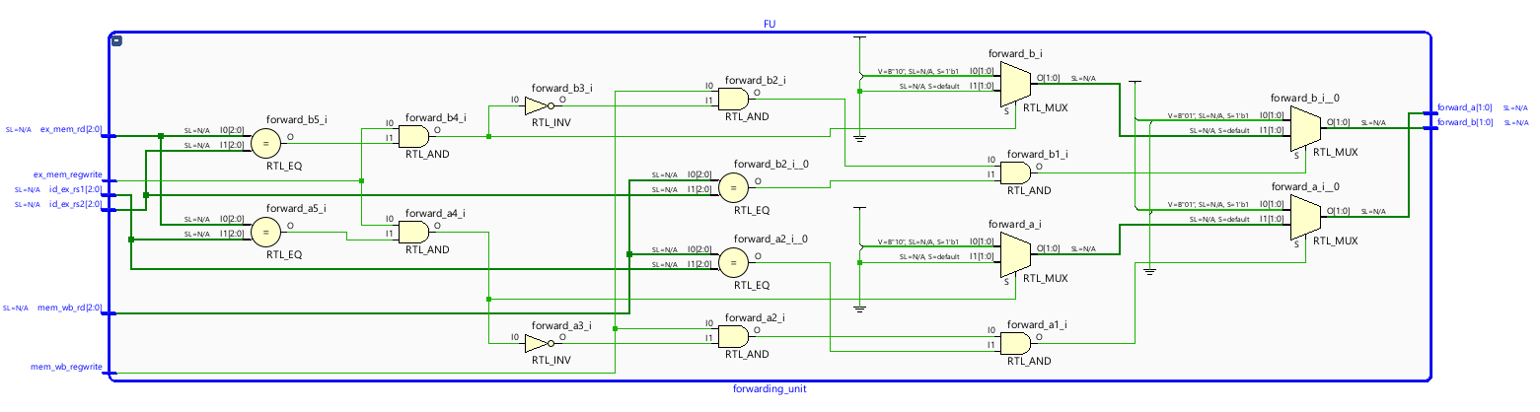
Signal Description of Forwarding Unit :
Signal |  |  |  |  |  | Type |  |  |  |  |  | Description
ex_mem_regwrite |  |  |  |  |  | Input |  |  |  |  |  | EX/MEM register write enable
mem_wb_regwrite |  |  |  |  |  | Input |  |  |  |  |  | MEM/WB register write enable
ex_mem_rd[2:0] |  |  |  |  |  | Input |  |  |  |  |  | Destination register from EX/MEM
mem_wb_rd[2:0] |  |  |  |  |  | Input |  |  |  |  |  | Destination register from MEM/WB
id_ex_rs1[2:0] |  |  |  |  |  | Input |  |  |  |  |  | Source register 1
id_ex_rs2[2:0] |  |  |  |  |  | Input |  |  |  |  |  | Source register 2
forward_a[1:0] |  |  |  |  |  | Output |  |  |  |  |  | Forward control for ALU input A
forward_b[1:0] |  |  |  |  |  | Output |  |  |  |  |  | Forward control for ALU input B

The Multiplier performs multiplication of two 8-bit operands.
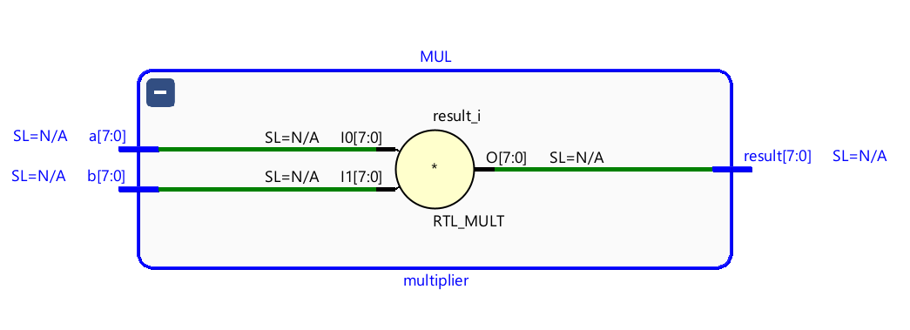

Signal Description of Multiplier :
Signal |  |  |  |  |  | Type |  |  |  |  |  | Description
a[7:0] |  |  |  |  |  | Input |  |  |  |  |  | Operand A
b[7:0] |  |  |  |  |  | Input |  |  |  |  |  | Operand B
result[7:0] |  |  |  |  |  | Output |  |  |  |  |  | Multiplication result

1.2.4 Memory Access (MEM)
Data Memory stores and retrieves data during load and store operations.
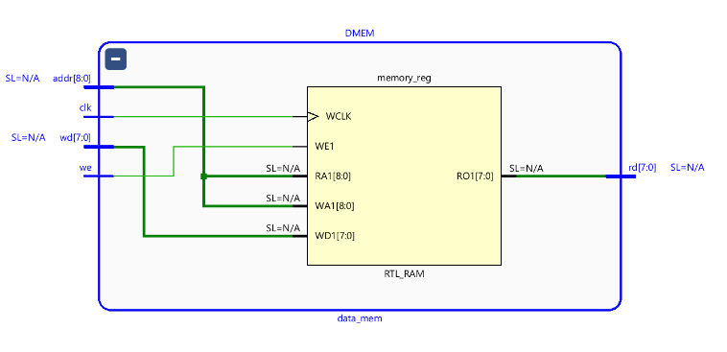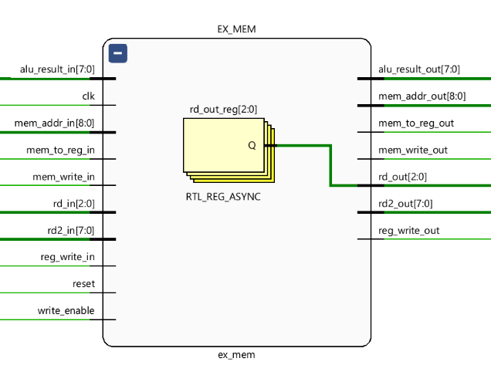
Signal Description of Data Memory :
Signal |  |  |  |  |  | Type |  |  |  |  |  | Description
clk |  |  |  |  |  | Input |  |  |  |  |  | Clock signal
we |  |  |  |  |  | Input |  |  |  |  |  | Write enable
addr[8:0] |  |  |  |  |  | Input |  |  |  |  |  | Memory address
wd[7:0] |  |  |  |  |  | Input |  |  |  |  |  | Data to write
rd[7:0] |  |  |  |  |  | Output |  |  |  |  |  | Data read from memory
Signal Description of EX/MEM Pipeline Register :
Signal |  |  |  |  |  |  |  | Description
alu_result |  |  |  |  |  |  |  | ALU output
rd2 |  |  |  |  |  |  |  | Data for store instruction
mem_addr |  |  |  |  |  |  |  | Memory address
reg_write |  |  |  |  |  |  |  | Register write control
mem_write |  |  |  |  |  |  |  | Memory write control
mem_to_reg |  |  |  |  |  |  |  | Memory read selection

1.2.5 Write Back (WB)
MEM/WB Pipeline Register stores memory and ALU results before write-back.
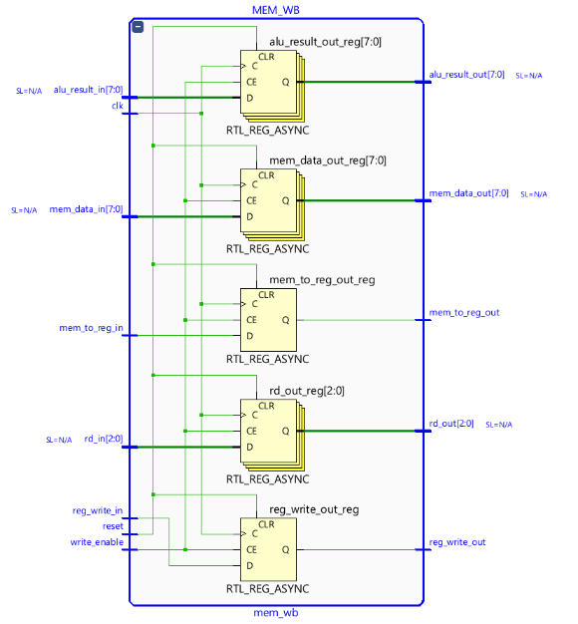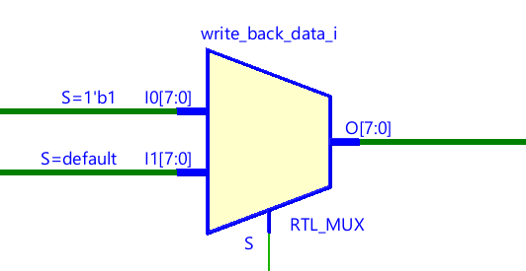
Signal Description of MEM/WB Pipeline Register :
Signal |  |  |  |  |  |  | Description
mem_data |  |  |  |  |  |  | Memory output
alu_result |  |  |  |  |  |  | ALU result
rd |  |  |  |  |  |  | Destination register
reg_write |  |  |  |  |  |  | Register write enable
mem_to_reg |  |  |  |  |  |  | Write-back selection

Instruction Format :
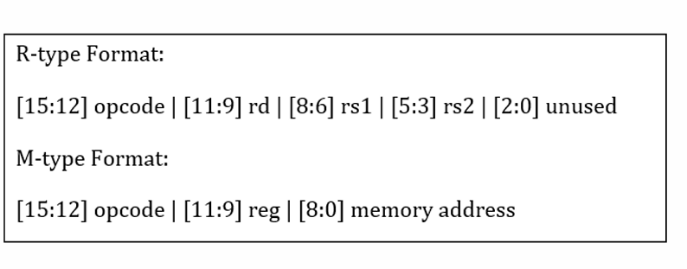

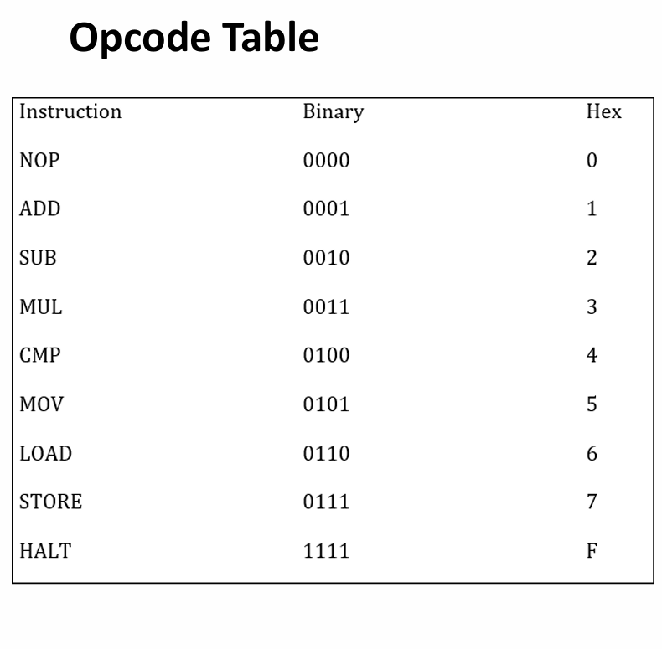
Assembly Program :
Instruction |  |  |  |  |  |  |  |  |  |  |  | Meaning
LOAD R1, [10] |  |  |  |  |  |  |  |  |  |  |  | Load memory[10] into R1
LOAD R2, [11] |  |  |  |  |  |  |  |  |  |  |  | Load memory[11] into R2
ADD R3, R1, R2 |  |  |  |  |  |  |  |  |  |  |  | R3 = R1 + R2
SUB R4, R1, R2 |  |  |  |  |  |  |  |  |  |  |  | R4 = R1 - R2
MUL R5, R3, R2 |  |  |  |  |  |  |  |  |  |  |  | R5 = R3 × R2
STORE R5, [20] |  |  |  |  |  |  |  |  |  |  |  | Store R5 into memory[20]
CMP R0, R3, R4 |  |  |  |  |  |  |  |  |  |  |  | Compare values
HALT |  |  |  |  |  |  |  |  |  |  |  | Stop execution
Instruction Encoding :
R-type Instruction format :
|15:12 |11:9|8:6 |5:3| 2:0|
|Opcode| RD |RS1|RS2|XXX|
M-type instruction format :
|15:12 |11:9| 8:0 |
|Opcode| reg |Memory Address|
Example-1:
ADD R3,R1,R2 – R type Instruction format
Opcode = 0001
RD = 011
RS1 = 001
RS2 = 010
Unused = 000
Binary:
0001 011 001 010 000
Hex:
1650
Example -2 :
LOAD R1,[10] – M type Instruction format
Opcode = 0110
RD = 001
Address= 000001010
Binary:
0110 001 000001010
Hex:
620A
Verification and Simulation :
Simulation performed using:
- Vivado 2024.2
- Behavioral Simulation
Signals monitored:
- PC
- Instruction
- Opcode
- Register values
- ALU result
- Memory data
- Forwarding signals
- Hazard signals

Problems Faced and Solutions :
Problem |  |  |  |  |  | Root Cause |  |  |  |  |  | Solution
Incorrect ALU output |  |  |  |  |  | Missing forwarding |  |  |  |  |  | Added forwarding logic
Hazard after LOAD |  |  |  |  |  | Data unavailable |  |  |  |  |  | Added stall mechanism
X values after 100ns |  |  |  |  |  | Instruction memory overflow |  |  |  |  |  | Added HALT instruction
MUL result incorrect |  |  |  |  |  | Wrong source selection |  |  |  |  |  | Fixed forwarding path
Register write issue |  |  |  |  |  | WB control signal mismatch |  |  |  |  |  | Corrected MEM/WB logic

Simulation Results :
Memory File Instruction | Operation
620A | LOAD R1, [10]
640B | LOAD R2, [11]
1650 | ADD R3, R1, R2
2850 | SUB R4, R1, R2
3AD0 | MUL R5, R3, R2
7A14 | STORE R5, [20]
40E0 | CMP R0, R3, R4
F000 | HALT

The waveform shown below corresponds to the execution of the above instruction sequence stored in program1.mem.

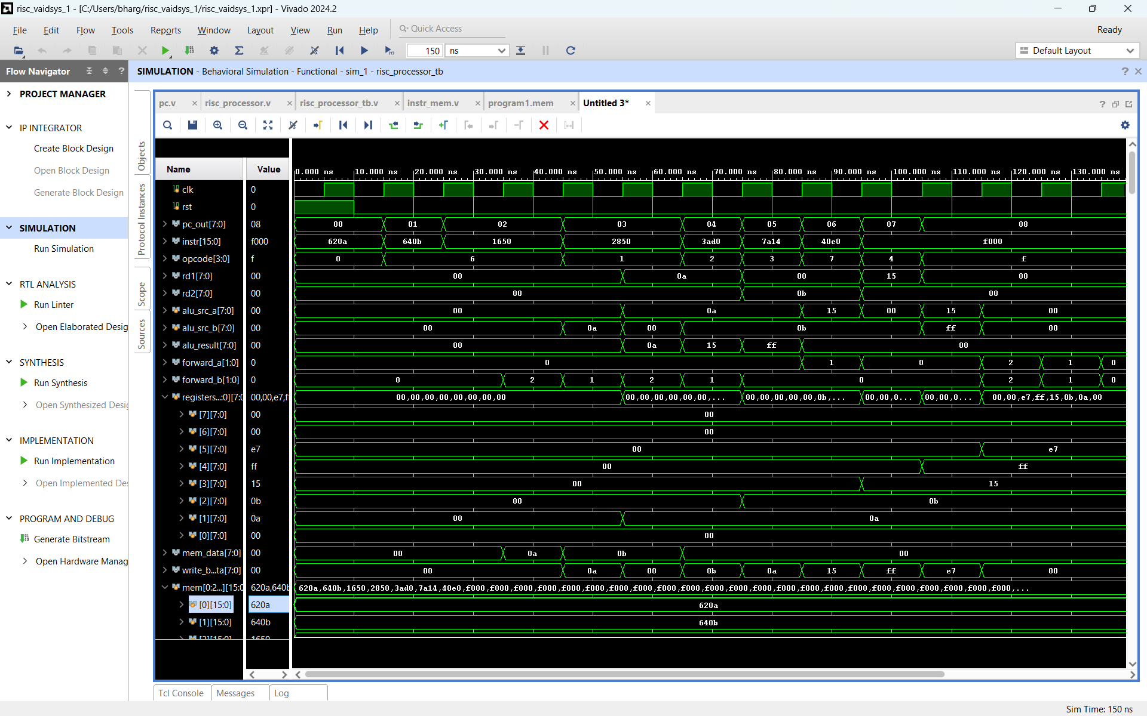
The simulation waveform represents the execution of the machine code program stored in the program1.mem file. During simulation, the Program Counter (PC) sequentially fetches instructions from Instruction Memory, and each instruction progresses through the five pipeline stages: Instruction Fetch (IF), Instruction Decode (ID), Execute (EX), Memory Access (MEM), and Write Back (WB).
The observed changes in opcode, register values, ALU results, memory addresses, and control signals directly correspond to the instructions encoded in the memory file. As the program executes, the processor performs load, arithmetic, multiplication, comparison, and store operations, resulting in the final register values:
R1 = 0A, R2 = 0B, R3 = 15, R4 = FF, and R5 = E7.
Therefore, the waveform serves as a verification of the correct execution of the program stored in Instruction Memory and confirms the proper functionality of the 5-stage pipelined RISC processor.

Conclusion :
A complete 5-stage pipelined RISC processor was successfully designed and implemented using Verilog HDL. Pipeline registers enabled concurrent instruction execution, while forwarding and hazard detection units resolved data dependencies. Functional verification using Vivado simulation confirmed correct processor operation, including arithmetic, multiplication, memory access, and write-back functionality.

