Claims Management System

Contents

Use Cases 3

Class Diagram 3

Sequence Diagram 3

Database Design 3

UI Screen 3

Login 3

Register 4

Login as Member 5

Raise Cliam Request………………………………………………………………………………………………………………6

Profile…………………………………………………………………………………………………………………………………...7

Claim Requests………………………………………………………………………………………………………………………8

Login as Admin…………………………………………………………………………………………………………………………………..9

Claims To be Processed………………………………………………………………………………………………………….10

Check Member Eligibility……………………………………………………………………………………………………….11

Profile…………………………………………………………………………………………………………………………………….12

List Claims………………………………………………………………………………………………………………………………13

Members Activation……………………………………………………………………………………………………………….14

# Use Cases

CMS_01: As a User, I should able to register as member or admin.

CMS_02: As a User, I should able to Login as admin without any authentication.

CMS_03: As a User, I should able to Login as member whenever admin provides status as accepted.

CMS_04: As a Member, I should able to raise a claim request.

CMS_05: As a Member, I should able to update my profile.

CMS_06: As a Member, I should able to see all claim requests raised by me.

CMS_07: As an Admin, I should able to provide access of application to the members.

CMS_08: As an Admin, I should able to process the claims raised by the members.

CMS_09: As an Admin, I should able to access the check member eligibility for processing the claims.

CMS_10: As an Admin, I should able to see the all claims raised by every member.

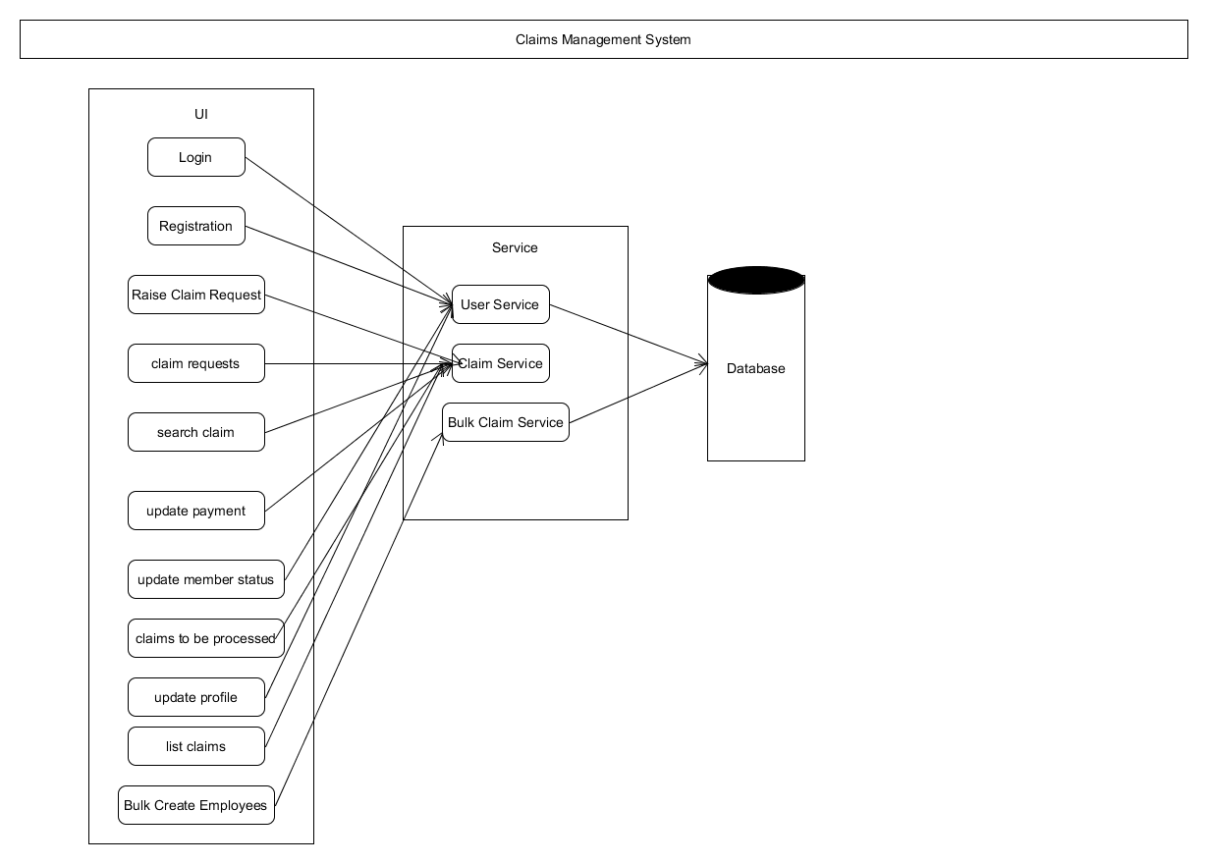

# Class Diagram

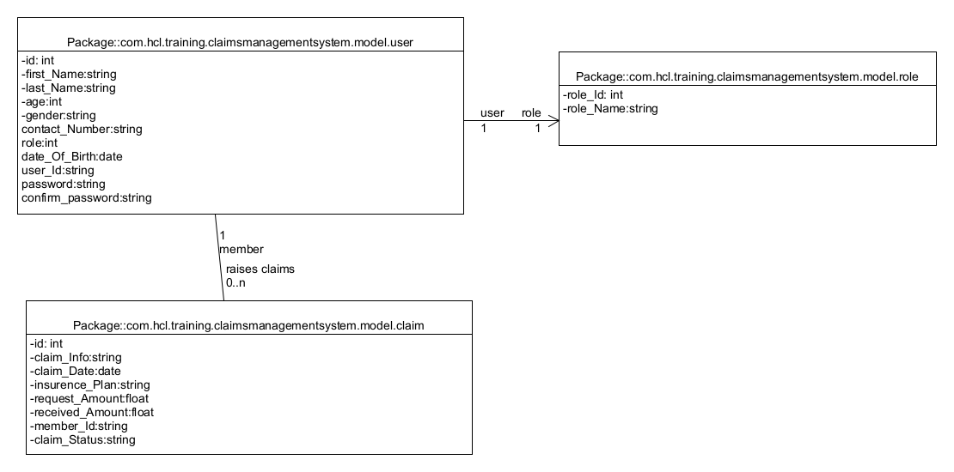

Sequential Diagrams

## Registration or Claim Request

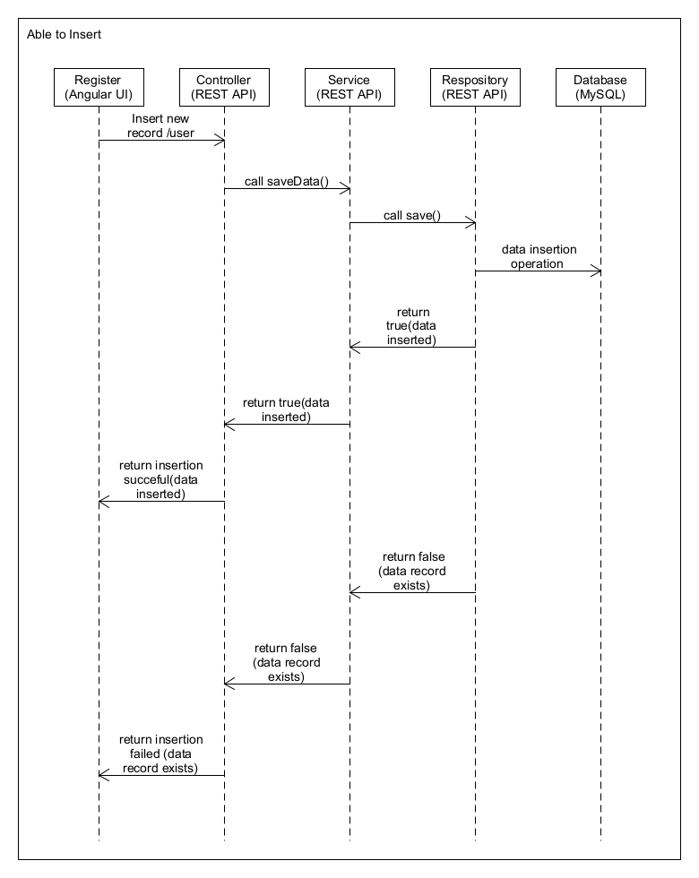

# Login

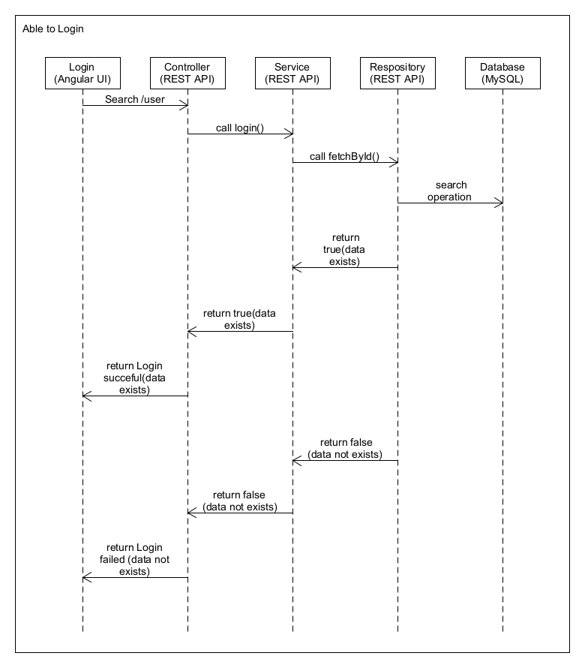

## List Data

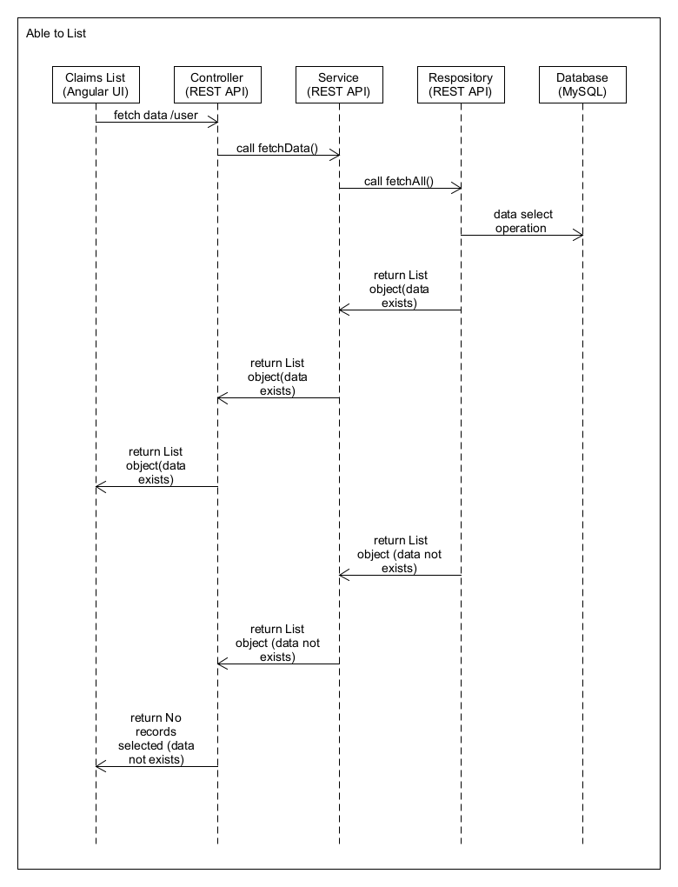

## Update Status

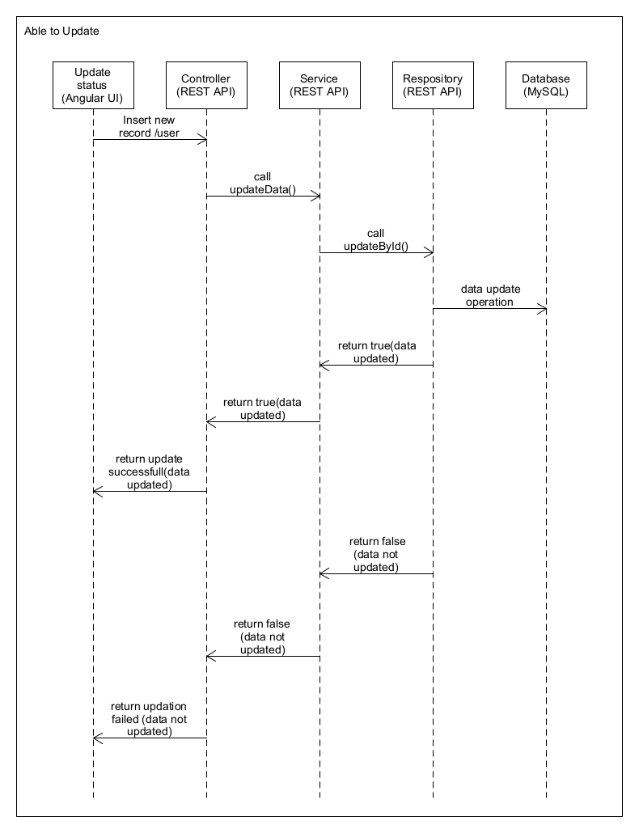

# Database Design

## Role

|  |  |  |
| --- | --- | --- |
| **Column Name** | **Data Type** | **Constraints** |
| ROLEID | Int | Primary key |
| ROLENAME | Varchar(10) | Not null |

### Sample Data

|  |  |
| --- | --- |
| ROLEID | ROLENAME |
| 1 | MEMBER |
| 2 | ADMIN |

USER

|  |  |  |
| --- | --- | --- |
| **Column Name** | **Data Type** | **Constraints** |
| ID | Int | Primary key |
| FIRST_NAME | Varchar(20) | Not null |
| LAST_NAME | Varchar(20) | Not null |
| AGE | Int | Not null |
| GENDER | Varchar(5) | Not Null |
| CONTACT_NUMBER | Varchar(10) | Not Null |
| ROLE | Int | Not Null |
| DATE_OF_BIRTH | Date | Not Null |
| USER_ID | Varchar(20) | UNIQUE and Not null |
| PASSWORD | Varchar(15) | NOT NULL |

# Sample data

|  |  |  |  |  |  |  |  |  |  |  |
| --- | --- | --- | --- | --- | --- | --- | --- | --- | --- | --- |
| ID | FirstName | LastName | age | gender | ContactNumber | role | DateOfBirth | UserId | password | status |
| 1 | Reddy | Madhumitha | 22 | female | 987654321 | ROLE_ADMIN | 18/03/1999 | 51887645 | 123456 | approved |
| 2 | M | madhu | 35 | female | 99012345678 | ROLE_USER | 1/01/1981 | 1 | 123456 | pending |

Claim

|  |  |  |
| --- | --- | --- |
| **Column Name** | **Data Type** | **Constraints** |
| CLIAM_ID | Int | Primary key |
| CLAIM_INFO | Varchar(20) | Not null |
| REQUEST_AMOUNT | DOUBLE | Not null |
| RECEIVED_AMOUNT | DOUBLE | Not null |
| CLAIM_DATE | Date | Not Null |
| INSURANCE_PLAN | Varchar(30) | Not Null |
| MEMBER_ID | Varchar(20) | Not Null |
| STATUS | Varchar(10) | Not Null |

Sample Data

|  |  |  |  |  |  |  |  |
| --- | --- | --- | --- | --- | --- | --- | --- |
| ClaimId | ClaimInfo | RequestAmount | ReceivedAmount | Claimdatw | InsurancePlan | MemberId | Status |
| 1 | Due to accident | 25000 | 0 | 11/12/2020 | Lifetime | 1 | pending |
| 2 | Due to earthquake | 30000 | 0 | 10/12/2020 | business | 1 | pending |

# UI Screens

## Login

Welcome To Claims Management System

Login

<User Id>

<password>

Login

Reset

Java Mode 2 HCL Training – Final Case Study

New User? SignUp

## Login - Error1(If fields are empty)

Welcome To Claims Management System

Login

<User Id>

<password>

Login

Reset

Java Mode 2 HCL Training – Final Case Study

New User? SignUp

Please enter user Id

Please enter password

# UI Screens

## Home Page

Welcome To Claims Management System

Home Page

Java Mode 2 HCL Training – Final Case Study

Register

Login

## 2.Registration Page

LastName

Age

Gender

ContactNumber

User ID

FirstName

Welcome To Claims Management System

Register

Enter Date

Date Of Birth

Reset

Register

Enter your Confirm Password

Choose role

Enter your FirstName

Enter your LastName

Enter your Age

Enter your Gender

Enter your Password

Enter your User Id

Enter your Contact Number

Role

Confirm Password

Password

Java Mode 2 HCL Training – Final Case Study

## 3.Registration-Error 1:(if userid already exists)

LastName

Gender

ContactNumber

User Id

FirstName

Welcome To Claims Management System

Register

Enter date of birth

Date of Birth

Java Mode 2 HCL Training – Final Case Study

Reset

Register

Please enter valid User Id

Enter your Confirm Password

Choose a Role

Enter your First Name

Enter your Last Name

Enter your Age

Enter your Gender

Enter your Password

Enter your user Id

Enter your Contact Number

Role

Confirm Password

Password

## 3.Registration-Error 2:(If Fields are missing)

LastName

Age

Gender

Contact Number

User Id

FirstName

Welcome To Claims Management System

Register

Enter Date

Enter Date

Date of Birth

Reset

Register

Java Mode 2 HCL Training – Final Case Study

Choose a role

Enter FirstName

Enter Confirm Password

Enter Password

Enter ContactNumber

Enter User Id

Enter Gender

Enter Age

Enter Last Name

Enter your Confirm Password

Choose a Role

Enter your FirstName

Enter your LastName

Enter your Age

Enter your Gender

Enter your Password

Enter your User Id

Enter your Contact Number

Role

Confirm Password

Password

## Registration Success-

Home

Login

Welcome To Claims Management System

Dear User! Your details are Successfully Submitted….

Java Mode 2 HCL Training – Final Case Study

## Login Success-As a admin, I am able to go to successful page and show the below details

Welcome To Claims Management System

Java Mode 2 HCL Training – Final Case Study

Madhumitha

Payment update

logout

Claims to be Processed

Members to be activated

Check Member Eligibility

Update Profile

List of Claims

## Members to be activated

Welcome To Claims Management System

Madhumitha

## Members to be activated

51887645

logout

Java Mode 2 HCL Training – Final Case Study

## Members to be activated

Welcome To Claims Management System

Back

Reset

Java Mode 2 HCL Training – Final Case Study

logout

Madhumitha

Update

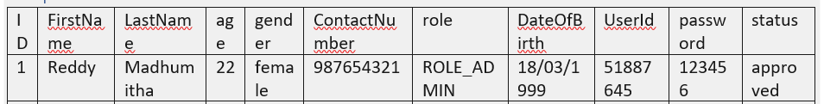

Members to be activated

## Members to be activated: - As a Admin, When Clicks on the Update button shows below details.

Welcome To Claims Management System

logout

Madhumitha

Java Mode 2 HCL Training – Final Case Study

Back

Dear Admin, your details are updated Successfully

Accepted

Status

User Id

51887645

## List of Claims.

Welcome To Claims Management System

Java Mode 2 HCL Training – Final Case Study

Back



logout

Madhumitha

Payment Status

## Claims to be Processed: As a Admin, When I click on Claims to be Processed shows below details.

Welcome To Claims Management System

logout

Madhumitha

Claims to be Processed

1

Java Mode 2 HCL Training – Final Case Study

## Claims to be Processed –As a Admin When I click on claim Id show the below details.

Welcome To Claims Management System

Update

logout

Madhumitha

Claims To Be Processed



Back

Java Mode 2 HCL Training – Final Case Study

## Update Profile- As a admin, I am able to Update my profile.

LastName

Age

Gender

ContactNumber

User Id

FirstName

Welcome To Claims Management System

logout

Madhumitha

Java Mode 2 HCL Training – Final Case Study

Back

Update

Update Profile

M

Madhu

21

Female

51887644

9012345678

## Update Profile Success- As a admin When I click on update, show the below details

Welcome To Claims Management System

Dear User! Your details are Updated Successfully

Java Mode 2 HCL Training – Final Case Study

logout

Dear Madhu

Back

## Check Member Eligibility: -As a Admin, When I click on Check Member Eligibility it shows below details.

Welcome To Claims Management System

#Claims Policy approved for natural causes

# Original Policy Certificate or government proof

Java Mode 2 HCL Training – Final Case Study

Dear Madhu

logout

Check Member Eligibility

Back

Login as User:

Welcome To Claims Management System

Java Mode 2 HCL Training – Final Case Study

logout

Dear Madhu

Claim Requests

Raise a claim request

Search claims and view Status

## Raise a Claim Request – As a User, When I raise a claim request below details are displayed

Claim Id

Welcome To Claims Management System

Enter insurance plan

Enter date

Insurance Plan

Claim Date

Reset

Back

Request

logout

Dear Madhu

Enter your Request Amount

Java Mode 2 HCL Training – Final Case Study

Request Amount

Enter your Claim Id

Enter your Claim Information

Claim Information

Raise Claim Request

## Update Profile- As a User, I am able search my claims.

Welcome To Claims Management System

logout

Dear Madhu

Search claims and view status

Search by claim

Back

search

Java Mode 2 HCL Training – Final Case Study

Claim Requests- As a User When I click on claim requests, it shows the claimid’s raised by me.

Java Mode 2 HCL Training – Final Case Study

1

Claim Requests

logout

Dear Madhavi

Welcome To Claims Management System