Claims Management System

Contents

Use Cases………………………………………………………………………………………………………………………………………….3

Class Diagram…………………………………………………………………………………………………………………………………….4

Sequence Diagram……………………………………………………………………………………………………………………………..4

Database Daigram……………………………………………………………………………………………………………………………..8

UI Screen……………………………………………………………………………………………………………………………………………9

Register……………………………………………………………………………………………………………………………………………10

Login…………………………………………………………………………………………………………………………………………………14

Login as a Admin……………………………………………………………………………………………………………………………….

Members Activation………………………………………………………………………………………………………………………….17

List Claims……………………………………………………………………………………………………………………………………..20

Claims To be Processed……………………………………………………………………………………………………………………21

Profile…………………………………………………………………………………………………………………………………………….24

Check Member Eligibility………………………………………………………………………………………………………………..25

Login as Member ……………………………………………………………………………………………………………………………...

Raise Claim Request…………………………………………………………………………………………………………………………..26

Claim Requests…………………………………………………………………………………………………………………………………27

Profile…………………………………………………………………………………………………………………………………...............29

# Use Cases

CMS_01: As a User, I will able to register as member or as a admin.

CMS_02: As a User, I will able to Login as admin without providing any authentication.

CMS_03: As a User, I will able to Login as a member whenever admin provides status as accepted.

CMS_04: As a Member, I will able to raise a claim request.

CMS_05: As a Member, I will able to update my profile.

CMS_06: As a Member, I will able to see all claim requests raised by me.

CMS_07: As an Admin, I will able to provide access of application to the members.

CMS_08: As an Admin, I will able to process the claims raised by the members.

CMS_09: As an Admin, I will able to access the check member eligibility for processing the claims.

CMS_10: As an Admin, I will able to see the all claims raised by every member.

# Class Diagram:

# 

# Sequential Diagrams

Registration or Claim Request

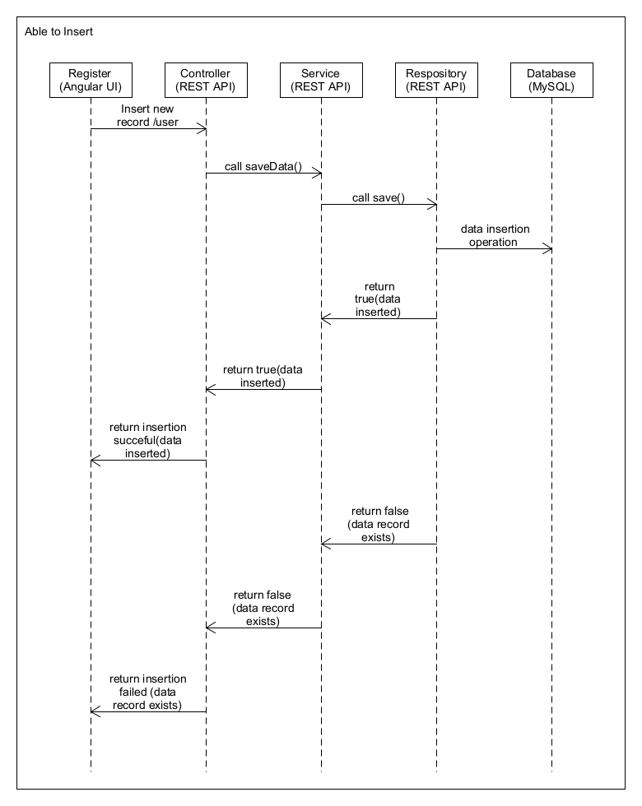

# Login

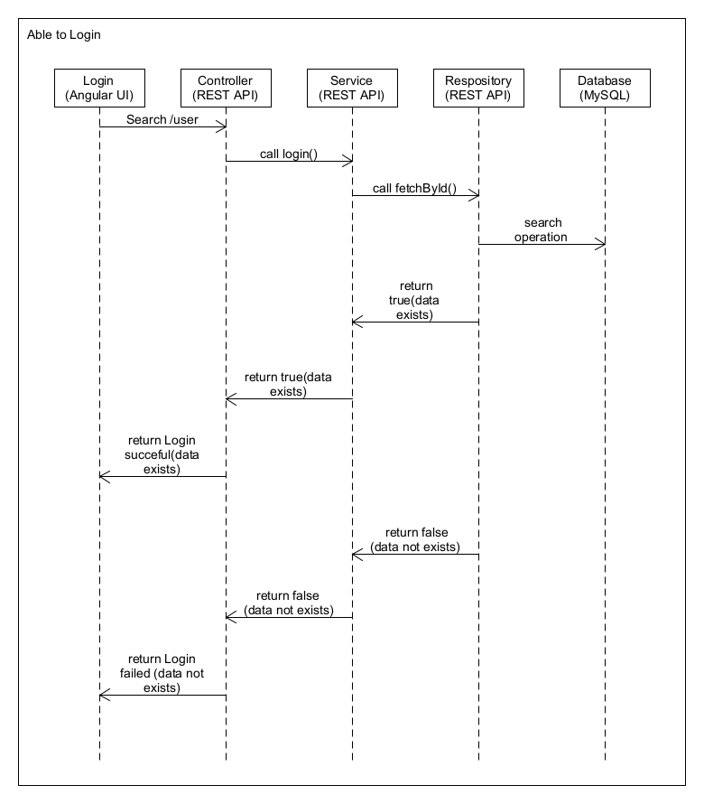

## List Data

# 

## Update Status

# 

# Database Design

## Role

|  |  |  |
| --- | --- | --- |
| **Column Name** | **Data Type** | **Constraints** |
| ROLEID | Integer | Primary key |
| ROLENAME | Varchar(10) | Not null |

### Sample Data

|  |  |
| --- | --- |
| ROLEID | ROLENAME |
| 1 | MEMBER |
| 2 | ADMIN |

# UI Screens

## Home Page

Register

Login

Welcome to Claims Management System

Welcome Page

Java Mode 2 HCL Training – Final Case Study

## 2.Registration Page

LastName

Age

Gender

ContactNumber

UserId

FirstName

Welcome to Claims Management System

Register

Choose your Role

Role

Enter your Date of Birth

Enter your ConfirmPassword

Enter your FirstName

Enter your LastName

Enter your Age

Enter your Gender

Enter your Password

Enter your User Id

Enter your Contact Number

Date of Birth

ConfirmPassword

Password

Register

Reset

Java Mode 2 HCL Training – Final Case Study

## 3.Registration-Error 1:(Missing the fields)

LastName

Age

Gender

ContactNumber

UserId

FirstName

Welcome to Claims Management System

Register

Date of Birth

Enter your Date of Birth

Role

Choose a Role

Java Mode 2 HCL Training – Final Case Study

Reset

Register

Please enter UserId

Enter your ConfirmPassword

Enter your FirstName

Enter your LastName

Enter your Age

Enter your Gender

Enter your Password

Enter your User Id

Enter your Contact Number

ConfirmPassword

Password

## 3.Registration-Error 2:(If Fields are Incorrect)

LastName

Age

Gender

ContactNumber

MemberId

FirstName

Welcome to Claims Management System

Register

Invalid Date of Birth

Date of Birth

Choose a Role

Role

Date of Birth

Java Mode 2 HCL Training – Final Case Study

Invalid FirstName

Reset

Register

Invalid ConfirmPassword

Invalid Password

Invalid ContactNumber

Invalid MemberId

Invalid Gender

Invalid Age

Invalid Last Name

Enter your ConfirmPassword

Enter your FirstName

Enter your LastName

Enter your Age

Enter your Gender

Enter your Password

Enter your Member Id

Enter your Contact Number

ConfirmPassword

Password

## Registration Success-

## Login-

Home

Login

Welcome to Claims Management System

Dear User! Your details are Successfully Submitted….

Java Mode 2 HCL Training – Final Case Study

Welcome to Claims Management System

Login

<UserId>

<password>

Login

Reset

Java Mode 2 HCL Training – Final Case Study

New User? SignUp

## Login-Error 2

Welcome to Claims Management System

Login

<UserId>

<password>

Login

Reset

Java Mode 2 HCL Training – Final Case Study

New User? SignUp

Incorrect

Please Enter Valid Credentials

## Register

After successful login below is the screen to be shown

## Login Success-As a admin, I am able to go to successful page and show the below details

Welcome to Claims Management System

Dear Admin! Your details are submitted successfully

Java Mode 2 HCL Training – Final Case Study

Claims to be Processed

Members to be activated

Check Member Eligibility

Update Profile

List of Claims

## Login Success-As a User, I am able to go to successful page and show the below details

Welcome to Claims Management System

Dear User! Your details are submitted successfully

Java Mode 2 HCL Training – Final Case Study

Update Profile

Claim Requests

Raise Claim Request

## Members to be activated-As a admin, When I click on Members to be activated shows the member ID link

Welcome to Claims Management System

Member Id

Java Mode 2 HCL Training – Final Case Study

## Members to be activated: - As a Admin, When Clicks on the( MemberId link) shows the below details.

LastName

Age

Gender

ContactNumber

UserId

FirstName

Welcome to Claims Management System

Date of Birth

22-10-1998

Members activated

Java Mode 2 HCL Training – Final Case Study

Reset

Update

**Madhumitha**

**Reddy**

**21**

**Female**

**Pending**

**51887645**

**9087654321**

Status

## Members to be activated: - As a Admin, When Clicks on the Update button shows below details.

Welcome to Claims Management System

Java Mode 2 HCL Training – Final Case Study

Back

Dear Admin, your details are updated Successfully

Accepted

Status

UserId

51887645

## List of Claims: As Admin, When I click on List of Claims below details are shown.

Claim Id

Welcome to Claims Management System

Enter the Claim Information

Claim Information

Java Mode 2 HCL Training – Final Case Study

Back

1

51887645

Member Id

List of Claims

## Claims to be Processed: As a Admin, When I click on Claims to be Processed shows below details.

Welcome to Claims Management System

Claim Id

Java Mode 2 HCL Training – Final Case Study

## Claims to be Processed –As a Admin When I click on claim Id show the below details.

Received Amount

Claim Id

Welcome to Claims Management System

1

Accepted

Status

Dear Admin, details are successfully submitted

125000

125000

Java Mode 2 HCL Training – Final Case Study

Request Amount

Back

Update

Claim Information

## Update Profile- As a admin, I am able to Update my profile.

LastName

Age

Gender

ContactNumber

UserId

FirstName

Welcome to Claims Management System

Java Mode 2 HCL Training – Final Case Study

Back

Update

Update Profile

Madhumitha

Reddy

23

Female

51887645

987654321

Date of Birth

22-10-1998

## Update Profile Success- As a admin When I click on update, show the below details

Welcome to Claims Management System

Dear User! Your details are Updated Successfully

Java Mode 2 HCL Training – Final Case Study

Back

## Check Member Eligibility: -As a Admin, When I click on Check Member Eligibility it shows below details.

Welcome to Claims Management System

#To Process the Claim, Age should be above 20 and below 65

#Claims Policy will not be given by the natural attacks.

# Original Policy Certificate should be there

Back

Java Mode 2 HCL Training – Final Case Study

## Raise a Claim Request – As a User, When I raise a claim request below details are displayed

Received Amount

Claim Id

Welcome to Claims Management System

Reset

0

Enter your Request Amount

Java Mode 2 HCL Training – Final Case Study

Request Amount

Back

Request

Enter your Claim Id

Enter your Claim Information

Claim Information

Raise Claim Request

## Claim Requests: As a User, When I click on Claim Request below details are submitted

## 

Received Amount

Claim Id

Welcome to Claims Management System

0

Enter your Request Amount

Java Mode 2 HCL Training – Final Case Study

Request Amount

Back

Enter your Claim Id

Enter your Claim Information

Claim Information

Claim Raised

## Update Profile- As a User, I am able to Update my profile.

LastName

Age

Gender

ContactNumber

UserId

FirstName

Welcome to Claims Management System

Java Mode 2 HCL Training – Final Case Study

Back

Update

Update Profile

Madhumitha

Reddy

23

Female

51887645

987654321

22-10-1998

Date of Birth

## Update Profile Success- As a User When I click on update, show the below details

Welcome to Claims Management System

Dear User! Your details are Updated Successfully

Java Mode 2 HCL Training – Final Case Study

Back