Library Management System

Contents

Use Cases 3

Class Diagram 3

Sequence Diagram 3

Database Design 3

UI Screen 3

Login 3

Register 4

Book Search (Initial) 5

Book Search (After Search) 6

# Use Cases

LMS_01: As a user, i should able to login to do the book search.

LMS_02: As a user, I should able to register myself into application.

LMS_03: As a user, after login I should able to enter the category to do the book search

# Class Diagram

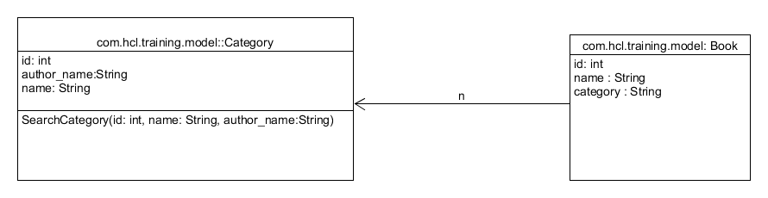

Sequence Diagram

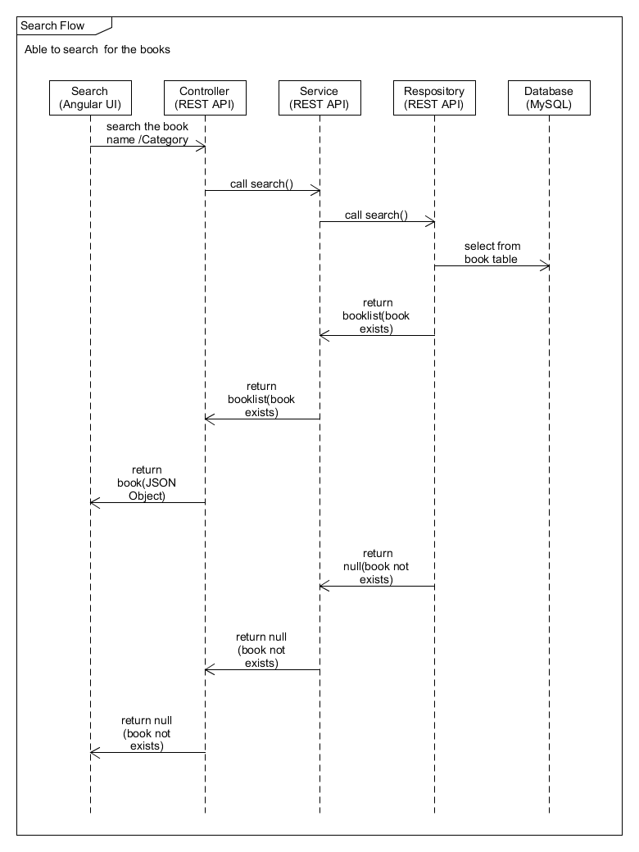

# Database Design

## Role

|  |  |  |
| --- | --- | --- |
| **Column Name** | **Data Type** | **Constraints** |
| ROLEID | Int | Primary key |
| ROLENAME | Varchar(10) | Not null |

### Sample Data

|  |  |
| --- | --- |
| ROLEID | ROLENAME |
| 1 | USER |
| 2 | ADMIN |
| 3 | LIBRAIAN |

# UI Screens

## Login

Welcome to Library Management System

Login

<Username>

<password>

Login

Reset

Java Mode 2 HCL Training – Final Case Study

New User? SignUp

## Login - Error1(If fields are empty)

Welcome to Library Management System

Login

<Username>

<password>

Login

Reset

Java Mode 2 HCL Training – Final Case Study

New User? SignUp

Please enter username

Please enter password

Login- Error2(if fields are incorrect)

Welcome to Library Management System

Login

<Username>

<password>

Login

Reset

Java Mode 2 HCL Training – Final Case Study

New User? SignUp

Invalid Password

Invalid username

## Register

After successful login below is the screen to be shown

Java Mode 2 HCL Training – Final Case Study

Reset

Register

Password

Confirm Password

School Name

Roll No

Class & Section

Username

Welcome to Library Management System

Register

## Book Search (Initial)

After successful login below is the screen to be shown

Welcome to Library Management System

Book Search

Search

Java Mode 2 HCL Training – Final Case Study

Category

Welcome Anbu

Logout

## Book Search (After Search)

Welcome to Library Management System

Book Search

Search

Java Mode 2 HCL Training – Final Case Study

Category

|  |  |  |
| --- | --- | --- |
| **Category** | **Book Title** | **Author** |
| Software | Java Programming Language | James |
| Electronic | Circuit Programming | CP |
| Electrical | Power Systems | PS |

Logout

Welcome Anbu