Setup first helm demo project

Step 1 : helm create demo

it will create helm tree structure
tree demo
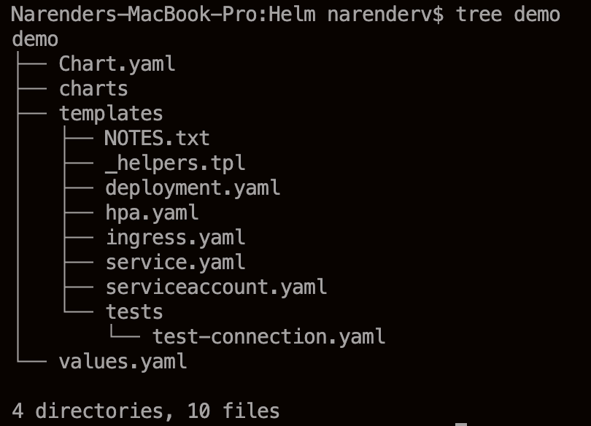

Step 2:
Now edit the image in values.yaml file by default helm will give nginx image replace with our own image i.e imagebuild7/react-frontend-dep

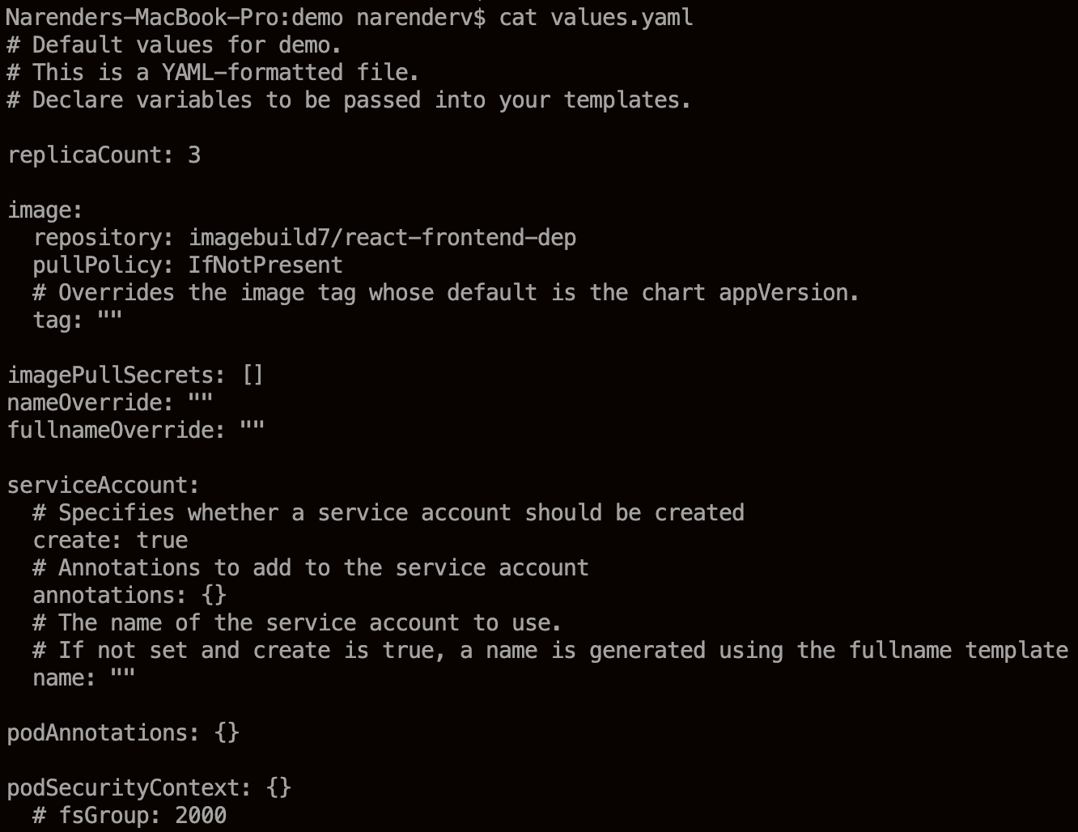
in above values yaml file we updated image details

Step 3 :
Now go to templete folder and edit deployment.yaml file and update few lines under spec image tag details which are not updated in values.yaml file so remove it from deployment.yaml

In the below image we can see only image called from values.image.repository not more tag and other details specified
image: "{{ .Values.image.repository }}"

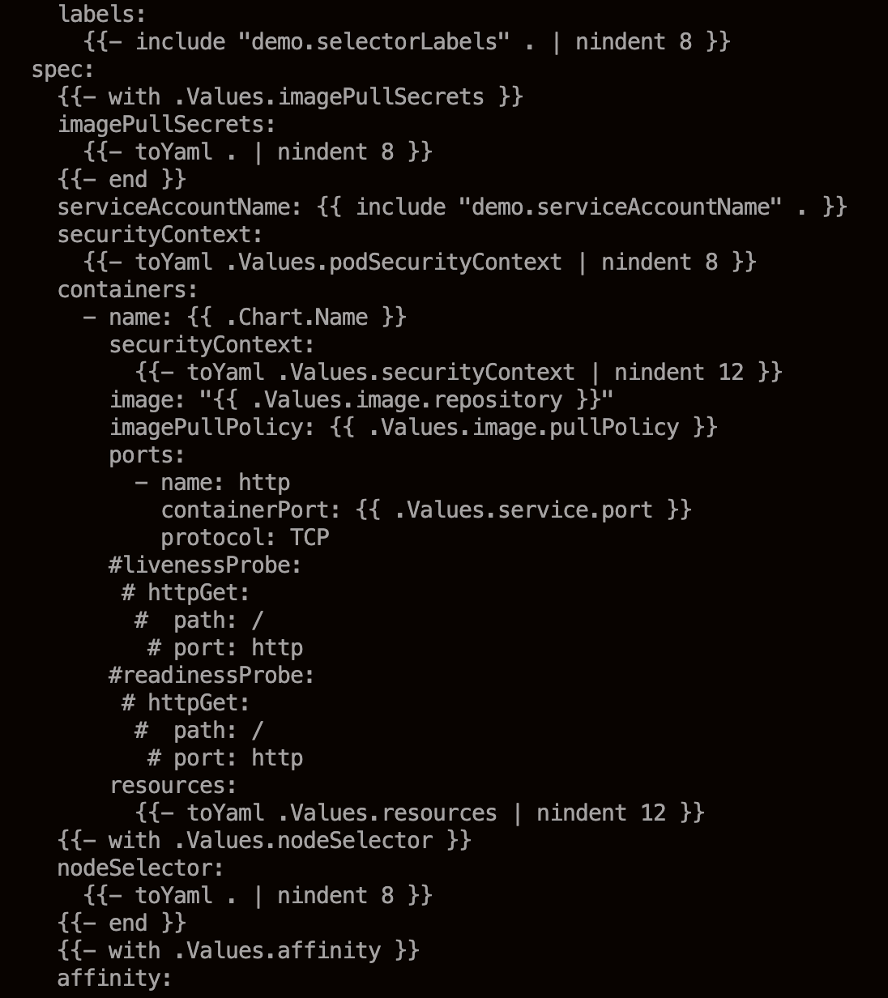
We can comment the livenessprobe & readinessProbe

Step 4 : to check the any syntax error or yaml errors we use Lint to check the project

helm lint demo

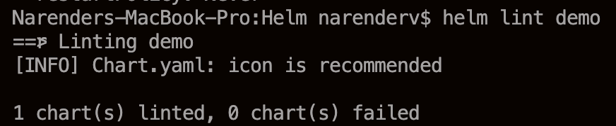
This is the output of the command it will suggest and give if any errors

Step 5:

Now we can check the temples using values.yaml file data to deploy pods
using
helm template demo
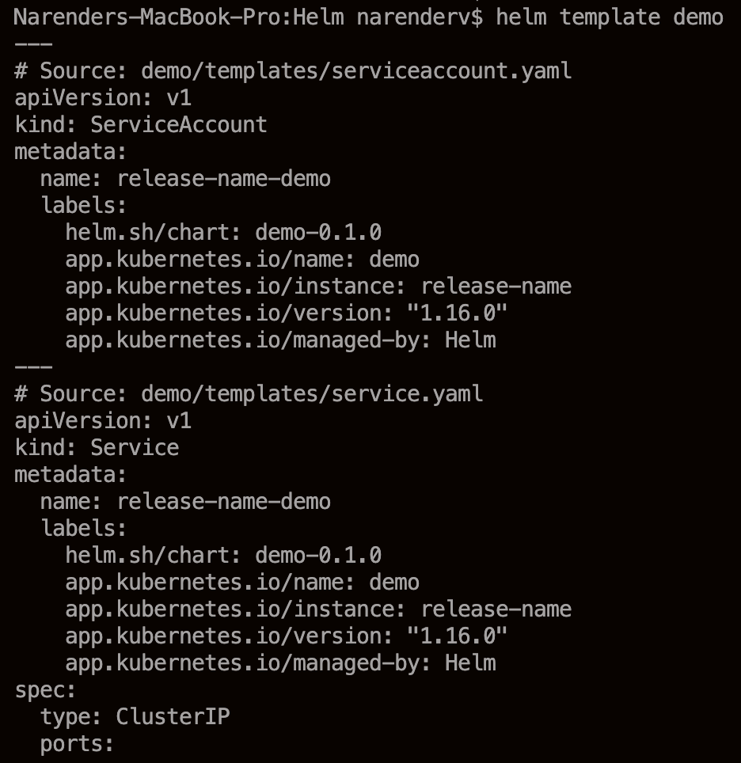
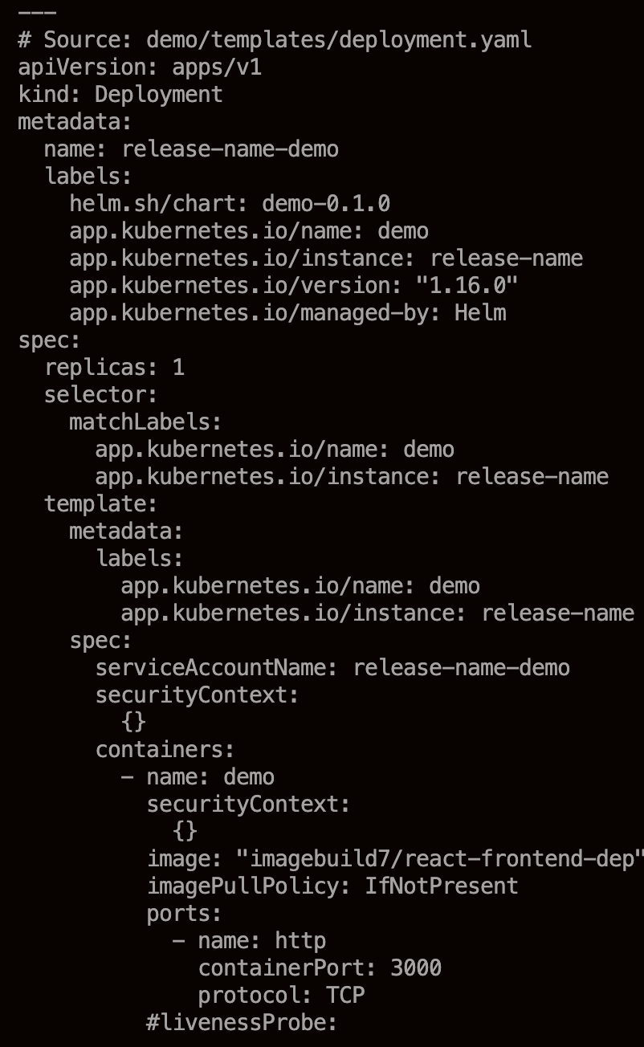
Now we can see the image pulling from external as shown above

Step 6:
another way we can test the image by running dry run on the chart
helm install react demo --dry-run
helm install react demo –dry-run

this will not run the deployment.yaml in k8s cluster

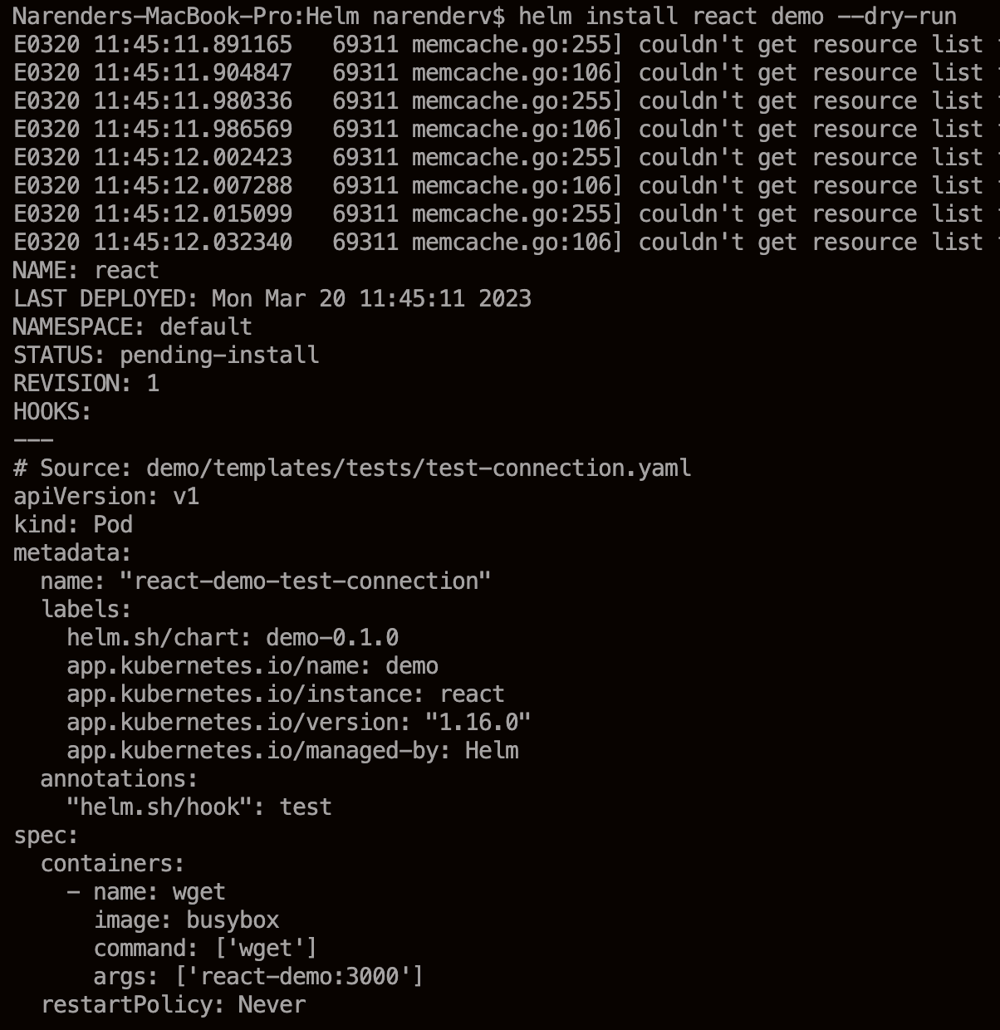
Now we can see the execution successfull or not buy using dry run with out deploying in k8s

step 7:

helm install react demo

this command will install deployment.yaml in k8s and

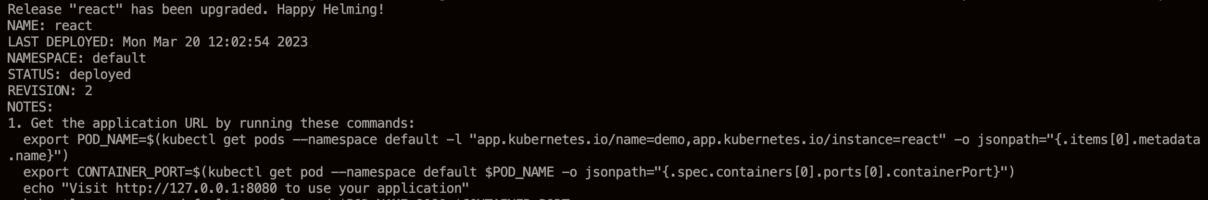
This is same as install .. above is for upgrade

now we can check it by kubectl get pods command or kubectl get all
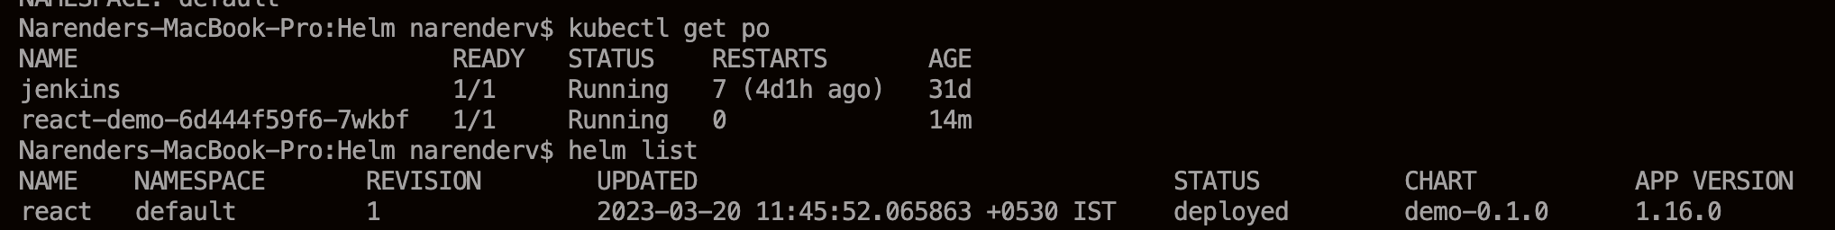
it will give pods details

we can check which releaase is up and running
helm list -a

step 8 : upgrade the helm deploment

helm upgrade react demo
note : if any changes in deployment we can do upgrade helm
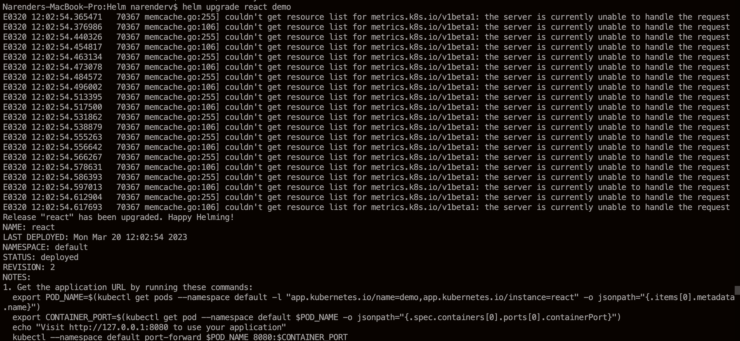
it will update the replica count

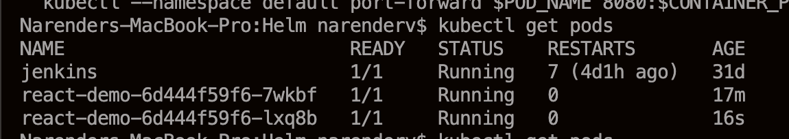
Now we can rollback to previous by using helm list command and identifying the revision number and applying it

helm rollback react 1
this will be rollback to previous state

step 9 :

We can delete the helm deployment in k8s by below command
helm delete react

this comman will delete all the deployment done by helm

