**EXPERIMENT – 1**

1. **Write a program to stimulate following CPU scheduling algorithms ?**

**a)FCFS b)SJF**

**a) First come first serve**

**AIM:- To write a program to stimulate following CPU scheduling algorithm.**

**Source code :**

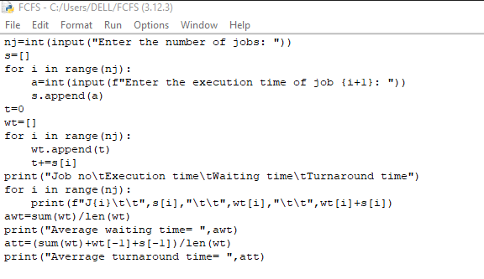

**OUTPUT :**

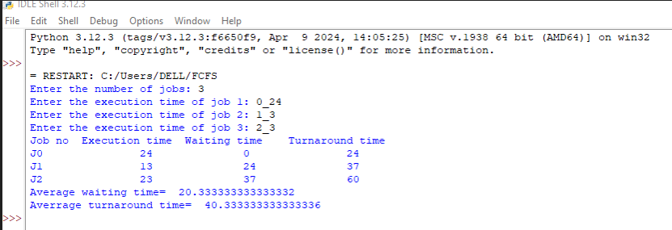

**CONCLUSION : To write a program to stimulate a following CPU scheduling algorithm is successfully executed.**

**b) shortest job first :-**

**AIM:- To write a program to stimulate a following CPU scheduling algorithm using SJF.**

**Source code:-**

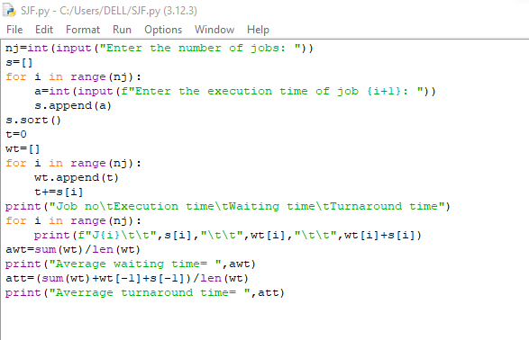**OUTPUT:-**

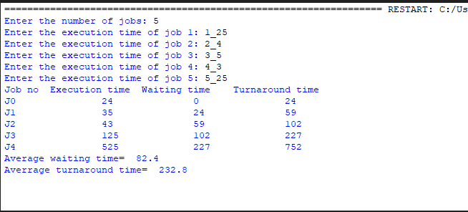

**CONCLUSION :- To write a program to stimulate following CPU scheduling algorithm using SJF successfully executed.**