Bloom
  - Small steps. Visible growth.
PROJECT ONE / ORIGINAL FLUTTER APP PROPOSAL / UNDERGRADUATE PATHWAY
Proposed topic adaptation: Habit Mastery League | Status: instructor approval pending | Draft date: October 18, 2026
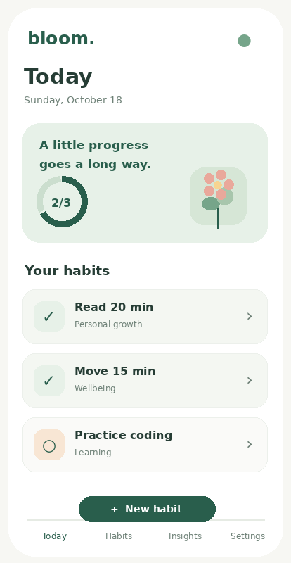
Concept UI only. The prototype screen above is a design mockup, not a built application.

Project idea
Bloom is a simple offline habit tracker for college students. Users create small daily habits, track progress toward each habit, save honest check-ins, and see a miniature garden grow as they complete their routines. The design avoids public rankings and pressure: one tap should tell the student what to do next.

What makes it distinctive without adding scope
Every completed check-in contributes to a calm “little garden” display. The garden is a lightweight visual representation of saved progress, not a separate game system. The app uses large cards, generous spacing, soft sage-green tones, clear progress visuals, and minimal navigation.

1. User stories and five screens
- As a student, I want to add a habit with a measurable daily target so I know exactly what I plan to do.
- As a student, I want to start, update, complete, or correct a daily check-in so my saved history is accurate.
- As a student, I want to review my weekly progress and optionally accept a suggested goal so the next week is manageable.
Screen | Purpose and interactions
Today / Dashboard | Habit cards, completion count, simple growing garden, weekly completion summary, open habit details; filter by category.
Create & Edit Habit | Form for name, category, unit, daily target, weekly frequency; slider for target when appropriate; validated Save.
Habit Detail / Activity | Start today’s check-in, update measurable progress, finish or reset; edit/delete habit; confirm destructive actions.
History & Insights | Calendar/list of saved check-ins; create/edit/delete a missed or incorrect entry; filter by habit; aggregate completed sessions and rate.
Settings | Default target, week start and reduced-motion setting; persist via SharedPreferences.

Sample user flow
Create “Read” with a 20-minute daily target → open today’s Read card → Start → move progress slider from 0 to 20 minutes → Finish → check-in is saved → dashboard progress updates → history remains after restarting the app.

Navigation & UI guidelines
Four bottom navigation tabs (Today, Habits, Insights, Settings) with Create/Edit accessible from Habits. The activity detail is reached from a habit card. Accessible contrast, readable text, obvious action buttons, polite confirmations, large tap targets and responsive portrait/landscape layouts are planned.

2. Data and workflow
Technology: Flutter + Dart, sqflite SQLite, shared_preferences; stateful interaction widgets and reusable stateless habit cards. No Firebase, cloud database, remote authentication, online syncing, or cloud AI.
Entity | Core columns | CRUD and validation
habits (parent) | id (PK), title, category, unit, daily_target, weekly_target, created_at, archived | Create, list/detail, edit and delete; nonempty unique-enough title per user; daily target >0; weekly goal 1–7; confirmation before delete.
check_ins (child) | id (PK), habit_id (FK), date, progress, status, note | Create, read, correct (update), delete; progress 0..daily_target; status started/in_progress/completed; note optional; no duplicate habit/date entry.
Relationship: one habit can have many check-ins. SQLite foreign keys are enabled; deleting a habit explicitly warns that its linked check-ins will also be deleted (ON DELETE CASCADE). Check-in deletion leaves the parent habit intact. Changes must remain after app restart.

State changes and integrity
Start creates or resumes a check-in for the selected day; update changes progress with the slider/stepper; Finish marks completion; Reset returns the current session to zero after confirmation, preserving history policies clearly. Only one active record per habit/day. Forms show friendly messages for empty names, out-of-range targets, duplicate check-ins and failed local saves.

Sample local records
Habit | Target | Example check-in
Read | 20 minutes/day; 4 days/week | Oct 18: 20 of 20 minutes, completed
Practice coding | 30 minutes/day; 3 days/week | Oct 18: 12 of 30 minutes, in progress
Walk | 15 minutes/day; 5 days/week | Oct 17: 15 of 15 minutes, completed

3. Required local smart helper
Name: Gentle Goal Suggestion. Question: Based on recent locally saved check-ins, what weekly completion target might be realistic for an individual habit? This is an explainable rule-based recommendation, not a trained AI model.
- Inputs: last 14 calendar days of completion data for one habit, current target, habit age, and valid check-in history.
- Method: if the habit has at least 7 tracked calendar days, count completed days during a full 14-day window, divide by 2, round to the nearest whole weekly day and clamp to 1–7. A newly created habit receives a “not enough history yet” message.
- Baseline: always suggest 3 days per week. Compare the baseline and history-based suggestion on the same small, separately prepared example cases.
- Explain and control: display “You completed 8 of the last 14 days; try 4 days/week.” Show Apply and Not now; never change the saved target until the user explicitly confirms Save.
- Data boundary: helper runs in Dart on-device only; no API calls and no claims about health outcomes or predictive accuracy.

Evaluation plan
Case | Expected behavior
Typical valid history | 8/14 completed → suggest 4 days/week and give reason.
No data / new habit | No fabricated suggestion; explain more history is needed.
Invalid input | Reject corrupt values and do not change stored goal.
Boundary and tie | Clamp within 1–7; define rounding and handle 0 completed days.
Counterexample | Show a week with unusual travel/exams where recent history may be misleading; user can ignore.
For numeric evaluation, withhold several synthetic examples with a following-week outcome; report mean absolute error in days/week for the proposed suggestion and fixed 3-day baseline. Show sample size and limitations in AI_FEATURE.md. Do not claim these small tests prove general accuracy.

Approval request
Please approve Bloom as a scoped adaptation of the Habit Mastery League topic. We will wait for approval before implementing; real board evidence, repository information and signatures must be completed by the team.

4. Testing, collaboration and milestones

Verification plan
- Validate both tables’ Create, Read, Update and Delete operations, including cascade delete and confirmation.
- Test empty form, invalid target, duplicate check-in, missing history, complete session and reset flow.
- Confirm records and settings survive app termination/restart, airplane mode, portrait/landscape and two Android devices/emulators.
- Run a short peer usability test, revise one confusing UI element and save before/after evidence.
- Demonstrate helper input → explanation → Apply/Not now; compare it to the baseline and log the five required case types.

Project team and coordination (fill in real details)
Item | Required entry
Team / group number | [ADD GROUP NUMBER AND TEAM NAME]
Members / roles | [ADD ALL MEMBERS, ROLE OWNERS AND UNDERGRAD/GRAD PATHWAYS]
New GitHub repo URL | [INSERT REAL NEW-REPOSITORY URL]
ClickUp board URL | [INSERT REAL SHARED BOARD LINK]
Dated proposal board snapshot | [INSERT GENUINE OCT 17 SCREENSHOT IF IT EXISTS; OTHERWISE DISCLOSE MISSING EVIDENCE]
Instructor decision | [APPROVAL STATUS, DATE, AND INSTRUCTOR FEEDBACK]
ClickUp statuses: Backlog → Ready → In progress (WIP one task/member) → Review/test (WIP two team tasks) → Done. Each card has an owner, acceptance criteria, due date, and links to authentic GitHub changes/tests. Members make 20 or more steady, meaningful commits each using reviewed branches/PRs. Do not backdate screenshots or invent commits.

Timeline (Eastern Time)
Date | Planned evidence
Oct 17 | Proposal due 11:59 PM; now past. Contact instructor about late submission; approval gate still applies.
Oct 20 | After approval: UI/navigation and end-to-end local data slice; actual board snapshot.
Oct 23 | After approval: both entities’ CRUD, helper, activity, settings; actual board snapshot.
Oct 24–25 | Two-device/offline/restart testing, usability revision, helper report.
Oct 26–27 | 20–25 minute demo, questions selection, evidence/ZIP/APK, individual iCollege upload by Oct 27 11:59 PM.

5. Annotated UI wireframes
These are design mockups only. Each represents a required screen role: dashboard, create/edit, activity detail, history/insights, and settings. The minimal botanical motif is driven by progress already saved in SQLite.


