Activity 11 — Ghost Hunt
Het Jani and Rohan Reddy | MAD4360 | Undergraduate track
Het’s AI-assisted contribution, integrated with Rohan’s published starting point. Evidence date: October 29, 2026, America/New_York.
Repository: https://github.com/ReddyR1105/mad4360-activity11
Branch: het/screens-and-evidence

C. Navigation
Navigator.push retains WelcomeScreen beneath SignupScreen, so Back from an unfinished form returns to the foyer. After validation and the two-second loading period, pushReplacement removes the submitted form and places SuccessScreen above the same foyer; using push instead would leave the submitted form underneath success. The new widget test completed two submission cycles using Demo Het and Ghost and verified that Back returned to the foyer without reopening SignupScreen. The test advances bounded animation frames and a final disposal frame rather than waiting for all confetti particles to settle. This is actual automated widget evidence, not a claim of student manual device testing.
Actual stack, repeated twice:
[Welcome] → push → [Welcome, Signup] → pushReplacement → [Welcome, Success] → Back → [Welcome]
If push were used instead:
[Welcome, Signup] → push → [Welcome, Signup, Success] → Back → [Welcome, Signup]
A later submission from that retained form would expose the old form again on Back.
Artifacts: test/het_navigation_test.dart; evidence/het/integrated-tests.log; test/het_capture_test.dart; the five real widget-rendered screenshots below.
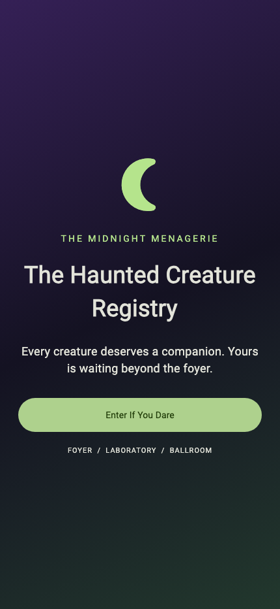
widget-01-welcome.png — actual Flutter widget-test rendering of the integrated app.
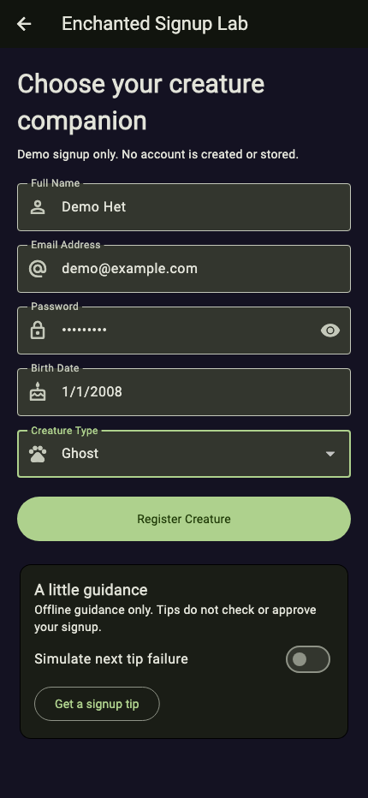
widget-02-filled-form.png — actual Flutter widget-test rendering of the integrated app.
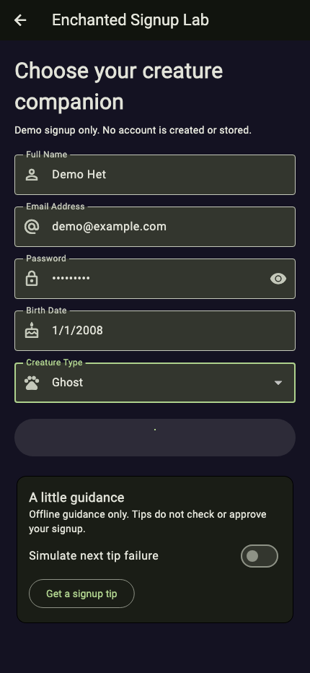
widget-03-loading.png — actual Flutter widget-test rendering of the integrated app.
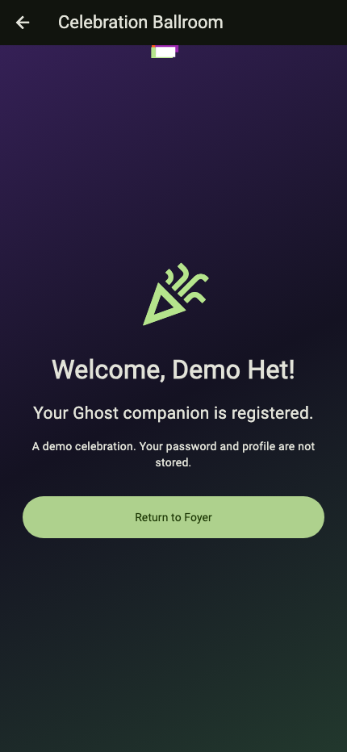
widget-04-success.png — actual Flutter widget-test rendering of the integrated app.
widget-05-back-to-foyer.png — actual Flutter widget-test rendering of the integrated app.

D. Constructor conflict
SuccessScreen requires userName and creatureType, so a caller that supplies only userName is expected to produce missing_required_argument. An isolated Dart example reproduced the diagnostic: “The named parameter 'creatureType' is required, but there's no corresponding argument.” Adding creatureType: 'Ghost' to the call made dart analyze report no issues. The interface rule is to keep the same required parameter names in the constructor and each navigation call, updating both together when the interface changes. The working app was not intentionally broken to collect this evidence.

conflict.dart.txt
class SuccessScreen {
const SuccessScreen({required this.userName, required this.creatureType});
final String userName;
final String creatureType;
}
void main() {
const SuccessScreen(userName: 'Demo Het');
}

diagnostic.log
Analyzing conflict.dart...
error - conflict.dart:7:9 - The named parameter 'creatureType' is required, but there's no corresponding argument. Try adding the required argument. - missing_required_argument
1 issue found.

fixed.dart.txt
class SuccessScreen {
const SuccessScreen({required this.userName, required this.creatureType});
final String userName;
final String creatureType;
}
void main() {
const SuccessScreen(userName: 'Demo Het', creatureType: 'Ghost');
}

fixed-analysis.log
Analyzing fixed.dart...
No issues found!

Verification and contribution limits
The integrated core suite passed 11 tests; one optional screenshot test was skipped in the ordinary run and then passed separately. Analysis passed. Existing date evidence was regenerated by the team’s evidence test, and the new small-display test found a real dropdown overflow that was fixed with isExpanded. Original form rules and constructor names were retained. Widget viewport changes are not physical-device rotation; complete emulator submission and physical-device testing are not claimed.
Actual Het-session work: welcome sizing/alignment, success gradient/safe area, confetti lifecycle and repeated Back tests, dropdown layout correction, evidence generation, and this report. AI assistance was used. Rohan’s prior published work remains in Git history. Both students must personally review the implementation, review each other’s changes, and confirm the two-person group meets their instructor’s requirements.
Reflection guidance to personalize: Describe a change you personally reviewed, explain why pushReplacement matters, and identify a test you personally ran. Do not turn these prompts into claims of experiences you have not had.

