.NET the application execution consists of 2 steps
1. Language compiler, compiles the Source Code into Intermediate Language (IL)
2. JIT compiler in CLR converts, the IL into native code which can then be run on the underlying operating system
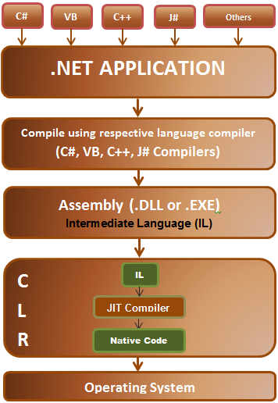
Note: Now open the assembly using ILDASM.exe and enter from VS command prompt.The default is 1.0.0.0. The version number of an assembly consists of the following four parts:
1. Major Version
2. Minor Version
3. Build Number
4. Revision Number
A strongly named assembly should have all of the following,
1. The textual assembly name.
2. The assembly Version number.
3. The assembly should have been signed with private/public key pair.
Built-in types in C#
1. Boolean type – Only true or false
2. Integral Types - sbyte, byte, short, ushort, int, uint, long, ulong, char
3. Floating Types – float and double
4. Decimal Types
5. String Type
Common Operators in C#
Assignment Operator =
Arithmetic Operators like +,-,*,/,%
Comparison Operators like ==, !=,>, >=, <, <=
Conditional Operators like &&, ||
Ternary Operator ?:

Null Coalescing Operator?? Ex:- p ?? q
Here, p is the left and q is the right operand of ?? operator. The value of p can be nullable type, but the value of q must be non-nullable type. If the value of p is null, then it returns the value of q. Otherwise, it will return the value of p.
Note: The operators ?? and ??= cannot be overloaded
// Ternary operator example
bool isNumber10 = number == 10 ? true : false;

String type in C#
// Displaying double quotes in c#
string Name = "\"Pragim\"";
Console.WriteLine(Name); --“Pragim”

// Displaying new line character in c#
Name = "One\nTwo\nThree";
Console.WriteLine(Name); -- One , Two , Three in new lines

// Displaying new line character in c#
Name = "D:\\Tutorials\\Azure Tutorials\\Azure Kudvenkat"; --same path
Console.WriteLine(Name);

// C# verbatim literal
Name = @"D:\Tutorials\Azure Tutorials\Azure Kudvenkat"; --same path
Console.WriteLine(Name);

Need to verify: https://docs.microsoft.com/en-us/dotnet/csharp/whats-new/csharp-10

