**HTML Basic Assignment**

1. **Try to design simple calculator using HTML**

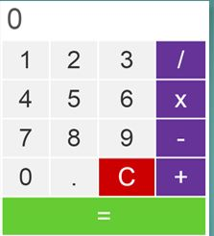

1. Try to design a table as depicted below

