**CSS Assignment for Beginners**

**Tasks Outline:**

When solving the day to day tasks/assignments, strive to create not just code that works, but code that is stylish and concise. Try to write small code which perform just a single task, and then combine those smaller pieces to create more complete web layout design. Be sure to write tags with exactly the specified name for each exercise (to help us evaluate your design).

**Forms:**

Design the following wire-frames.

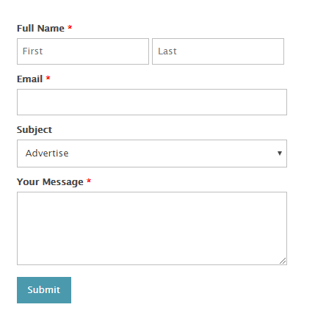

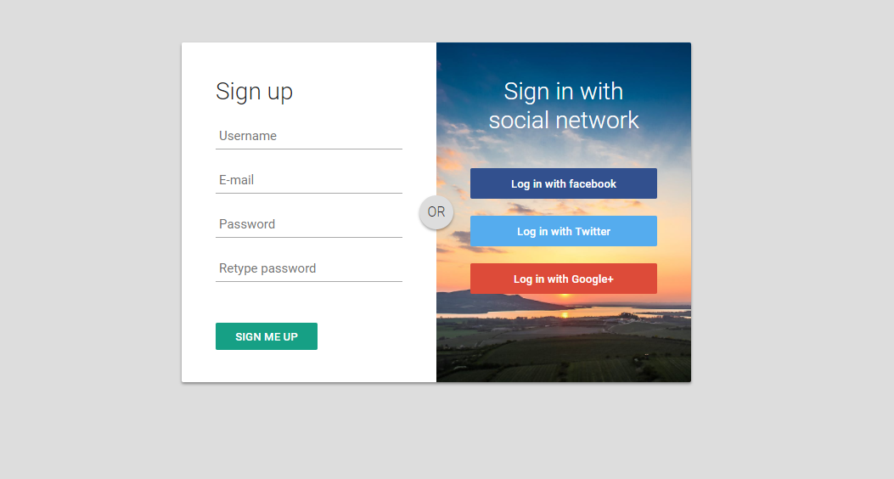



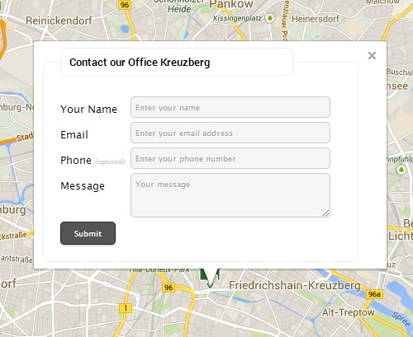

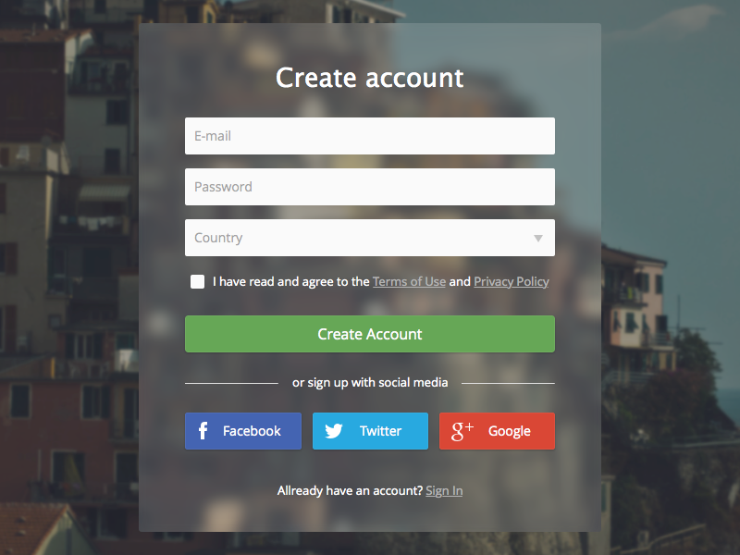

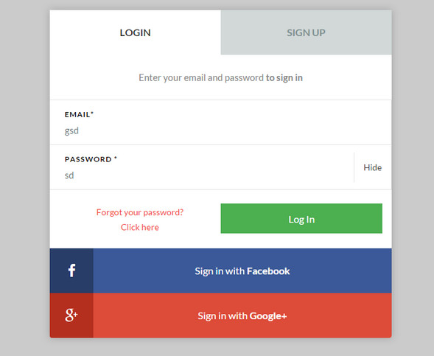

Hints: