**CSS Page layout divs Assignment**

**Prerequisite:**

*Make sure you save all your files (the html file, CSS file, and image file) designed based on project hierarchy.*

The purpose of this assignment is to show that you understand how to use CSS to create a page layout. Create a page that looks exactly like the one you see below. Don’t forget the title of the page.

*(Hints: id and class, Border, Margins, height, width, background-color, float, clear, padding, font-family,* *text-align, overflow)*

**Div1:**

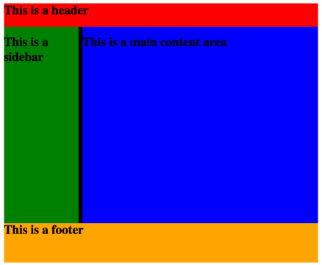

**Div2:**

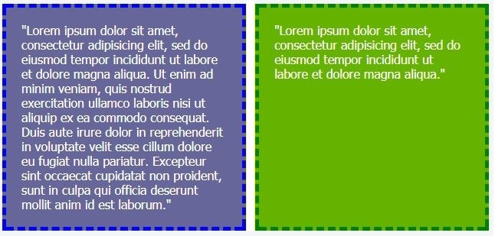

**Div3:**

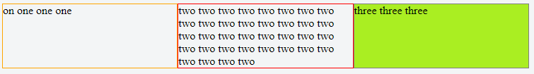

**Div4:**



**Div5:**

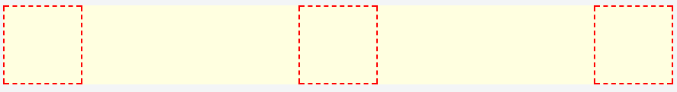

**Div6:**



**Div7:**

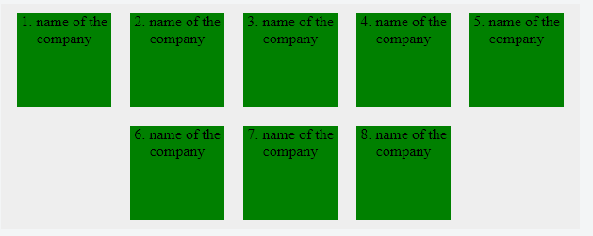

**Div8:**

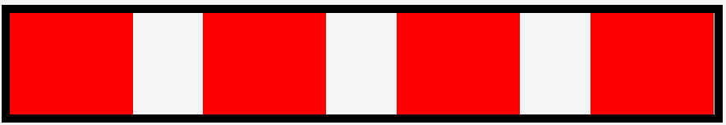

**Div9:**



**Div10:**



**Div11:**

