Try to display thickness and lightness of color as depicted below:

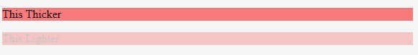

Try to display the list count as depicted below using CSS:

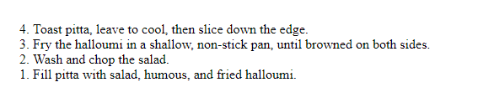

Try to Style first letter and first line (Hint: first-letter and first-line)

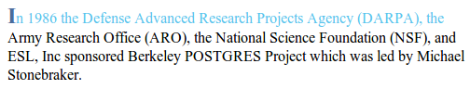

Style the element which is empty with image opacity

1. **<div** class="container"**></div>**
2. **<div** class="container1"**>**I am not empty**</div>**