**CSS Styling**

Try to display text as depicted below

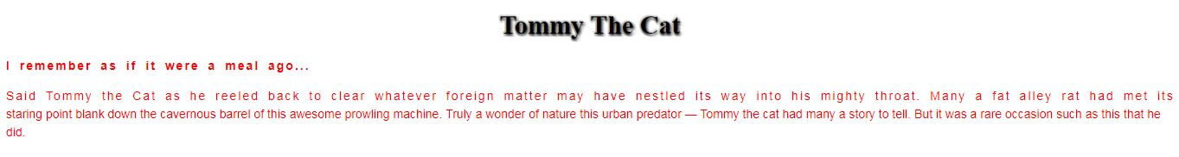

External Link Icon

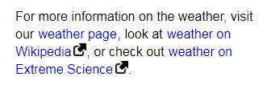

Link Buttons

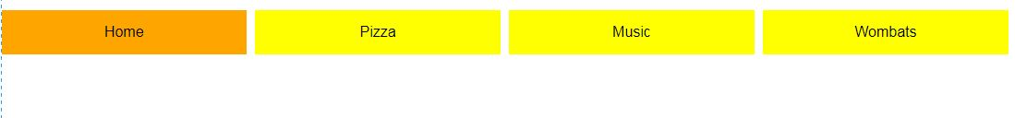

Styled links

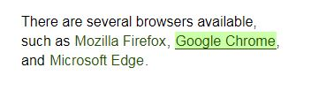

List Image

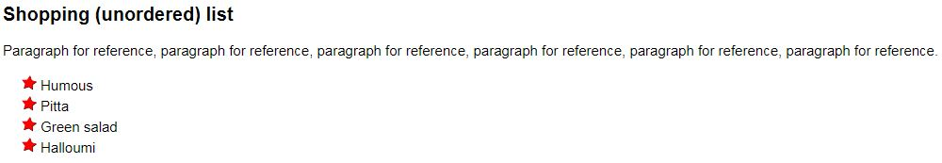

**Develop a web page**

