**GIT**

**Install Git**

Step1:

* For **Windows**

<https://git-scm.com/>

* For **Unbuntu**

Write command: sudo apt install git in terminal

Click on Enter

In between Installing Y/N : write Yes or Y

Step2:

* Sign up & login in

<https://github.com/>

* Remember your credentials.

Step3:

* Click on “+ “symbol as depicted above.
* Click on “New Repository”

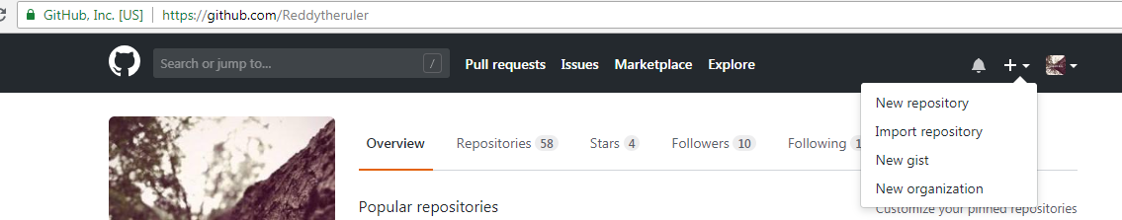

Step4:

* Write Repository name
* Choose on Initialize this repository with a README
* Click on “Create Repository”

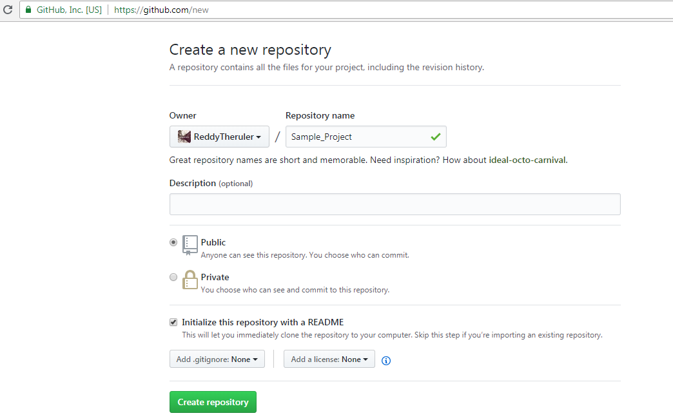

Step5:

* You’ll able to see this page with project folder (repository) and ReadMe.md file

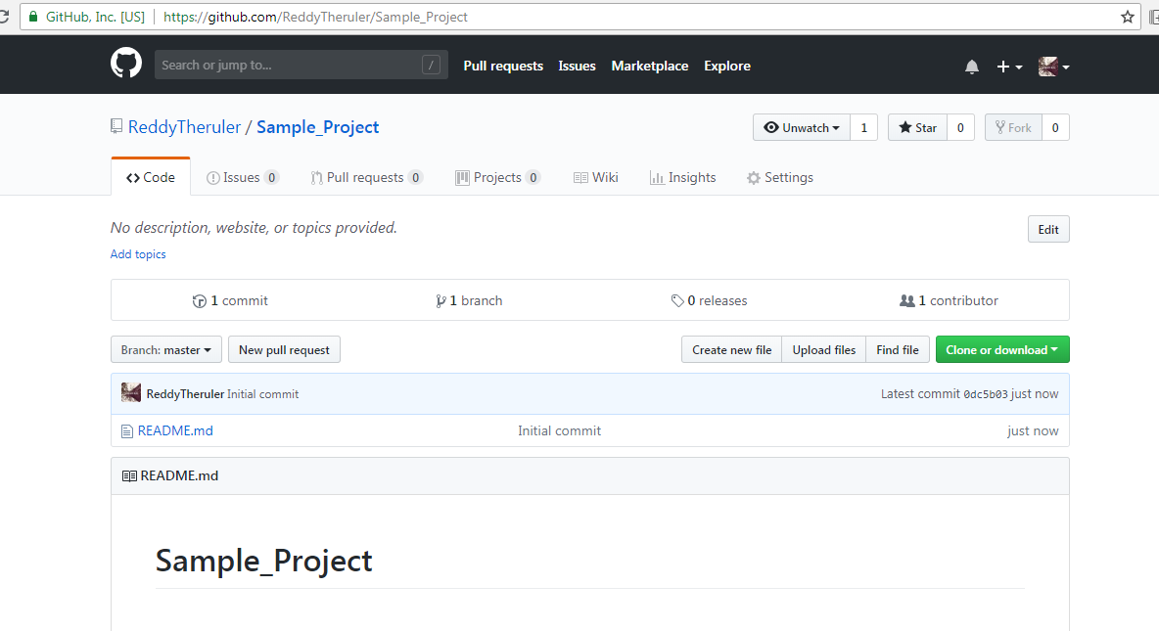

* Click on “Clone or download” a depicted in screenshot below
* Copy the URL

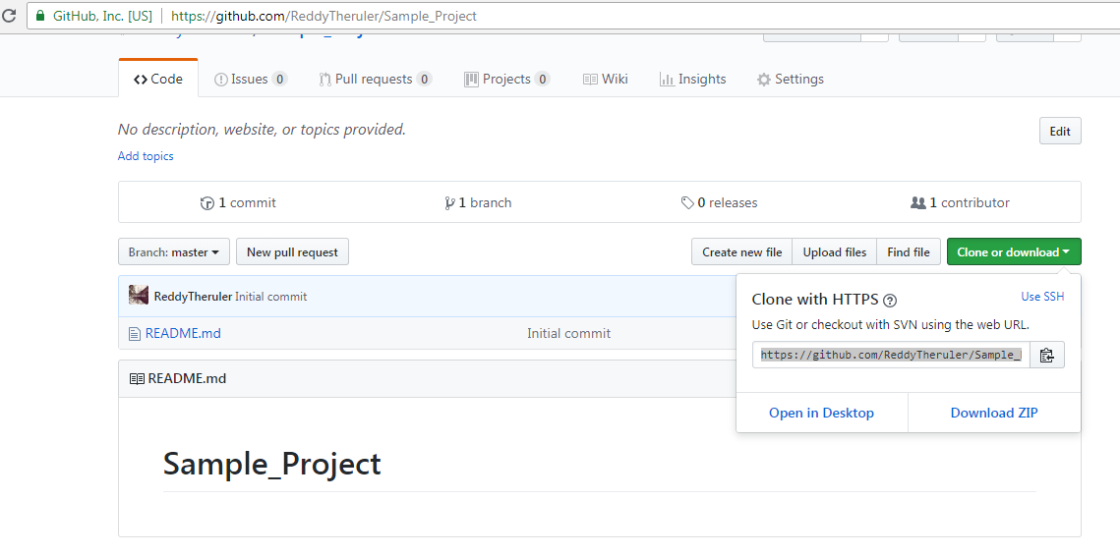

Step 6:

* Right click on any folder Open terminal in unbuntu
* In windows right click on desktop or any folder in drive

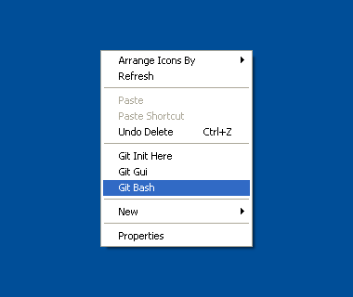

* Choose Gitbash here in Windows

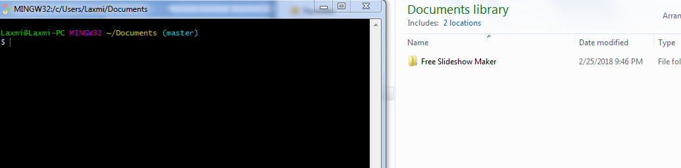

Step 7:

* Write down command in terminal as copied from Step5

Example: <https://github.com/ReddyTheruler/Sample_Project.git>

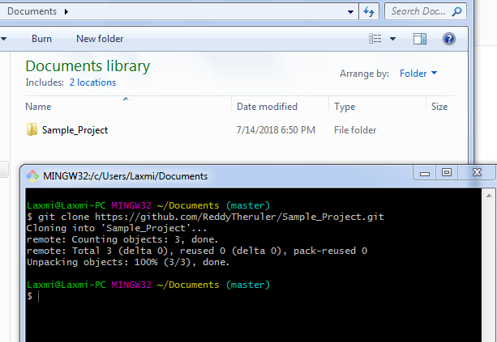

* Navigate to current folder using command cd “foldername”

Here in Example:

cd Sample_Project //cd – current directory

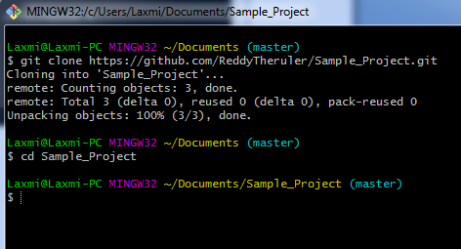

Step8:

* Add files in folder:

Git add –A

A indicates all here.

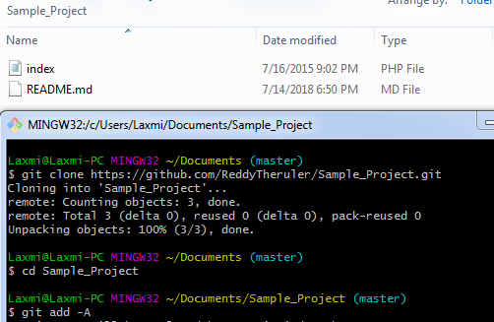

Step9:

* Write git commit –m “Hello” and click Enter

M – Indicates “message” after successful commit

“Hello” will echo in next line if it is successful commit.

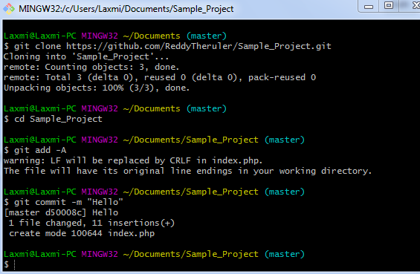

Step 10:

* Next write git push origin master

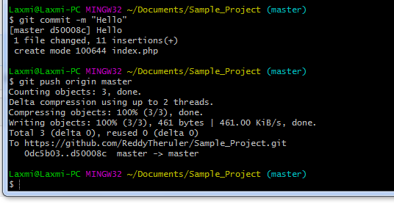

* Just refresh your profile after push command all files will be added.
* Here in our screenshot we have added only “index.php” file.

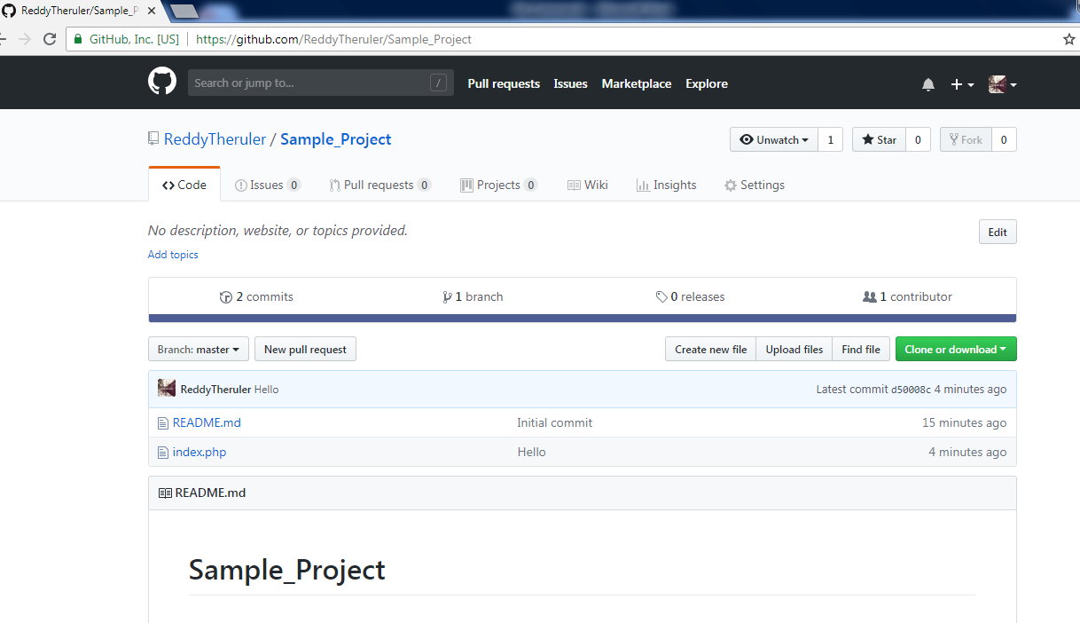

At End of document we have learnt

Summary:

* Git clone
* Git add
* Git commit
* Git Push

(Note: This is basic version of using Git)