**JAVA Assignment**

In this Assignment try make use of an application to access the World database using Java. You can use Postgre/Oracle/MySQL, the same code will work with other databases listed.

**Prerequisites:**

Java SE 1.8 SDK

Integrated Development tool (IDE), such as Eclipse, Net Beans, or a text editor

**Task:**

Make sure you’re aware of Simple CRUD applications.

**Login**

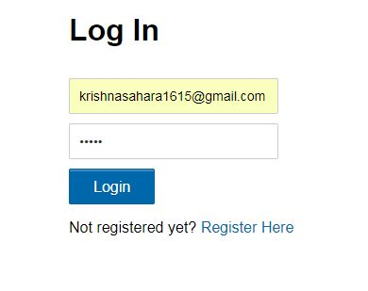

**Registration**

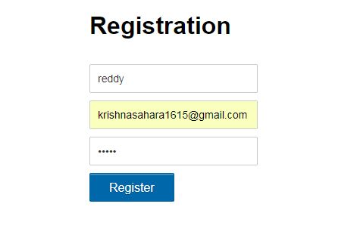

**Dash Board**

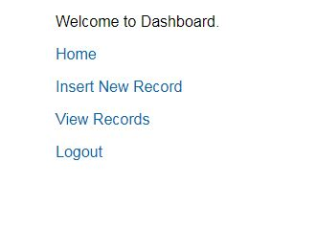

**Insert a Record**

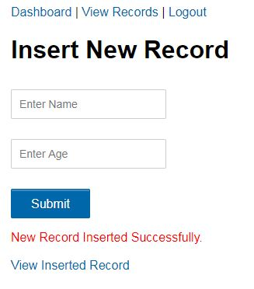

**View Records**

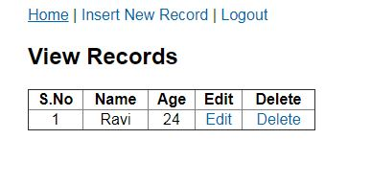

**Edit Records**

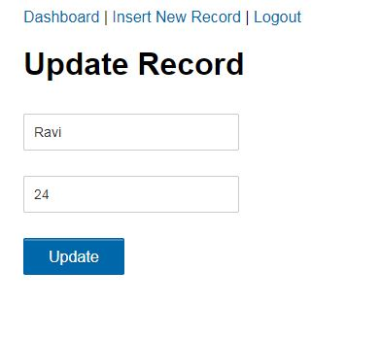

**Delete the Record after use.**