UNIVERSITY OF HERTFORDSHIRE

SQL Assignment - Library Management Database Creation

Submission By:
Student Name: Eswar Teja Reddy Yarragunta

Student ID: 25053409

A. Project Overview and Data Preparation
This Library Management Database was created with SQLite, Python for creating synthetic data. There was no download or use of external datasets or personal records. The relationship between books and library members and borrowing activities was addressed by a library management scenario.
There are three tables in the database such as Books, Members and Borrowings. Fictional data was generated using the Faker library for Python and random data was used for adding variations in the attributes like book genres, member types, borrowing date and borrowing status. The database contains 2,050 records in total, distributed as follows:
- Books: 300 records
- Members: 250 records
- Borrowings: 1,500 records
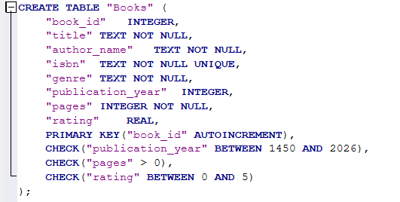
Figure 1: Books Table Creation - SQL Code
Members and Borrowings tables were created using a similar SQL structure shown in Figure 1. Various types of measurements were generated in the data. Genre and borrowing status are nominal data and membership type and book rating are ordinal data. Publication year is interval data, as differences in years are meaningful, but there is no meaningful zero point. The data of pages, fine and renewal count are ratio data because they have meaningful zero values. Data validation was also performed to verify the consistency of the data, integrity, and foreign key integrity. This ensured consistency and usefulness of the database created.

B. Database Structure and Relationships
The database consists of three related tables as follows:
- Books: Contains data on books such as the book ID, title, author name, ISBN, genre, publication year, number of pages and rating.
- Members: Keeps information about the library member, such as identification and membership information. There are three types of membership: Basic, Silver, Gold.
- Borrowings: Records borrowing transactions, including book ID, member ID, borrowing date, due date, return date, fine amount, borrowing status and renewal count.
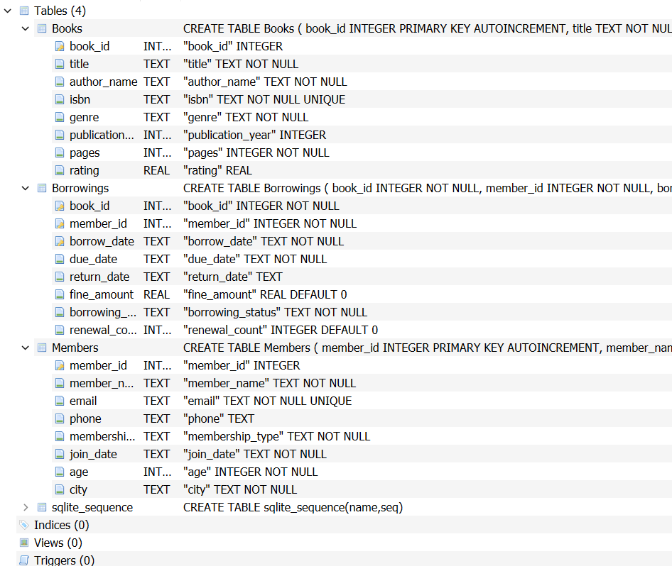
Figure 2: Database Table Schema Structure
There are foreign key relationships between the Books table and the Members table, as well as between the Members table and the Borrowings table. A book can be borrowed by multiple members and a member can borrow multiple books. The Borrowings table has a combination of three columns as its primary key using book ID, member ID and borrowing date to identify each borrowing.

C. Database Design Decisions and Constraints
The information was divided into three tables to organise the database and reduce unnecessary data duplication. Book details and member information are stored separately from borrowing transactions. For example, when a member borrows multiple books, their personal details do not need to be repeated as independent member records. Instead, the Borrowings table connects members with books through their respective IDs. Primary keys uniquely identify records and foreign keys provide referential integrity between tables. The Borrowings composite key makes it impossible to have two transactions with the same book, member and borrowing date.
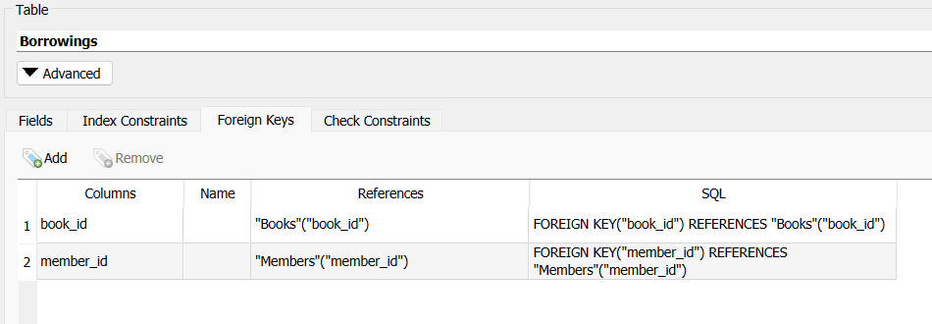
Figure 3: Creation of Foreign Keys in Borrowings Table
A few extra filters have been added to help clarify the data. NOT NULL constraints make sure that certain fields have values, UNIQUE constraints allow for no duplicate ISBNs or member email addresses. CHECK constraints are used to ensure that the amount of money and the number of renewals are not below zero, and that borrowing status can only have values like Borrowed, Returned and Overdue. These rules are for consistency and to avoid invalid records. This also allows for easy future maintenance and extension of the database.

D. Ethical Considerations and Conclusion

Data Ethics and Privacy Protection
Database development was done with regard to ethical and privacy issues. All records are fictional and created in Python, and do not actually represent library customers or people in general. This eliminated the use of or disclosure of actual personal information. Fictional names, email addresses and contact details were generated for the project but very similar information would need to be appropriately protected in a real library management system. Appropriate security protocols and secure data storage and handling procedures would also apply to ensure the confidentiality and integrity of data.
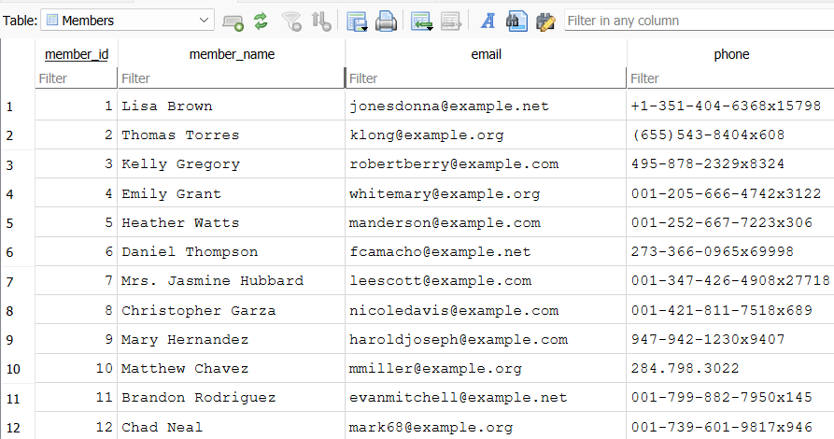
Figure 4: Members Table Including Fictional names, email addresses and contact details

Conclusion
This project demonstrated the creation of a relational database with SQLite and Python. The three-table design, the generated records, primary and foreign keys, and checks for data validations offered an organised way to manage library information. It also demonstrated the use of nominal, ordinal, interval and ratio data as well as ethical data generation and privacy.

