DEPARTMENTAL PROGRESS BRIEF
STATUS OF MUNIKUDALI WORKS
Munikudali Village · Seethanagaram Mandal · East Godavari District · Andhra Pradesh
POSITION AS ON 01 . 09 . 2026

Total Works  37 | Total Sanction  ₹601.77 L | Overall Completion  24.32% | Departments  06

Completed  4 | In Progress  26 | Not Started  7 | Executed Value  ₹186.93 L
Department-wise Summary
S.No | Department | Works | Sanction (₹ Lakh) | Completion % | Compl. | In Prog. | Not Std. | Target Completion
1 | Panchayat Raj | 15 | 173.00 | 34.00% | – | 14 | 1 | 15.09.2026 / 30.09.2026
2 | APEPDCL (Energy) | 14 | 141.33 | 48.93% | 4 | 7 | 3 | 10.09.2026 – 25.09.2026
3 | DWMA | 5 | 66.68 | 13.00% | – | 4 | 1 | 15.09.2026 / 30.09.2026
4 | RWS & S | 1 | 12.00 | 50.00% | – | 1 | – | 30.09.2026
5 | Endowment | 1 | 30.00 | 0.00% | – | – | 1 | 31.12.2026
6 | Irrigation | 1 | 178.76 | 0.00% | – | – | 1 | 31.03.2027
 | GRAND TOTAL | 37 | 601.77 | 24.32% | 4 | 26 | 7 | Up to 31.03.2027
Amounts in ₹ Lakh. Completion percentages are as recorded in the source register; the departmental figure is the simple average of the percentages of that department’s works.
Sanction vs. Executed Value
Department | Sanction (₹ Lakh) | Executed (₹ Lakh) | Physical–Financial Progress | Weighted %
Panchayat Raj | 173.00 | 80.80 |  | 46.71%
APEPDCL (Energy) | 141.33 | 91.69 |  | 64.88%
DWMA | 66.68 | 8.44 |  | 12.65%
RWS & S | 12.00 | 6.00 |  | 50.00%
Endowment | 30.00 | 0.00 |  | 0.00%
Irrigation | 178.76 | 0.00 |  | 0.00%
GRAND TOTAL | 601.77 | 186.93 | Bar length is proportional to sanction; the solid portion is executed value. | 31.06%
Executed value = sanction × recorded % of completion. Bars are drawn to a common scale, the longest being Irrigation at ₹178.76 Lakh.

Completion Schedule — Works Falling Due
Target Date | No. of Works | Sanction (₹ Lakh) | Departments / Remarks
10.09.2026 | 1 | 28.67 | APEPDCL — six 3-Ph 63 KVA DTRs (50% complete)
15.09.2026 | 12 | 202.31 | Panchayat Raj (9 works) · APEPDCL (1) · DWMA (2)
25.09.2026 | 7 | 43.65 | APEPDCL — LT lines, poles and switches
30.09.2026 | 10 | 50.37 | Panchayat Raj (6) · DWMA (3) · RWS & S (1)
31.12.2026 | 1 | 30.00 | Endowment — temple works, agreement yet to be concluded
31.03.2027 | 1 | 178.76 | Irrigation — Munikudali Ghat improvements
Not recorded | 5 | 68.01 | APEPDCL — 4 works already completed; 1 work (two 25 KVA DTRs) has no target date recorded
TOTAL | 37 | 601.77 | 30 works costing ₹325.00 Lakh fall due within September 2026.
Observations
▪ Physical position. 4 works costing ₹64.36 Lakh are completed, 26 works costing ₹306.77 Lakh are in progress and 7 works costing ₹230.64 Lakh are yet to commence.
▪ Financial position. Executed value is ₹186.93 Lakh against a sanction of ₹601.77 Lakh, being 31.06% on a sanction-weighted basis. The simple average recorded in the register is 24.32%.
▪ Schedule. 30 of 37 works, carrying ₹325.00 Lakh, fall due within September 2026. The earliest target is 10.09.2026 and the latest 31.03.2027.
▪ Departmental spread. APEPDCL records the highest weighted progress at 64.88%; DWMA the lowest among departments under execution at 12.65%. Endowment and Irrigation stand at nil.
▪ Largest sanction. Irrigation ghat improvement at ₹178.76 Lakh is 29.71% of the total outlay, stands at 0%, and carries the longest target date in the programme.
▪ Works not commenced. Panchayat Raj bus shelter ₹8.00 L; APEPDCL two 25 KVA DTRs ₹3.65 L, 1.8 km LT AB cable replacement ₹7.90 L and two line AB switches ₹1.05 L; DWMA avenue plantation ₹1.28 L; Endowment temple works ₹30.00 L; Irrigation ghat improvements ₹178.76 L.
▪ Pre-execution stage. Endowment work stands at tender completed with agreement yet to be concluded. Irrigation work stands sanctioned and awarded to the contractor.
▪ Drainage component. DWMA magic drain (3,416 m) and CC drain (1,540 m) together carry ₹53.31 Lakh, being 79.9% of the DWMA sanction, and stand at 12% and 5% against a target of 15.09.2026.
▪ Road component. Panchayat Raj CC road and drain packages of ₹95.00 Lakh stand at 60% each, with GSB and wet-mix layers completed and CC pavement in progress.
▪ Lighting component. Four high mast and decorative street lighting packages of ₹5.00 Lakh each stand uniformly at 50%, all due on 15.09.2026.
▪ Register entries. APEPDCL S.No 14 is recorded as “completed” against 50% progress. APEPDCL S.No 6 carries no target date. Panchayat Raj S.No 11 to 14 carry one common set of photographs.
▪ Photographs. 26 of 37 works carry photographs in the register — before and after stages for 20 works, and after stage only for 6 works.

1. PANCHAYAT RAJ | 15 Works │ ₹173.00 Lakh │ 34.00% Avg. Completion

Works  15 | Sanction  ₹173.00 L | Avg. Completion  34.00% | Weighted  46.71% | Executed  ₹80.80 L | Completed / Progress / Not Started  0 / 14 / 1

Work-wise Details
S.No | Name of Proposed Work | Sanction (₹ Lakh) | % of Completion | Status of Work | Target Date
1 | Providing CC Road &drains from 1. Kattaboyina Srinu (H) to PWD bund 2. Bandi Chakradar(H) to PWD bund and other internal roads & drains in Munikudali Ghat area of Munikudali Village in Seethangaram Mandal | 48.00 | 60% | IN PROGRESS  GSB & Wet mix layers completed.CC Pavement is in progress | 15.09.2026
2 | Providing CC road, CC drains & CC Ramps from 1. Rachuri Rangarao site to Bandi Chittabbairaju site 2.AELC church to Thummalanka Yeti Gattu and other internal raods & CС Ramps in Munikudali village in Seethanagaram Mandal | 47.00 | 60% | IN PROGRESS  GSB & Wet mix layers completed.CC Pavement is in progress | 15.09.2026
3 | Providing Ramps to PWD gattu at Munikudali Ghat area of Munikudali village in Seethanagaram Mandal | 18.00 | 40% | IN PROGRESS  under Progress | 15.09.2026
4 | Providing WBM Road from Durgadevi Temple to Poleramma Temple near Munikudali Ghat and other WBM Roads in Munikudali Village of Seethanagaram Mandal | 10.00 | 30% | IN PROGRESS  under Progress | 15.09.2026
5 | Renovation to old school Building near Munikudali Ghat in Munikudali village of Seethanagaram mandal | 5.00 | 30% | IN PROGRESS  under Progress | 15.09.2026
6 | Construction of Self-Sustaining Bus Shelter in Munikudali village of Seethanagaram mandal | 8.00 | 0% | NOT STARTED | 30.09.2026
7 | Providing High Mast Lights,Decorative street lights in Pushkar Ghat of Munikudali village of Seethanagaram mandal | 5.00 | 50% | IN PROGRESS  under Progress | 15.09.2026
8 | Providing High Mast Lights,Decorative street lights at R&B Road to Meet Pushkar Ghat of Munikudali village of Seethanagaram mandal | 5.00 | 50% | IN PROGRESS  under Progress | 15.09.2026
9 | Providing High Mast Lights,Decorative street lights at left side of the road from R&B Road to Pushkar Ghat of Munikudali village of Seethanagaram mandal | 5.00 | 50% | IN PROGRESS  under Progress | 15.09.2026
10 | Providing High Mast Lights,Decorative street lights at Right side of the road from R&B Road to Pushkar Ghat of Munikudali village of Seethanagaram mandal | 5.00 | 50% | IN PROGRESS  under Progress | 15.09.2026
11 | Construction of Pindapradanam shed No-1 at Pushkar Ghat at Munikudali village of Seethanagaram mandal | 4.00 | 10% | IN PROGRESS  Under Progress | 30.09.2026
12 | Construction of Pindapradanam shed No-2 at Pushkar Ghat at Munikudali village of Seethanagaram mandal | 4.00 | 10% | IN PROGRESS  Under Progress | 30.09.2026
13 | Construction of Pindapradanam shed No-3 at Pushkar Ghat at Munikudali village of Seethanagaram mandal | 4.00 | 10% | IN PROGRESS  Under Progress | 30.09.2026
14 | Construction of Pindapradanam shed No-4 at Pushkar Ghat at Munikudali village of Seethanagaram mandal | 4.00 | 10% | IN PROGRESS  Under Progress | 30.09.2026
15 | Terracotta Painting to Banyan Tree | 1.00 | 50% | IN PROGRESS  under Progress | 30.09.2026
 | TOTAL — Panchayat Raj | 173.00 | 34.00% | Weighted 46.71% · Executed ₹80.80 L

Brief Points — Position of Works
▪ CC Roads & Drains (S.No 1–2) — ₹95.00 Lakh, 60% each. GSB and wet-mix layers completed on both stretches; CC pavement in progress. Covers Kattaboyina Srinu (H) to PWD bund, Bandi Chakradar (H) to PWD bund, Rachuri Rangarao site to Bandi Chittabbairaju site, AELC Church to Thummalanka Yeti Gattu, together with other internal roads, drains and CC ramps. Target 15.09.2026.
▪ Ramps & WBM Road (S.No 3–4) — ₹28.00 Lakh. Ramps to PWD gattu at Munikudali Ghat area at 40%; WBM road from Durgadevi Temple to Poleramma Temple and other WBM roads at 30%. Both under progress, target 15.09.2026.
▪ Ghat Lighting (S.No 7–10) — ₹20.00 Lakh, 50% each. Four packages of high mast and decorative street lights — at Pushkar Ghat, on the R&B road meeting Pushkar Ghat, and on the left and right sides of the R&B road to Pushkar Ghat. ₹5.00 Lakh each, all under progress, target 15.09.2026.
▪ Pindapradanam Sheds (S.No 11–14) — ₹16.00 Lakh, 10% each. Four sheds at Pushkar Ghat at ₹4.00 Lakh each, all at initial stage. Target 30.09.2026.
▪ Buildings (S.No 5–6) — ₹13.00 Lakh. Renovation of the old school building near Munikudali Ghat at 30%, target 15.09.2026. Self-sustaining bus shelter (₹8.00 Lakh) not started, target 30.09.2026 — the only Panchayat Raj work yet to commence.
▪ Beautification (S.No 15) — ₹1.00 Lakh, 50%. Terracotta painting to banyan tree, under progress, target 30.09.2026.
▪ Position. 14 of 15 works in progress, 1 not started. Departmental average 34.00%; sanction-weighted 46.71% (₹80.80 Lakh executed of ₹173.00 Lakh). Nine works fall due on 15.09.2026 and six on 30.09.2026.

1. PANCHAYAT RAJ — SITE PHOTOGRAPHS | Photographs on record for 14 of 15 works

S.No 1 · CC Road & Drains — Kattaboyina Srinu (H) and Bandi Chakradar (H) to PWD bund  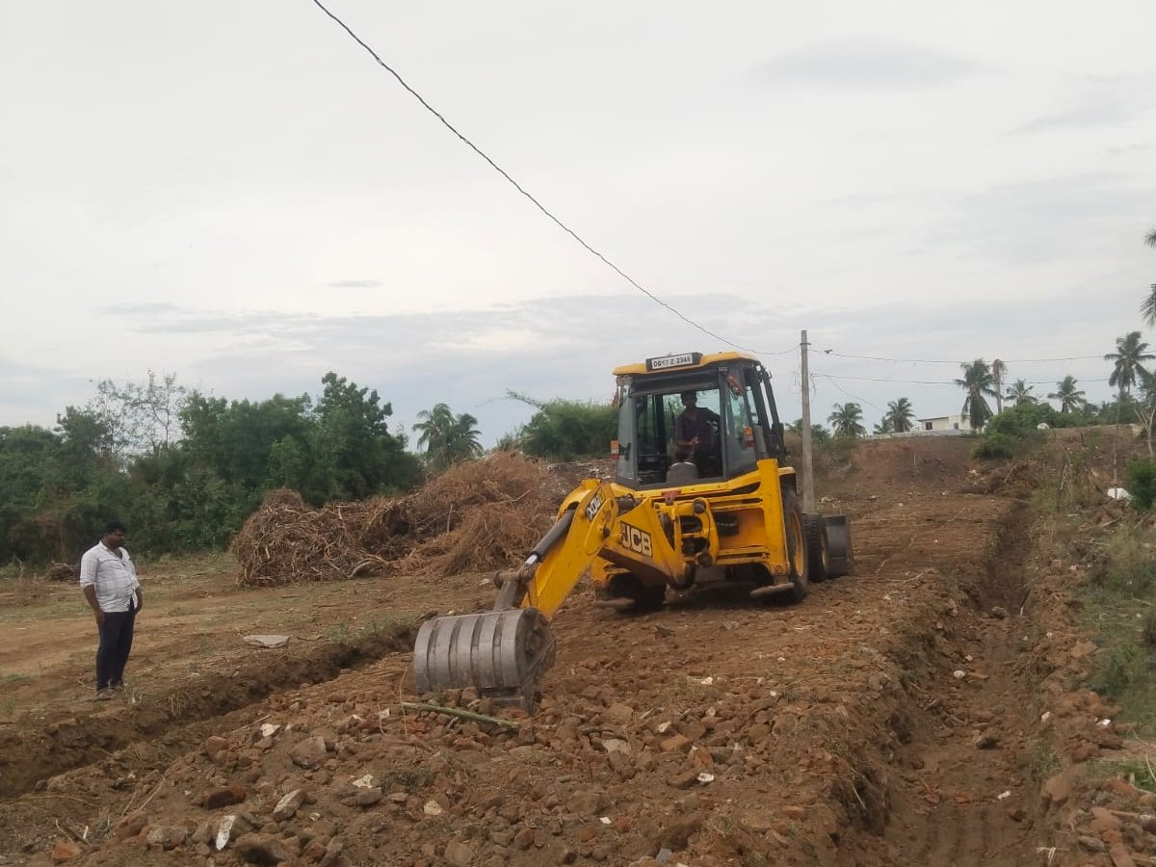 BEFORE 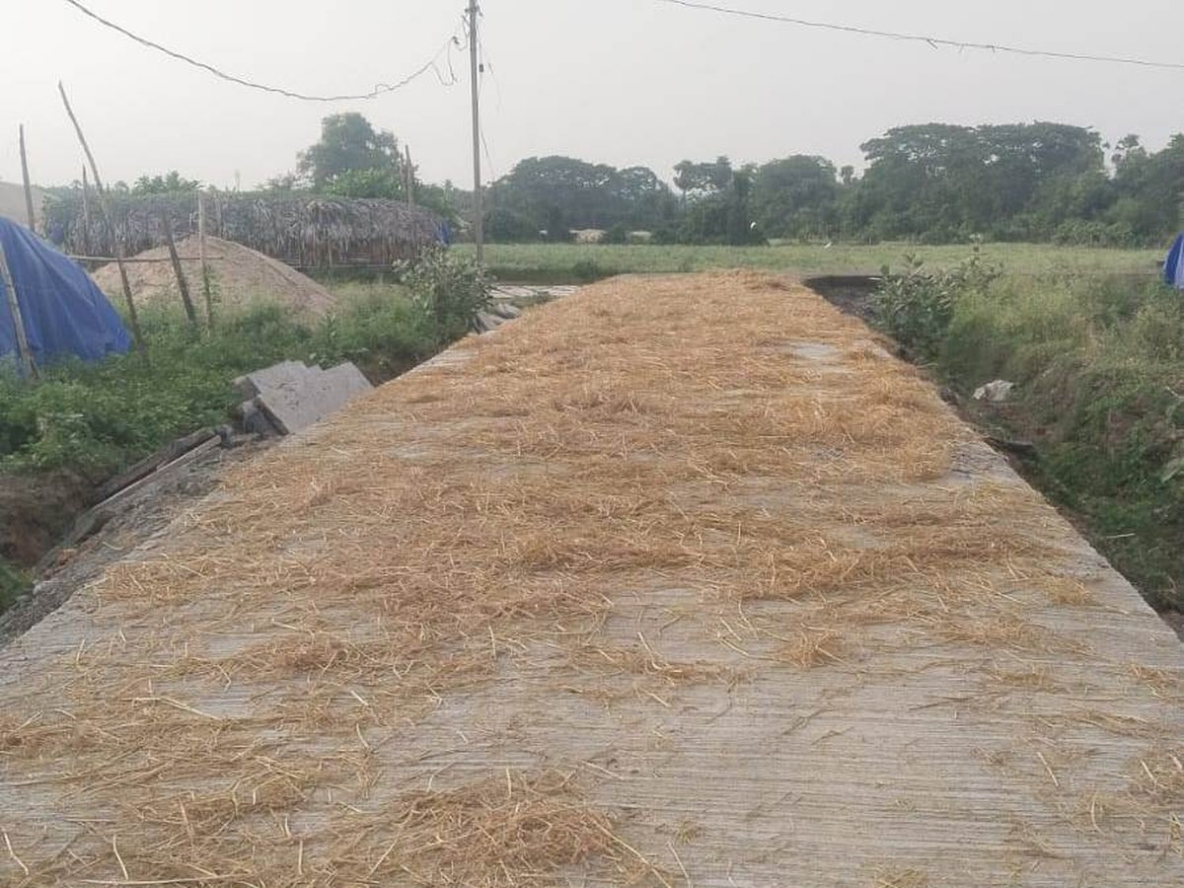 AFTER | S.No 2 · CC Road, Drains & Ramps — Rachuri Rangarao site and AELC Church stretch  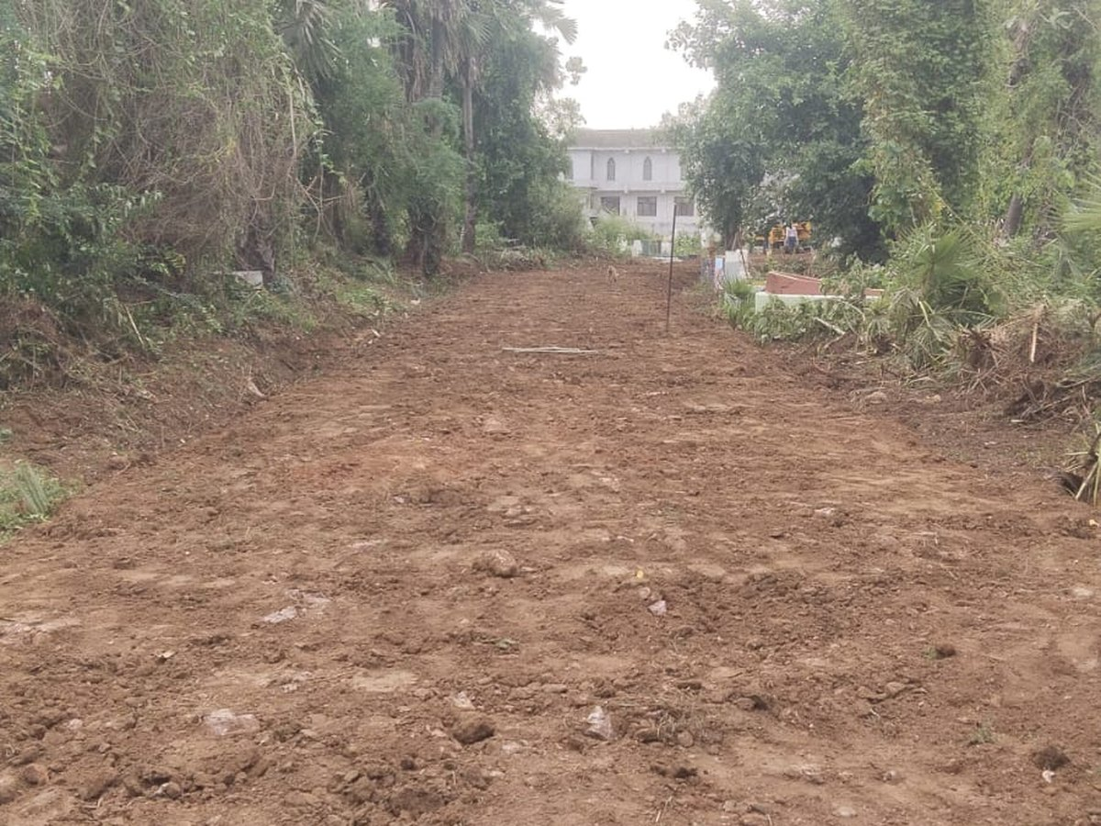 BEFORE 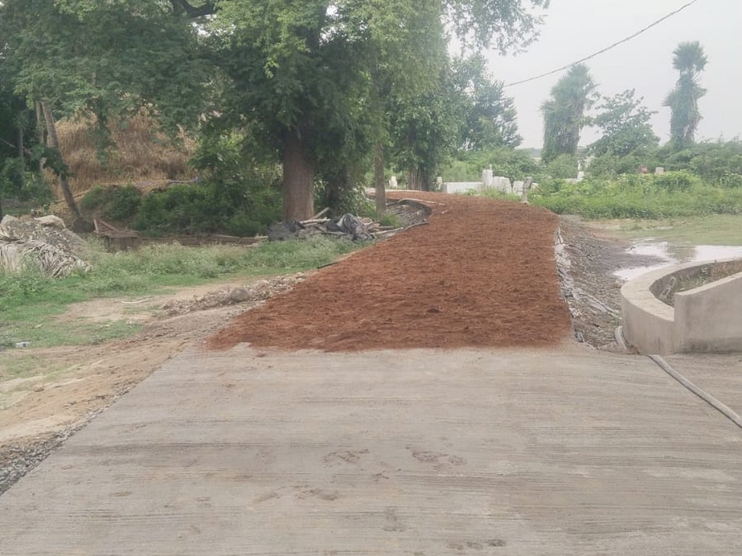 AFTER
S.No 3 · Ramps to PWD Gattu, Munikudali Ghat area  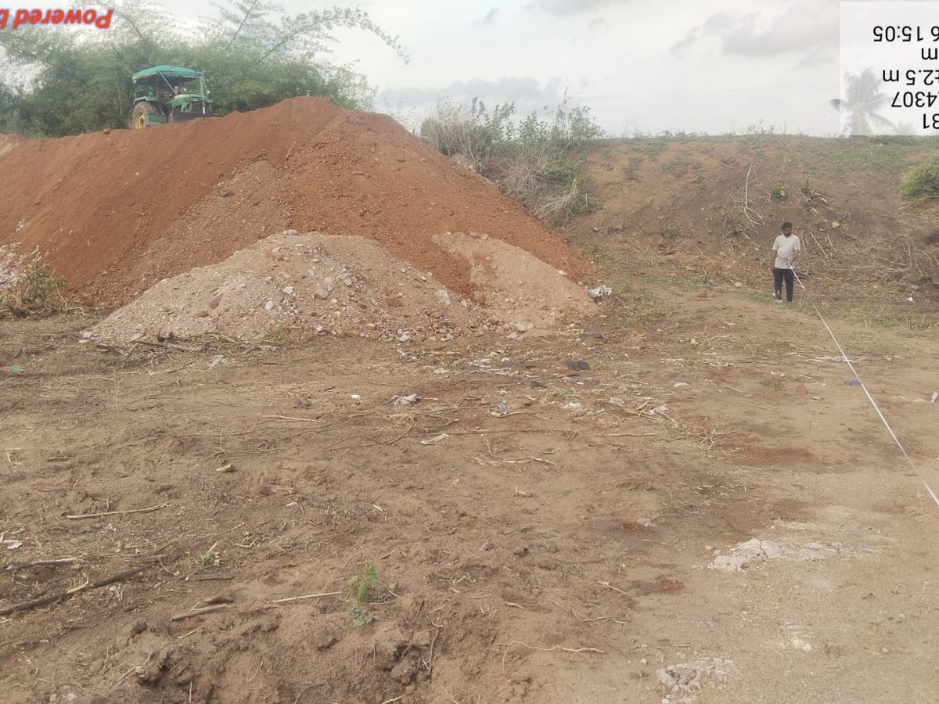 BEFORE 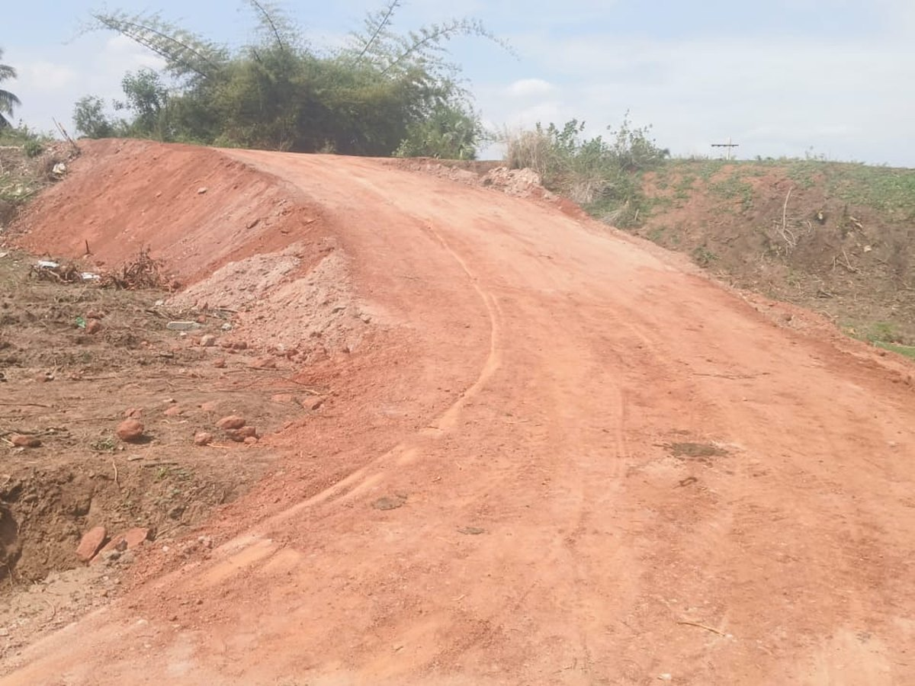 AFTER | S.No 4 · WBM Road — Durgadevi Temple to Poleramma Temple  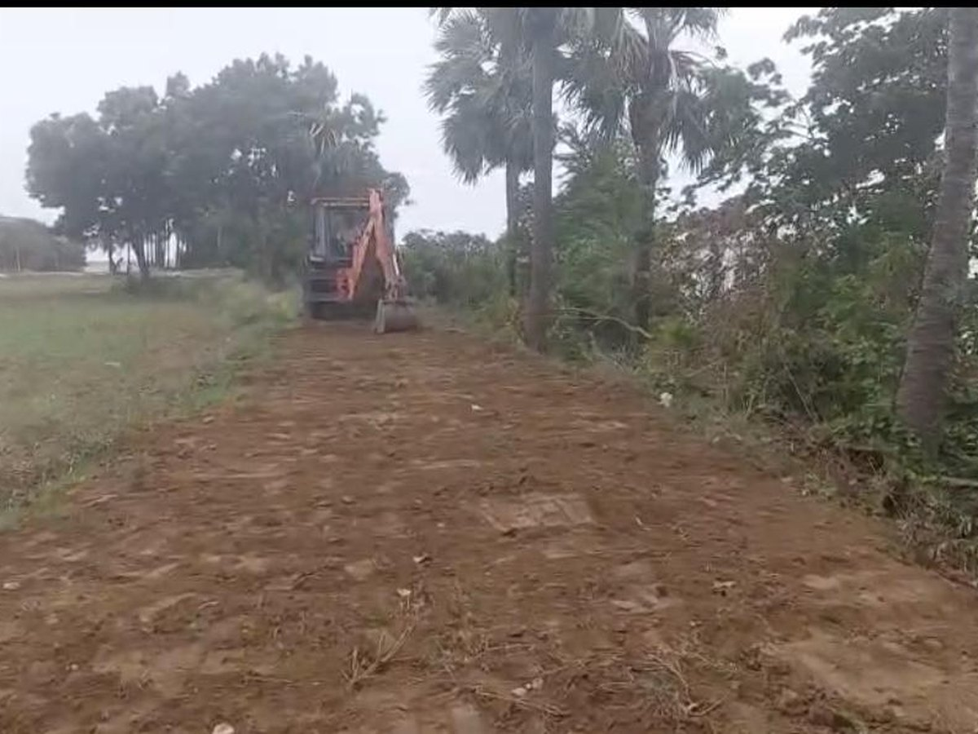 BEFORE 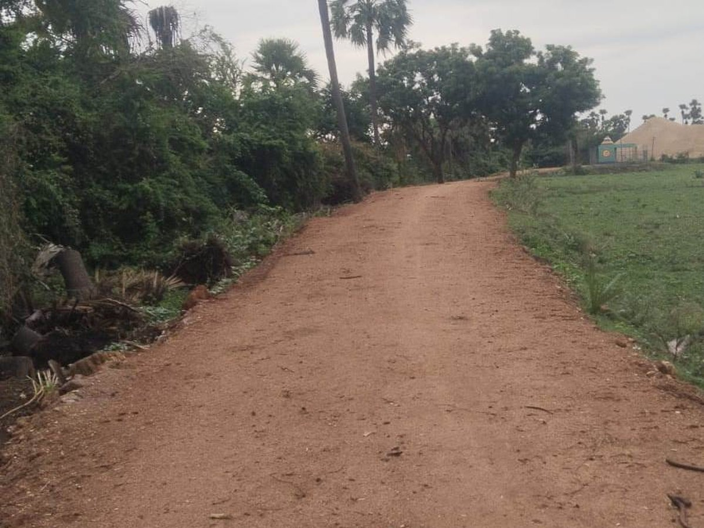 AFTER
S.No 5 · Renovation of Old School Building near Munikudali Ghat  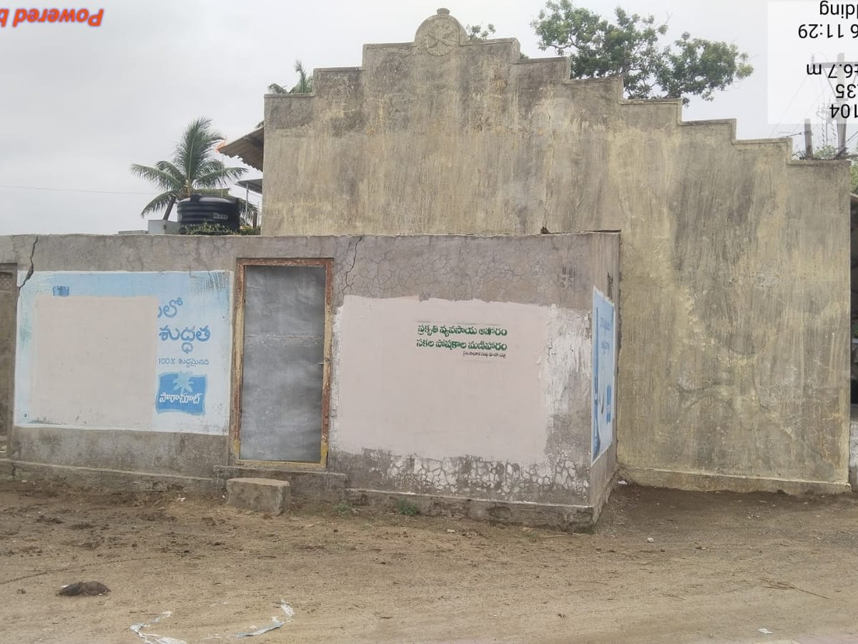 BEFORE 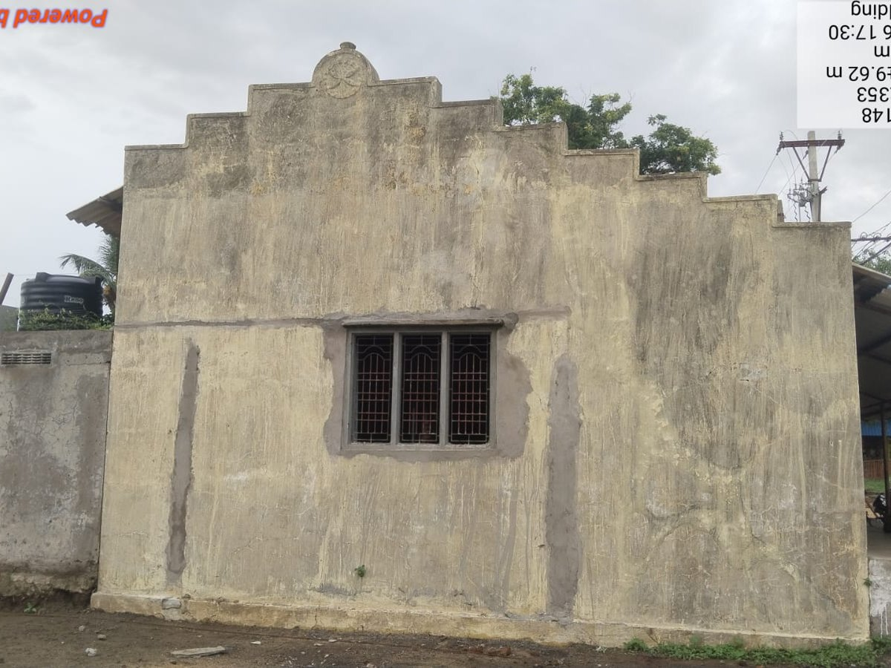 AFTER | S.No 7 · High Mast & Decorative Street Lights — Pushkar Ghat  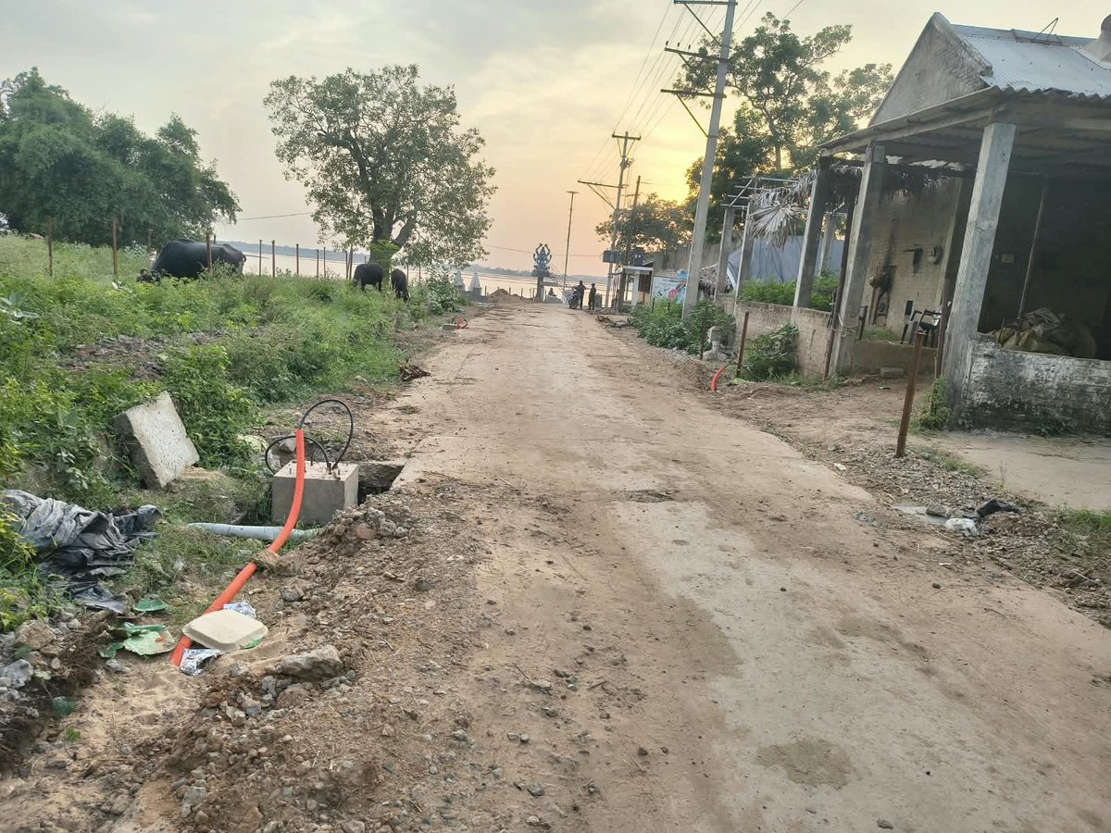 BEFORE 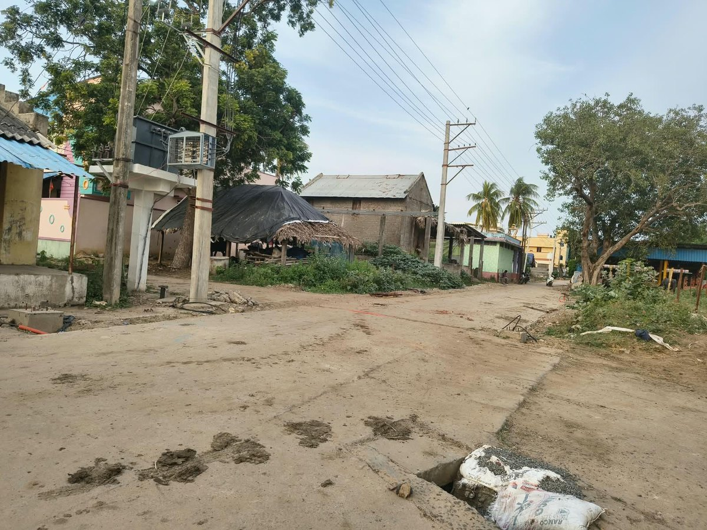 AFTER
S.No 8 · High Mast & Decorative Street Lights — R&B Road to Pushkar Ghat  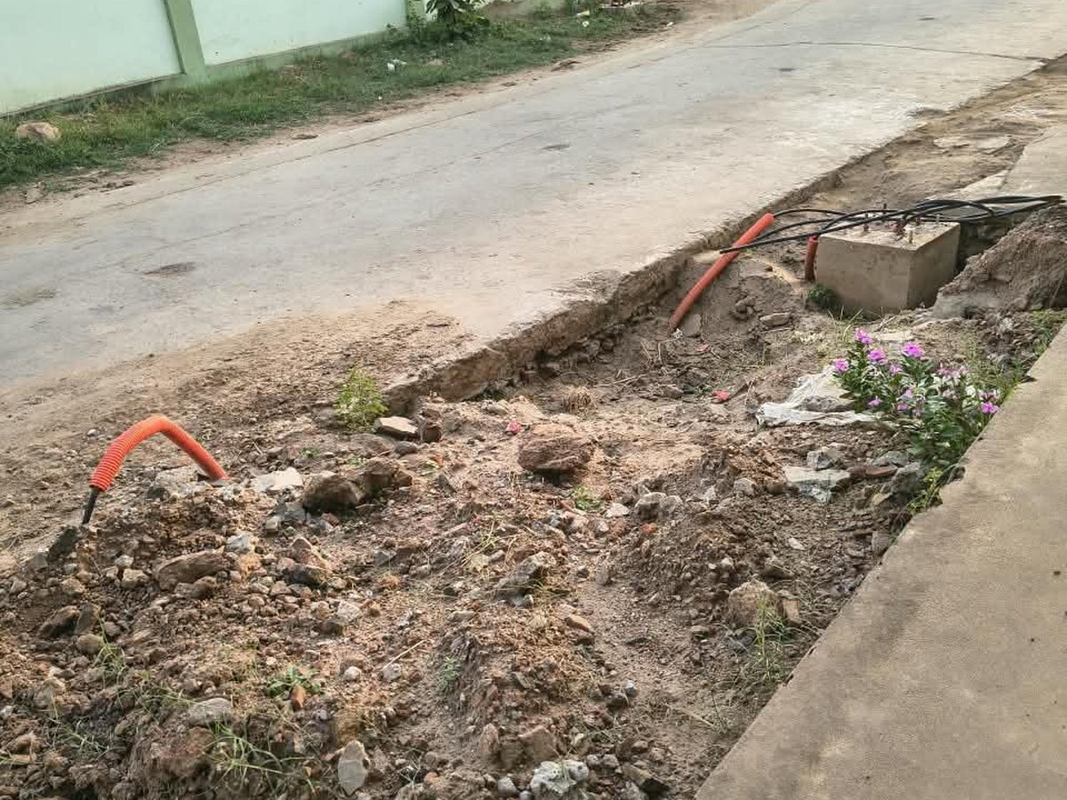 BEFORE 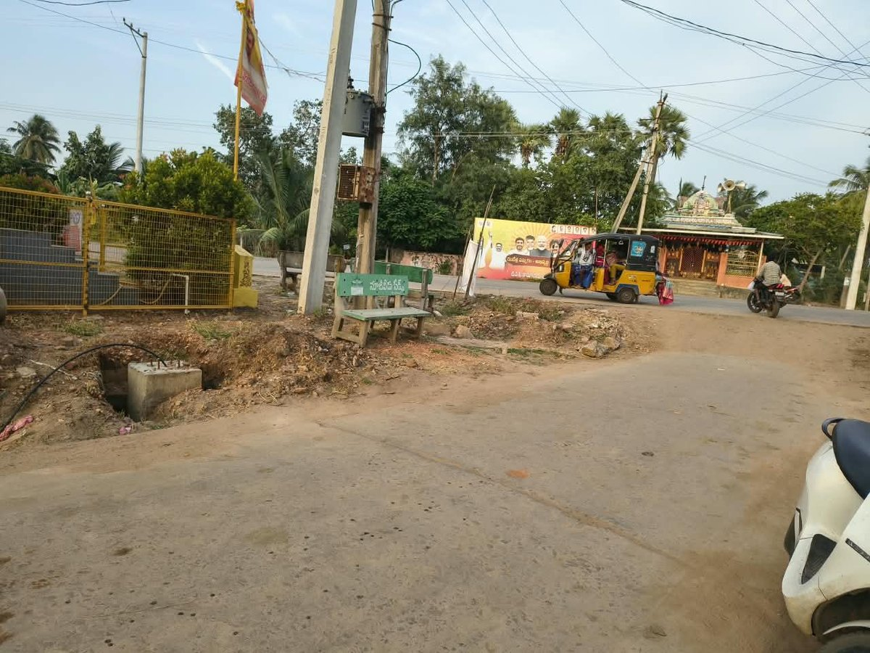 AFTER | S.No 9 · High Mast & Decorative Street Lights — Left side of R&B Road  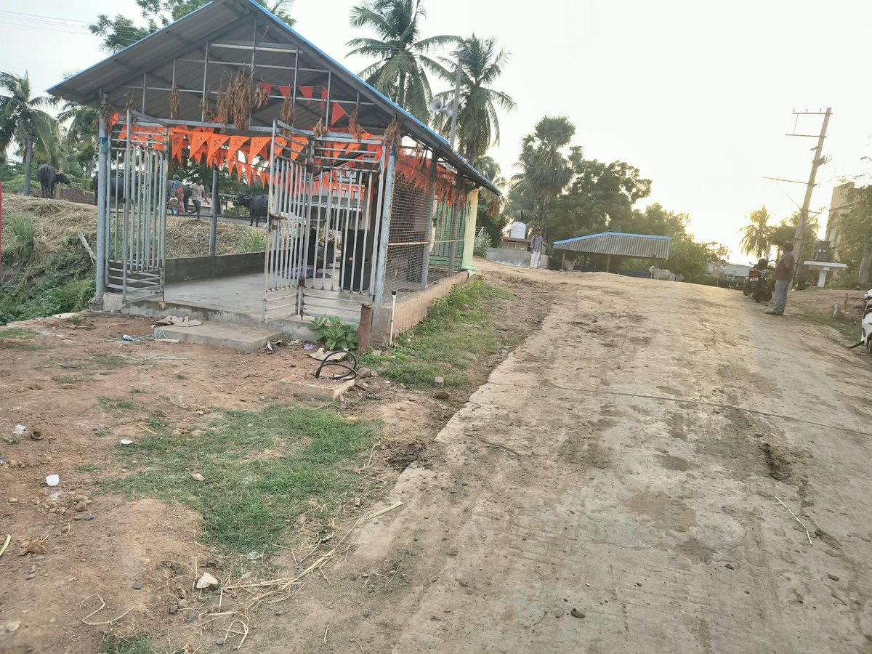 BEFORE 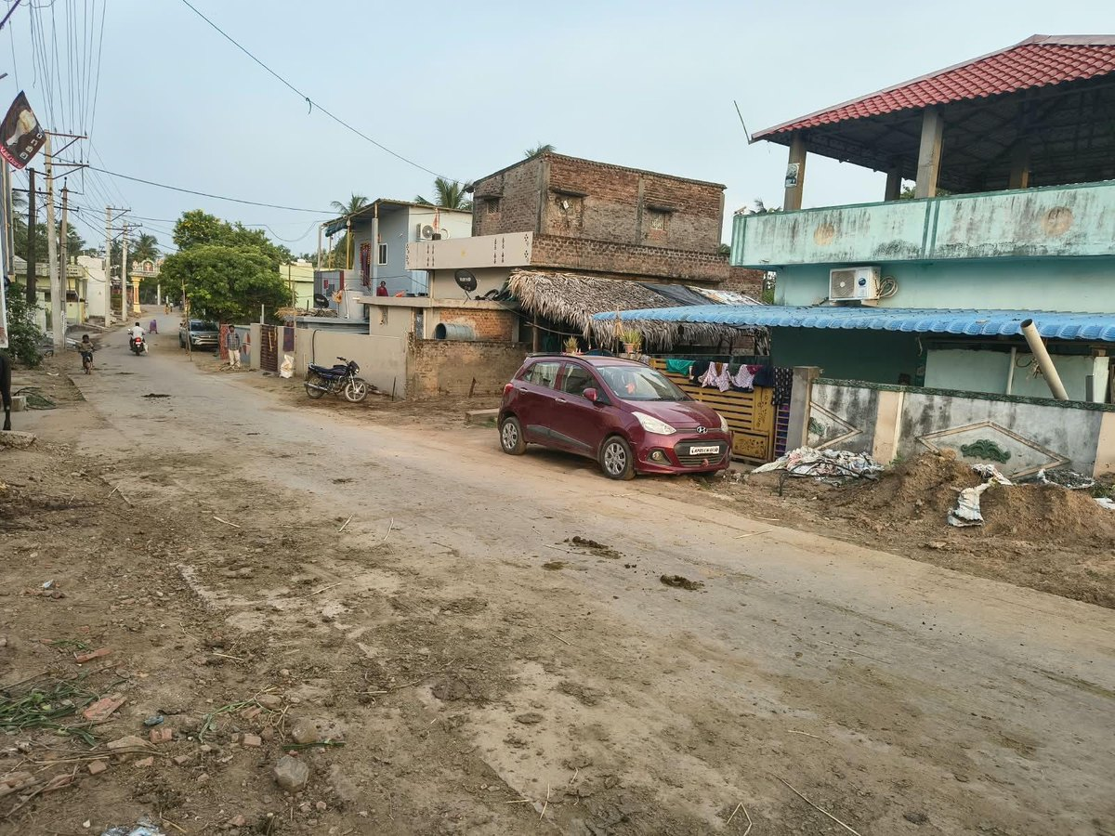 AFTER
S.No 10 · High Mast & Decorative Street Lights — Right side of R&B Road  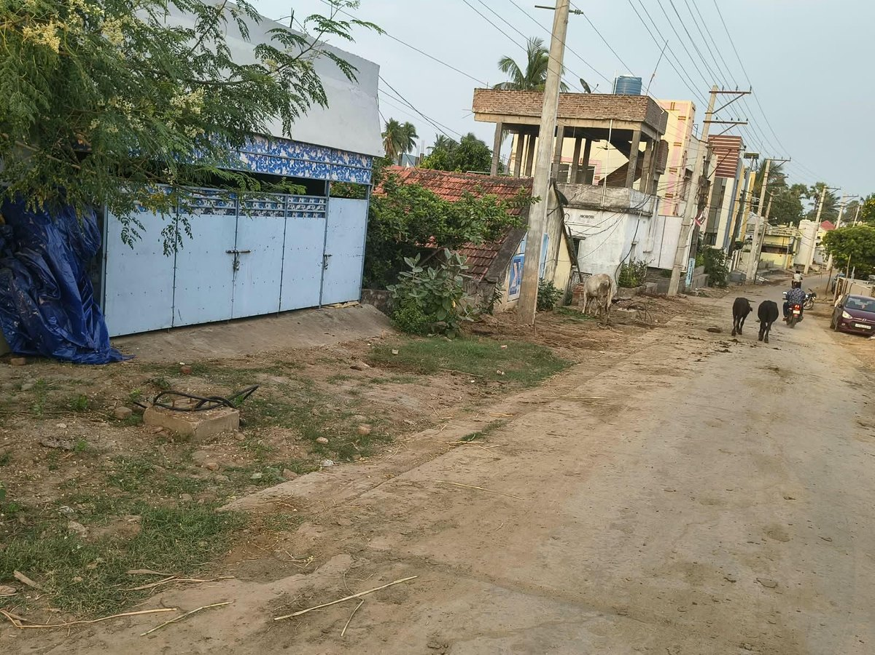 BEFORE 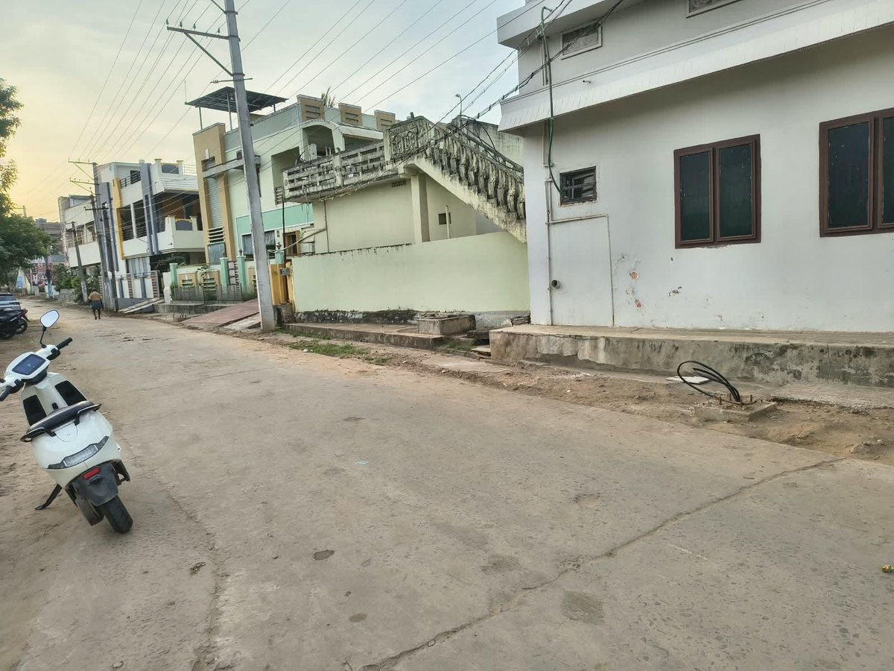 AFTER | S.No 11–14 · Pindapradanam Sheds No. 1 to 4, Pushkar Ghat  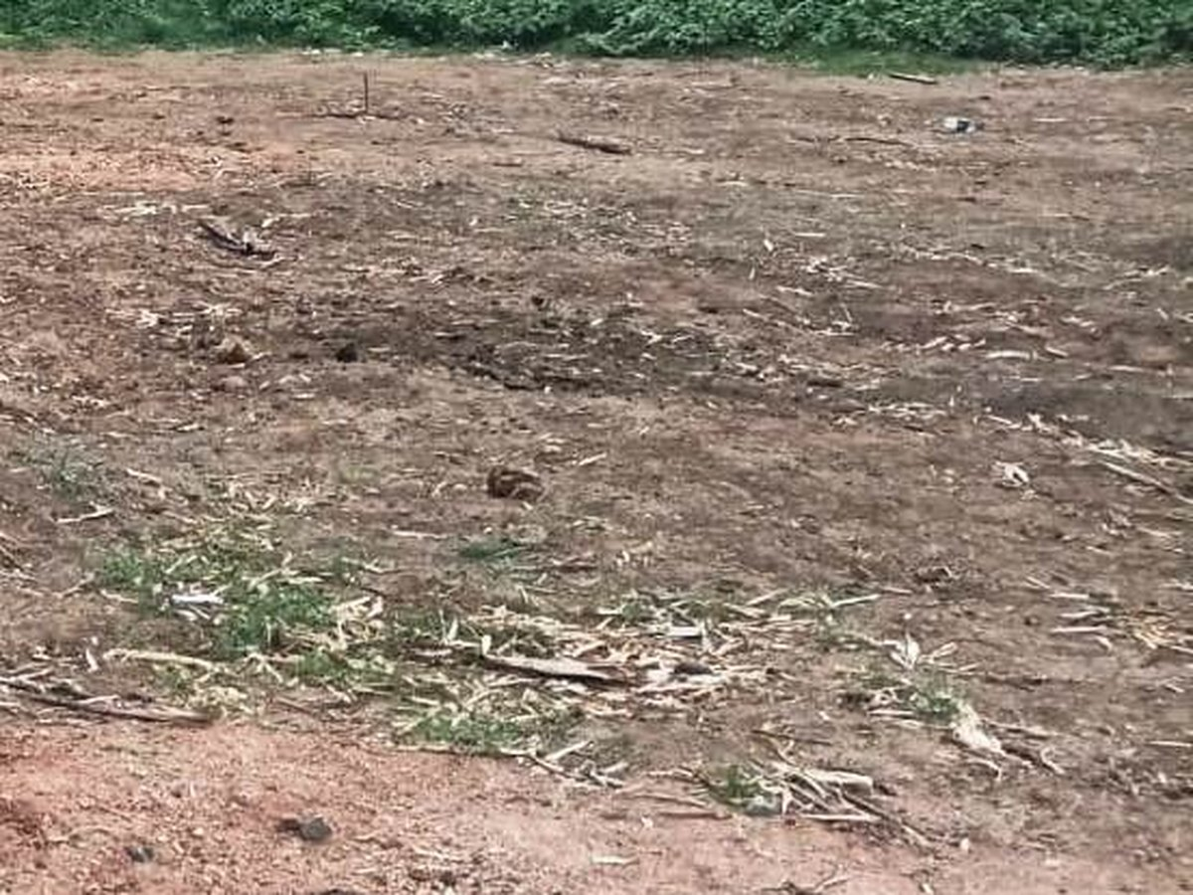 BEFORE 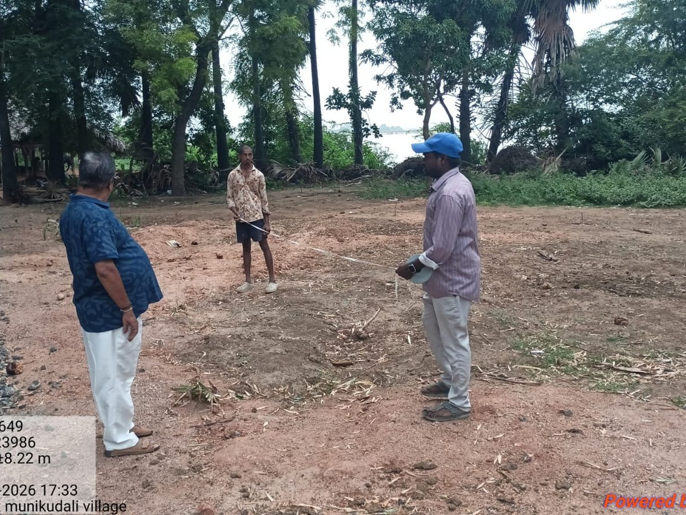 AFTER
S.No 15 · Terracotta Painting to Banyan Tree
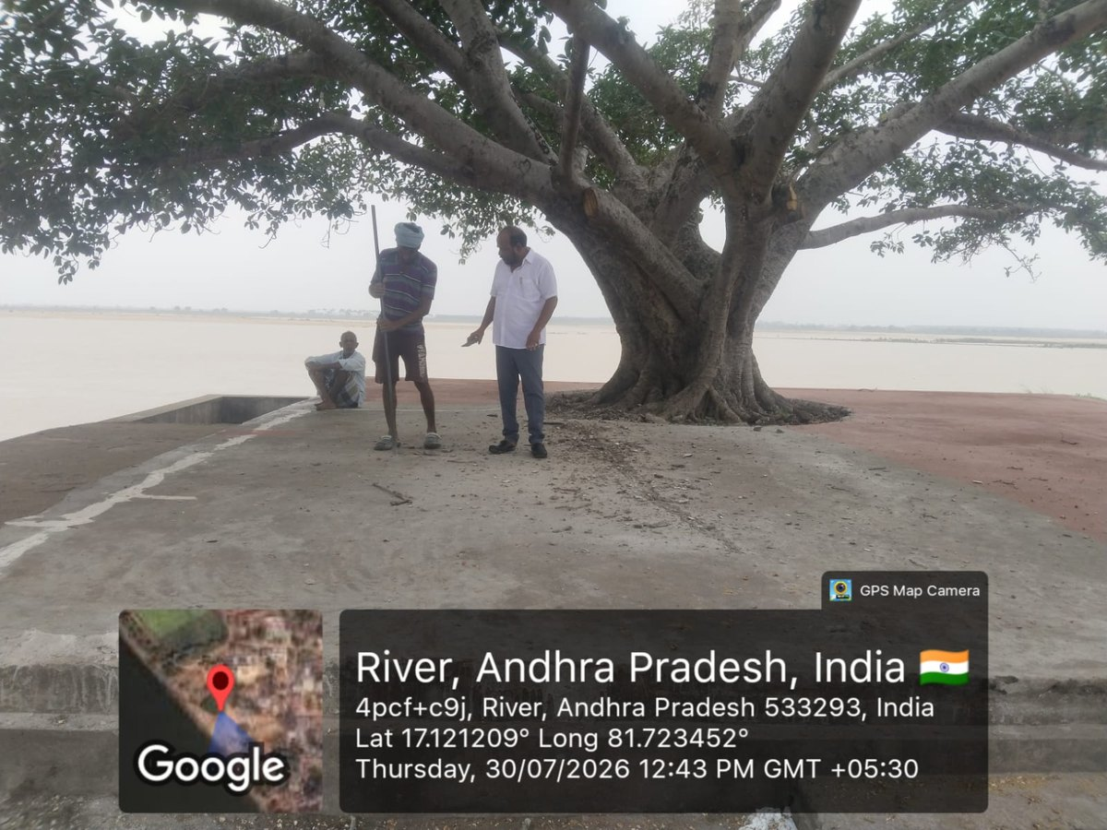  BEFORE | 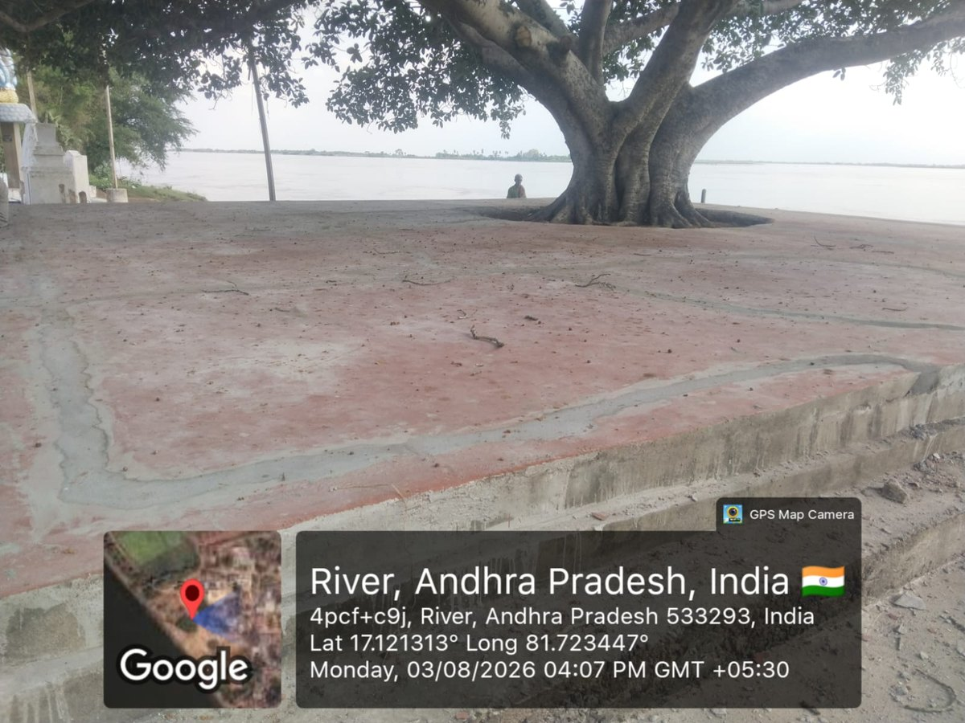  AFTER

2. APEPDCL (ENERGY) | 14 Works │ ₹141.33 Lakh │ 48.93% Avg. Completion

Works  14 | Sanction  ₹141.33 L | Avg. Completion  48.93% | Weighted  64.88% | Executed  ₹91.69 L | Completed / Progress / Not Started  4 / 7 / 3

Work-wise Details
S.No | Name of Proposed Work | Sanction (₹ Lakh) | % of Completion | Status of Work | Target Date
1 | Erection of New VCB With bay extension at 33/11 KV SS Katavaram | 19.60 | 100% | COMPLETED  Work Completed | —
2 | Erection of 11 KV Line with 55 Sq.MM AAAC Over 12.5 Mts. Spun Poles | 25.76 | 100% | COMPLETED  Work Completed | —
3 | Erection Of 11 KV Line with 55 Sq.MM AAA Conductor Over 11 Mts. Pscc Poles | 7.20 | 100% | COMPLETED  Work Completed | —
4 | 3 PH 100 KVA DTRs- 2 Nos 1.Near Munikudali Ghat 2.Near Raithu Barosa | 11.80 | 100% | COMPLETED  Work Completed | —
5 | 3 PH 63 KVA DTRs - 6Nos 1.Near Venkateswara Balakuti School 2.SC Colony Near Ambedkar Statue 3.Near Hospital 4.Near Amma Vari Temple 5.Near Parking Place 6.Near BC Colony | 28.67 | 50% | IN PROGRESS  Work under progress | 10.09.2026
6 | 3 PH 25 KVA DTRs -2Nos 1.Near PWS Drinking Water 2.Near Babu Jagajjeevan Rao Statue | 3.65 | 0% | NOT STARTED  work to be taken up | —
7 | Erection of 3.6KM new LT 3 ph 5 wire line using 55 sq.mm AAAC Near Ramarao gari House, Raithu Barosa Kendram, SC Colony, Near Sachivalayam | 7.50 | 45% | IN PROGRESS  Work under progress | 25.09.2026
8 | Conversion of 2.8KM 1-Ph 3 Wire To 3-Ph 5 Wire, Near Munikudali Ghat, Near Sivalayam Temple | 6.60 | 20% | IN PROGRESS  Work under progress | 25.09.2026
9 | Replacement of 4.2KM aged Conductor in LT Line with 55 Sq Mm AAA Conductor Near Churh area, SC Colony, Near Ambedkar Statue, Near Society, Near Medical Shop Area | 3.10 | 50% | IN PROGRESS  Work under progress | 25.09.2026
10 | Replacement of 1.8 KM Damaged LT AB Cable Line with AAA Conductor, Near Main Road, Near Munikudali Ghat Area, BC Colony, Near Water Tank Area, OC Colony | 7.90 | 0% | NOT STARTED  work to be taken up | 25.09.2026
11 | Providing of Line AB Switches - 2 Nos. 1.Near Kunavaram Road 2.Near Venkateswara Balakuti School | 1.05 | 0% | NOT STARTED  work to be taken up | 25.09.2026
12 | Replacement of Short Poles - 40Nos Near Churh area, SC Colony, Near Ambedkar Statue, Near Society | 10.00 | 40% | IN PROGRESS  Work under progress | 25.09.2026
13 | Providing of Intermediate Poles - 30Nos. Near Main Road, Near Munikudali Ghat Area, BC Colony, Near Water Tank Area | 7.50 | 30% | IN PROGRESS  Work under progress | 25.09.2026
14 | Tree trimming works From 33/11KV Katavaram SS to Munikudali Village | 1.00 | 50% | IN PROGRESS  completed | 15.09.2026
 | TOTAL — APEPDCL (Energy) | 141.33 | 48.93% | Weighted 64.88% · Executed ₹91.69 L

Brief Points — Position of Works
▪ Completed works (S.No 1–4) — ₹64.36 Lakh, 100%. New VCB with bay extension at 33/11 KV SS Katavaram (₹19.60 L); 11 KV line with 55 sq.mm AAAC over 12.5 m spun poles (₹25.76 L); 11 KV line with 55 sq.mm AAA conductor over 11 m PSCC poles (₹7.20 L); two 3-Ph 100 KVA DTRs near Munikudali Ghat and Raithu Barosa (₹11.80 L).
▪ Distribution Transformers (S.No 5–6) — ₹32.32 Lakh. Six 3-Ph 63 KVA DTRs (₹28.67 L) at 50% with target 10.09.2026 — the earliest deadline in the entire programme. Two 3-Ph 25 KVA DTRs (₹3.65 L) yet to be taken up, with no target date recorded.
▪ LT Line Works (S.No 7–10) — ₹25.10 Lakh, target 25.09.2026. 3.6 km new LT 3-Ph 5-wire line at 45%; conversion of 2.8 km 1-Ph 3-wire to 3-Ph 5-wire at 20%; replacement of 4.2 km aged conductor at 50%; replacement of 1.8 km damaged LT AB cable (₹7.90 L) yet to be taken up.
▪ Poles & Switches (S.No 11–13) — ₹18.55 Lakh, target 25.09.2026. Replacement of 40 short poles at 40% and provision of 30 intermediate poles at 30%; two line AB switches (₹1.05 L) yet to be taken up.
▪ Tree Trimming (S.No 14) — ₹1.00 Lakh. From 33/11 KV Katavaram SS to Munikudali village. Recorded as “completed” against 50% progress in the source register.
▪ Position. 4 works completed, 7 in progress, 3 yet to be taken up. Departmental average 48.93%; sanction-weighted 64.88% (₹91.69 Lakh executed of ₹141.33 Lakh) — the highest among the six departments. Seven works fall due on 25.09.2026.

2. APEPDCL (ENERGY) — SITE PHOTOGRAPHS | Photographs on record for 7 of 14 works

S.No 1 · New VCB with Bay Extension, 33/11 KV SS Katavaram  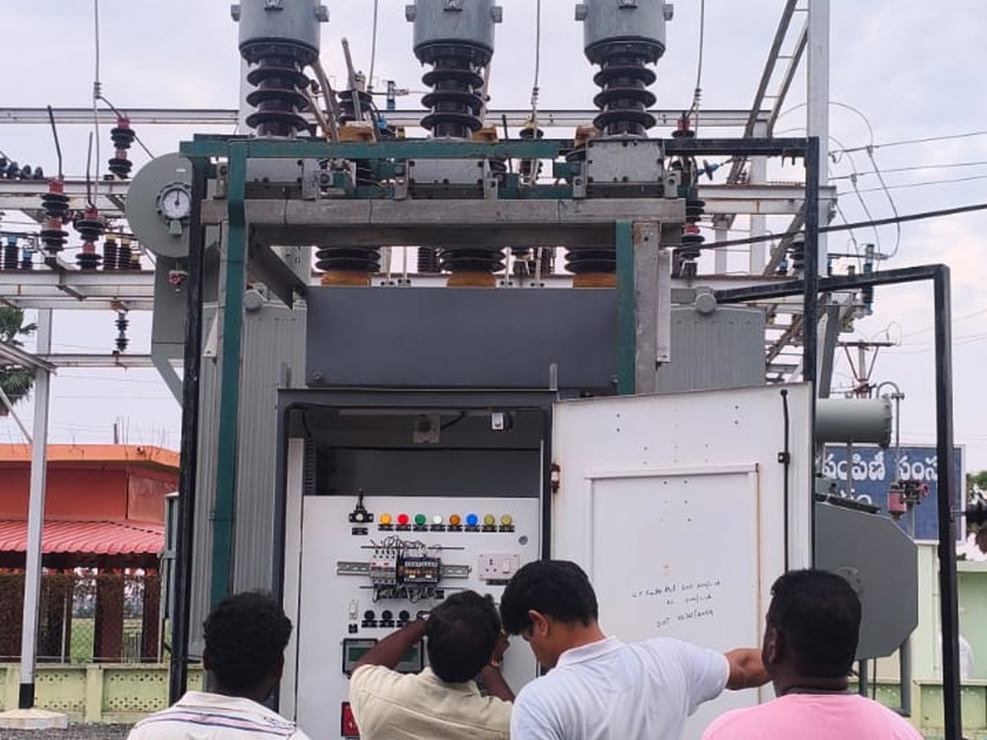 BEFORE 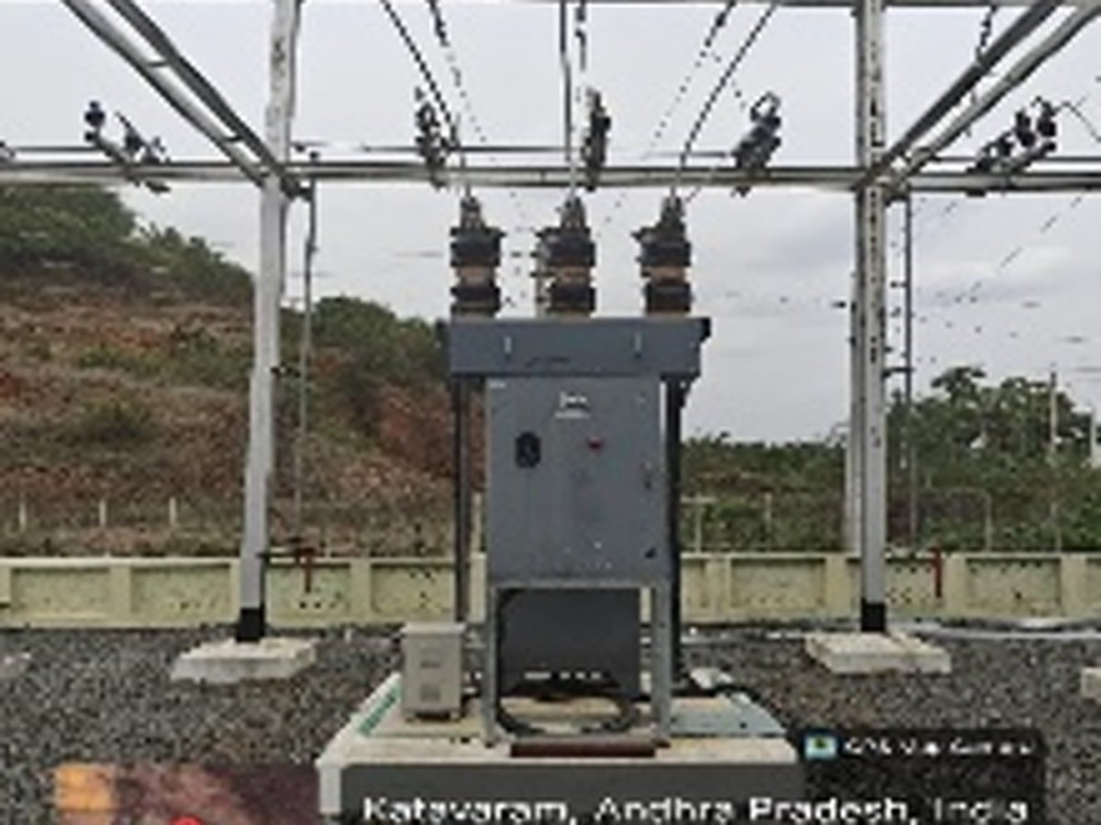 AFTER | S.No 2 · 11 KV Line — 55 sq.mm AAAC over 12.5 m Spun Poles  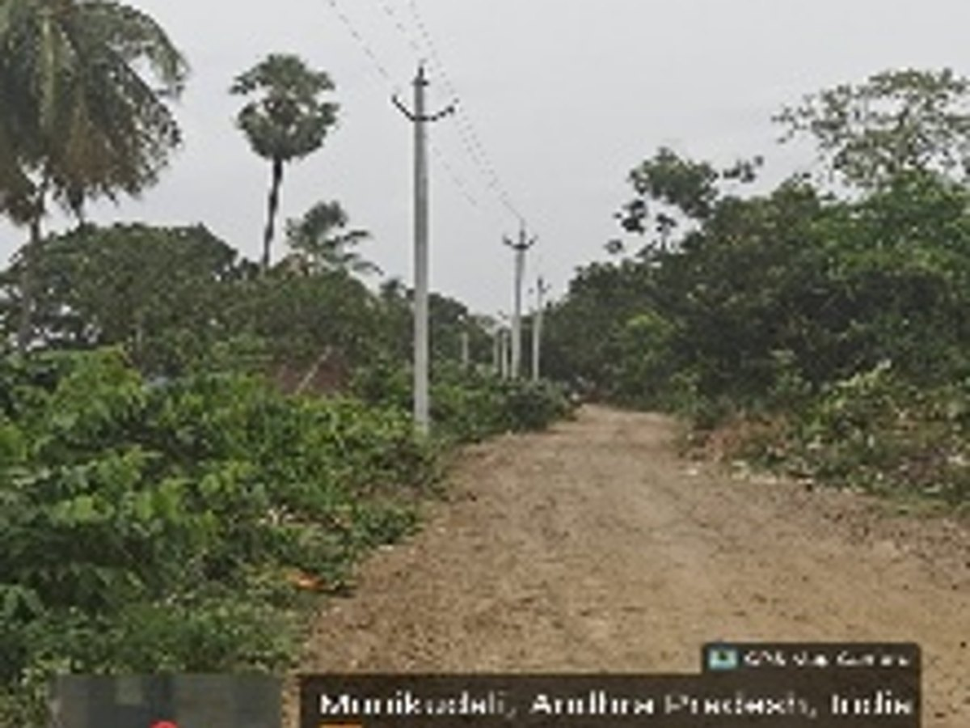  AFTER
S.No 3 · 11 KV Line — 55 sq.mm AAA Conductor over 11 m PSCC Poles  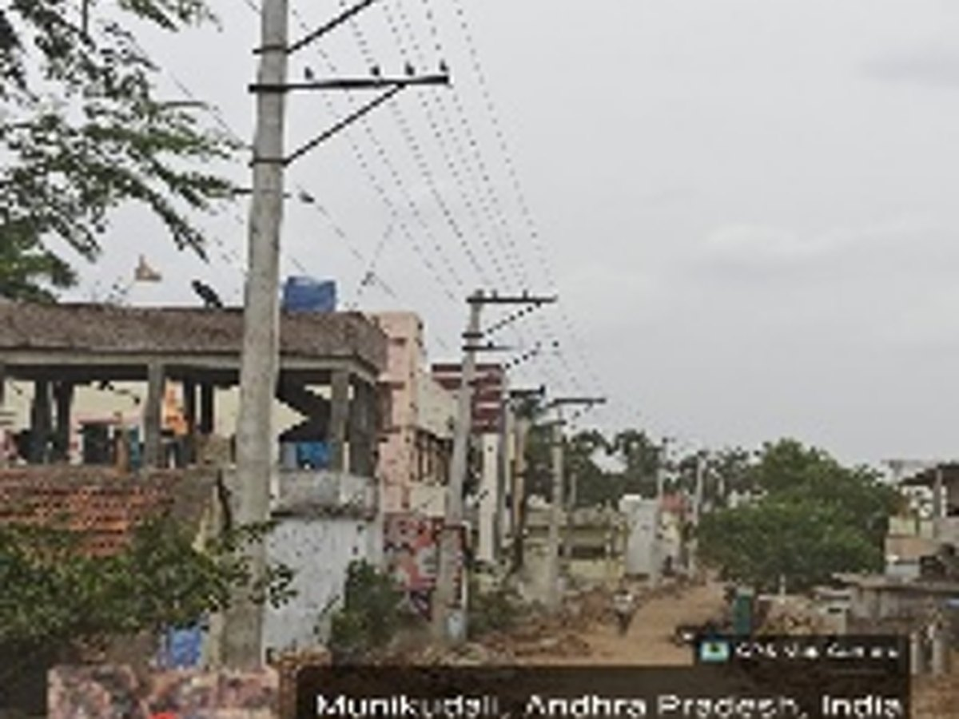  AFTER | S.No 4 · 3-Ph 100 KVA DTRs — 2 Nos.  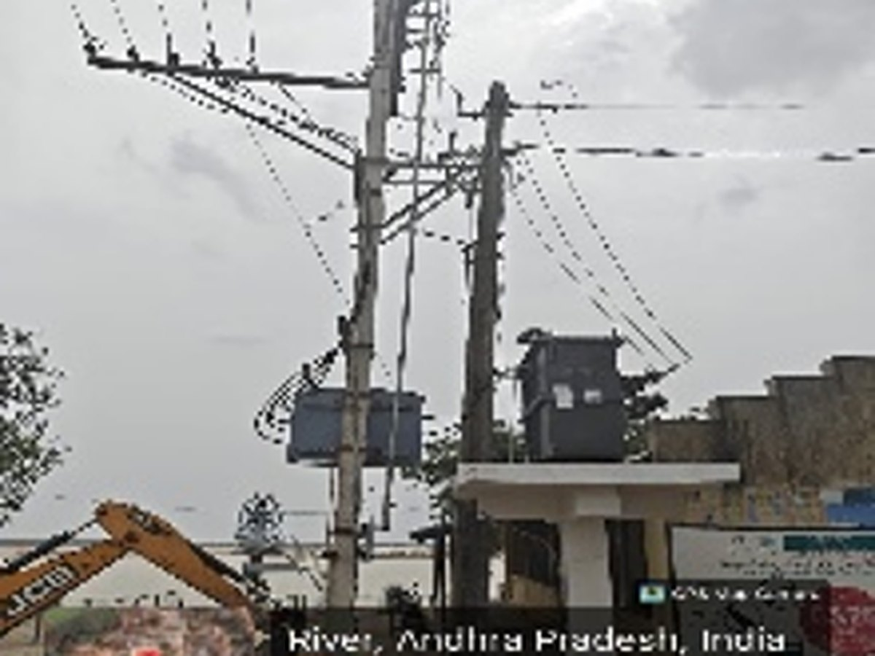  AFTER
S.No 5 · 3-Ph 63 KVA DTRs — 6 Nos.  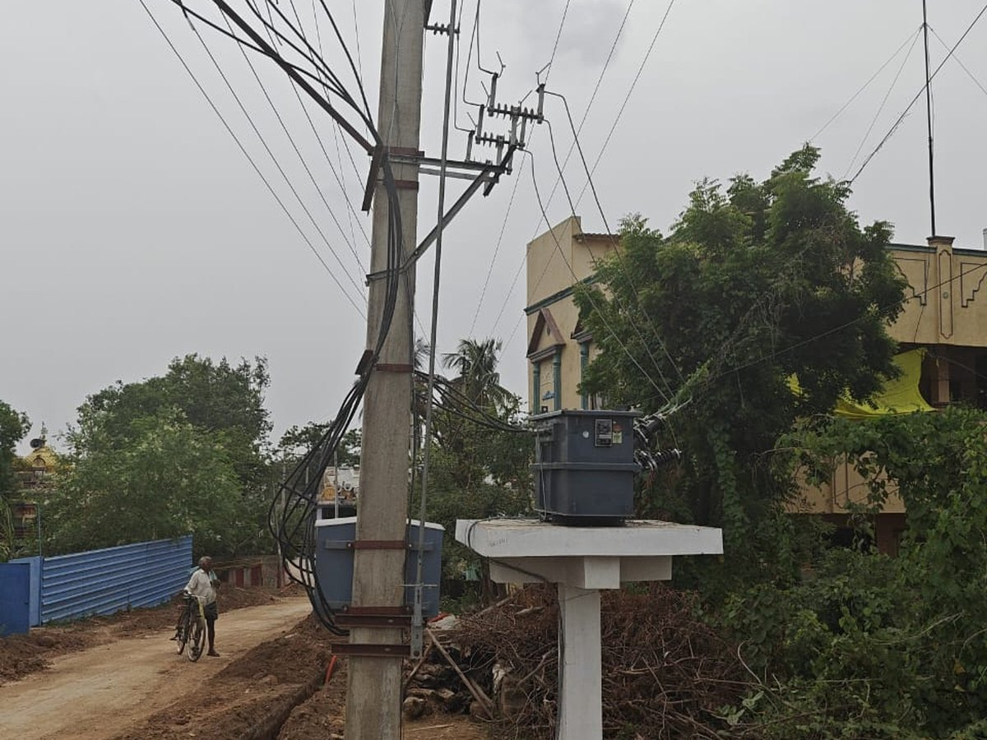  AFTER | S.No 8 · Conversion of 2.8 km 1-Ph 3-Wire to 3-Ph 5-Wire  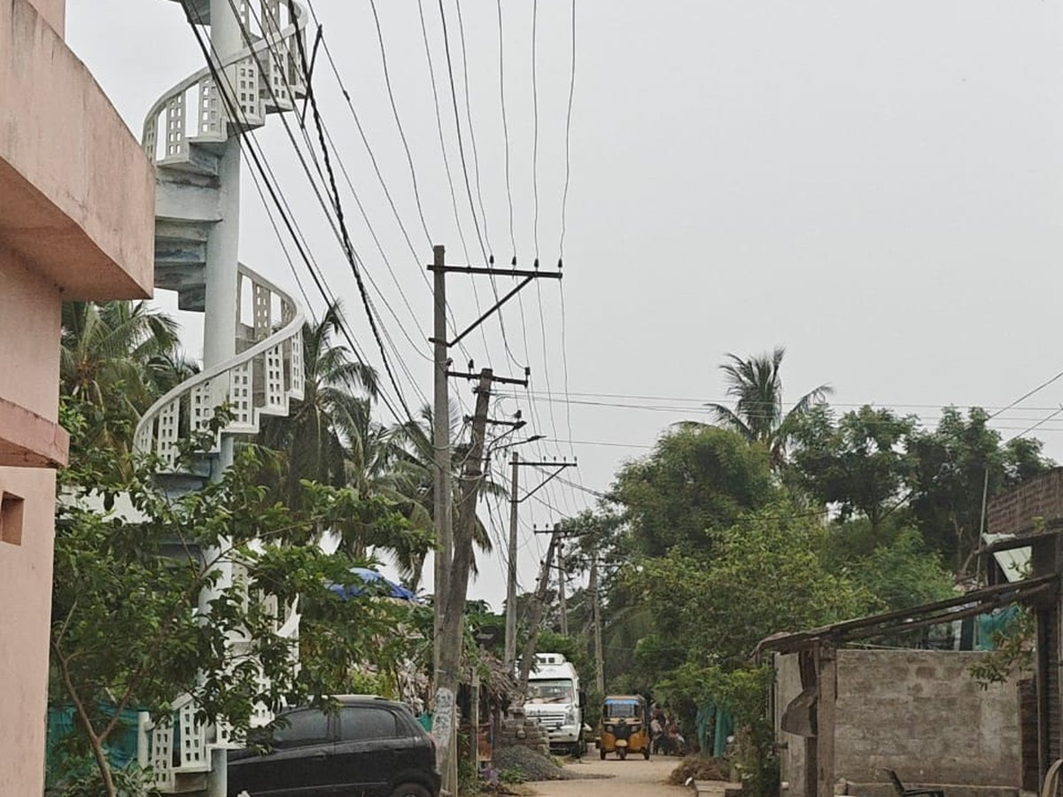  AFTER
S.No 9 · Replacement of 4.2 km Aged LT Conductor
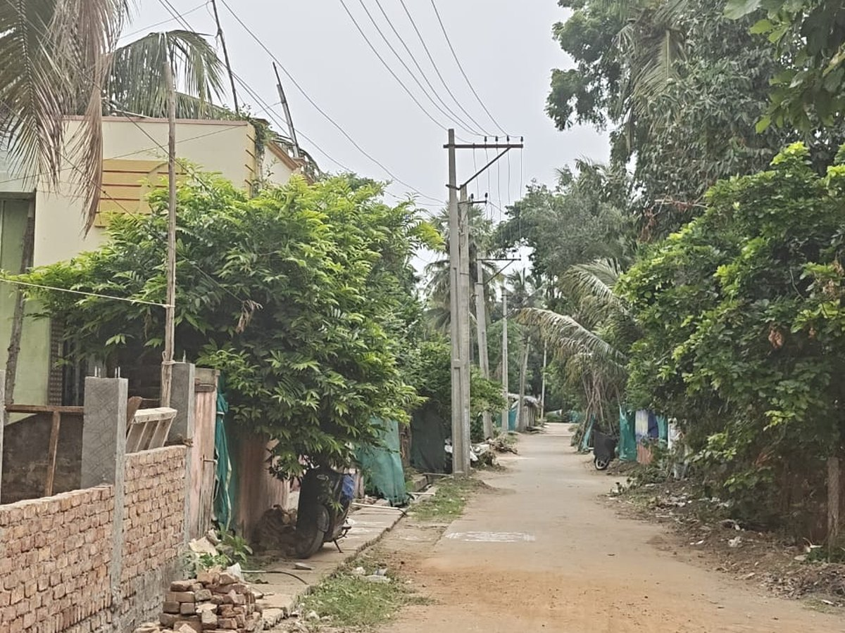
AFTER

3. DWMA | 5 Works │ ₹66.68 Lakh │ 13.00% Avg. Completion

Works  5 | Sanction  ₹66.68 L | Avg. Completion  13.00% | Weighted  12.65% | Executed  ₹8.44 L | Completed / Progress / Not Started  0 / 4 / 1

Work-wise Details
S.No | Name of Proposed Work | Sanction (₹ Lakh) | % of Completion | Status of Work | Target Date
1 | Construction of Magic Drain (Proposed Length : 3416 Mts.) | 40.99 | 12% | IN PROGRESS  under Progress | 15.09.2026
2 | Construction of CC Drain to Magic Drain (Proposed Length : 1540 Mts.) | 12.32 | 5% | IN PROGRESS  under Progress | 15.09.2026
3 | Construction of Community Soak pits (17 Nos.) | 5.61 | 24% | IN PROGRESS  under Progress | 30.09.2026
4 | Construction of Individual Soak Pits (108 Nos.) | 6.48 | 24% | IN PROGRESS  under Progress | 30.09.2026
5 | Avenue Plantation ( in KMs) | 1.28 | 0% | NOT STARTED | 30.09.2026
 | TOTAL — DWMA | 66.68 | 13.00% | Weighted 12.65% · Executed ₹8.44 L

Brief Points — Position of Works
▪ Magic Drain (S.No 1) — ₹40.99 Lakh, 12%. Proposed length 3,416 metres. Largest DWMA work, carrying 61.5% of the departmental sanction. Under progress, target 15.09.2026.
▪ CC Drain to Magic Drain (S.No 2) — ₹12.32 Lakh, 5%. Proposed length 1,540 metres. Under progress, target 15.09.2026.
▪ Soak Pits (S.No 3–4) — ₹12.09 Lakh, 24% each. 17 community soak pits (₹5.61 L) and 108 individual soak pits (₹6.48 L). Both under progress, target 30.09.2026.
▪ Avenue Plantation (S.No 5) — ₹1.28 Lakh. Not started; target 30.09.2026.
▪ Position. 4 works in progress, 1 not started. Departmental average 13.00%; sanction-weighted 12.65% (₹8.44 Lakh executed of ₹66.68 Lakh) — the lowest among departments with works under execution. The two drainage works together carry ₹53.31 Lakh, being 79.9% of the departmental sanction, against a target of 15.09.2026.

3. DWMA — SITE PHOTOGRAPHS | Photographs on record for 4 of 5 works

S.No 1 · Magic Drain — proposed length 3,416 m
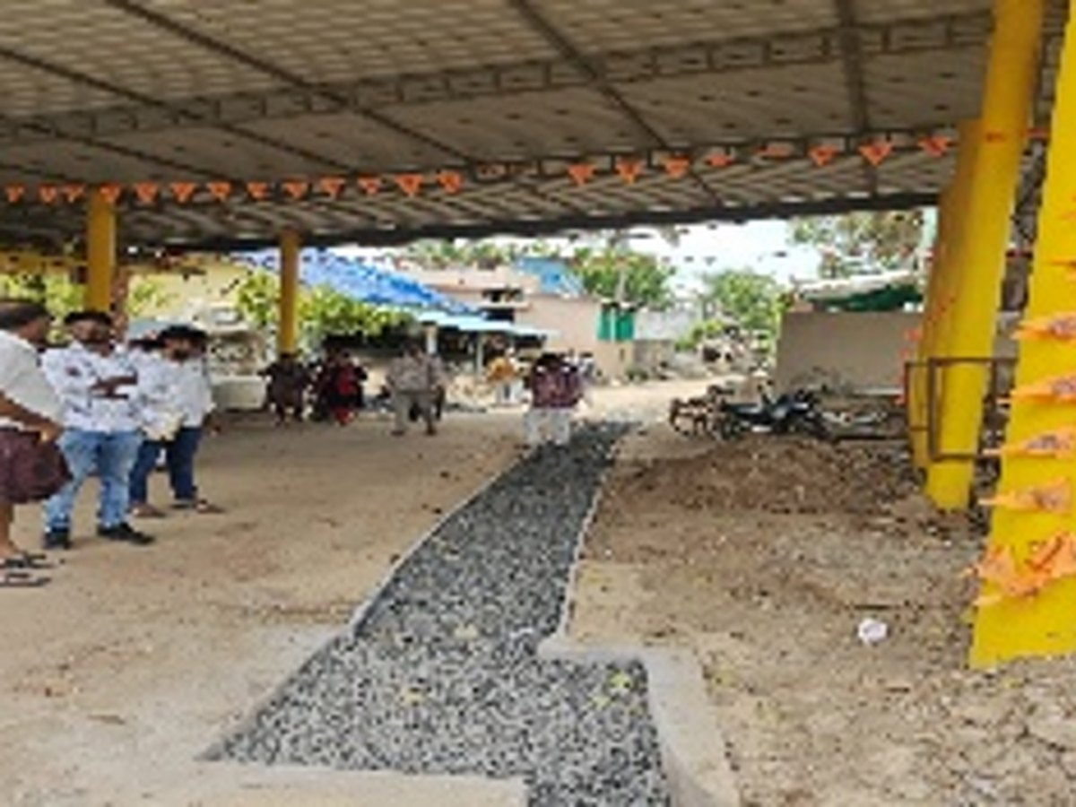  BEFORE | 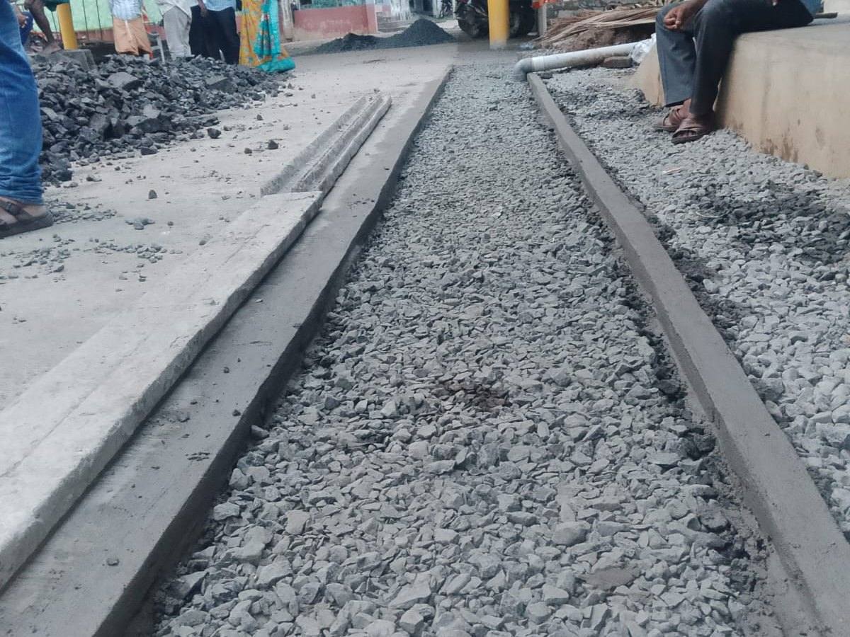  AFTER

S.No 2 · CC Drain to Magic Drain — proposed length 1,540 m
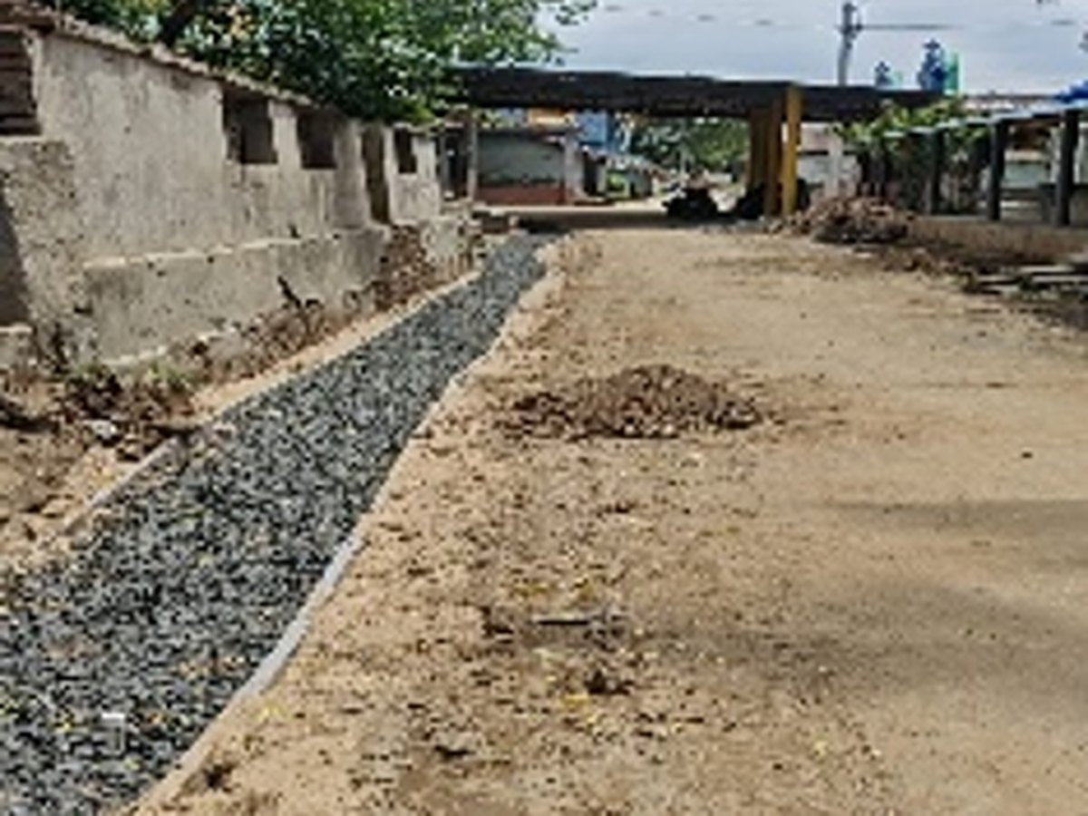  BEFORE | 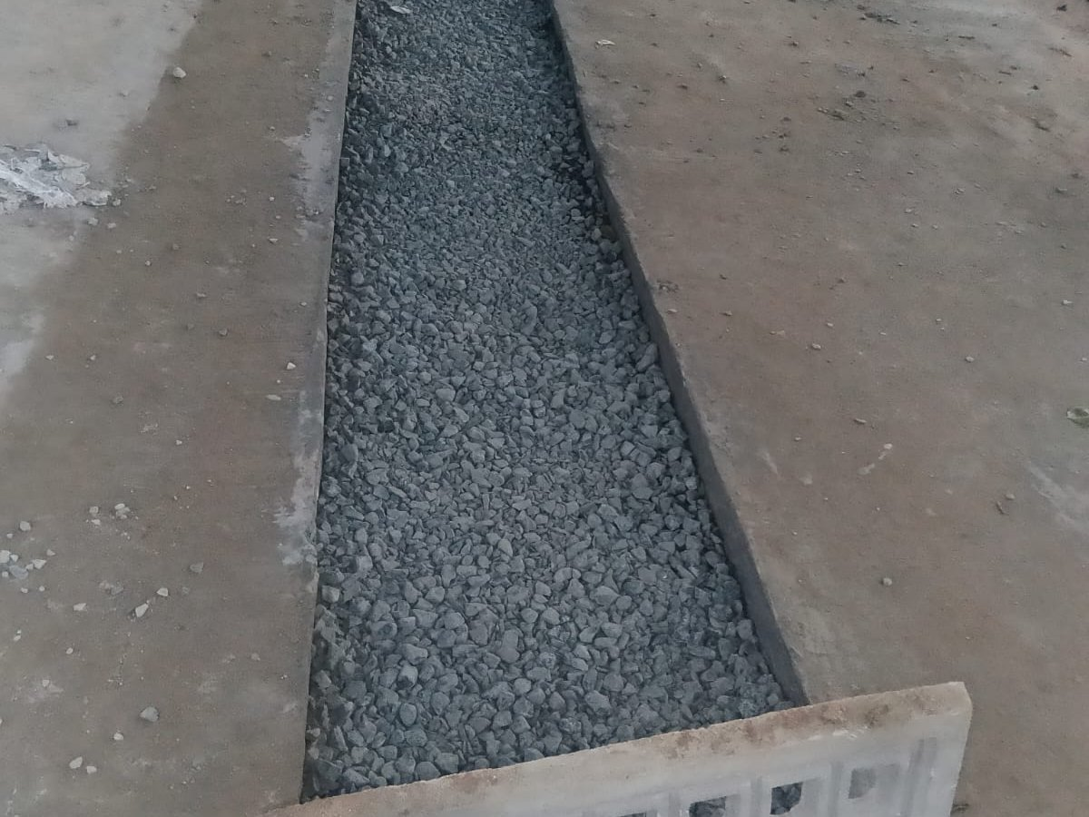  AFTER

S.No 3 · Community Soak Pits — 17 Nos.
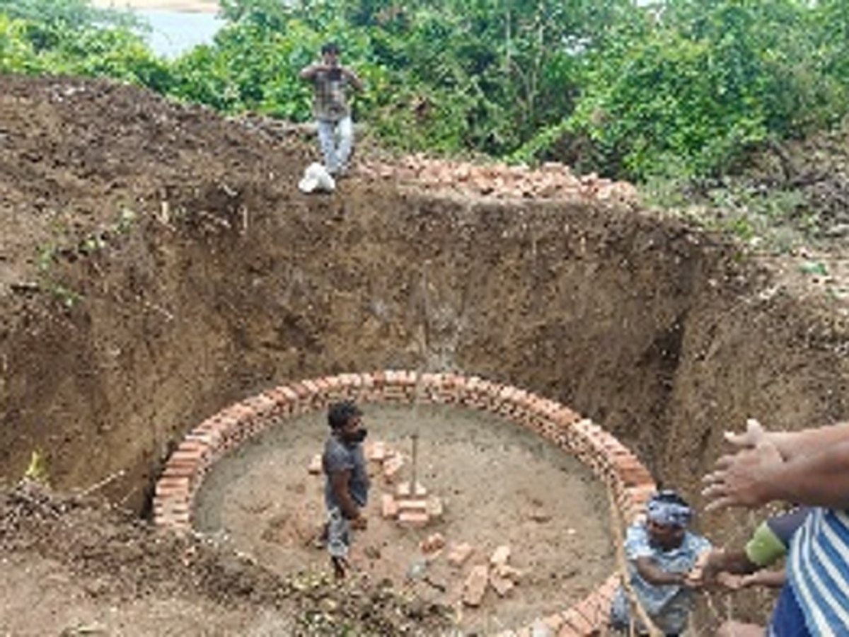  BEFORE | 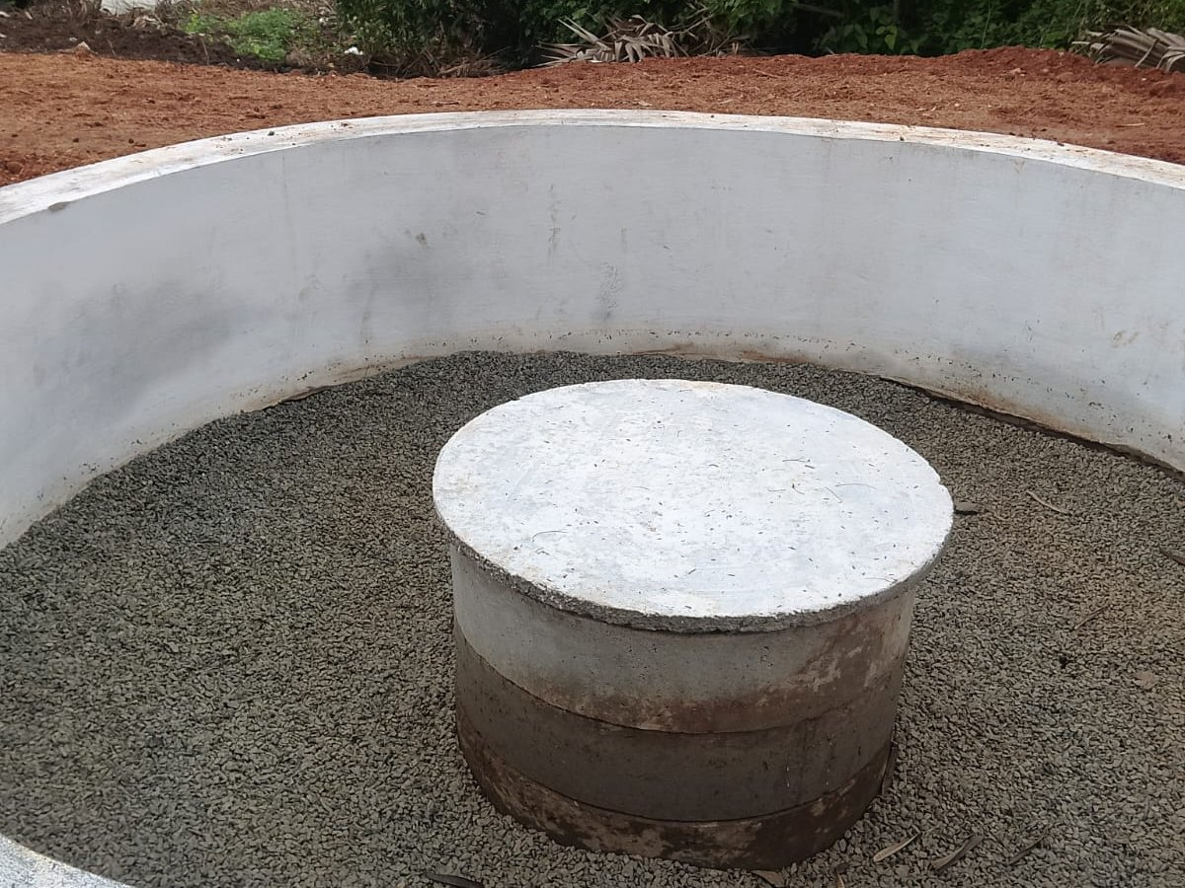  AFTER

S.No 4 · Individual Soak Pits — 108 Nos.
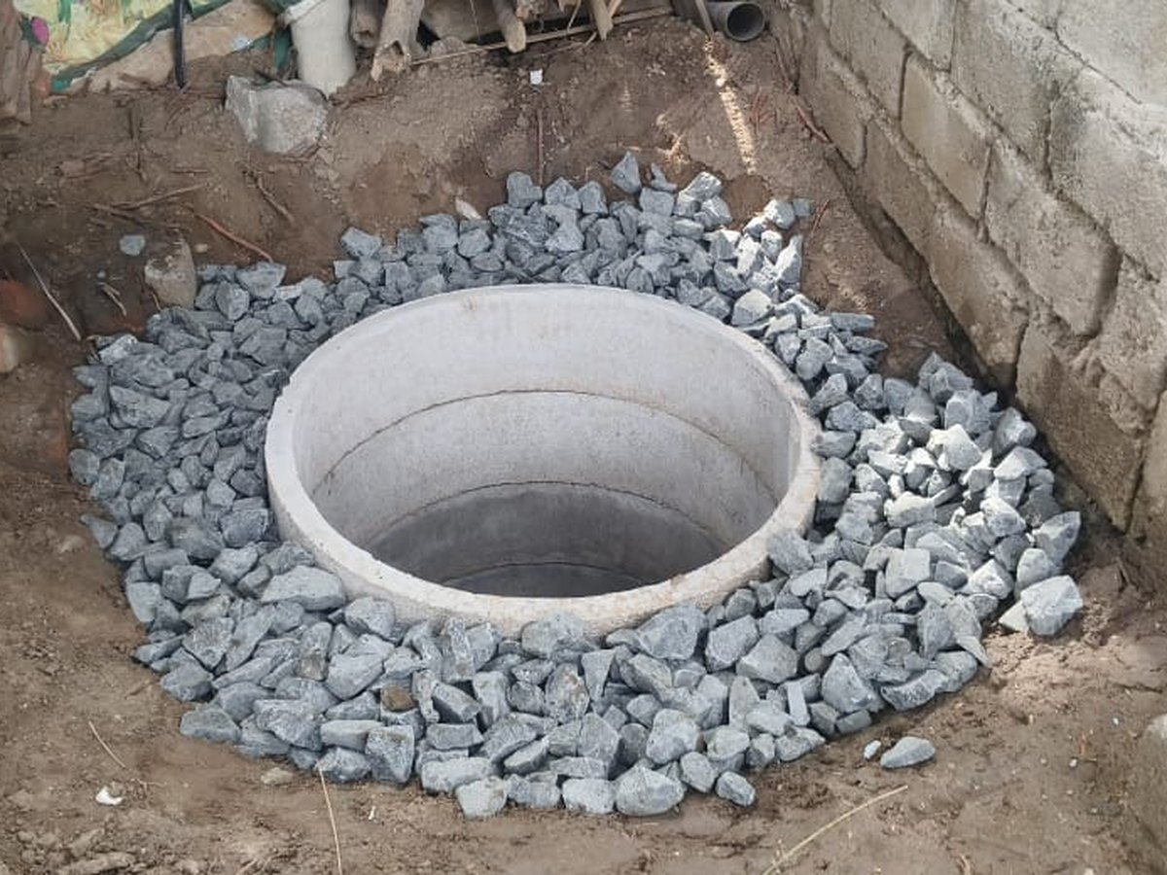  BEFORE | 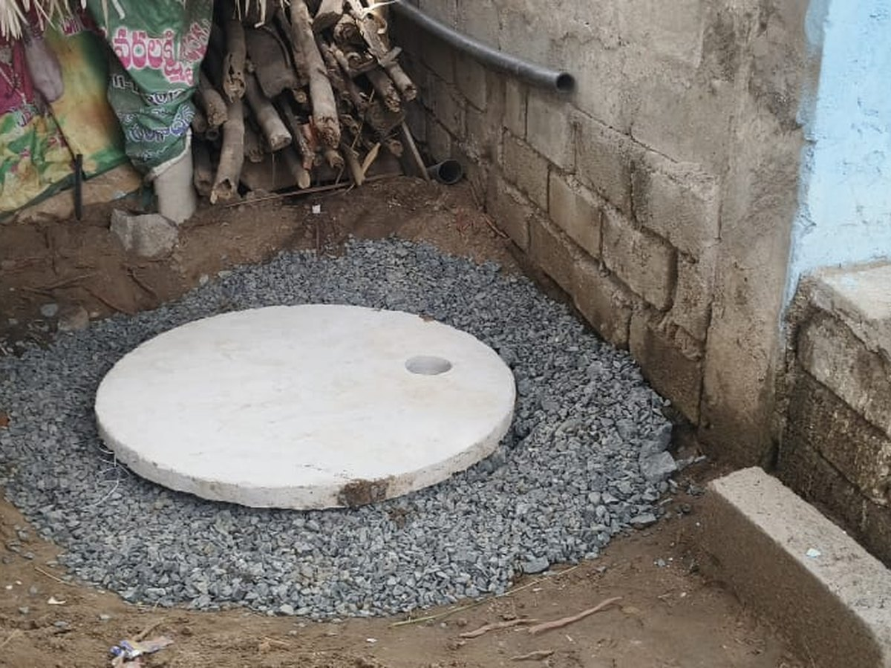  AFTER

4. RWS & S | 1 Work │ ₹12.00 Lakh │ 50.00% Avg. Completion

Works  1 | Sanction  ₹12.00 L | Avg. Completion  50.00% | Weighted  50.00% | Executed  ₹6.00 L | Completed / Progress / Not Started  0 / 1 / 0

Work-wise Details
S.No | Name of Proposed Work | Sanction (₹ Lakh) | % of Completion | Status of Work | Target Date
1 | providing Toilets -16Nos | 12.00 | 50% | IN PROGRESS  5 toilets slab completed&Brick work in progress | 30.09.2026
 | TOTAL — RWS & S | 12.00 | 50.00% | Weighted 50.00% · Executed ₹6.00 L

Brief Points — Position of Works
▪ Toilets (S.No 1) — ₹12.00 Lakh, 50%. 16 toilets sanctioned. Slabs of 5 toilets completed and brick work in progress. Target 30.09.2026.
▪ Position. Single sanctioned work, under progress at 50.00%. Executed value ₹6.00 Lakh of ₹12.00 Lakh, against a target of 30.09.2026.

4. RWS & S — SITE PHOTOGRAPHS | Photographs on record for 1 of 1 work

S.No 1 · Providing Toilets — 16 Nos.
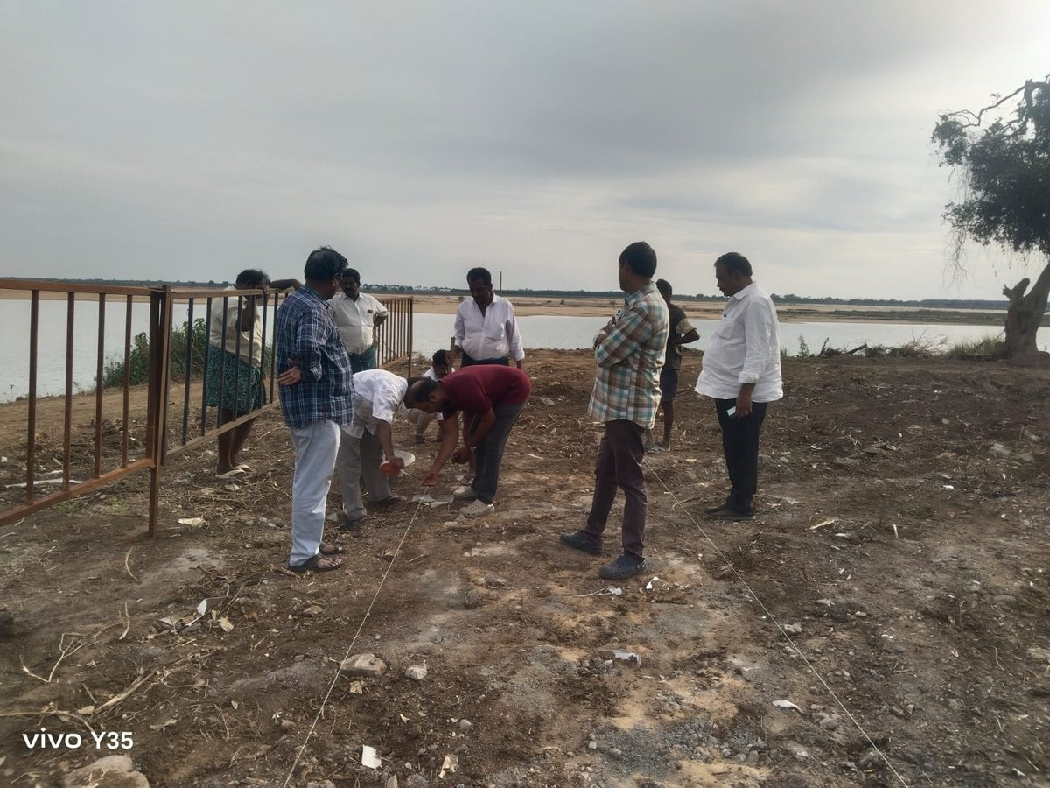
BEFORE
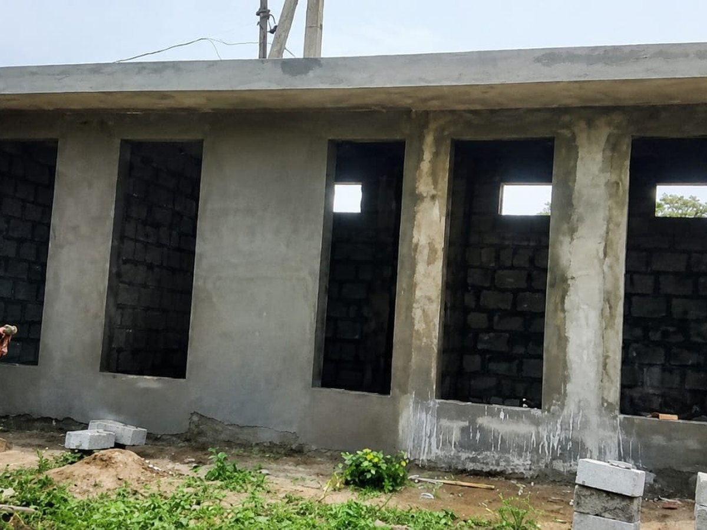
AFTER

5. ENDOWMENT | 1 Work │ ₹30.00 Lakh │ 0.00% Avg. Completion

Works  1 | Sanction  ₹30.00 L | Avg. Completion  0.00% | Weighted  0.00% | Executed  ₹0.00 L | Completed / Progress / Not Started  0 / 0 / 1

Work-wise Details
S.No | Name of Proposed Work | Sanction (₹ Lakh) | % of Completion | Status of Work | Target Date
1 | Re-construction of compound wall, flooring around temple,painting to temple, electrification, slab leaky proof treatment | 30.00 | 0% | NOT STARTED  Tender Completed and Agreement Yet to Be Concluded | 31.12.2026
 | TOTAL — Endowment | 30.00 | 0.00% | Weighted 0.00% · Executed ₹0.00 L

Brief Points — Position of Works
▪ Temple Works (S.No 1) — ₹30.00 Lakh, 0%. Re-construction of compound wall, flooring around temple, painting to temple, electrification and slab leak-proof treatment.
▪ Status. Tender completed; agreement yet to be concluded. Target 31.12.2026.
▪ Position. Nil physical progress. Work can commence only after conclusion of the agreement.

6. IRRIGATION | 1 Work │ ₹178.76 Lakh │ 0.00% Avg. Completion

Works  1 | Sanction  ₹178.76 L | Avg. Completion  0.00% | Weighted  0.00% | Executed  ₹0.00 L | Completed / Progress / Not Started  0 / 0 / 1

Work-wise Details
S.No | Name of Proposed Work | Sanction (₹ Lakh) | % of Completion | Status of Work | Target Date
1 | Improvements to existing Munikudali Ghat on Akhanda Godavari Left Bank at km 22.600 in Munikudali Village of Sithanagaram Mandal in East Godavari District | 178.76 | 0% | NOT STARTED  Work Sanctioned. Work awarded to Contractor. | 31.03.2027
 | TOTAL — Irrigation | 178.76 | 0.00% | Weighted 0.00% · Executed ₹0.00 L

Brief Points — Position of Works
▪ Munikudali Ghat Improvements (S.No 1) — ₹178.76 Lakh, 0%. Improvements to the existing Munikudali Ghat on Akhanda Godavari Left Bank at km 22.600, Munikudali village, Sithanagaram Mandal, East Godavari District.
▪ Status. Work sanctioned and awarded to contractor. Target 31.03.2027.
▪ Position. Largest single sanction in the programme — ₹178.76 Lakh, being 29.71% of the total outlay of ₹601.77 Lakh — at nil progress, and carries the longest target date in the programme (31.03.2027).

◆ ◆ ◆

