**1) Setup a virtual machine using Ubuntu image.**

* Virtual machine setup is completed

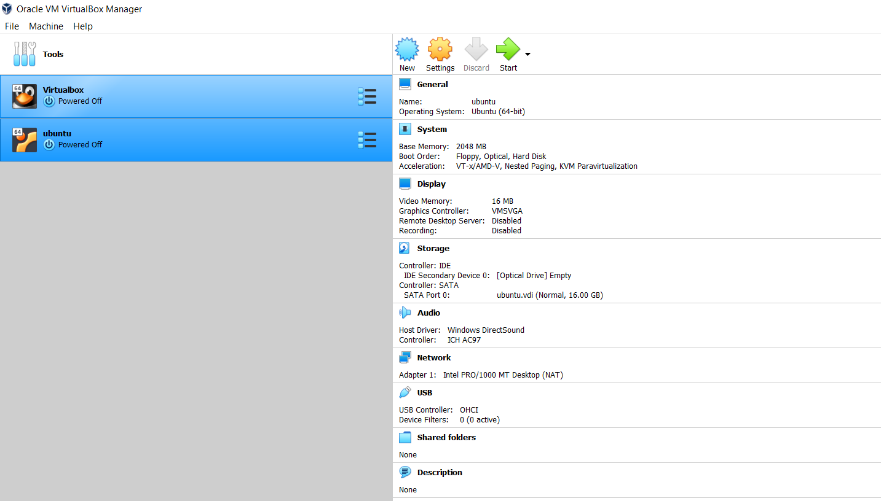

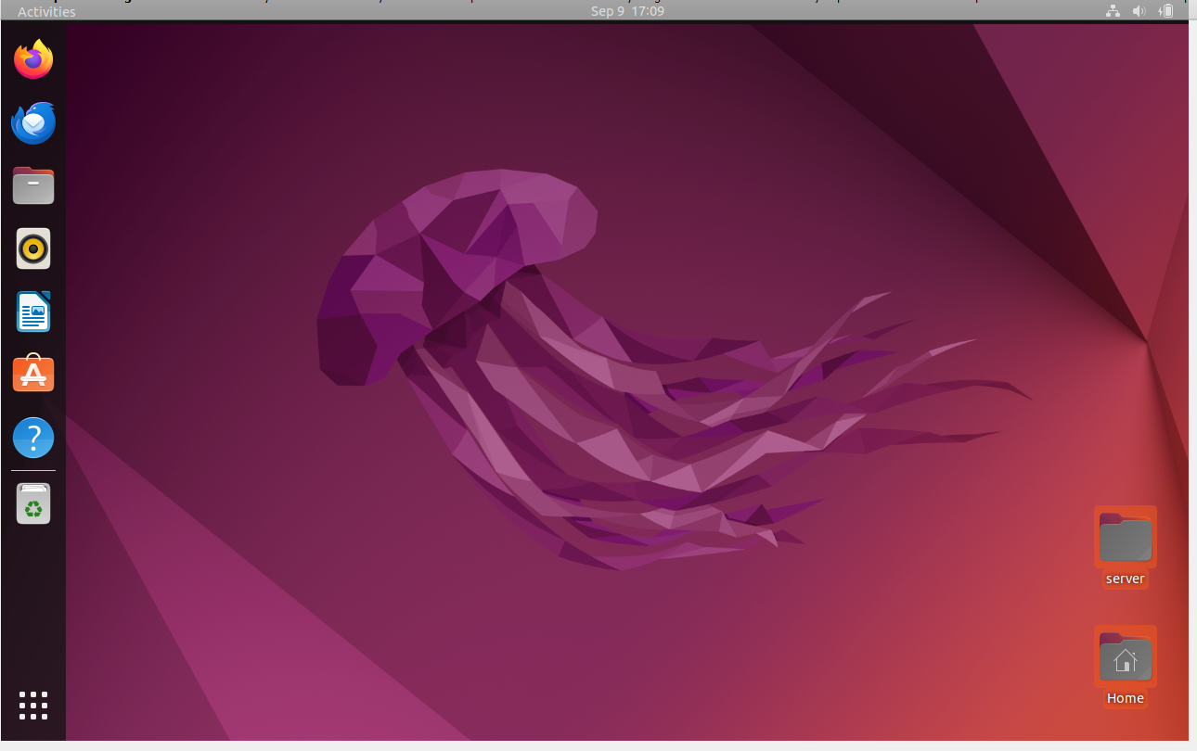

1. **Install docker on ec2.**

* First Install an ec2-instance with t2.large and connect

* Then install docket using below command

yum -y install docker

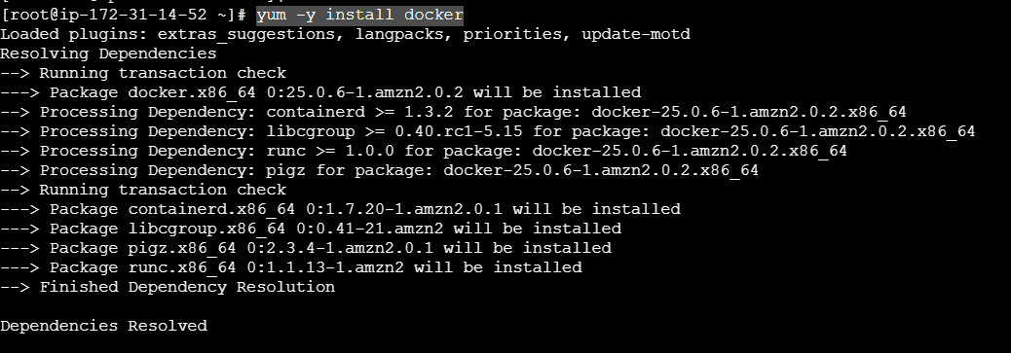

* After installation check the start the docker using below command

systemctl start docker

* Then check the status of dockerusing below command

systemctl status docker

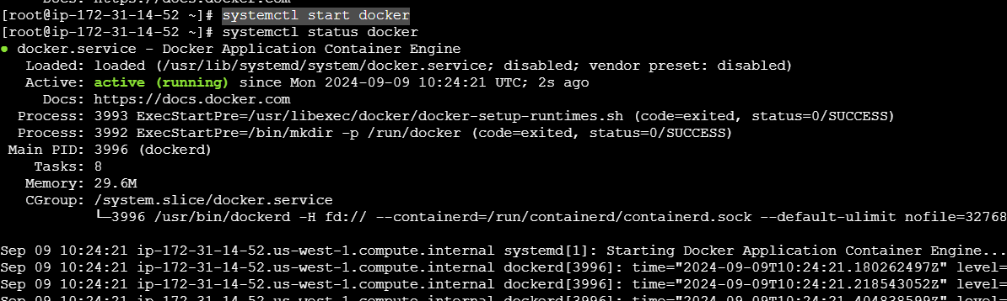

* To check the version of docker using **docker --version**



1. **Pull 5 docker images.(nginx,apache tomcat,ubuntu,jenkins,sonarqube)**

* **docker pull nginx** to download the nginx image into the docker

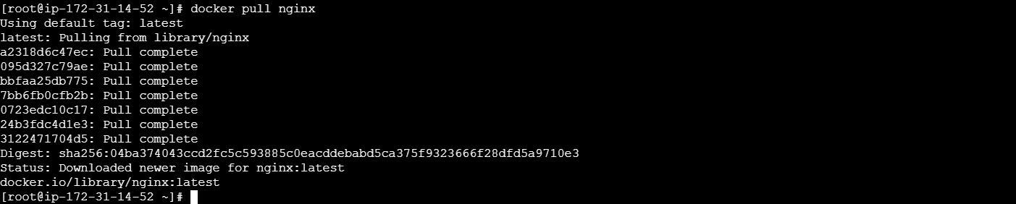

* **docker pull httpd** to downloaded the apache image

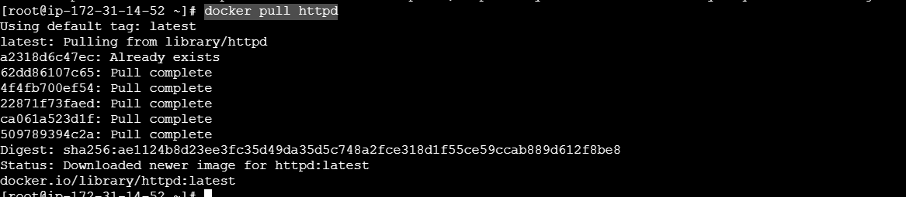

* **docker pull tomcat** to downloaded the tomcat image

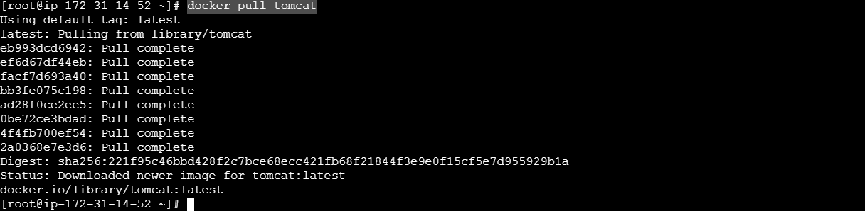

* **docker pull ubuntu** to downloaded the ubuntu image

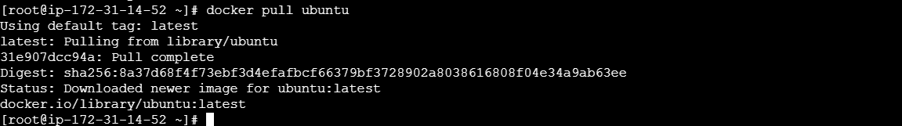

**\* docker pull sonarqube** to downloaded the sonarqube image

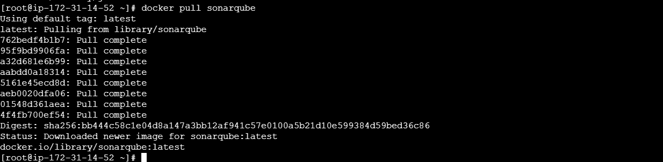

**\* docker pull jenkins:2.60.3** to downloaded the jenkins image

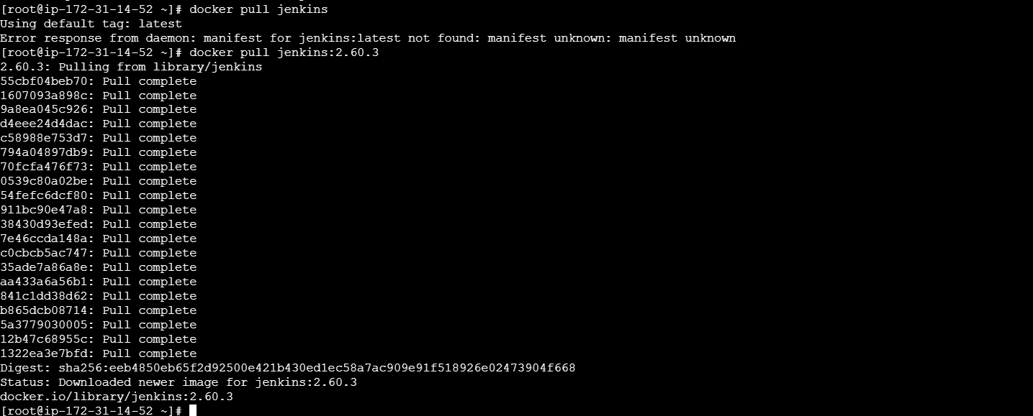

* To check the images which are dowloaded using **docker images**

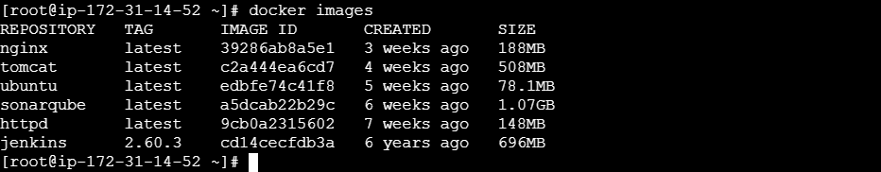

1. **Run nginx container and expose on port 81**

* first try to run the nginx conatiner using **docker container run nginx**, Then getting exited

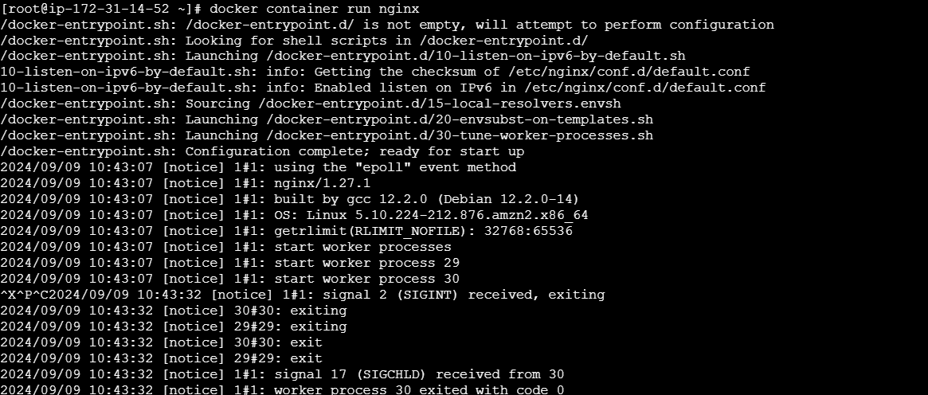

* After that using **docker container run -itd nginx** to run the nginx container which are running on default 80 port number

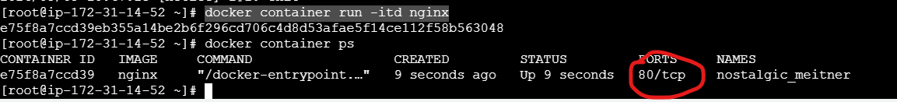

* Now changed the port number from 80 to 81 using below command and adding the name as well

**docker container run -itd -p 81:80 --name test-container nginx**

-> -it = is the interactive terminal

-> d = background/daemon mode



**\*** Now I want to know the public ip to check nginx server is running or not

“**docker container inspect ce1bb273846f”**

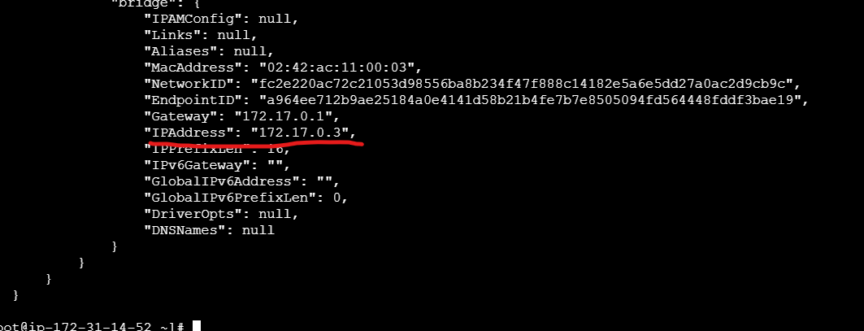

**curl 172.17.0.3** to check that nginx server is deploying or not using this ip

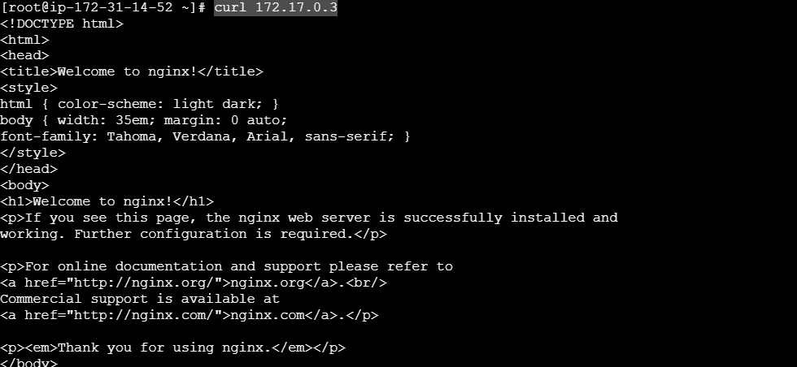

1. **Delete the apache tomcat image from local.**

**\*** Using below command to delete the tomcat using image id

**“docker image rmi c2a444ea6cd7”**

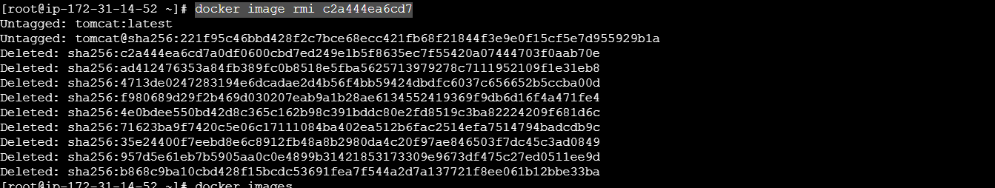

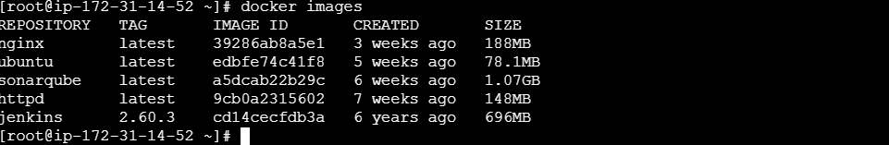

1. **Inspect the jenkins image,sonarqube image.**

* First we need to run the sonarqube and jenkins image

“docker container run -itd sonarqube”

“docker container run -itd jenkins:2.60.3”



* Then I checked these images which are running in container



* Now I inspect the **sonarqube** using below command

docker container inspect d275c8814c6d

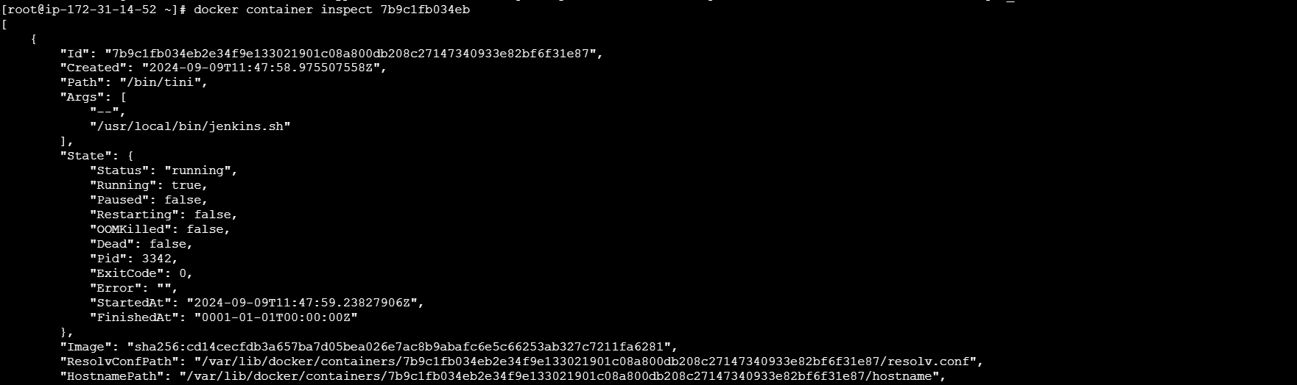

Now I inspect the **jenkins** using below command

**docker container inspect 7b9c1fb034eb**

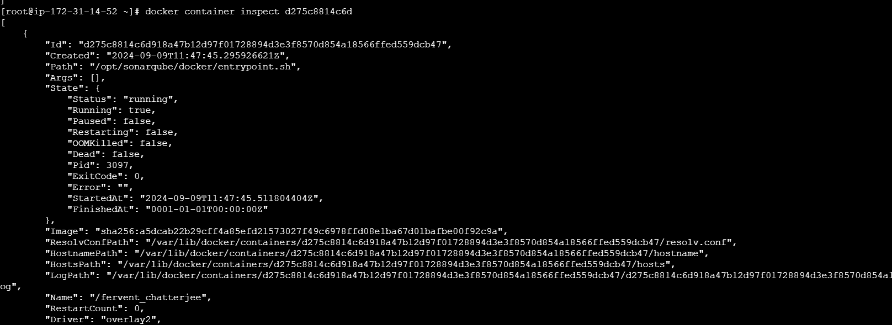

**7) Run jenkins contianer and run one sample job.**

* First I mapped this jenkins on 8080 port number



* By using below command to read the intial password and logged into jenkins

* Then created new job and execute a sample job

**docker exec 4732a4947743 cat /var/jenkins_home/secrets/initialAdminPassword**

