**Installing Jenkins**

1. **Install jenkins and run jenkins on port number 8081**

* First I created a ec2 Instance with t2.medium and 20 GB storage.

*Then connected to instance and installed “java” for prerequisition of jenkins

sudo apt update

sudo apt install fontconfig openjdk-17-jre

java -version

* Then Installed jenkins using below commands

* sudo wget -O /usr/share/keyrings/jenkins-keyring.asc \

https://pkg.jenkins.io/debian-stable/jenkins.io-2023.key

* echo "deb [signed-by=/usr/share/keyrings/jenkins-keyring.asc]" \

https://pkg.jenkins.io/debian-stable binary/ | sudo tee \

/etc/apt/sources.list.d/jenkins.list > /dev/null

* sudo apt-get update
* sudo apt-get install jenkins

* Then I changed a default port number at below file

* /lib/systemd/system/jenkins.service

* Restarted the jenkins using systemctl daemon-reload

* To start the jenkins by using systemctl start jenkins

Check the status of jenkins using systemctl status jenkins

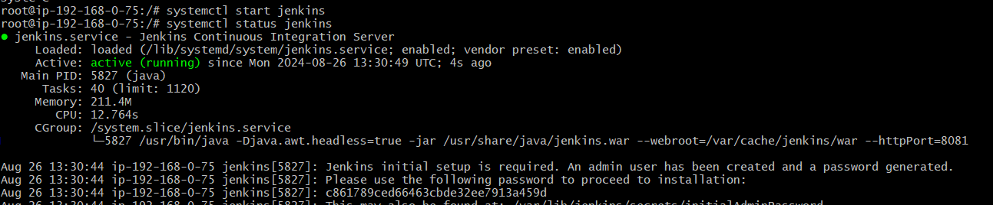

* After changing the port checked with public on 8081 port

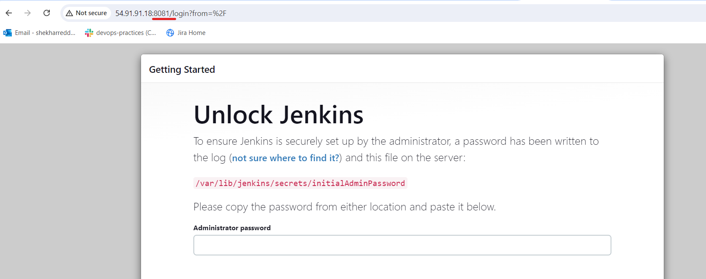

1. **Secure Jenkins server**

* Using Intialadminpassword opened the jenkins.

* After this added the credentials for security of jenkins

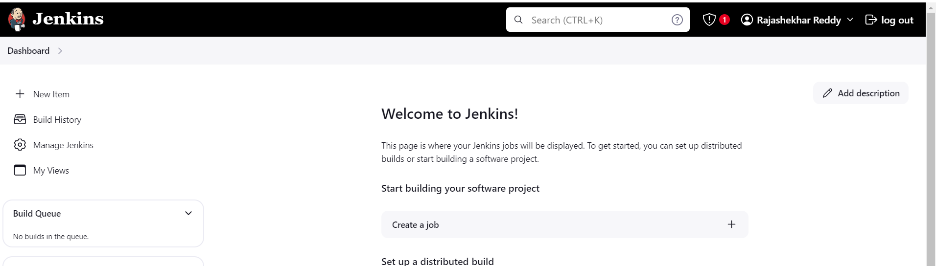

1. **Create users called Devops, Testing in Jenkins with Limited access**

* First need to download the role-basedauthoriztion

* Open the **Jenkins Dashboard →Manage jenkins→Security→click on users** to create the users

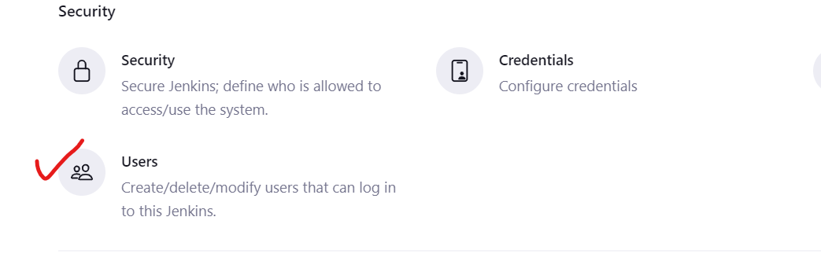

Created 3 Users

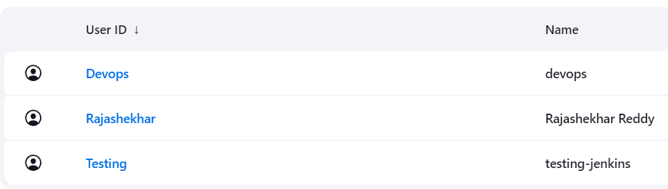

* Given the limited access for these created users.

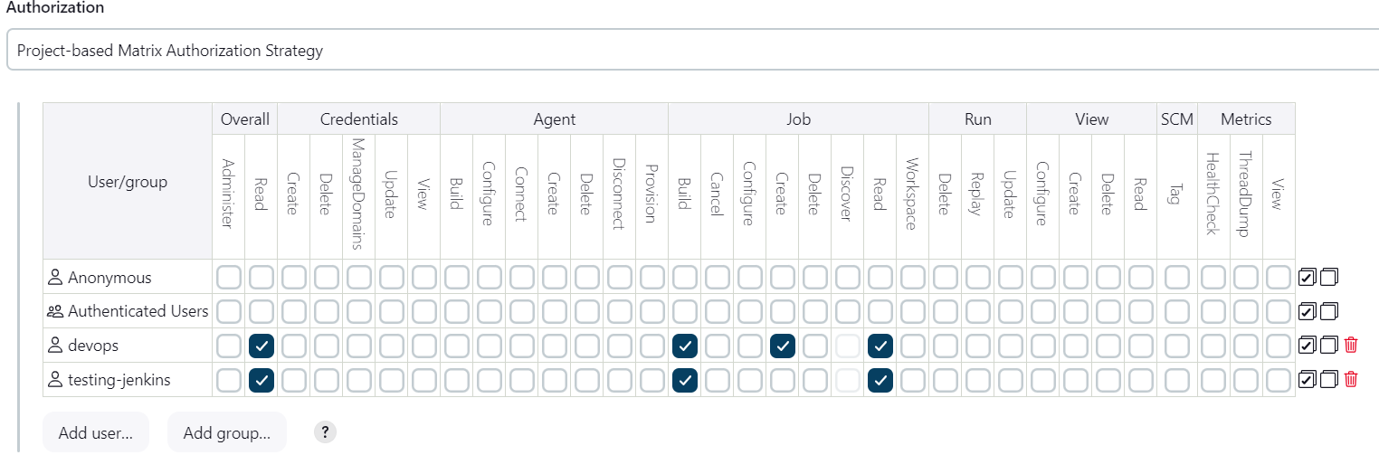

1. **Configure labels and restrict the jobs to execute based on label only.**

* First go to Jenkins Dashboard→manage jenkins→system→in label given a label name

* By using this label name I have given usage as **only build jobs with label expressions matching this node,**

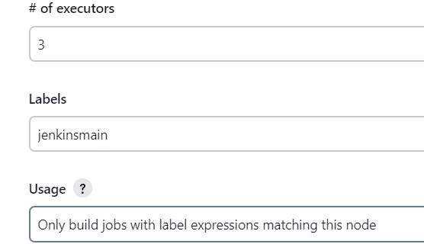

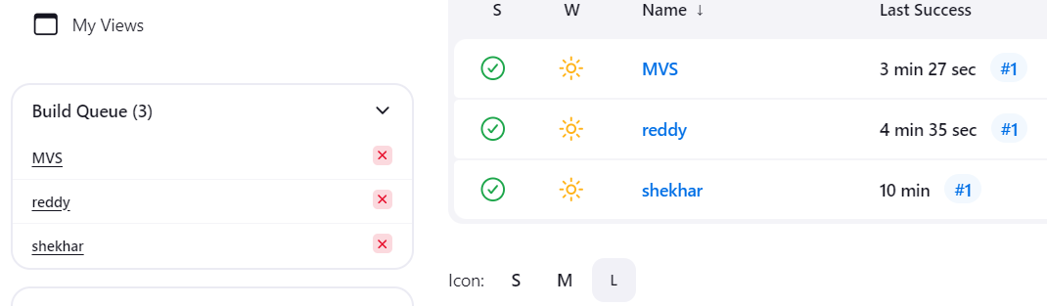

**\*** Using this for appling one job**”shekhar”** to execute the code only for having this label name of the job to execute the particular job only which is having this label name.

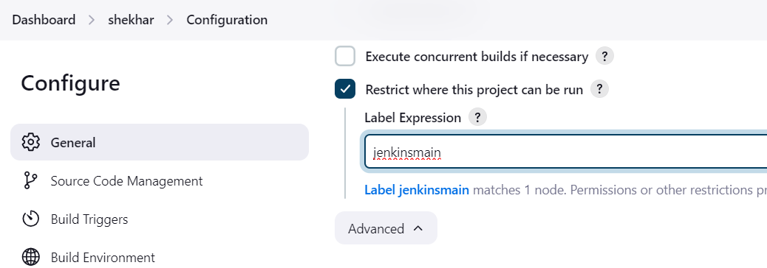

* for which job can I given the label name , which is only only build the job, remain two jobs are in queue, these two jobs are not to be execute

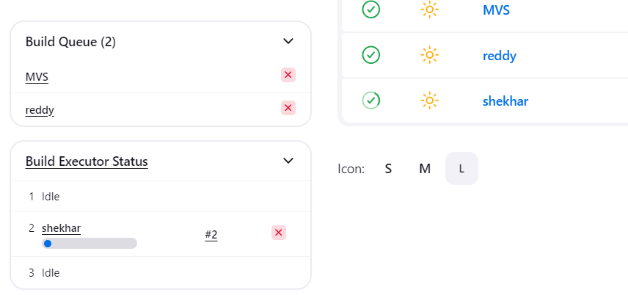

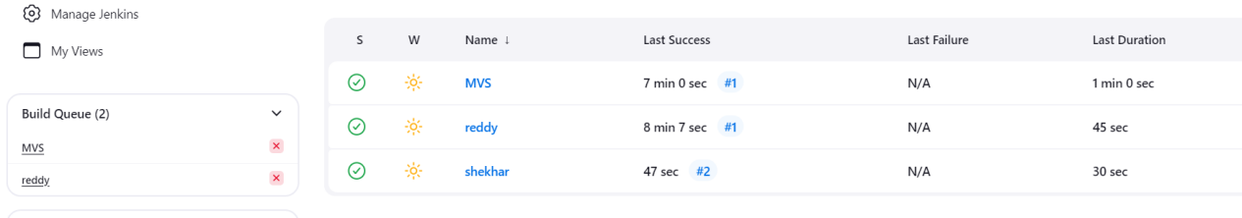

First go to Jenkins Dashboard→manage jenkins→system→in label given a label name

* By using this label name I have given usage as “**Use this node as much as possible”**

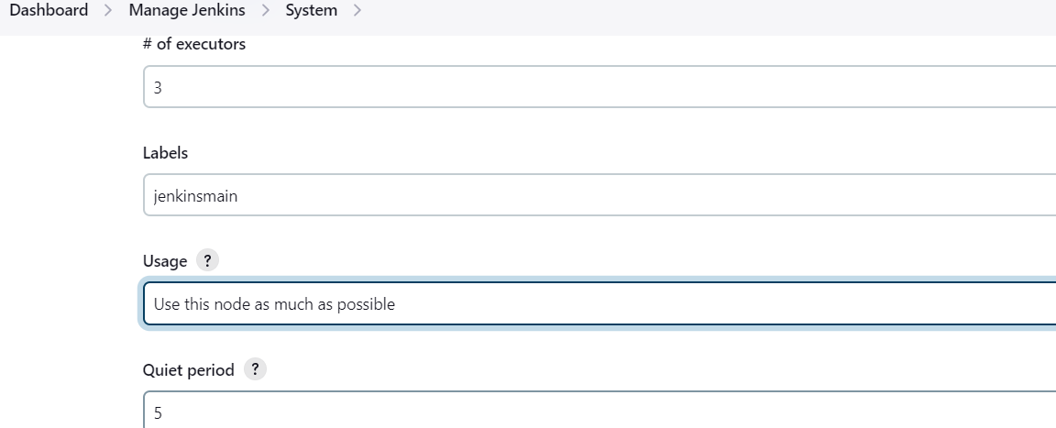

**\*** Using this label name for applying on one job**”shekhar”** to build the code which is running in first then after only another job **“reddy”** will be build the code

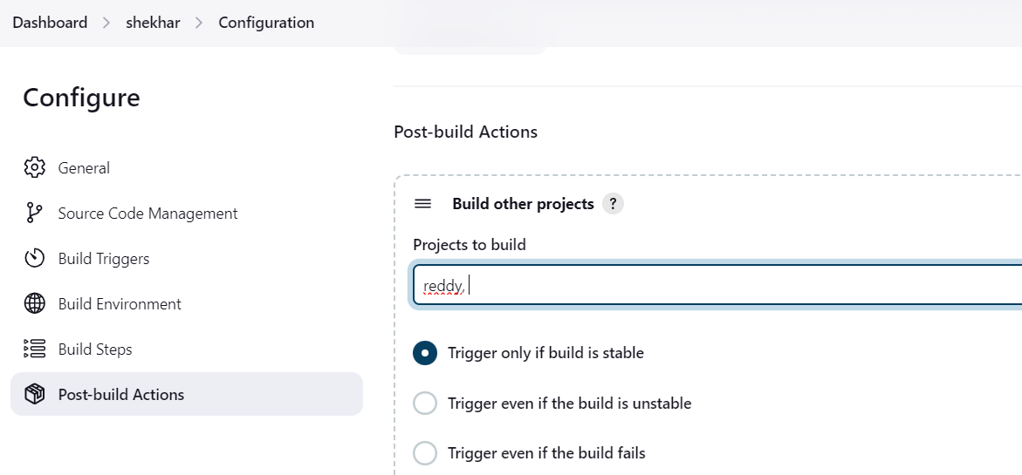

**5) Create Three sample jobs using the below URL.**

**<https://github.com/betawins/Techie_horizon_Login_app.git>**

* Created 3 sample jobs and with “github repository-url” added

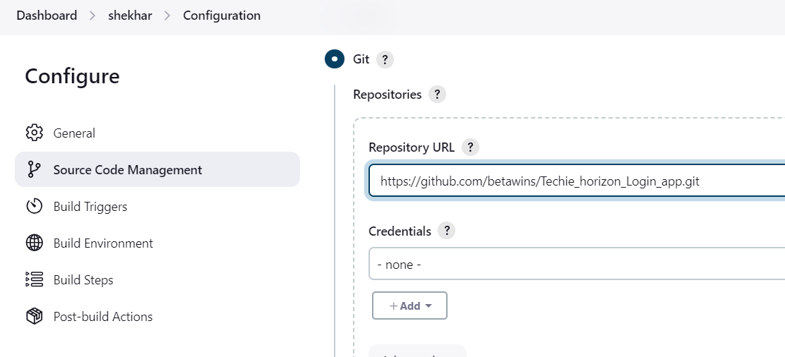

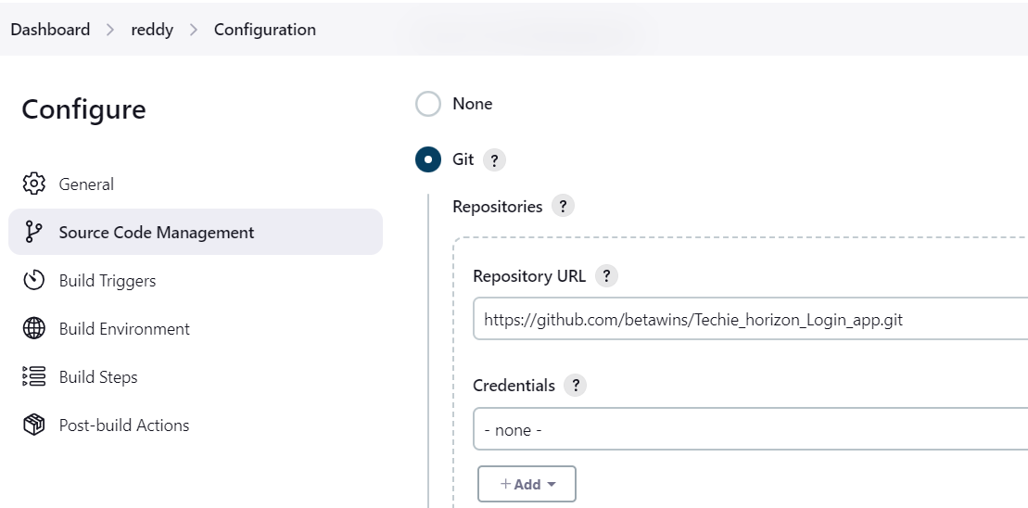

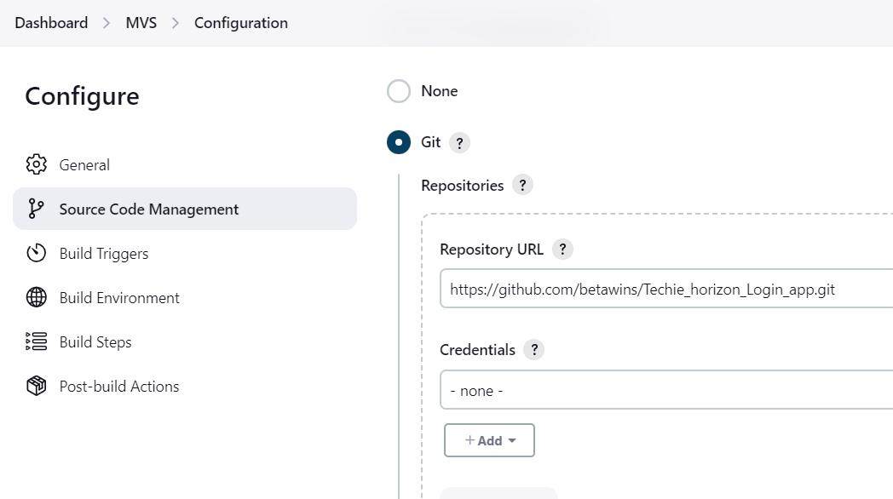

* Checked on jenkins workspace folder where these jobs are created or not

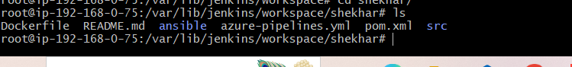

6)**Create one jenkins job using git hub Private repository**

* First I have created one “**Jenkins job”**

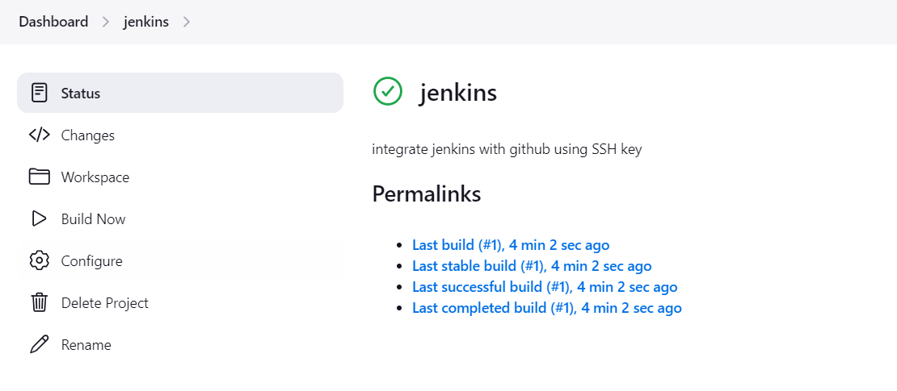

* Open the Git hub and created a Private repository

* Then created one personal access key token

* Copied it and go to jenkins Dashboard

\***Open the Jenkins job→go to configure→Source code management→Select git→Add the Repository URL and credentials→In Branches to build enter the branch name→save**

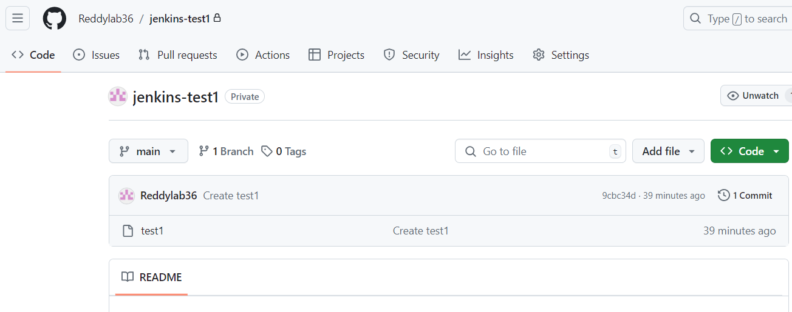

* Then Build the job and then it will gets successfully built

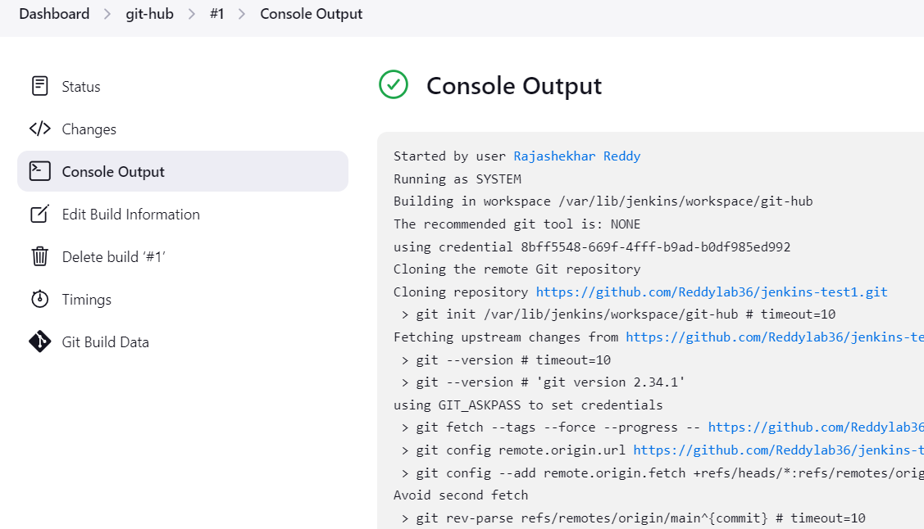

* From the Github private repository files has been added into jenkins

