**1) Watch terraform-06 video.**

1. **Execute the script shown in video.**

**\*** CREATING MODULES

* main.tf is the root module

resource "aws_instance" "webserver" {

  ami = var.ami

  instance_type = "t2.micro"

}

Defining variables in Variable.tf file of root module

variable "ami" {

}

* main.tf file of submodule

module "dev-webserver" {

  source = "../aws_instance"

  ami = "ami-0731b5a29c85c1f0c"

}

Using main module we can create sub-modules for various environments with same configurations of main modules

module "prod-webserver" {

  source = "../../aws_instance"

  ami = "ami-0731b5a29c85c1f0c"

}

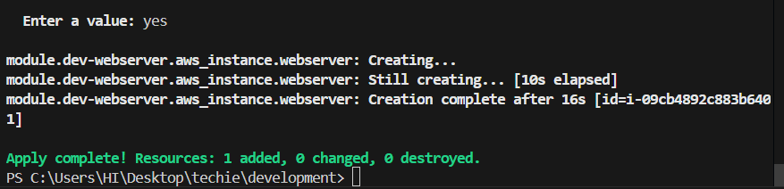

* Creating workspace

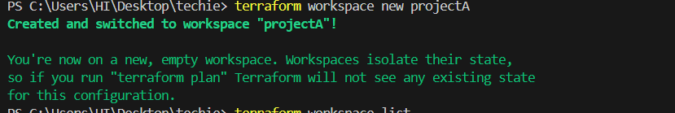

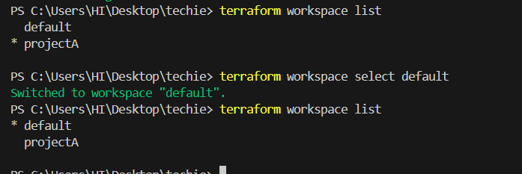

resource "aws_instance" "webserver" {

  ami = var.ami[var.project]

  instance_type = "t2.micro"

}

variable "ami" {

  type = map(string)

  default = {

    "ProjectA" = "ami-0731b5a29c85c1f0c",

    "ProjectB" = "ami-025258b26b492aec6"

  }

}

# Define the project variable

variable "project" {

  description = "The project for which to use the AMI"

  type        = string

  default     = "ProjectA"

}

Here we can see terraform.tfstatefile directory has been created here it will store the statefiles of all the projects

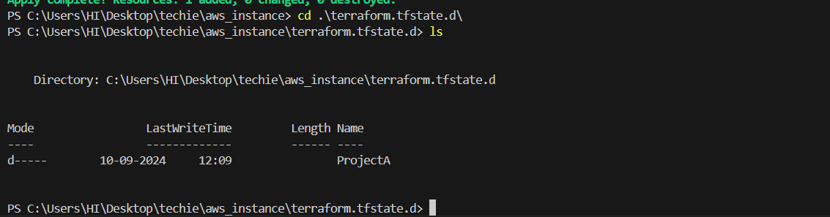

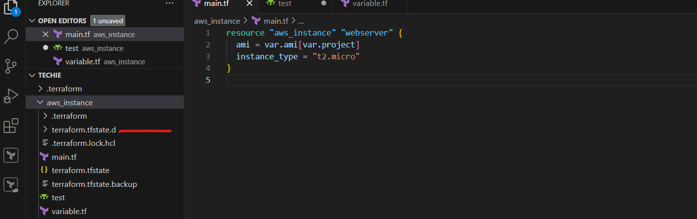

1. **Provision ec2,s3 and vpc using Terraform modules.**

**Main.tf** file for different Modelus

provider "aws" {

    region = "us-west-1"

}

module "vpc" {

  source = "./vpc"

}

module "ec2" {

  source = "./ec2"

}

module "s3" {

  source = "./s3"

}

Main.tf file for ec2

resource "aws_instance" "new-ec2" {

  instance_type = "t2.micro"

  ami = "ami-0731b5a29c85c1f0c"

  tags = {

    Name = "module-server"

  }

}

Main.tf file for vpc

resource "aws_vpc" "new-aws_vpc" {

  cidr_block = "192.168.0.0/16"

  enable_dns_hostnames = true

  enable_dns_support = true

  tags = {

    Name = "module-vpc"

  }

}

Main.tf file for s3

resource "aws_s3_bucket" "new-s3-bucketcheck" {

  bucket = "module363636"

  acl = "private"

}

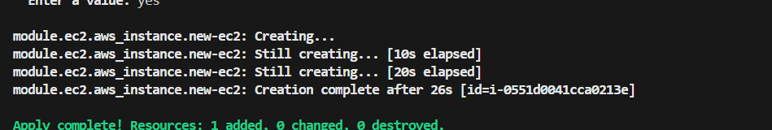

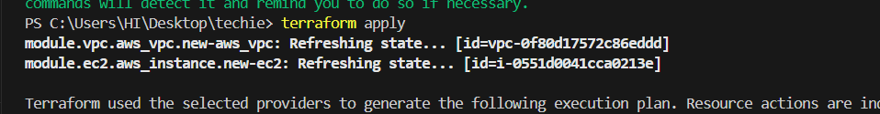

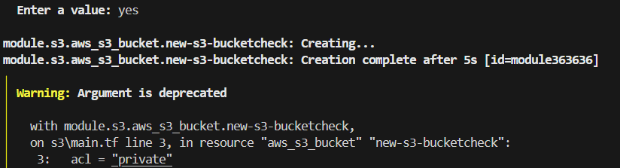

1. **Provision ec2 for 3 different environments (Dev, Staging and Prod) using terraform workspaces.**

**\* main.tf file**

resource "aws_instance" "instance-module" {

    ami = var.ami

    instance_type = "t2.micro"

    tags = {

      Name = "${terraform.workspace}"

    }

}

**Variable.tf file**

variable "ami" {

  type = string

}

**\***in **dev.tfvars file** added ami id

ami = "ami-0731b5a29c85c1f0c"

**\***in **prod.tfvars file** added ami id

ami = "ami-025258b26b492aec6"

**\***in **staging.tfvars file** added ami id

ami = "ami-0d53d72369335a9d6"

Here we are using single main.ft file to create multiple instances in different environments .Now change to project staging and run apply to create instance in development environment

**terraform init**

**terraform apply**

**terraform init**

**terraform workspace new dev**

**terraform workspace new prod**

**terraform workspace new staging**

**terraform workspace select dev**

**terraform apply -var-file="dev.tfvars"**

**terraform workspace select prod**

**terraform apply -var-file="prod.tfvars"**

**terraform workspace select staging**

**terraform apply -var-file="staging.tfvars"**

