**Terraform-Intial-setup**

1) Install Terraform on your PC

4) Integrate a sample Terraform template in jenkins.

1. **Install Terraform on your PC**

We need to download Terraform windows version from browser in zip file

*Then unzip it and save this application path in the environment variables in our local machine shown as below.

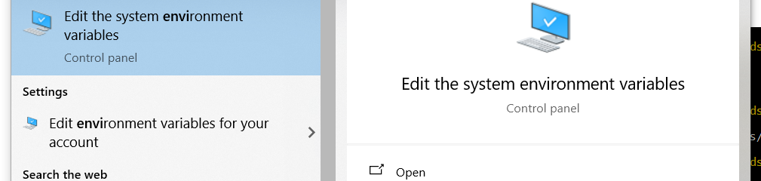

**\*** Add the path where our terraform application stores in local machine

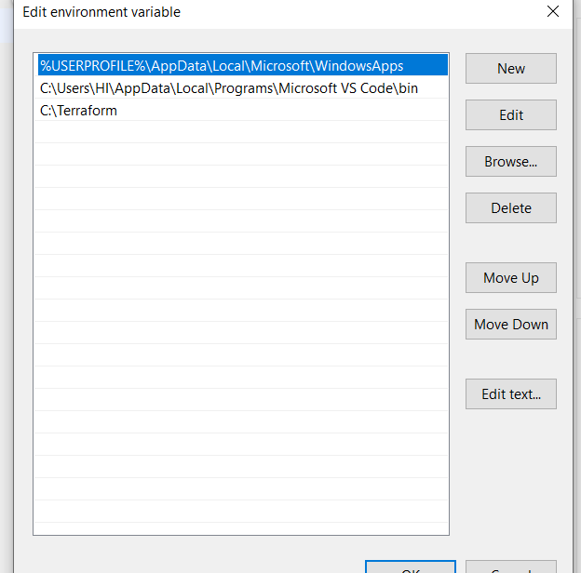

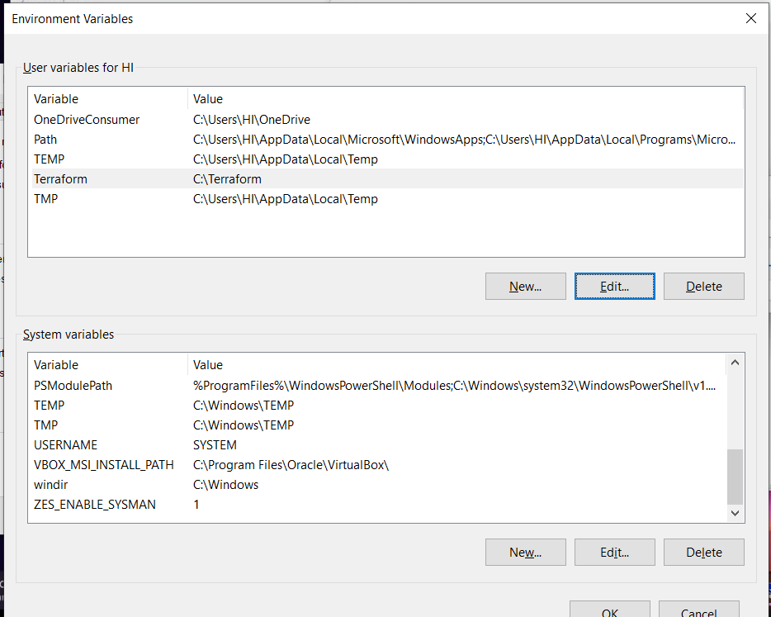

* After adding the path open VSC( Visual code studio), and install the terraform plugin

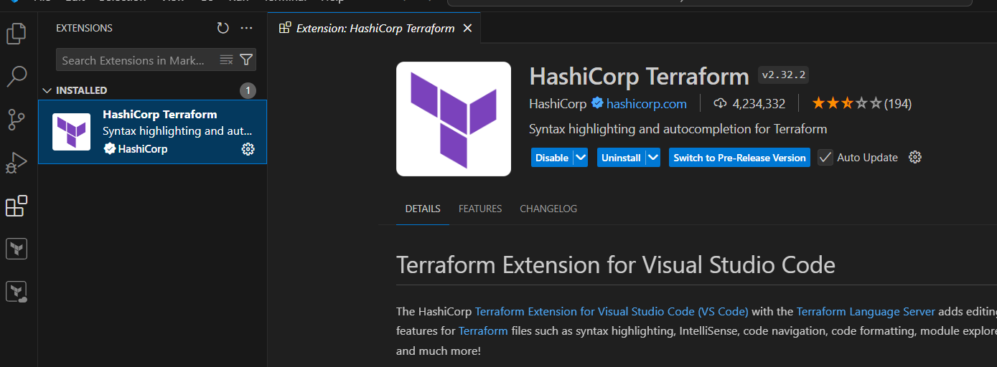

**2) Execute all the templates shown in video.**

**3) Note down below points,**

**Terraform Init**

**Terraform Plan**

**Terraform Apply**

**Terraform Provider**.

* First create a new file where we need to store executable resources

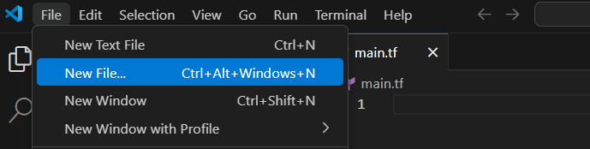

* Adding the local module with content into a new file

resource "local_file" "my_pet" {

    filename = "pet.txt"

    content = "i don't like pets!"

}

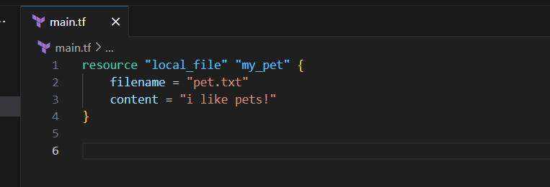

* First we need to initialize the terraform to install the new version of terraform, while intializing the provider plugin also create a lockfile

“terraform init”

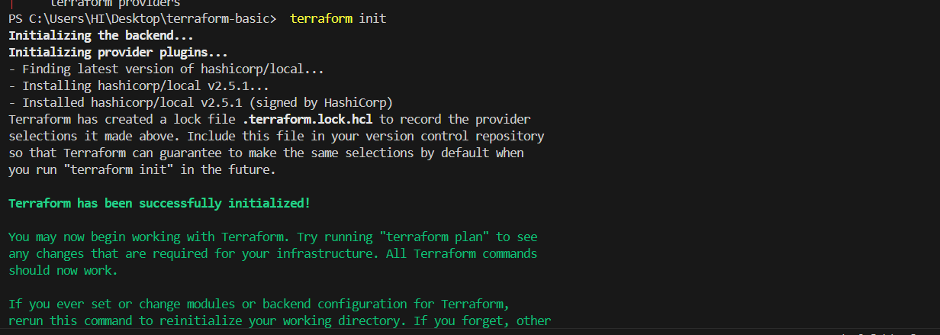

“terraform plan”

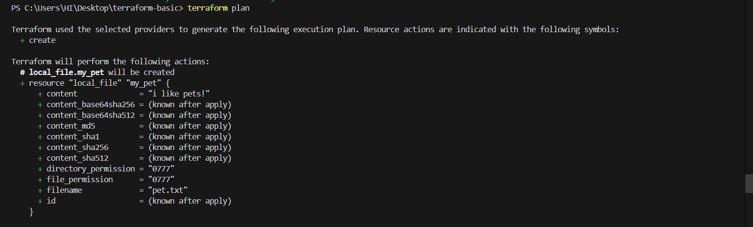

“terraform apply”

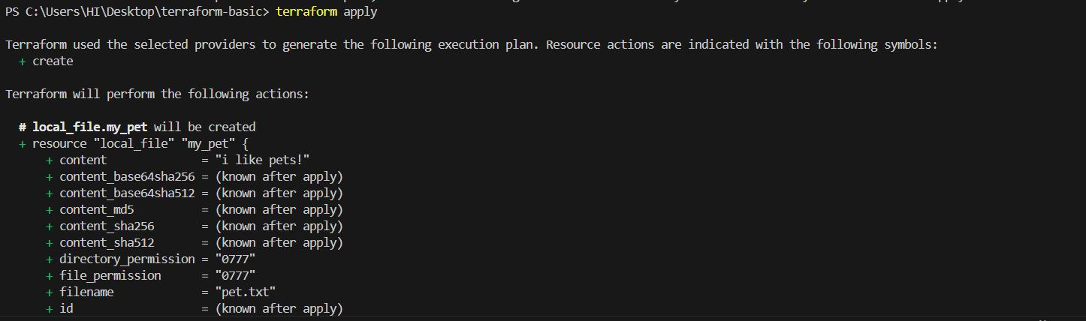

* After giving the permission it will create a file

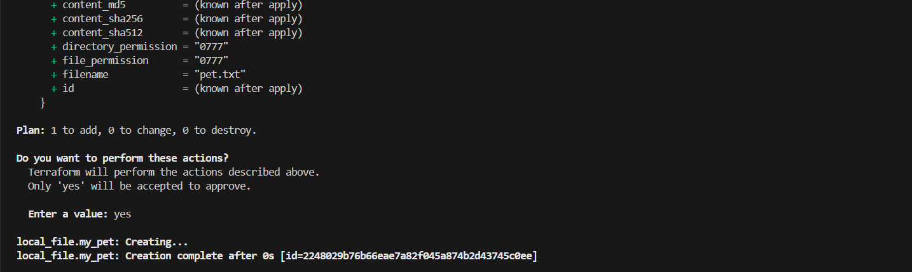

* After apply the file , again try to apply , when this I haven’t done any changes .now the terraform will checks the file and it’s content , it gives as “no changes have done”

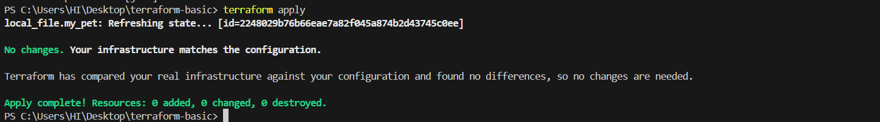

* Now am deleting the file using “ terraform destroy”

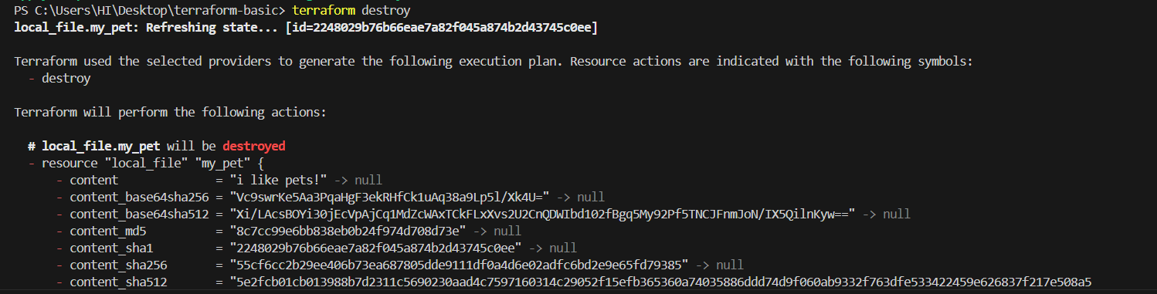

* while destroying it asks for permission, then am given yes for deleting the file

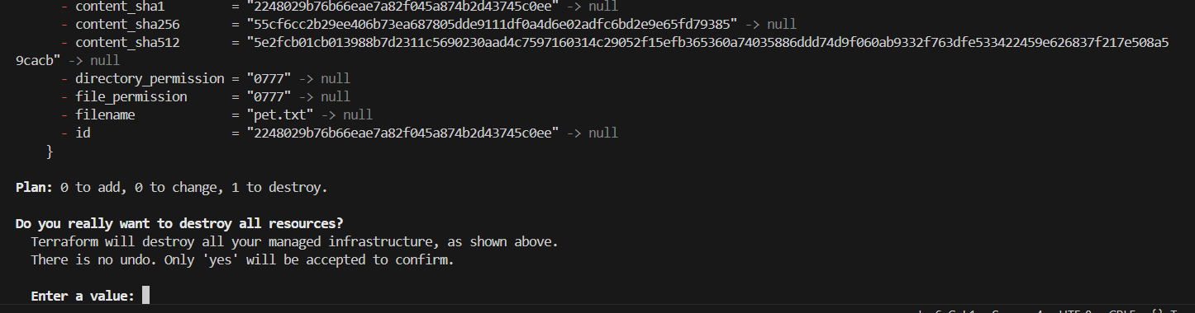

* Now it’s destroyed and given a “**destroy id**”

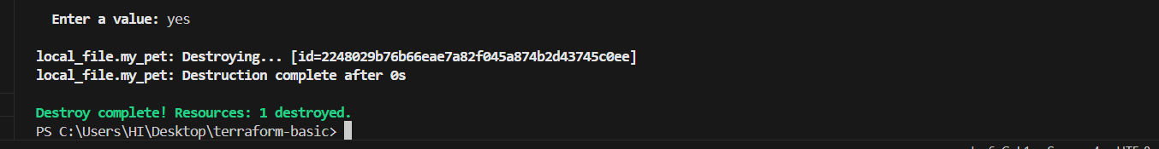

* Now am adding the another module as “**random”**

resource "local_file" "my_pet" {

    filename = "pet.txt"

    content = "i don't like pets!"

}

resource "random_pet" "my-pet" {

  prefix = "Miss"

 separator = "."

 length = "1"

}

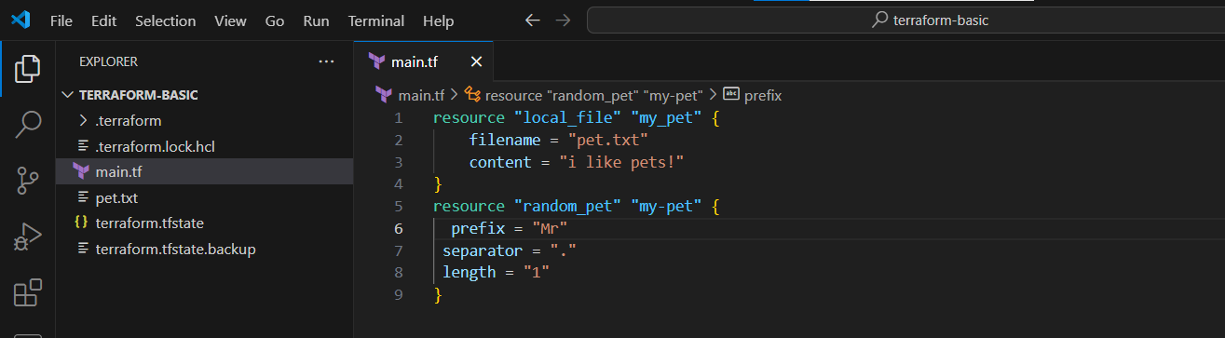

* Now am initialising the terraform to install the random provider

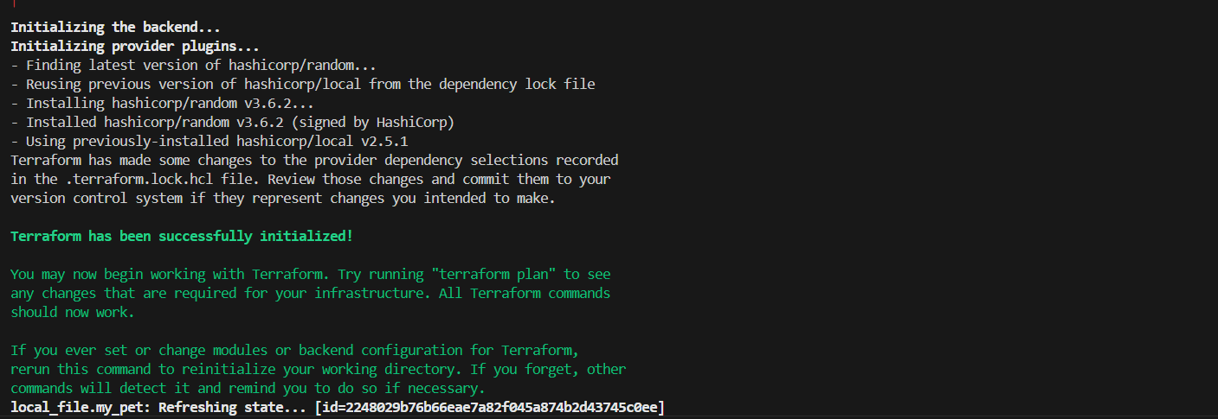

* Now add a plan

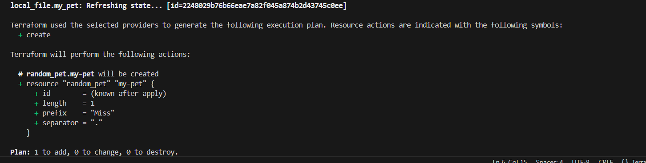

* now Apply

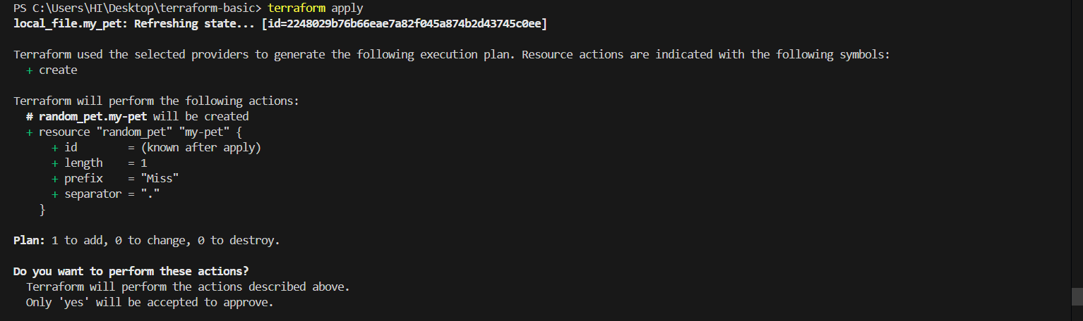

* Now am changed the prefix from “**Miss**” to “**Mr**”

* Then it will destroy the first content and added the new content

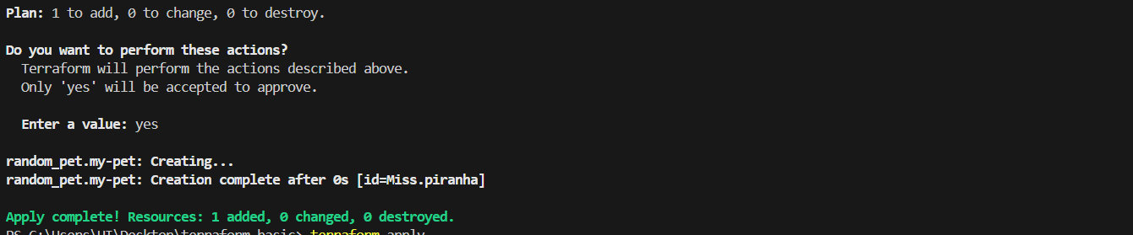

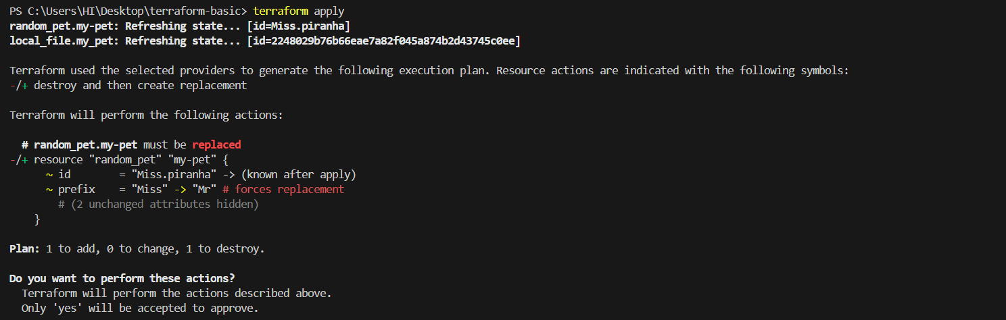

* New prefix will created

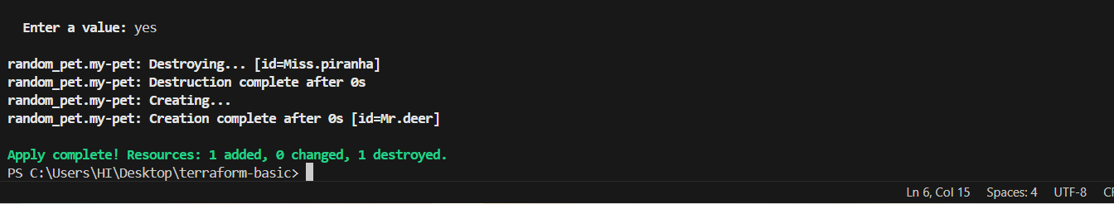

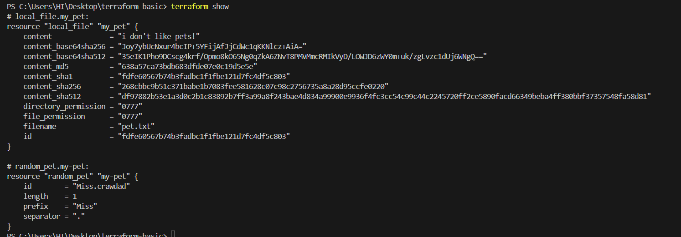

1. **Integrate a sample Terraform template in jenkins.**