**1) Create VPC**

terraform {

  required_providers {

    aws = {

        source = "hashicorp/aws"

        version = "~>2.70"

    }

  }

}

provider "aws" {

  region = var.aws_region

}

resource "aws_vpc" "new_vpc" {

  cidr_block = var.aws_vpc

tags = {

  Name = "New-vpc"

}

}

variable "aws_vpc" {

  default = "192.168.0.0/16"

}

variable "aws_region" {

  default = "us-west-1"

}

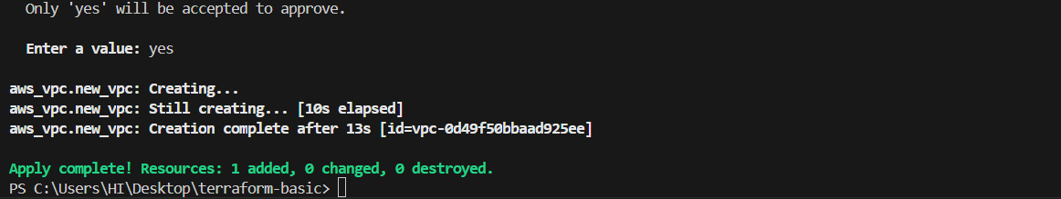



1. Create Internet gateway

terraform {

  required_providers {

    aws = {

        source = "hashicorp/aws"

        version = "~>2.70"

    }

  }

}

provider "aws" {

  region = var.aws_region

}

resource "aws_vpc" "new_vpc" {

  cidr_block = var.aws_vpc

tags = {

  Name = "New-vpc"

}

}

resource "aws_internet_gateway" "my_IGW" {

  vpc_id = aws_vpc.new_vpc.id

  tags = {

    Name = "MY-IGW"

  }

}

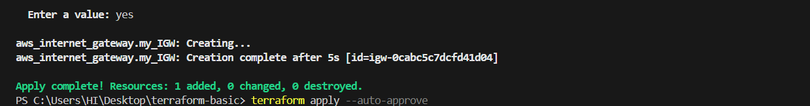



1. Create Custom Route Table

terraform {

  required_providers {

    aws = {

        source = "hashicorp/aws"

        version = "~>2.70"

    }

  }

}

provider "aws" {

  region = var.aws_region

}

resource "aws_vpc" "new_vpc" {

  cidr_block = var.aws_vpc

tags = {

  Name = "New-vpc"

}

}

resource "aws_internet_gateway" "my_IGW" {

  vpc_id = aws_vpc.new_vpc.id

  tags = {

    Name = "MY-IGW"

  }

}

resource "aws_route_table" "new_route_table" {

  vpc_id = aws_vpc.new_vpc.id

}

resource "aws_route" "main" {

  route_table_id = aws_route_table.new_route_table.id

  destination_cidr_block = var.destination_cidr_block

  gateway_id = aws_internet_gateway.my_IGW.id

}

variable "aws_vpc" {

  default = "192.168.0.0/16"

}

variable "aws_region" {

  default = "us-west-1"

}

variable "route_table_id" {

  default = "192.168.0.0/16"

}

variable "destination_cidr_block" {

  default = "0.0.0.0/0"

}

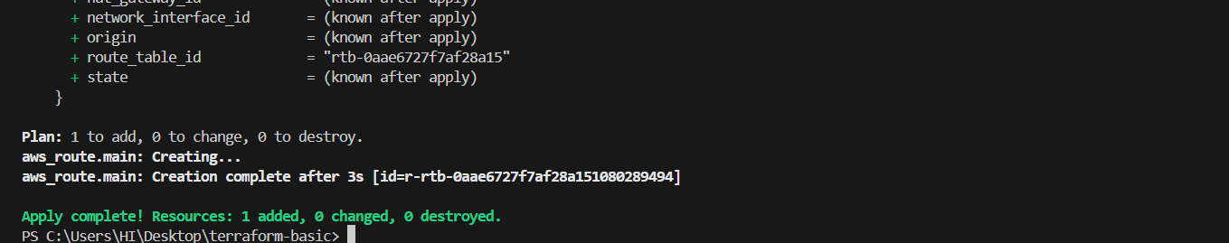

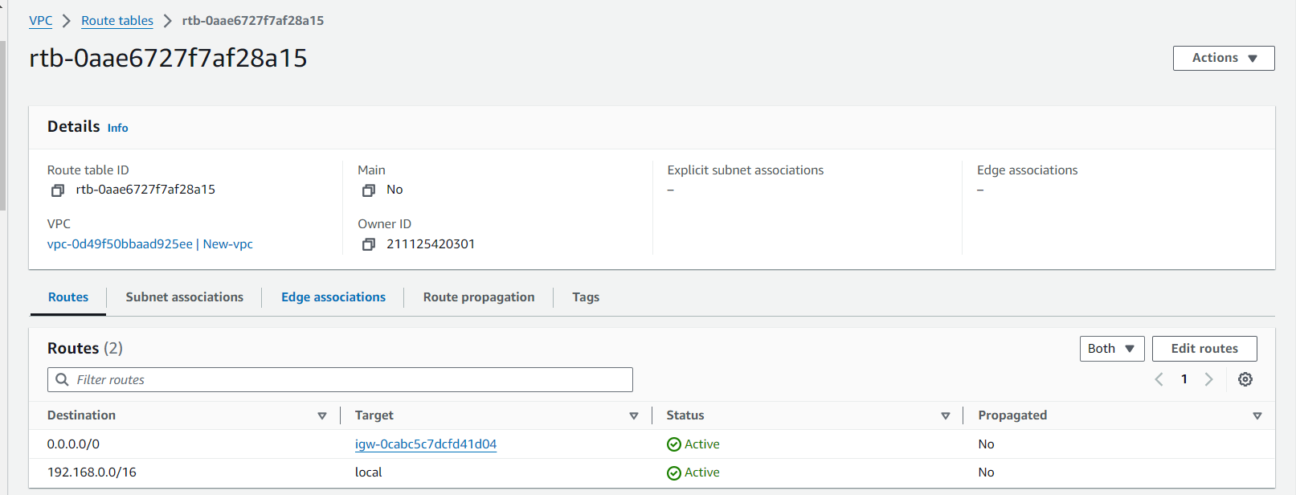

1. **Create Subnet**

terraform {

  required_providers {

    aws = {

        source = "hashicorp/aws"

        version = "~>2.70"

    }

  }

}

provider "aws" {

  region = var.aws_region

}

resource "aws_vpc" "new_vpc" {

  cidr_block = var.aws_vpc

tags = {

  Name = "New-vpc"

}

}

resource "aws_internet_gateway" "my_IGW" {

  vpc_id = aws_vpc.new_vpc.id

  tags = {

    Name = "MY-IGW"

  }

}

resource "aws_route_table" "new_route_table" {

  vpc_id = aws_vpc.new_vpc.id

}

resource "aws_route" "main" {

  route_table_id = aws_route_table.new_route_table.id

  destination_cidr_block = var.destination_cidr_block

  gateway_id = aws_internet_gateway.my_IGW.id

}

resource "aws_subnet" "first_subnet" {

  vpc_id = aws_vpc.new_vpc.id

  cidr_block = var.cidr_block

  map_public_ip_on_launch = true

  tags = {

    Name = "pub-subnet"

  }

}

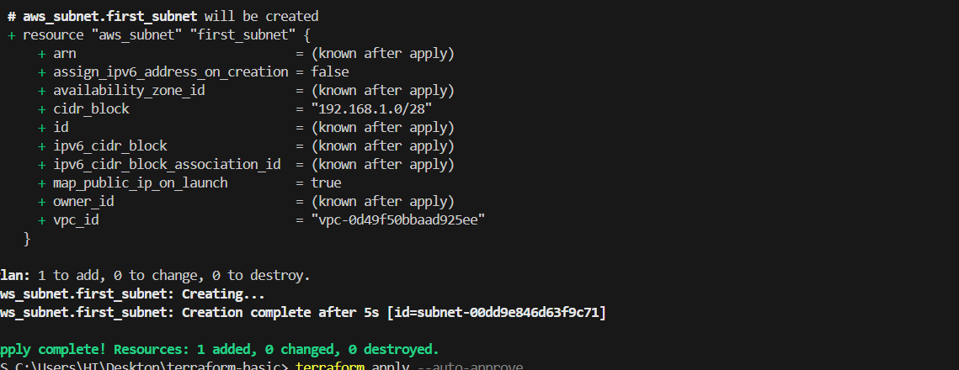

1. Associate subnet with Route Table

resource "aws_route_table_association" "aws_route" {

  subnet_id = aws_subnet.first_subnet.id

  route_table_id = aws_route_table.new_route_table.id

}

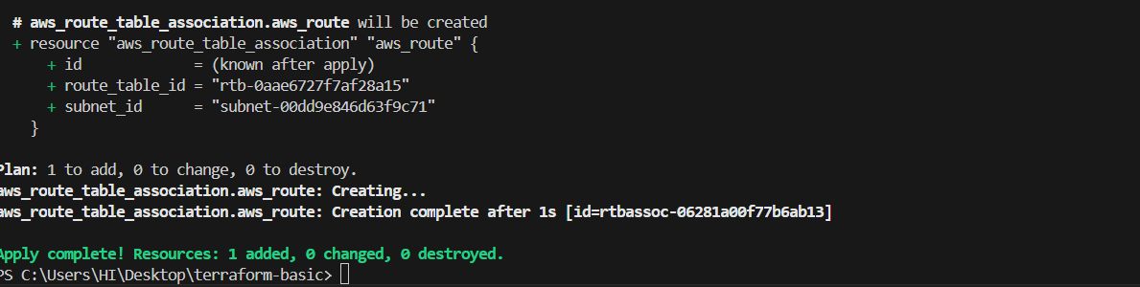

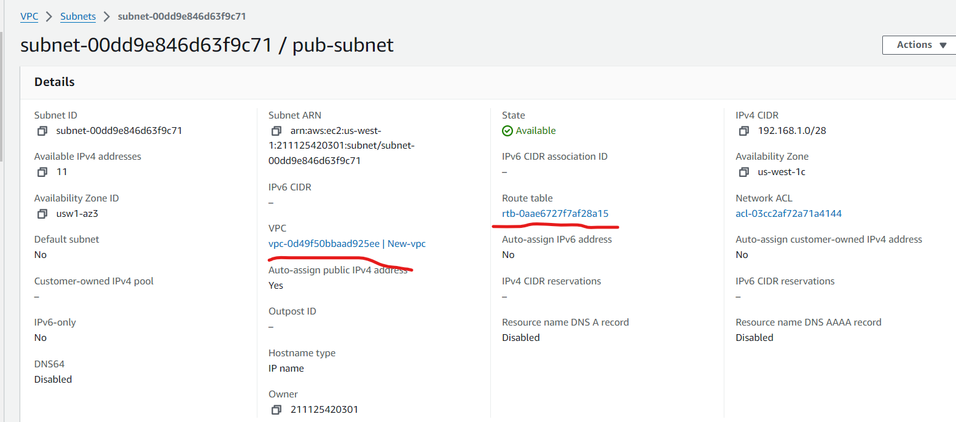

1. **Create Security Group to allow port 22.80,443**

terraform {

  required_providers {

    aws = {

        source = "hashicorp/aws"

        version = "~>2.70"

    }

  }

}

provider "aws" {

  region = var.aws_region

}

resource "aws_vpc" "new_vpc" {

  cidr_block = var.aws_vpc

tags = {

  Name = "New-vpc"

}

}

resource "aws_internet_gateway" "my_IGW" {

  vpc_id = aws_vpc.new_vpc.id

  tags = {

    Name = "MY-IGW"

  }

}

resource "aws_route_table" "new_route_table" {

  vpc_id = aws_vpc.new_vpc.id

}

resource "aws_route" "main" {

  route_table_id = aws_route_table.new_route_table.id

  destination_cidr_block = var.destination_cidr_block

  gateway_id = aws_internet_gateway.my_IGW.id

}

resource "aws_subnet" "first_subnet" {

  vpc_id = aws_vpc.new_vpc.id

  cidr_block = var.cidr_block

  map_public_ip_on_launch = true

  tags = {

    Name = "pub-subnet"

  }

}

resource "aws_route_table_association" "aws_route" {

  subnet_id = aws_subnet.first_subnet.id

  route_table_id = aws_route_table.new_route_table.id

}

resource "aws_security_group" "ELB_SG" {

  name = "new-security"

  vpc_id = aws_vpc.new_vpc.id

  ingress {

    from_port   = 22

    to_port     = 22

    protocol    = "tcp"

    cidr_blocks = ["0.0.0.0/0"]

  }

  ingress {

    from_port   = 80

    to_port     = 80

    protocol    = "tcp"

    cidr_blocks = ["0.0.0.0/0"]

  }

  ingress {

    from_port   = 443

    to_port     = 443

    protocol    = "tcp"

    cidr_blocks = ["0.0.0.0/0"]

  }

}

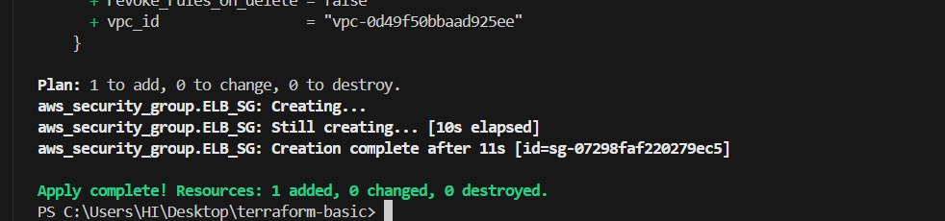

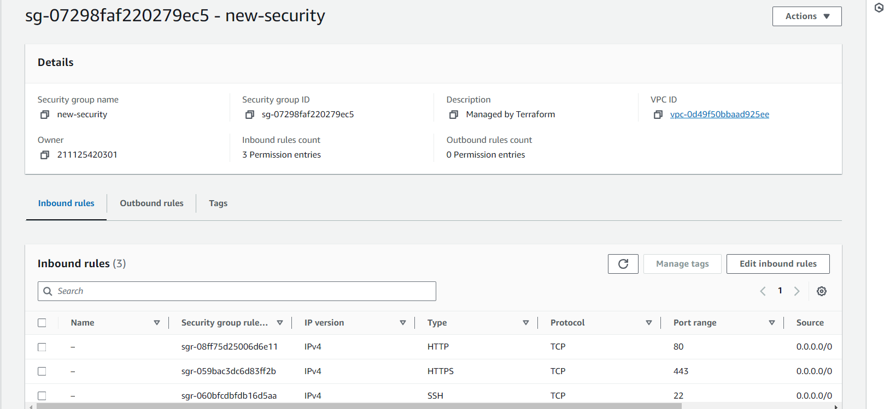

1. **Create a network interface with an ip in the subnet that was created in step 4**

resource "aws_network_interface" "server-interface" {

  subnet_id = aws_subnet.first_subnet.id

  private_ips = ["192.168.1.4"]

  security_groups = [aws_security_group.ELB_SG.id]

}

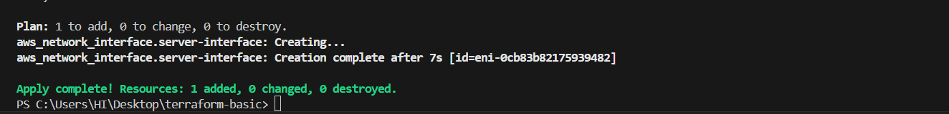

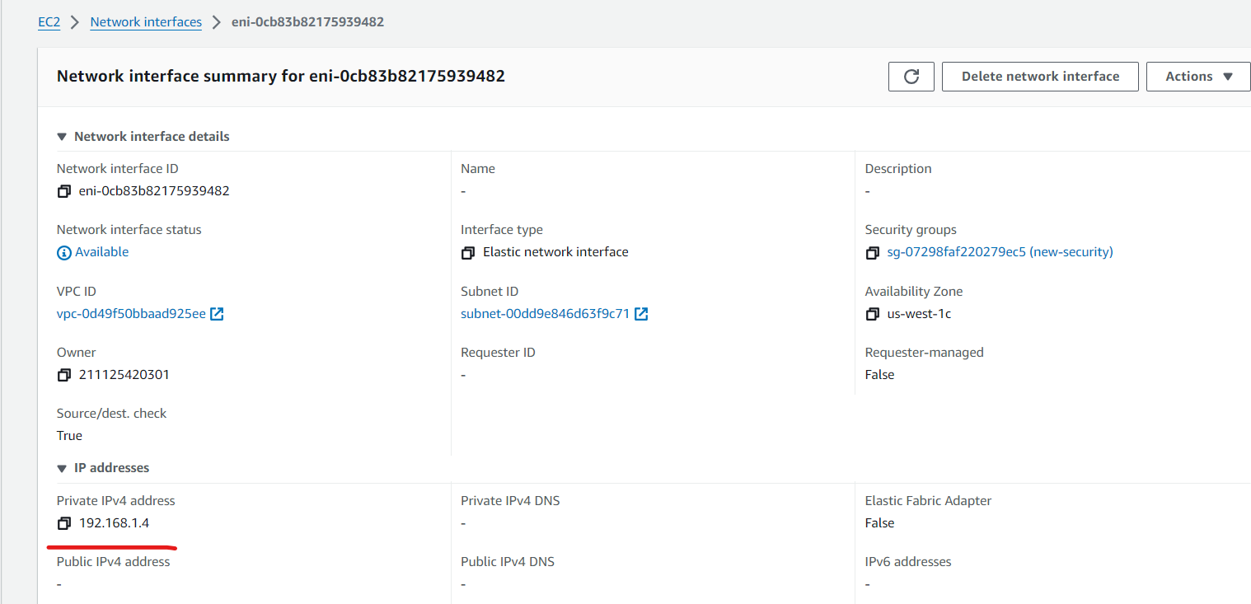

1. **Assign an elastic IP to the network interface created in step 7**

terraform {

  required_providers {

    aws = {

        source = "hashicorp/aws"

        version = "~>2.70"

    }

  }

}

provider "aws" {

  region = var.aws_region

}

resource "aws_vpc" "new_vpc" {

  cidr_block = var.aws_vpc

tags = {

  Name = "New-vpc"

}

}

resource "aws_internet_gateway" "my_IGW" {

  vpc_id = aws_vpc.new_vpc.id

  tags = {

    Name = "MY-IGW"

  }

}

resource "aws_route_table" "new_route_table" {

  vpc_id = aws_vpc.new_vpc.id

}

resource "aws_route" "main" {

  route_table_id = aws_route_table.new_route_table.id

  destination_cidr_block = var.destination_cidr_block

  gateway_id = aws_internet_gateway.my_IGW.id

}

resource "aws_subnet" "first_subnet" {

  vpc_id = aws_vpc.new_vpc.id

  cidr_block = var.cidr_block

  map_public_ip_on_launch = true

  tags = {

    Name = "pub-subnet"

  }

}

resource "aws_route_table_association" "aws_route" {

  subnet_id = aws_subnet.first_subnet.id

  route_table_id = aws_route_table.new_route_table.id

}

resource "aws_security_group" "ELB_SG" {

  name = "new-security"

  vpc_id = aws_vpc.new_vpc.id

  ingress {

    from_port   = 22

    to_port     = 22

    protocol    = "tcp"

    cidr_blocks = ["0.0.0.0/0"]

  }

  ingress {

    from_port   = 80

    to_port     = 80

    protocol    = "tcp"

    cidr_blocks = ["0.0.0.0/0"]

  }

  ingress {

    from_port   = 443

    to_port     = 443

    protocol    = "tcp"

    cidr_blocks = ["0.0.0.0/0"]

  }

}

resource "aws_network_interface" "server-interface" {

  subnet_id = aws_subnet.first_subnet.id

  private_ips = ["192.168.1.4"]

  security_groups = [aws_security_group.ELB_SG.id]

}

resource "aws_eip" "elastic-ip" {

  vpc = true

  network_interface = aws_network_interface.server-interface.id

  associate_with_private_ip = "192.168.1.4"

  depends_on = [ aws_internet_gateway.my_IGW ]

}

output "server_public_ip" {

  value = aws_eip.elastic-ip.public_ip

}

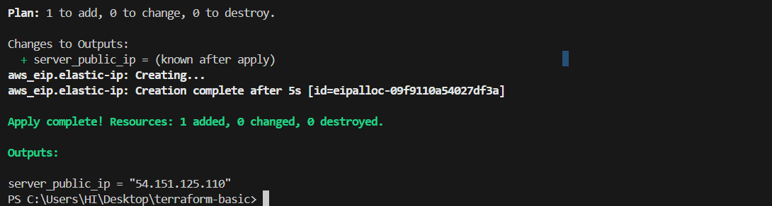

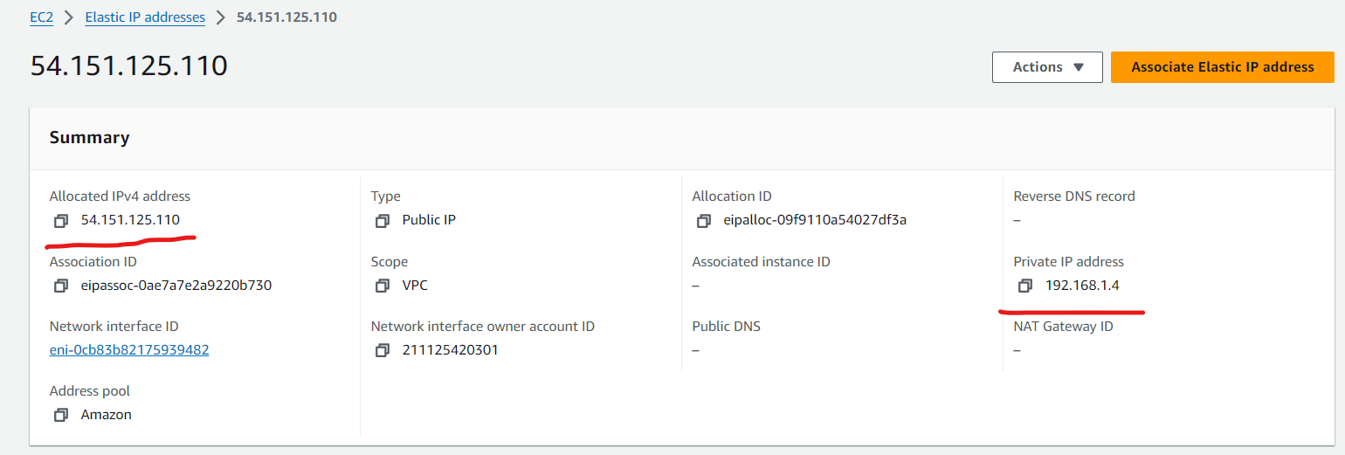

1. **Create Ubuntu server and install/enable apache2**

terraform {

  required_providers {

    aws = {

        source = "hashicorp/aws"

        version = "~>2.70"

    }

  }

}

provider "aws" {

  region = var.aws_region

}

resource "aws_vpc" "new_vpc" {

  cidr_block = var.aws_vpc

tags = {

  Name = "New-vpc"

}

}

resource "aws_internet_gateway" "my_IGW" {

  vpc_id = aws_vpc.new_vpc.id

  tags = {

    Name = "MY-IGW"

  }

}

resource "aws_route_table" "new_route_table" {

  vpc_id = aws_vpc.new_vpc.id

}

resource "aws_route" "main" {

  route_table_id = aws_route_table.new_route_table.id

  destination_cidr_block = var.destination_cidr_block

  gateway_id = aws_internet_gateway.my_IGW.id

}

resource "aws_subnet" "first_subnet" {

  vpc_id = aws_vpc.new_vpc.id

  cidr_block = var.cidr_block

  map_public_ip_on_launch = true

  tags = {

    Name = "pub-subnet"

  }

}

resource "aws_route_table_association" "aws_route" {

  subnet_id = aws_subnet.first_subnet.id

  route_table_id = aws_route_table.new_route_table.id

}

resource "aws_security_group" "ELB_SG" {

  name = "new-security"

  vpc_id = aws_vpc.new_vpc.id

  ingress {

    from_port   = 22

    to_port     = 22

    protocol    = "tcp"

    cidr_blocks = ["0.0.0.0/0"]

  }

  ingress {

    from_port   = 80

    to_port     = 80

    protocol    = "tcp"

    cidr_blocks = ["0.0.0.0/0"]

  }

  ingress {

    from_port   = 443

    to_port     = 443

    protocol    = "tcp"

    cidr_blocks = ["0.0.0.0/0"]

  }

}

resource "aws_network_interface" "server-interface" {

  subnet_id = aws_subnet.first_subnet.id

  private_ips = ["192.168.1.4"]

  security_groups = [aws_security_group.ELB_SG.id]

}

resource "aws_eip" "elastic-ip" {

  vpc = true

  network_interface = aws_network_interface.server-interface.id

  associate_with_private_ip = "192.168.1.4"

  depends_on = [ aws_internet_gateway.my_IGW ]

}

output "server_public_ip" {

  value = aws_eip.elastic-ip.public_ip

}

resource "aws_instance" "own-server" {

  ami = var.ami

  instance_type = "t2.micro"

  key_name = "america"

  availability_zone = "us-west-1c"

  user_data = <<-EOF

  #!/bin/bash

 sudo apt-get install apache2 -y",

      "sudo systemctl start apache2"

  EOF

network_interface {

  device_index = 0

  network_interface_id = aws_network_interface.server-interface.id

}

}

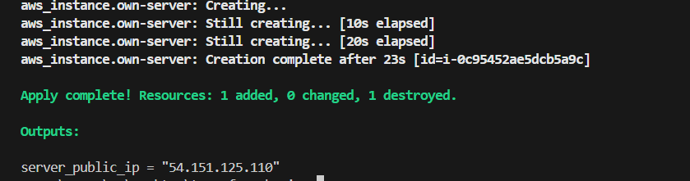

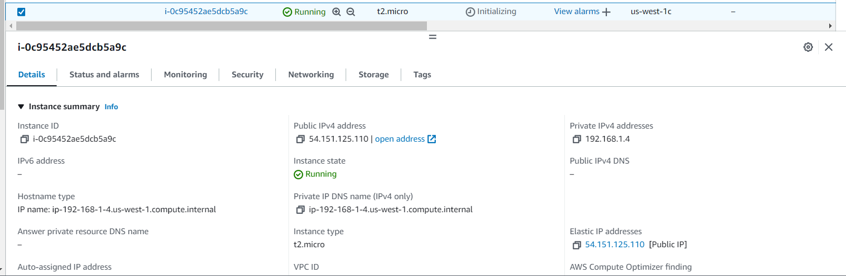

terraform {

  required_providers {

    aws = {

      source  = "hashicorp/aws"

        version = "~>2.70"

    }

  }

}

provider "aws" {

  region = var.aws_region

}

resource "aws_vpc" "new_vpc" {

  cidr_block = var.aws_vpc

tags = {

  Name = "New-vpc"

}

}

resource "aws_internet_gateway" "my_IGW" {

  vpc_id = aws_vpc.new_vpc.id

  tags = {

    Name = "MY-IGW"

  }

}

resource "aws_route_table" "new_route_table" {

  vpc_id = aws_vpc.new_vpc.id

}

resource "aws_route" "main" {

  route_table_id = aws_route_table.new_route_table.id

  destination_cidr_block = var.destination_cidr_block

  gateway_id = aws_internet_gateway.my_IGW.id

}

resource "aws_subnet" "first_subnet" {

  vpc_id = aws_vpc.new_vpc.id

  cidr_block = var.cidr_block

  map_public_ip_on_launch = true

  tags = {

    Name = "pub-subnet"

  }

}

resource "aws_route_table_association" "aws_route" {

  subnet_id = aws_subnet.first_subnet.id

  route_table_id = aws_route_table.new_route_table.id

}

resource "aws_security_group" "ELB_SG" {

  name = "new-security"

  vpc_id = aws_vpc.new_vpc.id

  ingress {

    from_port   = 22

    to_port     = 22

    protocol    = "tcp"

    cidr_blocks = ["0.0.0.0/0"]

  }

  ingress {

    from_port   = 80

    to_port     = 80

    protocol    = "tcp"

    cidr_blocks = ["0.0.0.0/0"]

  }

  ingress {

    from_port   = 443

    to_port     = 443

    protocol    = "tcp"

    cidr_blocks = ["0.0.0.0/0"]

  }

}

resource "aws_network_interface" "server-interface" {

  subnet_id = aws_subnet.first_subnet.id

  private_ips = ["192.168.1.4"]

  security_groups = [aws_security_group.ELB_SG.id]

}

resource "aws_eip" "elastic-ip" {

  vpc = true

  network_interface = aws_network_interface.server-interface.id

  associate_with_private_ip = "192.168.1.4"

  depends_on = [ aws_internet_gateway.my_IGW ]

}

output "server_public_ip" {

  value = aws_eip.elastic-ip.public_ip

}

resource "aws_instance" "own-server" {

  ami = var.ami

  instance_type = "t2.micro"

  key_name = "america"

  availability_zone = "us-west-1c"

  user_data = <<-EOF

  #!/bin/bash

  sudo apt update

sudo apt install apache2 -y

sudo systemctl status apache2

sudo systemctl start apache2

sudo systemctl enable apache2

  EOF

network_interface {

  device_index = 0

  network_interface_id = aws_network_interface.server-interface.id

}

}

resource "aws_dynamodb_table" "dynamodb-route_table_id" {

  name = "dbdynamo-terraform-state"

  hash_key = "LockID"

  read_capacity = 20

  write_capacity = 20

  attribute {

    name = "LockID"

    type = "S"

  }

}

terraform {

  backend "s3" {

    bucket = "techie050936"

    dynamodb_table = "dbdynamo-terraform-state"

    key = "terraform.tfstate"

    region = "us-west-1"

  }

}

