Design and Analysis of Algorithms
Week-2
Name: Musali Reddy Manish Reddy
Roll.no :CH.SC.U4CSE24129

Bubble Sort

PROGRAM:
#include <stdio.h> int main() {
int n;
printf("ENTER NO.OF.ELEMENTS:");
scanf("%d",&n); int arr[n];
printf("ENTER THE VALUES:");
for(int i=0;i < n;i++){ scanf("%d",&arr[i]);
}
for (int i = 0; i < n - 1; i++) {
for (int j = 0; j < n - i - 1; j++) { if (arr[j] > arr[j + 1]) {
int temp = arr[j]; arr[j] = arr[j + 1]; arr[j + 1] = temp;
}
}
}
printf("Sorted array: "); for (int i = 0; i < n; i++) {
printf("\t%d\t,",arr[i]);
}
return 0;
}

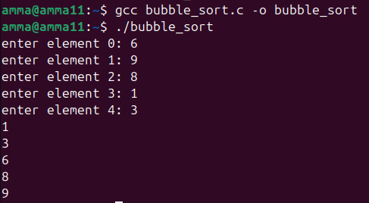

Time Complexity:
- Best Case: O(n²)
- Average Case: O(n²)
- Worst Case: O(n²)
Justification :
The code uses Bubble Sort with two nested loops.
- The outer loop runs (n − 1) times.
- The inner loop runs (n − i − 1) times for each iteration.
Even if the array is already sorted, there is no early termination condition, so all comparisons are still performed. Hence, the time complexity remains O(n²) in all cases.

Space Complexity:
- Space Complexity: O(n)
Justification:
The program uses an array arr[n] to store n elements. Apart from this array and a few variables (i, j, temp), no extra space is used. Therefore, space complexity is O(n).

Insertion Sort
PROGRAM:
#include <stdio.h> int main() {
int n;
printf("ENTER NO.OF ELEMENTS");
scanf("%d",&n); int arr[n];
printf("ENTER THE ELEMENTS:");
for(int i=0; i <n;i++){ scanf("%d",&arr[i]);
}
for (int i = 1; i < n; i++) { int key = arr[i];
int j = i - 1;
while (j >= 0 && arr[j] > key) { arr[j + 1] = arr[j];

j--;
}
arr[j + 1] = key;
}
printf("Sorted array: "); for (int i = 0; i < n; i++) {
printf("%d ", arr[i]);
}
return 0;
}

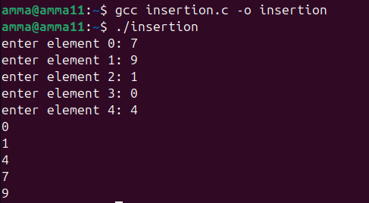

Time Complexity:
Best Case: O(n)
Average Case: O(n²)
Worst Case: O(n²)

Justification:
This code uses insertion sort. In the best case (already sorted array), the while loop condition fails immediately for each element, so only one comparison per iteration is done, resulting in O(n). In the average and worst cases, elements need to be shifted multiple times inside the while loop, leading to approximately n(n−1)/2 comparisons, which gives O(n²).

Space Complexity:
Space Complexity: O(n)

Justification:
The array arr[n] stores n elements. Apart from this array and a few variables (key, i, j), no extra memory is used. Hence, the space complexity is O(n).

Selection Sort

PROGRAM:
#include <stdio.h> int main() {
int n;
printf("ENTER NO. OF ELEMENTS: ");
scanf("%d", &n); int arr[n];
printf("ENTER THE VALUES: ");
for (int i = 0; i < n; i++) { scanf("%d", &arr[i]);
}
for (int i = 0; i < n - 1; i++) { int minIndex = i;
for (int j = i + 1; j < n; j++) { if (arr[j] < arr[minIndex]) {
minIndex = j;
}
}
int temp = arr[i];
arr[i] = arr[minIndex]; arr[minIndex] = temp;

}
printf("Sorted array: "); for (int i = 0; i < n; i++) {
printf("%d ", arr[i]);
}
return 0;
}

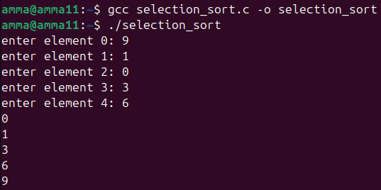

Time Complexity:

Best Case: O(n²)
Average Case: O(n²)
Worst Case: O(n²)

Justification:
This code uses selection sort. The outer loop runs (n − 1) times and the inner loop runs for the remaining unsorted elements each time to find the minimum element. The number of comparisons is fixed regardless of the input order, so the time complexity is O(n²) in all cases.

Space Complexity:
Space Complexity: O(n)
Justification:
The array arr[n] stores n elements. Apart from this array and a few variables (i, j, minIndex, temp), no extra memory is used. Therefore, the space complexity is O(n).

Bucket Sort

PROGRAM:
#include <stdio.h>

int main() { int n;
printf("ENTER NO. OF ELEMENTS: ");
scanf("%d", &n); int arr[n];
printf("ENTER THE VALUES (0 to 100): ");
for (int i = 0; i < n; i++) { scanf("%d", &arr[i]);
}
int bucket[101] = {0}; for (int i = 0; i < n; i++) {
bucket[arr[i]]++;
}
printf("Sorted array: ");
for (int i = 0; i <= 100; i++) { while (bucket[i] > 0) {
printf("%d ", i);
bucket[i]--;
}
}
return 0;
}

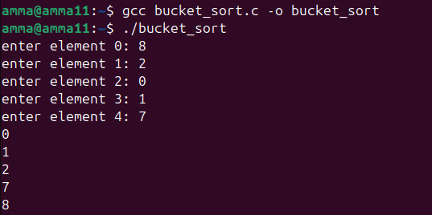

Time Complexity:
Best Case: O(n + k)
Average Case: O(n + k)
Worst Case: O(n + k)

Justification:
This code uses counting sort. The first loop reads n elements. The second loop counts the occurrences of each value in the bucket array. The final loop iterates through all possible values from 0 to 100 (k = 101) and prints elements based on their frequency. Since k is fixed and small, the overall time complexity is O(n + k), which effectively behaves as O(n).

Space Complexity:
Space Complexity: O(n + k)

Justification:
The program uses the input array arr[n] and an additional bucket array of size 101. Hence, the total extra space required is O(n + k), where k is the range of input values (0 to 100).

Heap Sort

PROGRAM:
#include<stdio.h> int main() {
int n;
printf("ENTER NO. OF ELEMENTS: ");
scanf("%d", &n); int arr[n];
printf("ENTER THE VALUES: ");
for (int i = 0; i < n; i++) { scanf("%d", &arr[i]);
}
for (int i = 1; i < n; i++) { int child = i;
while (child > 0) {
int parent = (child - 1) / 2;

if (arr[parent] < arr[child]) { int temp = arr[parent]; arr[parent] = arr[child]; arr[child] = temp;
child = parent;
} else {
break;
}
}
}
for (int i = n - 1; i > 0; i--) { int temp = arr[0];
arr[0] = arr[i]; arr[i] = temp; int parent = 0; while (1) {
int left = 2 * parent + 1; int right = 2 * parent + 2; int largest = parent;
if (left < i && arr[left] > arr[largest]) largest = left;
if (right < i && arr[right] > arr[largest])

largest = right;
if (largest != parent) {
int temp2 = arr[parent]; arr[parent] = arr[largest]; arr[largest] = temp2; parent = largest;
} else {
break;
}
}
}
printf("Sorted array: "); for (int i = 0; i < n; i++) {
printf("%d ", arr[i]);
}
return 0;
}

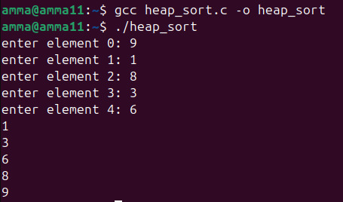

Time Complexity:
Best Case: O(n log n)
Average Case: O(n log n)
Worst Case: O(n log n)

Justification:
This code implements heap sort.
- The first part builds a max heap, which takes O(n log n) time because each insertion may move up the heap with height log n.
- The second part repeatedly removes the maximum element (root) and performs heapify, which takes O(log n) time for each of the n elements.
Therefore, the overall time complexity is O(n log n) in all cases, regardless of input order.

Space Complexity:
Space Complexity: O(n)

Justification:
The array arr[n] stores n elements. Apart from this array and a few temporary variables, no additional data structures are used. Hence, the space complexity is O(n).

