**Level Design Document (LDD)**

**Level Name:** [Temple Genesis]

**Document Date:** [07/14/2015]

**Author/Designer Name**: [Kyle Davis]

**Revision Number:** 0.0

**Date:** []

**Revision Details:**

* First Draft

# Quick Summary

Explore the mysterious temple and find the power of the elements light and earth. Use these elements to traverse the world and discover the secret to what tore the world apart.

# Gameplay Overview

Primarily a puzzle/platformer game the player must navigate the maze that is the temple and make use of the unique abilities of the elements as they are obtained. Clear gaps, avoid traps, and make use of pleasure plates to get through to new areas.

Light, the first elemental power obtained is a fast element. It is capable of short quick bursts in a given direction allowing the player to cover more distance faster and clear larger gaps.

Earth is a heavier element, incapable of movement other than down once formed this element can damage anything in its fall path and activate pressure plates.

# Objective Summary

* Collect the light element
* Collect the Earth element
* Collect the water element
* Learn what the world was like before the Tear.

# Challenge Highlights

First area the player has no special abilities. The area has no challenges or threats. The playable area is a single, open rectangular area of near total darkness. A single bright light floats around the room illuminating the area. In this way the player has a moment to play with the movement controls and a single obvious task of touching the white light. If the player does explore a little before reaching the white light the only thing they may encounter in a blacked out stairwell at the top of which is a gap they can not jump over and always fall back to the area with the light.

After attaining the light the scene lights up and the player now has an ability that will allow him to bring the gap at the top of the stairs. If they explore a bit before ascending the stairs they will see what is obviously a door but there appears to be no way to open it. (if the player turns into the light element in front of the door they will see some reference to the earth element as a hint that it is needed to pass this area.)

Up stairs the player bridges the gap onto a stone ledge along on side of the upper area. In the background, through an opening near the top of the temple, a large black spider will be seen crawling out of the whole to the outside. The player must use the lights movement ability to jump to a chandelier, then across the ledge on the far side of the room. Here the player if confronted with a few simple pendulum traps paced right be be complete without the light ability but more easily down with the light ability. On the far side of the traps is a small room with the earth element in it.

Upon acquiring the earth element the player is prompted to transform into this element. Upon doing so they turn to stone, breaking through the weak wooden floor beneath them. Time slows down in a cinematic for a moment as beneath the broken floor the player, now stone, is shown crushing a black, shadow like spider. Immediately the player regains control to find that the stone has minimal mobility and that for travel it is far more efficient to switch back to the human form or to use the light ability.

New things can be seen in the word, puffs of sand blow in through openings in the temple, edges lined with dirt, and a pressure plate has appeared before the door on the initial floor. The player must figure out that they can use the earth stone weight to open this door and continue on.  
  
The Bottom floor is about the same size as the above 2 floors. A number of chandeliers hang from the ceiling that that the player can use their light ability to jump to and see the room from a top down view. There is a single pressure plate on the far side of the room and a gate to outside the temple all the way across from it. Through the gate the water element can be seen. Less obvious, along the wall opposite the stairs is a small opening to a non-essential area upon pressing the pressure plate a number of spiders with enter the room and the gate will open. The player can crush and kill the spiders with the stone element effect, but the gate will close again if they do and each time the pressure plate is pressed the number of spiders will refresh. The player needs to use their light dash ability to get through the opening quickly.

# Water Cooler Moments

*on the second floor, on the first ledge at the far end of the path where it dead ends there will be a small mural that is only visible while the light element and it depicts a world of men in the prime of society, and a whole of its people rejoicing.

*return to this same area after acquiring the earth element and instead of seeing this mural, as the earth element the player will see a mural depicting the fall of this society. A sad people and a structure divided.

*On the bottom floor, in a small hidden hallway in the back is a weak wood wall. To break it will require the player to learn to switch element types while an effect is active (in this case light to earth mid dash) to get a combined effect. Done right the earth element will smash through the wall on the momentum of the lights dash. Inside here a humanoid show disappears in a puff of black smoke. Visible only for a second. The walls depict stones for each of the elements: light, dark, fire, air, water, earth, will and woe. Taking each elements form here will light up the stone related to that element.

# Level Overview

* **Theme and Mood:** mystery fantasy.
* **Setting:** Stone Temple
* **Time of Day:** Late afternoon/evening
* **Season and Weather:** hot and dry, till the very last scene. Then rainy
* **Play Time:** 15 minutes
* **Physical Dimensions:** TBA
* **Overarching Visual Themes:** light stone, primitive torches.

# Level Difficulty (scale of 1–5)

* **Beginning:** When players are just starting out, what is the difficulty like? 1 Casual, just experimenting with the controls and exploring.
* **Middle:** Once players have the hang of how to play, what is the difficulty like? 2 Mild, some gaps may take more than on try, and traps may send the player back to when they last got an element but this is a short period of time so there is little threat.
* **End:** At the pinnacle of the level mission, what is the difficulty like? 3 Mild, a sense of urgency is intended to be created by emphasizing that fleeing enemies will generally be more beneficial but the enemies are easily avoided and the time lost if killed is minimal.

# Game Story (or Scenario Rationale)

* **Introduction:**
* **In-Game:**
* **Extro:**

#### 

# Major Areas/Visual Themes

* **Terrain and Vegetation:** No vegetation.
* **Models and Architecture:**

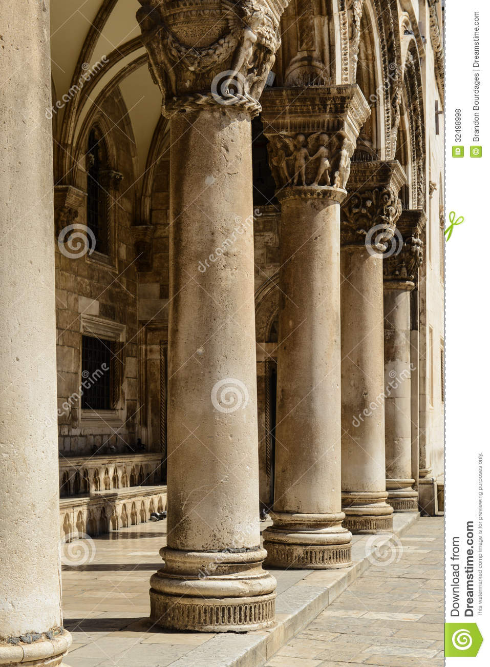

* **Textures and Lighting:** cell shading visual
* **Characters:** humanoid character that’s shading “evolves” as the game progresses. Particle effect based “wisp” forms for each element type, Shadow like Spiders and a Shadow formed humanoid in the extra area.
* **Vehicles:** N/A

# Gameplay Mechanics

* **Prerequisite Skills:** basic 3rd person control knowledge
* **Skills Learned:** Light dash, earth element
* **Primary Objective:** Escape the temple
* **Secondary Objectives:** Discover any clues you can about what happened to the world.
* **Game Controls:** The game will run best on a controller. Left joystick to move the player, right joystick to look around. Left and right bumper buttons to cycle elements, A to activate element effects (if applicable)

# Necessary Assets

* **Static and Skeletal Meshes:** List all 3D models required to build this level.

Humanoid skeletal mesh

Spider model

Stone pillars

Primitive chandeliers

Primitive torches

* **Textures:**

2d hieroglyphs for different wall murals

* **Music and SFX:**

Subtle classical music for the background

A

* **Player Actors:** List all playable characters.

***Player Actors***

* Model(s): Humanoid and various spherical particle systems for element forms
* Motives/Objectives: escape, explore, survive

# User Interface

* **Pregame Information:** Explain what information is covered in the pregame menus, such as selecting a playable character.  
  -Start game

-Load game

* **In-Game Information:** List any feedback the player will need during the game, such as an alert when a kill is made.

-upon gaining the first elemental ability the play needs to be informed how to select the element and use the ability. Preferable the actual effect of each ability will be shown rather than told, so the player will be propped to select the element and immediately be exposed to its effects and given room to experiment.

* **Post-game Information:** The final seen of the level would be a cinematic spiral out from the tempe showing the barren surrounding world in a drizzle of rain brought upon by obtaining the final water element. A single sproutingling popping out of the ground as a hint of hope for the world.
* **HUD Elements:** The only UI should be a number of hearts, that represent the number of hits the player can take before spawning back at the last check point. There should be one heart for each element obtained.

# User Interface Mock Up

Include a physical drawing or a digital representation of the HUD/UI elements; it may fill the whole page or be attached as a separate file.

*UI Design Notes:*

* *The UI should be minimal so as not to distract the player from the environment and puzzles.*

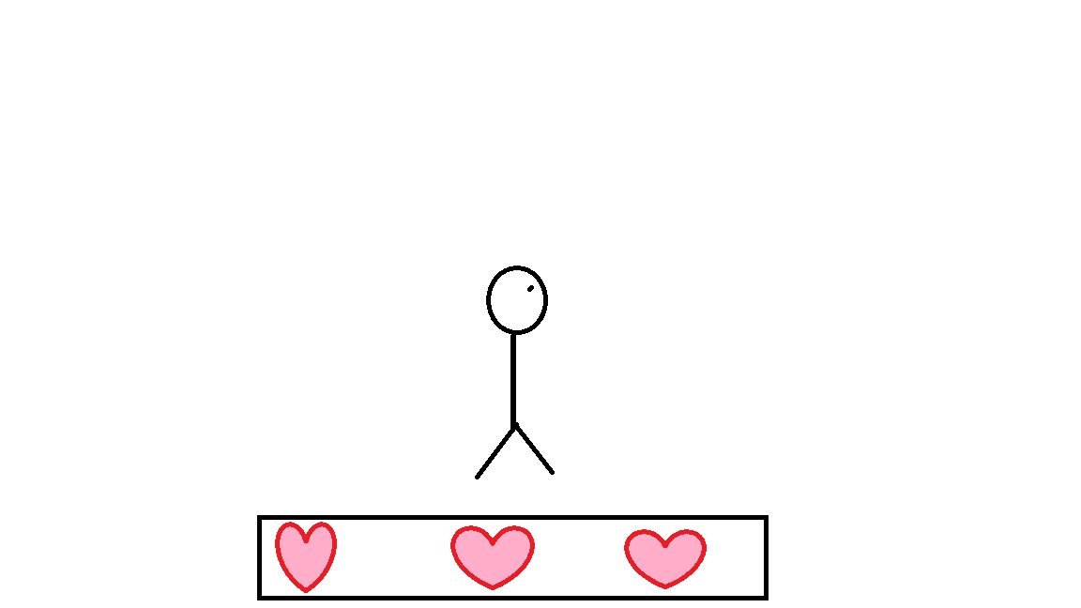

# Level Map

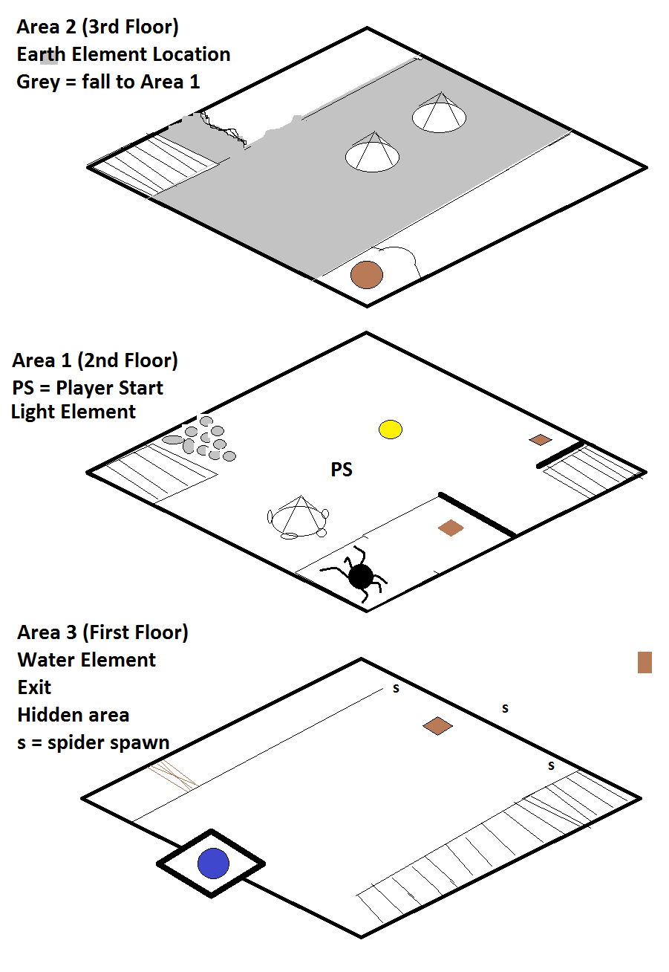

**Map Key (Legend)**

Include a key or legend, and label the following on your map; you may change the label markers.

|  |  |  |  |  |  |
| --- | --- | --- | --- | --- | --- |
| Water Cooler Moments: |  | Player Start Point: |  | ***Main Actors***   Spawn Point: |  |
| Challenge Highlights: |  | Player Optimal Route: |  | ***Main Actors*** Routes/Behavior: |  |
| Objectives: |  | Player Alternate Route: |  | ***Supporting Actors***  Spawn Point: |  |
| Skill Tests: |  | Area End Point: |  | ***Supporting Actors*** Routes/Behavior: |  |