Pandemic CoViD19 leads to Innovative Research and Journal Development

The Positive Impacts of CoViD19

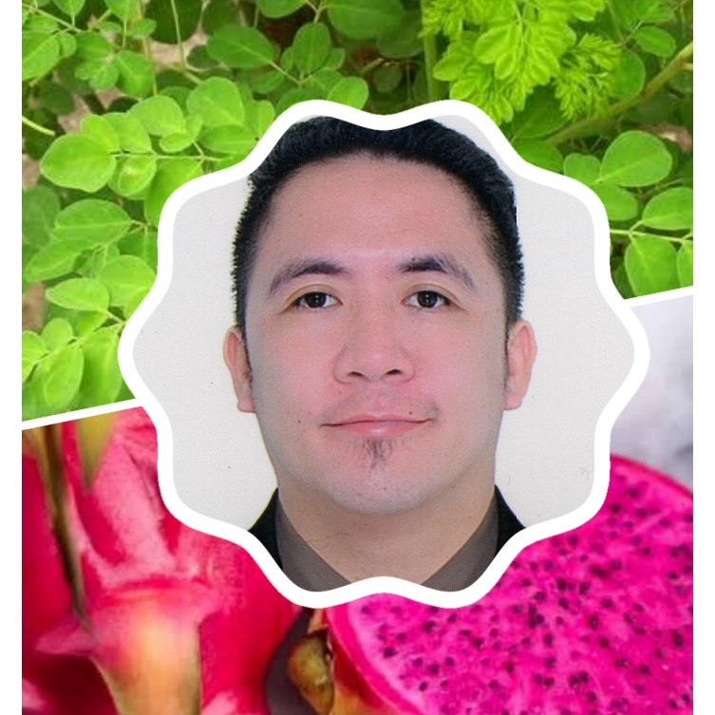Yves Infanta Gonzales (Green Power Ranger)

# Good Impact in Business and Education

GOOGLE MAP

Indeed, traveling is fun and educational.

As the physical lock-down is ongoing, I am realizing the above statement. As I trace back my travel history, I come to discover that travelling is a tool in economic growth and development.

As I go to different places together with my family, I learn the history, culture, customs, and traditions if a certain place which serve as a bases to what business shall be included in that place for the products and services to become marketable. But as we travel, we use google maps for us to locate properly the locations of strategic places for tourism activities. Also, the google may serve as a helpful geographic history library for its special features to make reviews and insights which another form of marketing strategies to help our business community in evaluating their establishment through customer satisfactions. Our business community contributes taxes that we are using in the different projects and services in the government. That is why we need to help them.

As the quarantine movement continuously taking place, we need to support the online and virtual business sides to make everything balance. These shall be the days that online or virtual business must be in their economic boosts because the physical world is contaminated by CoViD19, a catastrophe that economically declines the real physical business world transactions.

Therefore, poverty is one of the main roots of chaos and prosperity is one of the main sources of Global Peace and Unity.

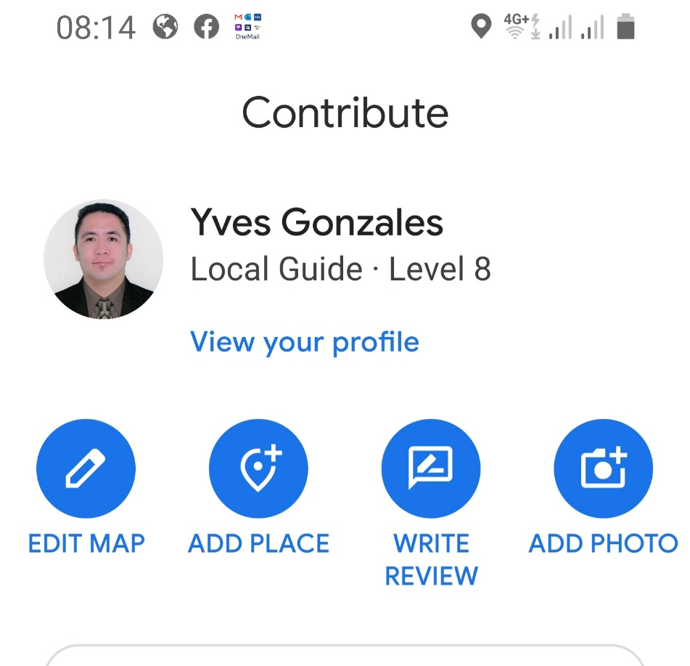GOOGLE MAP SCREEN LOCAL GUIDE PROFILE

## **Positive Impact in Families**

Due to busy schedules as every family aims for better future, the old traditional family bonding is compromised which lead to misunderstandings and worst – broken family.

That is why, these are the days of the reunion of every member of the family to enjoy together and chase and replace those previous golden days intended for family activities that tighten the relationships to lessen problem in “broken family”.

These are also the days that reunited families retighten the strong reengagement and trust with the LORD ALMIGHTY that all conundrums may be solved through HIM.

Therefore, the family that prays together stays together. Family is love . . .forever.

**Great Impact in Research and Developments**

With the global invasion of the pandemic CoViD19, the world come into an integrity test of Global Peace and Unity. These are the days that the world expose who really give helping hands and send golden hearts. These are the days that the world expose the power of great leadership, strong faith in God, and strong love for humanity and the world itself. These are the days that the world expose and showcase how properly mankind shall identify the prioritized and needed skills, talents, professionals without compromising the 4Es – Efficiency, Effectiveness, Equity/Equality and Excellence which are all products of research and developments.

After this catastrophe, everyone shall realize that everyone need to prioritize research first before developments for us to determine what are the needed and what shall be the correct undertakings. “We mankind are the world living in our own world and shall protect for the healthy survival and existence in the WORLD.”

**CONCLUSION and RECOMMENDATION:**

After an in-depth observations, research and significant experiences in the world; I came up with the following solution through the Four Directional Economoc Geographic Solution for Every WORLD:

NORTH – (the top a world, the strongest mechanism) shall focus and prioritized in research and developments, technology optimizations and revolutions, and solving the problem of the WORLD.

SOUTH – (the bottom part of the world, the food and survival provider) shall focus in agriculture and agribusiness to eliminate crisis in demands and supplies for the basic needs for survival.

EAST and WEST – (being at the middle, the WORLD balancer) shall focus in flexibility of acquiring the strengths and weaknesses of the NORTH and SOUTH to balance the their actions to lessen the WORLD’s imbalances that creates chaos/war, poverty, and great number of indecent deaths.