CERT/ACT Analysis

**Purpose**

The purpose of this analysis is to compare students’ scores on the CERT practice ACT assessment with their ACT scores in order to determine the validity of the CERT assessment as a predictor of Seigel High School’s ACT scores. Additionally, this analysis seeks to clarify what or if a relationship exists between Seigel High School (SGH) student performance on CERT practice ACT assessment and SGH student ACT scores.

**Research Questions**

The following research questions guided the analysis and were decided upon by committee in order to qualify differences between sets of data.

1. Does SGH ACT score (average) match the schoolwide CERT score?
2. On a student-by-student basis, are SGH student ACT scores significantly different than their corresponding CERT scores?
3. Are there particular subgroups of the school, or subtests of the ACT, for which the CERT assessment is (more) accurate and precise? (I.e., for English department, female students, those taking honors math/English, etc.)
4. Is the distribution of ACT scores for SGH students different than the distribution of CERT scores?
5. Are there correlations between students’ CERT scores and ACT scores?
6. Can a predictive model be created using the subsets of the CERT assessment data to predict how a student may have performed on their ACT test or subtest? (If so, is the model strong?

**Constraints**

It should be noted that the CERT assessment was administered after the real ACT test for the participants, and it was administered under less strict testing environments. This study is limited to less than 400 participants from a single cohort—many records were dropped for certain tests given that a number of students took the ACT but did not take/complete the CERT test. Given the relatively small set of data, any predictive model will likely be severely limited in usefulness or generalizability. Additionally, creating a machine-learning model to work with this data is time-consuming and dependent upon resources.

***Results***

**Question 1:** *Does SGH ACT score (average) match the schoolwide CERT score?*

As far as this year’s juniors’ scores are concerned, there is **no** significant difference between the overall SGH ACT score and the CERT score (note, there were many students who did not take the CERT, or complete all subparts of the CERT) . The ACT average composite was 18.74, and the CERT average composite was 18.38.

**Question 2:** *On a student-by-student basis, are SGH student ACT scores significantly different than their corresponding CERT scores?*

The ACT and CERT scores are significantly different on a student-by-student basis. This does not mean they are not related or useful, though. For the composite scores:

95.0%-Confidence interval for student score difference (ACT - CERT): (-0.88, -0.09).

This indicates that, on average, any given student’s ACT composite score was about 1 point lower than their CERT composite. This fluctuated greatly when individual subtests were considered. Thus, the next question.

**Question 3:** *Are there particular subgroups of the school, or subtests of the ACT, for which the CERT assessment is (more) accurate and precise?*

This question has great potential for consideration in further analysis. This review was limited to considering subtests as no demographic information was provided, such as student GPA, honors status, dual enrollment/AP, attended ACT camps/other programs, sought private tutoring, etc. The following table explains the differences.

|  |  |  |  |
| --- | --- | --- | --- |
| **Subtest** | **Sig. Different?** | **p-value, C.I. (**ACT – CERT**)** | **How?** |
| English | Y | p = 0.0000, C.I. = [-2.44, -1.38] | Typically, a given student was likely to score 1 to 2 points higher on their CERT English subtest than ACT English. |
| Math | Y | p = 0.0000, C.I. = [-1.85, -0.97] | A given student was likely to score 1 to 2 points higher on their CERT Math subtest. |
| Reading | N | p = 0.2476, C.I. = [-1.11, +0.29] | The Reading subtests actually matched, well-enough. If a student didn’t score the same, they likely were only off by 1 point. |
| Science | Y | p = 0.0000, C.I. = [+1.23, 2.36] | Oddly, a given student was likely to score 1 to 2 points higher on their ACT Science subtest than their CERT subtest. |
| p-values are the result of 2-sided, paired-sample t-tests, 0.0000 means the p-values was less than 0.0001 (0.01%), where anything less than 0.0500 (5%) was considered significant. | | | |

**Question 4:** *Is the distribution of ACT scores for SGH students different than the distribution of CERT scores?*

This violin plot can be read just like a standard boxplot with the addition of its verbosity which corresponds to the density of score distribution (i.e., the wider a part of a plot, the more students scored similarly). For example:

Considering the first plot on each section, the English Subtest:

* the range of ACT English scores varied a little more than the CERT English scores;
* the median score (white dot) of the CERT scores is about 1.5 points greater than the ACT median score
* on both the ACT and the CERT English subtests, student scores tended to cluster around the 1st and 3rd quartiles (around 15/22.5 and 14/24, respectively).

The following histograms illustrate the breakdown by score range on composite scores.

ACT


ACT Composite Score

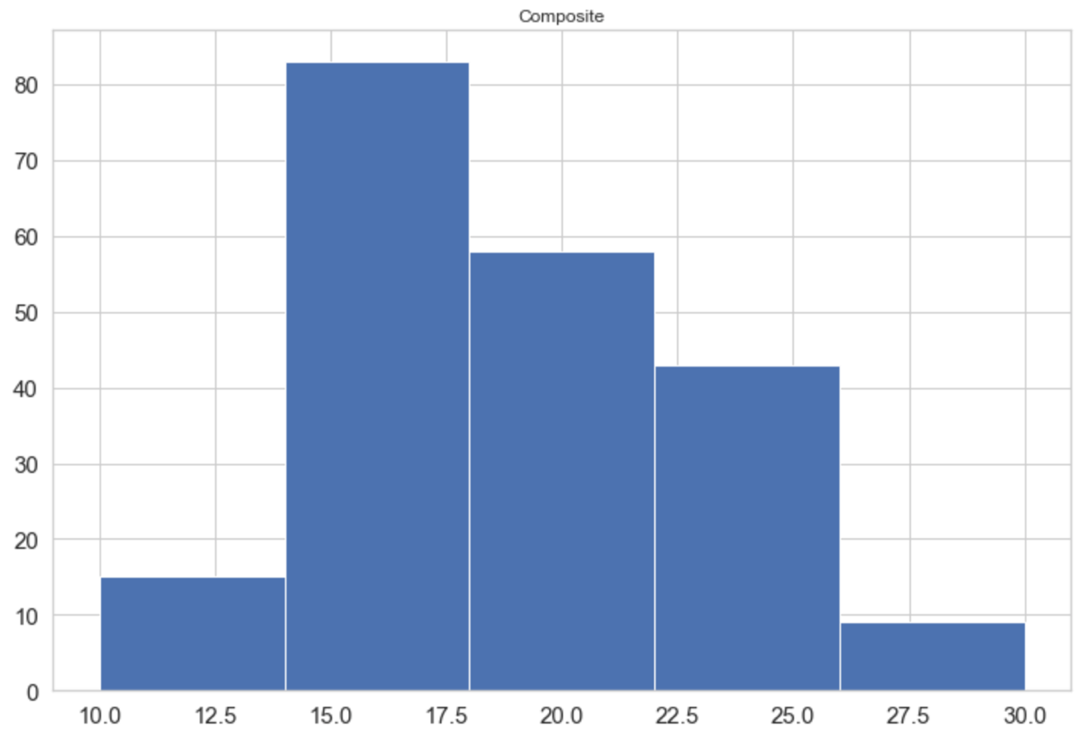

CERT Composite Score

**Question 5:** *Are there correlations between students’ CERT scores and ACT scores?*

There were a number of relatively strong correlations that exist between various subtests of the CERT and ACT. Attached you will see the full breakdown that considered every aspect of both ACT and CERT with every other aspect, if you are curious. A simplified and slightly more useful table is provided in this report.

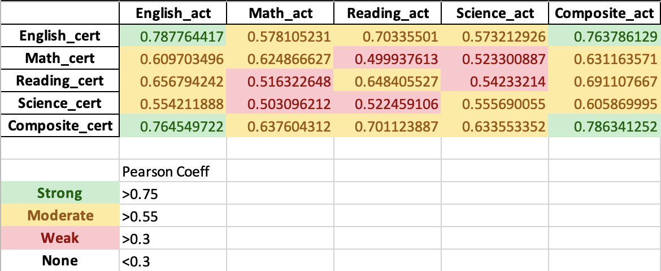

To clarify, a positive coefficient that is closer to 1 indicates a positive linear relationship exists (perhaps coincidentally—remember that correlation and causation are two very different ideas) between the two sets being considered.

For example, the is a strong positive correlation between CERT English score and ACT English score. This does not mean that CERT English and ACT English scores match. It indicates that most of the time a student who *does better (or improves)* on the CERT English subtest will usually *tend to do better (or improve)* on their ACT English subtest. The closer the coefficient is to 1 the more confident we expect improvements in one will be reflected by improvements in the other.

Note: I was picky with the ranges of strong, medium, weak above due to the limited size of the data. I want to ensure the greatest quality of analysis possible with as reliable as possible interpretations. Some reputable sources would classify a strong correlation to be anything greater than 0.5.

**Question 6:** *Can a predictive model be created using the subsets of the CERT assessment data to predict how a student may have performed on their ACT test or subtest? (If so, is the model strong?*

Given the time constraints and the relatively small set of data, I did not attempt to create a predictive or machine-learning model for this. Read additional context below if you would like to investigate some ideas for doing this in the future.

**Additional context**: According to TN.Chalkbeat.org, Siegel High’s ACT scores have steadily decreased over the prior two years from 20.9 in 2019, to 20.8 in 2020. However, this years scores are statistically significantly different than this trend and should be taken with a grain of salt given the extraordinary conditions of this school year. It is important to note that these significant conditions likely impacted the closeness with which ACT and CERT scores lined up. I recommend that these analyses be revisited throughout next year in order to verify the legitimacy of CERT as a predictor for student ACT achievement. I am happy to discuss long-term solutions and options. Over the course of even one more year, we would have a much more robust set of data and the idea of using machine-learning to create a model to predict student performance on ACT becomes more realistic.