下载MinGW

1. Go to winlibs.com
2. Scroll down and find the "UCRT runtime"
3. Download the "Zip archive" for Win64 (you can choose to download the one without clang)
4. Extract the mingw folder from zip and place it somewhere
5. Open mingw folder, there's a bin folder, open it
6. Copy the current path, e.g., "C:\mingw\bin"
7. Open environment variables editor
8. Open Path, add new and paste the above copied path

安装MinGW

将mingw-w64.zip解压到C盘，然后拷贝C:\MinGW\mingw64\bin到环境变量

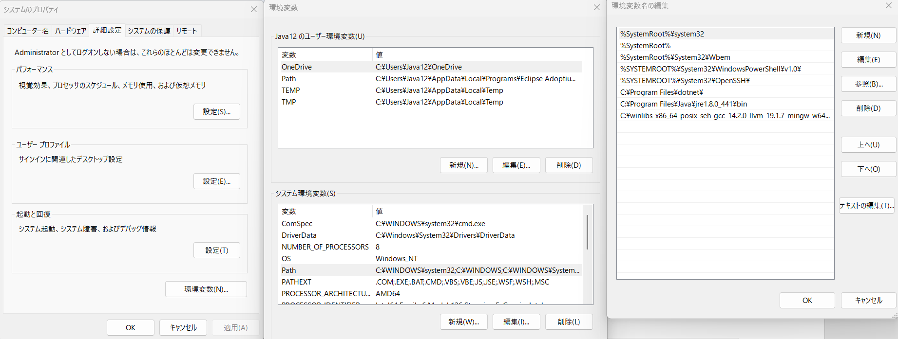

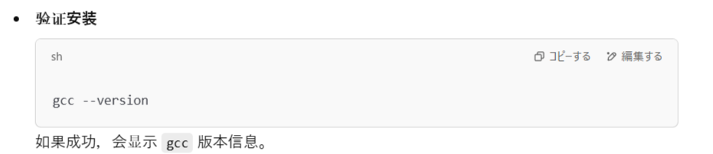

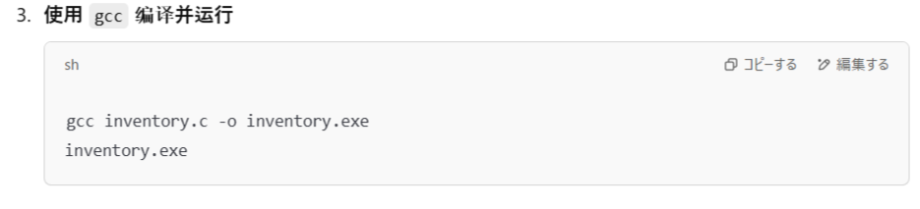

これは中国語バージョン

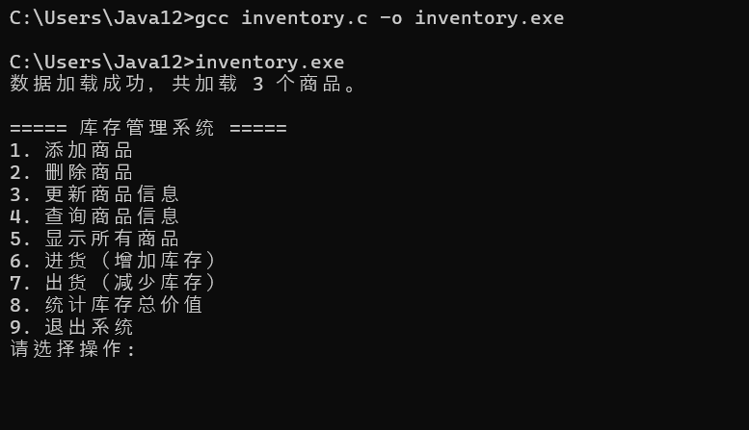

これは日本語バージョン

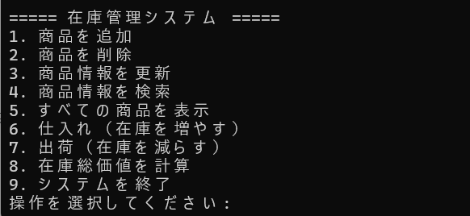

注意：商品ID　商品数量　商品価格の入力値はからなず半角、商品名は漢字かひらかなかカタカナ全てOKです