3. Настроить мониторинг созданных в рамках курса виртуальных машин.

Устанавливаем агента Zabbix на вторую машину. Для этого по аналогии с первым заданием устанавливаем пакет конфигурации репозитория.

Далее выполняем команды

dann@dann-VirtualBox:~$ sudo apt install zabbix-agent

Reading package lists... Done

Building dependency tree

Reading state information... Done

The following package was automatically installed and is no longer required:

libfprint-2-tod1

Use 'sudo apt autoremove' to remove it.

The following additional packages will be installed:

libcurl4

The following NEW packages will be installed:

libcurl4 zabbix-agent

0 upgraded, 2 newly installed, 0 to remove and 50 not upgraded.

Need to get 434 kB of archives.

After this operation, 1 506 kB of additional disk space will be used.

Do you want to continue? [Y/n] y

Get:1 http://ru.archive.ubuntu.com/ubuntu focal-updates/main amd64 libcurl4 amd64 7.68.0-1ubuntu2.2 [233 kB]

Get:2 http://repo.zabbix.com/zabbix/5.0/ubuntu focal/main amd64 zabbix-agent amd64 1:5.0.3-1+focal [201 kB]

Fetched 434 kB in 1s (353 kB/s)

Selecting previously unselected package libcurl4:amd64.

(Reading database ... 161949 files and directories currently installed.)

Preparing to unpack .../libcurl4_7.68.0-1ubuntu2.2_amd64.deb ...

Unpacking libcurl4:amd64 (7.68.0-1ubuntu2.2) ...

Selecting previously unselected package zabbix-agent.

Preparing to unpack .../zabbix-agent_1%3a5.0.3-1+focal_amd64.deb ...

Unpacking zabbix-agent (1:5.0.3-1+focal) ...

Setting up libcurl4:amd64 (7.68.0-1ubuntu2.2) ...

Setting up zabbix-agent (1:5.0.3-1+focal) ...

Created symlink /etc/systemd/system/multi-user.target.wants/zabbix-agent.service → /lib/systemd/system/zabbix-agent.service.

Processing triggers for systemd (245.4-4ubuntu3.2) ...

Processing triggers for man-db (2.9.1-1) ...

Processing triggers for libc-bin (2.31-0ubuntu9) ...

Создаем ключ шифрования соединения агента и сервера

dann@dann-VirtualBox:~$ sudo sh -c "openssl rand -hex 32 > /etc/zabbix/zabbix_agentd.psk"

dann@dann-VirtualBox:~$ cat /etc/zabbix/zabbix_agentd.psk

508d22a14226e2d7c8f3d64ee5854efd0be68d37f142644d64590828489748bf

Редактируем файл-конфиг агента

dann@dann-VirtualBox:~$ sudo nano /etc/zabbix/zabbix_agentd.conf

Прописываем

Server=192.168.88.219

Server=192.168.88.219

ServerActive=192.168.88.219

Hostname=192.168.88.219

TLSConnect=psk

TLSAccept=psk

TLSPSKIdentity=PSK 001

TLSPSKFile=/etc/zabbix/zabbix_agentd.psk

dann@dann-VirtualBox:~$ sudo systemctl restart zabbix-agent

dann@dann-VirtualBox:~$ sudo systemctl enable zabbix-agent

Synchronizing state of zabbix-agent.service with SysV service script with /lib/systemd/systemd-sysv-install.

Executing: /lib/systemd/systemd-sysv-install enable zabbix-agent

dann@dann-VirtualBox:~$ sudo systemctl status zabbix-agent

● zabbix-agent.service - Zabbix Agent

Loaded: loaded (/lib/systemd/system/zabbix-agent.service; enabled; vendor preset: enabled)

Active: active (running) since Tue 2020-09-15 21:42:30 MSK; 6s ago

Main PID: 4223 (zabbix_agentd)

Tasks: 6 (limit: 2319)

Memory: 4.9M

CGroup: /system.slice/zabbix-agent.service

├─4223 /usr/sbin/zabbix_agentd -c /etc/zabbix/zabbix_agentd.conf

├─4224 /usr/sbin/zabbix_agentd: collector [idle 1 sec]

├─4225 /usr/sbin/zabbix_agentd: listener #1 [waiting for connection]

├─4226 /usr/sbin/zabbix_agentd: listener #2 [waiting for connection]

├─4227 /usr/sbin/zabbix_agentd: listener #3 [waiting for connection]

└─4228 /usr/sbin/zabbix_agentd: active checks #1 [idle 1 sec]

сен 15 21:42:30 dann-VirtualBox systemd[1]: Starting Zabbix Agent...

сен 15 21:42:30 dann-VirtualBox systemd[1]: Started Zabbix Agent.

Добавляем хост на сервере Zabbix

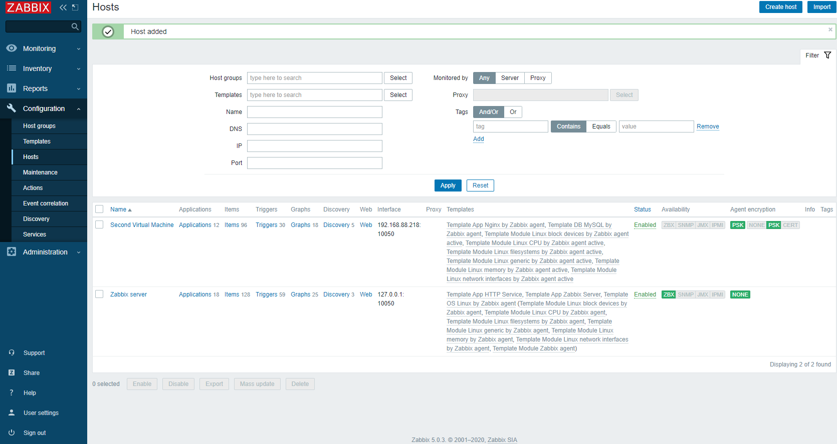

Сразу делаем задание №4 – добавляем хосту шаблон мониторинга NGINX

