

Redis App Studio

User Guide

Al Cole

June 1, 2022

Release 1.0

Redis App Studio 4

Overview 4

Solution Launching 4

Data Sources and Schema Files 5

Application Launcher 6

Data Modeler Application 7

RedisCore Application 8

RediSearch (Hash) Application 8

Tags 9

Add Rule 10

General Section 10

Search Term Matching 11

Catalog Document Fields 11

RedisJSON Application 12

Edit Rule Examples 12

RediSearch (JSON) Application 15

RedisGraph Application 15

Redis App Studio Administration 16

Overview 16

Rules Query Pipeline 16

Fusion Search UI 17

Rule Execution Examples 18

Filter List 18

Set Params 20

Rule Query Parameters 22

Additional Resources for Rules 22

Rules Manager Permissions Management 23

Rules Permissions Overview 23

Getting started 23

Advanced usage 23

Index pipeline 24

Query pipeline 24

Solution Download and Installation 25

Overview 25

# Redis App Studio

## Overview

This document describes the user and administration features behind the Redis App Studio solution developed by the Professional Services organization. Redis App Studio is a web application that can manage the life cycle of business rules for the Fusion search platform. The technology stack behind the rules editor includes a web UI, Fusion query pipelines and Solr for rule document persistence and query execution.

This document is structured into the following sections:

* Rules Editor User Section
* Fusion Rules Administration Section
* Solution Installation and Configuration Section

The goal of this document is to introduce concepts, terminologies and general features offered by the Redis Labs Rules Editor solution. Some of the examples shared in the guide will be based on the publically available catalog data set from the Best Buy Developer Portal web site. Our examples will not cover all customer-specific usage scenarios since that would involve a tight coupling to catalog data and time-sensitive business rules. We expect that once the business users have mastered the core capabilities of the tool, they will develop their own site-specific work instructions to manage the day-to-day maintenance of their rules.

## Solution Launching

The Redis Labs Rules Editor is a web application that can be launched within a browser such as Chrome via the following URL:

[http://localhost:8764/<COLLECTION_NAME>-rules-editor/#/rules](http://localhost:8764/%3CCOLLECTION_NAME%3E-rules-editor/#/rules)

Where “**hostname”** refers to the machine name where the Fusion instance is installed and the rules editor solution has been added to an existing collection <COLLECTION_NAME>. Details around the installation and configuration of the solution are provided later in this document.

## Data Sources and Schema Files

Once the solution has been launched, you will be presented with the main view of the rules editor (shown below). The UI of the main view is divided into several sections (described below from left-to-right).

**Add Rule** – Adds a business rule to the repository.

**Facets** – The facet areas allows you to isolate your rules during search operations.

**Row Selection** – Permits you to select all or none of the rules on a page.

**Bulk Actions** – Allows you to apply updates across one or more selected rules.

**Filter & Search** – Performs keyword searches and applies tag filters against your rules.

**Rule Grid** – Presents your existing rules in a table format for easy review and editing.

**Page Navigation** – Page offset information with Next and Previous page buttons.

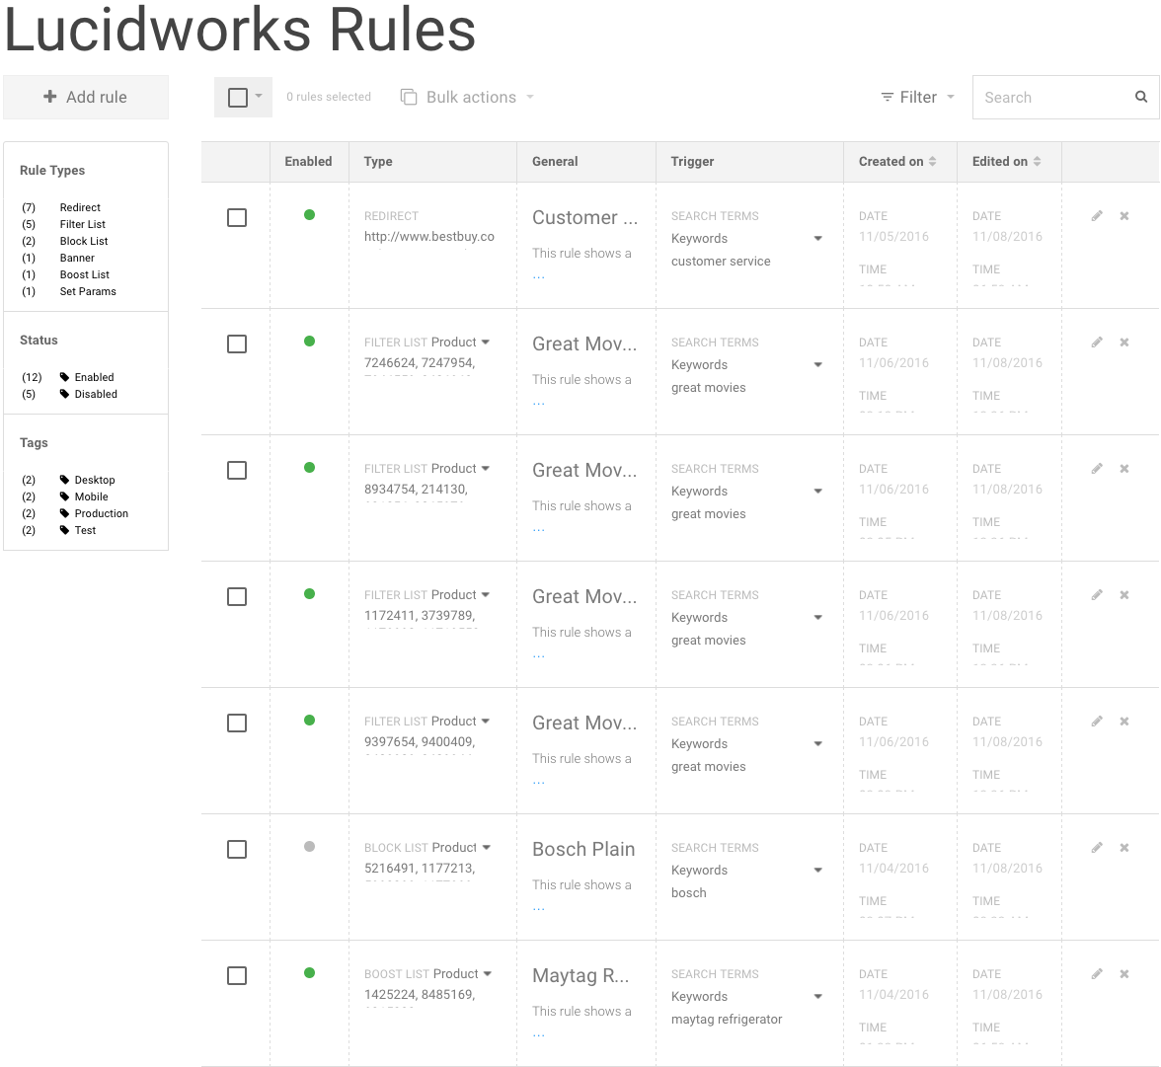

## Application Launcher

The business rules created in the editor are stored in Fusion/Solr as a collection, so searching for existing rules is as easy as typing your keywords into the search box in the top right section of the main view of the rules editor (see below).

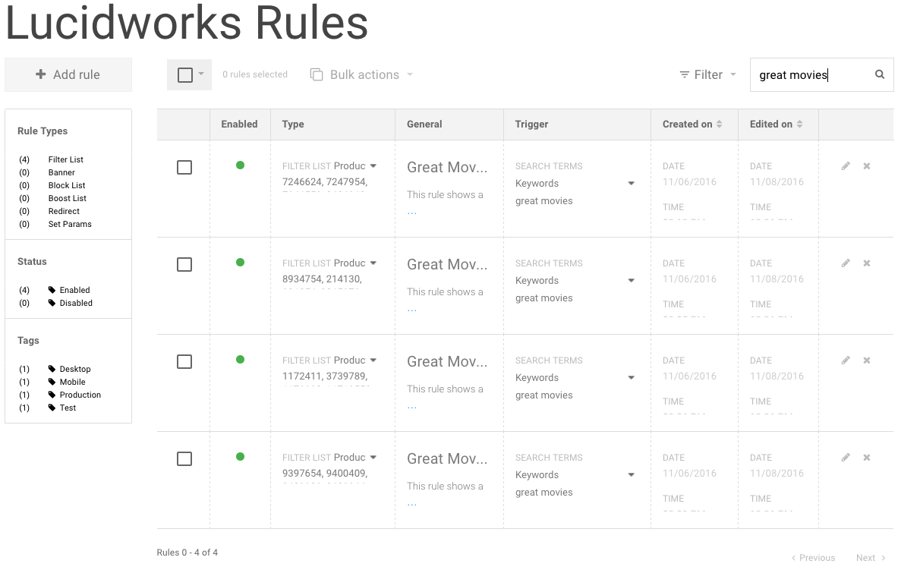

The keyword entered was ‘great movies’ and the search isolated the business rules with a name matching ‘great movies’. Each rule is displayed in the grid with the following columns.

**Selection** – Checkbox identifying if the rule is selected or unselected.

**Enabled** – Color-coded status for the rule. **Green** – is enabled, **Grey** – is disabled.

**Type** – Captures the rule type and any supporting values associated with that rule.

**General** – Shows the general properties of the rule (e.g. its name and description).

**Trigger** – Displays any trigger related properties of the rule (e.g. dates, tags).

**Created On** – Identifies the date/time the rule was first created.

**Edited On** – Identifies the date/time the rule was last edited.

**Operations** – Presents two icon operations for the row (e.g. edit and delete).

## Data Modeler Application

In addition to searching for your existing rules by keywords, you can also apply filters in the process. The filter section permits you to isolate your rules by trigger start date, end date, rule status and tags. In addition, this dialog is a convenient way to reset the criteria of a previous query (see below).

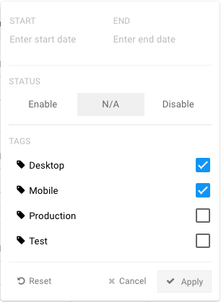

The above filter selections (when applied) will isolate the search to those rules with the trigger tags “Desktop” and “Mobile” assigned to them.

## RedisCore Application

After you have completed your search for existing rules, you can select all of them for a bulk action by selecting from the menu. “**All**” will select all existing rules on the page and “**None**” will deselect them (see below).

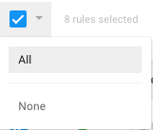

## RediSearch (Hash) Application

The rules editor bulk action feature is an accelerator operation that allows you to update an existing rule without having to select and edit them on an individual row-by-row basis (see below).

The Bulk Action dialog supports the following operations against selected rules.

**Delete Rule** – Deletes one or more selected rules from the Fusion/Solr repository.

**Enable/Disable** – Toggles the rule status. A disabled rule will not fire during a query.

**Assign Tags** – Permits the assignment and removal of tag names across the rules.

You will notice that many of our tag names follow a naming convention of “Desktop”, “Mobile”, “Test” and “Production”. These tag names were developed for demonstration purposes in this guide. A more appropriate list of recommended tag names is discussed below.

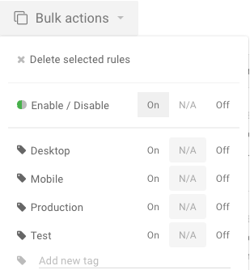

### Tags

The Redis Labs Rules Editor solution introduces a concept called “Tags” which can be thought of as user-defined labels on rules. You can use them to group your rules for organizational purposes in the editor or as a trigger isolation mechanism. Once assigned, these tag names can be incorporated into queries (e.g. &tags=Production) that are sent from your web applications to a Fusion query pipeline configured to process your business rules. If the tag name matches one or more of the business rules, then those rules will fire and the corresponding rule action will be applied (e.g. redirecting to a new catalog page). The following captures some example tag names that could be used for an e-commerce site – feel free to adapt as needed.

**Production** – Identifies rules that have been tested and are ready for production use.

**Test** – Identifies rules that are candidates for production, but require simulation testing.

**Desktop** – Identifies rules dedicated to web browsers for a desktop machine.

**Mobile** – Identifies rules dedicated to web browsers for mobile devices.

### Add Rule

You can add a new business rule to Fusion by pressing the “Add Rule” button on the top left in the main view of the business rules editor. Once pressed a new form will be presented with three sections of information (see below).

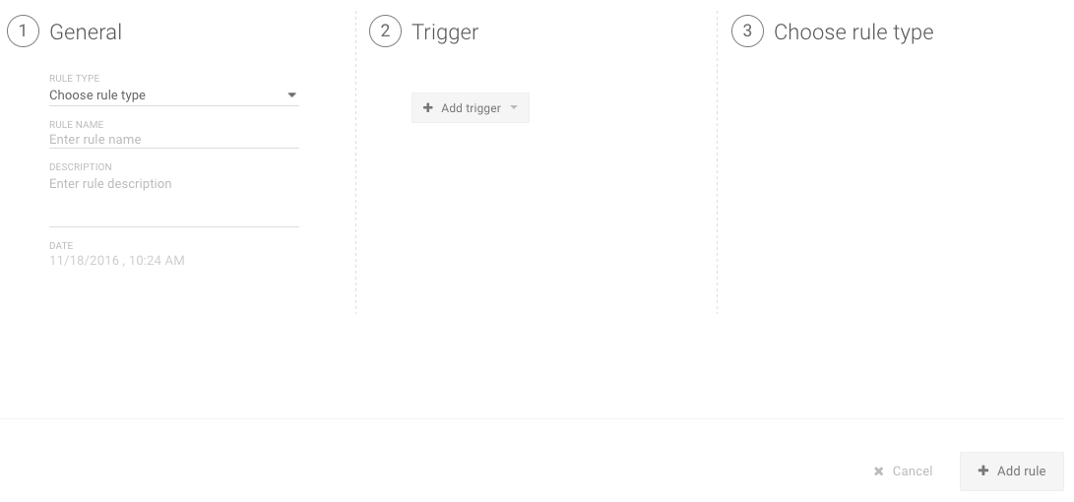

The “General” section will ask the business user to identify the rule type, rule name and a brief description. The “Created On” date will automatically be assigned.

### General Section

The list below describes each rule type supported in the “General” section.

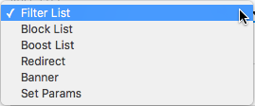

**Filter List** – Captures a merchandising product list (only these products will be shown).

**Boost List** – Boost a merchandising product list to the top of results.

**Block List** – Allows the suppression of one or more products from being displayed.

**Redirect** – Similar to a Fusion “Landing Pages” stage (enhanced with trigger features).

**Banner** – Displays a user-defined banner message when the rule fires.

**Set Params** – Corresponds to a Fusion “Set Params” stage and permits the complex modeling of a rule (e.g. category facet fields).

### Search Term Matching

Search terms allow for the specification of matching criteria along with the search term(s) themselves. The matching criteria options are explained below.

**Keywords** – Matches search terms exactly (one or more separated by commas) in a case-insensitive manner. This is the default selection.

**Contains** – Matches a substring of the search term provided (e.g. ‘**iphone**’ would match ‘**iphone**6’ and ‘**iphone**7’).

**Text** – Matches the search term using a text tokenization process (e.g. ‘**customer**’ would match ‘**customer** service’ and ‘**customer** help’).

### Catalog Document Fields

There are several instances where your business rules may be dependent on field values from your Solr documents. In those instances, you can obtain those field values from Fusion using the collection Search UI form and showing the fields (as shown below).

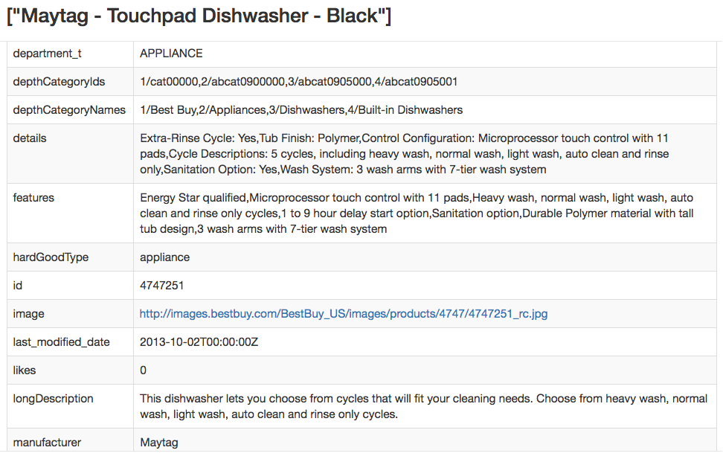

## RedisJSON Application

Any rule presented in the grid can be edited by selecting the pencil icon on the right side of the row. Once pressed, the entire row will transition into an editing mode where the “Type”, “General” and “Trigger” columns can be updated.

After you have completed your updates to the form sections, you can press the “Save” button on the right to save the rule changes to the repository.

### Edit Rule Examples

Several business rule edit examples are provided below.

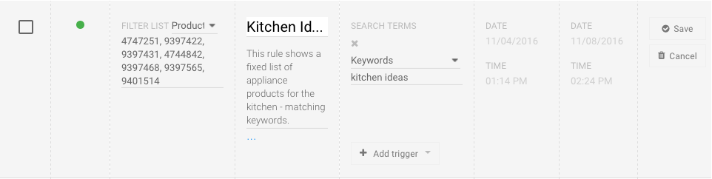

Above is a “Filter List” rule that contains several Product Id field values (with each value separated by a comma). This rule will trigger with the search terms ‘**kitchen ideas**’.

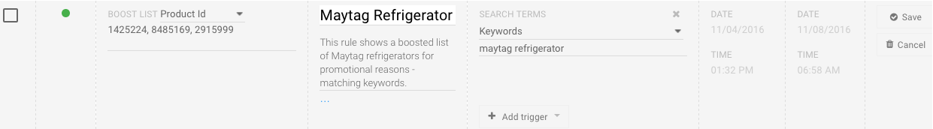

Above is a “Boost List” rule that contains several Product Id field values (with each value separated by a comma). This rule will trigger with the search terms ‘**maytag refrigerator**’.

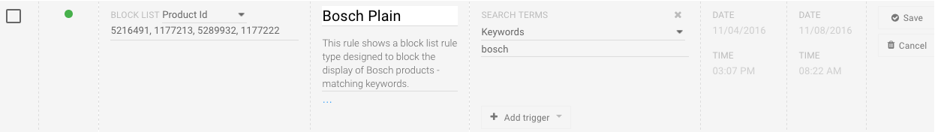

Above is a “Block List” rule that contains several Product Id field values (with each value separated by a comma). This rule will trigger with the search term ‘**bosch**’.

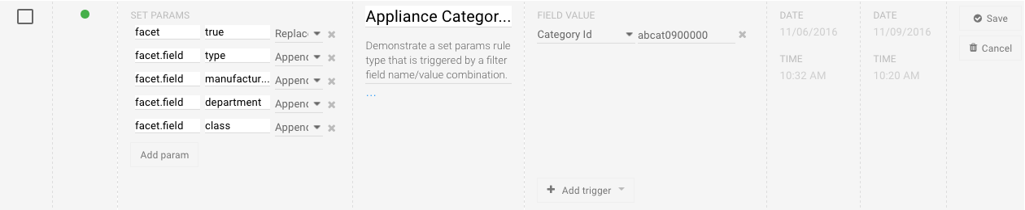

Above is a “Set Params” rule that contains several facet field parameters. This rule will trigger when the filter query parameter Category Id matches the value of ‘abcat0900000’ (e.g. &fq=categoryIds:abcat0900000).

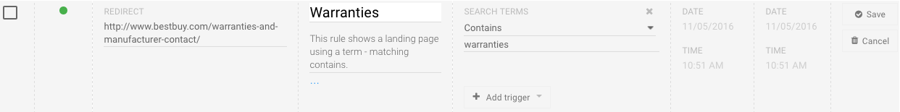

Above is a “Redirect” rule that will identify a landing page “*http://www.bestbuy.com/warranties-and-manufacturer-contact/*” in the query response payload. This rule will trigger with the search term ‘**warranties**’.

## RediSearch (JSON) Application

Any rule presented in the grid can be deleted by selecting the ‘x’ icon on the right side of the row. Once pressed, you will be presented with a confirmation dialog – select “OK” to delete the rule and “Cancel” to abort the operation (see below).

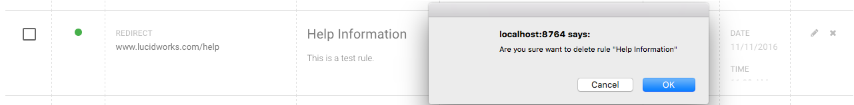

## RedisGraph Application

Any rule presented in the grid can be deleted by selecting the ‘x’ icon on the right side of the row. Once pressed, you will be presented with a confirmation dialog – select “OK” to delete the rule and “Cancel” to abort the operation (see below).



# Redis App Studio Administration

## Overview

The Redis Labs Rules Editor solution is built on top of the Fusion search platform. As queries are sent into Fusion, they will be evaluated for their applicability to rule execution (based on their trigger parameters). The rule evaluation and execution logic is captured in a Fusion query pipeline call ‘<COLLECTION_NAME>-rules’ and is described in detail in the next section.

### Rules Query Pipeline

The ‘‘<COLLECTION_NAME>-rules’ contains a collection of stages that support rule matching, Solr query execution and post processing operations (see below).

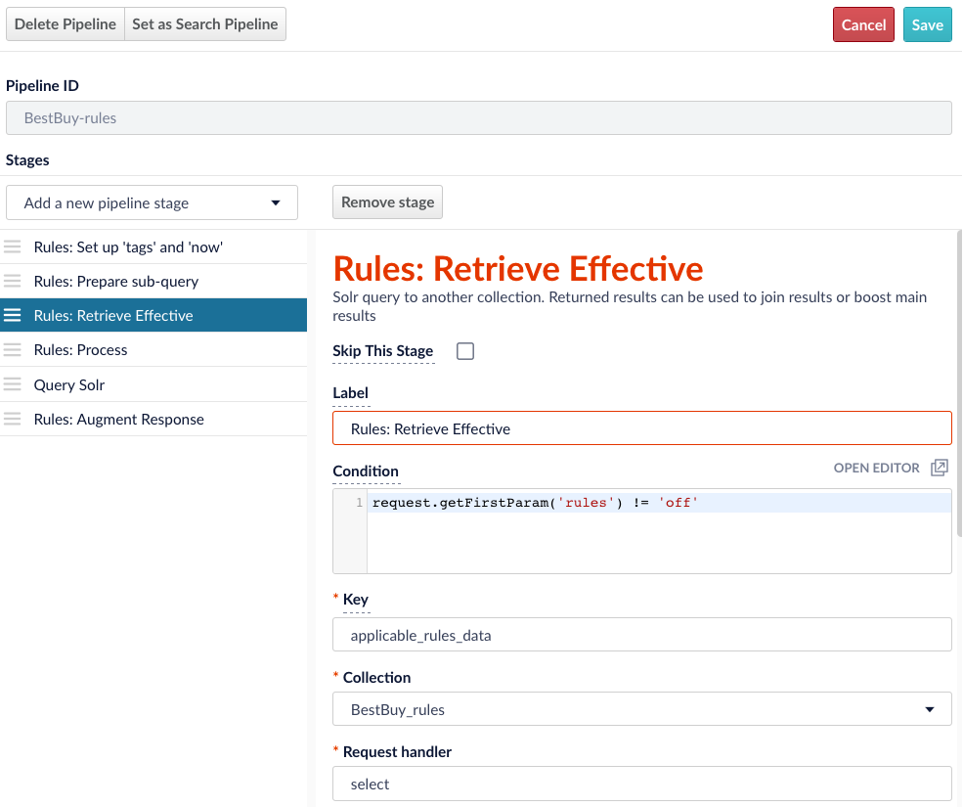

A description of each of the rule-specific query pipeline stages is presented below.

**Rules: Set up ‘tags’ and ‘now’** – Allows for rule parameter defaults or overrides to be defined and can be helpful in rule testing and troubleshooting.

**Rules: Prepare sub-query** – Creates Solr request parameters for a query into the business rules collection ‘‘**<COLLECTION_NAME>-rules**’. This is a JavaScript stage and its logic can be reviewed within Fusion using the Script Body editor.

**Rules: Retrieve Effective** – Executes the Solr query against the ‘‘**<COLLECTION_NAME>-rules**’ collection.

**Rules: Process** – Evaluates the list of applicable rules and updates the Solr request parameters for the product catalog query. This is a JavaScript stage and its logic can be reviewed within Fusion using the Script Body editor.

**Rules: Augment Response** – Incorporates additional rule-related content to the Fusion/Solr response payload. This is a JavaScript stage and its logic can be reviewed within Fusion using the Script Body editor.

### Fusion Search UI

The Search UI within Fusion can be used as a starting point for simulating the execution of rules. The following explains the steps that can be followed to review the firing of rules within Fusion.

1. Select “Collections” within the “Applications” menu (top left corner).
2. Select the name of the brand collection you would like to execute your rules against. Our example will use the ‘BestBuy’ collection.
3. Under the Home navigation area, select “Search” within the **Query** section.
4. Once the Search UI is displayed, select the ‘‘**<COLLECTION_NAME>-rules**’ query pipeline.
5. To the right of the search box, select the settings gear icon and enable the “Display Query URL” with a checkmark selection.

The resulting display of products should look similar to what is shown below.

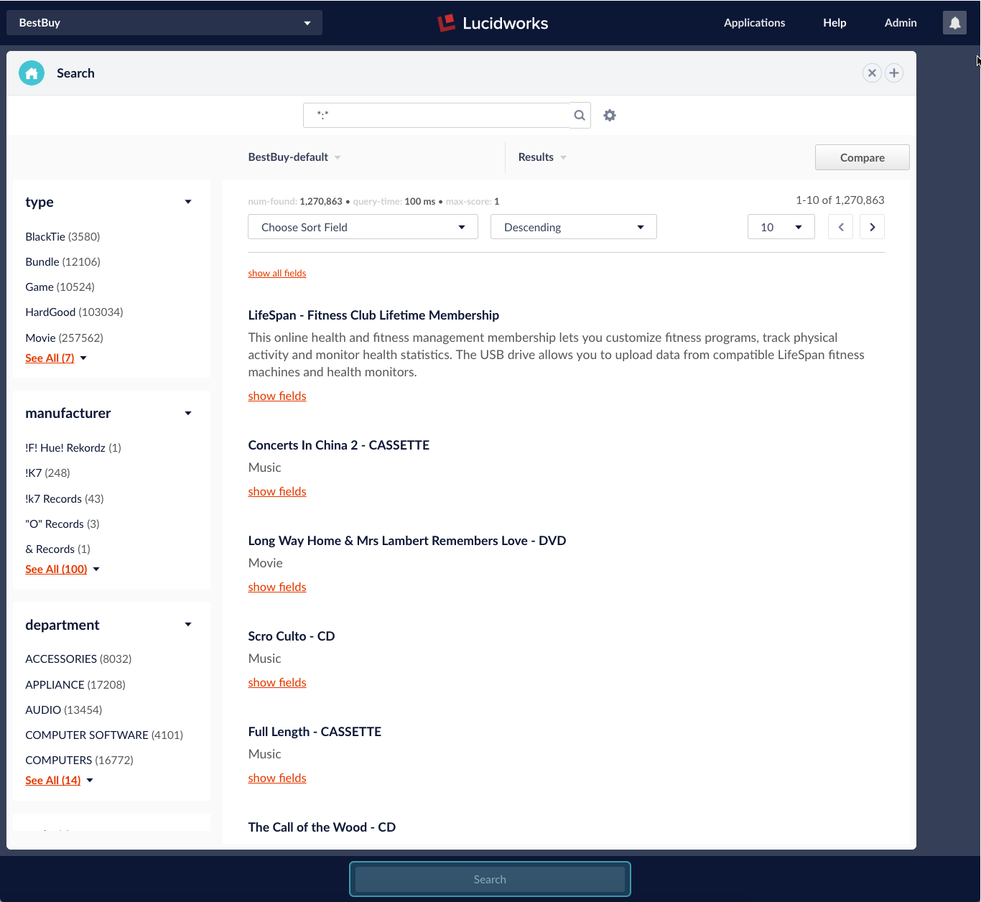

## Rule Execution Examples

This section will provide some example rules created using the Best Buy catalog data set.

### Filter List

In this example, we want seven products to be displayed in the search results when the search term “great movies” is used in a query.

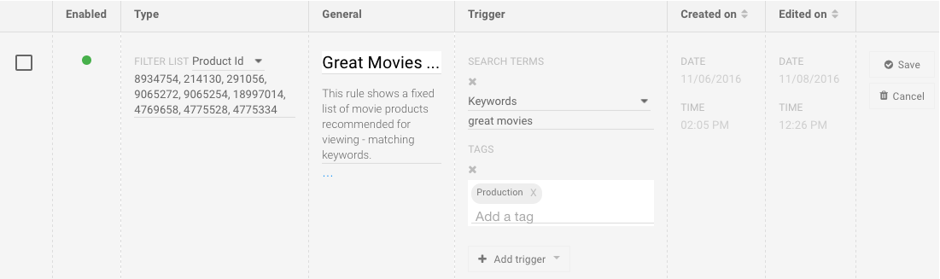

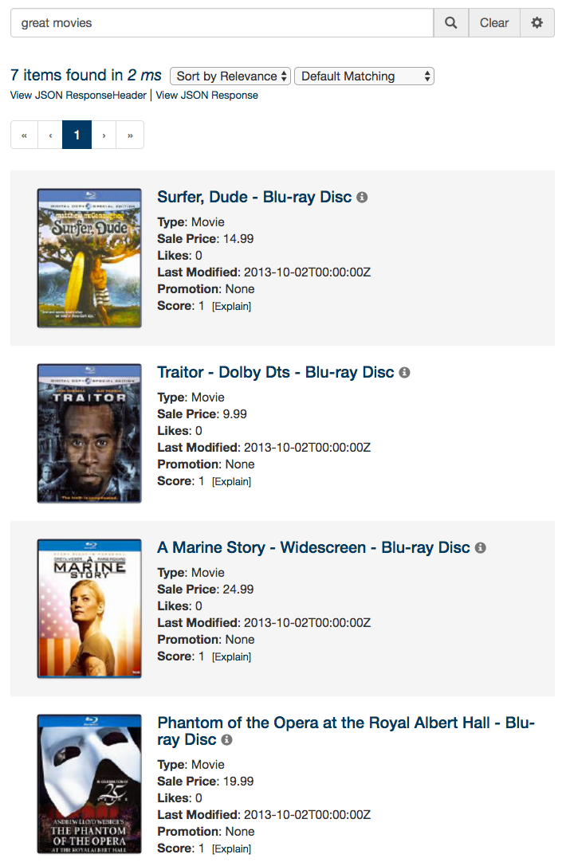

**Note 1**: In order for the rule to fire properly, you must amend the query submitted to Fusion with a ‘tags’ parameter assigned to the value of ‘Production’. See URL below.

[http://localhost:8764/api/apollo/query-pipelines/‘<COLLECTION_NAME>-rules/collections/‘<COLLECTION_NAME>/select?fl=%2A%2Cscore&echoParams=all&wt=json&json.nl=arrarr&sort&start=0&q=great+movies&debug=true&rows=10&tags=Production](http://localhost:8764/api/apollo/query-pipelines/'%3CCOLLECTION_NAME%3E-rules/collections/'%3CCOLLECTION_NAME%3E/select?fl=%2A%2Cscore&echoParams=all&wt=json&json.nl=arrarr&sort&start=0&q=great+movies&debug=true&rows=10&tags=Production)

**Note 2:** Multiple tags can be specified for the ‘tags’ parameter – you must comma separate the values. Also, you must ensure that the comma is URL encoded with “%2C”.

### Set Params

In this example, we want four facet fields to be displayed in the search results when the user navigates to a category id of ‘abcat0900000’ using a Solr filter query parameter (e.g. &fq=categoryIds:abcat0900000).

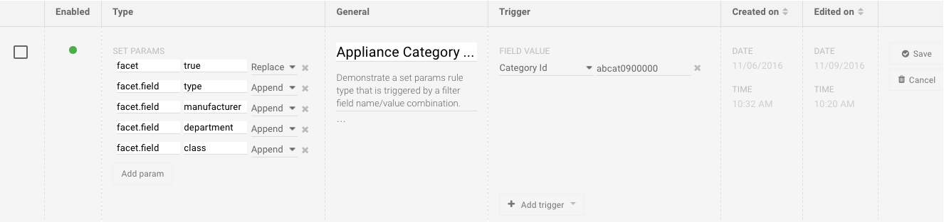

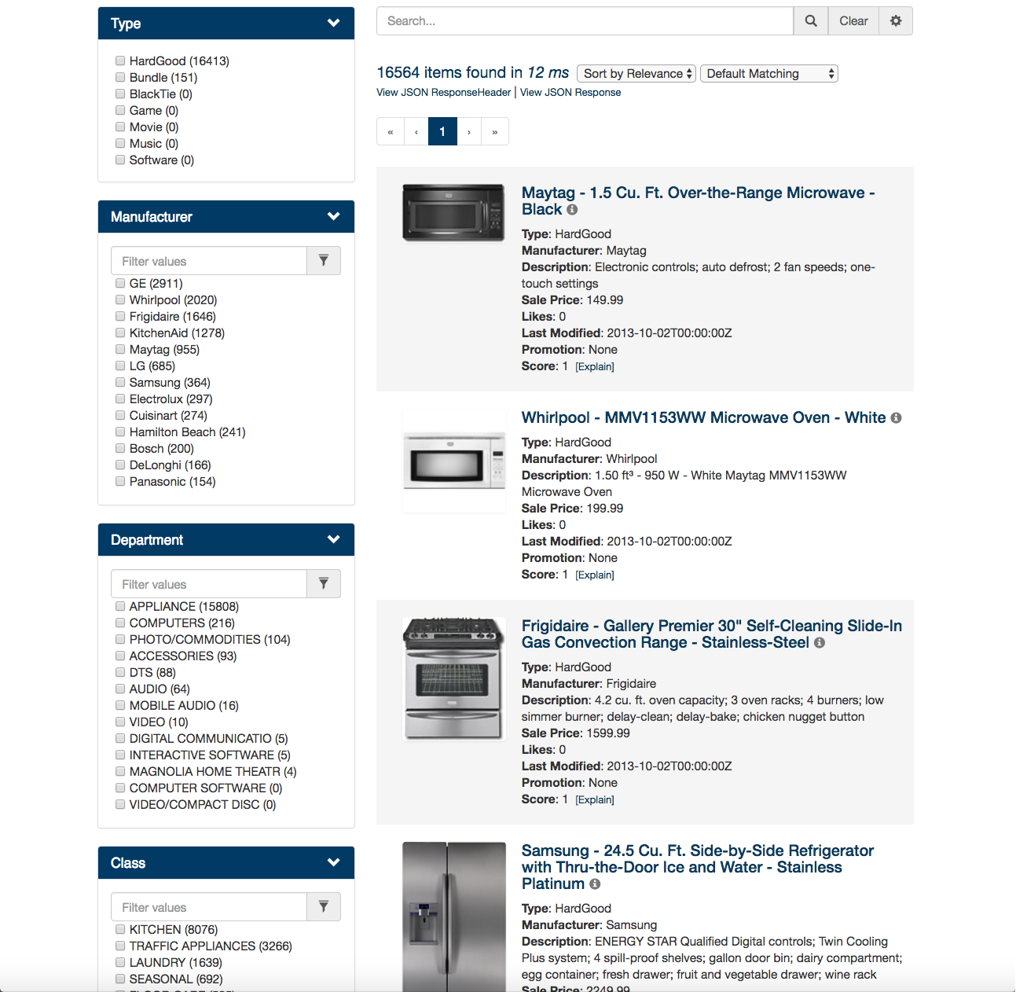

**Note 1**: In order for the rule to fire properly, you must amend the query submitted to Fusion with an ‘fq’ parameter assigned to the value of ‘categoryIds:abcat0900000’. See URL below.

[http://localhost:8764/api/apollo/query-pipelines/‘<COLLECTION_NAME>-rules/collections/‘<COLLECTION_NAME>/select?fl=%2A%2Cscore&echoParams=all&wt=json&json.nl=arrarr&sort&start=0&q=%2A%3A%2A&debug=true&rows=10&fq=categoryIds:abcat0900000](http://localhost:8764/api/apollo/query-pipelines/'%3CCOLLECTION_NAME%3E-rules/collections/'%3CCOLLECTION_NAME%3E/select?fl=%2A%2Cscore&echoParams=all&wt=json&json.nl=arrarr&sort&start=0&q=%2A%3A%2A&debug=true&rows=10&fq=categoryIds:abcat0900000)

## Rule Query Parameters

Fusion supports three rule query parameters within a query pipeline – each is described below.

**now** – Identifies the current date/time (Solr date format) to include in the rule query.

**tags** – Identifies one or more tag names to include in the rule query.

**tags_exclude** – Identifies one or more tag names to exclude from the query.

## Additional Resources for Rules

Redis Labs offers a number of additional resources to assist business users with their adoption of the Fusion rules management feature set.

1. [Redis Labs E-commerce, Rules and Relevance Presentation Slides](http://go.lucidworks.com/NM00NJSq0003ETL0dRa0A2F)
2. [Redis Labs E-commerce, Rules and Relevance Webinar Recording](https://lucidworks.com/resources/webinars/ecommerce-rules-relevance/) – featuring an interactive demonstration of the rules editor and Fusion query pipelines.
3. [Redis Labs Fusion Support Portal](https://support.lucidworks.com/hc/en-us) – available to Fusion subscribers who have technical questions about Fusion and the rules editor features.
4. [Redis Labs Training and Consulting](https://lucidworks.com/resources/solr-training-and-consulting/)

# Rules Manager Permissions Management

## Rules Permissions Overview

Access to add, and edit, rules is controlled through the UI and through the index pipelines. The basics of the functionality is that a user that has been assigned the Fusion role **rules-foo** will have access to save rules which specify the field **groups** as **rules-foo**, or through the UI, simply **foo**.

A user that has been assigned the Fusion roles **rules-foo** as well as **rules-bar** will have access to save rules for either of those two groups. The special role of **rules-admin** has access to edit ***any*** rules group. In the above case, this would mean **foo** and **bar**. Additionally **rules-admin** has access to set a special group on the rules that he controls, **rules-global** which all users have access to *see but not edit****.***

It is not permitted for a rule to belong to more than one group at a time.

## Getting started

When running the installer the role **rules-admin** will automatically be added. This role has access to the pipelines required to make the rules UI work correctly. You will need to assign this role to the users you wish to have access to the UI in an admin capacity.

If you wish to have rules editable only by users within **support**, for example, you can go into the Fusion Access Control UI and create a new role **rules-support**. Assign this role to all users within your support organization, and they will all have access to edit rules assigned to this group, and this group only. They will, additionally, be allowed to *see*rules assigned to the group **rules-global**, but they will not be permitted to edit these groups.

## Advanced usage

Two pipelines are available to enforce the permissions part of the rules engine. These are important to know if you intend to use the rules engine without directly using the UI. Sending requests to these pipelines as normal, with a user with the appropriate roles will enforce the role based access controls.

Index pipeline

The pipeline **<collection>-default-rules** enforces permissions, by making sure that any user submitting a rule has the role associated with the **groups** value in the posted JSON object. When posting JSON directly to this pipeline, it is strictly required that the documents contain a field **groups** that specifies the group to which this document belongs.

By default, this is the pipeline the UI uses.

### Query pipeline

The pipeline **auth_<collection>_rules-default** enforces permissions filtering to ensure that a user only gets to see the roles that they are able to edit ***plus*** rules assigned to the role **rules-global**, which can be created by a **rules-admin**.

# Solution Download and Installation

## Overview

There are software components associated with the Redis Labs Rules Editor solution. The first contains the Fusion query pipeline and stages for rule execution and the second contains the rules editor UI application. The release kits for both components can be downloaded from the following GitHub repository.

[https://github.com/redislabs/rules](https://github.com/lucidworks/rules)

**Install Steps**

1. Define FUSION_HOME, FUSION_API_BASE, and FUSION_API_CREDENTIALS, and then run bin/setup, providing the collection name to use as a base name for rules collection and pipeline names:

# export FUSION_HOME=$HOME/lucid/bestbuy-fusion-demo/

# export FUSION_API_BASE=http://localhost:8764/api/apollo

# export FUSION_API_CREDENTIALS=admin:password123

1. Run the setup for the collection using Rules ./bin/setup <COLLECTION_NAME>
2. Customize the Rules Editor behavior
   1. Open the FUSION_CONFIG.js in a text editor located in $fusion/apps/jetty/ui/webapps/<COLLECTION_NAME>-rules-editor/assets/js
   2. Change the “fields_to_display” and “field_display_labels” to the field names that you want displayed from your collection
   3. Add the type ahead field for the simulation UI search. Change the “typeahead_fields: ['id']” and substitute id with a field from your collection. You can also change the typeahead query pipeline from default to a custom pipeline.
   4. Create tags that are relevant to your Rules by modifying the “tags” list accordingly.
   5. Change the “documentFields” to the relevant fields in your collection.
3. Update the Simulation UI display fields
   1. Open the app.js in a text editor located in $fusion/apps/jetty/ui/webapps/<COLLECTION_NAME>-rules-editor/assets/js
   2. Navigate to the “documentFile” method.
   3. Modify the HTML in the “template” field to show the fields from your collection.

**Usage**

* Rules editor: http://localhost:8764/<COLLECTION>-rules-editor
* Rules pipeline: http://localhost:8764/api/apollo/query-pipelines/<COLLECTION>-rules/collections/<COLLECTION>/select