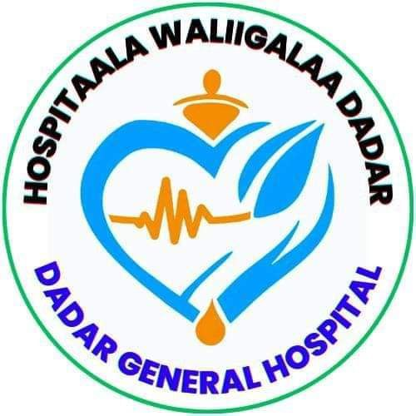

DEDER GENERAL HOSPITAL
Joint Plan for Integration of IPC Program with Other Health Programs

By: IPC Committee

July 2016E.C
Deder, Oromia
TABLE OF CONTENTS
Introduction 2
Goal 2
Objective 2
4. Integration of IPC Program with Other Programs 3
Conclusion 6

Introduction
Infection Prevention and Control (IPC) is a critical component of patient and healthcare worker safety and a cornerstone of quality health service delivery. To maximize its impact and ensure sustainability, IPC must be integrated with other hospital programs—both vertical (disease-specific or technical) and horizontal (system-wide or service-based). Integration enhances efficiency, minimizes duplication of efforts, and ensures a coordinated approach to infection risk reduction. This joint plan outlines how the IPC program at Deder General Hospital is linked with programs such as Water, Sanitation and Hygiene (WASH), Antimicrobial Stewardship (AMS), Surveillance, Quality Improvement (QI), Maternal and Child Health (MCH), Laboratory Services, and Human Resources.

Goal
To enhance the effectiveness and sustainability of Infection Prevention and Control practices through strategic integration with relevant vertical and horizontal health programs, thereby reducing healthcare-associated infections (HAIs), promoting antimicrobial stewardship, and improving overall quality of care.

Objective
- To align IPC program implementation with key supportive programs for coordinated infection prevention efforts.
- To foster joint planning, monitoring, and evaluation across IPC-related areas such as WASH, surveillance, and quality improvement.
- To promote efficient use of resources, capacity-building efforts, and system-wide adoption of IPC standards.
- To ensure sustained reduction in HAIs, antimicrobial resistance, and occupational exposure risks through shared responsibility.
- To support cross-functional collaboration and data sharing for continuous performance improvement.

4. Integration of IPC Program with Other Programs
1. IPC and Water, Sanitation & Hygiene (WASH)
Integration Area | Joint Activities
Safe water supply | Ensure availability and monitoring of clean water for hand hygiene and cleaning
Sanitation | Joint toilet cleaning schedules, solid and liquid waste management
Hand hygiene | WHO 5 Moments of Hand Hygiene promotion, availability of soap/alcohol-based rub
Environmental cleaning | Shared cleaning SOPs and performance monitoring tools
Monitoring tools | Utilize joint WASH/IPC audit and checklists

2. IPC and Disease Surveillance
Integration Area | Joint Activities
HAI surveillance | Data sharing and joint analysis of infection trends
Outbreak investigation | IPC team supports infection source control during outbreaks
Reporting system | IPC focal links with PHEM and HMIS for routine reporting
Feedback and action | Response planning and improvement interventions based on surveillance data

3. IPC and Antimicrobial Stewardship (AMS)
Integration Area | Joint Activities
Rational antimicrobial use | Promote STG compliance and prevent misuse of antibiotics
Resistance monitoring | Collaborate with lab and clinical teams to monitor and report resistance patterns
Prescriber feedback | Conduct audits and feedback sessions on prescribing practices
SOP development | Develop infection-related care protocols jointly with AMS team
4. IPC and Quality Improvement (QI)
Integration Area | Joint Activities
Clinical audits | Integrate IPC indicators in surgical, catheter-related, and injection safety audits
Patient safety improvements | Include IPC gaps in root cause analysis (RCA) and quality action plans
Staff training | Joint sessions on PPE, standard precautions, and safe waste handling

5. IPC and Human Resource Development
Integration Area | Joint Activities
Capacity building | Regular training of all cadres on IPC principles and procedures
Orientation of new staff | IPC modules included in induction sessions
Job descriptions | Define IPC-related roles in staff TORs and supervision tools

6. IPC and Maternal & Child Health (MCH)
Integration Area | Joint Activities
Safe delivery and newborn care | Implement clean birth practices and IPC in labor wards and neonatal units
Neonatal infection prevention | Cord care, proper hand hygiene, equipment disinfection
Immunization sessions | Injection safety and safe sharps disposal

7. IPC and Laboratory Services
Integration Area | Joint Activities
Sample collection and handling | Ensure PPE use and aseptic techniques during specimen processing
Waste management | Proper segregation and disposal of lab waste and sharps
Culture feedback | Share HAI pathogens and resistance patterns with IPC focal

8. Coordination & Oversight
Coordination Action | Responsible Body
Joint review meetings (monthly) | IPC Committee with WASH, Surveillance, HR, QI, AMS, and MCH focal leads
Integrated supervision | Management team and department heads
Joint planning and resource mobilization | Hospital leadership and program heads
Cross-program learning sessions | Shared quarterly performance and experience exchange platforms

Conclusion
This joint plan reinforces that IPC cannot function in isolation. When properly integrated with other health programs, IPC interventions become more sustainable, impactful, and system-wide. Coordinated implementation and shared ownership among departments are key to reducing HAIs, combating AMR, and delivering safe, quality healthcare services.

Table 1: Quarterly Activity Plan for IPC-Program Integration
Quarter | Activity | Lead Department(s) | Partners | Timeline | Quantity Planned
Q1 | Establish joint IPC integration committee and develop ToR | IPC, Quality, Medical Directorate | WASH, Surveillance, Pharmacy, HR | July, 2016 EC | 1 Committee established1 ToR developed
Q1 | Conduct baseline assessment on current level of integration | IPC, M&E Unit | All departments | August, 2016 | 1 assessment conducted1 report produced
Q1 | Align IPC activities into each program’s annual plan | IPC Chair | Program Leads | Sept, 2017 EC | 6 program plans aligned with IPC
Q2 | Conduct joint training on IPC, WASH, AMS, and Surveillance guidelines | IPC, HR Department | MOH, WHO, NGOs | October-December | 3 joint trainings90 staff trained
Q2 | Begin integrated supportive supervision using common checklist | Quality Directorate | IPC, WASH, Surveillance | Jan-June | 2 supervisions conducted1 checklist used
Q2 | Monitor HAIs and AMR trends with Surveillance and Pharmacy | IPC, Surveillance, Pharmacy | Laboratory | Monthly | 12 HAI reports4 AMR bulletins
Q3 | Integrate IPC indicators into DHIS2/HMIS reports | HMIS Focal | M&E, IT, IPC | Quarterly | 5 indicators added2 HMIS tools updated
Q3 | Joint review of IPC-linked commodity usage (e.g., PPE, disinfectants, antibiotics) | Procurement, Pharmacy | IPC, AMS Committee | Quarterly | 2 review meetings1 report prepared
Q3 | Facility-wide sanitation campaign with WASH and community services | WASH Coordinator, IPC | Municipality, CSO, media | May | 1 campaign100 participants involved
Q4 | End-year joint evaluation of IPC integration and lessons learned | IPC, Quality, M&E | All program leads | June | 1 evaluation1 presentation to SMT
Q4 | Develop integrated annual work plan for next year | IPC Focal | All program leads | June | 1 integrated AWP developed

