MODERNIZING CAMPUS ELECTIONS: THE USTP OROQUIETA ELECTORAL COMMISSION VOTING SYSTEM

A Capstone Project and Research Study
Presented to the
Department of Information Technology
University of Science and Technology of Southern Philippines
Oroquieta City



In Partial Fulfillment of the Requirements for
Capstone Project and Research Study Leading to the Degree in
Bachelor of Science in Information Technology

REDJAN PHIL S. VISITACION
KURT COLLIN CLINT MABALOD
LOLLAINE GUILL J. PUERTE
VON JUSHUA PEJE

November 2026


APPROVAL SHEET

TABLE OF CONTENTS
APPROVAL SHEET i
TABLE OF CONTENTS iii
LIST OF TABLES v
LIST OF FIGURES vi
CHAPTER I 1
1.1. Background of the Study 1
1.2. Statement of the Problem 3
1.3. Statement of the Objectives 4
1.4. Significance of the Study 5
1.5. Scope and Limitations of the Study 6
1.6. Definition of Terms 8
CHAPTER Ⅱ 13
2.1 Review of Related Literature 13
2.2 Review of Related Application 15
2.3 Synthesis and Gap Analysis 25
CHAPTER III 28
3.1 Research Methodology 28
3.2 Data Gathering Procedure 33
3.2.1 Research Instrument 34
3.2.2 Sampling Method 35
3.2.3 Statistical Treatment of Data 37
3.3 Description of the Current System 39
3.4 System Architecture and Development 41
3.4.1 Overview of the Proposed System 43
3.4.2 System Objectives 44
3.4.3 System Tools and Requirements 45
3.4.4 System Flow/Functions (Diagram: FLOWCHART) 51
3.4.5 Scope and Limitations of the System 52
3.4.6 Calendar of Activities (Gantt Chart) 54
3.5 Conceptual Design and Implementation 55
3.5.1 Database Design (Diagram: Entity Relationship Diagram.) 55
3.5.2 System Design 58
CHAPTER IV 63
4.1 Discussions 63
4.2. System Usability Scale (SUS) Evaluation Results 87
Calculation of the Overall SUS Score 88
CHAPTER V 90
5.1. Conclusion 90
5.2 Recommendations 92
BIBLIOGRAPHY 94
APPENDICES 97
APPENDIX A 98
APPENDIX B 100
APPENDIX C 102
APPENDIX D 103
APPENDIX E 106
APPENDIX F 109
APPENDIX G 111

LIST OF TABLES
Table 1. Comparison of Related Systems 24
Table 2. Likert Scale Table 39
Table 3. Programming Languages Used in Development 46
Table 4. Scripting Language Used in Development 46
Table 5. Markup Language Used in Development 46
Table 6. Style Sheet Language Used in Development 46
Table 7. Hardware Requirements 47
Table 8. Software Requirements 49
Table 9. Summary of System Usability Scale (SUS) Evaluation Results 88
Table 10. Mean Ratings of the System Usability Scale (SUS) Evaluation 89

LIST OF FIGURES
Figure 1. MSU Lopez Jaena User Interface 16
Figure 2. COMELEC Automated Election System Interface 18
Figure 3. POLYAS Online Voting System Interface 19
Figure 4. E-Voting System (SPUP) Interface 20
Figure 5. SSC FIRVS Interface 22
Figure 6. Agile Scrum Development Process 29
Figure 7. ECVS System Architecture and Voting Workflow 41
Figure 8. Flowchart Diagram 51
Figure 9. Gantt Chart 54
Figure 10. Database Design 56
Figure 11. Use Case Diagram 58
Figure 12. Context Diagram 59
Figure 13. Dataflow Diagram 61
Figure 14. ECVS Student Mobile Application Login Interface 64
Figure 15. Student Home Dashboard of the ECVS Mobile Application 65
Figure 16. ELECOM Admin Dashboard 67
Figure 17. Election Management Interface 67
Figure 18. List Candidates Interface 69
Figure 19. Register Candidate Interface 73
Figure 20. Pending Candidate Filing and Initial Review Interfaces 73
Figure 21. Supporting Documents Review Interfaces 75
Figure 22. Candidate Approval and Publication Interfaces 77
Figure 23. Election Results and Analytics Interfaces 78
Figure 24. Election Report Generation 79
Figure 25. Backup and Restore Management 81
Figure 26. EleVote AI Assistant and Live Support Chat 82
Figure 27. Network Authorization Interface 83
Figure 28. Facial Enrollment and Verification Interfaces 84
Figure 29. Student Voting Process and Ballot Confirmation 86
Figure 30. Transparency Logs and Vote Ledger Verification 87

CHAPTER I
INTRODUCTION
This chapter presents the background of the study, statement of the problem, objectives, significance of the study, scope and limitations, and definition of terms. It focuses on the development of the Electoral Commission Voting System (ECVS), a mobile and web-based platform designed to enhance the efficiency, security, accuracy, and transparency of student elections at the University of Science and Technology of Southern Philippines (USTP) Oroquieta Campus. The mobile application is intended for student voters, while the web-based platform is designed for election administration and management by the Electoral Commission (ELECOM).

1.1. Background of the Study
Student elections provide opportunities for students to practice leadership, participate in democratic processes, and exercise their voting rights (International IDEA, 2021). At the University of Science and Technology of Southern Philippines (USTP) Oroquieta Campus, student elections are managed by the Electoral Commission (ELECOM). The existing election process has relied on paper ballots, in-person voting, and manual vote counting.
Manual election procedures can result in long queues, time-consuming vote tallying, misplaced ballots, counting errors, and delays in announcing results (International IDEA, 2021; ACE Electoral Knowledge Network, 2022). Interviews with representatives of the University Student Government (USG) and ELECOM identified concerns involving limited voting resources, difficulty tracking voter participation, inadequate real-time monitoring, and limited mechanisms for auditing election results. These issues highlight the need for a more organized and verifiable election process.
To address these concerns, the researchers developed the Electoral Commission Voting System (ECVS), consisting of a mobile application for student voters and a web-based administration platform for ELECOM personnel. The mobile application provides candidate information, election notifications, ballot access, digital voting receipts, and a public vote-ledger view. The web platform supports election scheduling, candidate registration and document review, network authorization, election monitoring, result release, report generation, and backup and restoration.
The voting workflow includes facial enrollment for first-time users, an authorized-network check when voting is initiated, facial verification before candidate selection, and a second facial verification before final ballot submission. The system also uses cryptographic hashes in a linked vote ledger to support verification of recorded voting entries. These functions are intended to address identity verification, restricted voting access, administrative efficiency, and election transparency. Their effectiveness must be assessed through the project's testing and evaluation results.

1.2. Statement of the Problem
The current manual election process at the University of Science and Technology of Southern Philippines (USTP) Oroquieta Campus faces several challenges that affect efficiency, accuracy, transparency, and security. Based on interviews and observations conducted with students, the University Student Government (USG), and the Electoral Commission (ELECOM), the following problems were identified:
- Time Consuming Manual Vote Counting: The manual counting of votes requires significant time and effort, causing delays in releasing election results and reducing operational efficiency.
- Difficulty in Verifying Voter Participation: The existing process lacks a centralized system for monitoring voter participation, making voter tracking prone to errors and incomplete records.
- Human Errors in Vote Counting: Manual tallying increases the risk of miscounting, duplicate entries, and inaccurate recording of votes, which may affect the credibility of election results.
- Limited Transparency and Auditability of Election Results: The current system does not provide real-time monitoring and reliable auditing mechanisms, reducing transparency and stakeholder trust in the election process.
- Inefficient Election and Candidacy Management: Paper-based procedures require physical resources and manual processing of election documents, making candidate registration, candidacy filing, and election management time-consuming.
- Weak Voter Identity Verification: The current election process lacks biometric or facial verification mechanisms to ensure that only legitimate students can access and use the voting system.

1.3. Statement of the Objectives
The general objective of this study is to design and develop an Electoral Commission Voting System (ECVS) that enhances the efficiency, accuracy, security, and transparency of campus elections at the University of Science and Technology of Southern Philippines (USTP) Oroquieta Campus. Specifically this study aims to:

- To design and implement a mobile application that enables student voters to file candidacy, view candidate information, and securely cast their votes.
- To design and implement a web-based administration platform that enables the Electoral Commission (ELECOM) to manage candidacy applications, candidates, election schedules, voting activities, results, and reports.
- To integrate security and transparency mechanisms, including facial enrollment and verification, authorized-network voting, and blockchain-based vote recording, to support secure and verifiable election processes.

1.4. Significance of the Study
The study is intended to benefit the following stakeholders:
Electoral Commission (ELECOM) – The web-based platform provides tools for managing election schedules, candidates, voting activities, results, reports, and election records.
University Administration – The system offers a structured approach to administering and reviewing campus election activities.
Students (Voters) – The mobile application provides access to candidate information, authorized voting, vote confirmation receipts, notifications, and election-related assistance.
Candidates – The system provides students with a digital platform for filing candidacy, submitting required documents, and accessing election-related information. It also supports an organized review and approval process through ELECOM, reducing dependence on manual filing procedures.
Developers and Future Researchers – The project can serve as a reference for studying mobile voting, biometric verification, network restrictions, usability, and cryptographic vote-ledger mechanisms.

1.5. Scope and Limitations of the Study
The study covers the development and evaluation of the Electoral Commission Voting System (ECVS) for student elections at USTP Oroquieta Campus. It consists of a mobile application for student voters and a web-based platform for ELECOM administrators. The web system includes an election dashboard, election management, candidate registration and records, Certificate of Candidacy settings, network authorization, election results, report generation, transparency logs, backup and restoration, and live support chat. The mobile application includes a voter dashboard, election schedule, candidate directory and search, voting access, digital voting receipts, results, notifications, transparency information, account features, and the EleVote AI assistant.
First-time mobile users enroll their facial information for subsequent identity verification. When a student selects Vote Now or the voting icon, the system checks whether the device is connected to an authorized network. If the network is not authorized, the student is prevented from proceeding and is prompted to connect to an authorized network. After network authorization, the student completes facial verification before accessing candidate selection. A second facial verification is required before the selected ballot can be submitted. Upon successful submission, the system records the vote and provides a digital receipt. The system also supports student candidacy filing through the mobile application, allowing students to apply for elective positions and submit the required information and supporting documents. The web-based administration platform enables ELECOM personnel to review pending applications, verify supporting documents, manage Certificate of Candidacy (COC) settings, and approve qualified applicants before their information is included in the official candidate list.
The administrative platform allows ELECOM personnel to configure election dates and result-release schedules, manage candidates and supporting documents, monitor voter participation, inspect linked vote-ledger records, generate reports, and manage backups. Election results are withheld until the configured release conditions are met. The system incorporates blockchain-based vote recording through cryptographically linked blocks and SHA-256 hash verification to support the integrity, traceability, and transparency of election records.
The system is intended for USTP Oroquieta Campus elections and is not designed for public or national elections. Voting requires an eligible student account, successful facial verification, and access through an authorized network. Consequently, voting may be unavailable during network outages, when the authorized connection cannot be established, or when verification cannot be completed. The application requires compatible devices and network connectivity for its online functions. The study does not claim that biometric authentication or cryptographic verification eliminates every security risk.

1.6. Definition of Terms
Administrative Dashboard – A web-based interface that allows the Electoral Commission (ELECOM) to monitor voter participation, manage election activities, and access election-related information.
Automated Vote Counting – A system feature that automatically tallies electronically submitted votes to reduce manual counting procedures and support accurate election results.
Backend System – The server-side component responsible for processing requests, managing election data, handling authentication, and communicating with the database.
Blockchain-Based Vote Ledger – A digital record of voting transactions organized into cryptographically linked blocks, using hash verification to support the integrity, transparency, and detection of unauthorized modifications to election records.
Candidate Registration – The process of recording and managing candidate information, including student details, organization, position, platform, and supporting documents.
Candidacy Approval – The process through which ELECOM reviews and approves student candidacy applications and supporting documents before recognizing applicants as official candidates.
Candidacy Filing – The process through which eligible students submit applications to run for elective positions using the ECVS mobile application.
Certificate of Candidacy (COC) – An official document containing the required information of a student applying for an elective position, subject to verification and approval by ELECOM.
COC Management – A web-based administrative feature that allows ELECOM personnel to configure, preview, and manage Certificates of Candidacy for student elections.
Cryptographic Hash – A digital fingerprint generated from data to help detect unauthorized changes to recorded voting information.
Digital Voting Receipt – An electronic confirmation provided to a student after successfully submitting a ballot, containing a voting reference number and confirmation details.
Dynamic Network-Restricted Vote Casting – A security mechanism that allows students to proceed with voting only when their devices are connected to an ELECOM-authorized network.
Electoral Commission Voting System (ECVS) – A mobile and web-based election system developed for USTP Oroquieta Campus. The mobile application serves student voters, while the web-based platform supports election administration and management by ELECOM.
EleVote AI Assistant – A mobile application feature that provides students with guidance on voting procedures, candidate information, voting receipts, facial verification, and application support.
Facial Enrollment – The initial registration process in which first-time student users capture and register their facial information for subsequent identity verification.
Facial Verification – A biometric authentication process that compares a student's captured facial information with enrolled records to verify identity before candidate selection and final ballot submission.
Network Authorization – The process of checking whether a student's device is connected to an ELECOM-authorized network before allowing access to the voting process.
PostgreSQL Database – A relational database management system used to store and manage election-related information, including student accounts, candidate records, voting transactions, and system configurations.
Student Mobile Application – The voter-facing component of ECVS that allows students to file candidacy, view candidates, access election information, cast votes, receive digital receipts, and view notifications and election transparency information.
System Usability Scale (SUS) – A standardized ten-item questionnaire used to evaluate users' perceived usability of a system.
User Authentication – The process of verifying a user's identity before granting access to protected system functions.
Vote Verification – The process of checking recorded voting transactions and associated cryptographic hashes to support the integrity of election records.
Web-Based Administration Platform – The administrative component of ECVS used by authorized ELECOM personnel to manage elections, candidacy applications, candidate records, authorized networks, voting schedules, election results, and reports.

CHAPTER Ⅱ
REVIEW OF RELATED LITERATURE

2.1 Review of Related Literature
Student elections play an important role in educational institutions by promoting democratic participation, leadership development, and student governance. However, traditional election procedures involving paper ballots and manual vote counting may result in delayed results, human errors, and increased administrative workloads. According to International IDEA (2021), effective election administration requires reliable procedures that promote accuracy, efficiency, transparency, and public confidence. These considerations highlight the importance of integrating digital technologies into election management.
Electronic voting systems provide an alternative to traditional voting methods by allowing eligible voters to cast ballots through digital platforms. These systems support automated vote counting, organized election records, and timely result generation. The ACE Electoral Knowledge Network (2022) emphasizes the importance of security, voter privacy, and election integrity in implementing electronic voting technologies. These principles are essential in developing reliable voting systems for educational institutions.
Cryptographic technologies contribute to maintaining the integrity and verifiability of electronic voting records. Yaga et al. (2021) discussed distributed ledger technologies and cryptographic mechanisms, while Zheng et al. (2022) examined blockchain-related approaches to maintaining verifiable digital records. Cryptographic hashing helps detect unauthorized modifications to stored information. These concepts are relevant to the developed Electoral Commission Voting System (ECVS), which incorporates blockchain-based vote recording through cryptographically linked blocks and hash verification to support the integrity, security, and transparency of election records.
Mobile and web-based technologies provide accessible and organized platforms for conducting electronic elections. Mobile applications allow students to access election schedules, view candidate profiles, file candidacy applications, and participate in voting activities. Meanwhile, web-based administration platforms enable election officials to manage candidates, election schedules, voter participation, results, and reports. The integration of these platforms supports more efficient election management and improves access to election-related information.
Voter authentication is an essential component of electronic voting systems because it helps prevent unauthorized participation. Biometric authentication, particularly facial verification, provides an additional method of confirming voter identity. In the developed ECVS, first-time student users undergo facial enrollment, while facial verification is required before candidate selection and final ballot submission. Furthermore, authorized-network restrictions ensure that students can access the voting process only when connected to an ELECOM-authorized network. These mechanisms provide additional layers of access control during election activities.
Digital election management systems also support candidate registration, candidacy filing, document verification, and election reporting. In ECVS, students can submit candidacy applications and supporting documents through the mobile application, while ELECOM administrators manage Certificate of Candidacy (COC) settings, review applications, and approve qualified candidates through the web-based platform. Additional features, including automated vote counting, voter turnout monitoring, digital voting receipts, and scheduled result publication, support organized and transparent election operations.

2.2 Review of Related Application
This section reviews existing electronic voting systems and applications developed to improve the efficiency, accuracy, security, and transparency of election processes. These systems incorporate various technologies, including web-based and mobile platforms, automated vote counting, biometric authentication, and digital election management. The reviewed applications are examined based on their features, functionalities, and limitations to identify their similarities and differences with the developed Electoral Commission Voting System (ECVS). This comparison provides a basis for identifying existing gaps and determining how ECVS addresses the specific requirements of student elections at the University of Science and Technology of Southern Philippines (USTP) Oroquieta Campus.
Automated School Online Voting System for MSU Lopez Jaena
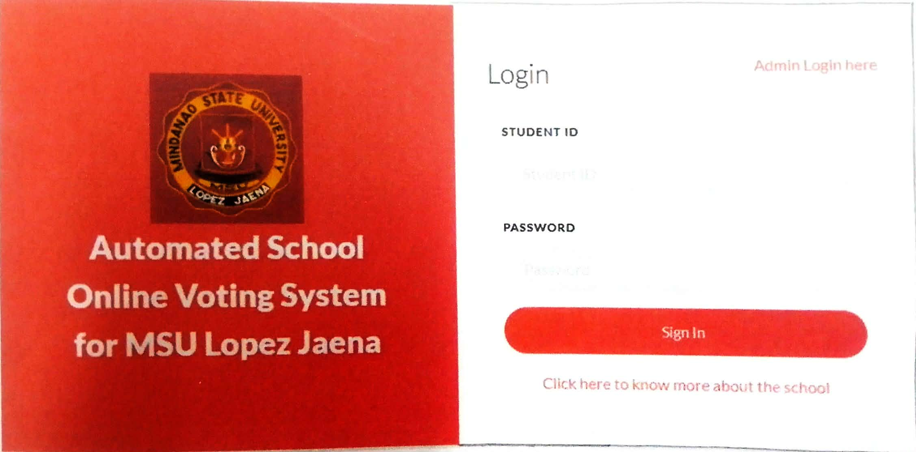

Figure 1. MSU Lopez Jaena User Interface

The Automated School Online Voting System for MSU Lopez Jaena was developed to improve the efficiency and reliability of student elections by replacing traditional paper-based voting and manual vote counting with a digital platform. The system aimed to address common challenges in manual elections, including lengthy vote counting, recording errors, and increased administrative workloads.
The system allows registered students to view candidate information and cast their votes electronically. It incorporates voter authentication, digital ballot presentation, automated vote counting, and result generation. Additionally, the administrative interface enables election officials to manage candidate records, monitor voter participation, and organize election information through a centralized database.
The Automated School Online Voting System demonstrates how digital technologies can simplify student election procedures and reduce dependence on manual processes. Similarly, the developed Electoral Commission Voting System (ECVS) supports electronic voting and automated vote counting. However, ECVS also incorporates facial enrollment and verification, authorized-network voting, digital candidacy filing, and a cryptographic linked vote ledger to address the specific election management requirements of USTP Oroquieta Campus.

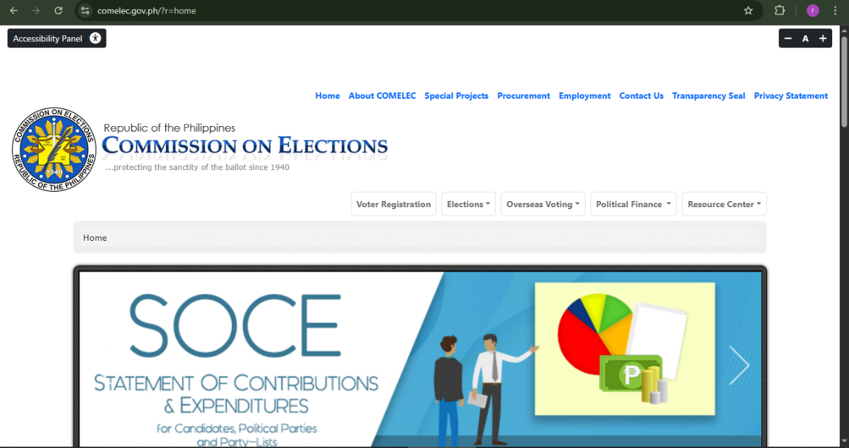
Commission on Elections (COMELEC) Automated Election System
Figure 2. COMELEC Automated Election System Interface

The COMELEC Automated Election System demonstrates the application of electronic technologies in improving election efficiency, accuracy, and vote counting. In comparison, the developed Electoral Commission Voting System (ECVS) is specifically designed for student elections at USTP Oroquieta Campus. It incorporates facial enrollment and verification, authorized-network voting, automated vote counting, and a cryptographic linked vote ledger to support secure voting access, accurate election records, and transparent election management.

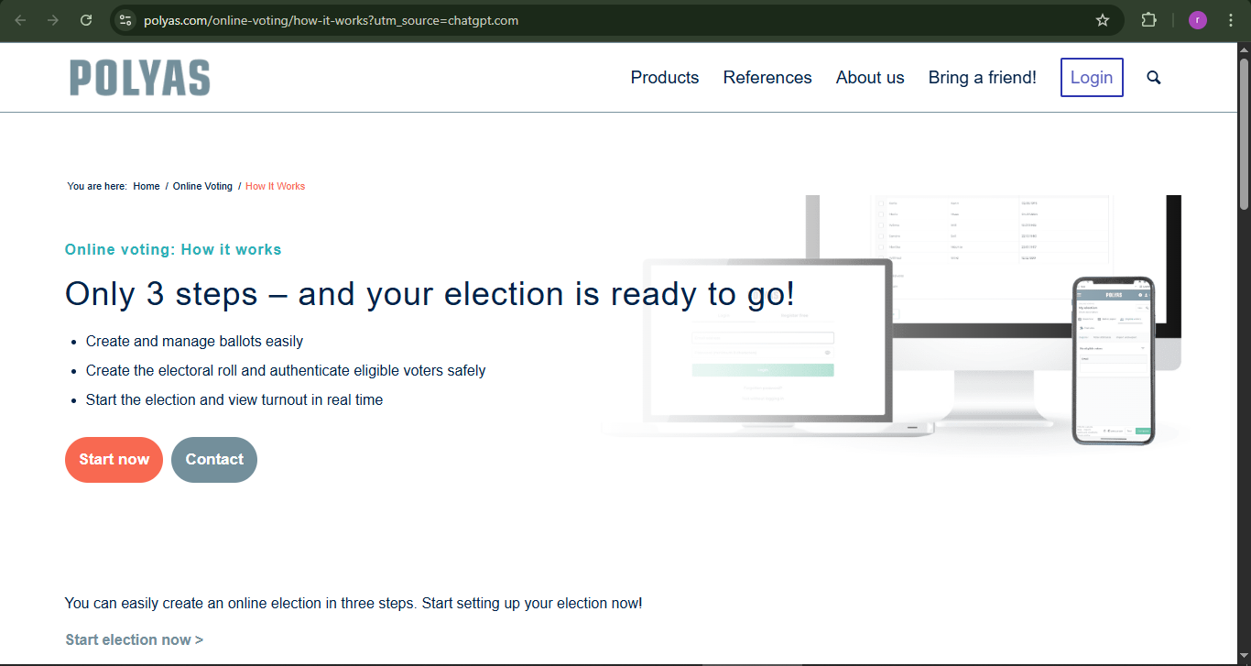
POLYAS Online Voting System
Figure 3. POLYAS Online Voting System Interface

The POLYAS online voting system enables organizations and institutions and universities to conduct safe and effective digital elections. The system allows administrators to create and manage ballots while determining voter eligibility and tracking election activities through a web-based system.
The official platform states that voters can complete the voting process through three main steps which involve creating ballots and authenticating eligible voters and launching the election with real-time monitoring capabilities. The system uses secure authentication techniques together with encrypted vote transmission to protect voter privacy and safeguard data.
The POLYAS Online Voting System demonstrates how web-based technologies support secure and organized election processes through digital ballot management, voter authentication, and election monitoring. In comparison, the developed Electoral Commission Voting System (ECVS) is designed specifically for student elections at USTP Oroquieta Campus. It integrates facial enrollment and verification, authorized-network voting, digital candidacy filing, automated vote counting, and blockchain-based vote recording to support election security, integrity, and transparency.
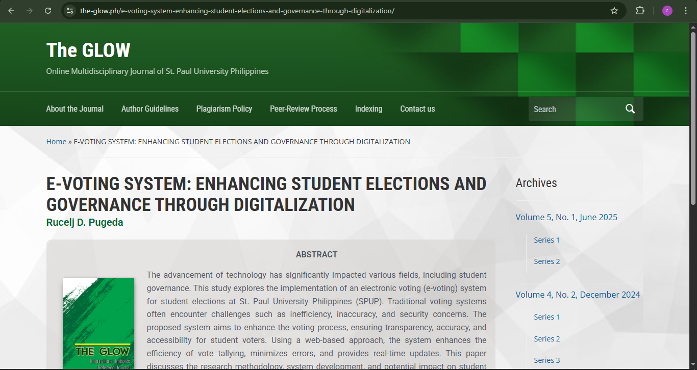
E-Voting System: Enhancing Student Elections and Governance Through Digitalization
Figure 4. E-Voting System (SPUP) Interface

The research study "E-Voting System: Enhancing Student Elections and Governance Through Digitalization" from St. Paul University Philippines demonstrates its implementation of a web-based electronic voting system designed to improve student election processes. The system was developed to address common issues in traditional voting such as inefficiency, inaccuracy, and security problems.
The proposed system enables students to vote electronically through its web-based platform which ensures secure access and accurate vote processing. The system includes automatic vote counting functions, live result displaying capabilities, and better access options for students who want to vote. The system decreases the need for people to manually operate processes while it boosts efficiency in managing electoral operations.


Supreme Student Council Fingerprint Recognition Voting System (SSC FIRVS)
Figure 5. SSC FIRVS Interface

The Supreme Student Council Fingerprint Recognition Voting System (SSC-FIRVS) was developed at the University of Science and Technology of Southern Philippines (USTP) Oroquieta Campus as an undergraduate thesis in 2021. The voting system employed fingerprint biometric scanning technology to establish a voting system which conducted student elections through its secure voting procedure. The SSC FIRVS system requires voters to confirm their identity through fingerprint scanning because voters need to use fingerprint scanning for identity verification before they can cast their votes.
The system provides essential functions through its biometric voter authentication system and digital ballot casting process and automatic vote counting feature. The system enables registered voters to cast only one vote which results in more precise election outcomes. The system achieves process efficiency through automated vote processing which reduces human errors in the entire procedure.
The SSC-FIRVS demonstrates the application of fingerprint-based authentication in securing student elections. In comparison, the developed Electoral Commission Voting System (ECVS) incorporates facial enrollment and verification, authorized-network voting, digital candidacy filing, automated vote counting, and blockchain-based vote recording. These integrated features are intended to support secure voter authentication, organized election management, and transparent voting records at USTP Oroquieta Campus.

Table 1. Comparison of Related Systems
System/Application | Automated Vote Counting | Secure Authentication | Blockchain Integration | Network Restricted Voting
Automated School Online Voting System  (MSU Lopez Jaena) | ✓ | ✓ | ✗ | ✗
COMELEC Automated Election System  (Philippines) | ✓ | ✓ | ✗ | ✗
E-Voting System  (St. Paul University Philippines, 2025) | ✓ | ✓ | ✗ | ✗
POLYAS Online Voting System | ✓ | ✓ | ✗ | ✗
SSC Fingerprint Recognition Voting System  (USTP, 2021) | ✓ | ✓ | ✗ | ✗
Electoral Commission Voting System (ECVS)  (Proposed System) | ✓ | ✓ | ✓ | ✓

Table 1 presents the comparison of related voting systems based on key features such as automated vote counting, secure authentication, blockchain integration, and network-restricted voting. The existing systems offer fundamental functions, but they lack the ability to implement both blockchain technology and network-restricted voting together. The proposed Electoral Commission Voting System (ECVS) demonstrates its value by using advanced features to improve security and transparency and system reliability.

2.3 Synthesis and Gap Analysis
The reviewed literature and related applications emphasize the importance of electronic voting systems in improving election efficiency, accuracy, security, and transparency. Traditional election procedures involving paper ballots and manual vote counting may result in delayed results, human errors, and increased administrative workloads. International IDEA (2021) highlights the importance of reliable election administration, while the ACE Electoral Knowledge Network (2022) emphasizes security, voter privacy, and election integrity in electronic voting systems.
Existing electronic voting applications demonstrate different approaches to voter authentication, automated vote counting, and digital election management. The Automated School Online Voting System for MSU Lopez Jaena, COMELEC Automated Election System, POLYAS Online Voting System, E-Voting System of St. Paul University Philippines, and Supreme Student Council Fingerprint Recognition Voting System (SSC-FIRVS) provide relevant examples of technologies applied to election processes. However, the reviewed applications do not establish the same combination of functionalities required for student elections at USTP Oroquieta Campus.
Cryptographic technologies contribute to maintaining the integrity and transparency of electronic voting records. Yaga et al. (2021) and Zheng et al. (2022) discuss distributed ledger and blockchain-related technologies that provide relevant concepts for maintaining verifiable digital records. These concepts are relevant to the developed Electoral Commission Voting System (ECVS), which incorporates blockchain-based vote recording through cryptographically linked blocks and hash verification to support the integrity and transparency of election records.
To address the identified requirements, the developed ECVS integrates a mobile application for student voters and a web-based administration platform for Electoral Commission (ELECOM) personnel. The system incorporates facial enrollment and verification, authorized-network voting, automated vote counting, digital candidacy filing, and cryptographic linked vote records. It also provides election scheduling, candidate management, voter participation monitoring, digital voting receipts, report generation, and scheduled publication of election results.
Through the integration of these features, ECVS aims to improve the efficiency, security, accuracy, and transparency of student elections at USTP Oroquieta Campus while providing a more organized election management process.

CHAPTER III
METHODOLOGY
This chapter presents the research methodology and system development approach which researchers used to create the Electoral Commission Voting System (ECVS), a digital solution which enhances voting efficiency and security for institutional election processes. The research used quantitative research design which enabled researchers to gather measurable data for system performance assessment and user satisfaction evaluation. The project implemented Agile Scrum methodology because it allowed for iterative system development through brief cycles which enabled ongoing system testing and evaluation together with user driven system enhancements.

3.1 Research Methodology
The researchers used a quantitative descriptive research design to identify the problems and challenges of the existing manual student election process and evaluate the developed Electoral Commission Voting System (ECVS). Before developing the system, the researchers conducted a survey with 69 respondents to understand their experiences and difficulties with manual voting. The results of the survey helped the researchers identify the features and requirements needed for the system.
After developing the ECVS, the researchers conducted a system-testing dry run with students to test the application and gather feedback on its functions and ease of use.
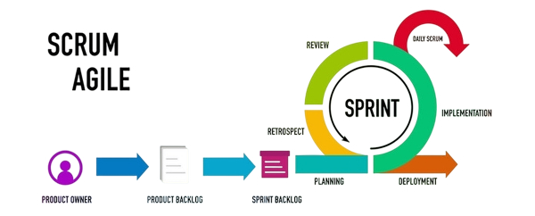
The researchers also used the Agile Scrum methodology to guide the planning, designing, development, testing, and improvement of the ECVS mobile application for student voters and the web-based administration platform for Electoral Commission (ELECOM) personnel.

Figure 6. Agile Scrum Development Process
The Agile Scrum methodology guided the system development of the Electoral Commission Voting System (ECVS). The development process was carried out through iterative cycles called sprints, allowing continuous improvement, testing, and feedback integration. Each sprint contributed to the gradual development and improvement of the system's features until the ECVS was ready for system testing and evaluation.
Product Owner
The client or Electoral Commission (ELECOM) representative served as the Product Owner during the development of the Electoral Commission Voting System (ECVS). The Product Owner provided the system requirements and prioritized the features based on the needs of the students and election administrators. These requirements guided the development team in planning and implementing the system.
Product Backlog
The product backlog contained the system requirements gathered through interviews and surveys with students and relevant stakeholders. These requirements included mobile voting, automated vote counting, blockchain-based vote recording, network-restricted voting, candidate management, and election result generation. The client or Electoral Commission (ELECOM) representative helped prioritize these features based on the needs of the election administrators and student voters.
Sprint Backlog
The development team selected and organized tasks from the product backlog based on the priorities identified by the client or Electoral Commission (ELECOM) representative. These tasks were assigned to specific sprint cycles to guide the development and implementation of the Electoral Commission Voting System (ECVS).
Planning
During the planning phase, the development team identified the objectives, system requirements, and features of the Electoral Commission Voting System (ECVS) based on the information gathered from students and the client or Electoral Commission (ELECOM) representative. The team organized development tasks, schedules, and priorities for each sprint cycle to guide the implementation of the system.
Implementation
During the implementation phase, the PENTACODE development team developed and integrated the features of the Electoral Commission Voting System (ECVS) based on the prioritized requirements and planned sprint tasks. The implementation included the student mobile voting application and the web-based administrative platform for the Electoral Commission (ELECOM). The team worked on features such as voter authentication, candidate management, digital voting, automated vote counting, and election result generation. The developed features were reviewed and refined throughout the sprint cycles to address identified issues and improve system functionality.
Daily Scrum
During the development of the Electoral Commission Voting System (ECVS), the PENTACODE team conducted regular discussions to monitor project progress, share updates on assigned tasks, and identify challenges encountered during implementation. These discussions allowed the team members to coordinate their activities, address technical issues, and make necessary adjustments to ensure that development tasks were completed according to the planned sprint objectives.
Sprint Review
During the Sprint Review, the PENTACODE development team evaluated the completed features of the Electoral Commission Voting System (ECVS) to determine whether they met the identified system requirements. The team reviewed the functionality of the student mobile voting application and the ELECOM web-based administrative platform. Feedback and identified issues were considered when making necessary improvements to the system during subsequent development activities.
Sprint Retrospective
During the Sprint Retrospective, the PENTACODE development team reviewed its performance and development activities after each sprint cycle. The team discussed the challenges encountered, evaluated the effectiveness of its development practices, and identified areas for improvement. The insights gained from these discussions helped the team improve task coordination, address recurring issues, and make necessary adjustments during subsequent sprint cycles of the Electoral Commission Voting System (ECVS) development.
Deployment
During the deployment phase, the PENTACODE development team prepared and configured the Electoral Commission Voting System (ECVS) for a system-testing dry run. The student mobile voting application and the ELECOM web-based administrative platform were set up to support the testing activities. Participating students were given the opportunity to use the mobile application and evaluate its functionality and usability. The team gathered feedback and identified issues that could guide further system improvements. This phase served as a preliminary evaluation of the developed system in preparation for its potential future implementation in campus elections.

3.2 Data Gathering Procedure
The researchers gathered data in two stages: before and after the development of the Electoral Commission Voting System (ECVS).
Before system development, the researchers conducted an initial survey with 69 respondents to identify their experiences and challenges with the existing manual student election process at USTP Oroquieta Campus. Interviews were also conducted with representatives of the University Student Government (USG) and Electoral Commission (ELECOM) to gather additional information about the current election procedures and problems. The collected information helped the researchers identify the requirements and features needed for the development of ECVS.
After developing the system, the researchers conducted a system-testing dry run with student participants. During the activity, students were given the opportunity to use and test the ECVS mobile application. After testing, the researchers used the System Usability Scale (SUS) questionnaire to evaluate the ease of use of the application. The questionnaire contained ten statements answered using a 5-point Likert scale, ranging from Strongly Disagree to Strongly Agree. The collected responses were used to assess the usability of the developed system and identify areas for improvement.

3.2.1 Research Instrument
The researchers used survey questionnaires and interviews to gather information for the development and evaluation of the Electoral Commission Voting System (ECVS).
Before system development, an initial survey questionnaire was given to 69 respondents to identify their experiences and challenges with the existing manual student election process. The results helped the researchers understand the problems of manual voting and determine the requirements needed for the system.
Interviews were also conducted with representatives of the University Student Government (USG) and Electoral Commission (ELECOM) to gather additional information about the existing election procedures, challenges, and suggestions for improvement.
After developing the ECVS, the researchers used the System Usability Scale (SUS) questionnaire, developed by John Brooke, to evaluate the usability of the mobile application during the system-testing dry run. The questionnaire contained ten statements using a 5-point Likert scale, ranging from 1 (Strongly Disagree) to 5 (Strongly Agree). The questions focused on the ease of use, complexity, consistency, and user confidence when using the application.
The collected responses were analyzed using the standard SUS scoring method to determine the overall usability of the developed ECVS mobile application.

3.2.2 Sampling Method
The researchers used purposive sampling to select respondents who had relevant knowledge and experience with the existing student election process at the University of Science and Technology of Southern Philippines (USTP) Oroquieta Campus.
Before system development, the study involved 69 respondents, consisting of one University Student Government (USG) moderator, one Electoral Commission (ELECOM) chairperson, and 67 students. These respondents were selected to provide information about the existing manual election process, including its challenges and limitations. The USG and ELECOM representatives provided information about election management, while the students shared their experiences with manual voting.
After developing the Electoral Commission Voting System (ECVS), the researchers conducted a system-testing dry run and usability evaluation involving 73 respondents, consisting of 71 students, one Electoral Commission (ELECOM) member, and one University Student Government (USG) officer. The respondents evaluated the developed system using the 10-item System Usability Scale (SUS) questionnaire. Their responses were collected to assess the usability of the ECVS and identify areas for improvement.
The selection of respondents allowed the researchers to gather information about the existing election process and obtain feedback on the usability of the developed system. The collected data served as a basis for identifying system requirements and areas for improvement.

3.2.3 Statistical Treatment of Data
To analyze the data gathered before system development, the researchers used thematic analysis to examine the open-ended responses of the 69 respondents. Similar answers were grouped into common themes to identify the challenges experienced during manual student elections and the features needed for the proposed Electoral Commission Voting System (ECVS). Frequency and percentage were used, where applicable, to summarize the occurrence of the identified themes.
For the post-development usability evaluation, the researchers used the standard System Usability Scale (SUS) scoring method to analyze the responses of 73 respondents, consisting of 71 students, one Electoral Commission (ELECOM) member, and one University Student Government (USG) officer, who participated in the ECVS system-testing dry run. The SUS questionnaire consisted of ten statements rated on a 5-point Likert scale, ranging from 1 (Strongly Disagree) to 5 (Strongly Agree). For odd-numbered items (1, 3, 5, 7, and 9), the adjusted score was calculated by subtracting 1 from the response. For even-numbered items (2, 4, 6, 8, and 10), the adjusted score was calculated by subtracting the response from 5. The adjusted scores were added and multiplied by 2.5 to obtain each respondent's SUS score, ranging from 0 to 100. The overall SUS score was determined by calculating the arithmetic mean of the individual SUS scores of the 73 respondents.
The results were presented in tables and interpreted to support the findings of the study.
For each respondent:
$$SUS=\left[\sum_{i=1,3,5,7,9}{\left(R_{i}-1\right)}+\sum_{i=2,4,6,8,10}{\left(5-R_{i}\right)}\right]×2.5$$
Where:
- \(R_i\) = respondent's rating for question \(i\)
- Odd-numbered questions: subtract 1 from the rating.
- Even-numbered questions: subtract the rating from 5.
- Multiply the total by 2.5 to obtain a score from 0 to 100.
To calculate the overall score:
$$\text{Overall SUS}=\frac{\sum_{j=1}^{N}{S}US_{j}}{N}$$
Where \(N\) is the total number of respondents.
Table 2. Likert Scale Table
Scale | Description
5 | Strongly Agree
4 | Agree
3 | Neutral
2 | Disagree
1 | Strongly Disagree

3.3 Description of the Current System
The existing student election process at the University of Science and Technology of Southern Philippines (USTP) Oroquieta Campus relied on manual voting procedures, including the distribution and collection of ballots and the counting of votes. Based on the information gathered from the pre-development survey and stakeholder interviews, the researchers identified several challenges associated with the manual election process, including:
- Delays in vote counting and result generation
- Human mistakes make the system more vulnerable to errors
- The manual voting process may be vulnerable to unauthorized interference and difficulties in verifying the accuracy and integrity of recorded votes.
- The system lacks both transparent operation and auditing capabilities
- These challenges highlighted the need for a more organized and efficient student election system. To address the identified limitations of the manual voting process, the researchers developed the Electoral Commission Voting System (ECVS), which incorporates digital voting, automated vote counting, voter verification, and election management features to support more efficient, accurate, and transparent election procedures.

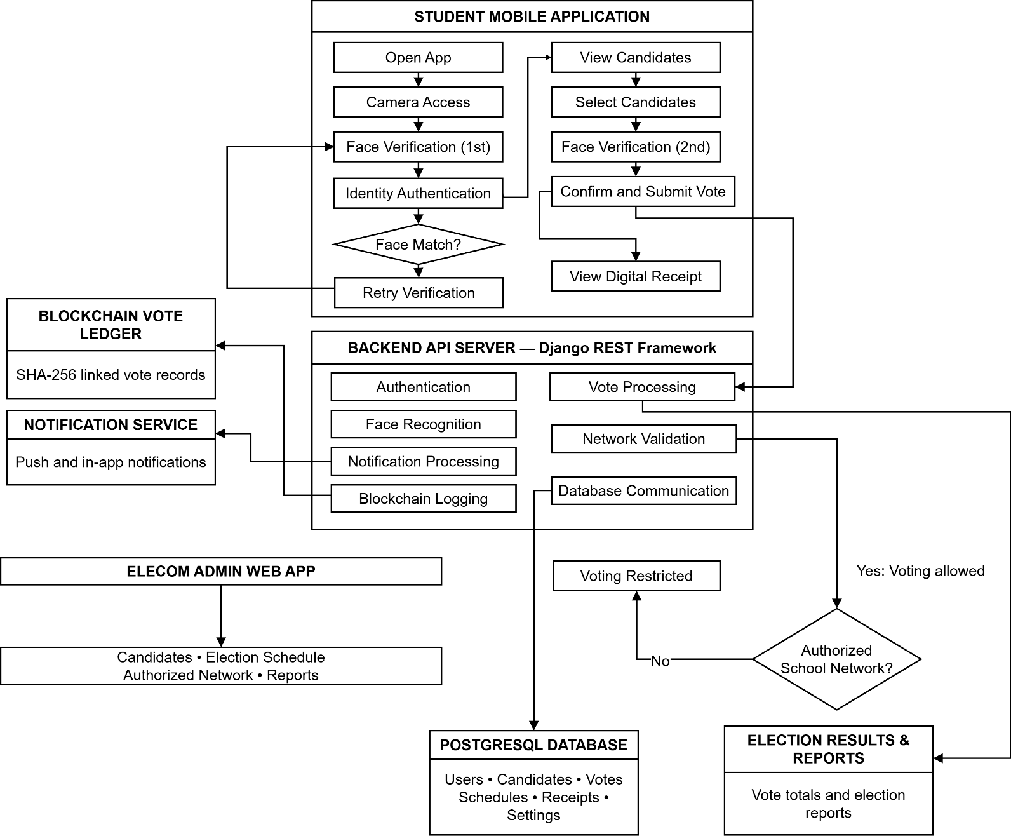
3.4 System Architecture and Development
Figure 7. ECVS System Architecture and Voting Workflow

The Electoral Commission Voting System (ECVS) functions as the main election management system for campus elections according to Figure 7, which shows its complete system architecture. The system connects student voters, administrators, and the backend server through a mobile and web-based interface. Students can log in, access the system through an authorized school network, view candidates, and cast their votes securely. The system requires users to validate their network access before they can submit votes because this measure helps prevent unauthorized voting.
The server handles all transaction processing which includes user authentication and vote recording and result generation activities. The database maintains user information and candidate information and election data. The system records votes using cryptographic hashing and ledger logging mechanisms to support transparency, data integrity, and the detection of unauthorized modifications to recorded voting information. The system enables administrators to control candidate activities and set election times and watch voting processes and create different types of reports.
The diagram illustrates how the system components interact to support voter authentication, authorized-network verification, vote processing, data storage, and election administration. These interconnected components are designed to improve the efficiency, security, accuracy, and transparency of the student election process.

3.4.1 Overview of the Proposed System
The Electoral Commission Voting System (ECVS) is a mobile and web-based election management system developed for student elections at the University of Science and Technology of Southern Philippines (USTP) Oroquieta Campus. The system consists of a mobile application for student voters and a web-based administration platform for Electoral Commission (ELECOM) personnel. It integrates facial verification, authorized-network voting, automated vote counting, and cryptographically linked vote records to support election security, efficiency, accuracy, and transparency.
The voting process begins with network authorization, followed by facial verification before candidate selection. After selecting their preferred candidates, students must complete a second facial verification before submitting their ballots. Once a vote is successfully submitted, the system records the transaction, generates a digital voting receipt, and updates the election records. Cryptographic hashing and linked vote records support the detection of unauthorized modifications to recorded voting information.
The system architecture consists of the following components:
Student Mobile Application – Allows students to view candidate information, file candidacy applications, complete facial verification, cast votes, and receive digital voting receipts.
ELECOM Web Administration Platform – Enables authorized election personnel to manage candidates, review candidacy applications, configure election schedules and authorized networks, monitor voting activities, and generate reports.
Backend Server – Uses Python Django REST Framework to process application requests, manage authentication, validate voting operations, and communicate with system components.
Cryptographic Vote Ledger – Records confirmed voting transactions using cryptographically linked entries and SHA-256 hash verification to support data integrity and tamper detection.
PostgreSQL Database – Stores and manages student accounts, candidate information, election schedules, voting records, and system configurations.

3.4.2 System Objectives
- The system aims to provide a reliable voting platform that incorporates voter authentication and access-control mechanisms to support secure election operations.
- The system aims to provide accurate vote recording and counting mechanisms while supporting the integrity of election records through cryptographic verification.
- The system aims to automate vote counting and generate accurate election results while following the configured result-release schedule.
- The system aims to improve election transparency by providing voting status updates, digital voting receipts, and election reports accessible to authorized users.
- The system aims to provide a user-friendly mobile voting application and web-based administration platform that improve accessibility, ease of use, and overall user satisfaction.

3.4.3 System Tools and Requirements
This section presents the tools, technologies, and requirements used in the development of the Electoral Commission Voting System (ECVS). These components ensure that the system operates efficiently, securely, and reliably across different platforms for both students and administrators.
Table 3. Programming Languages Used in Development
Programming languages | Description
Dart | Used for developing the Flutter-based mobile application for student voters.
Python | Used for backend development, API processing, authentication, and vote management.

Table 4. Scripting Language Used in Development
Scripting language | Description
JavaScript | Used for interactive web functionalities and frontend scripting.

Table 5. Markup Language Used in Development
Markup Language | Description
HTML | Used to structure and display content for the web-based administrative interface.

Table 6. Style Sheet Language Used in Development
Style Sheet Language | Description
CSS | Used to design and improve the appearance and layout of the web interface.

Hardware Requirements
Table 7. Hardware Requirements
Component | Description
Mobile Devices (Students/Voters) | The system requires compatible mobile devices, such as smartphones or tablets, capable of running the Flutter-based application. These devices must have sufficient processing power, memory, camera functionality for facial verification, and reliable network connectivity to support the voting process.
Desktop Computers (ELECOM Admin) | Desktop or laptop computers capable of running modern web browsers are required for ELECOM administrators to access the web-based administration platform, manage candidates, configure election schedules, monitor voting activities, and generate election reports.
Server Infrastructure | The system uses Kamatera cloud server infrastructure to host the ECVS backend application and support database operations. The server handles API requests, user authentication, vote processing, and cryptographic vote-ledger logging. Server resources are configured according to the system's processing, storage, and network requirements.
Network Infrastructure | The system requires a reliable campus network connection through Wi-Fi or LAN to support secure communication between student devices and the ECVS server. Voting access is restricted to authorized campus networks to ensure that students can cast their votes only within the approved network environment.

Software Requirements
Table 8. Software Requirements
Software | Description
Database | PostgreSQL Database – Used to store user credentials, candidate information, voting records, and election-related data required for the operation of the ECVS.
Front End Development | Flutter Framework (Dart) – Used to develop the ECVS mobile application interface, allowing student voters to access election information, view candidates, complete facial verification, and cast their votes.
Backend Development | Python (Django REST Framework) – Used to develop the ECVS backend, manage server-side operations, handle user authentication, process votes, and facilitate API communication between the mobile application, administrative interface, and database.
Cryptographic Hashing Libraries | SHA-256 Cryptographic Hashing – Used to generate cryptographic hashes for vote-ledger entries, support verification of recorded data, and help detect unauthorized modifications to voting records.
Development Tools | Visual Studio Code – Used as the primary integrated development environment for writing, editing, debugging, and managing the source code of the ECVS mobile application, web-based administrative interface, and backend system.

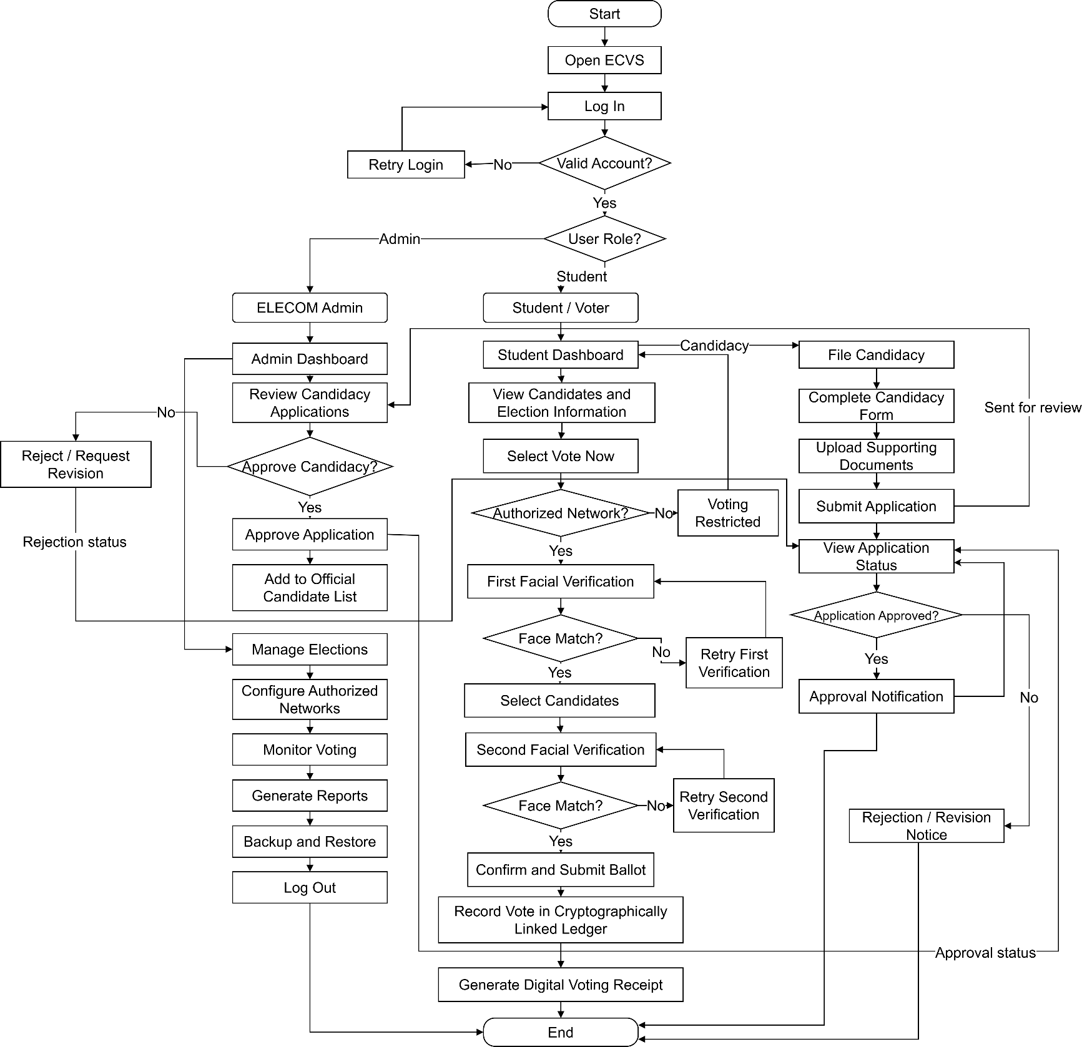
3.4.4 System Flow/Functions (Diagram: FLOWCHART)

Figure 8. Flowchart Diagram
Figure 8 illustrates the system flow of the Electoral Commission Voting System (ECVS), including the processes performed by student users and ELECOM administrators. Students can access the mobile application to view election information, file candidacy applications, submit supporting documents, and cast their votes. Submitted candidacy applications are reviewed by ELECOM administrators, who may approve or reject them based on the established requirements. Approved applicants are included in the official candidate list. During voting, the system verifies the authorized network connection and requires two facial verification checkpoints before final ballot submission. Successfully submitted votes are recorded in a cryptographically linked ledger, and digital voting receipts are generated. The administrative platform also supports election management, voting monitoring, report generation, and backup and restoration.

3.4.5 Scope and Limitations of the System
This project developed the Electoral Commission Voting System (ECVS), a mobile and web-based platform designed to support student elections at the University of Science and Technology of Southern Philippines (USTP) Oroquieta Campus. The mobile application allows students to view election information, file candidacy applications, submit supporting documents, monitor their application status, and cast votes. The voting process includes authorized-network verification and two facial verification checkpoints before final ballot submission. Successfully submitted votes are recorded in a cryptographically linked ledger, and digital voting receipts are generated. The web-based administration platform allows Electoral Commission (ELECOM) personnel to review and approve or reject candidacy applications, manage official candidates and election schedules, monitor voting activities, generate reports, and perform backup and restoration.
The Electoral Commission Voting System (ECVS) is designed specifically for student elections at the University of Science and Technology of Southern Philippines (USTP) Oroquieta Campus and would require modifications before being adopted by other institutions. The system depends on compatible devices and a reliable internet connection for user authentication, vote submission, and real-time updates. Students must connect to an ELECOM-authorized network to access the voting process, which restricts voting outside approved network environments. Voting also requires successful facial verification, and users may be unable to proceed when verification fails or network connectivity is interrupted. The blockchain-based vote ledger operates within a private system environment and uses cryptographic hashing to support the integrity and verification of recorded votes; it does not involve public cryptocurrency transactions. Although these mechanisms provide additional security controls, they do not eliminate all potential security risks. The system uses institutional account credentials and does not integrate with national identity verification services.


3.4.6 Calendar of Activities (Gantt Chart)

Figure 9. Gantt Chart

Figure 9 presents the 12-month project schedule for the development of the Electoral Commission Voting System (ECVS). The Gantt chart illustrates the major project phases, including planning, design, development, testing, deployment, review, and launch. These activities were organized to guide the development process, support the integration of essential system features, and monitor progress toward the scheduled completion of the project.

3.5 Conceptual Design and Implementation

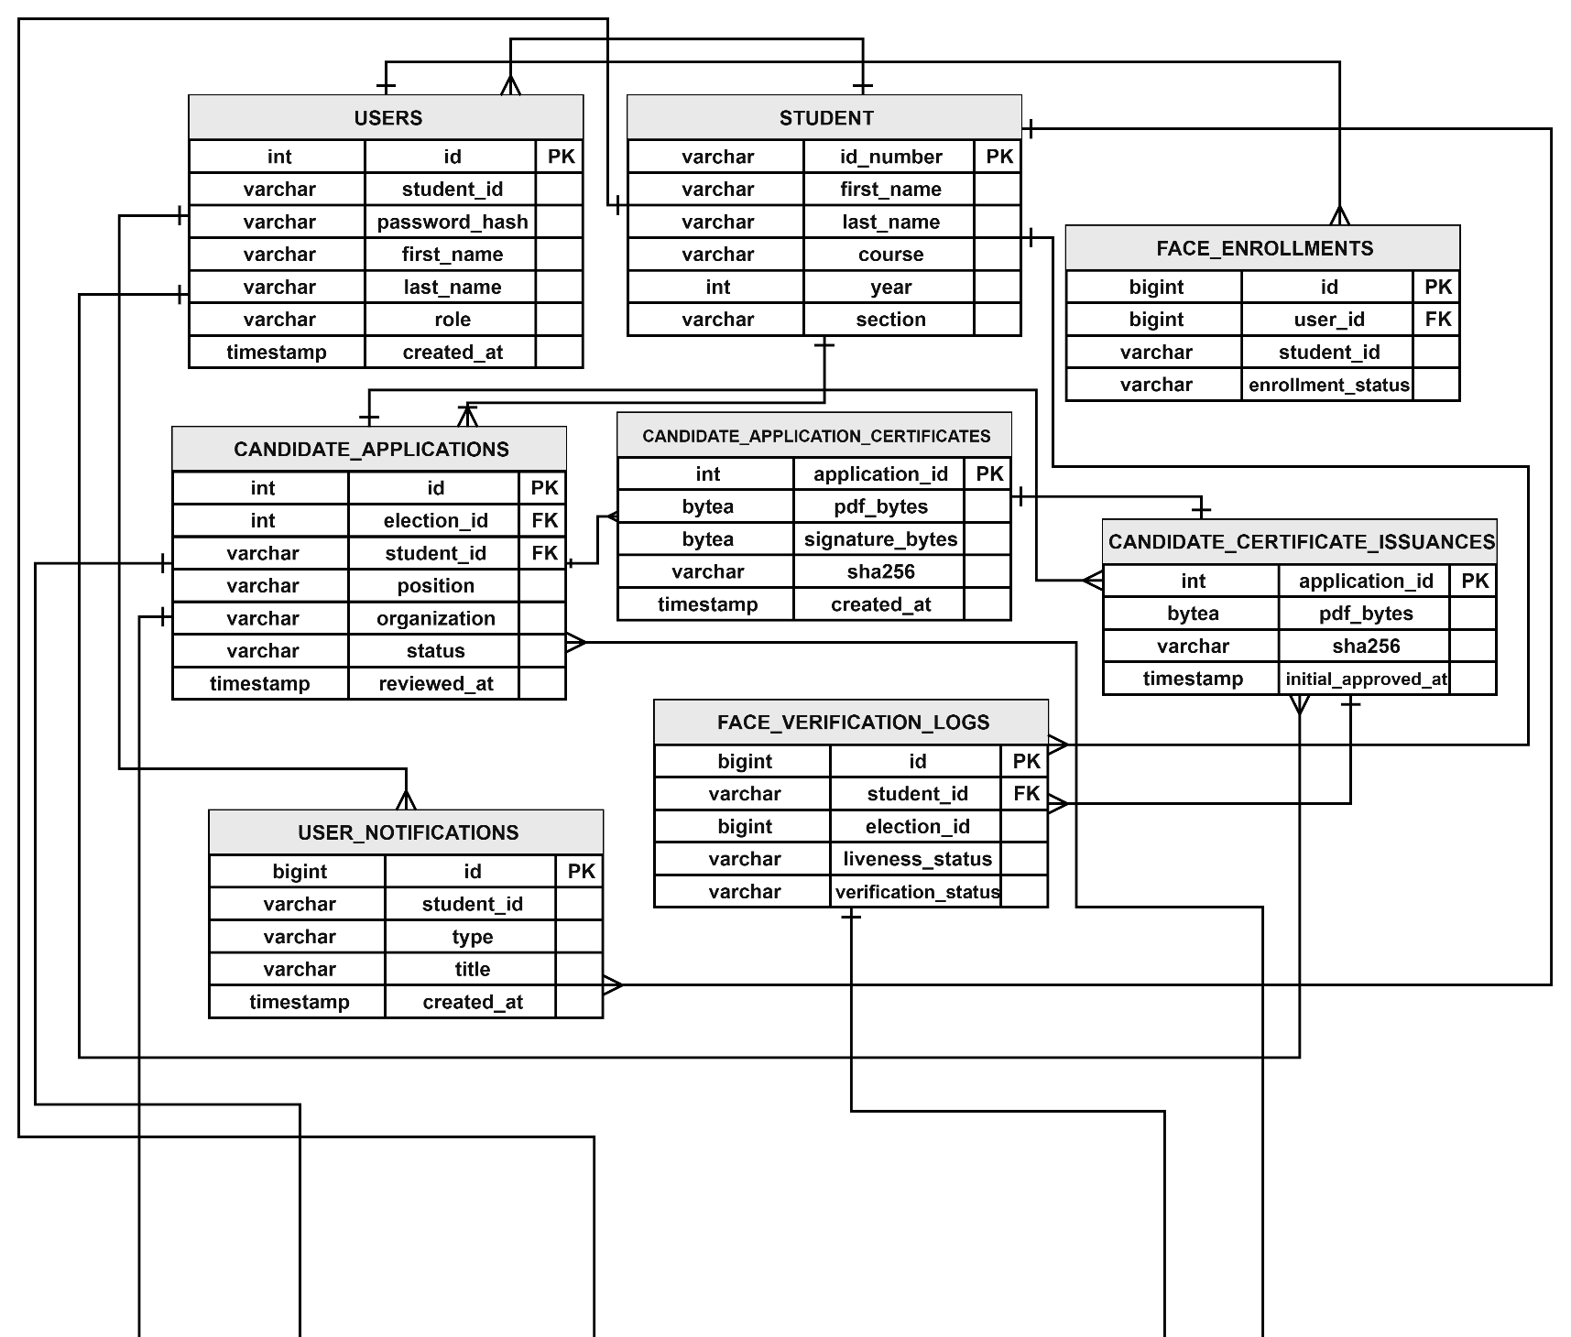
3.5.1 Database Design (Diagram: Entity Relationship Diagram.)

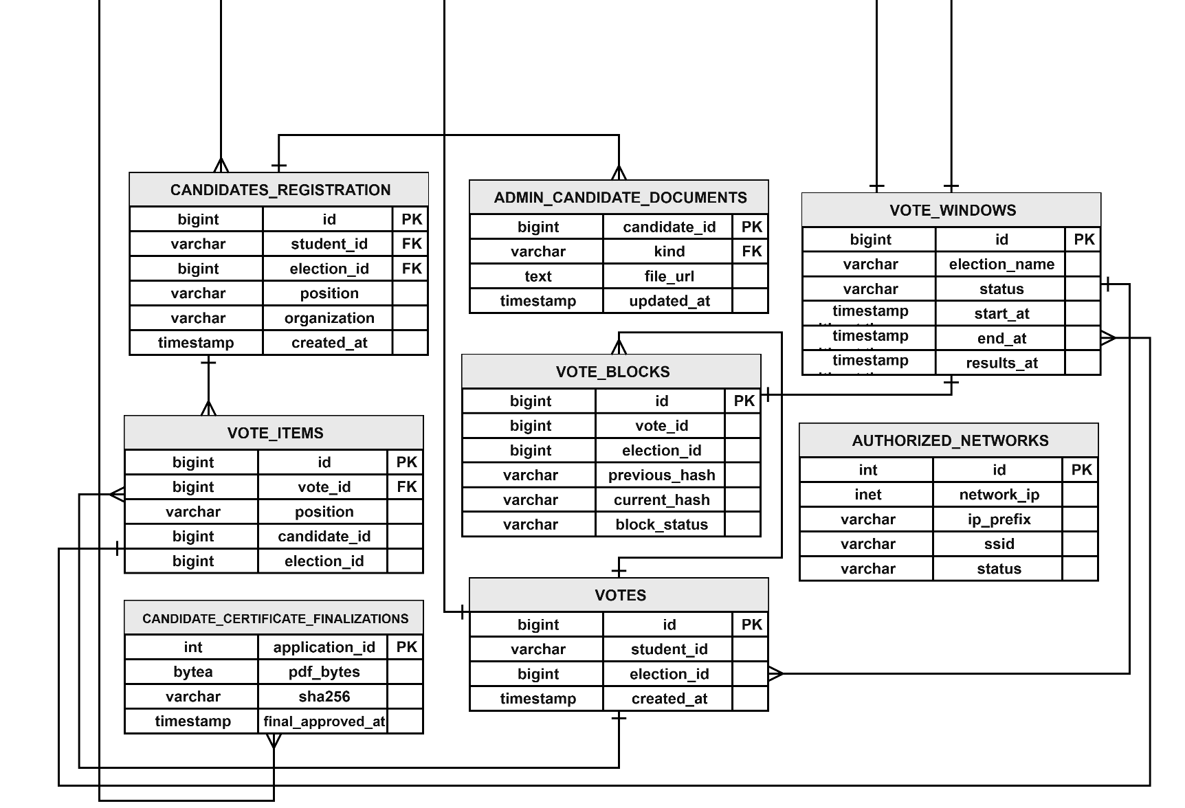

Figure 10. Database Design

Figure 10 presents the Entity Relationship Diagram (ERD) of the Electoral Commission Voting System (ECVS), illustrating the database structure and relationships among its 16 tables. The USERS and STUDENT tables manage user accounts and student information, while FACE_ENROLLMENTS and FACE_VERIFICATION_LOGS support facial enrollment and identity verification. The CANDIDATE_APPLICATIONS table stores student candidacy applications, while CANDIDATE_APPLICATION_CERTIFICATES, CANDIDATE_CERTIFICATE_ISSUANCES, and CANDIDATE_CERTIFICATE_FINALIZATIONS manage the corresponding certificate records throughout the candidacy approval process.
The CANDIDATES_REGISTRATION table maintains registered candidate information, while ADMIN_CANDIDATE_DOCUMENTS stores supporting candidate documents. The VOTE_WINDOWS table manages election schedules, voting periods, and result-release settings. The VOTES and VOTE_ITEMS tables record submitted votes and their corresponding candidate selections. Meanwhile, VOTE_BLOCKS stores cryptographic hash information associated with voting records to support vote integrity and verification.
The AUTHORIZED_NETWORKS table maintains permitted network information used to restrict voting access to authorized connections. The USER_NOTIFICATIONS table stores election-related notifications for students. Together, these database tables support voter authentication, candidate management, election scheduling, vote recording, security verification, and election administration within the ECVS.

3.5.2 System Design

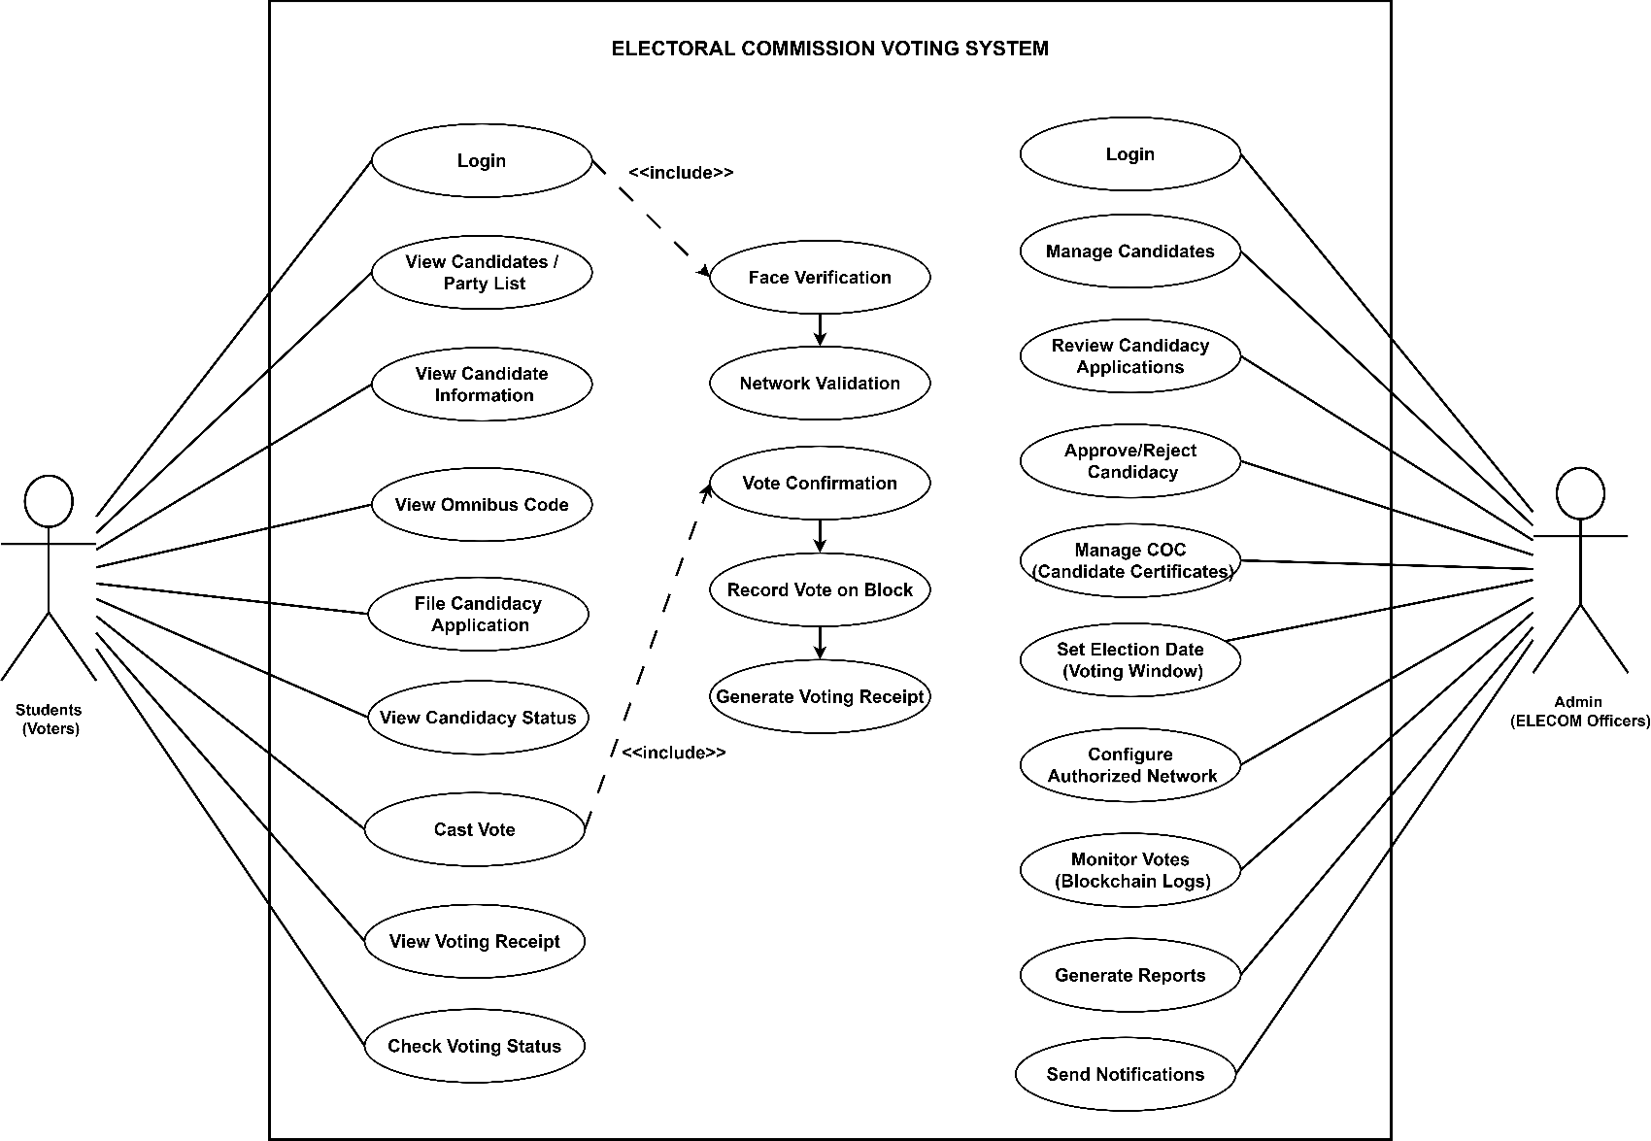
Use Case Diagram

Figure 11. Use Case Diagram

Figure 11 presents the Use Case Diagram of the Electoral Commission Voting System (ECVS), illustrating the interaction between two main user roles: Students (Voters) and Admin (ELECOM Officer). Students can access the system by logging in, viewing the list of candidates, and casting their votes during the election period.
On the other hand, the Admin (ELECOM Officer) manages the overall election process through the system. The admin is responsible for managing candidates, setting the election date, configuring the authorized network for voting restrictions, and generating reports for monitoring and evaluation purposes. The diagram highlights how both users interact with the system to ensure a secure and organized voting process.

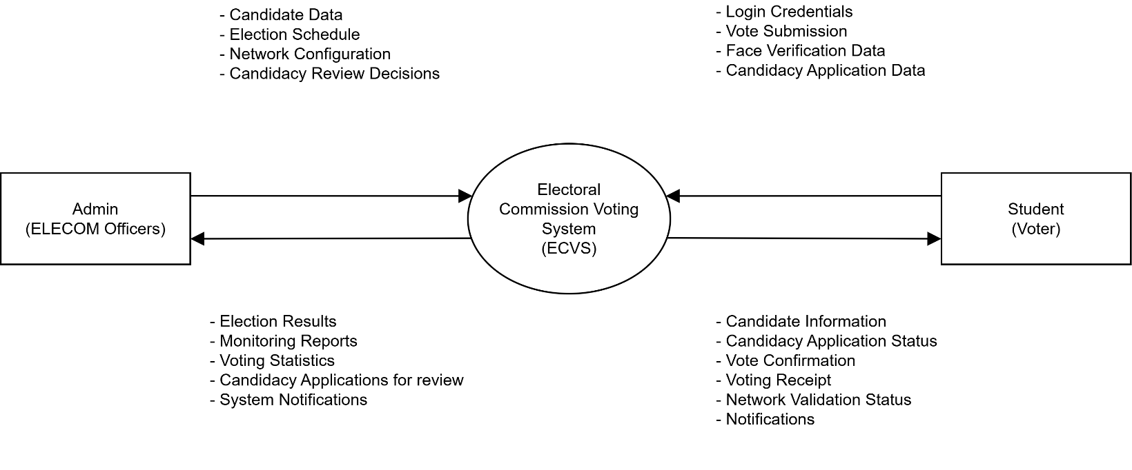
Context Diagram

Figure 12. Context Diagram

Figure 12 presents the Context Diagram of the Electoral Commission Voting System (ECVS), illustrating the exchange of information between the system and its two external entities: Student (Voter) and Admin (ELECOM Officers).
Students provide login credentials, facial verification data, vote submissions, and candidacy application information. In return, the system provides candidate information, candidacy application status, voting confirmation, voting receipts, network validation status, and notifications.
ELECOM Officers provide candidate data, election schedules, authorized-network configurations, and candidacy review decisions. The system provides election results, monitoring reports, voting statistics, candidacy applications for review, and system notifications.
The diagram illustrates how ECVS supports digital candidacy filing, election administration, secure voting, and communication between students and ELECOM Officers.

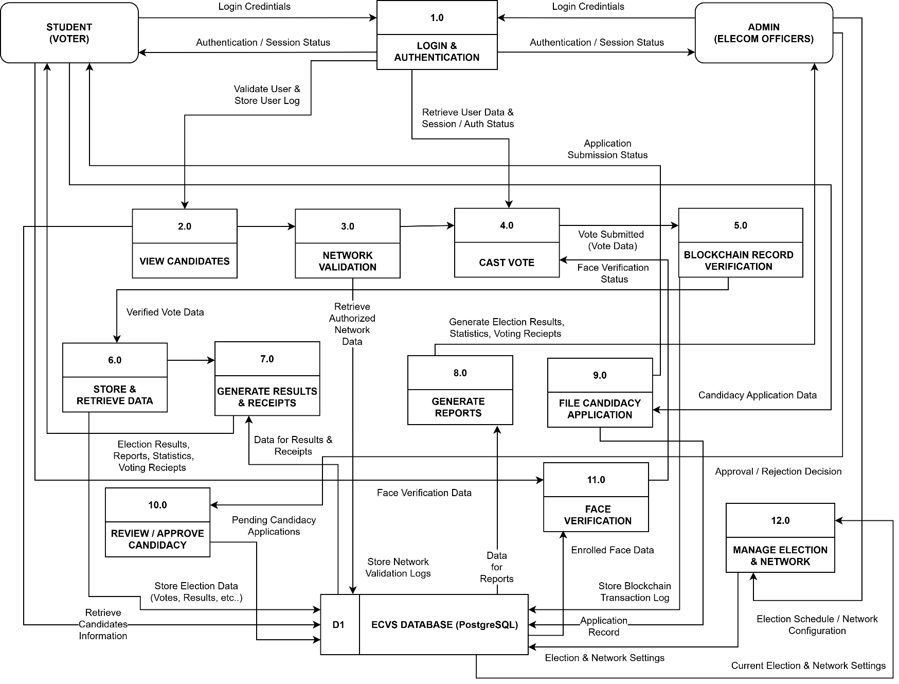
Data Flow Diagram

Figure 13. Dataflow Diagram

The Electoral Commission Voting System (ECVS) displays its data flow structure through Figure 13, which shows how students and voters and administrators interact with the system operations and its databases. The process begins with login and authentication, where user credentials are verified using the users database. Voters who pass the network validation process can access candidate information before casting their votes.
The voting process begins when a voter submits their ballot because the system records their choice through a blockchain system that protects the data until it gets stored in the vote database. The system uses the stored information to produce election outcomes and voting receipts which both voters and administrators can access. The administrator controls all aspects of candidate information and system configuration while monitoring the voting process. The diagram shows that the system enables secure transparent digital voting because it handles data according to proper methods and links its different processes.

CHAPTER IV
RESULTS AND DISCUSSIONS
This chapter presents the results of the developed Electoral Commission Voting System (ECVS) for USTP Oroquieta Campus. It explains the main features of the system, such as student login, face verification, candidate filing, online voting, election management, and election results. It also shows how the system works through screenshots of the student and admin interfaces.

4.1 Discussions
Discussion No. 1. To design and implement a mobile application that enables student voters to file candidacy, view candidate information, and securely cast their votes.
The Electoral Commission Voting System (ECVS) includes a mobile application developed for student voters at USTP Oroquieta Campus. The application allows students to log in, view election schedules and candidate information, submit candidacy applications, and participate in the voting process. It also provides digital voting receipts, election results, and notifications. These features provide students with an organized platform for accessing election information and participating in campus elections.

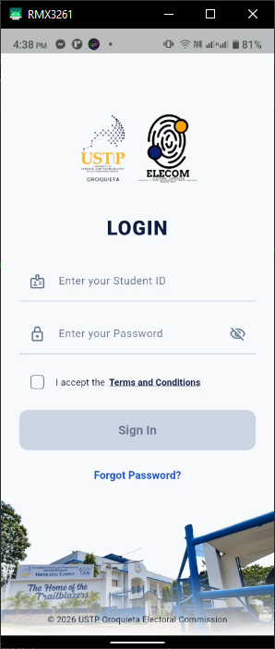
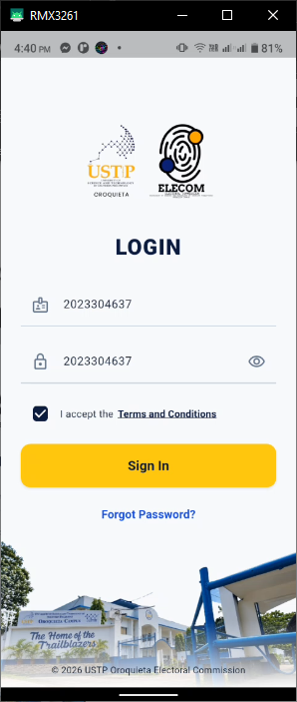

Figure 14. ECVS Student Mobile Application Login Interface

Figure 14 shows the login interface of the Electoral Commission Voting System (ECVS) mobile application. Students are required to enter their Student ID and password to access the system. The Sign In button becomes enabled once the required fields are completed and the Terms and Conditions are accepted. This feature ensures that only students with valid login information can access the ECVS mobile application.

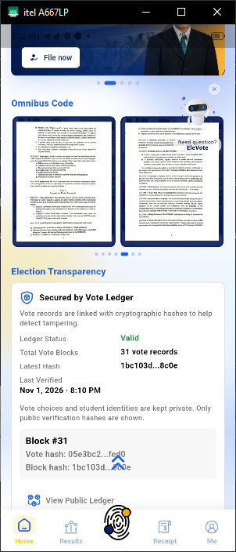
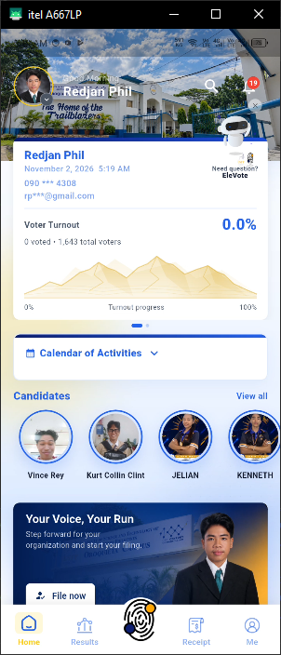
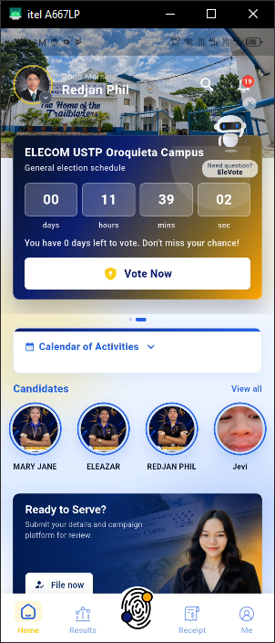

Figure 15. Student Home Dashboard of the ECVS Mobile Application

The Student Home Dashboard serves as the main page of the ECVS mobile application after the student logs in. It displays the student's profile, voter turnout, election countdown, calendar of activities, and candidate information. Students can also access candidacy filing, the Omnibus Code, election transparency information, and the EleVote AI assistant. The dashboard provides easy access to important election information and system features.

Discussion No. 2. To design and implement a web-based administration platform that enables the Electoral Commission (ELECOM) to manage candidacy applications, candidates, election schedules, voting activities, results, and reports.
The Electoral Commission Voting System (ECVS) includes a web-based administration platform developed for ELECOM personnel at USTP Oroquieta Campus. The platform allows administrators to manage election schedules, review candidacy applications, register and approve candidates, monitor voting activities, view election results, and generate reports. It also provides tools for managing election records and supporting the overall election process. These features help ELECOM personnel organize and manage campus elections through a centralized platform.
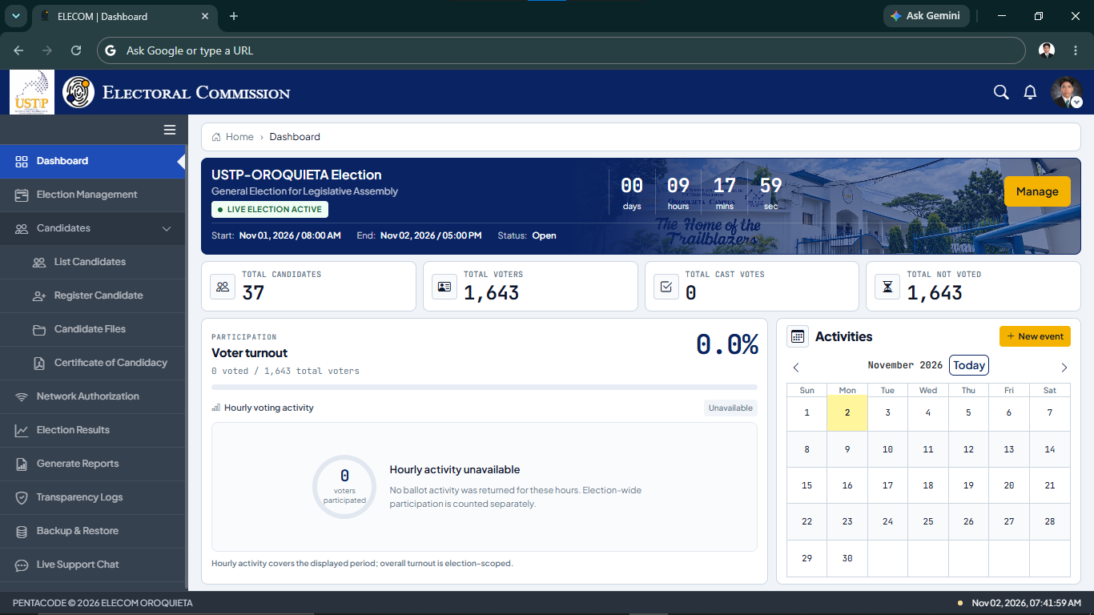

Figure 16. ELECOM Admin Dashboard

Figure 16 shows the ELECOM Admin Dashboard of the ECVS web-based administration platform. The dashboard displays the election status, schedule, countdown timer, total candidates, registered voters, cast votes, and voter turnout. It also includes a calendar of activities and a navigation menu for managing elections, candidates, network authorization, election results, reports, and other system features. This dashboard allows ELECOM administrators to monitor election activities and access important election information in one place.
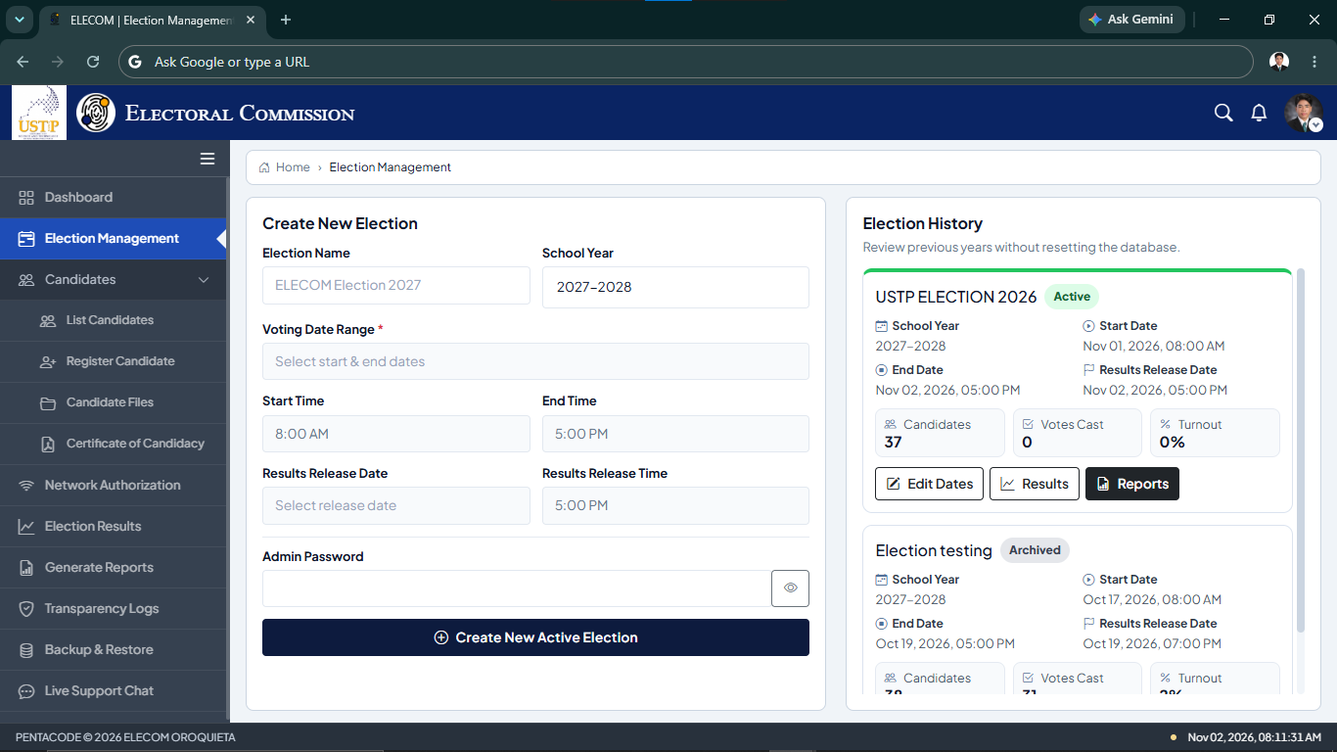

Figure 17. Election Management Interface

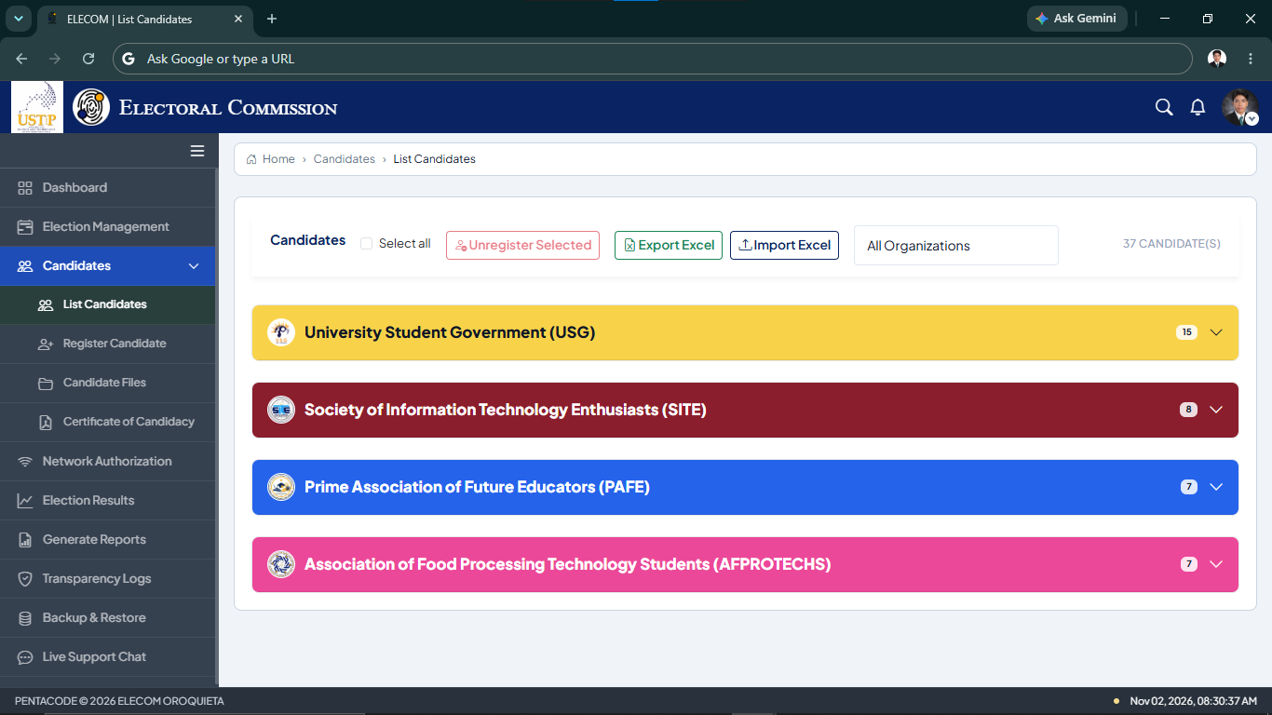
Figure 17 shows the Election Management interface of the ECVS web-based administration platform. This interface allows ELECOM administrators to create new elections by entering the election name, school year, voting dates, voting times, and results release schedule. It also displays the election history, including active and archived elections. Administrators can view election details, monitor the number of candidates, votes cast, and voter turnout, and access options for editing election dates, viewing results, and generating reports. This interface helps ELECOM organize and manage campus election activities.

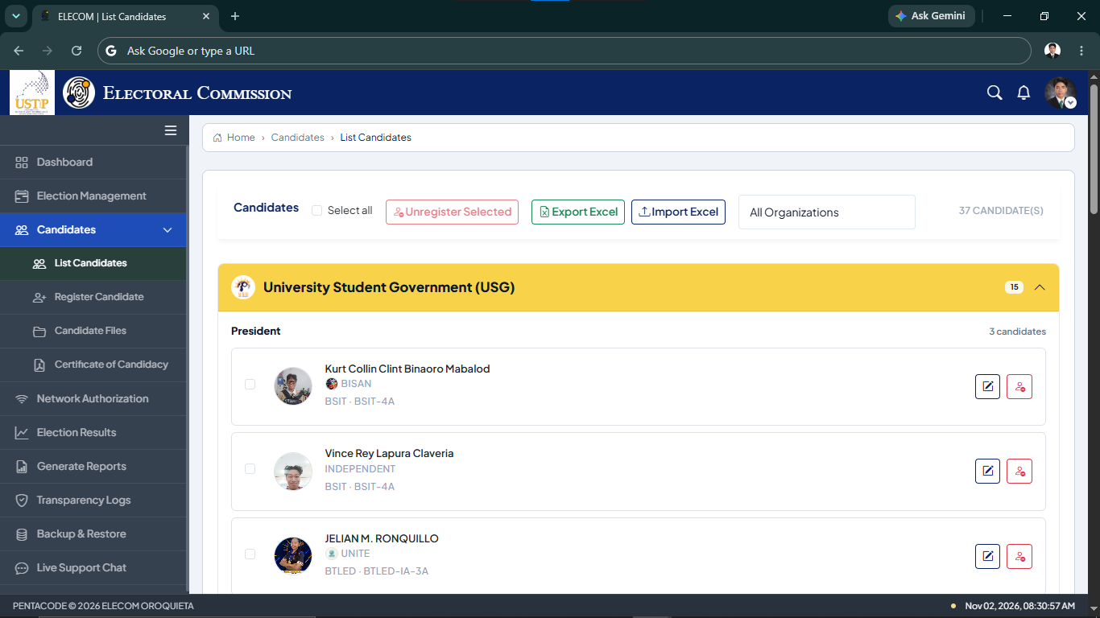

Figure 18. List Candidates Interface

Figure 18 shows the List Candidates interface of the ECVS web-based administration platform. The interface displays registered candidates grouped by student organization and electoral position. ELECOM administrators can view candidate information, including names, organizations, programs, and sections. It also provides options to edit candidate records, unregister selected candidates, import and export candidate information using Excel files, and filter candidates by organization. This interface helps ELECOM manage and organize candidate records for campus elections.
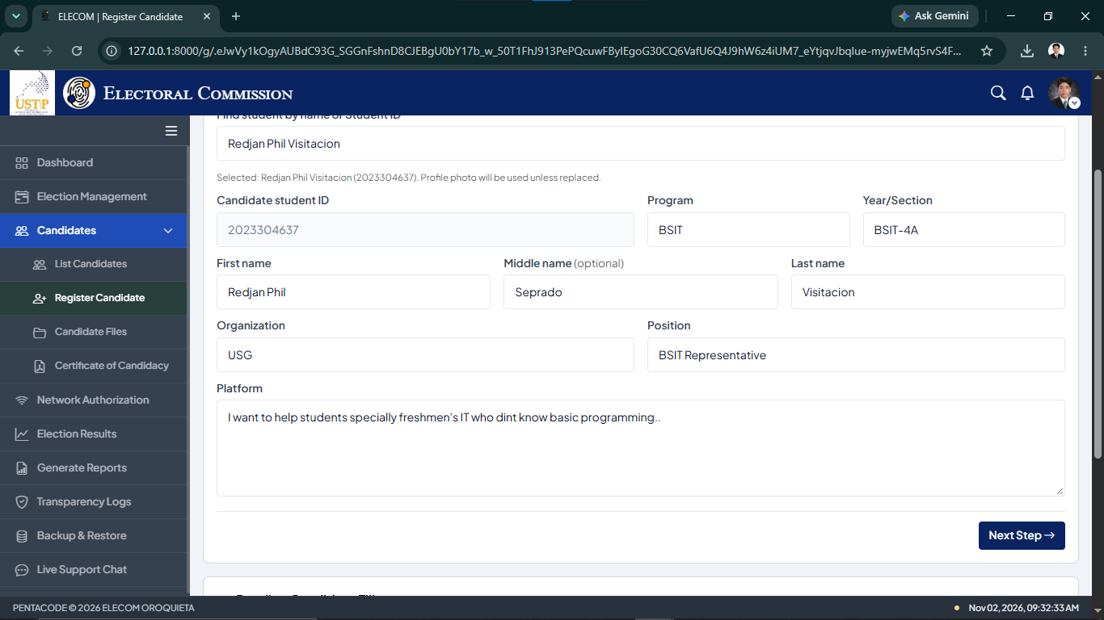

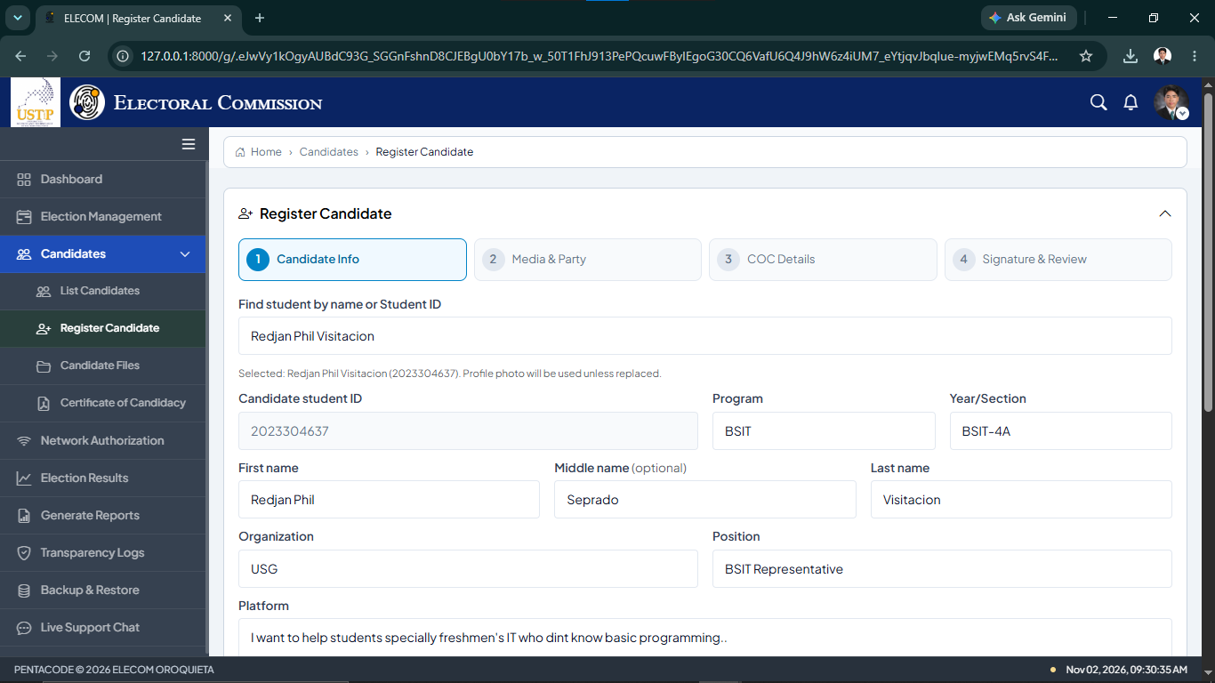

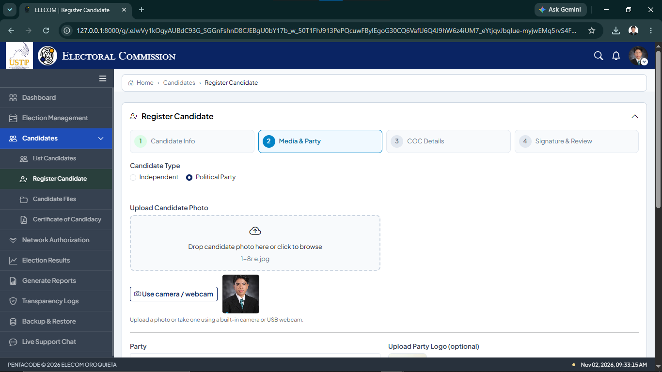

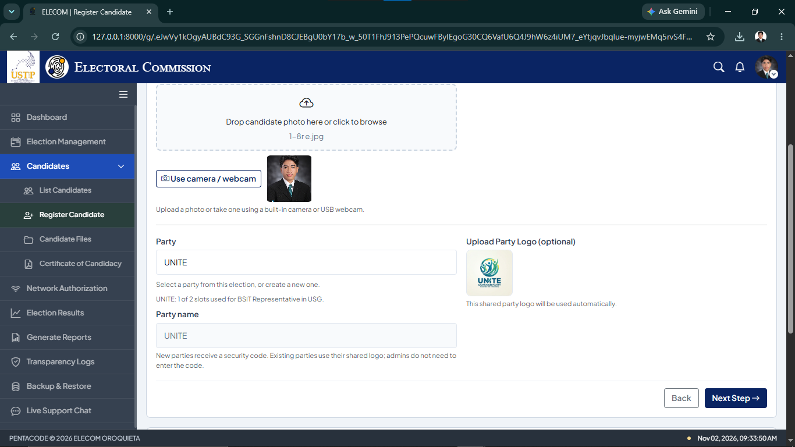

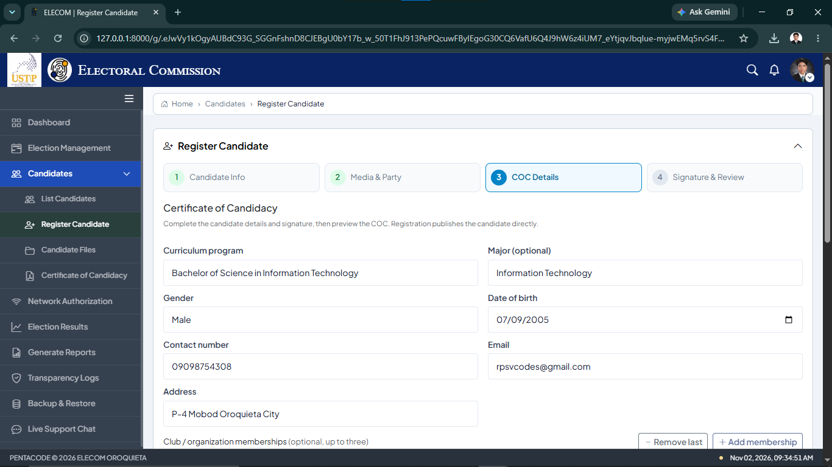

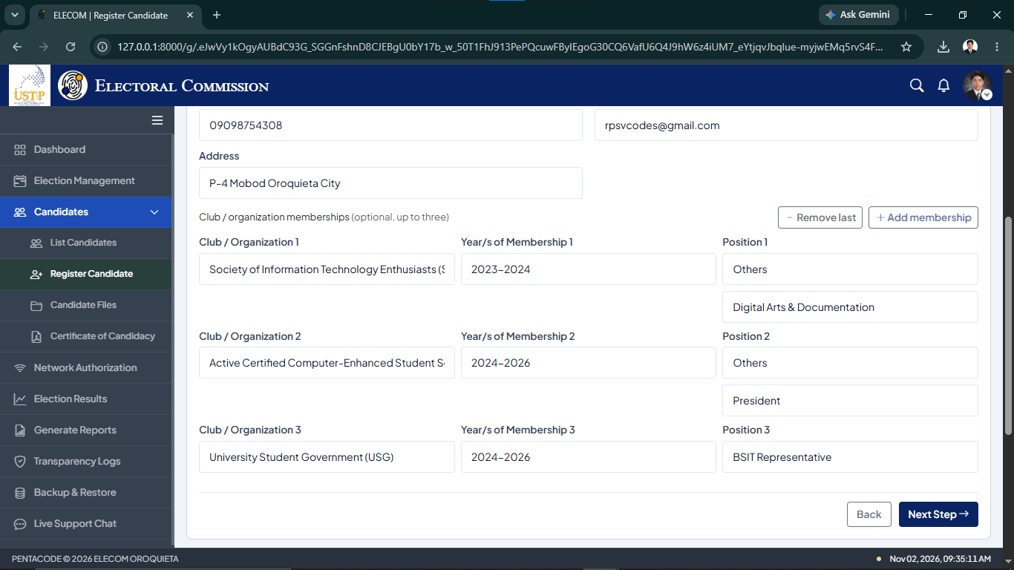

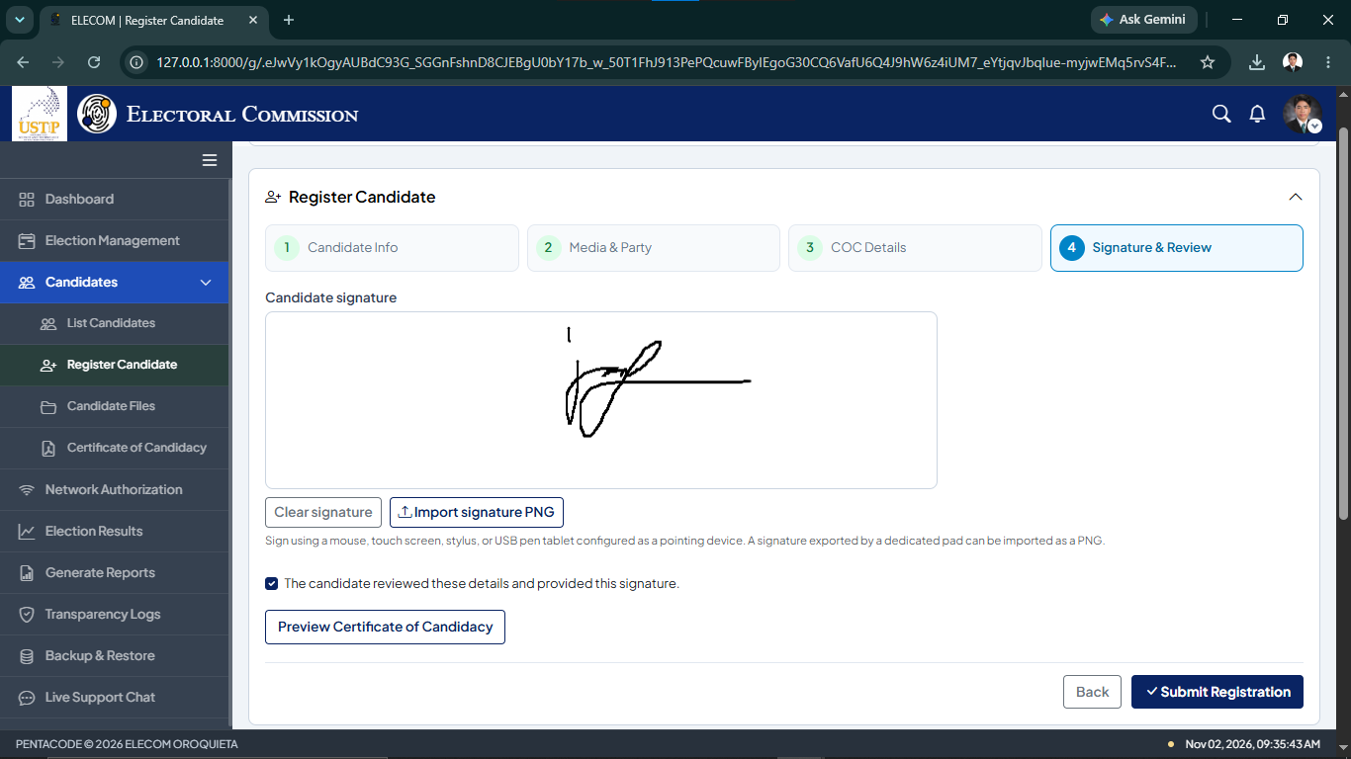

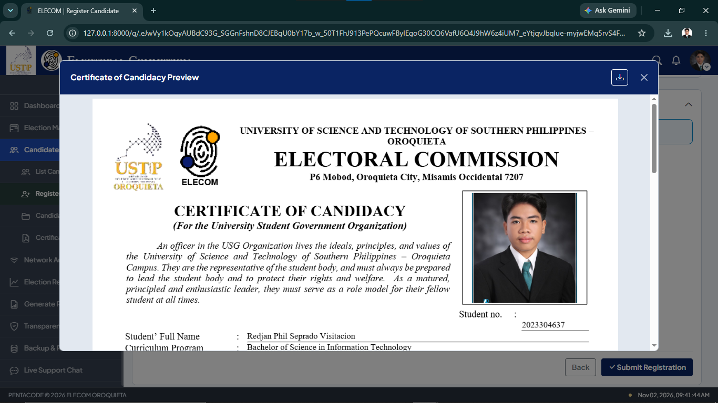

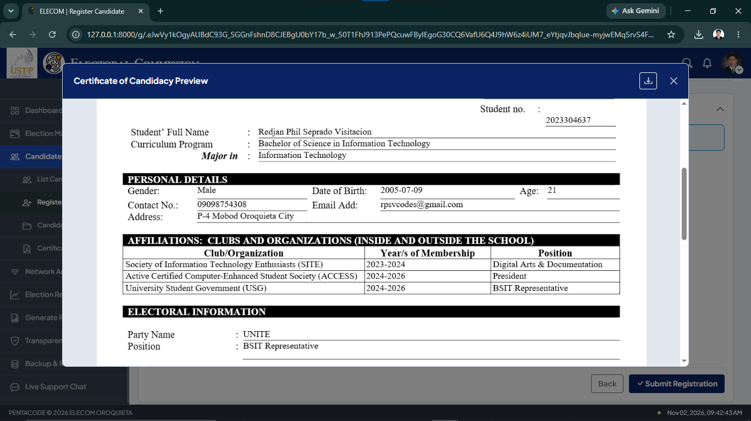

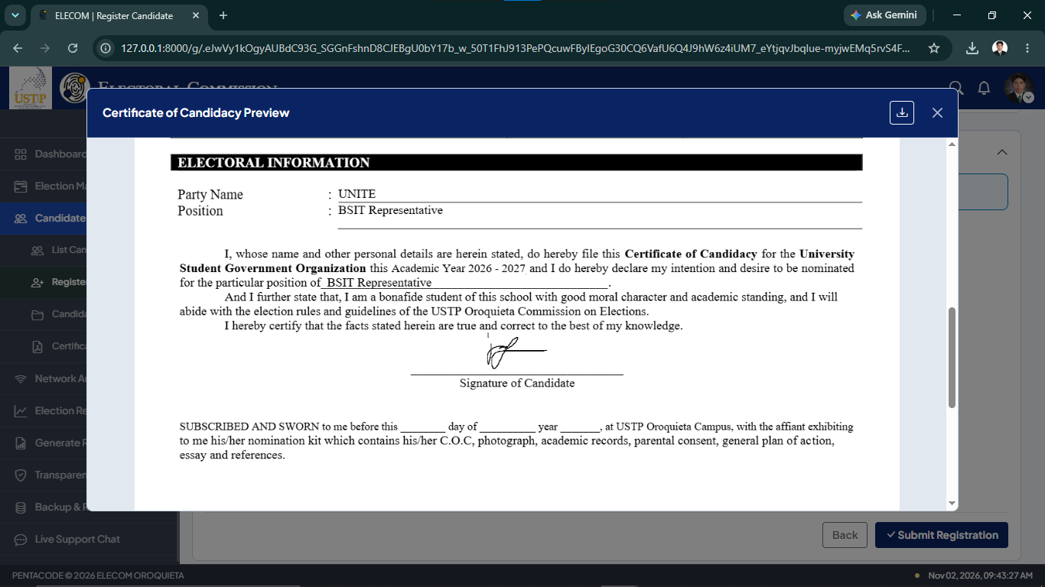

Figure 19. Register Candidate Interface
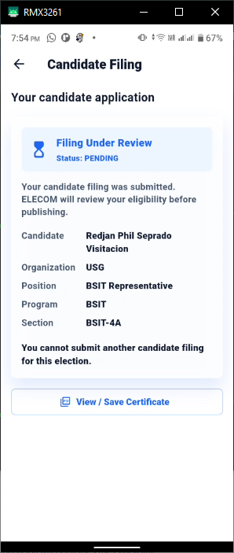
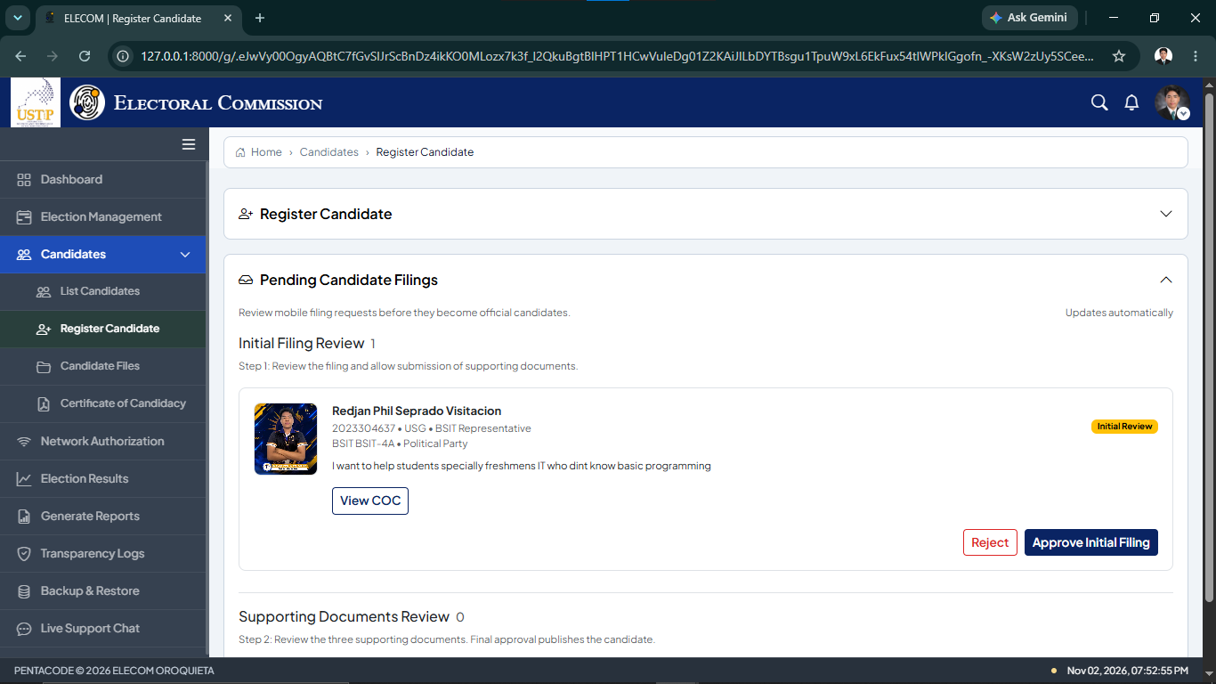
Figure 19 shows the Register Candidate Interface of the ECVS Web-Based Administration Platform. This interface allows ELECOM administrators to register candidates through four steps: Candidate Information, Media and Party, COC Details, and Signature and Review. Administrators can enter student information, select the organization and position, upload a candidate photo, provide party details, and complete the Certificate of Candidacy. The system also allows administrators to capture a digital signature and preview the completed COC before submitting the registration. This feature helps ELECOM manage candidate registration in an organized way.

Figure 20. Pending Candidate Filing and Initial Review Interfaces

Figure 20 shows the Pending Candidate Filing and Initial Review Interfaces of the Electoral Commission Voting System (ECVS). The web-based platform allows ELECOM administrators to review student candidacy applications, view the Certificate of Candidacy (COC), and approve or reject the initial filing. Meanwhile, the mobile application allows students to check the status of their submitted applications. The displayed status, "Filing Under Review," informs students that their applications are waiting for ELECOM review. This feature helps organize the candidacy process and keeps students informed about their application status.
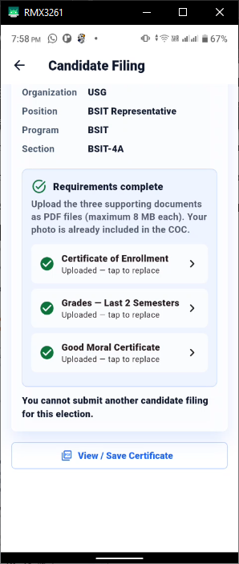
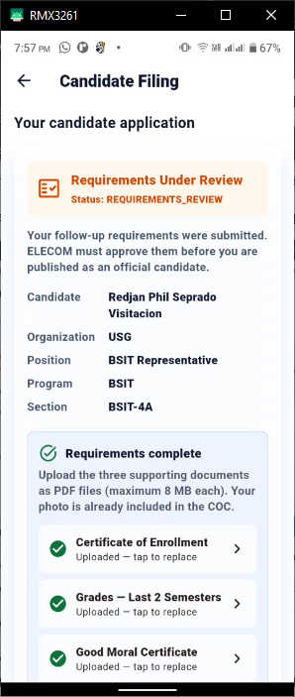

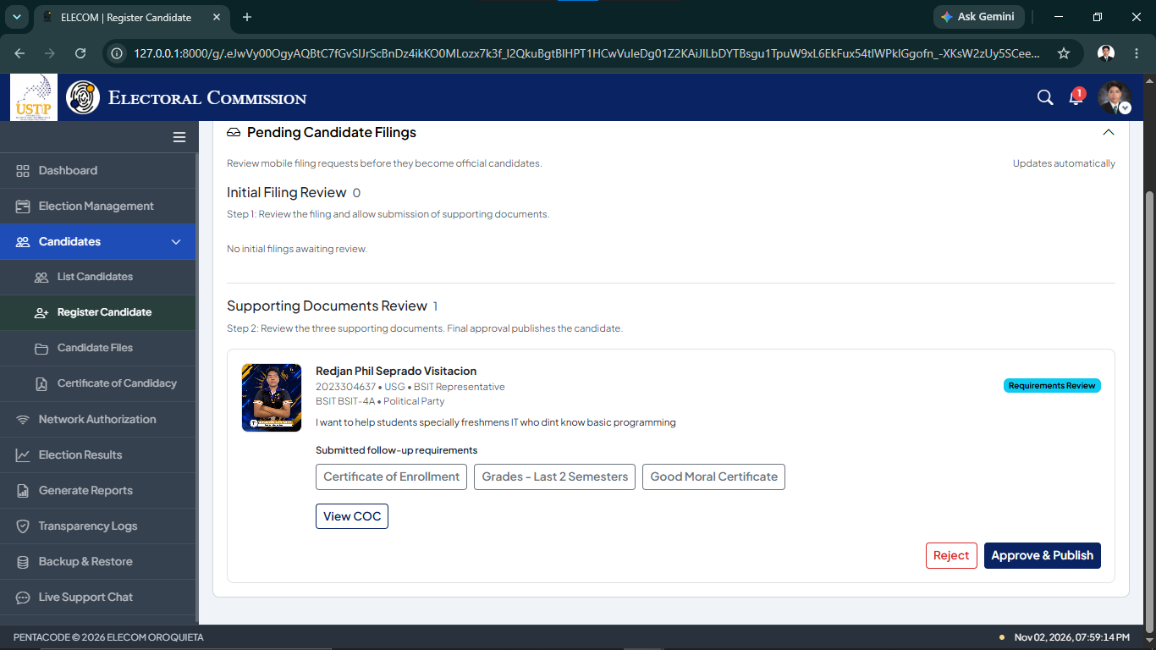

Figure 21. Supporting Documents Review Interfaces

Figure 21 shows the Supporting Documents Review interfaces of the Electoral Commission Voting System (ECVS). The mobile application allows students to submit three supporting documents: Certificate of Enrollment, Grades for the Last Two Semesters, and Good Moral Certificate. Students can also view their application status while waiting for ELECOM approval. On the web-based administration platform, ELECOM administrators can review the submitted documents and approve or reject the application. Once approved, the candidate can be published as an official candidate. This feature helps ELECOM manage and review candidacy requirements.

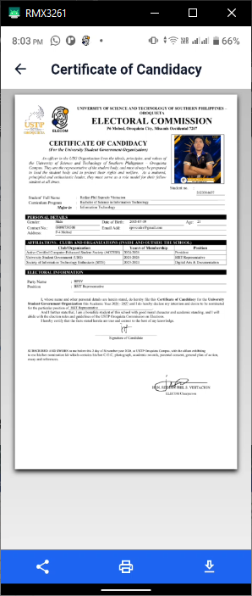
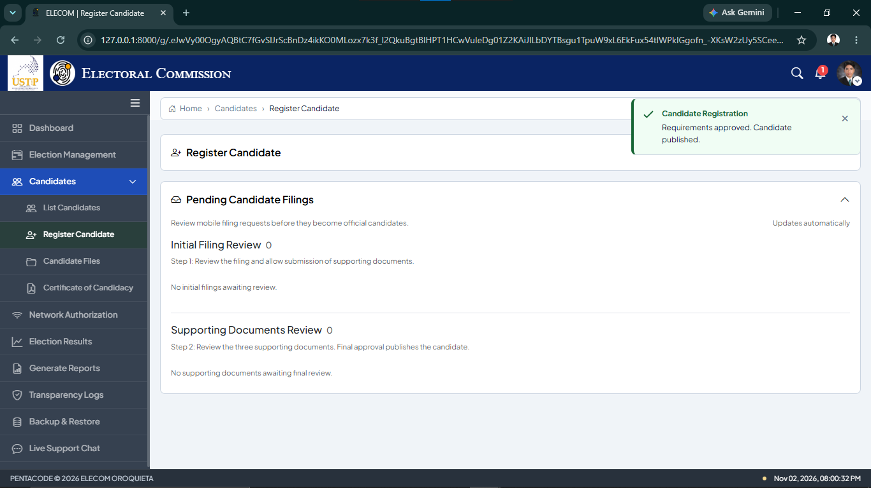
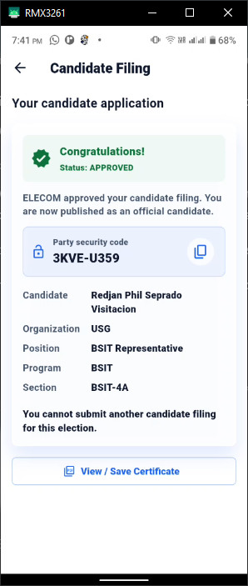

Figure 22. Candidate Approval and Publication Interfaces
Figure 22 shows the candidate approval and publication process in the ECVS. After ELECOM reviews and approves the submitted requirements, the candidate is published as an official candidate. The mobile application displays the approved status and provides a party security code. Meanwhile, the ELECOM web platform displays a confirmation message indicating that the candidate has been approved and published.
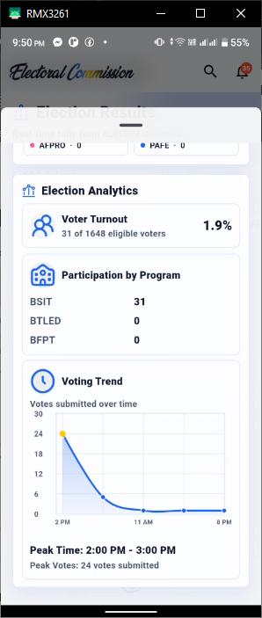
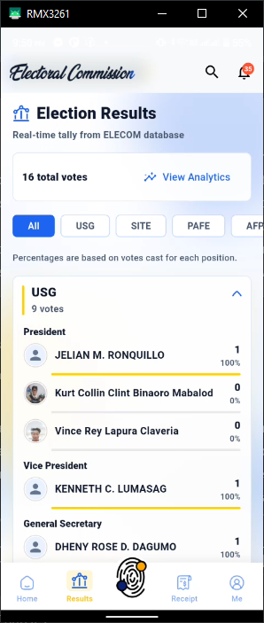
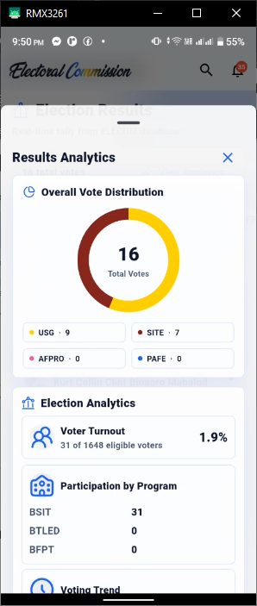

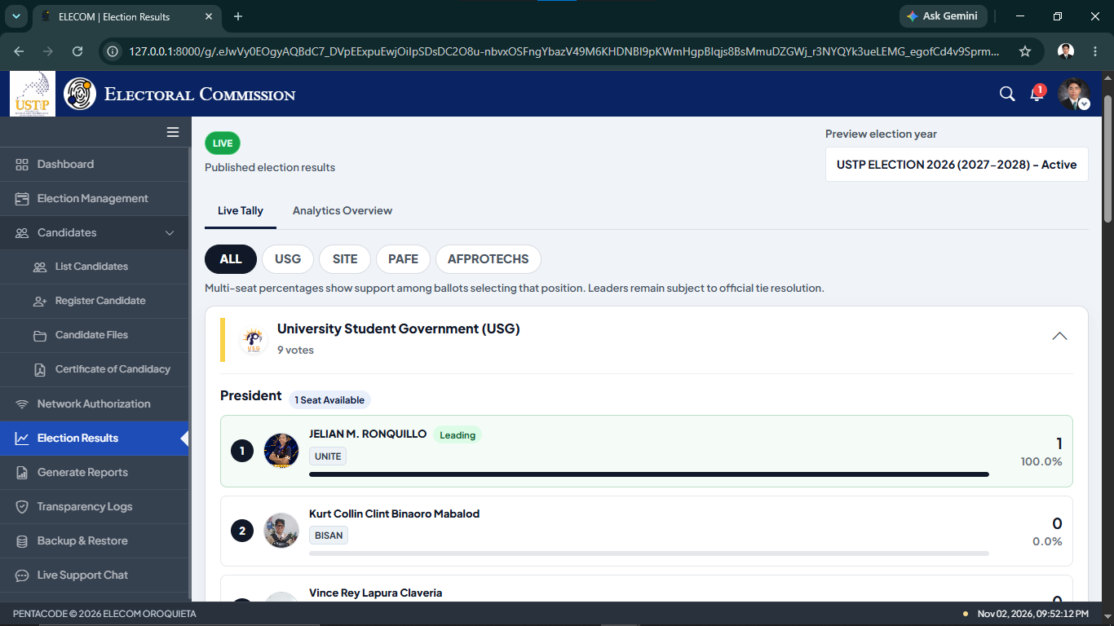
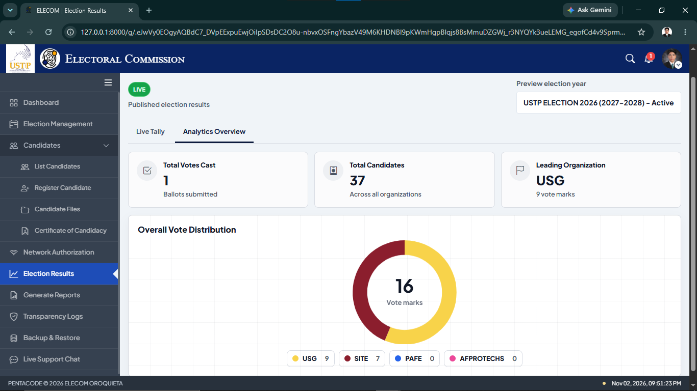

Figure 23. Election Results and Analytics Interfaces

Figure 23 shows the Election Results and Analytics interfaces of the ECVS web administration and mobile application. The system keeps election results locked until the scheduled release time. Once the results are available, ELECOM administrators and students can view the vote tallies for different student organizations and candidates. The interfaces also display election analytics, including vote distribution, voter turnout, participation by program, and voting trends. These features help users monitor election results and understand voting activities.
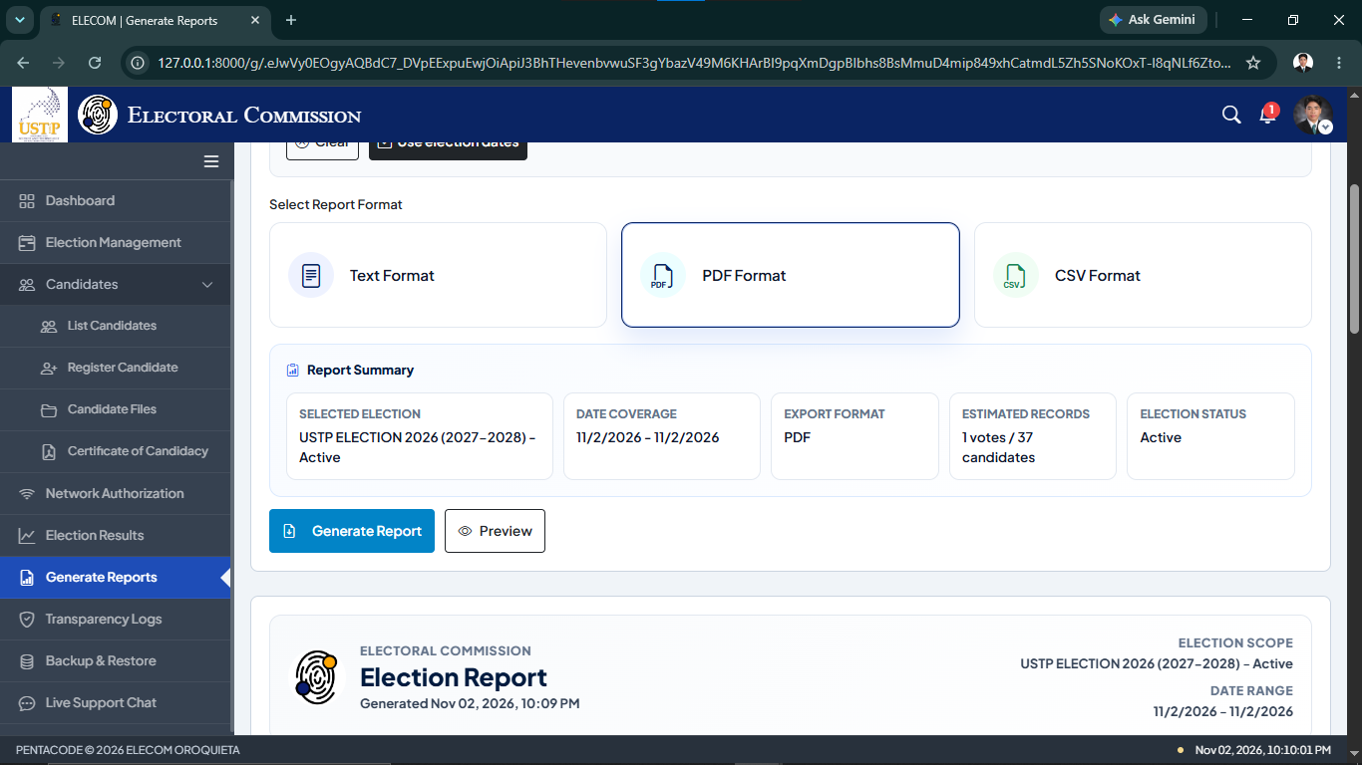

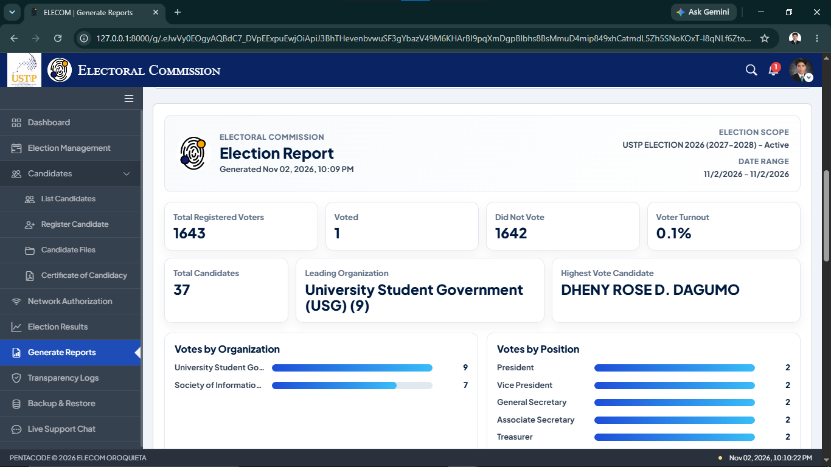

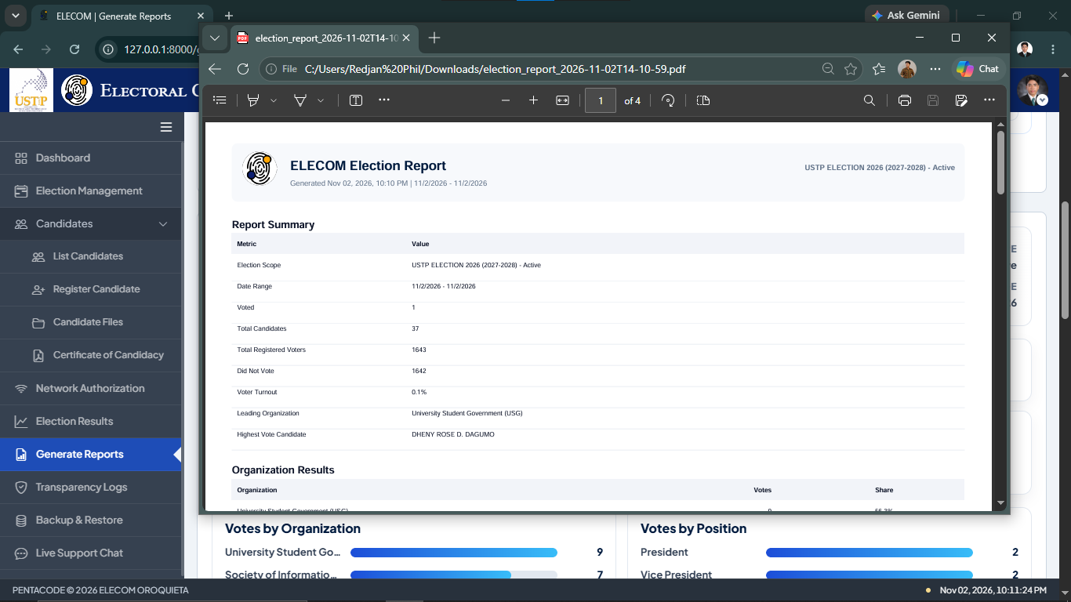

Figure 24. Election Report Generation

Figure 24 shows the Election Report Generation interface of the ECVS web administration. The ELECOM administrator can select an election, specify a date range, and choose a report format such as Text, PDF, or CSV. The system displays a report summary and allows the administrator to preview the election information before generating the report. The report includes registered voters, voter turnout, candidates, and election results. The generated PDF report can be saved for documentation and record-keeping purposes.
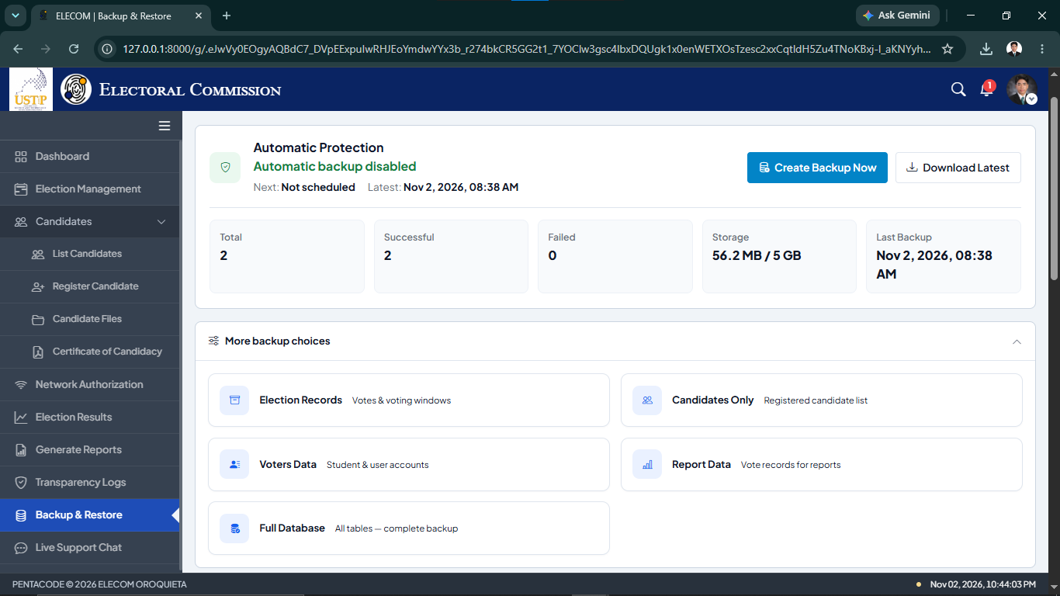

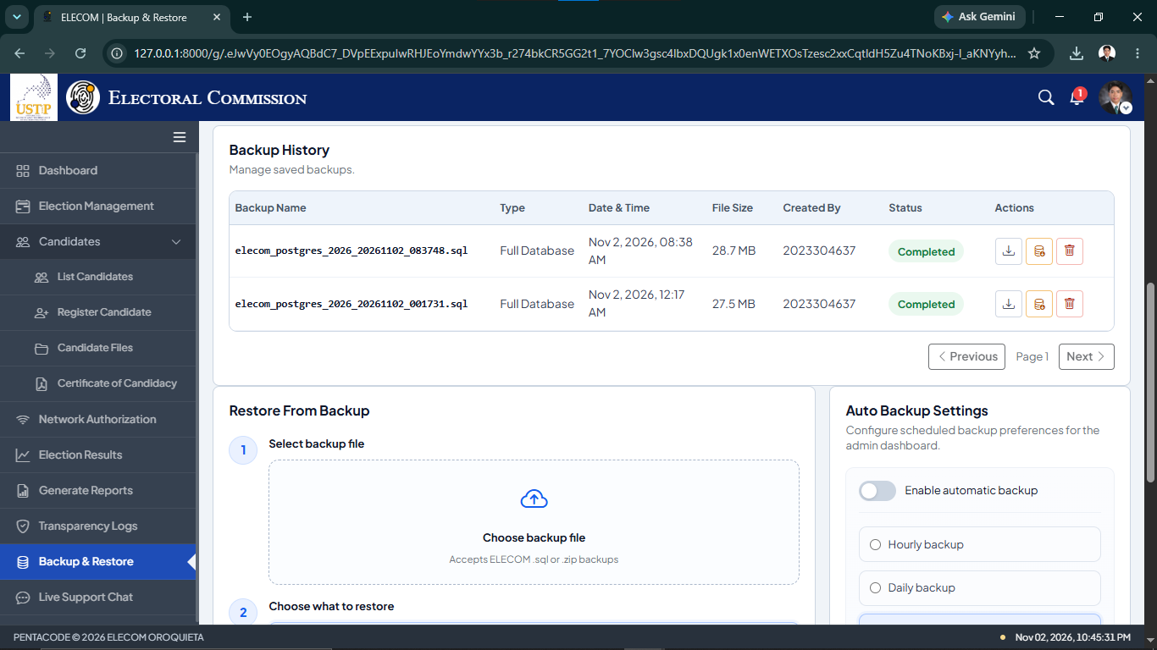

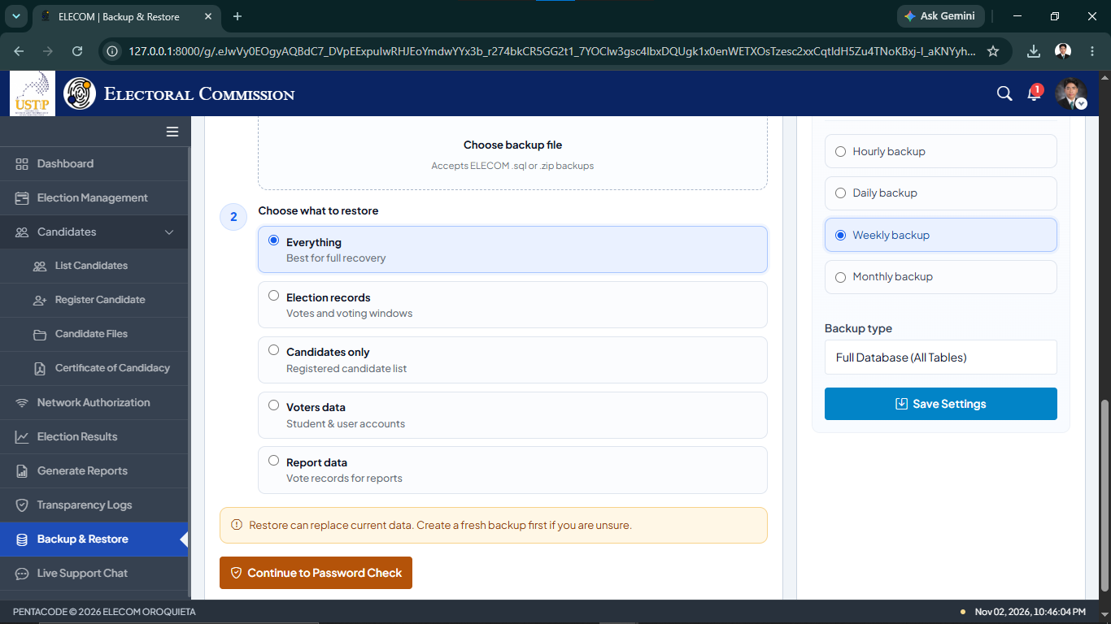

Figure 25. Backup and Restore Management

Figure 25 shows the Backup and Restore interfaces of the ECVS web administration. The system allows ELECOM administrators to create and download database backups and view previous backup records. Administrators can choose specific data to back up or restore, including election records, candidate information, voter data, and reports. The interface also provides automatic backup settings with hourly, daily, weekly, and monthly options. These features help administrators manage backup files and prepare for data recovery when needed.

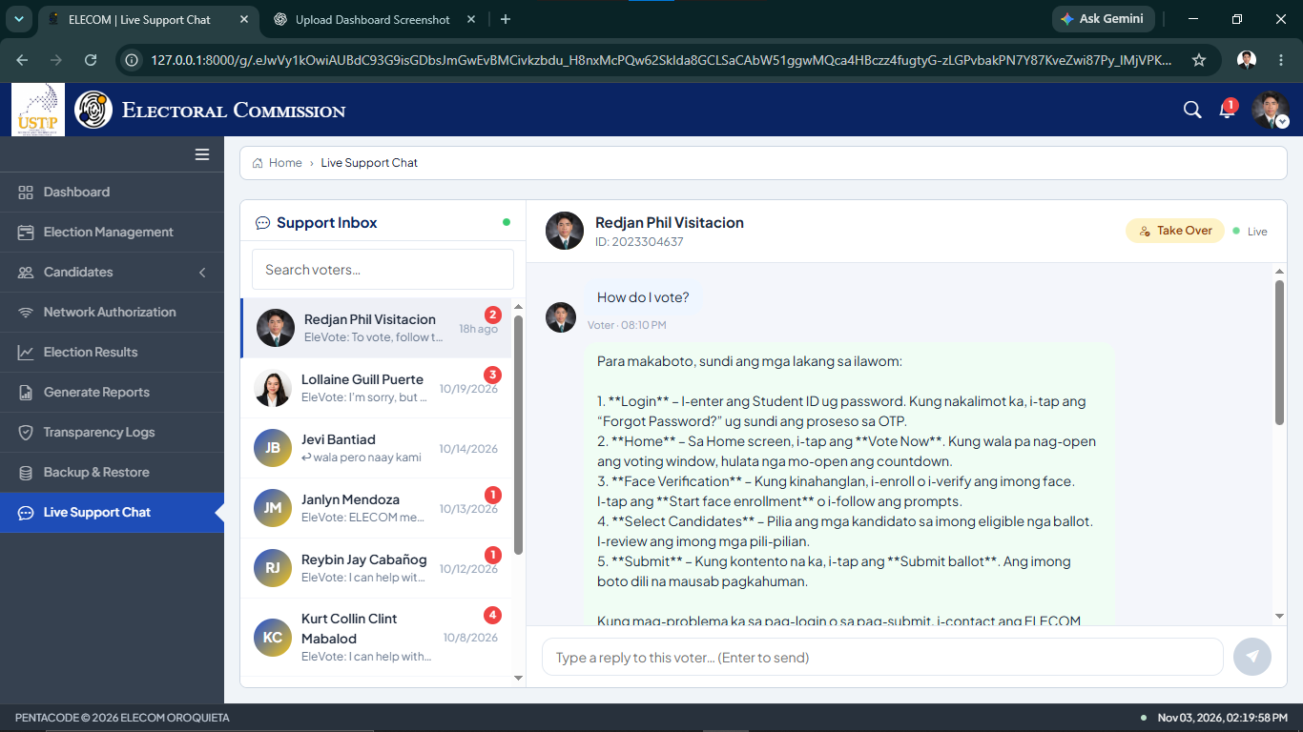
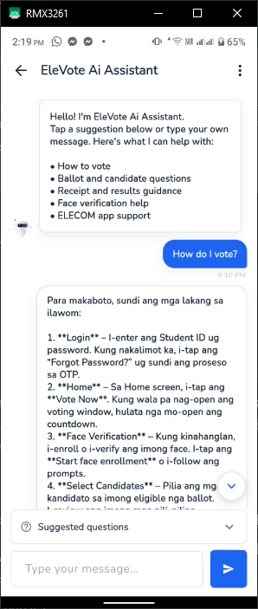

Figure 26. EleVote AI Assistant and Live Support Chat

Figure 26 shows the EleVote AI Assistant and Live Support Chat interfaces of the ECVS. The mobile application provides an AI assistant that helps students with voting procedures, candidate selection, facial verification, and other election-related questions. The ELECOM web administration displays student conversations through a support inbox, allowing administrators to review messages and provide assistance when needed. These features help students receive guidance and support while using the voting system.

Discussion No. 3. To integrate security and transparency mechanisms, including facial enrollment and verification, authorized-network voting, and blockchain-based vote recording, to support secure and verifiable election processes.
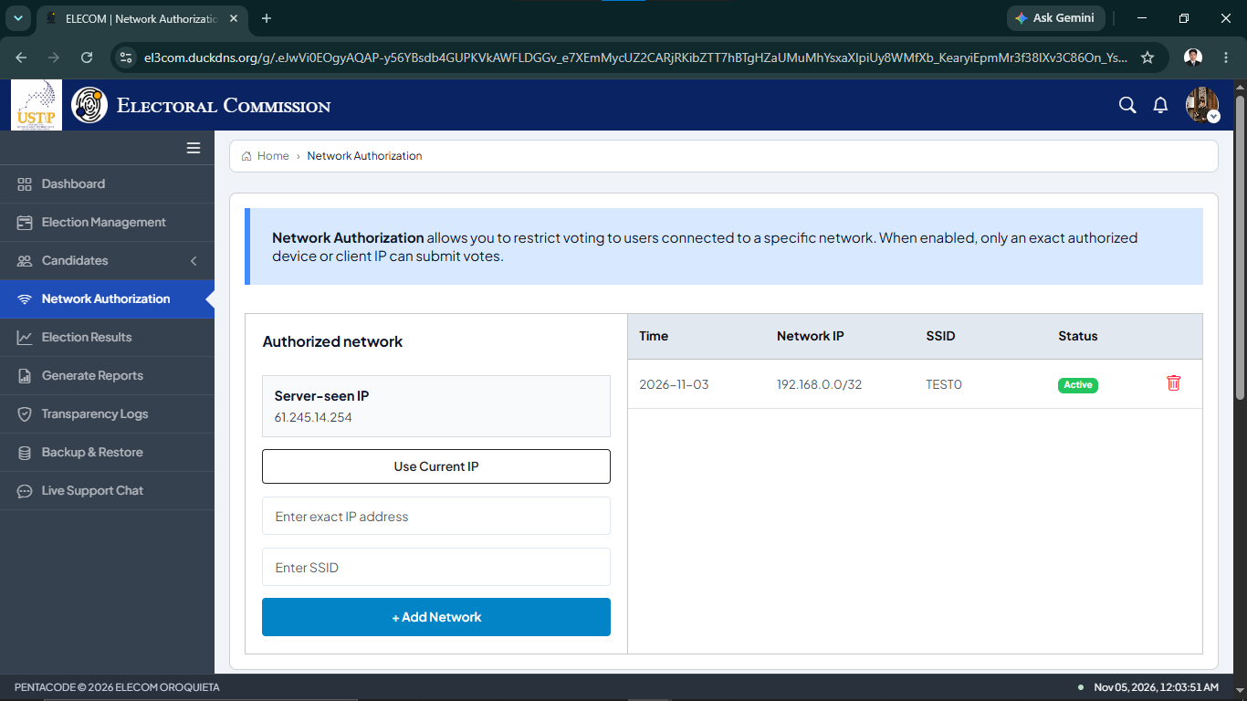
The Electoral Commission Voting System (ECVS) includes security and transparency features designed to protect the campus election process. The system uses facial enrollment and verification to help confirm the identity of student voters. It also includes authorized-network verification to restrict voting to approved network connections. In addition, the system uses a blockchain-based vote recording mechanism to maintain linked voting records and support the verification of election transactions. These features help reduce unauthorized voting activities and improve the transparency of campus elections.

Figure 27. Network Authorization Interface

Figure 27 shows the Network Authorization Interface of the Electoral Commission Voting System (ECVS) web-based administration platform. This interface allows ELECOM administrators to add and manage authorized networks by entering an IP address and SSID. It also displays the registered networks and their current status. This feature helps administrators control which network connections are permitted for voting and supports the security of the campus election process.
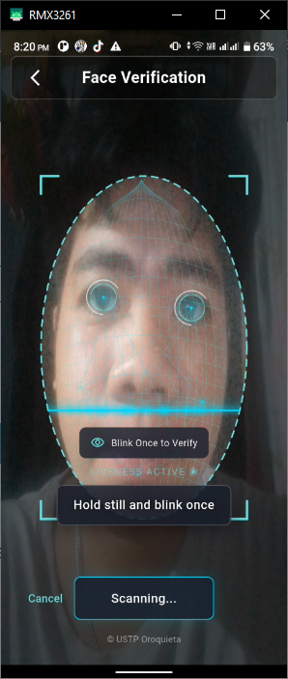
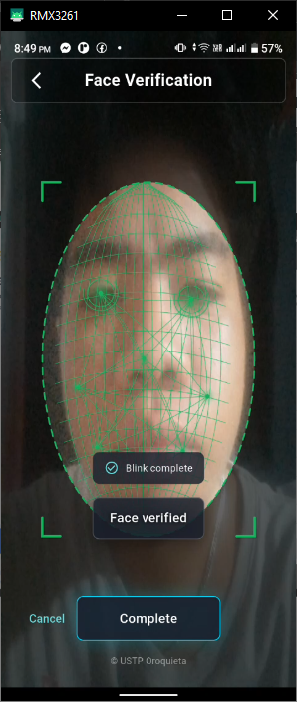

Figure 28. Facial Enrollment and Verification Interfaces

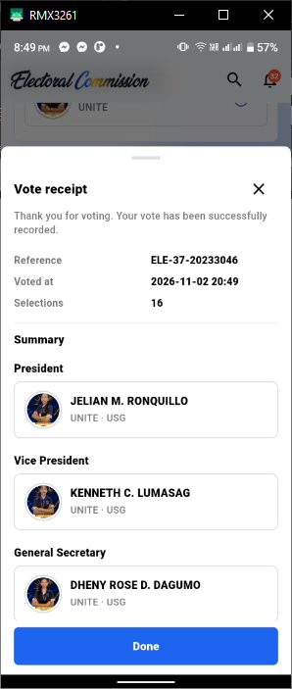
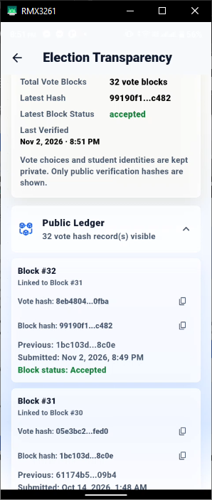
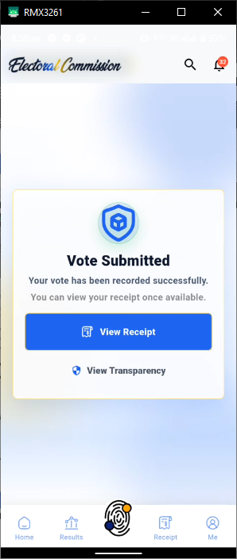
Figure 28 shows the Facial Enrollment and Verification Interfaces of the Electoral Commission Voting System (ECVS) mobile application. The facial enrollment feature allows students to register their facial information in the system. During the voting process, facial verification is used to help confirm the identity of the student before allowing them to proceed. These features provide an additional security measure to help prevent unauthorized voting and protect the integrity of campus elections.

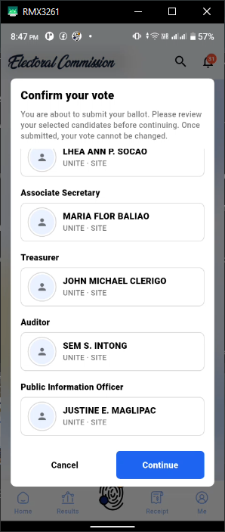
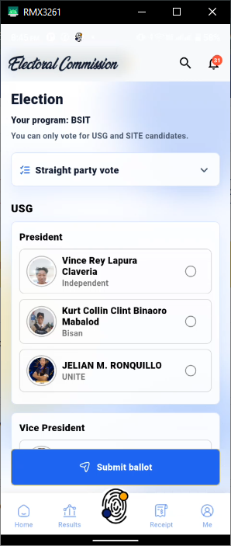
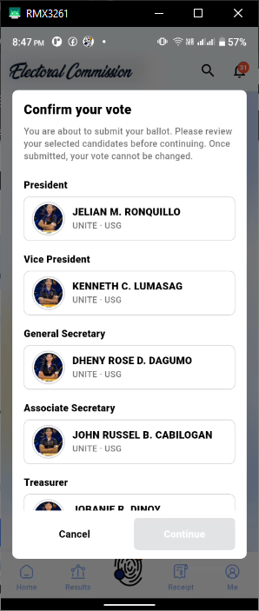
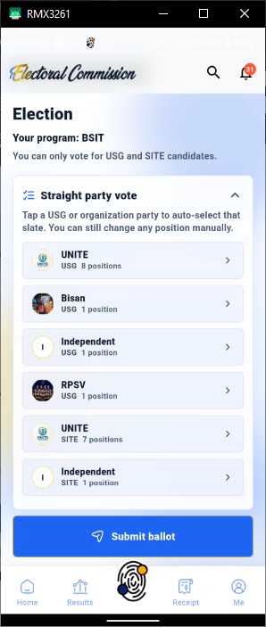

Figure 29. Student Voting Process and Ballot Confirmation

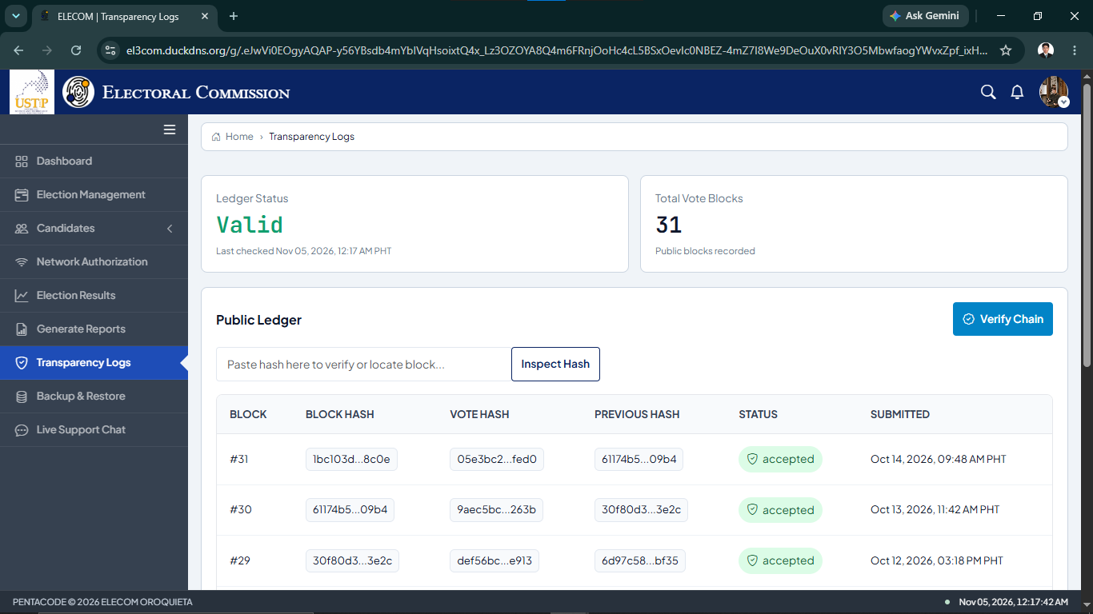
Figure 29 shows the Student Voting Process and Ballot Confirmation Interfaces of the Electoral Commission Voting System (ECVS) mobile application. These interfaces allow students to select their preferred candidates and review their choices before submitting their votes. The system displays a confirmation message to help students check their selections before final submission. After a successful submission, the application displays a notification confirming that the vote has been recorded. These features help students complete the voting process and reduce accidental voting errors.

Figure 30. Transparency Logs and Vote Ledger Verification

Figure 30 shows the Transparency Logs and Vote Ledger Verification Interface of the Electoral Commission Voting System (ECVS). This interface allows ELECOM administrators to view recorded voting transactions and examine the linked records stored in the system. The transparency logs provide information that supports the verification of election records. This feature helps administrators monitor voting transactions and identify possible changes or inconsistencies in the recorded data.

4.2. System Usability Scale (SUS) Evaluation Results
Table 9. Summary of System Usability Scale (SUS) Evaluation Results
Description | Result
Total Respondents | 73
Student Respondents | 71
ELECOM Member | 1
USG Officer | 1
Number of SUS Questions | 10
Overall SUS Score | 69.25
SUS Benchmark | 68
Interpretation | Above the Benchmark

Table 9 presents the results of the System Usability Scale (SUS) evaluation of the USTP Oroquieta Electoral Commission Voting System (ECVS). A total of 73 respondents participated in the evaluation, consisting of 71 students, one ELECOM member, and one USG officer. The system obtained an overall SUS score of 69.25 out of 100, which is above the commonly used benchmark of 68. This result indicates that the respondents generally perceived the system as usable and easy to interact with. The findings suggest that the ECVS provides a satisfactory user experience while still allowing opportunities for further improvements.

Calculation of the Overall SUS Score
Overall SUS Score = Total SUS Scores ÷ Total Respondents
Overall SUS Score = 5,055 ÷ 73
Overall SUS Score = 69.25

Table 10. Mean Ratings of the System Usability Scale (SUS) Evaluation
No. | SUS Question | Mean
 | I think that I would like to use the ELECOM Voting System frequently. | 4.14
 | I found the ELECOM Voting System unnecessarily complex. | 2.29
 | I thought the ELECOM Voting System was easy to use. | 3.66
 | I think that I would need the support of a technical person to be able to use the ELECOM Voting System. | 2.51
 | I found the various functions in the ELECOM Voting System were well integrated. | 4.01
 | I thought there was too much inconsistency in the ELECOM Voting System. | 2.30
 | I would imagine that most people would learn to use the ELECOM Voting System very quickly. | 4.15
 | I found the ELECOM Voting System very cumbersome to use. | 2.49
 | I felt very confident using the ELECOM Voting System. | 3.99
 | I needed to learn a lot of things before I could get going with the ELECOM Voting System. | 2.66

Table 10 presents the mean ratings of the ten System Usability Scale (SUS) questions answered by 73 respondents. Question 7 obtained the highest mean rating of 4.15, indicating that respondents generally believed most people could learn to use the ECVS quickly. Question 1 received a mean of 4.14, suggesting that respondents were interested in using the system frequently. Question 5 obtained a mean of 4.01, indicating positive feedback on the integration of system functions.
For the negatively worded questions, Question 2 obtained a mean of 2.29, while Question 6 received a mean of 2.30. These results suggest that respondents generally disagreed that the system was unnecessarily complex or inconsistent. Overall, the responses support the SUS score of 69.25, which is slightly above the commonly used benchmark of 68. However, the results also indicate opportunities to improve the system's usability.

CHAPTER V
CONCLUSIONS AND RECOMMENDATIONS
This chapter presents the summary of findings, conclusions, and recommendations of the study entitled "Modernizing Campus Elections: The USTP Oroquieta Electoral Commission Voting System (ECVS)." The study aimed to develop a mobile and web-based voting system to improve the efficiency, accuracy, security, and transparency of student elections at USTP Oroquieta Campus.

5.1. Conclusion
Based on the findings of the study, the researchers conclude that the developed Electoral Commission Voting System (ECVS) provides a digital platform for managing and conducting student elections at USTP Oroquieta Campus. The system integrates mobile voting, web-based election administration, and security and transparency features to support the campus election process.
The researchers also developed a web-based administration platform for the Electoral Commission (ELECOM). The platform provides features for managing candidates, reviewing candidacy applications, setting election schedules, monitoring voting activities, viewing election results, and generating reports. These functions were designed to help ELECOM personnel manage campus elections more efficiently and reduce dependence on manual procedures.
To support election security and transparency, the developed system includes facial enrollment and verification, authorized-network voting, and cryptographically linked vote records. These features were integrated to support voter identity verification, restrict voting access to authorized networks, and provide verifiable election records. The system also provides transparency logs to support the review of recorded voting activities.
The developed Electoral Commission Voting System (ECVS) was evaluated by 73 respondents, consisting of 71 students, one ELECOM member, and one University Student Government (USG) officer. The evaluation used the 10-item System Usability Scale (SUS) questionnaire. The system obtained an overall SUS score of 69.25 out of 100, which is slightly above the commonly used benchmark of 68. The results indicate that respondents generally perceived the system as usable, although further improvements may help enhance the overall user experience.

5.2 Recommendations
Based on the findings and conclusions of the study, the researchers recommend the following improvements for the future development of the Electoral Commission Voting System (ECVS).
First, the researchers recommend that future developers integrate fingerprint authentication as an additional security feature. The current system uses facial verification to confirm the identity of student voters. Adding fingerprint authentication may provide another method of identity verification and improve the security of the voting process.
Second, the researchers recommend further enhancing the user interface (UI) of the mobile application and web-based administration platform. Although the system obtained an overall System Usability Scale (SUS) score of 69.25, improvements in the design, layout, and navigation may provide a better user experience. These enhancements may help students and ELECOM personnel use the system more easily and efficiently.
Lastly, the researchers recommend developing a web-based voting platform for students. The current system provides voting through the mobile application, while the web platform is intended for ELECOM administration. Due to the limited development time, web-based voting for students was not included in the current version. Future researchers may extend the system by allowing students to cast their votes through a web browser while maintaining the necessary security and voter verification requirements. This improvement may provide students with another convenient way to participate in campus elections.

BIBLIOGRAPHY
ACE Electoral Knowledge Network. (2022). Electoral management and voting processes. https://aceproject.org
Cebu Technological University. (2021). Web-based voting system for student elections [Undergraduate thesis].
Commission on Elections (COMELEC). (2022). Digital transformation in electoral processes.
International IDEA. (2021). Electoral processes and challenges. https://www.idea.int
Kshetri, N., & Voas, J. (2021). Blockchain-enabled e-voting. IEEE Software, 38(1), 79–85.
Mindanao State University. (2021). Development of an online voting system for campus elections [Undergraduate thesis].
National Institute of Standards and Technology. (2024). NIST Cybersecurity Framework 2.0: Resource and overview guide (NIST Special Publication 1299). https://doi.org/10.6028/NIST.SP.1299
Open Worldwide Application Security Project. (2024). MASVS v2.1.0 release & MASVS-PRIVACY. https://mas.owasp.org/news/2024/01/18/masvs-v210-release--masvs-privacy/
Open Worldwide Application Security Project. (2025). Application Security Verification Standard (ASVS), version 5.0.0. https://asvs.owasp.org/
Pascoe, C., Quinn, S., & Scarfone, K. (2024). The NIST Cybersecurity Framework (CSF) 2.0 (NIST CSWP 29). National Institute of Standards and Technology. https://doi.org/10.6028/NIST.CSWP.29
Polytechnic University of the Philippines. (2021). Automated election system with database integration [Research study].
Temoshok, D., Fenton, J., Choong, Y.-Y., Lefkovitz, N., Regenscheid, A., Galluzzo, R., & Richer, J. (2025). Digital identity guidelines: Authentication and authenticator management (NIST Special Publication 800-63B-4). National Institute of Standards and Technology. https://doi.org/10.6028/NIST.SP.800-63b-4
University of the Philippines. (2021). Secure authentication in electronic voting systems [Research study].
Yaga, D., Mell, P., Roby, N., & Scarfone, K. (2021). Blockchain technology overview (NISTIR 8202). National Institute of Standards and Technology.
Zheng, Z., Xie, S., Dai, H., Chen, X., & Wang, H. (2022). Blockchain challenges and opportunities: A survey. International Journal of Web and Grid Services, 18(2), 123–146.

APPENDICES

APPENDIX A
Interview Questionnaire
for USG Moderator and ELECOM Chairperson

Name (Optional): __________________________________ Date: __________
Designation/Position Title: _____________

1. What is ELECOM? ________________________________________________________________________________________________________________________________________________________________________________________________________________________________________________________________________
2. How often do you conduct elections? ________________________________________________________________________________________________________________________________________________________________________________________________________________________________________________________________________
3. What challenges do you face in conducting elections? Why? ________________________________________________________________________________________________________________________________________________________________________________________________________________________________________________________________________
4. What did you do to solve this problem? What did we did? ________________________________________________________________________________________________________________________________________________________________________________________________________________________________________________________________________

Interview Questionnaire
for Students Who Have Experienced Campus Elections

Name (Optional): _________________________________ Date: ___________
Course/Year/Section: ____________ Designation/Position Title: ___________

1. Have you experience joining the election activities in our campus? Share to me your experience. ________________________________________________________________________________________________________________________________________________________________________________________________________________________________________________________________________

2. What are those challenges do you encountered? ________________________________________________________________________________________________________________________________________________________________________________________________________________________________________________________________________

3. What did you do to solve this problem? ________________________________________________________________________________________________________________________________________________________________________________________________________________________________________________________________________

APPENDIX B

SYSTEM USABILITY SCALE (SUS) QUESTIONNAIRE

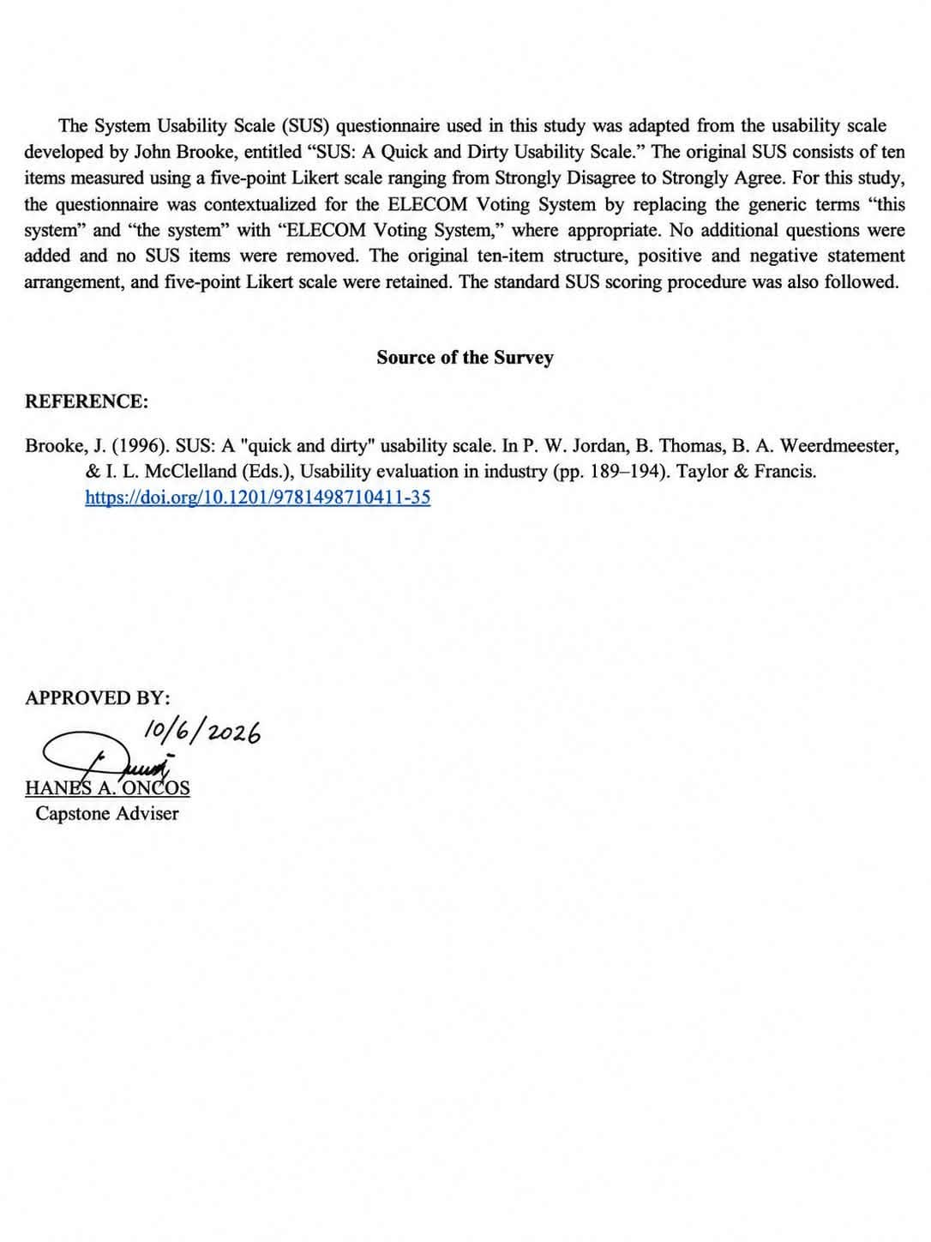

APPENDIX C
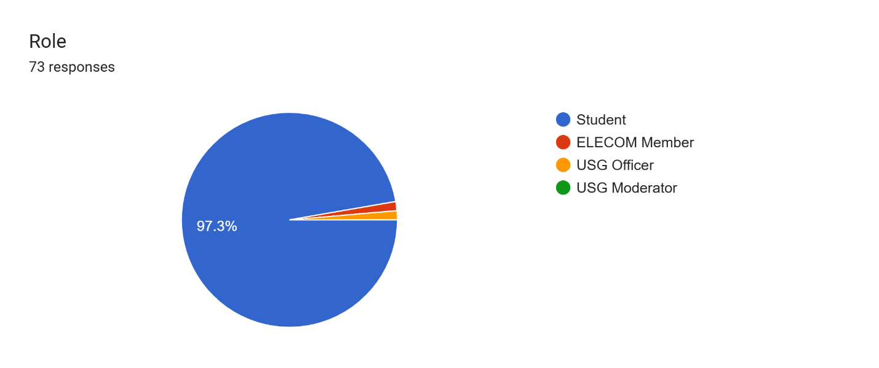
SURVEY QUESTIONNAIRE VIA GOOGLE FORMS

APPENDIX D
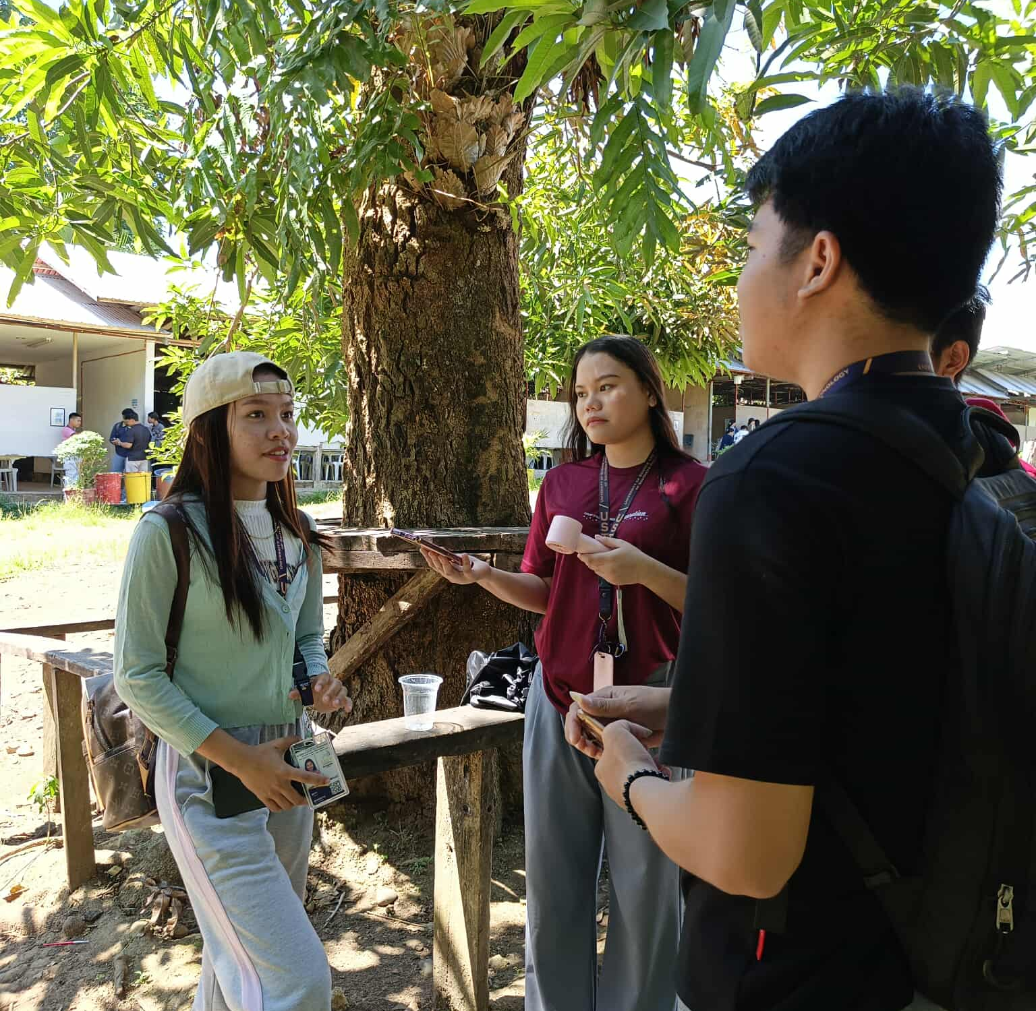
DATA GATHERING
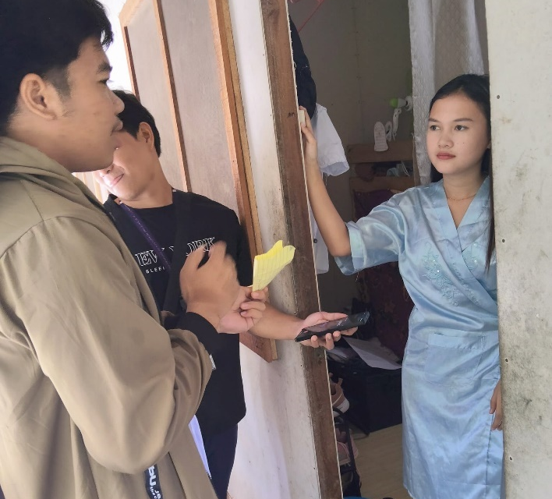

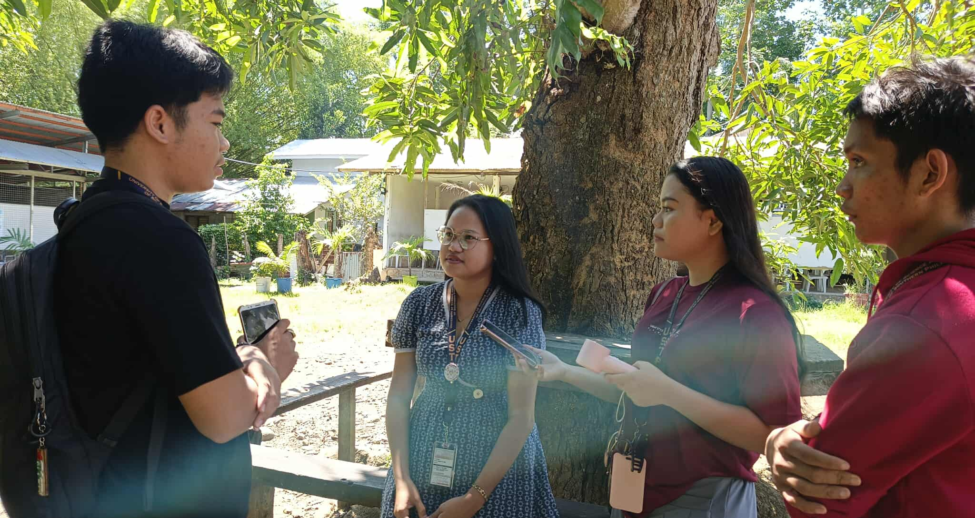

INTERVIEW WITH USG MODERATOR


INTERVIEW WITH ELECOM CHAIRPERSON
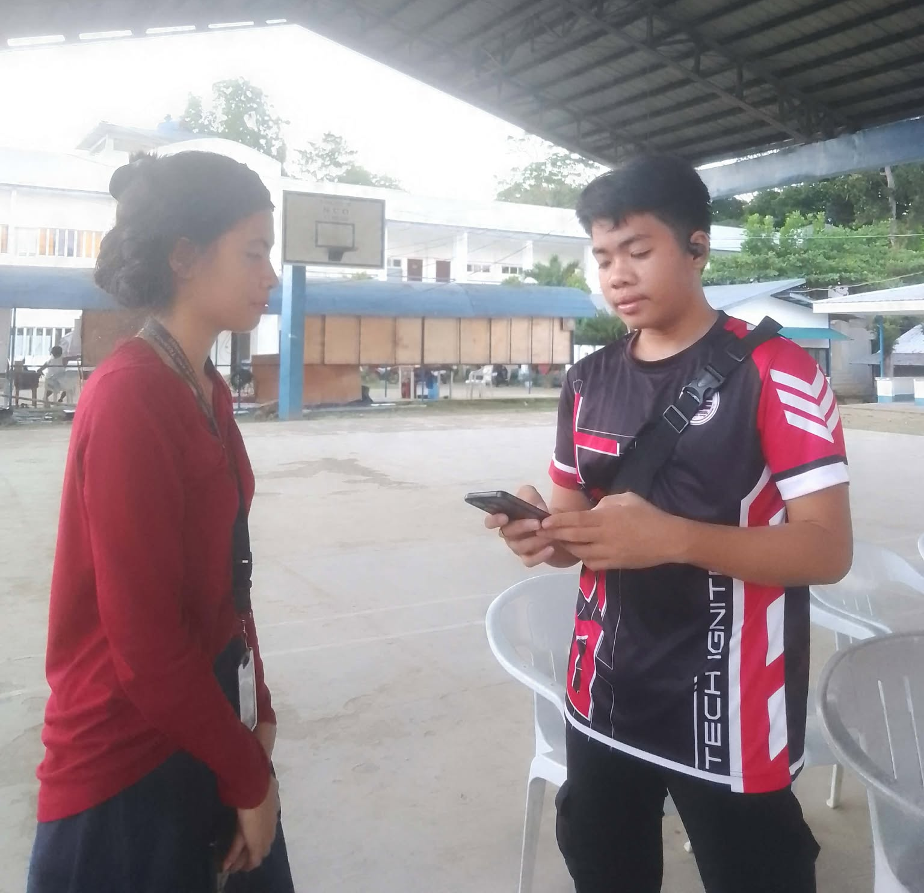

APPENDIX E
SYSTEM TESTING
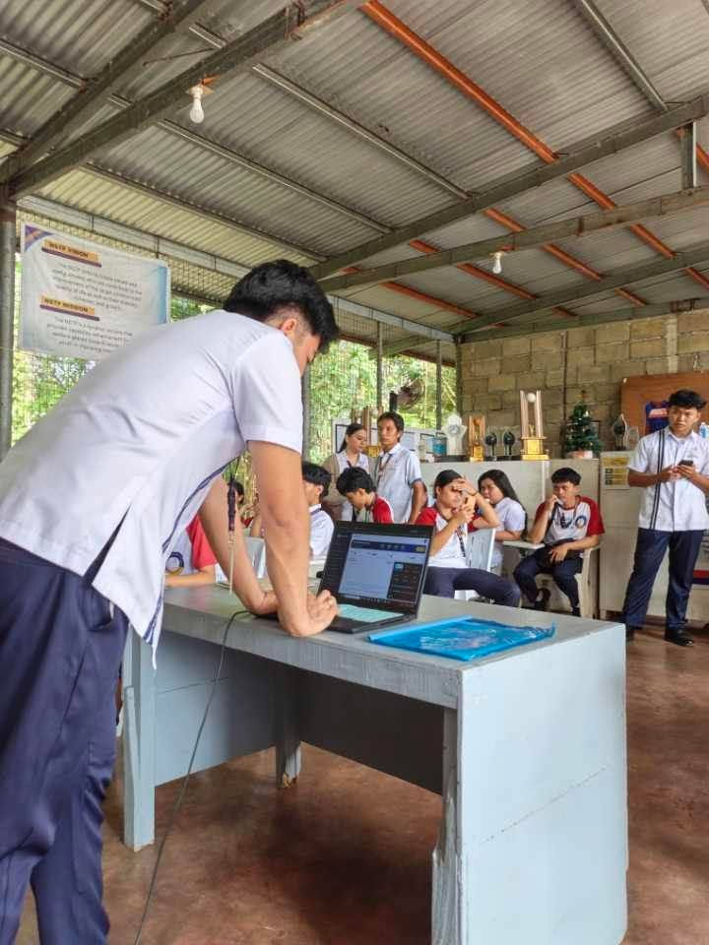
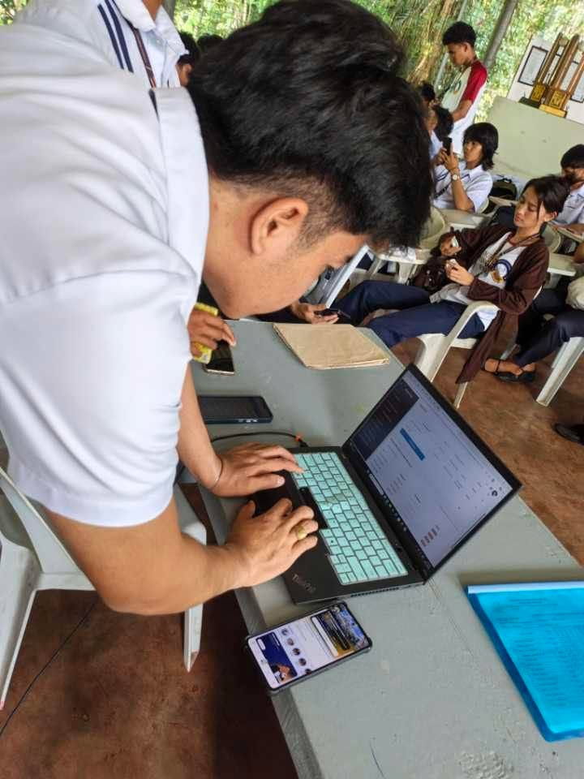

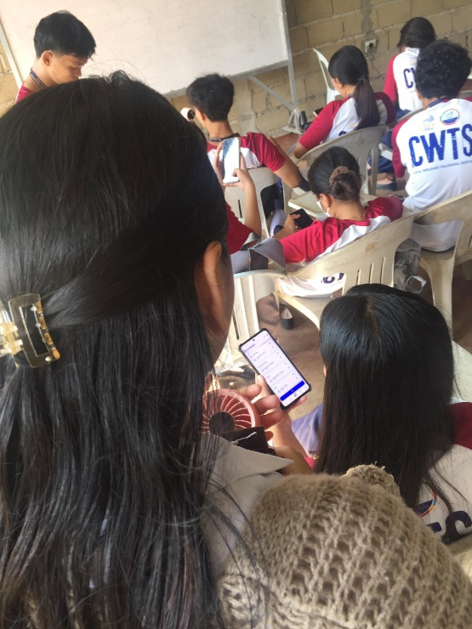
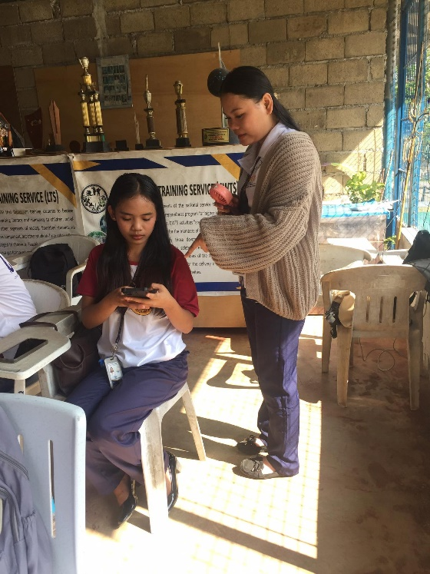

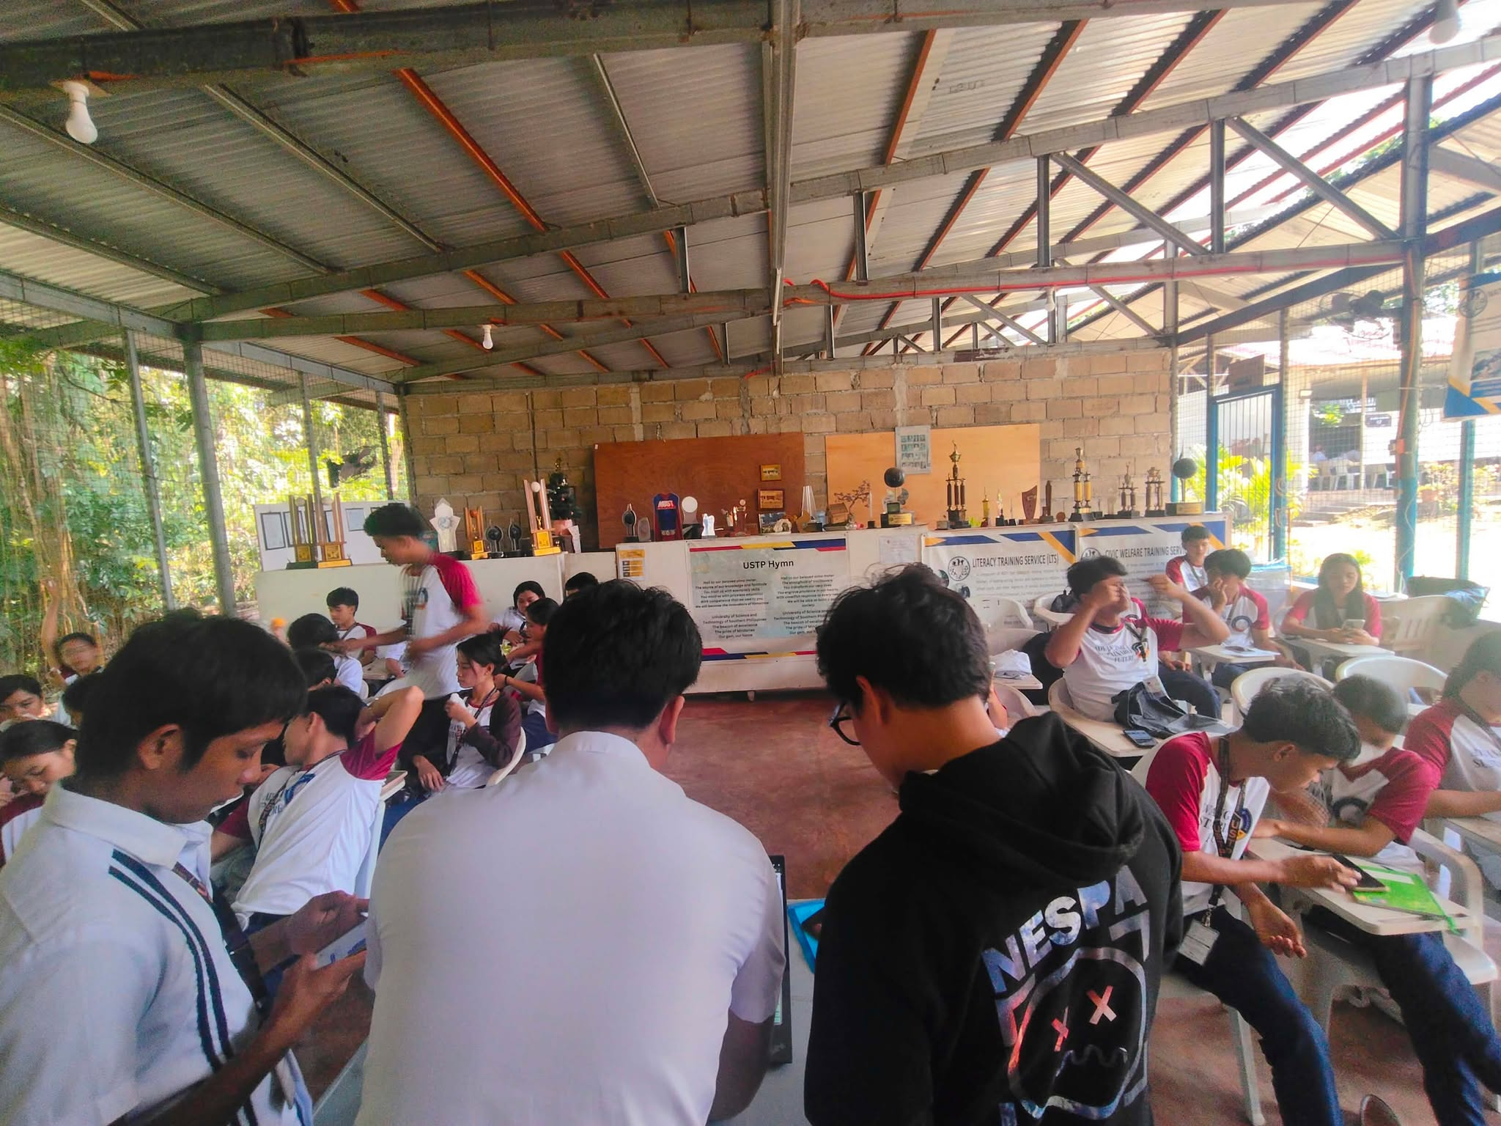

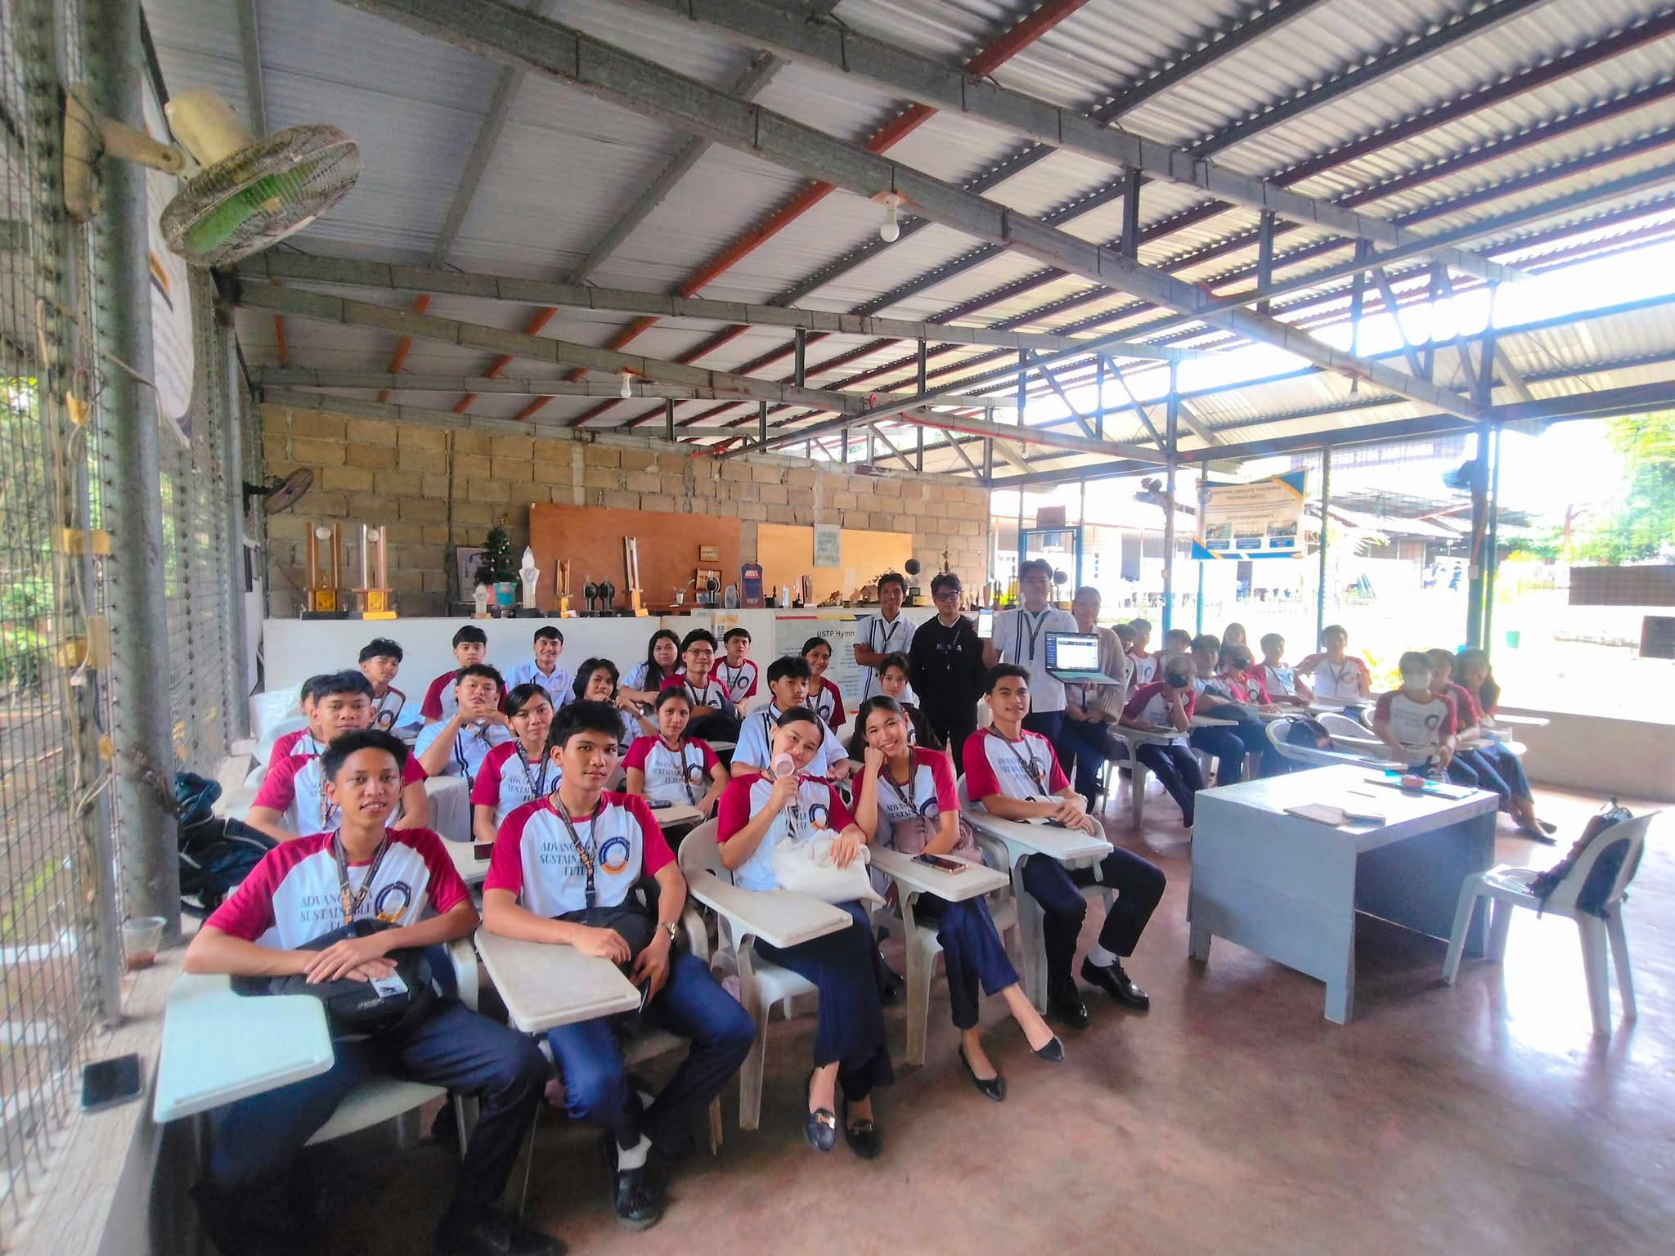

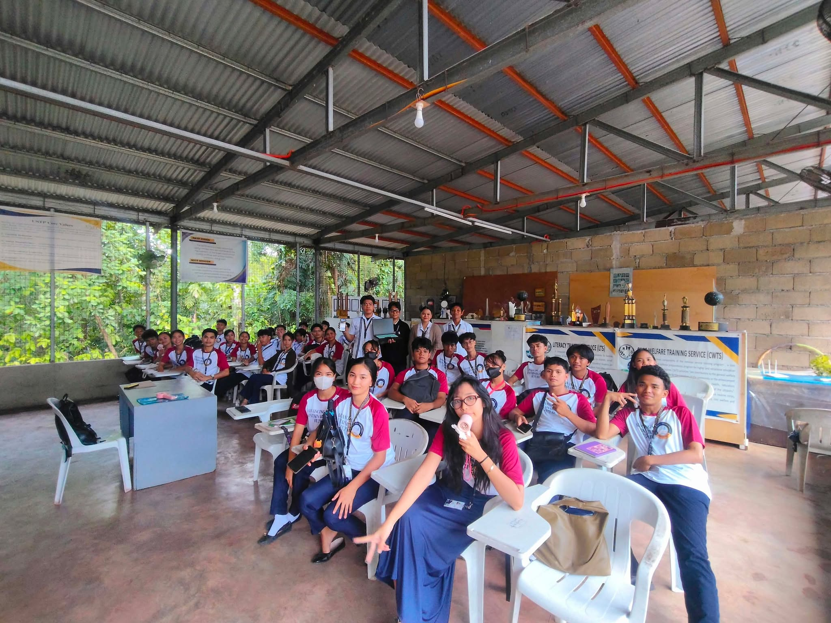




APPENDIX F
SYSTEM TESTING WITH CLIENT
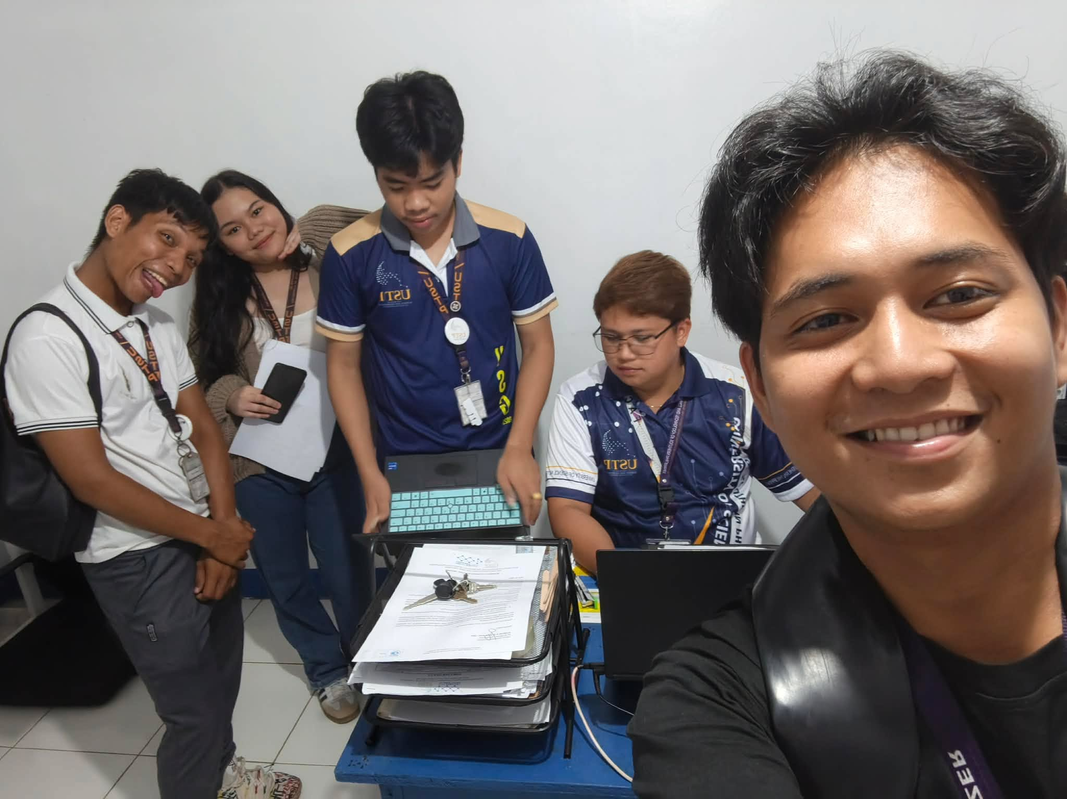

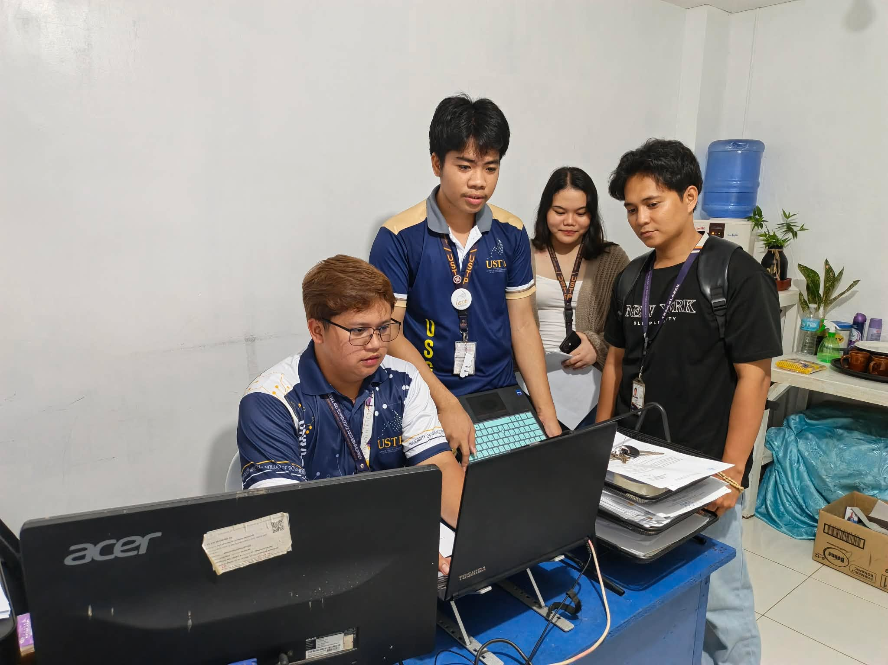

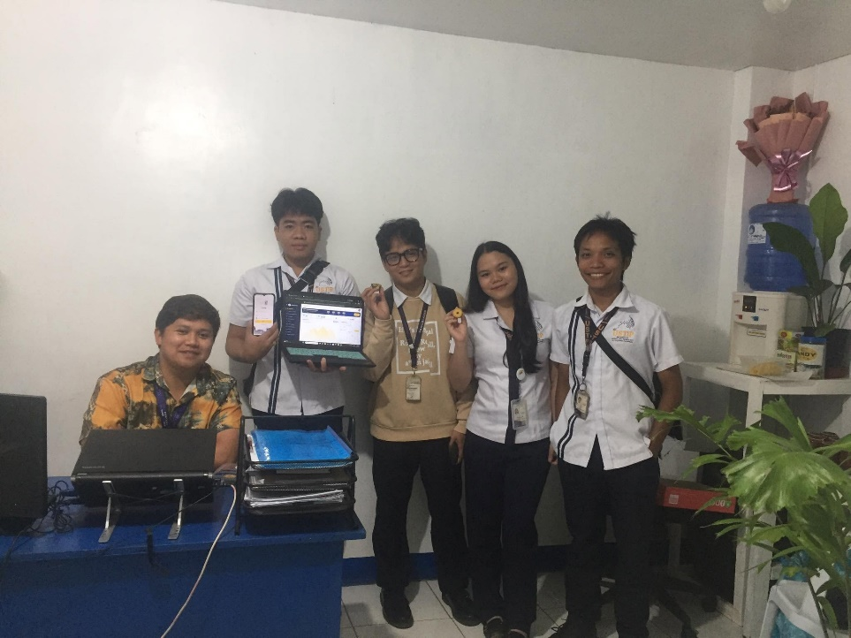

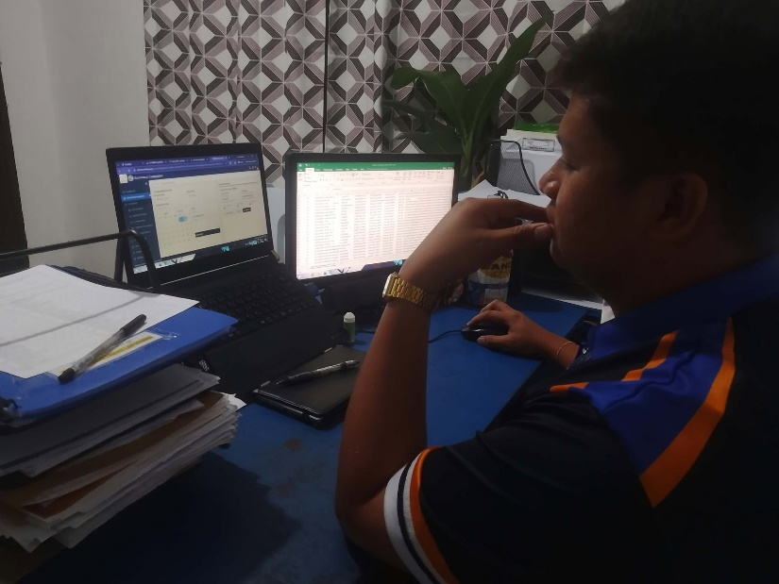
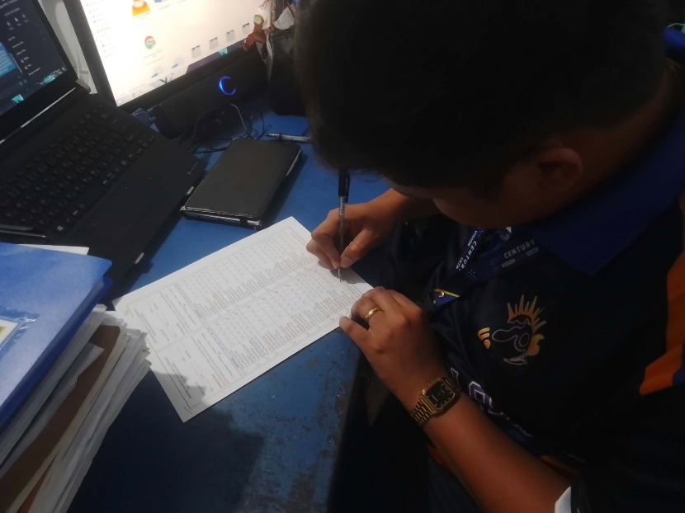



APPENDIX G
SYSTEM TESTING WITH CAPSTONE ADVISER
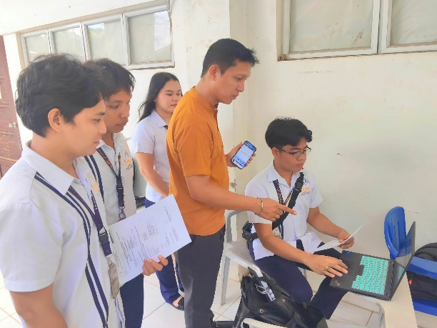
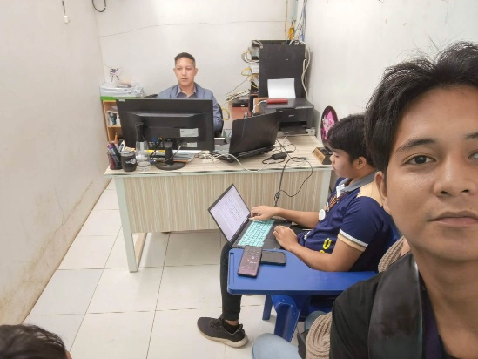

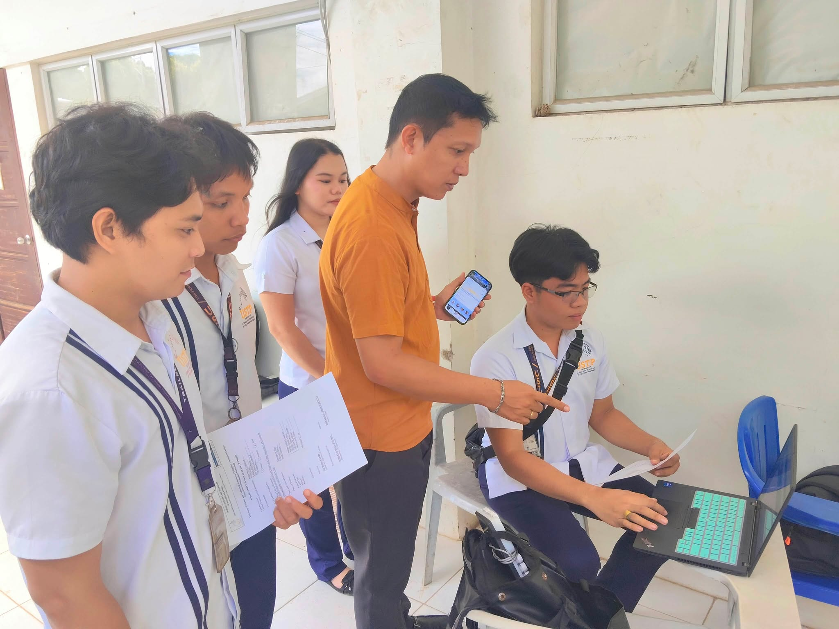

CURRICULUM VITAE


REDJAN PHIL S. VISITACION
Purok 4, Mobod
Oroquieta City Misamis Occidental
09534181760
visitacionredjanphils@gmail.com

A passionate and creative student with a strong interest in photography, Graphic design, and programming. Skilled in video editing and always eager to learn new technologies.
PERSONAL DATA
Place of Birth: Purok 4 Mobod, Oroquieta City Misamis Occidental
Birthdate: 07/09/2005
Age : 21
Civil Status: Single
Citizenship : Filipino
Religion : Roman Catholic
Mother’s Name: Rosita S. Visitacion
Father’s Name: Rogelio C. Visitacion

TECHNICAL SKILLS
Photographer
Graphic Design
Programmer
Video Editing

INTERESTS & HOBBIES
Hacking
Social Media

EDUCATIONAL BACKGROUND

2023 - 2027 | University of Science and Technology of Southern  Philippines  Bachelor of Science in Information Technology
2021 - 2023 | Deor & Dune Academe School of Technology, Inc.  Purok – 1 Mobod, Oroquieta City
2017 - 2021 | Mobod Integrated School  Purok – 2 Mobod, Oroquieta City
2011 - 2017 | Mobod Integrated School  Purok – 2 Mobod, Oroquieta City

LEADERSHIP BACKGROUND
2023 - 2024 | SITE Committee on Digital Arts and Documentation  USTP OROQUIETA
2024 - 2027 | Attended Trailblazers Leadership Summit  USTP OROQUIETA
2024 | IT Days Mobile Photo Contest Facilitator  USTP OROQUIETA
2024 - 2026 | Intramural Photo Contest Facilitator  USTP OROQUIETA
2024 - 2025 | Arts Month Photo Contest Facilitator  USTP OROQUIETA
2024 - 2025 | Arts Month Short Film Facilitator  USTP OROQUIETA
2024 - 2025 | Attended Basic Life Support Training  USTP OROQUIETA
2025 | IT Days Film Viewing Facilitator  USTP OROQUIETA
2025 | IT Days HACKathon Facilitator  USTP OROQUIETA
2024 - 2026 | Active Certified Computer-Enhance Students Society President  USTP OROQUIETA
2024 - 2026 | Active Certified Computer-Enhance Students Society Director in Developers and Robotics  USTP OROQUIETA
2024 - 2027 | University Student Government IT Representative  USTP OROQUIETA
2025 | Attended General Assembly for Accredited Student Organizations  USTP CAGAYAN DE ORO
2025 | Attended Leadership training & workshop, with Vice President of Student Affairs and Services  USTP CAGAYAN DE ORO
2025 - 2027 | Attended Leadership Through Evaluation, Alignment, and Development Training for the University Student Government officers.  USTP OROQUIETA
2025 | Attended Oroquieta Youth Leadership Summit with 10th Infantry "Steady On" Battalion  CAMP BURGOS OROQUIETA

AWARDS AND CERTIFICATES
2021 - 2023 | Senior High With Honors  DEOR & DUNE OROQUIETA
2023 | Computer System Servicing (NCII)  DEOR & DUNE OROQUIETA
2023 | Intramurals Photo Contest 3rd Placer  USTP OROQUIETA
2023 | ARDUINO IOThink Olympics 2nd Placer  USTP OROQUIETA
2024 | NSTP Certificates  USTP OROQUIETA
2024 | Microsoft Certificates  ONLINE
2025 | Google Gemini Certificates  ONLINE
2025 | Code Creed Certificates  ONLINE
2025 | (WAKAN) Short Film Champion  USTP CAGAYAN DE ORO
2025 - 2026 | As a Break trough Student leader  USTP OROQUIETA
2025 | As a Best Student Organization (ACCESS)  USTP OROQUIETA
2025 - 2026 | DICT Digital Bayanihan Para sa Kabatang Ligtas at Protektado Online and Cybersecurity 101 Certificates  USTP OROQUIETA
2026 | HACKERDNA Cyber Security Labs Capture the Flag 101 Certificates  ONLINE


VON JUSHUA PEJE
Purok 4 Tipan Oroquieta City, Misamis Occidental
Contact No. 09539468350

PERSONAL DATA
Date of Birth: November 17, 2003 Citizenship: Filipino
Birthplace: Poblacion Godod Zamboanga del Norte Civil Status: Single
Age: 22 Height: 5’6
Sex: Male Weight: 53
EDUCATIONAL ATTAINMENT
SENIOR HIGH SCHOOL. Godod National High School (2021-2023)
P 2 Poblacion
JUNIOR HIGH SCHOOL. Godod National High School (2017-2021)
P 2 Poblacion
ELEMENTARY LEVEL. Godod Central School (2011-2017)
P 2 Poblacion

SKILLS AND QUALIFICATIONS
• Adaptability and Flexible • Computer 80 hours of training under MDRRMO
• Quick to uptake any task
• Has patience at work
• Reliable and Honest
TRAININGS AND WORK EXPERIENCES
• Participant of Special Program for Employment of Students
• REDCROSS volunteer
• Participant of Trailblazer Leadership Summit
CHARACTER REFERENCES
Name: Honeylou A. Lomocso
Position: Master Teacher I
Institution: Godod National High School
Address: Godod Zamboanga del Norte


PUERTE LOLLAINE GUILL J.
Purok 5, San Andres, Panaon Misamis Occidental
Contact No. 09658730759
PERSONAL DATA
Date of Birth: December 19, 2003 Citizenship: Filipino
Birthplace: Balabagan Lanao Del Sur Civil Status: Single
Age: 22 Height: 5’3
Sex: Female Weight: 57
EDUCATIONAL BACKGROUND

SENIOR HIGH SCHOOL. | Panaon Community Highschool | (2020-2022)
JUNIOR HIGH SCHOOL. | Panaon Community Highschool | (2016-2020)
ELEMENTARY LEVEL. | Spencer Foundation School | (2010-2016)

SKILLS AND QUALIFICATIONS
- Good Communication Skills
- Time Management
- Willingness to learn
- Honest, panctual, and dependable


KURT COLLIN CLINT B. MABALOD
Purok 2, Dulapo, Oroquieta City
Contact No. 09632986745

PERSONAL DATA
Date of Birth: November 17, 2003 Citizenship: Filipino
Birthplace: Purok 2, Dulapo, Oroquieta City Civil Status: Single

Age: 23 Height: 5’6
Sex: Male Weight: 53
EDUCATIONAL ATTAINMENT
SENIOR HIGH SCHOOL. MONHS (2020-2022)
P 2 Poblacion
JUNIOR HIGH SCHOOL. MONHS (2016-2020)
P 2 Poblacion
ELEMENTARY LEVEL. Dulapo Elementary School (2010-2016)
P 2 Dulapo, Oroquieta

SKILLS AND QUALIFICATIONS
• Basic Computer and IT Skills
• Open to Training and Professional Development
• Willingness to Learn New Technologies
• Eagerness to Explore New Skills and Opportunities
TECHNICAL EXPERIENCE
• Assisted with basic electrical wiring installation.
• Gained hands-on experience in Wi-Fi installation and basic network setup.
• Familiar with basic cable connections and troubleshooting.
• Assisted in setting up internet connectivity and network equipment.
• Willing to learn more about electrical systems, networking, and IT-related technologies

